# Standard operating procedure for guideline management

National Water Quality Management Strategy

© Commonwealth of Australia 2017

**Ownership of intellectual property rights**

Unless otherwise noted, copyright (and any other intellectual property rights, if any) in this publication is owned by the Commonwealth of Australia (referred to as the Commonwealth).

**Creative Commons licence**

All material in this publication is licensed under a Creative Commons Attribution 3.0 Australia Licence, save for content supplied by third parties, logos and the Commonwealth Coat of Arms.

C:\Documents and Settings\west merryn\Local Settings\Temporary Internet Files\Content.Word\by.png

Creative Commons Attribution 3.0 Australia Licence is a standard form licence agreement that allows you to copy, distribute, transmit and adapt this publication provided you attribute the work. See the [summary of the licence terms](http://creativecommons.org/licenses/by/3.0/au/deed.en) or the [full licence terms](http://creativecommons.org/licenses/by/3.0/au/legalcode).

Inquiries about the licence and any use of this document should be emailed to [copyright@agriculture.gov.au](mailto:copyright@agriculture.gov.au).

**Cataloguing data**

This publication (and any material sourced from it) should be attributed as: Australian Government 2017, *Standard operating procedure for guideline management: National Water Quality Management Strategy*, Department of Agriculture and Water Resources, Canberra, March. CC BY 3.0.

This publication is available at [waterquality.gov.au](http://www.waterquality.gov.au/).

Department of Agriculture and Water Resources

Postal address GPO Box 858 Canberra ACT 2601

Telephone 1800 900 090

Web [agriculture.gov.au](http://agriculture.gov.au/)

The Australian Government acting through the Department of Agriculture and Water Resources has exercised due care and skill in preparing and compiling the information and data in this publication. Notwithstanding, the Department of Agriculture and Water Resources, its employees and advisers disclaim all liability, including liability for negligence and for any loss, damage, injury, expense or cost incurred by any person as a result of accessing, using or relying upon any of the information or data in this publication to the maximum extent permitted by law.

Contents

1 Purpose of this document 1

2 Approval processes 2

3 Approval of new guidelines 3

3.1 Preliminary agreement—meeting the principles 3

3.2 Developing the guideline 5

3.3 Independent verification 6

3.4 First draft of guideline 6

3.5 Consultation 6

3.6 Draft for approval 6

3.7 Categorising and publishing the guideline 7

4 Processes for ongoing committee approval—review, revise and retire 8

4.1 Review of guideline 8

4.2 Revision of guideline 12

4.3 Retiring or reclassifying guidelines 14

4.4 Summary of recommended level of approval 15

5 Dispute resolution 16

6 Alternative process for guidelines which have another approval authority 17

7 Effectiveness of guidelines and other NWQMS tools 18

8 More information 19

**Tables**

Table 1 Summary of recommended level of approval 15

**Figures**

Figure 1 Proposed flowchart for applying the principles for including a new guideline 5

Figure 2 Process for reviewing a guideline 12

Figure 3 Revision of a guideline where committee is the approval authority 14

Figure 4 Consultation requirements for review or revision of third-party guidelines that do not need committee approval 19

## Purpose of this document

This document provides the operational detail for approving, reviewing, revising and retiring guidelines under the National Water Quality Management Strategy (NWQMS). It is intended for the use of the NWQMS governing committee (initially the Water Quality Policy Sub Committee (WQPSC)). It should be read in conjunction with [National Water Quality Management Strategy: Design and requirements for a new guideline](http://www.waterquality.gov.au/guidelines/new-design-requirements).

A background to the NWQMS, including a glossary of terms, is in the [National Water Quality Management Strategy: The charter](http://www.waterquality.gov.au/about/charter).

## Approval processes

In general, all jurisdictions (authorised representatives from Australian, state and territory governments) must approve the adding, reviewing, revising and retiring of national guidelines. Where a guideline is the joint responsibility of the Australian and New Zealand (or other) governments, both governments will need to approve that guideline. There may be exceptions, such as where changes to an existing guideline are minor. More information about approving guidelines is in Section 4.4.

There are two important issues to note:

* New guidelines for the NWQMS can be developed by the NWQMS governing committee (referred to here as the committee) or by third parties such as another government agency/committee or a research body or industry group.
* Guidelines developed and maintained by third parties may not necessarily need ongoing approval by the committee.

Therefore, there are two different but related processes for NWQMS guidelines. The two processes are:

* the process where committee approval is required to add, review, revise, downgrade or retire guidelines, irrespective of whether they are developed by the committee or by third parties
* the process where committee approval is required to add, downgrade or retire a third-party guideline but not to coordinate or approve the review or revision process (for example, the *Australian drinking water quality guidelines* developed by the National Health and Medical Research Council). More information about this is in Section 6.

## Approval of new guidelines

To be included under the NWQMS, a new guideline would need to meet the [National Water Quality Management Strategy: Design and requirements for a new guideline](http://www.waterquality.gov.au/guidelines/new-design-requirements). The following information is provided to assist the committee to make decisions and is based upon the process flowchart in that guideline.

### Preliminary agreement—meeting the principles

A group, government body or organisation proposing to develop a new guideline (the proponent) will be encouraged to contact the committee before starting its guideline development. This will enable a discussion to be had on its scope and check that it will meet the key principles for including guidelines under the NWQMS. A flowchart for working through the principles and issues is at Figure 1.

Questions that can assist committee members to apply the principles are outlined below. The proponent can be asked to submit a proposal that addresses these principles. Note that, as this is only the scoping phase, the proponent may not have detailed information to clearly demonstrate that the guideline meets the principles, and the committee may need to rely on the judgment of committee members.

#### What are the issues and the intention of the guideline?

What is the scope of the new guideline? What issues will the guideline address? Will the guideline address one or more of the key principles for including new documents under the NWQMS:

* fundamental to protection of environmental or human health
* managing sensitive and/or contentious issues
* addressing an important knowledge gap or emerging issue

If the guideline will address at least one of these principles, proceed to the next question.

#### Is intervention better suited to the national level?

If the issue or guideline is more suited to local or state intervention then the guideline would not be included under the NWQMS.

If intervention is better suited to intervention at a national level then proceed to the next question.

#### Are there alternatives to a national guideline?

If there is general guidance or other material already available or if sharing of jurisdictional effective practices is more suited as a solution then the guideline would not be included under the NWQMS.

If there is no appropriate alternative then proceed to the next question.

#### What would be the benefits of a new guideline?

At this point, the committee would make an assessment about benefits of having a new national guideline. Benefits might include the following:

* it would harmonise the management of water resources and reduce duplication
* development and ongoing maintenance costs and resources could be shared
* it would contribute to achieving effective management and effective and efficient regulation
* any other benefits.

If these benefits appear likely to be realised then proceed to the next question.

#### What are the implementation implications of developing a new guideline?

The committee would make an assessment about the implications of a new guideline, including:

* whether there is the technology available to meet the requirements of the new guideline
* the probable monitoring requirements
* the approximate scale (both geographic and population) of the issue or topic that the guideline will address
* any other implications.

The committee will need to make a judgment about the benefits and implementation implications to assess whether the guideline should be under the NWQMS. This information would be supplied to the committee to inform the national view.

State and territory members may also do their own assessment of the implementation considerations for their jurisdiction.

#### How would a guideline impact on values?

This would be an assessment by the committee about the guideline’s likely impact on health, environment, social, cultural and economic values, whether negative or positive—for example:

* general environmental benefits and impacts
* industries and communities that may benefit or be impacted on.

If a guideline is likely to have a positive impact on one value but could have a negative impact on another, this would need to be weighed up by the committee. This may result in feedback to the proponent about the need for the guideline to manage negative impacts.

If the guideline is likely to have no beneficial impact on any of these values or a clearly unacceptable impact on one or more values then the committee may decide that the guideline should not be included under the NWQMS. If, in balance, the committee considers the guideline will be likely to be of net benefit, proceed to the next question.

#### Is it a priority to develop a new guideline?

The final assessment of the committee concerns whether it is a priority to develop this new guideline. This assessment may be based on resources available, the political environment, the capacity of committee and jurisdictional agencies to support development or other considerations. If the committee considers the new guideline a high priority then development should proceed immediately. If the committee considers the guideline a medium priority then development may be a judgment for the committee. If it is a low priority then development will almost certainly be delayed unless the committee decides otherwise.

Figure 1 Proposed flowchart for applying the principles for including a new guideline

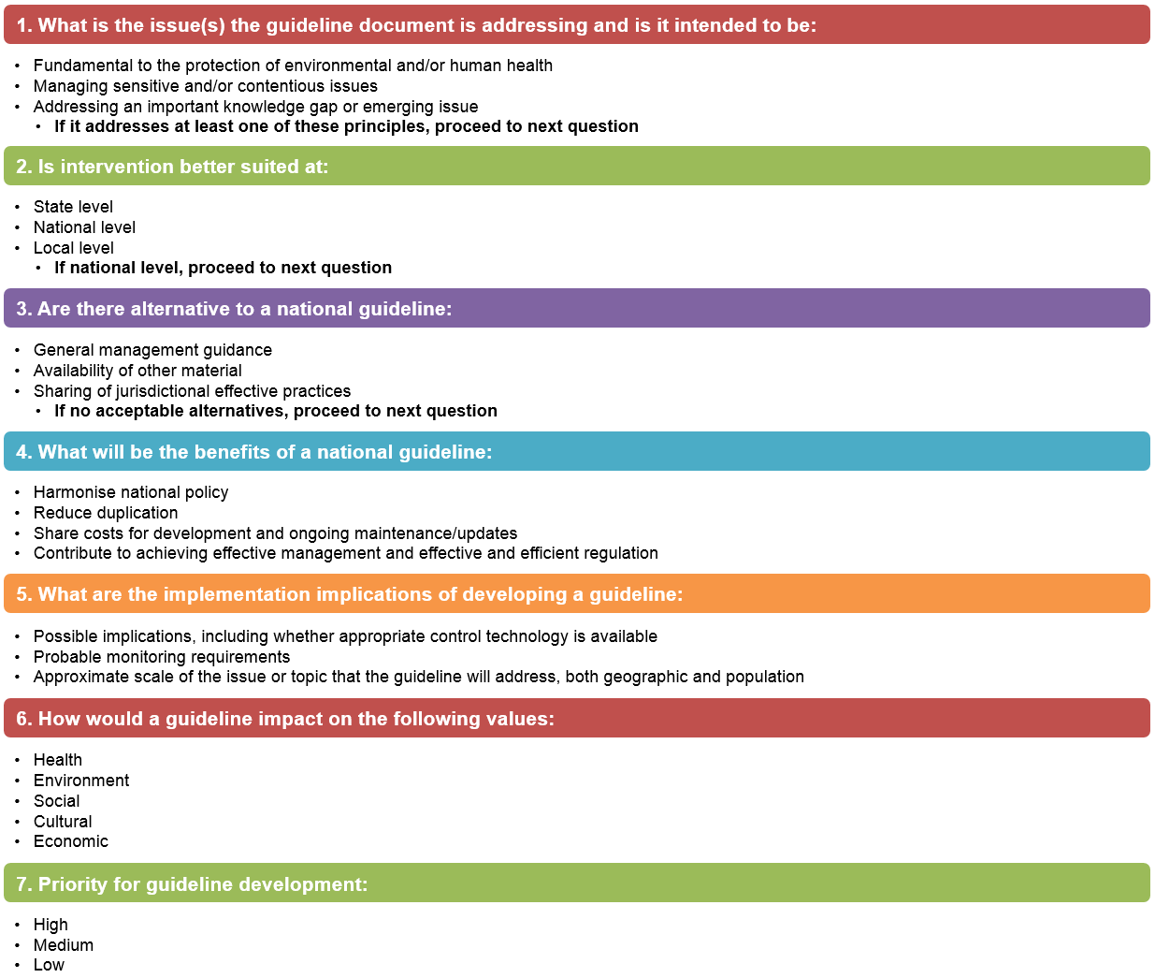

### Developing the guideline

If the committee agrees it is worth developing a guideline, the proponent will need to follow the requirements set out in the *National Water Quality Management Strategy:* *Design and requirements for a new guideline*. The committee may also recommend that the proponent establish a steering committee with key stakeholders, which may include a member/s from the committee, so that emerging issues can be addressed early. The committee must be kept informed about progress. Alternatively, a committee member could be a contact point for the proponent to allow for smooth communication between the committee and the proponent.

The committee could ask to see a draft of the guideline before full assessment to ensure it is on the right track. This would minimise the risk and expense of the proponent needing to get the guideline verified twice.

Where relevant, the committee should check that the principles for incorporating cultural and spiritual values into water quality management are followed (see the [National Water Quality Management Strategy: The charter](http://www.waterquality.gov.au/about/charter) for more details).

### Independent verification

Before submitting the draft guideline, the proponent needs to have arranged and carried out independent verification of the guideline information to ensure the guideline incorporates the best available information and tools. If the proponent is unable to arrange for independent verification (for example, because there could be a perception of conflict of interest) then the committee can do so. An independent review could be a peer review or multi-jurisdiction review, but the reviewer/s must have suitable expertise and have no conflict of interest.

### First draft of guideline

This step allows for the committee to see the details of the guideline. At this point, the committee can review the information and start preliminary discussions about the category for the guideline.

It is important that the committee sees the draft before any broader industry and community consultation is undertaken on a proposed guideline. Among other things, this may help to manage expectations and give governments options on how to proceed.

### Consultation

If the draft guideline seems on track to meet the NWQMS requirements and all jurisdictions are agreeable then consultation can occur. The proponent needs to arrange consultation or can ask the committee to do this if there is a perception of conflict of interest.

The aims of consultation are to identify if there is new evidence that should be included in the guideline and to give key stakeholders forewarning of changes that could impact on them. Key stakeholders are those that might be significantly impacted on by recommendations in the new guideline and hence should be given an opportunity to comment on the draft guideline. Evidence or concerns received through the consultation process may be used by the committee to recommend changes to the draft guideline or by jurisdictions and other regulators to assess if or how the guideline may be implemented.

### Draft for approval

A quick checklist for the committee to consider whether to approve a new guideline under the NWQMS can include the following:

* All design and specific requirements have been met (for example, that principles for incorporating cultural and spiritual values into water quality management have been followed where relevant).
* The information and results have been independently verified by a party with sufficient skills and expertise and who has no vested or conflict of interest in the guideline.
* It can be demonstrated that key stakeholders have been informed or consulted about the draft guideline.
* Arrangements for ongoing review, maintenance and revision are outlined in the guideline.

As per the *National Water Quality Management Strategy:* *Design and requirements for a new guideline*, the committee can take into account other considerations. For example, government policy or circumstances can change. For these reasons, committee members are encouraged to stay involved in the guideline development process and consult with their colleagues and government ministers (as necessary) in advance of this step to ensure that any issues are resolved early in the process. This could minimise negative feedback amongst stakeholders that may have invested considerable time and resources in developing a guideline. Nevertheless, the committee reserves the right to not approve a guideline for inclusion under the NWQMS or to ask for more information.

As a new guideline will be expected to apply nationally, all jurisdictions must approve its inclusion under the NWQMS. Generally, approval for new guidelines should be from a senior public servant representing each jurisdiction (such as deputy secretary or chief executive / deputy chief executives) or could be elevated to government ministerial approval. The level of approval would be determined by each jurisdiction. If all jurisdictions do not approve, see Section 5.

Documents that are not approved might be able to be included in the Reference category on the NWQMS website. The committee would generally make the decision about whether to approve a document to include in the Reference part of the website unless the document is likely to be sensitive or controversial. In this case, the level of approval would be determined by each jurisdiction, with the senior public servant being the minimum approval level required.

More information about approval is in Section 4.4.

### Categorising and publishing the guideline

The committee will categorise the guideline according to the primary and secondary criteria published in the *National Water Quality Management Strategy:* *Design and requirements for a new guideline*. The Department of the Environment will be responsible for publishing the new guideline on the NWQMS website unless another jurisdiction has responsibility for the website.

References will also be published on the website with a watermark stating these documents are for reference only.

## Processes for ongoing committee approval—review, revise and retire

The following sections describe the processes where committee approval is required to add, review, revise, downgrade or retire guidelines, irrespective of whether they are developed by the committee or by third parties. In some cases, the committee approval may not be required to review or revise a guideline: more information about this is in Section 6.

### Review of guideline

Information, tools and techniques can become out of date over time. A guideline may need to be updated when significant changes in the relevant science, expertise or information arise. A review (brief or comprehensive) can inform whether a guideline may need to be revised and updated.

Some guidelines may be based upon information that is unlikely to change for some time. Others may be affected by rapid advances in science, techniques and technology. For this reason, each guideline will need to identify a review process based upon the likelihood and consequences of change. However, it is good practice to have a review at least every five years to check that the guideline is not:

* significantly deficient, and/or possibly containing erroneous material
* superseded
* unhelpful as a reference document.

A review may not need to be extensive. A brief review can be performed by the committee or owner of a third-party guideline. The key questions for a brief review are as follows:

* Is it evident that the science, tools, techniques and other information underpinning the guideline have changed?
* How significant are the changes? Is it likely the changes will substantially change the guideline?
* If the changes are minor (for example, the name of the governing committee has changed), does the guideline need to be revised at all or can minor editorial changes be made relatively easily?

If the changes are likely to be significant, a more thorough review could be commissioned.

Figure 2 outlines a process for reviewing guidelines. Note that, if there is genuinely not the resources or capacity available to undertake a review, it can be deferred; however, a process should be undertaken to identify, as a minimum, a new time frame for review and the type of review to be undertaken.

#### Committee reviews

The committee can review a guideline it manages according to the review process or, if no review has occurred, once every five years to check the guideline is still relevant.

#### Third-party reviews

A guideline developed by a third party would usually be maintained and updated by that party. If the third party is no longer operational or does not have the capacity to do this, the committee may decide whether to review, revise or downgrade the guideline.

When the committee is considering adding a new guideline by a third party, one point to consider is the review and revision requirements. A clear process that identifies responsibilities for review and revision will be beneficial in the long term.

The process for third-party reviews is at

Figure 2. Key steps in the process include:

* whether a review will be undertaken
* the recommendations from the review
* whether to proceed with a revision of the guideline.

In this process, the committee will have approval authority for adding a revised document to the NWQMS, but it is unlikely that the committee can force a third party to review or revise a guideline.

However, if it is evident that a guideline is out of date or contains erroneous material, the committee may decide to move the guideline to the Reference category or remove the guideline altogether. The committee should discuss any action with the third party first.

#### Option for committee or third-party reviews

In some circumstances, the option of having either the committee or a third party undertaking a review of a guideline may be available. For example, the *Australian guidelines for water recycling: Managing health and environmental risks (Phase 1)* was originally approved by the Environment Protection and Heritage Council, the Natural Resource Management Ministerial Council and the Australian Health Ministers’ Conference in 2006; if a review was undertaken of the health aspects only and the review was not intended to make major changes to the risk framework or any other major component of the guideline, an option could be that a health authority, rather than the committee, could coordinate and approve the review and revisions.

A third-party review may be considered if, for example, it will be more efficient or effective for a third party to undertake a review or a third party has more expertise and authority than the committee. If the option is to use a third party then the process for the review in

Figure 2 and the consultation requirements for revision in Figure 4 should be followed.

Figure 2 Process for reviewing a guideline

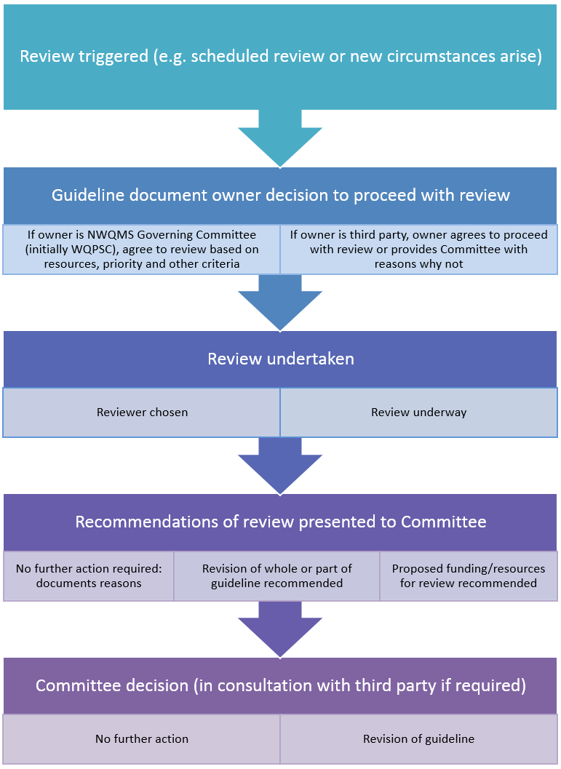

### Revision of guideline

The scope and scale of the revision of a guideline will depend on the review recommendations or what is most likely to need updating. For example, it may be that guideline values are updated as part of a rolling review process or a full guideline revision is undertaken if a review finds the guideline information is significantly out of date.

The same requirements for approving a guideline apply to approving a guideline revision as outlined in *National Water Quality Management Strategy:* *Design and requirements for a new guideline*. For example, a third-party owner of a guideline should approach the committee early to discuss the scope of the revision and there will still be the requirement for independent verification and consultation on significant changes.

A simplified process for a guideline revision is at Figure 3.

Minor editorial amendments may be made by the guideline owner on an as-needed basis without the need to seek committee endorsement. However, the revised guideline should be provided to the Department of Agriculture and Water Resources (unless another jurisdiction has responsibility for the website) with an indication of what amendments have been made so that a latest version can be added to the NWQMS web page.

Note that the resourcing and time for revising a guideline can be significant. For example, the revision of the *Australian and New Zealand guidelines for fresh and marine water quality* cost almost $1 million in combined jurisdictional funding; involved two full-time and two part-time personnel from the Australian Government as well as significant in-kind time from the jurisdictions; and took over five years.

Figure 3 Revision of a guideline where committee is the approval authority

The steps to be taken in revising a guideline are:
• guideline document owner decides to proceed with revision
• scope of revision is developed and resources allocated
• revision is undertaken
• independent review of revision work 
• draft revision is presented to the committee
• committee decides whether more information / stakeholder communication is required
• committee consults with stakeholders
• final draft submitted for approval
• if approved, the revised guideline is published.


### Retiring or reclassifying guidelines

A review can establish whether a guideline no longer provides useful information relevant to a contemporary position on water quality management or has no benefit as a reference document.

For guidelines managed by the committee, the committee will decide whether the document should be updated, re-categorised or removed from the NWQMS. It is good practice to undertake appropriate consultation with stakeholders who could be significantly impacted on by this decision and incorporate their feedback into the final decision.

For third-party guidelines, the committee may provide recommendations for further action to the organisation, body or group responsible for the guideline to bring the guideline up to the requirements for inclusion under the NWQMS or to be re-categorised as a reference document.

If these actions cannot be undertaken, the committee should advise the guideline owner and give four weeks’ notice to respond. If there is no response, or the guideline owner agrees, the appropriate action will be undertaken by the committee. The committee reserves the right to remove any guideline from the NWQMS.

### Summary of recommended level of approval

To assist the committee, a summary of the recommended level of approval is provided in   
Table 1.

Guidelines should be considered on a case-by-case basis, but generally the greater the likely impacts of changes to the guideline on stakeholders (including costs and regulatory burden), communities or the environment, the more senior the officer of government would need to be to approve the guideline. Therefore, a new or significantly revised guideline would require senior public servants or government ministers to approve, while minor changes could only require committee level approval.

Table 1 Summary of recommended level of approval

| Task | Recommended level of approval |
| --- | --- |
| Adding a new guideline | Each jurisdiction to decide appropriate approval level—at minimum, this will be the senior public servant level |
| Reviewing a guideline | Each jurisdiction to decide appropriate approval level—at minimum, this will be the committee |
| Revising a guideline—significant changes that could have major impacts | Each jurisdiction to decide appropriate approval level—at minimum, this will be at the senior public servant level |
| Revising a guideline—minor changes (no resource implications) | The committee, unless it is decided to escalate to senior public servant level |
| Revising a guideline—minor editorial changes | The guideline owner |
| Adding a reference document | The committee, unless it is decided to escalate to senior public servant level |
| Retiring or re-categorising a guideline | Each jurisdiction to decide appropriate approval level—at minimum, this will be the committee |

## Dispute resolution

Where there is a dispute, the parties will try to resolve it first though informal discussion. If there is no resolution then the parties will try to resolve the dispute through direct negotiation, which could include referring the matter to persons who have the authority to intervene and direct some form of resolution.

If there is still no resolution of the dispute, parties may agree to mediation by an independent or third party. If mediation is not agreed and the dispute is preventing the committee from undertaking its responsibilities in respect to guideline management, the chair of the committee may write to the members outlining the nature of the dispute and seeking advice from committee members about how to proceed. This could include referring the dispute to a more senior committee or to government ministers as appropriate.

## Alternative process for guidelines which have another approval authority

For some guidelines, such as the *Australian drinking water quality guidelines* and the *Guidelines for managing risks in recreational water*, the committee will not be the ongoing approval authority. This is because those two guidelines are managed by the National Health and Medical Research Council. Having two approving authorities can add unnecessary duplication and slow down the process for revising and updating information.

Once a new third-party guideline has been approved to be included under the NWQMS, the committee may want to consider whether it is appropriate to have ongoing approval authority for reviews and revisions. Ongoing approval may not be required if:

* there is an independent approval authority such as an intergovernmental committee
* there is a transparent process for reviewing and revising that includes consultation with stakeholders
* the best available science and information is utilised and checked by a third party with suitable expertise and no vested interest.

Where the committee does not have approval authority, the consultation mechanism for reviews and revisions will be particularly important. The recommended minimum requirements for consultation are outlined in Figure 4.

## Effectiveness of guidelines and other NWQMS tools

A monitoring and evaluation plan will set out performance indicators and targets to determine whether NWQMS guidelines, tools and arrangements assist water quality planning. The monitoring and evaluation plan will also identify reporting frequency and responsibilities. Unless otherwise agreed by the committee, the Australian Government will collect the information from the reporting parties and prepare a report to the committee about the effectiveness of the guidelines, tools and arrangements. The committee may use this information to institute or recommend changes to guidelines, tools and arrangements.

## More information

The [NWQMS website](http://www.waterquality.gov.au/) has up-to-date information, including contacts, which can assist proponents who wish to develop a new guideline. Alternatively, proponents can telephone the Department of Agriculture and Water Resources on 1800 900 090.

Figure 4 Consultation requirements for review or revision of third-party guidelines that do not need committee approval

The steps are:
• The responsible committee or council agrees to revise the guidelines.
• A decision is made about the scope of the guideline revision.
• The revision process is undertaken.
• Review and consultation takes place  on draft revised guideline (including review by a third party with suitable expertise and no vested interest).
• The revised guideline is approved.
 At each stage, there are communication requirements involving the NWQMS governing committee, jurisdictions and stakeholders.
