# National Acid Sulfate Soils Guidance

National acid sulfate soils sampling and identification methods manual

June 2018

© Commonwealth of Australia 2018

**Ownership of intellectual property rights**

Unless otherwise noted, copyright (and any other intellectual property rights, if any) in this publication is owned by the Commonwealth of Australia (referred to as the Commonwealth).

**Creative Commons licence**

All material in this publication is licensed under a Creative [Commons Attribution 4.0 International Licence](https://creativecommons.org/licenses/by/4.0/legalcode) except content supplied by third parties, logos and the Commonwealth Coat of Arms.

Inquiries about the licence and any use of this document should be emailed to [copyright@agriculture.gov.au](mailto:copyright@agriculture.gov.au).

by

**Cataloguing data**

This publication (and any material sourced from it) should be attributed as: Sullivan, L, Ward, N, Toppler, N and Lancaster, G 2018, *National Acid Sulfate Soils guidance: National acid sulfate soils sampling and identification methods manual,* Department of Agriculture and Water Resources, Canberra ACT. CC BY 4.0.

This publication is available at waterquality.gov.au.

Australian Government Department of Agriculture and Water Resources

GPO Box 858 Canberra ACT 2601

Switchboard +61 2 6272 3933 or 1800 900 090

Email [waterquality@agriculture.gov.au](mailto:waterquality@agriculture.gov.au)

**Liability**

The Australian Government acting through the Department of Agriculture and Water Resources has exercised due care and skill in preparing and compiling the information in this publication. Notwithstanding, the Australian Government Department of Agriculture and Water Resources, its employees and advisers disclaim all liability, including liability for negligence and for any loss, damage, injury, expense or cost incurred by any person as a result of accessing, using or relying on any of the information or data in this publication to the maximum extent permitted by law.

**Acknowledgements**

The authors would like to acknowledge the Department of Environment Regulation, Western Australia, Queensland Acid Sulfate Soils Investigation Team, Queensland Acid Sulfate Soil Management Advisory Committee, NSW Acid Sulfate Soils Management Advisory Committee, National Committee for Acid Sulfate Soils and Southern Cross University for producing the guidelines and manuals that were used in the development of this guidance. The authors would also like to thank the reviewers for their comments on the draft report, including Dr Steve Appleyard (Department of Environment Regulation, Western Australia), Dr Mitch Tulau (Office of Environment and Heritage, NSW) and Dr Liz Barnett (Department of Environment, Water and Natural Resources, South Australia).



Contents

1 Introduction 1

1.1 The purpose of the guidance 1

1.2 Defining acid sulfate soils 2

1.3 ‘Acid’ soil and ‘acid sulfate’ soils 3

2 Background information 5

2.1 Acid sulfate soil formation 5

2.2 Acid sulfate soil disturbance processes and impacts 7

3 When do sites need to be investigated for acid sulfate soils? 10

3.1 Acid sulfate soil risk maps 10

3.2 Investigation process stages 12

3.3 Selection of consultants for acid sulfate soil investigations 13

4 Stage 1: Desktop assessment 14

5 Stage 2: Site inspection 16

5.1 Field soil and water characteristics as indicators of ASS materials 18

5.2 Groundwater analysis as indicators of impact from ASS materials 19

5.3 Identification of monosulfidic black oozes (MBOs) 20

5.4 Consideration of soil, water and groundwater indicators 21

5.5 Laboratory chemical analysis to confirm presence or absence of ASS 22

5.6 Establish the general charactreristics of proposed works 24

5.7 Reporting on the preliminary assessment (Stages 1 and 2) 24

5.8 Is further investigation required? 25

6 Stage 3: Detailed soil sampling and field testing 26

6.1 Occupational health and safety considerations 26

6.2 Quality control/quality assurance (QC/QA) 27

6.3 Minimum soil sampling density 27

6.4 Location of sampling points 29

6.5 Depth of sampling points 29

6.6 Sampling equipment 29

6.7 Soil sampling procedure 32

6.8 Sample handing, transport and storage 39

6.9 Soil field tests 41

6.10 Which samples need laboratory analysis? 41

7 Further information 43

Appendix A: Soil field tests 44

A1.1 Soil field test equipment 44

A1.2 Conducting field tests – some considerations 44

A1.3 On-site chemical and material safety precautions 45

A1.4 Field pH tests 46

A1.5 Field carbonate test – NSM-2.1 50

Appendix B: Soil sampling equipment 52

Appendix C: Recommended mass of sampled MBO material to allow laboratory analyses 54

Appendix D: Determination of soil texture 55

D1.1 Soil Texture – NSM-3.1 55

Glossary 58

References 60

Figures

Figure 1.1 Examples of acid sulfate soils. 2

Figure 2.1 Formation and accumulation of ASS materials. 5

Figure 2.2 Types of development that may cause ASS problems. 8

Figure 2.3 Potential impacts due to the disturbance of ASS materials. 9

Figure 3.1 ASS investigation process stages. 12

Figure 4.1 Key elements required in a desktop assessment process. 14

Figure 5.1 Minimum requirements of a site inspection (Stage 2). 16

Figure 5.2 Indicators of a Potential ASS materials following field peroxide testing. 19

Figure 5.3 Black oily appearance of MBO gel collected from the Peel region, Western Australia. 21

Figure 5.4 Selection criteria for preliminary chemical analysis of soil samples. 23

Figure 5.5 Factors to be considered in developing mitigation strategies. 24

Figure 6.1 Factors to consider when choosing sample locations. 29

Figure 6.2 Sampling MBOs using a sediment coring device. 31

Figure 6.3 Sampling MBOs using a Van Veen grab sampler. 32

Figure 6.4 Bore log of a soil profile comprised of two horizons. 33

Figure 6.5 Bore log of a soil profile comprised of many distinctly different soil layers. 34

Figure 6.6 A protocol for selecting samples for laboratory analysis from small-scale disturbance. 37

Tables

Table 2.1 Areas where ASS materials are generally found. 6

Table 4.1 Site criteria to determine if coastal ASS materials are likely to be present. 15

Table 5.1 Indicators of ASS materials. 17

Table 5.2 Additional indicators of RIS oxidation in groundwater and indicative values. 20

Table 5.3 Soil and water indicators for the presence or absence of ASS materials. 22

Table 5.4 Action criteria based on the texture and volume of material disturbed. 23

Table 6.1 Minimum soil sampling densities for ASS investigations. 28

Table 6.2 Minimum number of soil samples to be submitted for laboratory analysis for small-scale disturbances. 37

Table A1 Soil reaction rating scale for the pHFOX test. 48

Table A2 Interpretation of some pHF test ranges. 49

Table A3 Interpretation of pHFOX test results. 49

Table A4 Soil reaction rating scale for the fizz test. 51

Table B1 Manual soil sampling equipment and their likely suitability for ASS materials. 52

Table B2 Mechanical soil sampling equipment and their likely suitability for ASS materials. 52

Table C1 Recommended mass of sampled MBO material to allow laboratory analyses. 54

Table D1 Field tecture grades. 56

Maps

Map 3.1 Example of ASS risk map for the central metropolitan region of Perth, Western Australia. 11

## Introduction

### The purpose of the guidance

The purposes of this guidance are to provide technical and practical advice on the identification and sampling of acid sulfate soil (ASS) materials prior to field investigations and when in the field. Guidance is also provided on the sampling requirements necessary to define the extent of ASS materials in the landscape.

It complements other guidance literature including a synthesis of acid sulfate soil guidance including a decision support tool (Sullivan et al, 2018a) that provides assistance in accessing appropriate guidance.

This guidance document also complements other guidance literature including:

* National Acid Sulfate Soils Identification and Laboratory Methods Manual
* Overview and Management of Monosulfidic Black Ooze (MBO) Accumulation in Waterways and Wetlands
* Guidelines for the Dredging of Acid Sulfate Soil Sediments and Associated Dredge Spoil Management
* Guidance for the Dewatering of Acid Sulfate Soils in Shallow Groundwater Environments.

**It is essential that the reader consult relevant jurisdictional guidance and regulations and contact the relevant state or territory government department for specific local and regional information and advice.**

This guidance document is divided into six sections:

1. An introduction to ASS and outlines the scope of the document.
2. A background on ASS formation and impacts that may occur arising from the disturbance of these soil materials.
3. A description of the conditions under which sites will require investigations for the presence or absence of ASS materials.
4. A description of the utility of desktop assessment of sites prior to field investigations.
5. Details the requirements of inspections of sites reasonably suspected to contain ASS materials, including an examination of the field indicators of ASS materials and useful preliminary soil and water assessments that need to be undertaken.
6. Details the minimum requirements for soil sampling and field testing including the location and number of sampling points, depth of sampling, sampling procedures including handling, transport and storage and soil field tests.

The appendices provide further information on soil field tests and their interpretation and recommendations on the most suitable sampling equipment for different field conditions.

This guidance provides current good practice management for ASS investigations and sampling for management purposes.

### Defining acid sulfate soils

Acid sulfate soil (ASS) materials are distinguished from other soil or sediment materials (referred to as ‘soil materials’ throughout this guideline) by having properties and behaviour that have either:

1. been affected considerably by the oxidation of Reduced Inorganic Sulfur (RIS), or
2. the capacity to be affected considerably by the oxidation of their RIS constituents (Figure 1.1).

The factor common to all ASS materials is that RIS components have either had, or may have, a major influence on the properties or behaviour of these soil materials.

These soils are typically found in low-lying coastal areas and saline inland areas, however, they have been identified in a wide range of environmental settings.

Figure 1.1 Examples of acid sulfate soils.

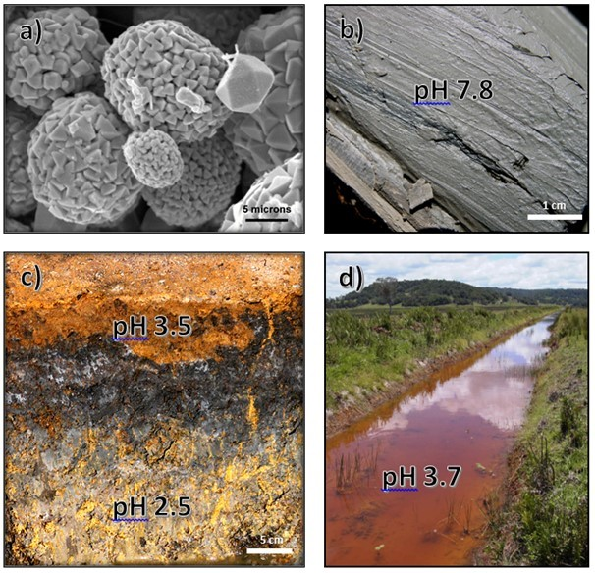

Note: a) PASS containing framboidal pyrite (FeS2) crystals. b) Blue-greenish grey PASS. c) AASS profile showing surficial iron oxide and yellow jarosite segregations. d) Iron staining (by schwertmannite and goethite) of a drain in an ASS landscape.

Source: Photographs from LA Sullivan.

In a waterlogged anoxic state (that is depleted of dissolved oxygen), these materials remain benign and do not pose a significant hazard to human health or the environment. However, ASS disturbance, and exposure to oxygen, may result in a wide range of environmental hazards, including:

* severe acidification of soil and drainage waters (below pH 4 and often pH less than 3),
* mobilisation of metals (for example iron, aluminium, copper, cobalt, zinc), metalloids (for example arsenic), nutrients (for example phosphate) and rare earth elements,
* deoxygenation of water bodies,
* production of noxious gases (for example hydrogen sulfide),
* production of greenhouse gases, and
* scalding (that is de-vegetation) of landscapes.

These hazards have the potential to cause a number of significant environmental and economic impacts such as fish kills, loss of biodiversity in wetlands and waterways, contamination of groundwater resources, loss of agricultural productivity, and corrosion of concrete and steel infrastructure (DER 2015a).

Acid sulfate soil materials include Potential acid sulfate soils (PASS or sulfidic soil materials) and Actual acid sulfate soils (AASS or sulfuric soil materials). These are often found in the same profile, with AASS overlying PASS.

* Potential acid sulfate soils (PASS) are soil materials which contain RIS such as pyrite (for example Figure 1.1a). The field pH of these soils in their undisturbed state is usually more than pH 4 and is commonly neutral to alkaline (pH 7–9) (for example Figure 1.1b). These soil materials are invariably saturated with water in their natural state. Their texture may be peat, clay, loam, silt or sand and is often dark grey in colour and soft in consistence (for example Figure 1.1b), but these materials may also exhibit colours that are dark brown, or medium to pale grey to white.
* Actual acid sulfate soils (AASS) are soil materials which contained RIS such as pyrite that have undergone oxidation. This oxidation results in low pH (that is pH less than 4) and often a yellow (jarosite) and/or orange to red mottling (ferric iron oxides) in the soil profile (for example Figure 1.1c). Actual ASS contains Actual Acidity, and commonly also contains RIS (the source of Potential Sulfuric Acidity) as well as Retained Acidity.

Projects involving the disturbance of ASS materials must assess the hazards associated with disturbance and consider potential impacts. Activities with a potential to disturb ASS materials, either directly, or by lowering the watertable, need to be managed appropriately to avoid environmental harm.

Successful management of ASS materials depends on a detailed investigation to determine the nature of the hazards presented by these soil materials and hence a determination of the most appropriate management strategy. Wherever possible, management measures should be governed by the guiding principle of avoiding disturbance of ASS materials.

### ‘Acid’ soil and ‘acid sulfate’ soils

The acidity hazard of soil materials that are strongly acidic due to processes other than RIS oxidation is not considered an ASS acidity hazard. While Actual ASS and sulfuric soil materials are acid soil materials, not all acid soil materials are Actual or sulfuric ASS materials.

Naturally-occurring acidic soils are not considered an environmental hazard and indeed are usually part of acidophilic ecosystems whose health depends on maintaining an acidic environment. As an example, many soil materials in naturally acidic landscapes, such as acidic peatlands and coastal heaths, often have low pH values and high acidities.

If it can be demonstrated the majority of the acidity of acidic soil materials is not, or could not be derived from the oxidation of RIS, then these materials should not be treated as if they were ASS materials. To do so may result in the liming of naturally acidic ecosystems. This could lead to unnaturally alkaline environments resulting in severe ecological damage to the acidophilic organisms that relied on the acidic nature of these ecosystems.

Field investigation can help determine whether acidic soil materials are ASS materials or not. The presence of jarosite in a soil material, or adjacent soil material, is strong evidence of prior oxidation of RIS. Documented jarosite, along with field pHs less than 4, can be used to identify these soil materials as Actual ASS materials rather than just acid soil materials. Further information is provided in the National Acid Sulfate Soils Identification and Laboratory Methods Manual (Sullivan et al, 2018b) to help distinguish naturally-occurring acidic soil materials from Actual ASS materials.

## Background information

### Acid sulfate soil formation

The formation of acid sulfate soils (ASS) materials occurs under waterlogged conditions in the presence of no or minimal oxygen. Under these anaerobic conditions, sulfate-reducing bacteria in the soil materials convert dissolved sulfate present in the pore water into Reduced Inorganic Sulfur (RIS).

The RIS produced then reacts with metals, particularly iron, resulting in the formation of metal sulfides (principally pyrite). A supply of easily decomposable organic matter (such as decaying vegetation) is also required to provide sufficient energy for the bacteria to convert the sulfate into RIS.

Under favourable environmental conditions iron monosulfides (for example FeS) may form, sometimes resulting in the accumulation of monosulfidic black ooze (MBO).

Figure 2.1 summarises the key processes leading to the formation and accumulation of ASS materials.

For further details on the formation and accumulation of MBO see the Overview and Management of Monosulfidic Black Ooze (MBO) Accumulation in Waterways (Sullivan et al, 2018c).

Figure 2.1 Formation and accumulation of ASS materials.

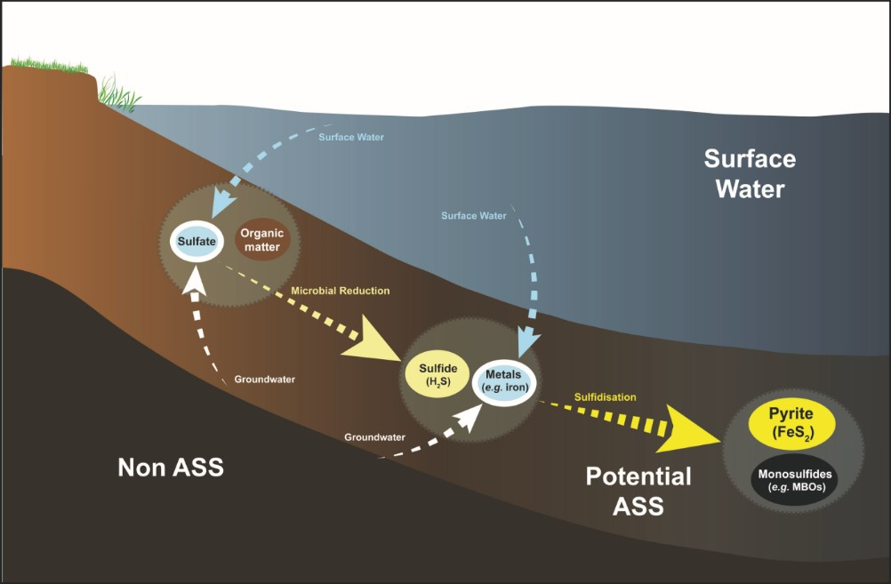

Note: not to scale.

Source: Adapted from EPHC & NRMMC (2011) and Ward et al. (2013).

Highly favourable conditions for RIS formation and the accumulation of ASS materials were widespread following the last major sea level rise, and resulted in the accumulation of extensive deposits of Holocene age (less than 10 000 years BP) ASS materials in coastal floodplains and inter-tidal swamps worldwide (Dent 1986). Pyrite (the most common form of RIS in ASS materials) is also found in older sediments in Australia (that is Pleistocene age) and continue to form and accumulate in coastal and inland environments where suitable conditions for their formation exist. While ASS materials can be found in a wide variety of areas, some of the general situations where ASS materials are found are listed in Table 2.1.

Table 2.1 Areas where ASS materials are generally found.

|  |
| --- |
| a) Areas depicted on geology and/or geomorphological maps as ‘geologically recent’ such as: |
| * shallow tidal flats or tidal lakes, * shallow estuarine, or shallow marine deposits, * stranded beach ridges and adjacent swales, * interdune swales or coastal sand dunes, * coastal alluvial valleys, * wetlands (groundwater dependant and perched), * floodplains, * waterlogged areas, * scalded areas, * sump land, * marshes, and * swamps. |
| b) Areas depicted in vegetation mapping as: |
| * mangroves, * wetland-dependent vegetation such as reeds and paperbarks (Melaleuca spp.), and * areas where the dominant vegetation is tolerant of salt, acid and/or waterlogged conditions for example mangroves, salt couch, swamp-tolerant reeds, rushes, paperbarks and swamp oak (Casuarina spp.). |
| **c) Areas identified in geological descriptions or in maps as:** |
| * bearing iron sulfide minerals, * former marine or estuarine shales and sediments, * coal deposits, and * mineral sand deposits. |
| d) Areas known to contain peat or a build-up of organic material. |
| e) Areas where the highest known watertable level is within 3 metres of the surface. |
| f) Land with elevation less than 5 metres above Australian Height Datum (AHD). |
| g) Any areas (including inland areas) where a combination of all the following pre-disposing factors exist: |
| * organic matter, * iron minerals, * waterlogged conditions or a high watertable, and * sulfidic minerals. |

Source: DER (2015a).

### Acid sulfate soil disturbance processes and impacts

In a waterlogged anoxic state potential acid sulfate soils (PASS) materials are benign. However, when these soil materials are drained or excavated, oxygen from the atmosphere reacts with the RIS in the soil resulting in the production of sulfuric acid. This acidity releases constituents such as metals and nutrients from the soil which may also be transported to waterways, wetlands and groundwater systems, often with adverse environmental and economic impacts.

Development projects may adversely disturb ASS materials where they involve temporary or permanent lowering of the watertable, excavation, compaction of saturated soil materials, and/or lateral displacement of previously saturated soil materials. A list of some of these types of developments is provided in Figure 2.2.

The disturbance of ASS materials can adversely affect soil, water and biota, and have a detrimental impact on agriculture, fishing, aquaculture, recreation and tourism, as well as on human health and visual amenity. The impacts of ASS leachate may persist over a long time, or peak seasonally with the first drought-breaking rains after extended dry periods. For example, in some areas of Australia, ASS materials drained 100 years ago are still releasing acid (Sammut & Lines-Kelly 2000). Some of the potential environmental, social and economic consequences of ASS disturbance are listed in Figure 2.3.

Figure 2.2 Types of development that may cause ASS problems.

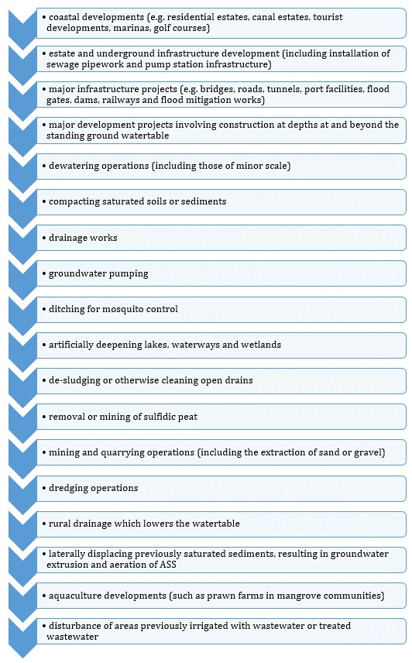

Figure 2.3 Potential impacts due to the disturbance of ASS materials.

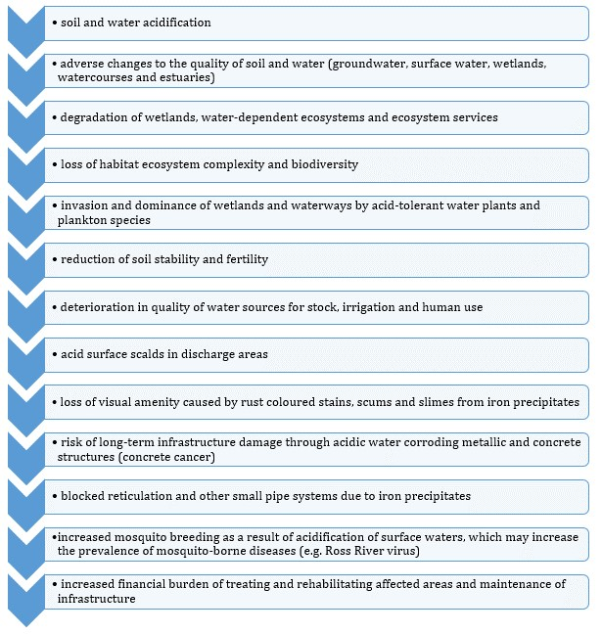

## When do sites need to be investigated for acid sulfate soils?

Investigations to determine the likely presence and distribution of ASS materials should ideally be undertaken in the early stage of a land-use planning process. Identification of ASS materials at an early stage can allow the design of development works to be modified to avoid or minimise the disturbance of ASS materials. Further guidance on the specific requirements for ASS investigations at each stage of the planning process is provided in state and territory planning guidance literature.

Investigations are required for developments that involve ground disturbance, or a change in groundwater levels in ASS landscapes, to determine the presence or absence of ASS materials. These investigations should be undertaken prior to ground and groundwater disturbance to fully characterise their nature and extent.

Sites should be investigated for ASS materials if there is any evidence that reasonably suggests that ASS materials may be present in the vicinity and that these materials may be disturbed. Examples, of such evidence may include any of the following:

* soil materials disturbance of 100 m3 or more located within an area mapped with at least a moderate risk of ASS materials occurring within 3 m of the natural soil surface,
* soil materials disturbance of 100 m3 or more, with excavation likely from below the natural watertable, in an area with at least a moderate risk of ASS materials occurring within 3 m of the natural soil surface, or with at least a moderate risk of ASS materials occurring deeper than 3 m of the natural soil surface,
* temporary or permanent lowering of the watertable in areas mapped with a risk of ASS materials occurring within 3 m of the natural soil surface (for example for groundwater abstraction, dewatering, installation of new drainage, modification to existing drainage),
* dredging operations,
* extractive industry works (for example mineral sand mining) in the areas listed in Table 2.1, and
* flood mitigation works, including construction of levees and flood gates, in the areas listed in Table 2.1.

### Acid sulfate soil risk maps

The ASS risk maps should be consulted to determine if the proposed disturbance is in an area where there is a known ASS risk (for example Map 3.1). Most states and territories in Australia have ASS risk maps available that indicate the likely distribution and depth of ASS materials. While the risk maps do not provide details of the actual severity of the ASS materials, they identify the probability of their occurrence (for example low probability, high probability) within one or more depths from the ground surface (for example 1 m, 1–3 m, greater than 3 m).

Map 3.1 Example of ASS risk map for the central metropolitan region of Perth, Western Australia.

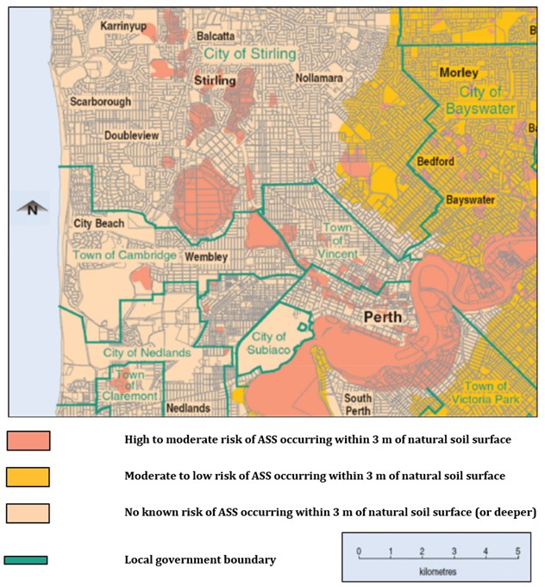

Source: DEC (2012).

The ASS risk maps are based on the interpretation of desktop information (for example geological records, aerial photos, digital elevation models, soil analyses) together with on-ground assessments and soil analyses to validate ASS materials occurrence. However, the level of detail these maps provide, including the map scale and depth to ASS materials, varies between each state and territory.

The ASS risk maps can either be downloaded or accessed via geographical information software (GIS). Further information related to state and territory ASS risk maps available at the time of publication is provided at the following links:

* [New South Wales](http://data.environment.nsw.gov.au/dataset/acid-sulfate-soils-risk0196c)
* [Northern Territory](http://www.ntlis.nt.gov.au/metadata/export_data?metadata_id=2DBCB771210406B6E040CD9B0F274EFE&type=html)
* [Queensland](https://data.qld.gov.au/dataset/acid-sulfate-soils-series)
* [South Australia](https://data.environment.sa.gov.au/NatureMaps/Pages/default.aspx)
* [Tasmania](http://www.thelist.tas.gov.au)
* [Victoria](https://www.data.vic.gov.au/data/dataset/coastal-acid-sulphate-soils)
* [Western Australia](https://www2.landgate.wa.gov.au/bmvf/app/waatlas)

National ASS risk maps are also available on the Australian Soil Resource Information System (ASRIS). [The Atlas of Australian Acid Sulfate Soils](http://www.asris.csiro.au/themes/AcidSulfateSoils.html) is located on this system and provides information on the distribution and properties of ASS.

It is important to note the state and territory ASS risk maps are designed for use in broad-scale planning and are not intended to depict ASS risk at an individual property level. The maps should be read at the scale of their intended use (for example 1:25,000) and are not suitable for interpretation at a smaller scale unless more detailed risk mapping has been carried out. In addition, when viewing the risk maps one should be aware there may be considerable spatial variation in the distribution of ASS materials within any mapping unit.

Following consideration of the ASS risk maps, further field and laboratory investigations are required to determine whether ASS materials are present and, if present, to quantify the hazard they pose to the surrounding environment and to inform their management.

### Investigation process stages

The five stages required in a full ASS investigation process are shown in Figure 3.1. The completion of a desktop assessment (Stage 1) and site inspection (Stage 2) are the minimum requirement of all ASS investigations. If the results of these two stages suggest ASS materials may be present, or the results are inconclusive, all five investigation stages are usually undertaken. The only instances where further investigation is not required are discussed at the end of Section 5 (see Is further investigation required? for further details).

Figure 3.1 ASS investigation process stages.

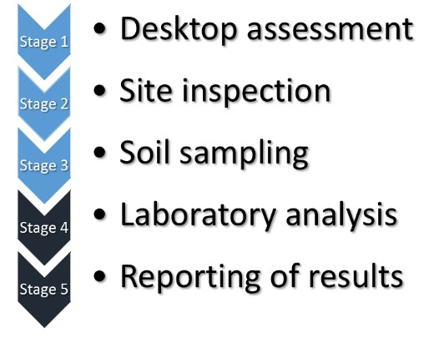

This guidance document outlines the requirements of the first three stages of the ASS investigation process [that is desktop assessment (Stage 1), site inspection (Stage 2) and soil sampling (Stage 3)]. The first two stages of the investigation process are commonly referred to as the preliminary ASS assessment (for example Ahern et al. 1998b). Further information on the requirements for laboratory analysis (Stage 4) and the reporting of results (Stage 5) is provided in the National Acid Sulfate Identification and Laboratory Methods Manual (Sullivan et al, 2018b). The selection of soil samples for laboratory analysis is outlined in this manual.

Each project should allow sufficient time to complete all stages of the ASS investigation and if required the development of a management plan before earth works commence.

### Selection of consultants for acid sulfate soil investigations

A suitably qualified and experienced consultant should be engaged to develop and undertake the ASS investigation program. Qualified persons are regarded as possessing an appropriate tertiary degree that includes specialisation in soil science, or hydrology, or geochemistry, and experience in ASS assessment, and preferably accredited by an appropriate professional organisation such as the Soil Science Australia [that is. a Certified Professional Soil Scientist (CPSS)].

## Stage 1: Desktop assessment

The initial stage of the acid sulfate soil (ASS) investigation process (Stage 1) involves a desktop assessment to determine the likelihood of ASS materials being present at the site. The desktop assessment should provide a description of the site from the available published data (including maps, photographs and any other relevant available reports and studies). A summary of the key elements required in the desktop assessment process are given in Figure 4.1.

Figure 4.1 Key elements required in a desktop assessment process.

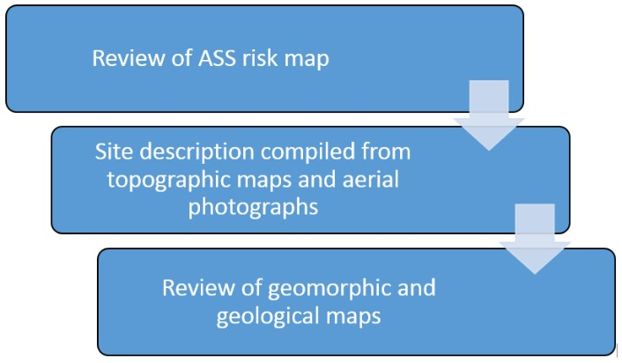

Review of an ASS risk map covering the site will identify the probability of ASS occurring and an indication of the potential ASS depth. If the proposed site is in an area mapped as having an ASS risk, the proponent will be required to undertake all stages of the investigation process to determine the hazards posed by ASS materials and possibly prepare a management plan.

Following the review of the ASS risk map for the area, a site description should be compiled from topographic maps and aerial photographs. The site description should always include an appropriately-scaled map delineating the area to be disturbed. Further useful information may be collected from maps describing the soil landscapes/attributes, geology, hydrogeology/groundwater and vegetation communities. A recent colour image or high-quality black and white aerial photo will assist in identifying vegetation communities and other site characteristics.

The final step in the desktop assessment is a review of geomorphic and geological maps to determine if the area includes units where ASS materials are expected to occur. This step may prove particularly useful in areas not covered by ASS risk maps. Aerial photos viewed stereoscopically may also provide further understanding of the geomorphology and formation or alteration of the landscape.

A summary of the desktop assessment criteria used to determine if coastal ASS materials are likely to be present is provided in Table 4.1. Some of these indicators can apply to inland ASS materials, however, the current useful desktop assessment criteria are inconclusive for these inland environments.

Table 4.1 Site criteria to determine if coastal ASS materials are likely to be present.

|  |  |
| --- | --- |
| Sediment characteristics | * sediments of recent geological age (Holocene), * marine or estuarine sediments, * areas identified in geological descriptions or in maps as bearing sulfide minerals, coal deposits or former marine shales/sediments (geological maps and accompanying descriptions may need to be checked), and * deep estuarine sediments greater than 10 metres below ground surface, Holocene or Pleistocene age (only an issue if deep excavation or drainage is proposed). |
| Landscape characteristics | * waterlogged or scalded areas, * tidal lakes, * coastal wetlands or back swamp areas, and * interdune swales or coastal sand dunes (if deep excavation or drainage proposed). |
| Vegetation characteristics | * areas where the dominant vegetation is mangroves, reeds, rushes and other vegetation associated with areas of shallow watertables such as flooded gums (*Eucalyptus rudis*) (*Eucalyptus robusta*), paperbarks (*Melaleuca* spp.) and casuarinas (*Casuarina* spp.). |

Source: Ahern et al. (1998b).

## Stage 2: Site inspection

The second stage of the investigation process (Stage 2) involves a site visit to identify the presence of any indicators of ASS materials. The desktop assessment only provides an indication of the site characteristics; a site inspection is required to confirm and add to the findings of this initial assessment. It may be beneficial to carry out the site inspection in stages, particularly when examining large sites.

The minimum requirements of a site inspection are summarised in Figure 5.1. An initial visual assessment of topography and geomorphology, combined with the information collected during the desktop assessment, will provide an indication of areas most likely to have ASS materials present. Table 5.1 provides a list of soil, water and vegetation indicators suggestive of the presence of ASS materials. Note some of the indicators will only be visible in boreholes or from examining soil profiles. During the site inspection, in addition to identifying indicators of ASS materials, it is important to gain an understanding of the hydrology of the site, particularly the likely flow directions.

Figure 5.1 Minimum requirements of a site inspection (Stage 2).

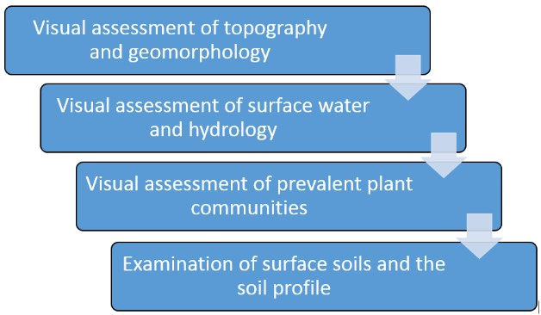

When reporting on a site assessment, it is important to describe the area of the total site, with emphasis on the area of any proposed disturbance. It is also important to inspect the vicinity surrounding the site, especially if off-site impacts are likely during planned disturbances (for example as a result of activities that cause dewatering and lowering of watertables). The site investigation should examine the presence of both actual acid sulfate soils (AASS) and potential acid sulfate soils (PASS) materials. As shown in Table 5.1, many of the indicators for AASS and PASS are substantially different. Commonly AASS are found overlaying PASS, and both are often covered by non ASS topsoil layers.

Table 5.1 Indicators of ASS materials.

| Soil type | Indicators |
| --- | --- |
| Potential acid sulfate soil (PASS) | Soil characteristics   * soil pHF > 4 and commonly neutral * soil pHFOX < 3, with large unit change from pHF to pHFOX, together with volcanic reaction to peroxide# * waterlogged soils—unripe muds (soft, sticky and can be squeezed between fingers, blue grey or dark greenish grey mud with a high water content, for example Figure 1.1b), silty sands or sands (mid to dark grey) or bottom sediments (dark grey to black for example monosulfidic black oozes) possibly exposed at sides and bottom of drains, cuttings or in boreholes * peat or peaty soils * coffee rock horizons, and * a sulfurous smell for example hydrogen sulfide or ‘rotten egg’ gas.   Water characteristics   * waterlogged soils, and * water pH usually neutral but may be acidic * oily looking iron bacterial surface scum (the similar appearances of iron bacterial scum and a hydrocarbon slick can be differentiated by disturbing the surface with a stick—bacterial scum will separate if agitated whereas a hydrocarbon slick will adhere to the stick upon removal). Caution should be taken when inspecting highly-altered landscapes in the field (for example where inert fill has been placed over ASS material, dredge spoil, et cetera.). Soil, water and landscape indicators may be masked by past landscape and drainage modifications and this should be taken into consideration when determining borehole locations.   Vegetation characteristics   * dominant vegetation is tolerant of salt, acid and/or waterlogging conditions for example samphires, salt couch, Phragmites (a tall acid-tolerant grass species), swamp-tolerant reeds, rushes, paperbarks (*Melaleuca* spp.) and casuarinas (*Casuarina* spp.). |
| Actual acid sulfate soil (AASS) | Soil characteristics   * soil pHF < 4 (when soil pHF > 4 but < 5 this may indicate some existing acidity and other indicators should be used to confirm presence or absence of AASS) * sulfurous smell for example hydrogen sulfide or ‘rotten egg’ gas * any jarositic horizons (for example Figure 1.1c) or substantial iron oxide mottling in the surface encrustations or in any material dredged or excavated and left exposed, and * presence of corroded mollusc shells.   Water characteristics   * water of pH < 5.5 (and particularly below 4.5) in surface water bodies, drains or groundwater (this is not a definitive indicator as organic acids may contribute to low pH in some environments such as Melaleuca swamps) * unusually clear or milky blue-green water flowing from or within the area (aluminium released by ASS materials acts as a flocculating agent) * extensive iron stains on any drain or pond surfaces (for example Figure 1.1d), or iron-stained water and ochre deposits, and * oily looking bacterial surface scum (differentiated from a hydrocarbon slick of similar appearance as described for PASS).   Vegetation characteristics   * dead, dying, stunted vegetation* * scalded or bare low-lying areas*, and * poor vegetation regrowth in previously disturbed areas.   Infrastructure   * corrosion of concrete and/or steel structures* (including foundations, fences, masonry/brick walls, pipes). |

# Further guidance on the interpretation of field testing results for ASS materials is provided in Appendix A.

* May also be due to excessive salinity or to salinity in combination with AASS.

Source: modified from DER (2015a).

### Field soil and water characteristics as indicators of ASS materials

If soil materials or associated water bodies display one or more of the indicators of ASS materials in Table 5.1, the presence of ASS materials is likely, but not conclusive.

The determination of the soil field pH (pHF) provides a useful quick indication of the likely presence and severity of Actual ASS (AASS). In undertaking pHF testing at the site inspection stage the sampling frequency, as a minimum, should be similar to that required during soil sampling (Stage 3), with a higher density of testing in areas where the site characteristics indicate ASS materials may be present. The location of soil samples should be recorded using the full Australian Map Grid reference and current surface height, relative to Australian Height Datum (AHD). Further details on the sampling frequency requirements in Stage 3 are given in the Minimum soil sampling density section in Section 6.

Field pH readings should be taken at regular intervals down the soil profile (that is at least every 25 cm, or where there is a change in soil horizon, whichever is the smallest interval).

* pHF readings less than 4, along with other indicators of ASS such as jarosite and/or reddish-orange iron mineral staining in the horizon, or the presence of jarosite and/or reddish-orange iron mineral staining or PASS in the vicinity, indicates the soil is an AASS with past oxidation of RIS, resulting in an acidic soil material (and acidic soil pore water).
* pHF readings greater than 4 may indicate the absence of AASS but PASS may still be present.

A field pH peroxide test (pHFOX) is often used as an indicator of the presence of Reduced Inorganic Sulfur (RIS) and hence PASS. This field test for PASS uses concentrated (that is 30 %) hydrogen peroxide to rapidly oxidise RIS within a sample of soil, resulting in the production of acidity and a corresponding drop in pH. A positive peroxide test for PASS may include one, but preferably more, of the indicators shown in Figure 5.2. However, it is important to note false positives are common when high levels of organic material or manganese are present in the soil material tested.

Figure 5.2 Indicators of a Potential ASS materials following field peroxide testing.

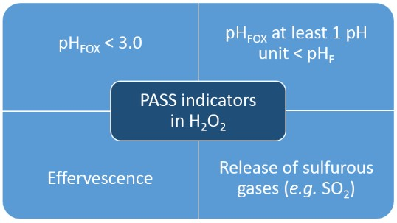

For inland situations only, electrical conductivity (EC; greater than 1750 µS/cm in water or greater than 400 µS/cm in 1:5 soil:water extract) and sulfate concentrations (greater than 10 mg/L in water or greater than 100 mg/L in 1:5 soil:water extract for dry soil) can be used to indicate the likely presence of ASS materials (EPHC & NRMMC 2011).

Further guidance on conducting field pH tests and the interpretation of these results is provided in Appendix A.

### Groundwater analysis as indicators of impact from ASS materials

An examination of the groundwater quality in the proposed area can also be used to provide an indication of whether RIS oxidation has occurred in the vicinity. Groundwater quality parameters that can be used to indicate the presence of ASS materials include a soluble sulfate to soluble chloride (SO42-:Cl-) of more than 0.25 (Mulvey 1993), and a pH of less than 4 (for example DER 2015a, 2015b).

The analysis of groundwater (and drain water) for SO42-:Cl- ratio has frequently been used as an indicator of ASS. As seawater has a sulfate concentration of approximately 2700 mg/L and chloride concentration of approximately 19 400 mg/L, the SO42-:Cl- ratio of seawater and coastal landscapes on a mass basis is 0.14. The ratio of dominant ions in saline water remains approximately the same when diluted with rainwater, and therefore, estuaries, coastal saline creeks and associated groundwater can be expected to have similar dominant anion ratios to seawater. Any other source of sulfate ions (such as the oxidation of RIS) in these locations can lower this ratio and hence provide an indication of the possible presence of ASS materials in the surrounding landscape.

A SO42-:Cl- ratio of greater than 0.5 is a strong indicator of an extra source of sulfate from RIS oxidation (Mulvey 1993).

The utility of the SO42-:Cl- ratio to identify ASS materials diminishes as the salinity of groundwater approaches that of freshwater.

The SO42-:Cl- ratio of groundwater (or indeed of the soil material’s soluble ions) is especially useful to help discriminate between Actual ASS materials and naturally-occurring acidic soil materials.

Other indicators that have been used as indicators of RIS oxidation and associated acidification in groundwater, and their indicative values are presented in Table 5.2.

Table 5.2 Additional indicators of RIS oxidation in groundwater and indicative values.

|  |  |  |
| --- | --- | --- |
| Indicator | Indicative value | Comments |
| SO4/alkalinity ratio | > 0.2 | May indicate sulfide oxidation and/or consumption of alkalinity |
| Al/Ca mole ratio | > 1 | May indicate Ca depletion and potential for Al toxicity to plants |
| Alkalinity | < 10 mg/L | pH can reduce rapidly if alkalinity decreases to 0. Noting decreasing trends is important prior to extreme acidification |
| Al | > 1 mg/L | Indicative of Al mobilisation; should correlate with pH–note that Al may be present as colloids at higher pH, and small filter sizes (for example 0.1–0.2 μm) |
| Other trace metals & metalloids | variable | Useful to monitor and compare with ANZECC guideline values for ecosystem protection |

Source: Modified from Shand et al. (2017).

### Identification of monosulfidic black oozes (MBOs)

An initial field assessment of sediments may provide an indication of whether monosulfidic black oozes (MBOs) are present at the site. Unoxidised MBOs typically have a near neutral pH (pH 7–8), together with high organic matter contents and low redox potentials (Eh). MBOs also usually have a distinct strong black colour, gel consistence and sometimes an oily appearance (Figure 5.3); some MBOs are dark grey in colour. A rotten egg odour from the reduction of sulfate to hydrogen sulfide may also further indicate the presence of MBOs; hydrogen sulfide gas can be detected by its odour at very low concentrations.

However, the defining characteristic of a MBO is its enrichment with monosulfides. In the field the addition of concentrated hydrochloric acid (HCl) to MBOs will yield H2S (that is ‘rotten egg gas’). This test should only be carried out using small amounts of material (that is less that a teaspoon) with only a few drops of concentrated HCl in a well-ventilated setting. The field identification of MBO must be confirmed by the appropriate laboratory analysis [see Sullivan et al (2017a, b)].

Figure 5.3 Black oily appearance of MBO gel collected from the Peel region, Western Australia.

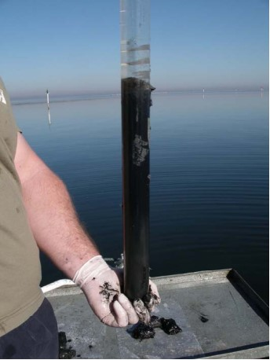 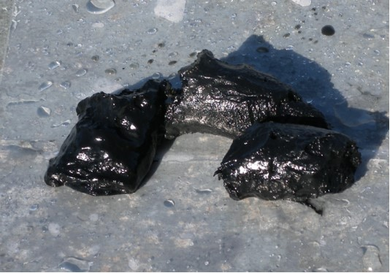

Source: Sullivan et al. (2006).

The environmental setting of the sediments may also indicate the likelihood of the presence of MBOs. Monosulfidic black oozes accumulate in large quantities in locations with the appropriate conditions for their formation, including waterways affected by one or a combination of ASS materials, eutrophication or salinisation. These sites are usually dominated by low velocity flow conditions where there is an abundant supply of organic matter, iron and sulfate. Recent research by Wong et al. (2016) indicates accumulation of sulfidic materials (including monosulfidic materials) occurs preferentially downstream of channel obstructions, such as submerged logs or in scour pools. The accumulation of these MBOs was not limited to lower energy parts of the channel as would be expected for fine-grained organic sediments.

Further information in relation to MBO is available in the following national ASS guidance document: Overview and Management of Monosulfidic Black Ooze (MBO) Accumulation in Waterways (Sullivan et al, 2018c).

### Consideration of soil, water and groundwater indicators

Once all the site assessment data has been collected a preliminary determination should be made as to whether ASS materials are present or absent at the site. All field soil and water indicators (Table 5.1), including field pH test results, and any groundwater SO42-:Cl- ratio results should be considered in this determination.

Table 5.3 contains a range of outcomes and possible interpretation of these results. The table includes suggestions for further investigations to clarify the presence or absence of ASS. Please note there are circumstances where these general indicators do not apply because of the soil, geology or water characteristics.

Table 5.3 Soil and water indicators for the presence or absence of ASS materials.

|  |  |  |  |  |
| --- | --- | --- | --- | --- |
| Field pH of water | Water analysis SO42-:Cl- (by mass) | Field soil or water indicators | Typical soil reaction to 30% H2O2 | Preliminary assessment |
| 6–8 | Approx. 0.14 but may be in the range 0.1–0.2 | Nil | Nil reaction and no drop in pH | No PASS material present. Must be verified by laboratory chemical analysis |
| PASS indicators present | Mild to strong effervescence and drop in pH | PASS present but has probably not been oxidised at any time. Must be verified by laboratory chemical analysis |
| < 5 | Approx. 0.14 but may be in the range 0.1–0.2 | Nil | Nil reaction and no drop in pH | No PASS present and low pH can be attributed to causes other than RIS oxidation. Must be verified by laboratory chemical analysis |
| PASS indicators present | Mild effervescence and drop in pH | PASS present but probably has not been oxidised at any time. Existing low pH can be attributed to other causes. Must be verified by laboratory chemical analysis |
| 6–8 | 0.2–0.5 | Unclear indicators | Mild effervescence and drop in pH | Presence of PASS is uncertain. Must be verified by laboratory chemical analysis |
| > 0.5 | Indicators of AASS or PASS present | Mild to strong effervescence and drop in pH | Presence of PASS plus the presence of substantial Acid Neutralising Capacity. Must be verified by laboratory chemical analysis |
| < 5 | 0.2–0.5 | Unclear indicators | Mild effervescence and drop in pH | Presence of PASS is uncertain. Must be verified by laboratory chemical analysis |
| < 5 | > 0.5 | Indicators of AASS or PASS | Mild to strong effervescence and drop in pH | Presence of PASS with little or no Acid Neutralising Capacity. Must be verified by laboratory chemical analysis |

Source: Modified from Ahern et al. (1998b).

### Laboratory chemical analysis to confirm presence or absence of ASS

Samples of materials need to be tested in the laboratory to definitively indicate the presence or absence of ASS materials.

A sufficient number of samples with the highest probability of being ASS, based on field pH testing (pHF and pHFOX) and soil characteristics (for example jarosite, iron mottling), should undergo laboratory chemical analysis to either ensure ASS materials are not found on site, and hence an ASS management plan is not required, or to help confirm the presence of ASS materials. Figure 5.4 shows the criteria commonly used to select soils samples for preliminary laboratory chemical analysis.

Figure 5.4 Selection criteria for preliminary chemical analysis of soil samples.

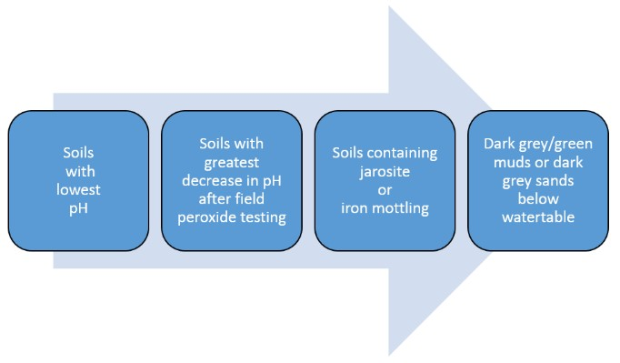

Sufficient number of samples should be analysed from all areas which have a high probability of ASS materials to ensure its absence or indicate its presence. The total number of samples for analysis depends on factors such the areal extent and depth of the planned disturbance and the associated hazards. At this stage of the assessment process and for the later development of management plans, it is important to know which areas of the site and which soil layers are unlikely to contain ASS materials.

Laboratory chemical analysis of the selected samples should be undertaken to ascertain if PASS and Actual ASS materials are present and to quantify the Net Acidity (See Sullivan et al, 2018b). If the Net Acidity of any individual ASS material tested is equal to or greater than the action criterion (see Table 5.4), a detailed ASS management plan will need to be prepared. Details on the laboratory analyses required to determine Net Acidity, and the action criteria triggering an ASS management plan, are provided in the National Acid Sulfate Identification And Laboratory Methods Manual (Sullivan et al, 2018b).

Table 5.4 Action criteria based on the texture and volume of material disturbed.

|  |  |  |  |  |  |
| --- | --- | --- | --- | --- | --- |
| Type of material | | Net Acidity | | | |
| Texture range*  (NCST 2009) | Approximate clay content (%) | 1–1000 t materials disturbed | | > 1000 t materials disturbed | |
| % S-equiv. (oven-dried basis) | mol H+/t (oven-dried basis) | % S-equiv. (oven-dried basis) | mol H+/t (oven-dried basis) |
| Fine  light medium to heavy clays | > 40 | ≥ 0.10 | ≥ 62 | ≥ 0.03 | ≥ 18 |
| Medium  clayey sand to light clays | 5–40 | ≥ 0.06 | ≥ 36 | ≥ 0.03 | ≥ 18 |
| Coarse and Peats  sands to loamy sands | < 5 | ≥ 0.03 | ≥ 18 | ≥ 0.03 | ≥ 18 |

* If bulk density values are not available for the conversion of cubic meters to tonnes of soil, then default bulk densities, based on the soil texture, may be used (see Table 2 in Sullivan et al. (2017b)).

Source: Adapted from Dear et al. (2014).

### Establish the general characteristics of proposed works

The general characteristics of the proposed works should be considered in conjunction with the outcomes of the preliminary assessment. Ideally, all development should be planned to avoid or minimise ASS disturbance. The key issues to be taken into consideration are outlined below.

#### Extent of earthworks onsite

The depth and nature of the soil disturbance should be identified. Strategies for the treatment for reuse, or disposal to an approved facility need to be contemplated. Factors to be considered in developing mitigation strategies at this stage are listed in Figure 5.5.

Figure 5.5 Factors to be considered in developing mitigation strategies.

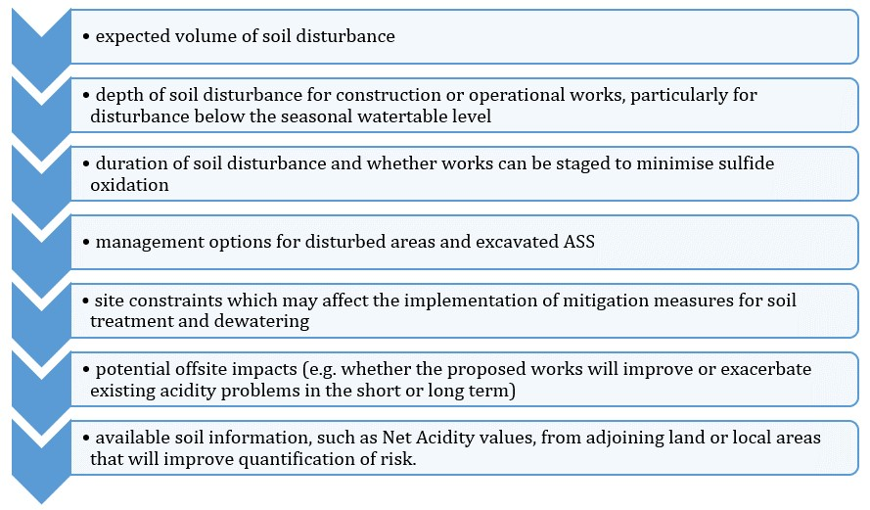

#### Extent of groundwater disturbance

Dewatering activities can result in oxidation of RIS and acidification of surface and groundwater. Areas mapped as having an ASS risk are vulnerable to acidification if dewatering operations are undertaken. This should be considered in the preliminary assessment of potential impacts.

For works in areas mapped with at least a moderate risk of ASS materials occurring, a preliminary groundwater assessment should be undertaken to establish the background water conditions and determine if the activity is likely to affect the groundwater quality and watertable levels.

More information on hazard assessment and management options can be found in Guidance for the Dewatering of Acid Sulfate Soils in Shallow Groundwater Environments (Shand et al, 2018).

### Reporting on the preliminary assessment (Stages 1 and 2)

If ASS materials are present at the site and at least one of the samples of these materials returns a Net Acidity that meets or exceeds the action criterion in Table 5.3, then the preparation of a management plan is triggered. The preliminary report should document the desktop assessment (Stage 1), field inspection (Stage 2) and all laboratory analysis undertaken. The report should contain the following:

* details of the proposed works and the likelihood of ASS disturbance or lowering of watertable levels,
* physical site characteristics,
* location of soil and water sampling sites, clearly marked on a map with grid references and height (m AHD),
* field soil pH (pHF), reaction to peroxide and pH after peroxide oxidation (pHFOX), recorded by depth,
* chemical data for soil samples selected for laboratory analysis,
* groundwater pH,
* groundwater SO42-:Cl- ratio, if used as an indicator of RIS oxidation, and
* groundwater hydrological studies, where they assist in indicating the likely impacts of watertable lowering on ASS, including piezometer locations and depths, and any flow analysis.

Based on the preliminary assessment, a decision can be made as to whether ASS materials are likely to be disturbed, and whether further assessment is required to quantify the hazard. Where there is sufficient certainty that ASS materials will not be disturbed, no further assessment will be required. In areas mapped as having a risk of ASS, this decision must be supported by an appropriate level of laboratory analysis.

Where there is uncertainty in the data to date, or an ASS management plan is required as per Table 5.3, further detailed investigations will be necessary (that is Stages 3–5). However, before proceeding to the expense of more detailed investigations, mitigation strategies to reduce or avoid the level of disturbance should be considered.

### Is further investigation required?

If the results of the desktop assessment (Stage 1) and site inspection (Stage 2) suggest ASS materials may be present, or the results are inconclusive, an intrusive investigation involving soil sampling and laboratory analysis should be undertaken.

The only instances in which soil sampling and laboratory analyses are not required are:

* where soils and groundwater at a site will not be disturbed, or
* where the ASS risk maps indicate the site does not have a low, medium or high probability of ASS occurrence.

In these instances, the proponent may submit the desktop assessment and site inspection report to support their professional opinion that further investigation to establish the absence of an acidity hazard from ASS materials is not required.

## Stage 3: Detailed soil sampling and field testing

The third stage of an acid sulfate soil (ASS) assessment (Stage 3) involves the detailed collection of soil samples for laboratory analysis. These data are then used to create a detailed three-dimensional map of the acidity hazard at the site. This detailed information is essential when deciding whether a proposed development or disturbance is feasible from an environmental, engineering and economic perspective (Ahern et al. 1998a).

The four primary aims of soil sampling and laboratory analysis are to:

1. conclusively determine whether ASS materials are present or absent,
2. delineate the lateral and vertical extent of ASS materials,
3. quantify the maximum amount of Net Acidity that will require treatment and management if ASS is disturbed, and
4. provide data upon which to base the development of effective management strategies for any proposed ASS disturbance.

Sufficient soil sampling and analysis should be undertaken to understand and manage the site without causing harm to the environment. For large or complex projects, it can often be cost efficient to conduct the soil investigations in a number of stages. When using a staged sampling strategy, the initial results can be used to refine the latter stages of the sampling program to gain greater effectiveness and efficiencies. Consultation with key government authorities after the results of each sampling stage have been analysed can assist in focusing the investigations for further sampling stages.

### Occupational health and safety considerations

Intrusive ASS investigations have occupational health and safety risks, particularly when digging soil inspection pits, working around drill rigs, handling chemicals (for example hydrogen peroxide and hydrochloric acid) and other substances (for example dry ice and liquid nitrogen) and from hydrogen sulfide gas poisoning. Further information on the handling of chemicals for field testing can be found in Appendix A: Soil field tests.

The current legislation places a clear obligation on a person to ensure the safety and health of anyone they engage to do work (such as drillers, earthmoving contractors and consultants). It is, therefore, recommended that Health, Safety and Environment Plans (HSEPs) be produced and the contents adequately communicated to all site personnel prior to the commencement of site works.

Any risks to the public, such as adjacent landowners/occupants, should also be identified and measures implemented to minimise them.

The dangers associated with hydrogen sulfide gas are an important occupational health and safety consideration when working in ASS landscapes, as disturbance may results in the release hydrogen sulfide. This gas has a characteristic, offensive ‘rotten egg’ odour, which at even relatively low concentrations can, after exposure, inhibit the sense of smell and hence its further detection.

Hydrogen sulfide is heavier than air and so tends to settle in depressions and may reach toxic levels within excavations and in confined spaces. Therefore, it is strongly recommended that onsite gas monitoring and occupational health and safety measures are implemented to deal with this contingency during the disturbance of ASS materials, particularly when carried out in urban environments.

### Quality control/quality assurance (QC/QA)

The accuracy and reproducibility of field data is essential to ASS assessment and management. Quality control (QC) measures should be described and implemented to provide data quality assurance (QA). Field data, and consequently laboratory analysis, cannot be considered representative of site conditions without appropriate QC/QA.

Minimum required QC/QA procedures include:

* collection of one field duplicate for every 20 investigative samples,
* use of standardised field sampling forms, methods and Chains of Custody, and
* documented calibration of field instruments.

Field duplicates are used to assess small-scale variability at a single sampling point. To measure repeatability, field duplicates must be taken from the same soil sample after mixing. Field duplicates should be submitted to the laboratory as blind samples with no indication to the laboratory that these samples are duplicates.

### Minimum soil sampling density

The necessary soil sampling density is dependent on a number of factors, including the nature and variability of the soil materials, both laterally and vertically on the site, and the nature, depth and size of the proposed development. Sufficient soil sampling should be undertaken to create sufficiently detailed three-dimensional maps and cross-sections of soil materials at the site especially including the spatial extent of Net Acidities by depth to allow the development of adequately detailed management plans.

Guidance in this section is provided on the minimum soil sampling requirements for an ASS investigation. The minimum number of sampling locations varies depending on the volume of soil to be disturbed and the nature of the disturbance. Table 6.1 summarises the minimum number of sample locations required for different types of ASS disturbances.

Table 6.1 Minimum soil sampling densities for ASS investigations.

| Type of disturbance | Extent of site | Sample point frequency |
| --- | --- | --- |
| Small volumes (≤ 1000 m3) – prior to disturbance | Volume of disturbance (m3) | Number of boreholes |
| < 250  251–500  501–1000 | 2  3  4 |
| Large volumes (> 1000 m3) – prior to disturbance | Project area (ha) | Number of boreholes |
| < 1  1-2  2-3  3-4  > 4 | 4  6  8  10  10 plus 2 per additional hectare |
| Linear | Width and volume | Intervals (m) |
| Minor1  Major2 | 100  50 |
| Existing stockpiles & verification testing | Volume (m3) | Number of samples |
| < 250  251-500  1000  > 1000 | 2  3  4  4 plus 1 per additional 500 m3 |

1 Minor Linear Disturbance – for example underground services, narrow shallow drains (less than 1 m below ground level).

2 Major Linear Disturbance – for example roads, railways, canals, deep sewer, wide drains, deep drains and dredging projects#.

# Further guidance is provided in the Guidelines for the dredging of acid sulfate soil sediments and associated dredge spoil management (Simpson et al. 2017).

Source: EPA (2009) and DER (2015a).

The minimum number of samples required for dredging projects varies considerably depending on the volume of ASS material to be dredged, the nature of the material and the existing information available on the sediment composition (Simpson et al. 2017). Further guidance on the number of sampling locations for dredged ASS materials is provided in the Guidelines for the Dredging of Acid Sulfate Soil Sediments and Associated Dredge Spoil Management (Simpson et al, 2018).

The minimum recommended number of sampling locations is not usually sufficient when sampling MBOs, as the properties of these materials can be highly variable spatially. When sampling MBOs, care should be exercised to make sure the sampling strategy is sufficient to ensure representative samples are gained from the area of interest.

For large projects (greater than 20 ha) a reduced sampling density may be acceptable, providing the investigation program can be clearly demonstrated to have satisfactorily characterised the various geological/geomorphological units at the site.

In some cases, especially where dewatering or other groundwater disturbance is proposed, or for example, where there is an unusually high variability in the spatial distribution of the acidity hazard at the site, the initial soil sampling and analysis program may not provide sufficient information upon which to base a comprehensive and effective management plan. In these instances, additional investigations will be required before an appropriate management plan can be developed.

### Location of sampling points

Information from the desktop assessment (Stage 1) and site inspection (Stage 2) should be used to select the location of the investigative boreholes, in conjunction with an understanding of the nature of the proposed soil disturbance. The factors to consider when choosing soil sampling locations are listed in Figure 6.1. Sampling locations should be representative of the site, particularly the area of disturbance. Undertaking a mapping exercise, which seeks to delineate the lateral and vertical extent of ASS horizons and of the acidity hazard in the area of disturbance is usually more useful than a gridded sampling pattern, particularly for the investigation of large project areas.

Figure 6.1 Factors to consider when choosing sample locations.

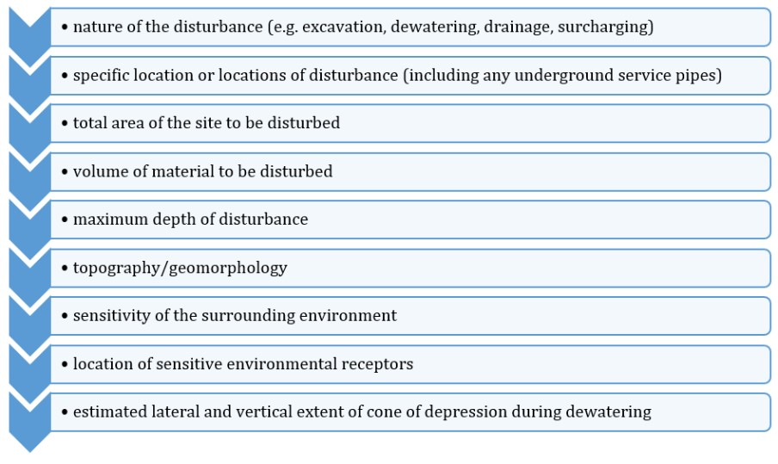

Source: DER (2015a).

### Depth of sampling points

The depth of soil sampling required depends on the maximum depth of disturbance and whether the groundwater level is expected to be altered as a consequence of the undertaken activities (for example drainage, pumping).

Where no groundwater alteration is expected, soil sampling locations need to extend to at least one metre below the maximum depth of disturbance.

Where alteration of groundwater levels might be reasonably expected, then soil sampling should extend to at least one metre below the depth of the lowest estimated groundwater drawdown.

### Sampling equipment

#### Sampling equipment for soils

A range of manual and mechanical equipment is available for sampling soils. The choice of equipment will depend on site access and environmental sensitivities, soil texture, wetness and depth of layers in the profile.

Commonly used equipment are listed in Table B1 and Table B2 in Appendix B with comments on their suitability for sampling of ASS material. In some instances, where soils are very soft, manual augering may be the most appropriate equipment. As a general rule, augers should have an internal diameter of at least 5 cm to ensure representative soil sampling. Details of the sampling equipment should be provided in the assessment report. If drilling equipment is used, the drilling operator’s name and contact phone numbers should also be provided.

Sampling equipment should be washed down and cleaned between the collection of samples. A high pressure washing system is considered essential to clean mechanical drilling equipment. Failure to adequately clean sampling equipment can result in trace amounts of sulfidic material from the previous sampling contaminating the next sample, resulting in a false positive test. Failure to adequately clean sampling equipment can lead to unnecessary, costly earthworks and liming of non ASS.

Sample collection from below the watertable often proves difficult, particularly for gravel or sand materials.

Care should also be taken when drilling through coffee rock below the watertable, as this activity may cause significant damage to surrounding aquifers. Prior to drilling, advice on local aquifer characteristics should be obtained from the relevant regulatory body.

Ensuring representative samples are gained from soil materials with high spatial variability such as peats, other soil materials with high organic matter contents, and dredge spoil heaps, can be challenging but is essential for the derivation of accurate three-dimensional maps and cross-sections.

#### Sampling equipment for sediments

A variety of sampling equipment is available for the collection of sediments, including grab and core samplers (Standards Association of Australia 1999). It is important that the selected device is able to maintain the integrity of the sample, as disruption of the sediment’s structure could change its chemical and physical characteristics (US EPA 2001; Simpson et al. 2005).

The choice of equipment often depends on the amount of surface water present and the depth of sampling. Spades and soil augers are often suitable for collecting sediment where there is little surface water present, particularly for monosulfidic black oozes (MBOs). When surface water is present, intact cores can be collected using polypropylene push-tube coring devices (for example Figure 6.2).

Figure 6.2 Sampling MBOs using a sediment coring device.

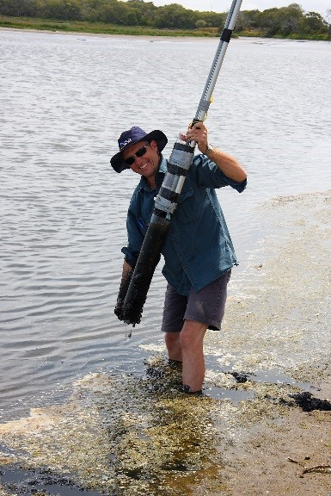 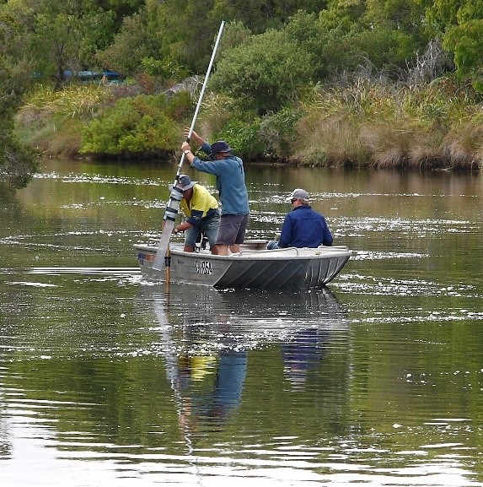 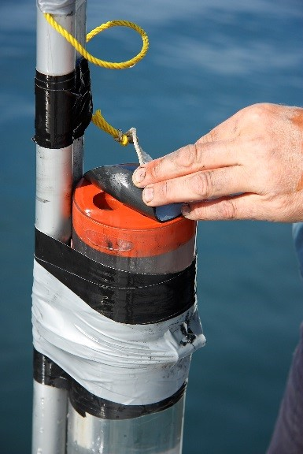

Note: Left and middle image of the coring device and right image of the water outlet at the top of the device.

Source: Ward et al. (2009).

As with the collection of soil samples, a minimum internal core diameter of 5 cm should provide sufficient sample for replicate analysis. However, practice has shown that a 10 cm diameter core is often required to collect a sufficient quantity of MBO sample for analysis (see Table C1 in Appendix C for the recommended quantities required for analyses).

To prevent sediment loss during sampling, corers should to be capped prior to extracting MBOs from shallow waterbodies; a water outlet control at the top of the corer is recommended when collecting MBOs from deeper waterbodies (for example Figure 6.2).

Compression of the sediment core can occur with push-tube coring devices on especially soft sediments. This can be reduced by using corers with sharpened edges (with the internal core edge as the cutting edge) and/or cores with larger internal diameters.

Alternatively, sediment grab samplers (for example Figure 6.3) can be used to collect representative surface sediments where the depth of surface waters prevents sampling by the other means previously mentioned (for example Eckman, Ponar and Van Veen grab samplers). However, care needs to be taken when using grab samplers, as fine-grained sediment is easily lost with this type of device.

Sediment sampling equipment must also be meticulously cleaned between samplings to minimise the potential for sample contamination.

For further guidance on the sediment sampling devices available refer to AS/NZS 5667.12:1999 Guidance on sampling of bottom sediments (AS/NZS 1999) and the Methods for collection, storage and manipulation of sediments for chemical and toxicological analyses (US EPA 2001).

Figure 6.3 Sampling MBOs using a Van Veen grab sampler.

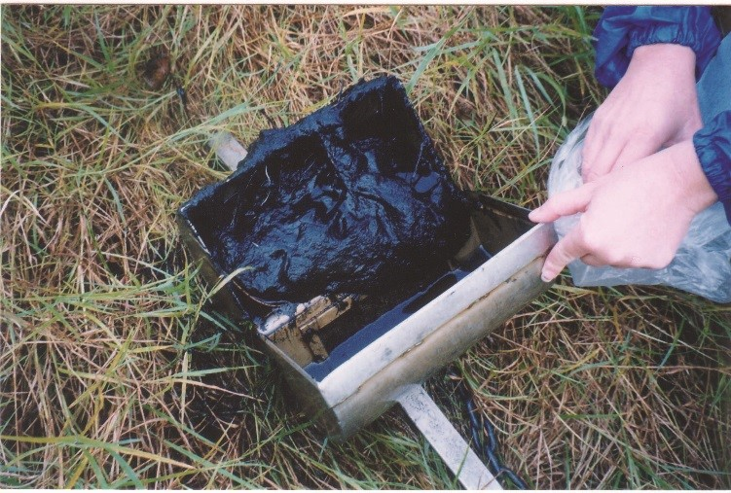

Source: Photographed by DM Fyfe.

### Soil sampling procedure

#### Borehole location

The following borehole location data should be collected:

* the full Australian Map Grid reference and current surface height, relative to Australian Height Datum (AHD), for each borehole (the location to be recorded on an appropriately-scaled map), and
* the vertical dimensions of the borehole or test pit, relative to existing surface height and AHD, to enable the production of accurate cross-section diagrams.

#### Soil profile description

The production of a detailed and accurate field soil profile description is a fundamental requirement:

* for the design of further sampling strategies,
* to assist in the interpreting of laboratory analytical results, and
* to inform the development of optimum management plans.

As a minimum, the following information should be collected for each soil profile:

* location (both latitude and longitude coordinates and the position on an appropriately scaled map),
* soil texture, grain size, roundness, sorting and sphericity using the Australian Soil and Land Survey Field Handbook (NCST 2009),
* colour and mottling using a Munsell colour chart,
* presence of organic matter and other diagnostic features (for example presence of jarosite),
* presence of shell material, its location within the profile, and its size and relative abundance,
* the watertable height relative to the soil surface,
* photographs of the soil profile clearly identifying each horizon/layer/stratum in the profile, and
* a brief description of the sampling equipment, the sampling date, the sampling team, and methods used to retrieve and analyse the samples.

The procedure for determining the soil texture is outlined in Appendix D.

Examples of bore log descriptions for two soil profiles are presented in Figure 6.4 and Figure 6.5. Note, the bore logs also show the location of the sampling depths required to provide the minimum number of samples needed for further laboratory chemical analyses for linear disturbances, large-scale disturbances (greater than 1000 m3) and/or groundwater disturbances.

Figure 6.4 Bore log of a soil profile comprised of two horizons.

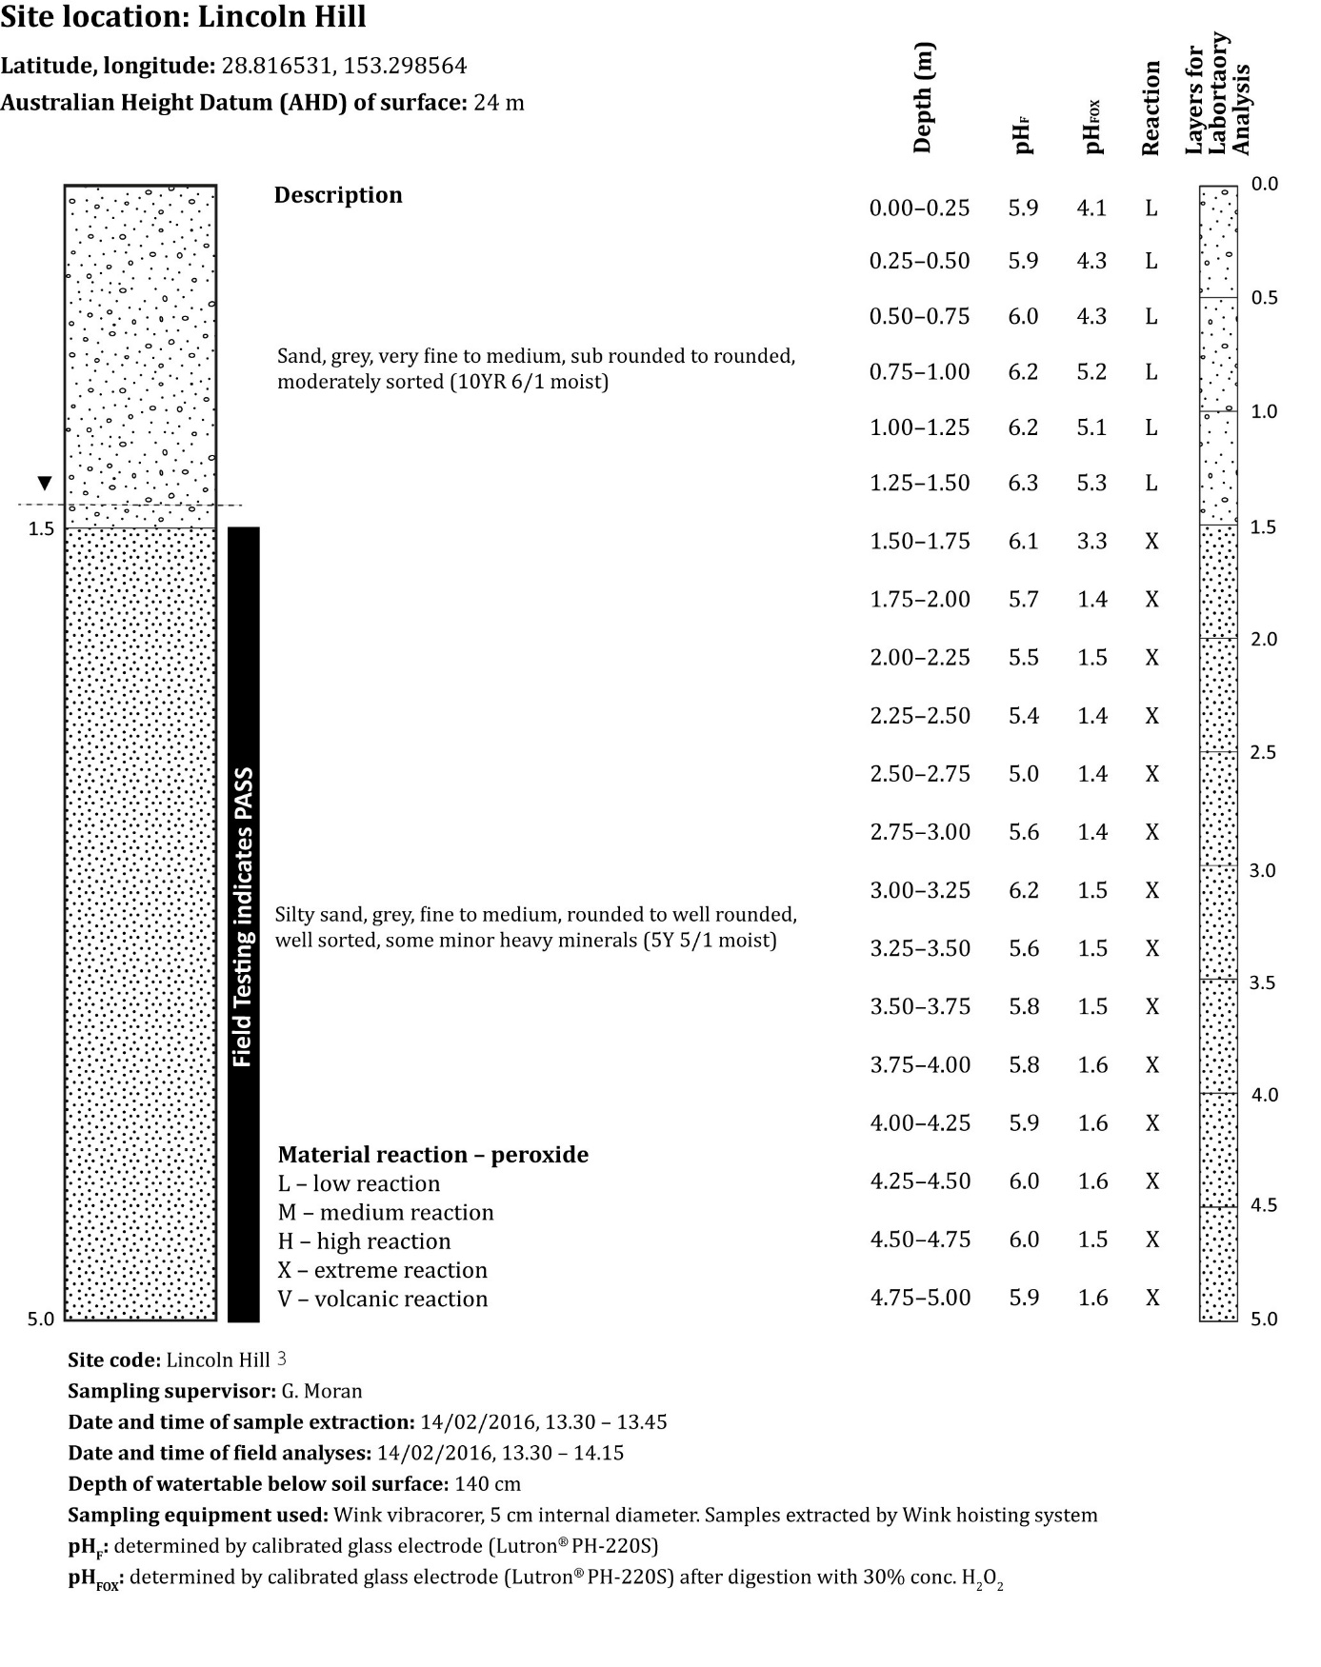

Note: The soil profile of two horizons gives the minimum detail required for the profile descriptions and shows an appropriate sampling strategy for both field testing and laboratory analysis.

Figure 6.5 Bore log of a soil profile comprised of many distinctly different soil layers.

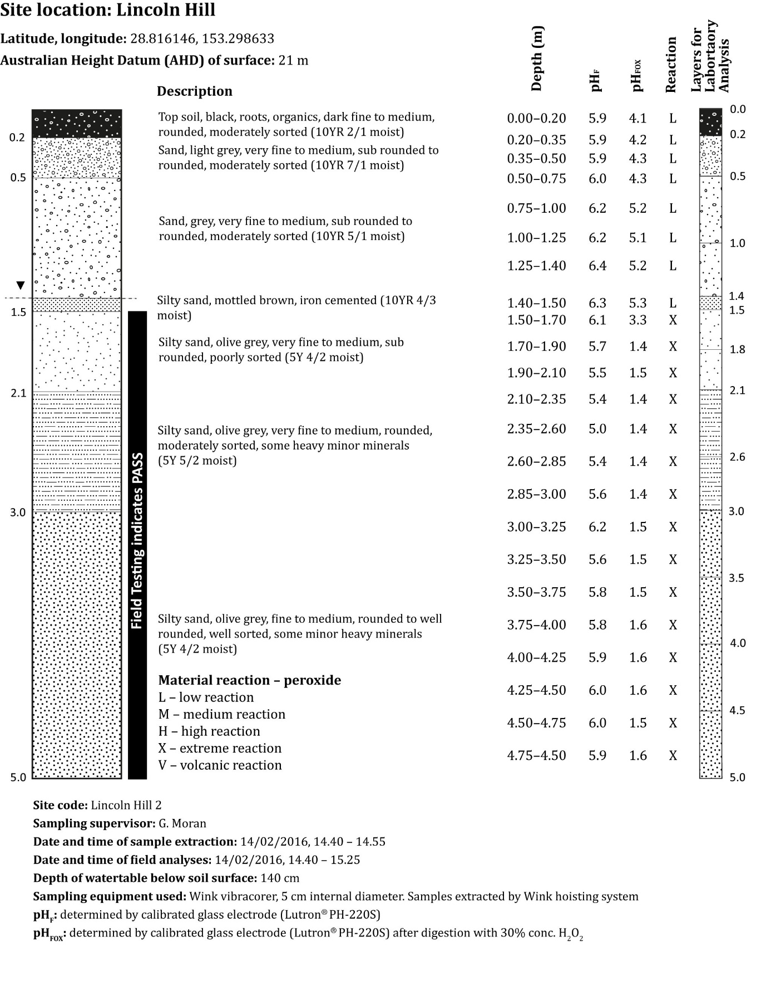

Note: This soil profile comprises of many distinctly different soil layers of varying thickness and shows an appropriate sampling strategy for both field testing and laboratory analysis.

#### Sampling from cores and pits

The protocol outlined for selecting samples for laboratory analysis in this section is applicable to any large-scale disturbance (greater than 1000 m3), all linear disturbances, and any developments likely to cause groundwater disturbance.

Once boreholes have been drilled and/or test pits dug, and the profiles described and photographed, soil samples should be collected from each profile. Starting from the present ground surface, soil samples should be representatively collected within intervals not exceeding 0.25 m down the profile and field tested.

Where individual soil layers or soil horizons are encountered with a thickness of between 0.01 m and 0.25 m, sampling frequency should be increased to ensure that at least one sample is collected from each of these layers or horizons. Sampling intervals must not include two or more different layers or horizons.

After soil materials have been sampled, it is important to preserve their condition as far as possible (see the Sample handling, transport and storage section for further details).

Any meaningful changes in soil properties with depth (such as colour, texture, moisture content, field pHF and pHFOX, et cetera) should be identified.

Figure 6.4 shows the sampling procedure for a soil profile with two horizons, with field pH testing every 0.25 m. Figure 6.5 gives the required sampling procedure and field pH testing when there are soil layers with a thickness of less than 0.25 m.

As per the previous section, soil layers or horizons with clearly different physical, visual or chemical properties should be sampled separately. Different soil layers or horizons should not be bulked together as even apparently uniform soil layers (from field determinable characteristics and behaviour) can possess markedly different chemical properties.

For the collection of materials for laboratory analysis, start from the present ground surface and take samples at intervals not exceeding 0.5 m down the profile at each sampling location. Where individual soil strata units or soil horizons are encountered with a thickness of less than 0.5 m, the frequency of laboratory analysis will need to be increased to ensure that at least one sample is analysed from each unit or horizon.

The use of composite samples for laboratory analysis is only acceptable when taking samples for verification purposes after management treatments have been applied.

Ideally, each soil sample should be equivalent to 200–500 g of air dry soil to allow sufficient sample mass for physical and chemical analysis. The volume required to give this mass is dependent upon the bulk density of the sample (that is a greater volume of peat would be required than for a sand to provide the required mass). The required minimum soil sample quantity should be confirmed with the chosen analytical laboratory before sample collection commences.

Any visible shell, carbonate nodules and other large fragments (such as wood, charcoal and stones) should be noted and then removed from the samples in the field. However, biological remnants such as small roots may contain RIS and should not be removed from the soil sample.

Laboratories routinely sieve samples (to less than 2 mm) submitted for ASS testing, after drying, and prior to grinding and analysis. However, this sieving is frequently difficult, particularly with clayey samples as these often set hard on drying, making removal of shell or carbonate nodules without breakage extremely difficult. Shells or carbonates nodules disturbed in this manner will often have an increased surface area which can lead to an overestimation of the neutralising capacity of the soil materials as found in the field.

Drilling techniques can also shatter some shell and carbonate materials and this should be considered when selecting appropriate sampling methods for a site.

The bulk density of the soil will need to be determined for converting analytical results determined on a gravimetric (that is mass) basis back to a volumetric basis. A volumetric basis usually provides the most useful measure for field operations, whereas gravimetric basis is the most useful measure to derive meaningful laboratory results. The soil’s bulk density, as found in the field, provides the link for converting between gravimetric based and volumetric based measures.

Bulk density can be determined by taking a known volume of soil as found in the field, using a sampling method that preserves the integrity of the sample (for example one that can provide ‘intact’ soil cores).

Some laboratories use default bulk densities based on texture, however, bulk density values for ASS commonly range between 0.5 g/cm3 and 1.8 g/cm3 and may be as low as 0.2 g/cm3 for peats. Such wide variation indicates that using default bulk densities will result in sub-optimal management. Best practice involves determination of the bulk densities of the soil layers/horizons as found in the field. For further details on bulk density methods, refer to the Acid sulfate soil identification and laboratory methods manual (Sullivan et al. 2017b).

#### Small-scale disturbance (less than or equal to 1000 m3) not involving groundwater disturbance (excluding linear disturbances)

For small-scale, non-linear disturbances (that is less than or equal to 1000 m3, and not drains or trenches) where dewatering or groundwater pumping will not be conducted, a reduced number of laboratory analyses may be performed (refer to Table 6.2) provided sufficient information is collected to enable sound management practices. Whether further laboratory analyses than those indicated in Table 6.2 are required will depend on the outcomes of the initial testing.

At each sampling location, soil samples should be collected using the protocol described previously for cores and pits.

However, only selected samples that are likely, on the basis of their field properties and behaviour, to have the highest potential of an acidity hazard, are required for initial laboratory analysis, as per the guidance in Figure 6.6.

As additional laboratory analyses beyond those indicated in Table 6.2 may be required, all soil samples should be retained until the regulator has assessed the ASS investigation report. The regulator should request the analysis of additional samples if they are not satisfied with the samples selected for laboratory analysis, or is of the view these samples do not provide an adequate representation of the hazard presented by the proposed development.

Table 6.2 Minimum number of soil samples to be submitted for laboratory analysis for small-scale disturbances.

| Volume of disturbed soils | Maximum disturbance depth | | | |
| --- | --- | --- | --- | --- |
| < 1 m | 1–2 m | 2-3 m | 3-4 m |
| ≤ 250 m3 | 3 | 4 | 5 | 6 |
| 251–500 m3 | 4 | 5 | 6 | 7 |
| 500–1000 m3 | 5 | 6 | 7 | 8 |

Note: Small scale is considered less than or equal to 1000 m3 and does not involve dewatering or groundwater pumping (excluding linear disturbances). Number of samples to be analysed per total volume of soil to be disturbed, not per borehole. Depth of disturbance to be measured from ground surface. Borehole depth must be at least 1 m below maximum proposed depth of disturbance.

Source: Adapted from DER (2015a).

Figure 6.6 A protocol for selecting samples for laboratory analysis from small-scale disturbance.

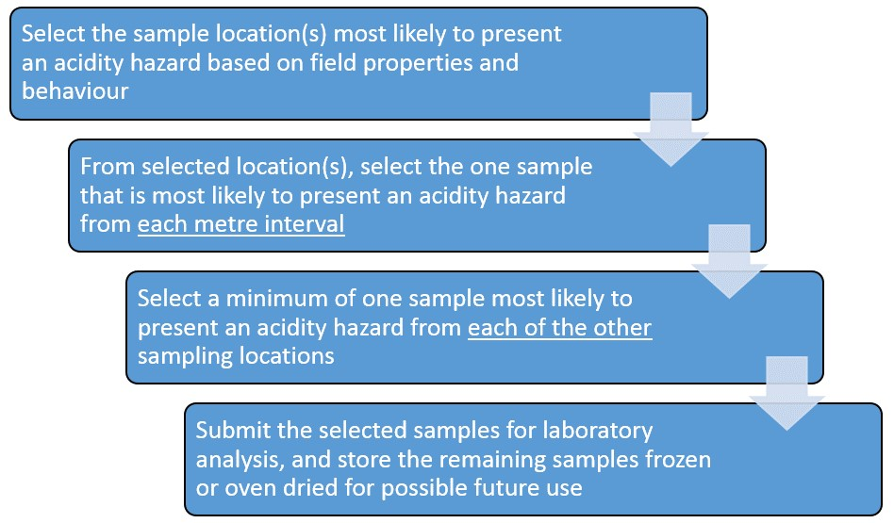

Note: Small scale is considered less than or equal to 1000 m3 and does not involve groundwater disturbance (excluding linear disturbances).

#### Sediment sampling

Dredging of coastal rivers, lakes, dams, drains, canals and wetlands should be treated as major linear disturbances. Sampling of these material should be undertaken at 50 m intervals (see Table 6.1).

At a minimum, samples should be collected at intervals not exceeding 0.25 m from the sediment surface, to at least one metre below the maximum depth of expected material extraction. Where individual layers are encountered with a thickness of between 0.01 m and 0.25 m, sampling frequency should be increased to ensure that at least one sample is collected from each of these layers or horizons. Sampling intervals must not include two or more different layers or horizons.

Any meaningful changes in properties with depth (such as colour, texture, moisture content, field pHF and pHFOX, et cetera) should be identified.

As per the previous section, layers or horizons with clearly different physical, visual or chemical properties should be sampled separately. Different layers or horizons should not be bulked together as even apparently uniform layers (from field determinable characteristics and behaviour) can possess markedly different chemical properties.

After sediments have been sampled, it is important to preserve their condition as far as possible (see the Sample handling, transport and storage section for further details).

Particular care must be taken when sampling bottom sediments in drains, or sediments likely to contain appreciable monosulfides (that is MBOs). These will require special sampling, storage and treatment (see the Sample preservation techniques for monosulfidic materials section for further details). Monosulfidic compounds and minerals can oxidise readily (within minutes) at room temperature and should, therefore, be preserved immediately after sample collection.

When collecting sediment samples located within waterways or inundated wetlands, careful attention must be paid to ensure all sediment fractions are collected. The fine silt and clay fraction of dredged materials (typically with a particle size less than 65 μm) may contain high concentrations of RIS and metals, but these ‘fines’ can easily be lost from the coarser fractions of the sample during collection.

In some wet dredging operations, such fines can separate from the coarse-grained, RIS-poor, carbonate-rich sediments (sands and carbonates) and be lost during stockpiling. Analysis and assessment of such dredged material may require the constituent fractions to be separated and tested accordingly.

Interpretation of analysis on the dredge material may be further complicated by the neutralising influences of fine shell material or trapped pore water within the sample. For further guidance refer to Sediment quality assessment: A practical guide (Simpson & Batley 2016) and the Methods for collection, storage and manipulation of sediments for chemical and toxicological analyses (US EPA 2001).

Sediment characterisation should include particle size analysis, total organic carbon content, total metal concentrations in solution and solid phase (Simpson & Batley 2016).

Sediments that may be reasonably suspected to contain monosulfides will require analysis by the Acid Volatile Sulfide method and should be quantified for Net Acidity [see the National Acid Sulfate Identification and Laboratory Methods Manual (Sullivan et al. 2018b) for further details].

The amount of MBO required for laboratory analysis depends on a number of factors including the sample moisture content and the required tests. Table C1 in Appendix C gives the recommended amount of MBO required for various laboratory analyses.

#### Sampling from existing stockpiles

Some sites may contain existing stockpiles of suspected or known ASS materials (for example dredge spoil stockpiles, excavated soil materials). Existing stockpiles are most likely found in areas where there was development prior to the adoption of ASS management procedures.

When encountered, such stockpiles should be assessed for their acidity hazard. The minimum number of samples which should be collected for further laboratory analysis is dependent upon the volume of the stockpile, as outlined in Table 6.1.

Samples should be representative of all the materials contained within the stockpile (that is samples should be collected from various depths and locations). It is not acceptable to collect and analyse only surface or near-surface samples.

#### Sampling for verification testing

When collecting samples for verification testing more than a single sample is required to be tested, regardless of how evenly the ameliorant has been mixed with the soil mass. The minimum number of samples which should be collected from such stockpiles for further laboratory analysis is outlined in Table 6.1.

### Sample handing, transport and storage

Upon collection in the field, soil samples should be immediately placed in leak proof containers that minimise the sample’s contact with air and to avoid moisture loss from the sample (for example soil placed in sealable plastic bags with air extruded).

It is recommended that the polymer bags used should be of a thickness at least 30 μm and composed of High Density Polyethylene (HDPE) to minimise diffusion of oxygen into the sample. Bags composed of HDPE are nearly an order of magnitude more effective in restricting oxygen diffusion than bags of equivalent thickness composed of Low Density Polyethylene (LDPE).

Soil materials should be immediately chilled and kept cold (less than 4 °C) in the field to aid preservation. Unless over loaded with samples, a portable 12 V car freezer or sealed cold box containing dry ice have been demonstrated to be effective, but if these options are not available, the use of freezer bricks and sealed cold boxes should be employed for cooling.

Where elutriate testing is required the seawater should be collected from the proposed site in a container with minimum headspace and stored at 4 °C for no longer than 24 h (Simpson & Batley 2016).

It is most important that sample labelling and documentation remain with the samples at all times. The labels used should be persistent and hence need to be water-proof, wear-proof and oven-proof.

Further details on the special sample preservation techniques required for monosulfidic materials are provided at the end of this section.

It is preferable that samples reach the selected laboratory within 24 h of collection. For transport and short-term storage during transit, samples should be kept chilled and stored in an insulated container so that they reach the laboratory at less than 4 °C.

If samples cannot be received by the laboratory within 24 h of collection, the samples must be managed by additional strategies aimed at sample preservation. Such methods include:

* Quick oven drying the sample at 80–85 °C in a large capacity fan-forced convection oven (care must be taken not to overload the oven’s moisture removal capacity). These oven-dried samples must then be stored in sealed containers in a low humidity environment. Oven-drying is not appropriate for samples that require laboratory incubation, monosulfide and metal analysis as preserved field moist samples are required for each of these procedures.
* Freezing the sample in sealed, air-tight containers.
* Vacuum sealing and storing in either a cold (that is less than 4 °C) or frozen state.

Note that samples stored in a refrigerator (that is not in a frozen state in a freezer) commonly start to oxidise within days, as indicated by a lowering of pH, and sometimes even by the formation of jarosite.

It is important to inform the laboratory both prior to and when samples are about to be delivered for analysis to allow the laboratory to prepare for timely sample pre-treatment to minimise the potential for oxidisation of RIS in soil samples.

It is also important to require the laboratory to confirm the time and date of receipt of the samples and indicate the time and date and method by which the samples were pre-treated prior to analysis. This information is critical as delays in either transport or pre-treatment can lead to inconsistencies in field and laboratory data and laboratory results that do not reflect conditions in the field at the time of sampling.

It is recommended that auditable sample records be maintained at all times by the agencies undertaking both the sampling, and the laboratory analysis.

Information on the pre-treatment of ASS samples is available as an Australian Standard (AS 4969.1).

#### Sample preservation techniques for monosulfidic materials

Monosulfides oxidise rapidly during oven drying. Monosulfides are highly reactive and rapidly oxidise (within minutes) at room temperature when exposed to the atmosphere. Accordingly, special storage techniques must be used to minimise the oxidation of monosulfides in samples of MBOs.

Ideally, samples suspected of containing monosulfides should be immediately frozen on sampling. Samples can be frozen rapidly in the field by using either dry ice or liquid nitrogen; ensure appropriate occupational health and safety procedures are followed if using either of these approaches.

An alternative approach is to place monosulfidic samples into either screw-top plastic containers (for example 50 mL centrifuge tubes) with no headspace, or into HDPE plastic bags with the air removed, before placing these samples in a cold box with freezer bricks.

If storing monosulfidic samples in plastic bags, double bagging is recommended to minimise the potential exposure of the samples to air.

In addition, purging sealed air-tight storage containers holding such potentially sensitive samples with nitrogen will minimise the potential for oxidation in samples that were in a reduced state at the time of sampling. It should, however, be noted that the nitrogen purging approach may conversely initiate reduction within samples that were in an oxidised state at the time of sampling. Accordingly, before using this approach on any particular sample it is essential that the Eh of the sample be determined and this approach only used for samples that were in a reduced state at the time of sampling.

Experience indicates that freeze-drying does not preserve monosulfides in soil samples and this analysis pre-treatment should be avoided for MBOs.

### Soil field tests

The soil field tests commonly used for investigations for ASS materials include field pH (pHF) and field pH peroxide (pHFOX) tests.

Soil pHF tests should be conducted regularly down the soil profiles at the same frequency as indicated for sampling, that is, within intervals not exceeding 0.25 m down the profile. Where individual soil layers or soil horizons are encountered with a thickness of between 0.01 m and 0.25 m, the frequency of soil pHF tests should be increased to ensure at least one pHF result is recorded from each of these layers or horizons.

The pHF test can help identify Actual ASS. While a pHF of less than or equal to 4 is indicative of the presence of Actual ASS, it is not conclusive of the presence of ASS on its own, as naturally occurring, non ASS soils such as many organic soils (for example peats) and heavily leached soils may also have pHF less than or equal to 4. To identify an Actual ASS other evidence must be presented that indicates the low pHF has been mainly caused by the oxidation of RIS. Such information includes the presence of jarosite in the soil layer/horizon, or the location of other Actual ASS or PASS materials within the sampling location or in the nearby vicinity.

The difference between the pHF and the pHFOX is helpful in the preliminary identification of PASS. Combined, the pHF and pHFOX results can be a useful aid with soil sample selection for laboratory analysis during Stage 2 of the field site investigations.

The pHFOX result, when compared to the pHF result, can give an indication of the presence of RIS in the sample. To ensure accurate results both of these tests must be conducted in the field as soon as possible after the sample is collected, as the pH of the soil sample can change relatively quickly with time (hours to days) even when recommended sample preservation techniques are employed. For example, it is not unusual for a soil pH test carried out at a laboratory to differ considerably (that is greater than a pH unit) from a soil pH test measured in the field after even one day of storage, and as such, a laboratory determination of pHF at a later date cannot be relied upon to represent field conditions at the time of sampling.

Soil field pHF and pHFOX tests, whilst useful exploratory tools, are not determinative and cannot be substituted for laboratory analysis for either the identification of ASS materials or the quantification of the acidity hazards these materials pose. A recent review of these field tests in Western Australia indicated ASS materials were accurately identified in only 60 to 80 per cent of cases (DER 2015a).

A field test for the presence of soil carbonate (for example fine shell, crushed coral, et cetera – commonly referred to as the ‘fizz test’) provides an indication of whether the soil may have a capacity to neutralise acidity produced from RIS oxidation. It is important to note that carbonate identified by this test may react too slowly to counteract acidity derived from RIS oxidation. A positive carbonate test is not sufficient to demonstrate this source of acid neutralising capacity is effective under field conditions.

Details on how to perform and interpret the results of pHF, pHFOX and carbonate tests are provided in Appendix A.

### Which samples need laboratory analysis?

Appropriate laboratory analyses are required to either:

* confirm that the Net Acidities of all samples are lower than the appropriate action criterion that would trigger the need for the development of an ASS management plan, or
* confirm that an ASS management plan is required, and to identify the location and depth where acidity hazards are presented, and to quantify the magnitude of these acidity hazards (and other hazards such as deoxygenation and metal mobilisation, as required).

Details on the laboratory analyses required to identify ASS and quantify the hazards these materials pose are provided in the National Acid Sulfate Identification and Laboratory Methods Manual (Sullivan et al. 2018b). The number of samples that should be submitted to a laboratory is dependent on the size and type of disturbance.

It is important to note again that field tests are only capable of indicating the possible presence or absence of ASS materials. Laboratory analyses are required to determine the absence of ASS materials at the analytical frequencies indicated elsewhere in this guideline.

## Further information

Further national guidance on acid sulfate soils can be obtained from the following documents:

Shand, P, Appleyard, S, Simpson, S.L. & Degens, B 2018, *Guidance for the Dewatering of Acid Sulfate Soils in Shallow Groundwater Environments*, Department of Agriculture and Water Resources, Canberra.

Simpson, SL, Mosely, LM, Batley, GE, Shand, P 2018, *Guidelines for the Dredging of Acid Sulfate Soil Sediments and Associated Dredge Spoil Management*, Department of Agriculture and Water Resources, Canberra.

Sullivan, LA, Clay, C, Ward, NW, Baker AKM, & Shand P 2018a, *Acid Sulfate Soils Guidance: A Synthesis*, Department of Agriculture and Water Resources, Canberra.

Sullivan, LA, Ward, NJ, Toppler, NR & Lancaster, G 2018b, *National Acid Sulfate Soils Identification and Laboratory Methods Manual*, Department of Agriculture and Water Resources, Canberra.

Sullivan, LA, Ward, NJ, Bush, RT, Toppler, NR & Choppala, G 2018c, *Overview and Management of Monosulfidic Black Ooze (MBO) Accumulation in Waterways and Wetlands*, Department of Agriculture and Water Resources, Canberra.

## Appendix A: Soil field tests

This Appendix provides information on how to perform field pH and carbonate tests and interpret their results. It is important to note that, while a useful exploratory tool, field tests are indicative only. They cannot be used as a substitute for laboratory analysis to determine the presence or absence of acid sulfate soils (ASS).

Further laboratory analysis is also needed to quantify the acidity and other hazards.

Details on the laboratory analyses required for ASS are provided in the National Acid Sulfate Soils Identification and Laboratory Methods Manual (Sullivan et al. 2018b).

### A1.1 Soil field test equipment

It is important that prior to conducting the field tests, the appropriate testing equipment is obtained. For a basic set up the following items are required:

1. pH meter and electrode (charged and calibrated),
2. at least 2 buffer solutions (for example pH 4.0 and pH 7.0),
3. centrifuge tubes or beakers – wide, unbreakable, heat resistant and clear (for example Falcon 50 mL polypropylene),
4. centrifuge tube or jar rack marked with soil sample depths – use a separate rack for pHF tests and pHFOX tests in case they bubble over,
5. stirrers for centrifuge tubes,
6. 30% hydrogen peroxide (H2O2) pH adjusted to 4.5–5.5,
7. storage bottle for H2O2,
8. sodium hydroxide (NaOH) to raise pH of peroxide to 4.5–5.5 (pH 5.5 ideal),
9. deionised (DI) water,
10. squirt bottle for DI water,
11. tissues,
12. gloves and safety glasses,
13. protective clothing,
14. bucket to collect used soil and hydrogen peroxide,
15. bucket and brush to clean tubes for next sample,
16. recording sheets,
17. excess water for rinsing,
18. first aid kit – especially eye wash solutions, and
19. 1 M hydrochloric (HCl) acid to test for shell presence.

### A1.2 Conducting field tests – some considerations

When the analytical results are reported, both the field test results and informative soil profile descriptions will aid the interpretation of the laboratory results and help provide a better understanding of the soil properties and behaviour on the site, especially with respect to the acidity hazard.

When performing pHF tests, soil samples must be analysed as soon as possible after sampling. If Reduced Inorganic Sulfur (RIS) are present, they are often capable of rapid oxidation causing substantially lowered pHF values. Delayed determinations of pHF may provide results that do not faithfully represent pH conditions in the field at the time of sampling.

The rate of reaction in the pHFOX test is temperature dependent and can take up to an hour to complete under cold conditions. It is important to allow sufficient time for the reaction to occur, especially in cool weather.

Field pH tests should be performed on site, however, there are many areas (for example wetlands) where performing field tests in situ can prove difficult (for example too wet, mosquito problems). In such situations, samples should be preserved (for example kept on dry ice), taken to a suitable location for the conduct of field tests and the delay in time between sampling and ‘field’ analysis recorded with the field test results.

### A1.3 On-site chemical and material safety precautions

#### A1.3.1 Hydrogen peroxide

Care needs to be taken when using hydrogen peroxide (H2O2) in the field. Hydrogen peroxide (30%) is used as the primary reagent in the pHFOX test. The concentration is 10 times stronger than the peroxide commonly found in household medicine cabinets. The reaction of peroxide with soil containing RIS may produce sulfurous gases and generate heat in excess of 90 °C.

Caution: 30% hydrogen peroxide is a strong oxidising agent and should be handled carefully with appropriate eye and skin protection. This test is suitable for experienced operators only.

The peroxide when first received may have a pH of 3.5 or lower. Chemical companies commonly put stabilisers in the peroxide to prevent it from decomposing and releasing oxygen by keeping the pH low. The pH required for the pHFOX is pH 4.5–5.5; this may be obtained by adding sodium hydroxide (NaOH; pH14).

Since both of these chemicals are highly corrosive and many of the long-term side effects are not fully known, it is recommended the following precautions are taken when performing field tests.

Always:

* use gloves, safety glasses, lab coat or protective clothes,
* conduct pH peroxide test in a well-ventilated area,
* use test tubes capable of withstanding rapid heat changes and high temperatures,
* avoid skin and eye contact with peroxide, and
* label all peroxide bottles with safety data information.

#### A1.3.2 Other chemicals

Several other chemicals are used in the field when sampling suspected ASS materials. Buffering solutions and potassium chloride (KCl) solutions are used to calibrate and maintain pH meters and care should be exercised when using these substances. Follow the appropriate safety directions on Safety Data Sheets (SDS).

Hydrochloric acid (HCl) is used when performing tests to assess the presence of carbonates in soil material (see Field carbonate test). Hydrochloric acid is strongly acidic and is very corrosive to the skin, therefore, caution is required when using it. Again, follow the appropriate directions outlined in the SDS.

Store HCl separately from buffer solutions as HCl gas may slowly diffuse through the plastic bottles and alter the buffer solutions.

### A1.4 Field pH tests

#### A1.4.1 Introduction

The pHF and pHFOX tests have been developed for rapid assessment in the field for the likelihood of ASS. These tests are easy to conduct, quick, and have a minimum set-up cost. The field tests have been developed to give reasonable indication for many soils (provided the tests are performed properly). Although these field tests may provide an indication of ASS presence, they are purely qualitative, indicative, and do not give quantitative measures of the amount of acid that has been or could be produced through the RIS oxidation process.

Field pH tests should be part of any ASS investigation. The field pH tests (both pHF and pHFOX) should be conducted at 0.25 m intervals on the soil profile, ensuring at least one test per soil layer/horizon.

It is recommended that field tests be conducted on-site. If the tests cannot be performed in the field, tests should be conducted as soon as possible, ensuring appropriate sample and preservation procedures are observed (see the Sample handling, transport and storage section in Section 6 for further details) and delays between sampling and the ‘field’ analysis are recorded with the results.

Samples suspected of containing monosulfides should undergo field pH testing immediately.

The field pH tests outlined below are from the Queensland Acid Sulfate Soils Investigation Team (QASSIT) Acid Sulfate Soils Laboratory Methods Guidelines (Ahern et al. 2004).

#### A1.4.2 Field pH test (pHF) – NSM-1.1

The procedure for the pHF is outlined below:

* Calibrate battery powered field pH meter according to manufacturer’s instructions.
* Prepare the centrifuge tubes in a tube rack. Mark the rack with the depths to identify the top and bottom of the profile. Use separate racks for the pHF and pHFOX tests to prevent cross contamination from violent pHFOX reactions.
* Conduct tests at intervals on the soil profile of 0.25 m, or at least one test per soil layer/horizon, whichever is lesser.
* For each layer place approximately half a teaspoon of soil into each of the pHF and pHFOX tubes. It is important the two sub-samples come from the same depth and are similar in characteristics. For example, do not take half a teaspoon of grey mud from the 0–0.25 m depth for one test and then select half a teaspoon from the same depth layer that has yellow mottles for the other test.
* Place enough deionised (DI) water in the pHF test tube to make a paste similar to ‘grout mix’ or ‘white sauce’; stir the soil:water paste to ensure all soil ‘lumps’ are removed (demineralised water can be substituted; never use tap water). Water must be added to the soil samples within 10 min of sampling to reduce the risk of RIS oxidation; monosulfidic material may start to oxidise in less than 5 min, substantially affecting pHF results.
* Immediately place the pH spear point electrode into the soil:water paste, ensuring the spear point is completely submerged. Never stir the paste with the electrode as this may damage the semi-permeable glass membrane.
* Measure the pHF with the calibrated pH meter.
* Wait for the reading to stabilise and record the pH measurement.
* All measurements should be recorded on a data sheet.

#### A1.4.3 Field pH peroxide test (pHFOX) – NSM-1.2

It is recommended that 30% hydrogen peroxide (H2O2) be used in the pHFOX test.

Hydrogen peroxide (30%) is highly corrosive and care should be taken when handling and using the peroxide. Safety glasses and gloves should be worn when handling and using peroxide. All chemical bottles should be clearly labelled and Safety Data Sheets (SDS) should be kept with the chemicals at all times. Appropriate health and safety precautions should be adhered to. Peroxide should be kept in the fridge when not in use.

The procedure for the field pH peroxide test (pHFOX) is outlined below:

* Adjust the pH of the H2O2 to between 4.5 and 5.5 before going into the field. While stirring, add a few drops of dilute NaOH and regularly check the pH with a calibrated electrode until the correct range is reached. Allow the peroxide to stand for 15 min and then recheck the pH. As H2O2 degrades over time, only buffer small quantities at a time and refrigerate when not in use.
* Calibrate battery powered field pH meter according to manufacturer’s instructions.
* Prepare heat-resistant centrifuge tubes in a tube rack. Mark the rack with the depths to identify the top and bottom of the profile. Use separate racks for the pHF and pHFOX tests to prevent cross contamination from violent pHFOX reactions.
* Conduct pHFOX tests at intervals on the soil profile of 0.25 m or at least one per horizon, whichever is lesser.
* To the pHFOX tube, prepared while sampling for pHF, add sufficient 30% H2O2 (at room temperature) to cover the soil, then stir the mixture.
* Rate the reaction of soil and peroxide using the reaction scale in Table A1.
* Allow approximately 15 min for any reactions to occur. The reaction may be rapid and vigorous if substantial RIS is present. If the reaction is violent and the soil:peroxide mix may overtop the tube, use a wash bottle to add small amounts of deionised or demineralised water to cool and calm the reaction. Do not add too much water as this may dilute the mixture and affect the pH value.
* Add a further 1–2 mL of H2O2, mix, allow to react for 15 min and rate the reaction. Continue this process until the soil:peroxide mixture reaction has slowed. This will ensure most of the RIS have reacted.
* If there is no initial reaction, individual tubes containing the soil:peroxide mixture can be placed in direct sunlight. This may encourage the initial reaction to occur.
* Wait for the soil:peroxide mixture to cool. This may take up to 10 min as the reaction can exceed 90 °C. Check the temperature rating of the pH meter and probe as high temperatures can damage the electrode and result in inaccurate readings. A more accurate pH is recorded if a temperature probe is used, however, this may be impractical in some field situations.
* Place the spear point pH electrode into the soil:peroxide mixture, ensuring the spear point is completely submerged. Never stir the paste with the electrode as this may damage the semi-permeable glass membrane.
* Measure the pHFOX with the calibrated pH meter.
* Wait for the reading to stabilise and record the pHFOX measurement.
* All measurements should be recorded on a data sheet.

##### Rating soil reactions of the pHFOX test

Table A1 indicates the reaction scale for pHFOX tests. The rate of the reaction generally indicates the level of RIS present, but depends also on texture and other soil constituents. A soil containing very little RIS may only have a slight reaction (L), however a soil containing high levels of RIS (remember the exact level of RIS cannot be determined using the pHFOX test) is more likely to have an extreme/volcanic reaction (X–V), although there are exceptions. This rating scale alone should not be used to identify ASS. It is not a very reliable feature in isolation as there are other factors including manganese and organic acids which may trigger reactions. Reactions with organic matter tend to be more ‘frothing’ and do not tend to generate as much heat as sulfidic reactions. Manganese reactions can be quite extreme, but do not tend to lower the pHFOX.

Table A Soil reaction rating scale for the pHFOX test.

|  |  |
| --- | --- |
| Reaction scale | Rate of reaction |
| L | Low reaction |
| M | Medium reaction |
| H | High reaction |
| X | Extreme reaction |
| V | Volcanic reaction |

Source: DER (2015a).

#### A1.4.4 Interpretation of field pH tests

The pHF test can help identify Actual ASS. While a pHF of less than or equal to 4 is indicative of the presence of Actual ASS, it is not conclusive of the presence of ASS on its own, as naturally occurring, non ASS soils such as many organic soils (for example peats) and heavily leached soils may also have pHF less than or equal to 4. To identify as an Actual ASS, other evidence must be presented that indicates that the low pHF has been mainly caused by the oxidation of RIS. Such information includes the presence of jarosite in the soil layer/horizon, or the location of other Actual ASS or PASS materials within or in the nearby vicinity to the sampling location.

The difference between the pHF and the pHFOX is helpful in the preliminary identification of PASS. Combined the pHF and pHFOX results can be a useful aid with soil sample selection for laboratory analysis during Stage 2 of the field site investigations.

The pHFOX result when compared to the pHF result can give an indication of the presence of RIS in the sample. To ensure accurate results both of these tests must be conducted in the field as soon as possible after the sample is collected as the pH of the soil sample can change relatively quickly with time (hours to days) even when recommended sample preservation techniques are employed. For example, it is not unusual for soil pH test carried out at a laboratory to differ considerably (that is greater thana pH unit) from soil pH test measured in the field after even one day of storage, and as such, a laboratory determination of pHF at a later date cannot be relied upon to represent field conditions at the time of sampling.

Soil field pHF and pHFOX tests whilst useful exploratory tools, however, are not determinative and cannot be substituted for laboratory analysis for either the identification of ASS materials and quantification of the acidity hazards these materials pose. A recent review of the utility of these field tests in Western Australia indicated that these tests only accurately identified ASS materials in 60 to 80 per cent of cases (DER 2015a).

A comparison of pHF and pHFOX test results can often give a strong indication of the presence of ASS. The greater the drop in pH from pHF following the addition of peroxide, the greater the likelihood of PASS, although there are exceptions. A combination of a large difference between the two pH tests, a strong reaction with peroxide and a low pH after peroxide oxidation (that is pHFOX less than 3) strongly indicates the presence of PASS.

However, it is important to note that the definitive confirmation of either the presence or absence of PASS materials in the field can only be accomplished by appropriate laboratory testing.

Tables A2 and A3 provide some guidance on the interpretation of pHF and pHFOX test results, respectively.

Table A Interpretation of some pHF test ranges.

|  |  |  |
| --- | --- | --- |
| pH value | Result | Comments |
| pHF ≤ 4, jarosite not observed in the soil layer/horizon | May indicate an AASS indicating previous oxidation of RIS or may indicate naturally occurring, non ASS soils | Generally not conclusive as naturally occurring, non ASS soils, such as many organic soils (for example peats) and heavily leached soils, often also return pHF ≤ 4 |
| pHF ≤ 4, jarosite observed in the soil layer/horizon | The soil material is an AASS | Jarosite and other iron precipitate minerals in ASS such as schwertmannite require a pH < 4 to form and indicate prior oxidation of RIS |
| pHF > 7 | Expected in waterlogged, unoxidised, or poorly drained soils | Marine muds commonly have a pH > 7 which reflects a seawater (pH 8.2) influence. Oxidation of samples with H2O2 can help indicate if the soil materials contain RIS |

Source: Adapted from DER (2015a).

Table A Interpretation of pHFOX test results.

| pH value and reaction | Result | Comments |
| --- | --- | --- |
| Strong reaction of soil with H2O2 (that is X or V) | Useful indicator of the presence of RIS but cannot be used alone | Organic rich substrates such as peat and coffee rock, and soil constituents like manganese oxides, can also cause a reaction. Care must be exercised in interpreting these results. Laboratory analyses are required to confirm if appreciable RIS is present |
| pHFOX value at least one unit below field pHF and strong reaction with H2O2 (that is X or V) | May indicate PASS | The difference between pHF and pHFOX is termed the ΔpH. Generally the larger the ΔpH the more indicative of PASS. The lower the final pHFOX the better the likelihood of an appreciable RIS content. For example, a change from pHF of 8 to pHFOX of 7 (that is a ΔpH of 1) would not indicate PASS, however, a unit change from pHF of 3.5 to pHFOX of 2.5 would be indicative of PASS. Laboratory analyses are required to confirm if appreciable RIS is present |
| pHFOX < 3, large ∆pH and a strong reaction with H2O2 (that is X or V) | Strongly indicates PASS | The lower the pHFOX below 3, the greater the likelihood that appreciable RIS is present. A combination of all three parameters – pHFOX, ΔpH and reaction strength – gives the best indication of PASS. Laboratory analyses are required to confirm that appreciable RIS is present |
| A pHFOX 3–4 and Low, Medium or Strong reaction with H2O2 | Inconclusive | RIS may be present; however, organic matter may also be responsible for the decrease in pH. Laboratory analyses are required to confirm the presence of RIS |
| pHFOX 4–5 | Inconclusive | RIS may be present in small quantities, or poorly reactive under rapid oxidation, or the sample may contain shell/ carbonate which neutralises some or all acid produced on oxidation. Equally, the pHFOX value may be due to the production of organic acids with no RIS present. Laboratory analyses are required to confirm if appreciable RIS is present |
| pHFOX > 5, small or no ∆pH, but Low, Medium or Strong reaction with H2O2 | Inconclusive | For neutral to alkaline pHF with shell or white concretions, the fizz test with 1 M HCl can be used to identify the presence of carbonates. Laboratory analyses are required to confirm if appreciable RIS is present and further testing is required to confirm that effective self-neutralising materials are present |

Source: Adapted from DER (2015a).

### A1.5 Field carbonate test – NSM-2.1

The field carbonate test (commonly referred to as the ‘fizz test’) is used to determine the presence of carbonates in soil. It is a quick, easy, cheap test to conduct in the field. The test should be conducted on samples suspected of containing carbonates (for example fine shell, crushed coral, et cetera). The carbonate content of the soil can be quantified in the laboratory by the determination of the Total Organic Carbon content (NLM-5.1) (Sullivan et al. 2017b). The field carbonate test outlined below is from the QASSIT Acid Sulfate Soils Laboratory Methods Guidelines (Ahern et al. 2004).

* Place approximately one teaspoon of soil into a clean, clear test tube. It is important that test tubes used in the fizz test are not used for the field pH tests as cross-contamination may occur, affecting pH readings.
* Place two or three drops of 1 M hydrochloric acid (HCl) onto the soil sample. HCl is highly corrosive so safety precautions must be exercised.
* Rate the reaction (see Table A4).
* All measurements should be recorded on a data sheet.

Table A4 Soil reaction rating scale for the fizz test.

|  |  |
| --- | --- |
| Reaction scale | Rate of reaction |
| N – non-calcareous | No audible or visible effervescence |
| S – slightly calcareous | Slightly audible but no visible effervescence |
| M – moderately calcareous | Audible and slightly visible effervescence |
| H – highly calcareous | Moderate visible effervescence |
| V – very highly calcareous | Strong visible effervescence |

Source: McDonald et al. (1990).

## Appendix B: Soil sampling equipment

Table B1 Manual soil sampling equipment and their likely suitability for ASS materials.

|  |  |
| --- | --- |
| Manual sampling equipment | |
| Jarret auger | * use only to sample the upper profile of dry and moist soil * not generally suitable for sands. |
| Tapered gouge auger | * suitable for unconsolidated materials with a weak plastic consistence such as soft muds, and often for peaty materials, but not for sands. |
| Russian corer (aka Russian D-section auger) | * suitable for unconsolidated materials with a weak plastic consistence such as soft muds, and often for peaty materials, but not for sands. |
| Push tube with tapered tip | * limited use due to sample loss, as suction is created on extraction (adding a sealable cap before extraction improves retention) * limited use with sticky soils as it is hard to remove sample from the tube * not generally suitable for saturated sands. |
| Piston sampler | * acceptable for many wet soils * good for saturated sands but limited by the length of the piston as walls collapse as it is withdrawn. Using a suitable size poly pipe for casing can increase the depth of excavation on saturated sands but care is needed to limit contamination or sample mixing * allows only one extraction per hole. |

Source: Adapted from Ahern et al. (1998b).

Table B2 Mechanical soil sampling equipment and their likely suitability for ASS materials.

|  |  |
| --- | --- |
| Mechanical sampling equipment | |
| Hydraulic push tube | * limited use due to sample loss, as suction is created on extraction (adding a sealable cap before extraction improves retention) * limited use on sticky soils because of difficulties in removing sample * limited use on wet sands because of sample loss. |
| Spiral auger | * generally unsatisfactory as it mixes the sample. |
| Hollow flight screw auger incorporating an internal ‘split tube’ sampler | * acceptable for most soils * some difficulties with compression of muds * some difficulties may be experienced with saturated sands with loss of sample on sands below the watertable. A catcher may improve sand retention. |
| Wash bore drilling combined with a driven Standard Penetration Test (SPT) | * may have a limited use for deep drilling particularly on saturated sands * with a bentonite and polymer solution continually pumped under pressure, the borehole walls may remain sufficiently intact for reasonable sampling * contamination of samples can be a problem even when the upper part of the core is rejected. |
| Core sampling employing a suction and vibrating technique (for example vibrocore) | * recommended and ideal on wet sands, muds and soft soils, giving accurate depths and intact cores. Compressed air is used to remove the sample from the tube into a ‘clean plastic sausage’ * if the upper profile is hard and dry, a hydraulic push tube or auguring device may be required until soft moist material lower in the profile is encountered |

Source: Adapted from Ahern et al. (1998b).

## Appendix C: Recommended mass of sampled MBO material to allow laboratory analyses

Table C1 Recommended mass of sampled MBO material to allow laboratory analyses.

|  |  |
| --- | --- |
| Analytical Parameter | Amount of MBO required (g, wet weight) 1 |
| Moisture Content | 10–50 |
| Acid Volatile Sulfide (AVS) | 10–50 |
| Net Acidity | 20–50 |
| Particle Size Analysis | 50–100 |
| Total Organic Carbon (TOC) | 10–50 |
| Metals/Metalloids | 10–50 |
| Nutrients (for example NH4+, NO3-, PO43-) | 50–100 |
| Water extractable ions (for example SO42-, Cl-) | 50–100 |
| Elutriate Testing (metals and metalloids) | 200 2 |
| Organic compounds | 100 |
| Pore water analysis | 200 |

1 For MBOs with higher than normal moisture contents, greater masses may be required.

2 Up to 1 L of sediment may be required, plus four times the volume of seawater, from the disposal site (Commonwealth Government 2009).

Source: Adapted from Commonwealth Government (2009).

## Appendix D: Determination of soil texture

Soil texture is an important property to determine as it can affect the action criteria used to trigger an ASS management plan. When the mass of the material to be disturbed is less than 1000 t, the action criterion varies depending on the texture of the soil (refer to Table 5.4 and Table D1).

The clay content of a soil tends to influence the soil’s natural buffering capacity. Fine texture soils, with clay contents of greater than approximately 40%, usually have a greater buffering capacity than coarse texture soils with less than 5% clay.

The action criteria used for ASS management are grouped into three broad texture categories:

* fine (light medium to heavy clays),
* medium (clayey sand to light clays), and
* coarse (sands to loamy sands and peats).

The action criteria range from 18 mole H+/t for a coarse texture soil to 62 mole H+/t for fine texture soil; medium texture soils have a criterion of 36 mole H+/t. The action criteria are based on Net Acidity values.

### D1.1 Soil Texture – NSM-3.1

The Soil Texture procedure, outlined below, is a method described by NCST (2009).

* Take a sample of soil that fits comfortably in the palm of the hand.
* Incrementally moisten and knead the soil until it forms a ball (bolus) that fails to stick to the fingers. This is the sticky point and approximates the soil’s field capacity.
* If the bolus becomes too wet, add more soil.
* Continue kneading and moistening until there is no apparent change to the bolus.
* While undertaking this process, refer to Table D1 The behaviour of the soil during bolus formation is used to characterise the field texture.
* Shear the bolus between thumb and forefinger to create a ribbon. When the ribbon naturally breaks, measure the length of the broken section. Be careful not to pinch the ribbon, as this can lead to an underestimation of ribbon length, and therefore, clay content. Repeat the ribboning process a number of times to get an average length.
* To classify the field texture work down the texture grades in Table D1 If the behaviour of the moist bolus and the ribbon length do not match the first texture description move on to the next grade. Continue to do so until all conditions of the texture class are met.

Table D1 Field texture grades.

| Texture | | Behaviour of moist bolus | Approximate clay content (%) |
| --- | --- | --- | --- |
| S | Sand | coherence nil to very slight, cannot be moulded; sand grains of medium size; single sand grains adhere to fingers. | commonly < 5% |
| LS | Loamy sand | slight coherence; sand grains of medium size; can be sheared between thumb and forefinger to give minimal ribbon of about 5 mm. | about 5% |
| CS | Clayey sand | slight coherence; sand grains of medium size; sticky when wet; many sand grains stick to fingers; will form minimal ribbon of 5–15 mm; discolours fingers with clay stain. | 5–10% |
| SL | Sandy loam | bolus coherent but very sandy to touch; will form ribbon of 15–25 mm; dominant sand grains are of medium size and are readily visible. | 10–20% |
| L | Loam | bolus coherent and rather spongy; smooth feel when manipulated but with no obvious sandiness or ‘silkiness’; may be somewhat greasy to the touch if much organic matter present; will form ribbon of about 25 mm. | about 25% |
| ZL | Silty loam | coherent bolus; very smooth to often silky when manipulated; will form ribbon of about 25 mm. | about 25% and with silt 25% or more |
| SCL | Sandy clay loam | strongly coherent bolus, sandy to touch; medium-size sand grains visible in finer matrix; will form ribbon of 25–40 mm. | 20–30% |
| CL | Clay loam | coherent plastic bolus, smooth to manipulate; will form ribbon of 40–50 mm. | 30–35% |
| CLS | Clay loam, sandy | coherent plastic bolus; medium-size sand grains visible in finer matrix; will form ribbon of 40–50 mm. | 30–35% |
| ZCL | Silty clay loam | coherent smooth bolus, plastic and often silky to the touch; will form ribbon of 40–50 mm. | 30–35% and with silt 25% or more |
| LC | Light clay | plastic bolus; smooth to touch; slight resistance to shearing between thumb and forefinger; will form ribbon of 50–75 mm. | 35–40% |
| LMC | Light medium clay | plastic bolus; smooth to touch; slight to moderate resistance to ribboning shear; will form ribbon of about 75 mm. | 40–45% |
| MC | Medium clay | smooth plastic bolus; handles like plasticine and can be moulded into rods without fracture; has moderate resistance to ribboning shear; will form ribbon of 75 mm or more. | 45–55% |
| MHC | Medium heavy clay | smooth plastic bolus; handles like plasticine; can be moulded into rods without fracture; has moderate to firm resistance to ribboning shear; will form ribbon of 75 mm or more. | 50% or more |
| HC | Heavy clay | smooth plastic bolus; handles like stiff plasticine; can be moulded into rods without fracture; has firm resistance to ribboning shear; will form ribbon of 75 mm or more. | 50% or more |

Source: NCST (2009).

## Glossary

|  |  |
| --- | --- |
| Term | Definition |
| Acid Base Accounting (ABA) | The procedure by which acid-producing components of the soil are compared with the acid neutralising components so that the soil’s Net Acidity can be calculated. |
| Action criteria | The measured level of potential plus existing acidity beyond which management action is required if an ASS material is to be disturbed. The trigger levels vary for texture categories and the amount of disturbance. The action criteria only apply to ASS materials and do not apply for acidic materials such as naturally occurring, non ASS soils, for example, many organic soils (for example peats) and heavily leached soils. |
| Actual Acidity | The soluble and exchangeable acidity already present in the soil, often as a consequence of previous oxidation of RIS. It is this acidity that will be most mobilised and discharged following a rainfall event. It is measured in the laboratory using the Titratable Actual Acidity method. It does not aim to include the less soluble acidity (that is Retained Acidity) held in hydroxy-sulfate minerals such as jarosite. |
| Actual ASS (AASS) | Soils containing highly acidic soil horizons resulting from the oxidation of soil materials are rich in RIS, primarily pyrite. When this oxidation of RIS produces acidity in excess of the soil material’s capacity to neutralise this acidity, the soil material will often acidify to a pH 4 or less, forming an Actual ASS. The recognition of Actual ASS materials can be confirmed by the presence of jarosite in these materials, or the location of other Actual ASS or PASS materials within or in the nearby vicinity to the sampling location. |
| Acid Neutralising Capacity (ANC) | A measure of a soil’s inherent ability to buffer acidity and resist the lowering of the soil pH. |
| Australian Height Datum (AHD) | The datum used for the determination of elevations in Australia. The measurement uses a national network of benchmarks and tide gauges, and sets mean sea level as zero elevation. |
| Bulk density | The mass of an oven-dry soil material per unit volume of the soil material as found in the field. In an ASS risk assessment context, planned disturbance volumes can be converted to tonnage using the bulk density (volume x BD = tonnage). Expressed in units of g/cm3 or t/m3, which are numerically equivalent (that is 1.5 g/cm3 is the same as 1.5 t/m3). |
| Existing Acidity | The acidity already present in ASS, usually as a result of oxidation of RIS, but which can also be from organic material or acidic cations. It can be further sub-divided into Actual Acidity and Retained Acidity, that is, Existing Acidity = Actual Acidity + Retained Acidity. |
| Fizz test | The field test used to test for the presence of carbonate minerals in soil material, whereby hydrochloric acid is added to the soil. An effervescent fizzing reaction indicates the presence of carbonate minerals. |
| Jarosite | An acidic, pale yellow (straw- or butter-coloured) iron hydroxysulfate mineral: KFe3(SO4)2(OH)6. Jarosite is a by-product of the ASS oxidation process, forms at pH < 3.7, and is commonly found precipitated along root channels and other soil surfaces exposed to air. It is an environmentally important store of acidity as it can hydrolyse to release acidity relatively rapidly. |
| Monosulfides | The term given to highly reactive RIS compounds with the approximate cation:sulfur ratio of one. In ASS materials RIS includes iron monosulfide minerals, such as greigite and mackinawite, as well as aqueous FeS ad HS-. Monosulfides are operationally measured as Acid Volatile Sulfide (AVS). |
| Monosulfidic black ooze (MBO) | The term used to describe black, gel-like materials (moisture content > 70%), often oily in appearance, greatly enriched in monosulfides (up to 27%), high in organic matter (usually 10% organic carbon) that can form thick (> 1.0 m) accumulations in waterways (including drains), in ASS wetlands. |
| Net Acidity | The measure of the acidity hazard of ASS materials. Determined from laboratory analysis, it is the result obtained when the values for various components of soil acidity and Acid Neutralising Capacity (but only after corroboration of the ANC’s effectiveness) are substituted into the Acid Base Accounting equation. |
| pHF | Field pH. Field determination of pH in a soil:water paste or equivalent. |
| pHFOX | Field peroxide pH. Field determination of pH in a soil: conc. H2O2 mixture after the complete reaction between 30% H2O2 and RIS has taken place. |
| Potential ASS (PASS) | Soils that contain appreciable RIS that have not oxidised but will acidify to a pH of < 4.0 after oxidation. The soils are also known as hypersulfidic soil materials. The field pH of these soils in their undisturbed state is pH 4 or more, and may be neutral or slightly alkaline. Potential ASS pose an environmental hazard if disturbed, as they can generate considerable acidity if mismanaged. |
| Potential Sulfidic Acidity | The latent acidity in ASS materials that will be released if the RIS they contain (for example pyrite) are oxidised. It is quantified from determinations of SCR or SPOS contents. |
| Qualified person | A person with an appropriate tertiary degree that includes specialisation in soil science, or hydrology, or geochemistry, and experience in ASS assessment, and preferably accredited by an appropriate professional organisation such as the Soil Science Australia [that is a Certified Professional Soil Scientist (CPSS)]. |
| Reduced Inorganic Sulfur (RIS) | Inorganic sulfur compounds containing sulfur in a reduced state, that is, sulfur with an oxidation state of less than +6. In ASS materials this includes a wide variety of compounds, such as pyrite, marcasite, greigite, mackinawite, aqueous FeS, HS-. |
| Retained Acidity | The ‘less available’ fraction of the existing acidity (not measured by the TAA) that may be released into the environment by hydrolysis of relatively insoluble sulfate salts (such as jarosite, natrojarosite, schwertmannite and other iron and aluminium hydroxy-sulfate minerals). |
| Schwertmannite | An iron oxy-hydroxysulfate mineral with the formula Fe8O8(OH)6SO4 that forms in low-pH, iron-rich waters. Schwertmannite is the major component of iron floc in such waters, and acts as a buffer to keep ASS-affected waters highly acidic. |
| Soil materials | The term soil material refers to both soil materials and sediments in this guideline. |

## References

Ahern, CR, Ahern, MR & Powell, B 1998a, *Guidelines for sampling and analysis of lowland acid sulfate soils (ASS) in Queensland*, Queensland Department of Natural Resources, Brisbane, Queensland.

Ahern, CR, Stone, Y & Blunden, B 1998b, *Acid sulfate soils assessment guidelines Acid Sulfate Soils Manual 1998*, Acid Sulfate Soil Management Advisory Committee, Wollongbar, New South Wales, pp. 56–58.

Ahern, CR, Sullivan, LA & McElnea, AE 2004, *Acid sulfate soils laboratory methods guidelines*, Queensland Department of Natural Resources, Mines and Energy, Indooroopilly, Queensland.

AS/NZS 1999, Australian/New Zealand Standard AS/NZS 5667.12:1998, *Water Quality - Sampling - Guidance on Sampling of Bottom Sediments*, Standards Australia, Homebush, New South Wales.

Commonwealth Government 2009, *National Assessment Guidelines for Dredging*, Canberra, Australian Capital Territory.

Dear, S-E, Ahern, CR, O'Brien, LE, Dobos, SK, McElnea, AE, Moore, NG & Watling, KM 2014, *Queensland Acid Sulfate Soil Technical Manual: Soil Management Guidelines*, Queensland Government, Brisbane, Queensland.

DEC 2012, *Acid sulfate soil risk maps*, Fact Sheet 3, Acid Sulfate Soils Fact Sheet, Department of Environment and Conservation, Perth, Western Australia.

Dent, D 1986, *Acid sulphate soils: a baseline for research and development*, International Institute for Land Reclamation and Improvement ILRI, Wageningen, The Netherlands.

DER 2015a, *Identification and investigation of acid sulfate soils and acidic landscapes*, Acid Sulfate Soils Guideline Series, Department of Environment Regulation, Perth, Western Australia.

DER 2015b, *Treatment and management of soil and water in acid sulfate soil landscapes*, Acid Sulfate Soils Guideline Series, Department of Environment Regulation, Perth, Western Australia.

EPA 2009, *Acid Sulfate Soil and Rock*, Information Bulletin 655.1, Industrial Waste Resource Guidelines, Environmental Protection Authority Victoria.

EPHC & NRMMC 2011, *National guidance for the management of acid sulfate soils in inland aquatic ecosystems*, Environment Protection and Heritage Council & Natural Resource Management Ministerial Council, Canberra, Australian Capital Territory.

McDonald, RC, Isbell, RF, Speight, JG, Walker, J & Hopkins, MS 1990, *Australian Soil and Land Survey Field Handbook* (2nd edn), CSIRO Publishing, Canberra, Australian Capital Territory.

Mulvey, P 1993, *Pollution, prevention and management of sulphidic clays and sands*, paper presented at the Proceedings national conference on acid sulphate soils, Coolangatta, Queensland.

NCST 2009, *Australian soil and land survey field handbook* (3rd edn), CSIRO Publishing, Collingwood, Victoria.

Sammut, J & Lines-Kelly, R 2000, *An introduction to acid sulfate soils* (2nd edn), Environment Australia, National Heritage Trust, Coastal Acid Sulfate Soils Program and Agriculture, Fisheries and Forestry, New South Wales.

Shand, P, Appleyard, S, Simpson, SL & Degens, B 2018, *Guidance for the Dewatering of Acid Sulfate Soils in Shallow Groundwater Environments*, Department of Agriculture and Water Resources, Canberra.

Simpson, S & Batley, G (eds) 2016, *Sediment quality assessment: A practical guide* (2nd edn), CSIRO Publishing, Clayton South, Victoria.

Simpson, SL, Batley, GE, Chariton, AA, Stauber, JL, King, CK, Chapman, JC, Hyne, RV, Gale, SA, Roach, AC & Maher, WA 2005, *Handbook for Sediment Quality Assessment*, CSIRO, Bangor, New South Wales.

Simpson, SL, Mosely, LM, Batley, GE, Shand, P 2018, *Guidelines for the Dredging of Acid Sulfate Soil Sediments and Associated Dredge Spoil Management*, Department of Agriculture and Water Resources, Canberra.

Standards Association of Australia 1999, AS/NZS 5667.12-1999: *Water Quality - Sampling - Part 12: Guidance on sampling of bottom sediments*, Standards Association of Australia, Sydney, New South Wales.

Sullivan, L, Bush, R & Burton, E 2006, *Acid Sulfate Soil Development Issues in the Peel Region*, a report produced for the Department of Environment, Western Australia, Southern Cross University, Lismore, New South Wales.

Sullivan, LA, Clay, C, Ward, NW, Baker, AKM & Shand, P 2018a, *Acid Sulfate Soils Guidance: A Synthesis*, Department of Agriculture and Water Resources, Canberra.

Sullivan, LA, Ward, NJ, Toppler, NR & Lancaster, G 2018b, *National Acid Sulfate Soils Identification and Laboratory Methods Manual*, Department of Agriculture and Water Resources, Canberra.

Sullivan, LA, Ward, NJ, Bush, RT, Toppler, NR & Choppala, G 2018c, *Overview and Management of Monosulfidic Black Ooze (MBO) Accumulation in Waterways and Wetlands*, Department of Agriculture and Water Resources, Canberra.

US EPA 2001, *Methods for collection, storage and manipulations of sediments for chemical and toxicological analyses: Technical manual*, EPA 823-B-01-002, US Environmental Protection Agency, Office of Water, Washington, United States of America.

Ward, N, Bush, R, Sullivan, L, Burton, E & Cheeseman, P 2009, *Study of monosulfidic black ooze (MBO) in the Geographe Bay area, Western Australia*, Southern Cross GeoScience Report 909, Southern Cross University, Lismore, New South Wales.

Ward, NJ, Sullivan, LA & Bush, RT 2013, *Lower Lakes acid sulfate soil detailed conceptual models*, Southern Cross GeoScience Technical Report No. 113, Southern Cross University, Lismore, New South Wales.

Wong, VNL, Cheetham, MD, Bush, RT, Sullivan, LA & Ward, NJ 2016, 'Accumulation of sulfidic sediments in a channelised inland river system, southern Australia', *Marine and Freshwater Research*, vol. 67, pp. 1655–1666.