National Water Quality Management Strategy
Overview of the Australian Guidelines
for Water Recycling: Managing Health
and Environmental Risks 2006
NATURAL RESOURCE MANAGEMENT MINISTERIAL COUNCIL
ENVIRONMENT PROTECTION AND HERITAGE COUNCIL
AUSTRALIAN HEALTH MINISTERS’ CONFERENCE
Web copy: ISBN 1 921173 28 9
Print copy: ISBN 1 921173 27 0
A publication of the Environment Protection and Heritage Council, the Natural Resource Management Ministerial Council and the Australian Health Ministers’ Conference.
© March 2008
This work is copyright. It may be reproduced in part subject to the inclusion of acknowledgement of the source and no commercial sale.
The contents of this document have been compiled using a range of source materials, and, while reasonable care has been taken in its compilation, the member governments of the Environment Protection and Heritage Council, the Natural Resource Management Ministerial Council and the Australian Health Ministers’ Conference and the organisations and individuals involved with the compilation of this document shall not be liable for any consequences which may result from using the contents of this document.
Writing and editing by Biotext Pty Ltd, Canberra

01 Introduction

As climate variability and population levels increase, many areas of Australia are facing a serious water shortage. Alternative sources of water are becoming more important as water restrictions become more widespread and severe. One option for an alternative water source is to reuse water such as storm water, greywater and treated sewage. Through a combination of careful management, appropriate use and education of water users, these types of water can be recycled safely and sustainably.
In 2006, the first phase of the new Australian guidelines for water recycling was published. Titled Australian Guidelines for Water Recycling: Managing Health and Environmental Risks, the document was released under the National Water Quality Management Strategy. The guidelines document provides a mechanism for the expanded use of recycled water in a nationally consistent manner, and cover particular sources of water and particular uses (summarised below). It is based on a risk management approach, which involves anticipating potential problems and preventing them from arising. (See box 1.3 on page 8 of the full document)
This document provides an overview of the guidelines, as an introduction for anyone interested in recycling water. The aim is to give readers an idea of the scope and content of the full guidelines, and highlight some of the main issues in water recycling. Anyone involved in recycling should consult the full document (see Australia’s water recycling guidelines, below) and should not rely on this summary. Throughout the text there are links to the relevant sections of the full document, where more detailed information can be found.

Australia’s water recycling guidelines
This brochure is a guide to Phase 1 of Australia’s guidelines for water recycling. Phase 1, titled
Australian Guidelines for Water Recycling: Managing Health and Environmental Risks, was written in 2006 for the Natural Resource Management Ministerial Council, the Environment Protection and Heritage Council, and the Australian Health Ministers’ Conference. The full guidelines document is available at http://www.environment.gov.au, and more information on the National Water Quality Management Strategy can be found at http://www.environment.gov.au/water/.
Phase 1 of the guidelines covers the use of water recycled from greywater and treated sewage for specific uses, including:
- residential garden watering, car washing, toilet flushing and clothes washing
- irrigation for urban recreational and open space
- irrigation for agriculture and horticulture
- fire protection and firefighting systems
- industrial uses, including cooling water (from a human health perspective).
Additional documents on water recycling are being developed in Phase 2 and will cover:
- the use of recycled water to augment drinking water supplies
- the use of stormwater and roofwater for purposes such as irrigation
- managed aquifer recharge.

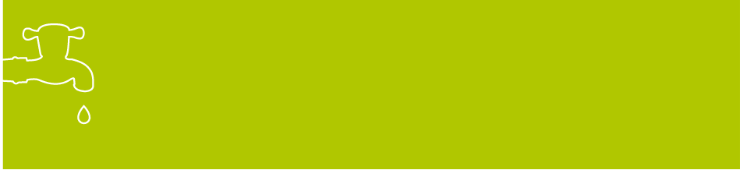
Stormwater is rain draining into the stormwater system from roofs, roads, footpaths and other ground surfaces. Rain collected from a roof is sometimes called roofwater.
Greywater is wastewater from kitchen, laundry and bathroom drains, but not from toilets.
Sewage is material collected from internal household and other building drains. It includes faecal waste and urine from toilets, shower and bath water, laundry water and kitchen water.
Treated sewage is the product that flows out of a sewage treatment plant.

02 A Risk Management Approach
Any scheme to recycle water must ensure that public health and the environment are protected. This is best achieved through a risk management approach, which involves actively identifying and managing risks, rather than simply reacting to problems if they arise.

A risk management approach has been used in the food industry for many years, where it is known as ‘HACCP’; that is, ‘hazard analysis and critical control point’. Under this approach, producers first identify any potential hazards to food safety, and then identify particular points (critical control points) in production and preparation systems where action can be taken to reduce or eliminate the risk that the hazards will occur. This system is designed to ensure that food supplied to consumers is safe to eat.
More recently, other areas have adopted risk management; for example, the approach is used in:
- deciding whether to import certain foods into Australia
- managing diseases of farm stock
- managing risks associated with drinking water.
The new Australian guidelines for water recycling adopt a risk management approach. Phase 1 of the guidelines applies this approach to managing risks to human health and the environment from recycling of water from greywater and treated sewage.

A framework for risk management
The approach to risk management used in the 2006 Australian Guidelines for Water Recycling: Managing Health and Environmental Risks is modelled closely on the approach developed for the 2004 edition of the Australian Drinking Water Guidelines (available from www.environment.gov.au). The guidelines incorporate a generic framework that can be applied to any system that is recycling water, whatever its size or type. The framework contains 12 elements organised into four main areas, as shown in the figure on the next page. (See Section 1.25 on page 11 of the full document)
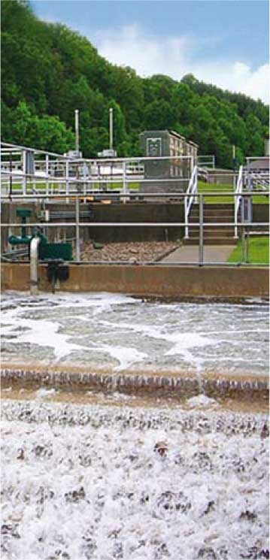

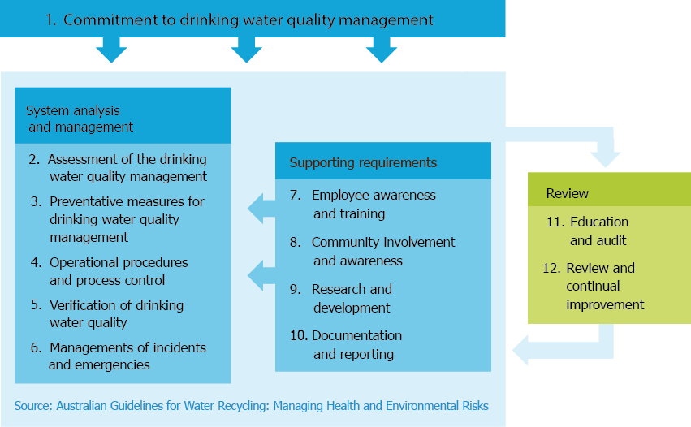
See box 1.4 on page 10 of the full document

WHAT RISK MANAGEMENT INVOLVES
The process of risk management can be summarised as a series of questions that fall into three main categories:
- assessing risks
- What might happen?
- What is the likelihood that it will happen?
- How serious will it be if it does happen (i.e. impact or consequence)?
- managing risks
- What can we do to stop it happening?
- monitoring and reviewing risks
- Are the individual measures operating correctly?
- Did the management system work?
The 12 elements are related, and all need to be considered for the risk management approach to be successful. Well-designed recycling schemes already use many elements of the framework. For example, many schemes already include a series of preventive measures (referred to as ‘multiple barriers’), which form an important element of the System analysis and management area of the risk management framework.
Every recycled water system should have a risk management plan, based on the framework. The complexity of the plan will depend on the size of the system. Plans for small systems involving, for example, drip irrigation of trees will be much simpler than plans for residential dual-reticulation systems involving toilet flushing and garden use.

The table below shows how each of these questions might apply to a system recycling water from greywater or sewage. Each question is illustrated with examples of risks to human health and the environment.

The risk management approach in water recycling
Question | Action | Example–human health | Example–environment
What might happen? | Look at possible hazards in the recycled water that could affect human health or the environment | Presence of rotavirus which could cause gastroenteritis | High levels of salinity which could make crops unproductive or could stress garden palnts
What is the likelihood that it will happen?  How serious will it be if it does happen? | For each hazard identifies, assess– through the whole system of water treatment, delivery, storage and use– how likely is it that the event will happen and the potential consequences if it did. | Sewage is highly likely to contain rotavirus, greywater less likely.  Infection with rotavirus mainly causes diarrhoea, but can cause severe diarrhoea in some cases. It has, on rare occasions, caused death in very young children. | Sewage may have a high level of salinity if trade wastes are entering the treatment plant. Salinity can corrode assets, stress plants, and contaminate groundwater and surface water.
What can we do to stop it happening? | Identify preventive measures (multiple barriers) to control hazards | Put in place multiple treatment processes (e.g. filtration, coagulation, disinfection and storage) and restrictions on uses of recycled water (e.g. use only for purposes other than food crops). | Put in place controls on trade waste (source control) or on uses of recycled water (e.g. use only on salt-tolerant plants).
Are the individual measures operating correctly?  Did the management system work? | Monitor to ensure that the preventive measures are working effectively, and verify to check that the system consistently provides recycled water of quality that is fit for its intended use. | Monitor quality of treated water and performance of treatment processes. | Monitor to ensure that quality of treated water and soil salinity is maintained at appropriate levels.
The next sections look at assessing, managing, monitoring and reviewing risks in relation to recycling of water from greywater and sewage. These activities do not take place in a vacuum—a recycling scheme will only be successful if the community supports the scheme. The final section of the document therefore discusses the consultation and communication process.

03 Assessing Risks
The first steps in the risk management approach are to commit to developing a recycled water scheme and then assess any risks it may pose. The Australian Guidelines for Water Recycling: Managing Health and Environmental Risks provides a stepwise method for assessing risks to human health (in Chapter 3) and the environment (in Chapter 4). The two approaches are illustrated in the figure below.

Assessing risks to human health
Identify the hazards that might be present in the water source and what effect those hazards may have on human health.
Work out how likely it is that humans will be exposed and the amount (dose) of the hazard that relates to the likelihood of illness (response).
Consider the possible impacts of a hazard or hazardous event, in terms of the potential seriousness of the impact and the size of the population likely to be affected
Combine the information gained from Steps 1–3 to assess the overall risk posed by each potential hazard.
Step 1.
Identify hazards and
hazardous events

Step 2.
Estimate likelihood
Step 3.
Assess impact
Step 4.
Characterise the risk
Assessing risks to the environment
Identify the hazards that might be present in the water source and the hazardous events that could occur, and the effect they may have on the environment.
Work out how likely it is that hazardous events (such as a sudden increase in salinity) will happen.
Consider the possible effects of a hazard or hazardous event, both where the recycled water will first be used (e.g. to water crops) and where it might end up (e.g. in groundwater).
Combine the information gained from Steps 1–3 to assess the overall risk posed by each potential hazard or hazardous event.

A hazard is a biological, chemical, physical or radiological agent that has the potential to cause harm to people, animals, crops, plants or organisms; to the soil, air or water; or to the general environment.
A risk is the likelihood that a hazard will harm exposed populations or receiving environments in a particular timeframe, combined with the severity of the impact.

Campylobacter is a microorganism occurring in most animals and often found in contaminated food or water. It is generally regarded as the most common bacterial cause of gastroenteritis worldwide, with symptoms including diarrhoea, vomiting, stomach pains and cramps, and fever.
Cryptosporidium is a microorganism commonly found in lakes and rivers, with cysts that are not easily inactivated or killed by disinfection. It has caused several large outbreaks of gastrointestinal illness, with symptoms such as diarrhoea, nausea and stomach cramps.
Rotavirus is a virus that is commonly present in water contaminated with human waste. Infection with rotavirus generally causes mild to severe diarrhoea; the organism is a major cause of viral gastroenteritis in young children.
See Table 4.8 on page 142 of the full document

KEY HAZARDS TO
THE ENVIRONMENT
The Australian Guidelines for Water Recycling: Managing Health and Environmental Risks identify nine key hazards in recycled water:
Boron, chloride, sodium, cadmium and chlorine are toxic to plants in large quantities
(chlorine is also dangerous to aquatic organisms).
Salinity causes water stress in plants, degrades soils and makes cadmium already in the soil more available to plants.
Sodium excesses can cause soils to become sodic and can degrade soil structure, making it difficult for water and plant roots to penetrate the soil.
Phosphorus and nitrogen can affect nutrient balances in plants, and choke waterways with algal bloom.
In addition, water excesses can cause waterlogging, raise the water table and potentially cause soil salinity.

Identifying potential hazards

Hazards to human health
Sewage and greywater can contain a range of different contaminants that are hazardous to human health, all of which need to be considered in identifying potential hazards. Sewage and greywater may contain:
- pathogenic (disease-causing) microorganisms, such as: – bacteria; for example, certain types of Campylobacter and Salmonella
- viruses; for example, rotavirus and hepatitis A
- protozoa; for example, Cryptosporidium and Giardia
- helminths; for example, Ascaris (roundworm)
- harmful chemicals; for example, pesticides. In recycled water, pathogenic microorganisms generally pose a greater risk to human health than chemicals, and these are the main focus of Chapter 3 of the first phase of the Australian water recycling guidelines.

Hazards to the environment
In looking at potential hazards to the environment in treated sewage and greywater, the Australian Guidelines for Water Recycling: Managing Health and Environmental Risks focuses on chemical rather than microbial hazards.This is because—like other sources of recycled water—sewage and greywater can contain a wide range of inorganic and organic chemical agents, and chemical hazards generally pose a greater risk to the environment than microbial hazards. For pathogenic microorganisms, the preventive measures taken to protect human health will generally be more than sufficient to protect the environment.
Part of the process of developing the first phase of the Australian water recycling guidelines was to identify the main environmental hazards that should be of highest priority when assessing the environmental risk associated with specific uses of recycled water. Nine key hazards were identified and are listed in the adjacent box.
See Section 4.2 on page 122 of the full document
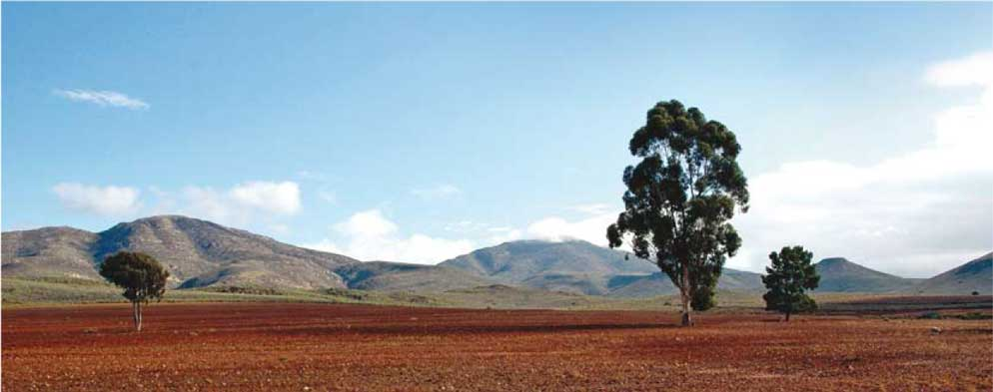

Assessing likelihood and impact
All activities carry some risks, even everyday activities such as driving a car or boiling a kettle, and it is impossible to remove risk completely. In working with recycled water, potential risks to human health and the environment have to be reduced to levels that are acceptable for the proposed end use. The first step in managing risks is therefore to determine what level of risk is acceptable, so that targets can be set for the specific hazards identified in the first stage of risk assessment.

MEASURING HEALTH RISKS
USING DALYS
A disability adjusted life year (DALY) is a measure of the impact of an event, such as an accident or an outbreak of disease. The unit combines years of life lost and the years lived with disability or illness. It also includes an adjustment for the severity of the illness or disability, so that a mild illness counts for fewer DALYs than a severe one. Thus, one DALY is equivalent to one person losing one year of life or 800 people contracting a diarrhoeal illness lasting 7 days.

Assessing impacts on human health
The various hazards that can be present in sources of recycled water can have very different health outcomes. Some outcomes are mild (e.g. diarrhoea) while others can be severe (e.g. reactive arthritis). To compare different risks to human health, the recycling guidelines use a unit of risk called a ‘disability adjusted life year’ (DALY), which can be used in a water recycling scheme to:
- define the level of risk to public health that is acceptable
- compare impacts from different hazards; for example, those that cause acute impacts (such as a brief episode of diarrhoea) and those that cause chronic impacts (such as arthritis)
- ensure that control efforts are directed at hazards with the greatest potential impact on public health.
Australia’s water recycling guidelines use a level of one-millionth of a DALY per person per year as the acceptable risk to human health. This is roughly equivalent to one person in a thousand contracting diarrhoea in one year due to a water recycling scheme (by comparison, the normal rate of diarrhoea in Australia is far higher, at just under one case per person per year).
The acceptable risk can be used to set health-based targets—the ‘goal-posts’ or ‘benchmarks’ that have to be met by each recycled water scheme to ensure that risk remains at or below an acceptable level. The most common targets are guideline values for chemical hazards and performance targets for microbial hazards.
See Section 3.2.2 on page 89 of the full document

Assessing impacts on the environment
As with human health, potential risks to the environment from recycled water have to be reduced to acceptable levels, and this involves determining what is an acceptable level of risk. Published environmental guideline values provide the concentrations (of chemicals) or characteristics (of soil, air or water) that do not pose a significant risk to the environment.
see section 4.2.2 on page 124 of the full document
The point where recycled water is used or ends up is referred to as the environmental endpoint. For example, in a recycling scheme where recycled greywater is used for garden watering, endpoints might include lawns, the surrounding soils and trees in the garden. Assessing environment risk involves considering a large number of different endpoints, in contrast to assessing health risk, which focuses on a single endpoint—humans. To simplify the assessment, endpoints are usually grouped into broad categories such as air, soils, plants and groundwater.
Because of the wide range of potential endpoints and different impacts, it is helpful to first narrow down the assessment of environmental risks through a screening-level risk assessment. This initial assessment uses broad information to screen out any hazards that are unlikely to happen or to have any significant impact. More detailed information is then obtained for any remaining risks.

Characterising risks
Characterising risks involves combining information on the potential hazards with their likelihood and seriousness in relation to human health and the environment.
see page 40 of the full document
In assessing the overall risk posed by a particular hazard, each risk is considered at two levels:
- residual risk—the risk posed after taking into account existing preventive measures
- maximum risk—the risk posed if there were no preventive measures.
The residual risk is useful for working out whether the existing preventive measures are sufficient to ensure that the recycling scheme is safe, or whether additional preventive measures (barriers) are needed (illustrated by the case study for watering food crops with water recycled from treated sewage, on page 12). The maximum risk is useful for working out which risks are high priority (i.e. are likely to have serious consequences) and what plans should be made to deal with an emergency, in the event that the preventive measures fail.
The risk remaining after preventive measures should be below the acceptable level of risk for human health and the environment, discussed above.
see Box 3.1 on page 84 of the full document

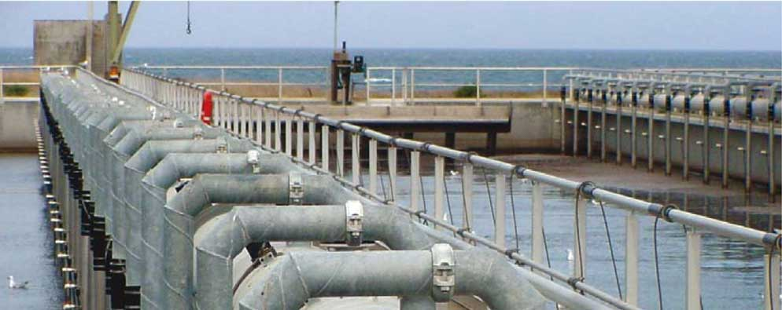

04 Managing Risks

Having assessed the risks to human health and the environment from recycled water, the next step is to manage those risks. Crucial to the risk management approach is the use of a series of preventive measures—referred to as multiple barriers— to control potential hazards. This section explains multiple barriers and a related concept, that of ‘critical control points’.
See Section 2.3 on page 40 of the full document

Multiple barriers and
critical control points
The concept of multiple barriers is based on the idea that if one barrier is not working to full capacity, other barriers will continue to provide control, so that system continues to function and provide protection. Also, it may be possible to temporarily increase the performance of the remaining barriers while the faulty barrier is being repaired. In water recycling, multiple barriers are used to:
- prevent hazards entering recycled water; for example, restricting the types of industrial chemicals that can be put down drains (i.e. exclusion barrier)
- remove hazards using treatment processes; for example, disinfecting water to inactivate disease-causing organisms (i.e. treatment barrier)
- reduce exposure to hazards; for example, using preventive measures at the site of use (e.g. only irrigating parks and gardens at night) or restricting uses (e.g. allowing water to be used to water grapevines but not salad vegetables, which is an end-use restriction barrier).
This combination of treatment processes with on-site controls and use restrictions is used to provide water of acceptable quality for identified uses. Preventive measures that are vital for controlling high-risk hazards are known as ‘critical control points’. Such measures keep high-risk hazards in check, either removing them or reducing them to acceptable levels. To be classed as a critical control point, a measure must:
- remove a high-risk hazard or reduce it to acceptable levels
- be able to be monitored, and corrected for if it fails
- be essential to the functioning of the recycling scheme (that is, if the measure fails, the scheme must shut down unless the measure is corrected for).
An example of a critical control point in a water recycling scheme using treated sewage would be disinfection and storage for control of the high-risk hazard Giardia. Together, disinfection and storage meet the above criteria for being classed as critical control points. If monitoring equipment showed that insufficient disinfectant was entering the water, or that the water had spent insufficient time in storage, the recycled water would need to be turned off until these faults were fixed. In practice, monitoring of such a scheme should be designed so that variations in disinfection and storage times are detected quickly and corrective actions are triggered before critical limits are reached.

The Australian Water Recycling Guidelines: Managing Health and Environmental Risks explain in detail how multiple barriers can be used to meet performance targets for microorganisms and keep concentrations of any chemical contaminants below guideline values. The preventive measures chosen for a particular recycling scheme will depend on a range of factors —cost, the treatment facilities available, public perceptions, etc.—but need to be appropriate for the potential hazards, which in turn will depend on the source of the water and its intended uses.
Using treatment as the main way to minimise risk from microbiological hazards focuses control within a treatment plant. However, treatment is relatively expensive, and management of a treatment plant requires a high degree of technical expertise. Employing on-site controls and restrictions on use of the water reduces the focus on treatment. Controls can be used in combination with standard recycled water treatment processes—such as secondary treatment, storage lagoons and disinfection—with or without recycling of the final product. In this way, recycling can be introduced at existing facilities without the need for expensive retrofitting or treatment upgrades.
The guidelines summarise typical combinations of preventive measures for various types of recycling, showing in each case what effect the measures are likely to have in reducing levels of microbes or chemicals. Two case studies given on pages 12 and 13—on irrigating crops with treated sewage and using greywater in households —illustrate these points.
The types and levels of contaminants vary between sewage and greywater; therefore, the guidelines look separately at how to deal with the risks linked to each of these types of source water.

Managing risks to human health
As explained above, pathogenic organisms represent the main risk to human health. Preventive measures to protect human health therefore focus on inactivating such organisms or reducing their numbers to levels that do not pose a risk.
see section 3.4 on page 93 of the full document

Managing risks to the environment
Measures to deal with risks to the environment tend to focus on controlling the hazards entering the water that is to be recycled. For example, greywater systems may have a diverter switch to allow the householder to choose which stream of the greywater flow is put onto the garden, and how often. Similarly, sewage treatment plants may have an agreement with industries to prevent trade waste and other hazardous materials from entering the sewerage system.
One preventive measure specific to protection of the environment is the use of ‘buffer strips’, which are spaces between the area where the water is used and areas where sensitive plants (or other environmental endpoints) are located. Buffer strips can help to protect plants that might be sensitive to chemicals remaining in recycled water.
See section 4.3 on page 143 of the full document

05 Monitoring

In addition to assessing the risks to human health and the environment from recycled water, and setting up measures to manage those risks, it is essential to monitor water recycling, to answer the questions:
- Where are we now?—obtaining baseline data
- Will it work?—validating systems
- Is it working now?—obtaining operational data
- Did it work?—verifying that the processes used in recycling are effective.
All four types of monitoring are used in relation to both human and environmental health risks. The case studies below illustrate how risk assessment, risk management and monitoring are put into practice.
See Chapter 5 on page 151 of the full document
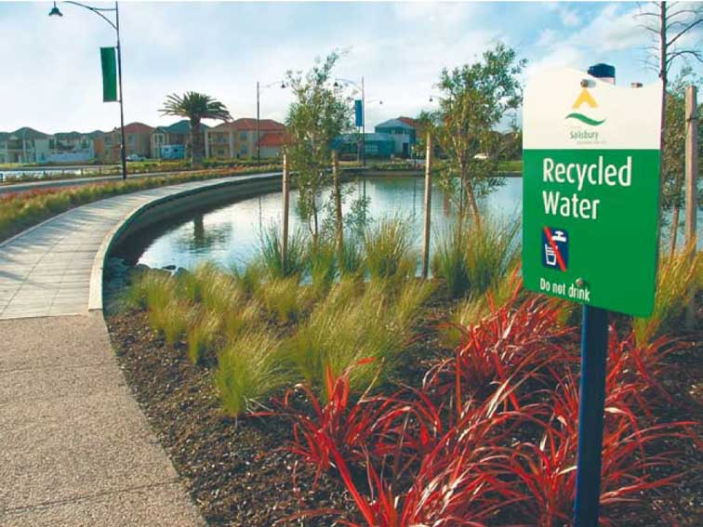

CASE STUDY—SAFE IRRIGATION OF FOOD CROPS

A water recycling project in Australia uses treated sewage to irrigate food crops.

What might happen?
Because the source of the recycled water is treated sewage, the main hazards to human health are pathogenic organisms and harmful chemicals that could potentially affect those working with or eating the crops.
The main hazards to the crops and the environment are chemicals or salts entering the sewage from industrial activities.
See section A1.1 on page 187 of the full document

What is the likelihood that it will happen? How serious will it be if it does happen?
The likelihood of sewage containing pathogenic organisms depends on levels of disease in the humans or animals that the sewage came from. The consequences of pathogenic organisms in the recycled water could be serious; for example, they could cause outbreaks of diseases such as gastroenteritis in those working with or eating the crops. It is difficult to work out how likely it is that pathogens will be present, so the safest approach is to assume that they will be present, and treat the sewage accordingly, which is the approach taken in this recycling scheme.
The likelihood of the sewage containing chemicals harmful to human health or the environment depends on the types and amounts of contaminants entering the water. In humans, the effects of chemicals are generally seen after prolonged exposure, and chemicals are less likely than pathogenic organisms to cause immediate illness. Effects of chemicals on the environment could be more immediate; for example, causing plants to die or fail to thrive.
To work out the likelihood that the sewage would contain harmful chemicals, the assessment team investigated the industrial activities in the catchment. The team found that the catchment has effective trade-waste controls (i.e. controls on what contaminants industries can put into the water) that generally keep the amount of chemicals entering the water low. The main environmental hazard identified was high levels of salinity; other environmental hazards were chloride, sodium, nitrogen, phosphorus, hydraulic load and boron.

What can we do to stop it happening?
In this recycling scheme, different measures have been set up to ensure that any potential hazards do not pose an unacceptable risk to human health or the environment.
General safety measures include:
- fitting devices to the pipework to prevent recycled water flowing backwards through the pipes, or recycled water pipes being connected to those carrying drinking water
- installing colour-coded pipework and signage at all irrigation sites to alert users to the fact that the water was recycled
- educating users of the recycled water on how to use the water safely.
Preventive measures (barriers) used to reduce the risk to human health include:
- implementing a trade-waste control program to reduce the likelihood of toxic chemicals contaminating the water before it reached the treatment plant
- adding treatments (coagulation, filtration and disinfection) to improve the quality of the water leaving the plant
- storing treated water in a lagoon to allow time for disease-causing organisms to be inactivated and any high levels of contaminants to be detected and dealt with.
Preventive measures (barriers) used to prevent salinity damage to crops and the environment include:
- selecting appropriate crops, such as salt-tolerant plants
- avoiding the use of the recycled water on certain soils sensitive to salinity
- adding soil-improving agents, such as gypsum
- offsetting nutrient requirements by considering nutrients applied through irrigation of recycled water
- diluting recycled water back to safe levels when salinity levels increased to unacceptable levels.
Are the individual measures operating correctly? Did the management system work?
Levels of the relevant hazards in the water, the crops and the environment (soils, surface water and groundwater) were tested before the system was put into use; testing continues during the operation of the system. Laboratory tests showed that the multiple barriers reduce disease-causing organisms and chemical or salt contaminants to acceptable levels in the treated sewage. After the system had been in use for 2–3 years, edible parts of the crops were tested for cadmium, because high salinity can increase uptake of cadmium already present in the soil. Cadmium concentrations in recycled water were low and therefore low risk, and the testing showed low, safe levels of this heavy metal in the edible parts of the crops.

CASE STUDY—SAFE USE OF GREYWATER IN THE HOME

A water recycling scheme in Australia uses treated greywater from an apartment block for flushing toilets, drip irrigation of garden beds and subsurface irrigation of grassed areas.

What might happen?
Greywater contains only the water from internal household drains and thus generally contains fewer hazards than sewage. However, it can contain pathogenic organisms (e.g. from showering or from washing nappies and soiled clothing) and chemicals that can be harmful to humans and the environment (e.g. from inappropriate household cleaning products or laundry detergents). Greywater is usually alkaline and saline, with high levels of sodium, carbonates and phosphates.
See section A1.5 on page 219 of the full document

What is the likelihood that it will happen? How serious will it be if it does happen?
The greywater is likely to contain some pathogenic organisms because activities such as showering and washing soiled clothing are normal, everyday events. If these are present, they could cause diseases such as gastroenteritis in people using the water.
The likelihood of the greywater containing chemicals harmful to human health or the environment depends on whether or not people put inappropriate chemicals into the greywater sources (drains). The chemicals are more likely to pose a hazard to the environment than to human health; for example, high levels of salinity may kill sensitive plants.

What can we do to stop it happening?
In this recycling scheme, different preventive measures were set up to ensure that the potential hazards do not pose an unacceptable risk to human health or the environment. Because the risks posed by greywater are less than those for sewage, this scheme requires only two types of treatment (filtration and disinfection), in contrast to the multiple treatments required to generate sewage effluent from sewage and recycle water from the effluent.
General safety measures include:
- fitting devices to the pipework to prevent recycled water flowing backwards through the pipes, or recycled water pipes being connected to those carrying drinking water
- installing colour-coded pipework (purple and/or with text) and signage at all irrigation sites to alert users to the fact that recycled water is being used
- installing signage at the site to alert plumbers to the recycled water system and coordinating plumbers through the body corporate
- maintaining the drinking water system at higher pressure than the recycled water supply.
Preventive measures (barriers) used to reduce the risk to human health include:
- treating the greywater with a combination of filtration and disinfection
- educating residents on how to avoid inappropriate disposal of household wastes.

Preventive measures (barriers) used to reduce the risk to the environment include:
- encouraging residents to use environmentally friendly detergents in the bathroom and to be careful in disposing of household and garden chemicals
- providing residents with a list of detergents considered appropriate for use in the apartment building and updating the list each year
- not planting salt-sensitive plants
- reducing fertiliser application to take into account nutrients in the treated greywater.

Are the individual measures operating correctly? Did the management system work?
Levels of the relevant hazards in the water were tested before the system was put into use, and testing continues while the system is in operation. Laboratory tests found that the multiple barriers reduced disease-causing organisms and household chemicals to acceptable levels in the treated greywater. Visual assessment of gardens plants and lawns indicate a healthy garden. Soil tests will be used in future monitoring to minimise the risk of nutrients moving off-site.
See section 2.3.2 on page 45 of the full document

06 Consulting the Public

Why consult the public?
Water recycling schemes provide benefits for the community, but also present costs and risks. Therefore, the community has an expectation that it should be consulted when recycling schemes are proposed. To increase the acceptance of a water recycling scheme, all those who might be affected should be involved in the decision making, including landowners, industry, special interest groups, wholesalers, retailers, customers and the community in general.
Community consultation alone is not sufficient for a recycled water scheme to be successful. The community also needs to be sure that those planning and operating the scheme are trustworthy and that the scheme will not pose an unacceptable risk to public health or the environment.
See Chapter 6 on page 177 of the full document

Potential problems
Lack of community support has led to rejection of proposed water recycling schemes in Australia and overseas. In some cases, people believed that planning was being done secretly and that their concerns were not recognised. In others, authorities and water recycling organisations did not do enough to promote the benefits of their operations or to allay fears about possible risks to human health and the environment.
Trust in the water recycling system can easily break down if there is poor public consultation and communication. For example, delays in passing on information can spark rumours, increasing the community’s concerns about the water recycling scheme or causing people to question the organisation’s motivations and intentions.

Effective communication
To be successful, a water recycling scheme needs a communication strategy that allows the community to:
- study the evidence and draw their own conclusions about water recycling
- see that both the decision-making process and the decisions themselves are transparent and fair
- share responsibility for solving the problems of water supply, recycling water or disposing of wastewater (this includes having many opportunities to participate in the decision-making processes during the planning and operation stages).
A case study on page 15 shows how important good community consultation is for the success of a proposed water recycling scheme.
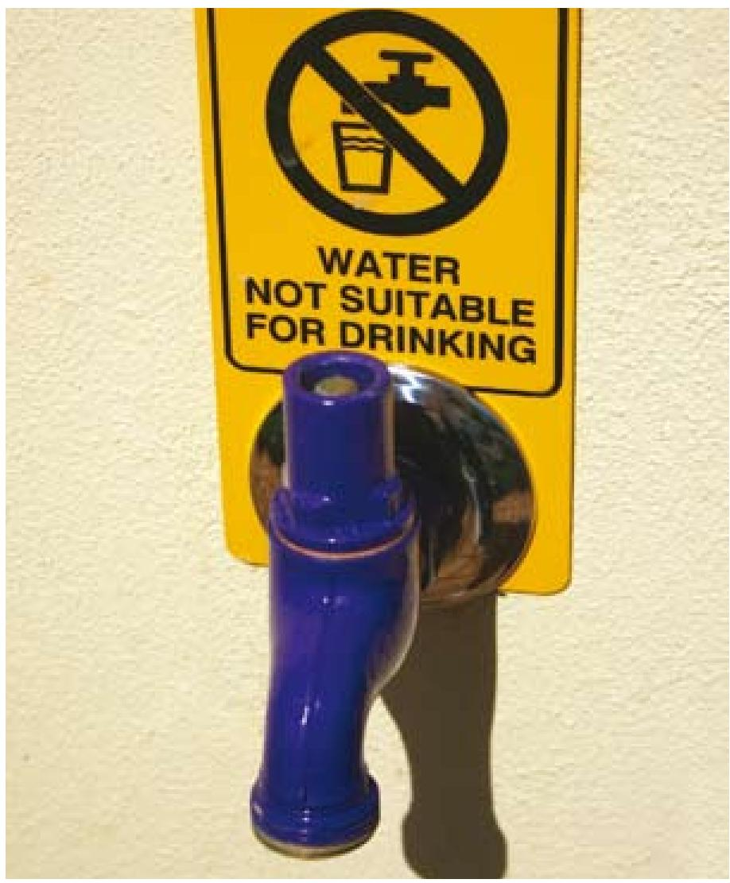

CASE STUDY—

USING RECYCLED WATER IN THE HOME: A SUCCESS STORY

The system
At a new housing development in an Australian state capital, each household has two water supplies: one for drinking and washing, the other—which is recycled water—for toilet flushing, garden watering, car washing and other similar activities. Initially, water of drinking-water quality was delivered through both sets of pipes to test the system; recycled water then began flowing through the pipes designed for recycled water.
See section A7.2 on page 347 of the full document

Teething problems
Initially, those buying property in the development and wanting more information about the dual-reticulation system were referred to their state water authority. That organisation provided more details on request; however, some residents picked up incorrect information from other sources (such as newspapers)— particularly about water prices and the source of the recycled water. Also, ownership of the recycled water system was not resolved until five years into the project, when it was agreed that the state water authority would become the owner and operator of the system, and thus take over communication with residents.

Improved communication
Just before the scheme switched over to using recycled water, each household received a detailed letter about the scheme and a series of information sheets. Further details were made available on the internet, including educational resources and a recycled water plumbing guide. People were encouraged to check their own homes, to ensure that the recycled water system was not connected to their drinking water systems. This step helped residents to learn how their recycled water system worked and to feel more involved in the scheme.

Resolving confusion
Three years after the scheme opened, residents were still confused about issues such as supply and price of the recycled water. However, some two years later, more than half said that they trusted the water authority and were reasonably confident that the recycled water posed no health risks. Residents can find out more about the system through websites and a call centre managed by the supplier.

Lessons learnt
An important lesson learnt from this experience was the need to think about misconceptions or misinformation that may come from sources outside the water recycling organisation—for example, from newspapers—and deal with them.

07 Further information

Further information
For further information about water recycling, consult the national guidelines (http://www.environment.gov.au) or contact the relevant state or territory authority. The most appropriate organisation to contact will depend on the nature of the enquiry, but is usually an environment, natural resources or health agency.

Main entry points, service pages and directories for Australia’s state and territory governments

Australian Capital Territory
Australian Capital Territory Government Entry Point tinyurl.com/35pze4/
Australian Capital Territory Government Directory tinyurl.com/2uncw2/
Canberra Connect
tinyurl.com/2p6xw4/
New South Wales
New South Wales Government Entry Point
http://www.nsw.gov.au/
New South Wales Government Directory http://www.directory.nsw.gov.au/
Northern Territory
Northern Territory Government Entry Point http://www.nt.gov.au/
Northern Territory Government Contacts www.nt.gov.au/ntg/contacts.html
Northern Territory A–Z Government
tinyurl.com/33fymp/
Queensland
Queensland Government Entry Point
http://www.qld.gov.au/
Queensland Government Directory
http://www.qgd.qld.gov.au/
South Australia
South Australian Government Entry Point www.sa.gov.au/site/page.cfm
South Australian Government Online Services http://www.service.sa.gov.au/
South Australian Government Directory
tinyurl.com/2l4trz/
Tasmania
Tasmanian Government Entry Point
http://www.tas.gov.au/
Tasmanian Government Online Services http://www.service.tas.gov.au/
Tasmanian Government Directory
tinyurl.com/yr2gsr
Victoria
Victorian Government Entry Point
http://www.vic.gov.au/
Victorian State Government Contacts
tinyurl.com/2osqbz
Western Australia
Western Australian Government Entry Point http://www.wa.gov.au/
Western Australian Government Departments and Agencies
www.wa.gov.au/agencies/

Norfolk Island
http://www.norfolk.gov.nf/

