# National Acid Sulfate Soil Guidance

Overview and management of monosulfidic black ooze (MBO) accumulations in waterways and wetlands

June 2018

© Commonwealth of Australia 2018

**Ownership of intellectual property rights**

Unless otherwise noted, copyright (and any other intellectual property rights, if any) in this publication is owned by the Commonwealth of Australia (referred to as the Commonwealth).

**Creative Commons licence**

All material in this publication is licensed under a Creative [Commons Attribution 4.0 International Licence](https://creativecommons.org/licenses/by/4.0/legalcode) except content supplied by third parties, logos and the Commonwealth Coat of Arms.

Inquiries about the licence and any use of this document should be emailed to [copyright@agriculture.gov.au](mailto:copyright@agriculture.gov.au).

by

**Cataloguing data**

This publication (and any material sourced from it) should be attributed as: Sullivan, LA, Ward, NJ, Bush, RT, Toppler, NR, Choppala, G 2018, *National Acid Sulfate soils Guidance: Overview and management of monosulfidic black ooze (MBO) accumulations in waterways and wetlands,* Department of Agriculture and Water Resources, Canberra. CC BY 4.0.

This publication is available at waterquality.gov.au.

Australian Government Department of Agriculture and Water Resources

GPO Box 858 Canberra ACT 2601

Switchboard +61 2 6272 3933 or 1800 900 090

Email [waterquality@agriculture.gov.au](mailto:waterquality@agriculture.gov.au)

**Liability**

The Australian Government acting through the Department of Agriculture and Water Resources has exercised due care and skill in preparing and compiling the information in this publication. Notwithstanding, the Australian Government Department of Agriculture and Water Resources, its employees and advisers disclaim all liability, including liability for negligence and for any loss, damage, injury, expense or cost incurred by any person as a result of accessing, using or relying on any of the information or data in this publication to the maximum extent permitted by law.

**Acknowledgement**

The authors would like to acknowledge the input provided by National Committee for Acid Sulfate Soils into the development of this synthesis. They would also like to thank the reviewers for their comments on the draft report, including Dr Steve Appleyard (Department of Water and Environment Regulation, Western Australia) and Laurence Fox (Fox Environmental Consulting).



Contents

1 The purpose of this guidance 1

2 Introduction 2

2.1 Overview and management of MBO accumulation in waterways and wetlands 2

3 Discussion on extent, risks, legacies and potential liabilities 3

3.1 Description and definition of MBOs 3

3.2 Extent 5

3.3 Formation of MBO 5

3.4 Hazards associated with MBOs 7

3.5 Factors to consider for the dredging and disposal of MBOs 11

4 Discussion on policy and regulator environment 13

5 Discussion on current management practices and approaches 14

5.1 Policy and guidelines 14

5.2 Assessment of MBO accumulations 15

5.3 Assessment of hazard posed by MBO accumulations 22

5.4 Management strategies 24

5.5 Framework to assess the potential for impact associated with MBO accumulation 30

5.6 Current gaps in our knowledge of MBO accumulations and their management 32

Appendix A: Case Studies 34

A1.1 Floodgated drains in ASS landscapes: North Coast NSW 34

A1.2 Dredge spoil (mainly MBO) containment dump: Peel region, Western Australia 38

A1.3 Tidally affected coastal waterways: Geographe Bay area, Western Australia 41

A1.4 Inland river: Talbragar River, central New South Wales 44

A1.5 Saline water disposal basin: Loveday Basin, Lower River Murray Region 47

Glossary 51

References 57

Figures

Figure 3.1 Transmission electron microscopy (TEM) micrographs showing nanoparticulate mackinawite in sulfidic materials. 3

Figure 3.2 Spatial distribution of AVS (%S) in the Richmond River catchment. 4

Figure 3.3 Conceptual model of in-situ iron transformations in accreting coastal ASS-associated drain sediments. 6

Figure 3.4 The effect of adding drain MBOs on the oxygen content of freshwater. 8

Figure 3.5 The effect of adding different drain MBOs on the pH of freshwater. 9

Figure 3.6 Changes to the sulfur speciation and pH during oxidation of MBO. 9

Figure 5.1 Black oily appearance of MBO gel collected from the Peel region, Western Australia. 16

Figure 5.2 Sampling MBOs using a sediment coring device. 17

Figure 5.3 Sampling MBOs using a Van Veen grab sampler. 17

Figure 5.4 Core sample collected in the Vasse Estuary, Western Australia. 21

Figure 5.5 Sediment profiles showing variation in MBO thickness within waterways in the South Yunderup region, Western Australia. 21

Figure 5.6 Example of a reed bucket used to remove MBOs from waterways. 27

Figure 5.7 A small-cutter suction dredge removing MBOs from the Peel-Harvey Estuary, Western Australia. 27

Figure 5.8 Using dewatering bags with MBOs at the Peel-Harvey Estuary, Western Australia. 29

Figure 5.9 General decision framework. 31

Figure A1 Monosulfide sulfur contents in the transect to Yellow Creek. 36

Figure A2 Evidence for the mobilisation of MBO accumulations. 37

Figure A3 Soil profile within the South Yunderup Dredge Spoil disposal site. 40

Figure A4 Pit outside bund wall showing sulfide oxidation products and an unoxidised monosulfidic layer. 41

Figure A5 Surface MBOs at Port Geographe (left and middle) and seagrass accumulation at Toby Inlet (right), Geographe Bay. 43

Figure A6 Reduce inorganic sulfide (RIS) content (µmol/g) of sediments at Site 14 in the Vasse Estuary. 44

Figure A7 Black monosulfidic layer (approximately 8 cm thick) in Talbragar River bed sediments. 46

Figure A8 AVS content in sediments and sulfate content of water in the Talbragar River. 46

Figure A9 AVS content in sediments and dissolved oxygen content of water in the Talbragar River. 47

Figure A10 Vertical sections of Talbragar river sediments at the same site near Boomley. 47

Figure A11 The alternating wetting and drying cycles Loveday Disposal Basin experiences creates deeply cracked sediments during dry times. 49

Figure A12 Loveday Disposal Basin sediment profile showing surficial saline crust, a black underlying MBO layer overlying a sulfidic (pyritic) layer. 50

Tables

Table 5.1 Recommended amount of MBO required for various analyses. 18

Table A1 Selected soil properties at the South Yunderup Dredge Spoil containment dump. 39

Maps

Map A1 Deep drainage network at Moto Swamp on the Lower Manning River floodplain. 34

Map A2 Location of the Tuckean Swamp drainage network study site. 35

Map A3 Location Sampling locations in Tuckean Swamp. 36

Map A4 South Yunderup Dredge Spoil dump location in relation to the navigation channel. 38

Map A5 Location of sampling sites in the Geographe Bay area. 42

Map A6 Location of Talbragar River. 45

Map A7 Loveday Disposal Basin and nearby towns in the Riverland Region of South Australia. 48

Equations

Equation 3.1 Iron monosulfide formation. 6

Equation 3.2 Oxidation of MBO – Step 1. 9

Equation 3.3 Oxidation of MBO – Step 2. 10

## The purpose of this guidance

Our awareness of monosulfidic black oozes (MBOs) in the waterways and wetlands of our landscapes and of the potential of these materials to pose environmental hazards was first identified only two decades ago (Sullivan and Bush, 2000, Sullivan et al., 2002a). Much of our efforts over the past 15 years has focused on the assessment, characterisation and understanding of the behaviour of these materials. This document provides best management practices for the management of MBO accumulations in waterways for the first time.

The occurrence of MBOs in waterways and wetlands across diverse landscapes and the range of severe hazards that can arise from the disturbance of these materials necessitate the provision of suitable guidance material on their assessment and management. The purpose of this guideline is to provide technical and procedural advice to assess and manage MBO encountered in waterways and wetlands. **It is essential that the reader consult relevant jurisdictional guidance and regulations and contact the relevant state or territory government department for specific local and regional information and advice.**

This guideline document is divided into four sections:

1. an introduction to the management of MBO accumulation in waterways and wetlands,
2. an examination of the literature available on the extent, risks, legacies and potential liabilities of MBOs,
3. an outline of the policy and regulatory environment of acid sulfate soil materials including MBOs,
4. current best management practices for MBOs.

## Introduction

### Overview and management of MBO accumulation in waterways and wetlands

MBOs are materials found in soils and sediments that contain monosulfides (predominantly iron monosulfides, but also consisting of other compounds including H2S) in sufficient concentration to affect the properties and behaviour of those soils and sediments. In soil materials, contents of greater than or equal to 0.01% acid volatile sulfide (AVS) are sufficient for these materials to be classified as ‘monosulfidic’ (Sullivan et al. 2012).

MBOs form in situations where sulfate reduction occurs in the presence of abundant ferrous iron (Fe2+). The Fe2+ is produced through the activity of ferric iron (Fe3+) reducing microorganisms and can react rapidly with hydrogen sulfide (H2S), a product of sulfate reduction, to form black iron monosulfide precipitates. Typically these conditions arise in the basal sediments of waterways affected by even relatively low levels of salinity; for example, areas influenced by seawater intrusion (for example tidally affected estuaries and rivers), or other sources of salinity (specifically, sulfate) such as salinised areas in inland regions. The formation and accumulation of MBOs are common in acid sulfate soil (ASS) affected drainage channels, in slow flow situations including drains and waterways behind floodgates and barrages.

MBO accumulation has only recently been recognised as a process that presents severe environmental hazards. For example, the propensity for MBOs to accumulate and be mobilised by floodwaters in drainage channels has been identified as a contributing factor to deoxygenation in ASS areas. MBOs can exert a high oxygen demand when mobilised into the water column following flood events.

Other hazards associated with MBO accumulation include severe acidification, and the release of toxicants (for example heavy metals, metalloids such as arsenic, and high levels of nutrients) from MBOs subsequent to disturbance of these materials (Sullivan et al. 2012).

## Discussion on extent, risks, legacies and potential liabilities

### Description and definition of MBOs

Monosulfidic black oozes (MBOs) are typically black gel-like materials (moisture contents often greater than 70% by weight), frequently ‘oily’ in appearance, enriched in acid volatile sulfur (that is equal to or greater than 0.01% acid volatile sulfide (AVS) and up to 27% AVS compared to a maximum of 1% AVS for estuarine sediments), high in organic matter (typically greater than 10% organic carbon) and can form thick (that is greater than 1 m) accumulations in waterways within acid sulfate soil (ASS) landscapes (Sullivan and Bush, 2002).

Monosulfidic black oozes generally also have a distinct rotten egg gas odour resulting from the reduction of sulfate to hydrogen sulfide (H2S). MBOs can accumulate in large quantities in slow-flowing waterways and wetlands affected by one or a combination of acid sulfate soil processes, eutrophication and salinisation. MBOs are found around the world and have been described by a variety of names including ‘sapropels’ and ‘gyttja’ although both of these term also include organic matter-rich sediments containing negligible acid volatile sulfur.

The presence of monosulfides (predominantly iron monosulfides) distinguishes MBO from other oozes of similar black, gel-like appearance. Iron monosulfides vary in form and include aqueous FeS (FeSaq), mackinawite (FeS1-x) and greigite (Fe3S4) (Morse et al., 1987). Mackinawite has been identified as the dominant iron monosulfide mineral in these materials (Burton et al., 2006d). The nanoparticulate (5–30 nm) mackinawite provides the strong black colour seen in many of these monosulfidic materials (Burton et al., 2009) (Figure 3.1). These monosulfide minerals are highly reactive and undergo rapid chemical oxidation over a wide pH range if disturbed. While MBOs in sediments and soils largely consist of iron monosulfides, other metal monosulfide minerals may also be present (for example those of cadmium, nickel, lead, zinc or silver (Carbonaro et al., 2005)).

Figure 3.1 Transmission electron microscopy (TEM) micrographs showing nanoparticulate mackinawite in sulfidic materials.

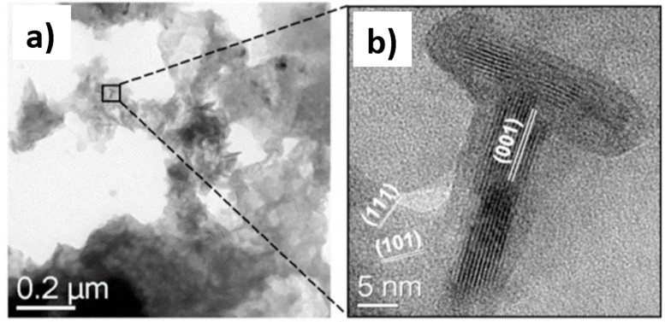

Note: image adapted from Burton et al., 2009.

While the presence of iron monosulfides is the defining geochemical property of MBO, other reduced inorganic sulfur species (including pyrite, elemental sulfur, and dissolved sulfide) can also be important components. Under prolonged reducing conditions iron monosulfides transform to pyrite, whereas elemental sulfur is an oxidation product of both iron monosulfides and dissolved sulfide. Therefore, the co-occurrence of these reduced sulfur fractions is common in MBO accumulations that experience fluctuating oxic and anoxic-reductive redox conditions. MBOs with high concentrations of dissolved sulfide are only usually observed in environments where there is limited iron availability (Ward et al., 2010a).

The physical properties of MBOs are highly variable, and the concentrations of their major components (that is sulfide, organic matter, metals and nutrients) vary widely. MBOs with similar visual appearance may have vastly differing geochemical properties. Blackness is usually a poor indicator of their monosulfide content and other geochemical properties. While iron monosulfides (particularly mackinawite) are a major contributor to the black appearance of MBO, it takes only a small amount of these highly effective black pigmentation agents to create the black colour of these materials.

Undisturbed MBO typically has a near neutral pH (that is pH 7–8), and the low redox potential required for its formation. The concentration of monosulfides in MBOs vary substantially both spatially (Figure 3.2a) across landscapes, and with depth (Figure 3.2b) in the sediment profile. Monosulfide concentrations often decrease with depth (Figure 3.2b), as it is converted into a more stable pyritic form with time.

Figure 3.2 Spatial distribution of AVS (%S) in the Richmond River catchment.

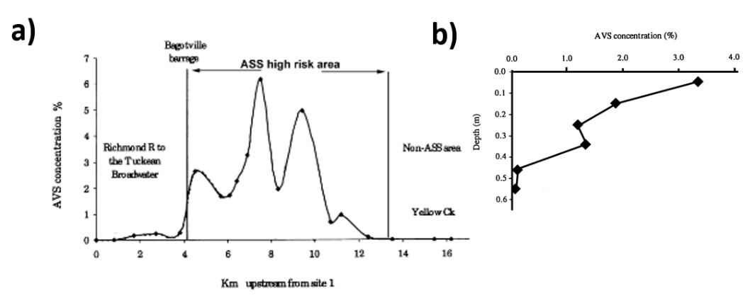

(a) surficial oozes and (b) variation in AVS (%S) with depth for drain oozes.

Source: Sullivan et al., 2002a.

While monosulfidic materials have the ability to favourably affect surrounding environments by immobilising potential metal pollutants (Simpson et al., 1998), a number of hazards are posed to waterways associated with their disturbance. The hazards may include deoxygenation, severe acidification, and the release of toxicants (for example heavy metals, metalloids such as arsenic, and high levels of nutrients) (refer to 3.4.2 for further details).

The variation in the physical and chemical properties of MBOs means the potential hazards may vary considerably. For example, laboratory experiments have clearly shown acidification is one of the major hazards associated with these materials (Figure 3.5), however, some materials with high acid neutralising capacities do not cause acidification when drained or disturbed. Further details on assessing the hazards of these materials are given in section 5.3.

### Extent

Iron monosulfides are found in low concentration in most sediments. These minerals are usually transient in nature and are readily oxidised or converted to a more stable form (that is pyrite). Iron monosulfide enriched sediments are commonly associated with ASS landscapes. Such enrichments have been attributed to retardation of the common pyrite formation process by numerous physicochemical factors including unusually high concentrations of Fe2+ in the sediment (see Kraal et al. (2013a) for further details of such processes).

Monosulfidic black oozes were initially identified in ASS landscapes in coastal areas of Australia (Sullivan and Bush, 2000, Sullivan et al., 2002a), and have since been found to be widespread in inland areas subject to sulfate salinisation (MDBA, 2011) and eutrophic waterways (Kraal et al., 2013a). MBOs have been observed in a variety of coastal and inland environmental settings including lakes, rivers, estuaries, drainage channels, tidal swamps, salt marshes and mine tailing dams.

The sources of sulfate contributing to the accumulation of MBOs can be a wide range of natural and artificial sources of salinity including tidal water, sea spray, fertilisers, and even sewage.

Significant deposits of MBOs, can be found in a variety of locations around Australia and internationally, notably include:

* floodgated drains in ASS landscapes, northern NSW (Sullivan and Bush, 2000, Sullivan et al., 2002a, Bush et al., 2004a),
* coastal waterways, Western Australia (Sullivan et al., 2006a, Ward et al., 2010a),
* inland freshwater waterways and wetlands in the Murray-Darling Basin (Sullivan et al., 2002b, Fitzpatrick and Shand, 2008, Ward et al., 2010b, MDBA, 2011, Cheetham et al., 2012), often when affected by salinity, and
* salt lakes in South Australia and Tasmania (EPHC & NRMMC, 2011).

The Atlas of Australian Acid Sulfate Soils provides information on the distribution and properties of ASS (including monosulfidic materials) across Australia and is available on the Australian Soil Resource Information System (ASRIS). While currently there is limited data in the atlas on the distribution of MBOs, at least 81 km2 of MBO has been observed and identified within the atlas (Fitzpatrick et al., 2008).

Case studies providing further details of the nature of MBOs found in many of these landscapes are presented in Appendix 1.

### Formation of MBO

#### How MBO forms

Iron monosulfides are the initial products formed in the reaction between sulfide and dissolved ferrous iron. Under reducing conditions in sediments, where there is an abundance of sulfate and an effective absence of O2, sulfate-reducing bacteria produce sulfide during the decomposition of organic matter. Ferrous iron (FeII) is also formed under reducing conditions in sediments from the reduction of iron minerals (such as goethite (αFeOOH) and schwertmannite (Fe8O8(OH)6(SO4)·nH2O) (Figure 3.3)). Iron monosulfides can form rapidly (that is in the order of days to weeks), and their presence is often a prerequisite for sedimentary pyrite formation.

The overall reaction for iron monosulfide formation can be written as (Smith and Melville, 2004):

Equation 3.1 Iron monosulfide formation.

$$4 FeOOH_{(s)}+4 {SO}_{4}^{ -2}+9 {CH}_{2}O + 8 H^{+}→4 FeS_{(s)}+ 9 {CO}_{2}+15 H_{2}O$$

The reaction above shows that the formation of monosulfides in acidic environments consumes some of the acidity (H+), and therefore, is considered to be able to improve water quality in such environments (Smith and Melville, 2004).

Figure 3.3 Conceptual model of in-situ iron transformations in accreting coastal ASS-associated drain sediments.

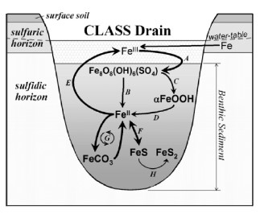

Note: Reactions D and F show iron pathway within Equation 3.1.

Source: Burton et al., 2006d.

#### Factors that promote the formation of MBO

MBO forms in environments where favourable conditions for iron monosulfide formation occur. The factors that promote monosulfide formation include:

* Supply of soluble sulfate
* Supply of easily decomposable organic matter for sulfate-reducing bacteria
* Anaerobic conditions as a consequence of inundation
* Adequate supply of iron (usually abundant in sediments)
* Either flushing to remove bicarbonate, or precipitation as an insoluble carbonate (Figure 3.3).

The factors that promote the formation of MBO are found in a wide range of coastal and inland environmental settings including lakes, rivers, estuaries, drainage channels, tidal swamps and salt marshes.

#### Factors that promote the accumulation of MBO

The factors that promote the accumulation of MBO include:

* High rates of supply of iron, sulfate and readily available organic matter,
* hydrology (including drainage, rainfall patterns and water allocation strategies) resulting in prolonged inundation and low-flow conditions in waterways,
* rheology (that is slow flow conditions in waterways that do not exceed the relatively low shear stresses that can lead to MBO mobilisation),
* location in waterway (including to lower energy parts of the channel and regions protected from high flow rates by channel obstructions),
* high nutrient environments resulting in the rapid formation of highly reducing conditions,
* physicochemical factors retarding the conversion of monosulfides to pyrite, and
* elevated temperatures.

### Hazards associated with MBOs

The hazards associated with MBOs can be divided into two distinct groups:

1. hazards associated with the formation and accumulation of MBOs (that is pre-mobilisation hazards), and
2. hazards that result from the mobilisation of MBOs as a consequence of disturbance (that is post-mobilisation hazards).

Potential pre- and post-mobilisation hazards associated with MBOs are discussed below.

#### Pre-mobilisation hazards

A number of pre-mobilisation hazards are associated with formation and accumulation of MBOs including nutrient cycling, reduced hydraulic functioning of the waterway, benthic environment modification and the emission of noxious gases.

* Accelerated nutrient cycling – The formation and accumulation of MBOs with high organic carbon contents may lead to accelerated nutrient cycling with the build-up of high nutrient concentrations in pore waters (Morgan et al., 2012). The release of these nutrients into the surrounding water column may result in an increase in biomass, including algal blooms.
* Altered hydraulic functioning of waterways – The accumulation of MBO, and the increase in aquatic vegetation often associated with their accumulation, can reduce flow in the waterways. This reduction in flow can further enhance MBO accumulation.
* Benthic environment modification – The formation and accumulation of thick layers of MBO can smother benthic communities within the waterways. This may lead to a change in the flora and fauna present and a decline in species diversity.
* Emission of noxious gases – An excess of labile carbon and stagnant water bodies create conditions that favour hydrogen sulfide (H2S) emissions in landscapes containing MBO. Hydrogen sulfide is a highly noxious gas that threatens aquatic organisms and may cause distress to humans. Other noxious gases that can emanate from these materials include volatile organic sulfur compounds (VOSC) and sulfur dioxide (SO2) (Hicks and Fitzpatrick, 2008).

#### Post-mobilisation hazards

MBOs are easily mobilised during runoff events by even moderate energy flows and can be distributed into rivers, or if flooding occurs, distributed over surrounding landscapes. In shallow waterways, waves caused by winds, and boat traffic can cause mobilization and suspension of MBO.

Initially these materials were shown to have the capability to cause severe deoxygenation, severe acidification of surface waters, or both (Sullivan et al., 2002a). Further research has since shown that the disturbance of MBOs can also result in the release of potentially toxic metals, metalloids (for example arsenic) and high levels of nutrients (Burton et al., 2006a, Sullivan et al., 2008): Kraal et al. 2013b).

##### Deoxygenation and acidification

The propensity for MBO to accumulate, and then be mobilised by floodwaters in waterways such as drainage channels, has been identified as a contributing factor to deoxygenation in ASS areas (Sullivan and Bush, 2000, Sullivan et al., 2002a). The chemistry of surface waters during hypoxic events has indicated elevated concentrations of redox sensitive chemical species associated with ASS (for example Fe2+, dissolved Mn, and elemental sulfur) (Wong et al., 2010), further implicating ASS and MBO materials in deoxygenation events.

The role of MBO in deoxygenation and latter acidification in ASS landscapes has only been considered in the past two decades (Sullivan and Bush, 2000, Sullivan et al., 2002a). Sullivan et al. (2002a) found the oxidation of MBO caused rapid deoxygenation and subsequent acidification of the overlying water when these materials were suspended in water (Figure 3.4 and Figure 3.5).

Figure 3.4 The effect of adding drain MBOs on the oxygen content of freshwater.

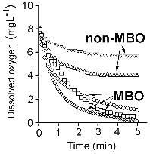

Source: Sullivan et al., 2002a.

Figure 3.5 The effect of adding different drain MBOs on the pH of freshwater.

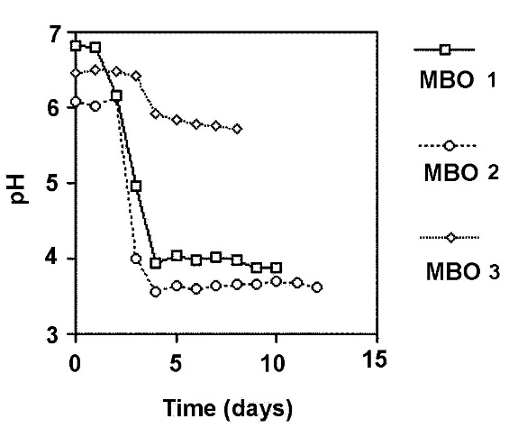

Note: MBOs 1 and 2 both had appreciable monosulfide contents whereas MBO 3 had minor monosulfide concentration.

Source: Sullivan et al., 2002a.

The oxidation dynamics of MBO when mobilised into oxygenated water have been described by Burton et al. (2006a). A summary of the changes in pH and sulfur speciation (including pyrite (FeS2), iron monosulfide (FeS), elemental sulfur (S80) and sulfate (SO42-)) during MBO oxidation is shown in Figure 3.6.

Figure 3.6 Changes to the sulfur speciation and pH during oxidation of MBO.

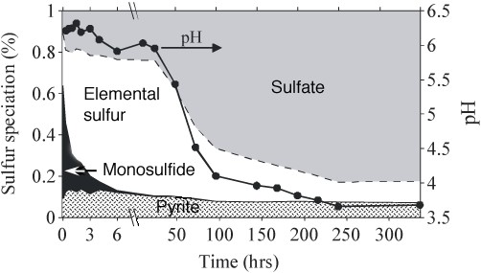

Source: Burton et al., 2006a.

The complete oxidation of MBO follows a two-step process with oxygen consumption occurring with each step (after Burton et al., 2006a):

Equation 3.2 Oxidation of MBO – Step 1.

$FeS\left\{\begin{aligned}{Fe}^{2+}+0.25 O_{2}+1.5 H_{2}O→2 H^{+}+FeOOH \\ S^{2-}+0.5 O_{2}+2 H^{+}→H_{2}O+0.125 S_{8}\end{aligned}\right.$

Equation 3.3 Oxidation of MBO – Step 2.

$0.125 S_{8}+1.5 O_{2}+H_{2}O→{SO}_{4}^{ -2}+ 2 H^{+}$

The first step is a rapid chemical reaction of iron monosulfide minerals with oxygen, forming iron oxides and elemental sulfur. This initial oxygen-consuming step does not affect pH and is therefore non-acidifying. It is probably for this reason that the role of MBO in deoxygenation was overlooked until recently. The second acidifying step occurs after a few days. It requires an accumulation of sulfur-oxidising microbes for oxidation of the elemental sulfur produced in the first step. The oxidation of elemental sulfur is responsible for the acidification associated with MBO oxidation (Figure 3.6).

Elevated elemental sulfur concentrations in the waters of deoxygenated waterways in ASS landscapes may be a useful indicator that MBOs have been a contributing cause to deoxygenation. However, care needs to be taken in making such interpretations as elemental sulfur can also form as a primary product of H2S oxidation, and may be present within MBOs prior to flood events (Burton et al., 2006b, Burton et al., 2006c, Ward et al., 2010a).

While the oxidation of iron monosulfides and elemental sulfur both consume oxygen, the organic matter in MBO may contribute towards the deoxygenation of waterways. Floodplain vegetation is also known to contribute towards deoxygenation (Eyre et al., 2006) in landscapes where MBO have been observed.

The potential ecological impacts of deoxygenation and acidification in waterways of acid sulfate soil containing landscapes have been well documented and include fish kills, loss of native aquatic macrophytes and fauna followed by invasion by acid tolerant species, mass mortality of crustaceans and shell fish, and loss of benthic communities. However, deoxygenation and/or acidification does not always occur following the disturbance of MBOs (Morgan et al., 2010). Their occurrence depends on various factors including a) the volume and characteristics of the MBO mobilised (for example concentration of monosulfides, buffering capacity), and b) the volume and characteristics of the receiving waters (for example buffering capacity).

##### Release of contaminants

In addition to deoxygenation and acidification, MBO disturbance and oxidation can potentially result in the rapid release of toxic concentrations of associated metals to surrounding surface waters (Burton et al., 2006a, Sullivan et al., 2008). Monosulfides are an important sink for trace metals, accumulating by co-precipitation with sulfides, through sorption, or both. Burton et al. (2006a) demonstrated a rapid release of metals (including aluminium, manganese, nickel and zinc) to the water column on oxidation and acidification due to the highly reactive nature of the iron sulfides. This process can result in metal concentrations far exceeding the Australian and New Zealand Environment Conservation Council (ANZECC/ARMCANZ 2000) water quality trigger values, even where total metal concentrations in an MBO are below the sediment threshold guidelines. Metal mobilisation can also occur following the inundation of dried MBO materials, resulting in high to extremely high concentrations of various metal(loid)s (including aluminium, arsenic, cadmium chromium cobalt copper, manganese, nickel and silver) (Sullivan et al., 2008).

The release of elevated concentrations of nutrients (including ammonia, nitrate and phosphate) to the water column has been clearly shown following the disturbance or inundation of MBOs (Sullivan et al., 2008, Morgan et al., 2012). The formation of phosphorus scavenging iron (hydr)oxides by iron monosulfide oxidation strongly limits the dissolved phosphate concentrations in surface waters (Morgan et al., 2012).

##### Smothering

While the accumulation of thick layers of MBO can smother benthic communities, this may also occur following deposition of MBOs following flood events. Field observations have indicated a significant amount of MBO can be eroded and redistributed by mass movement during a flood event (Bush et al., 2004b). Recent research has also suggested large volumes of monosulfidic sediments may be suspended in the water column, partially-oxidised and then redeposited further downstream (Cheetham et al., 2012).

### Factors to consider for the dredging and disposal of MBOs

In well-flushed open waters, the risks posed by disposal of sediments classified as containing MBOs may be relatively small. However, many freshwater and marine sediments naturally contain sufficient quantities of sulfuric, sulfidic and monosulfidic materials to pose a risk to the environment during dredging and disposal within confined waterways, or following placement on land.

The National Assessment Guidelines for Dredging (NAGD) 2009 (Commonwealth Government, 2009) primarily focuses on contaminant impacts. Due to the extensive scale of the open marine environment, many of the risks associated with the disposal of sulfidic sediments are considered negligible. The volume and pH buffering capacity provided by seawater makes changes in acidity unlikely due to dumping of sulfidic sediments. Similarly, in large well-mixed water volumes, deoxygenation of the water column through dumping MBOs and other monosulfidic materials is unlikely to be significant. The NAGD (Commonwealth Government, 2009) does not provide guidance on best-practice for disposal of dredged materials that contain significant amounts of sulfidic materials, either within waterways or on land.

The environmental issues for ASS dredge material will vary depending largely on whether the material will be disposed to land, or returned to another location within the waterbody. In general for both strategies, the risks are lower for onshore disposal, as the problem soils are more accessible to management and remediation.

For ASS disposal back to the water body, the release of nutrients into the water column, leading to excessive algal growth, can be a moderate risk depending on factors including the nature of the ASS dredge material and the nature of the receiving water body (such as size, rate of flushing, water temperature and water quality). This is because elevated concentrations of nutrients (notably NH4+) and iron in the water column can be generated from disturbed ASS sediments at a very localised scale (within 100 m of spoil placement).

The more direct risks of placing dredge material back to the waterbody include the smothering of seagrass and alteration of benthic habitat. It is possible that some seagrass will be present and productive on the spoil bank area during the dredging program in near shore coastal settings. Seagrass areas of deposition may be affected if the sediment layer is greater than approximately 5 cm thick (deeper than petiole length). Impacts on seagrass are not expected when dredging outside the main growing season. The capacity of the substrate to support seagrass is expected to return within days to weeks, in time for the re-establishment of seagrass meadows the following summer.

Investigations of maintenance dredging of ASS and legacy environmental impacts have become well documented. Examples include the maintenance dredging of sediments within the Peel Region for the Western Australian government authorities (Sullivan et al., 2006a). In general, the materials routinely dredged in this location are black oozes to a depth of at least 30 cm (the depth of sampling). They have low trace metal concentrations, yet high inorganic sulfur contents (Chromium Reducible Sulfur (CRS) concentration of 1.6% S and acid volatile sulfide (AVS) 0.6% S). The metal sulfide contents of these materials exceed their inherent acid neutralising capacity (ANC), with a propensity to generate an excess of up to 400 mol H+/t (equivalent to a reduced concentration of 0.54% S). This explains why these sediments have developed into extreme examples of ASS where they have been disposed of on the shoreline and used for land reclamation. The sediments are dominated by fine silt and clay particles (less than 63 µm).

Morgan et al. (2012) measured nitrogen (as total nitrogen) and total phosphorus mean concentrations within the black muds at approximately 8540 mg/kg and approximately 735 mg/kg, respectively. Acidification and mobilisation of aluminium and iron when disposed to land are the major environmental issues reported in the Peel Estuary. The potential influence of nutrient and iron release on aquatic production and acute algae blooms has also been considered. The sediments at both the disposal site and collected in the channel are confirmed as potential ASS (PASS). Acidity, both inorganic and organic forms, were detected across the site with inorganic (that is pyritic acidic) being the dominant form.

Although laboratory analysis may often show a significant amount of ANC in sediments, much of it found in PASS exists as shell fragments. Shell grit material is generally an inefficient neutralise agent, and therefore, lime treatment of the material in the case of the Peel-Harvey Estuary is now considered necessary to safeguard against acidification where the sediment is disturbed and is to be placed in an oxidising environment for the long-term.

Case Study 2 (section A1.2 Dredge spoil (mainly MBO) containment dump: Peel region, Western Australia) in Appendix A describes the acidification of a dredge spoil dump resulting from the deposition of MBOs in the Peel region of south-west Western Australia.

The national guidelines for the dredging of acid sulfate soil sediments and associated dredge spoil management (Simpson et al. 2018) provides further details on sampling and management of MBOs in relation to dredging activities.

## Discussion on policy and regulatory environment

It is understandable given the relatively recent identification of monosulfidic black oozes (MBOs) and the hazards they present and the relative lack of proven management options available for the management of MBOs in waterways and wetlands, that there is at present very little policy and regulation that directly address MBOs and their management. While several guidelines mention MBOs and their potential environmental hazards, the management of these materials has only been briefly referred to.

Each of the states and territories have a range of legislation (Acts) that require consideration when assessing and providing approval consents for activities that involve disturbance of the landscape. These regulations, of course, need to be considered and adhered to in project planning and implementation.

Project proposals (and their consent) will also need to consider any local plans and systems, such as Catchment Management Plans/Strategies and Coastal Management Plans, Resource Management and Planning System (RMPS), and guidance specific to ASS management), and water, sediment and soils quality (ANZECC/ARMCANZ, 2000; NEPM, 2013).

## Discussion on current management practices and approaches

### Policy and guidelines

As mentioned in the previous section, currently in Australia there are no policies that deal directly with the accumulation and management of monosulfidic black oozes (MBOs) in waterways. A brief description follows on the main points on MBO management practices and approaches from these guidelines. More information on current MBO management approaches is found in Section 5.4.

#### Minimisation of organic material accumulation

One of the key determinants of MBO formation and accumulation is the build-up of organic materials. The decomposition of organic matter drives the sulfidisation cycle leading to the formation of MBOs under anaerobic conditions. Thus any practice or strategy that minimises the production or accumulation of organic materials within waterways will also minimise the formation and accumulation of MBOs.

Monosulfidic black oozes can form from organic materials produced within the waterways at or close to the site of formation, for example, from rotting debris derived from water plants. Alternatively the organic matter may have formed remotely from the site of MBO formation and been transported by wind or water to the site.

Tulau (2007) assessed the effect of flushing freshwater drains with saline tidal waters through floodgate opening techniques. The conclusion was that these weed control and water improvement strategies produced only transient benefits as the consequent death of this vegetation would initially enhance MBO formation and accumulation.

On the other hand, the hydrological and geochemical results of a field trial by Johnston et al. (2003) led them to consider that tidal flushing through open floodgates could reduce MBO accumulation by: reducing concentrations of iron and sulfate in the drain water; helping to aerate the sediments in the base of drains, and; enhancing in-drain flow velocities. Further research is clearly required to determine the optimum management approaches necessary to minimize MBO accumulation when the intrusion of saline tidal waters are used to manage/remediate waterways such as formerly freshwater drains behind floodgates.

#### Establishing flow rates that minimise accumulation of MBOs

MBOs tend to accumulate in areas where flow conditions are minimal, for example, behind floodgates and barrages, in lakes, wetlands and in rivers that experience long periods of minimal velocity flows due to tides or floodwaters (that is at least several months). MBOs are easily mobilised and become entrained in even low flow conditions such as in estuaries experiencing even low to moderate tidal flows.

As MBOs tend not to accumulate in areas where there is appreciable flow rates, flushing of waterways by erosive flows of water can remove accumulated MBOs. If this management practice is used to prevent the accumulation of MBOs then care should be taken not to allow the accumulation of MBO build up to the extent that it could pose an environmental hazard to the waters receiving the MBOs post mobilisation.

#### Waterway in-filling

In-filling of waterways basically removes the conditions that allow the formation and accumulation of MBOs. Of course, this practice also removes the functioning of these waterways, be they hydraulic or ecological, and this practice is best suited to conditions where the services provided by the waterway to be in-filled, are minimal. An example of such a situation is drains that are excess to requirements (for example drains within over-drained landscapes).

#### Waterway and wetland wet/dry cycling

In managed waterways and wetlands the use of regular wetting and drying cycles can prevent the accumulation of MBOs. Monosulfides are quickly decomposed by desiccation (Bush and Sullivan, 1997) and drying cycles cause removal of MBOs from waterways (see Case Study 4. A1.4 Inland river: Talbragar River, central New South Wales). It follows that regular drying can be used for waterways and wetlands prone to MBO formation to oxidise MBOs accumulations that have accumulated during prolonged wetting times.

### Assessment of MBO accumulations

#### Identification of MBOs

An initial field assessment of sediments may give an indication whether MBOs are present at a site. Unoxidised MBOs typically have a near neutral pH (pH 7–8), together with high organic matter contents and low redox potentials. MBOs also usually have a distinct strong black colour, gel consistence and sometimes an oily appearance (Figure 5.1); some MBOs are dark grey in colour. A rotten egg odour from the reduction of sulfate to hydrogen sulfide (H2S) may also further indicate the presence of MBOs; H2S can be detected by its odour at very low concentrations. However, the defining characteristic of a MBO is enrichment in acid volatile sulfur. Field screening tests for acid volatile sulfur content exist ranging from simply adding concentrated acid to the sediment and assessing whether H2S gas is evolved through to more sophisticated methods (Simpson 2001), but the quantification of acid volatile sulfur and hence identification of MBO must be confirmed by an appropriate laboratory analysis (see Section 5.2.4).

Figure 5.1 Black oily appearance of MBO gel collected from the Peel region, Western Australia.

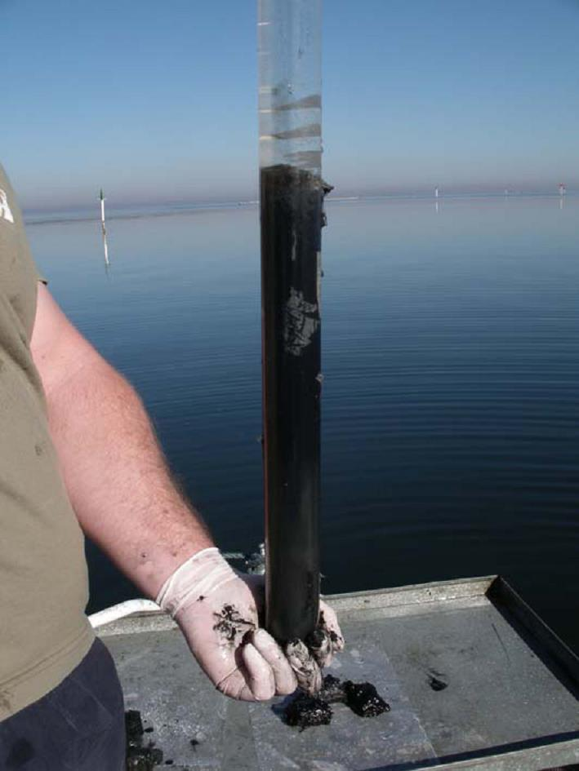 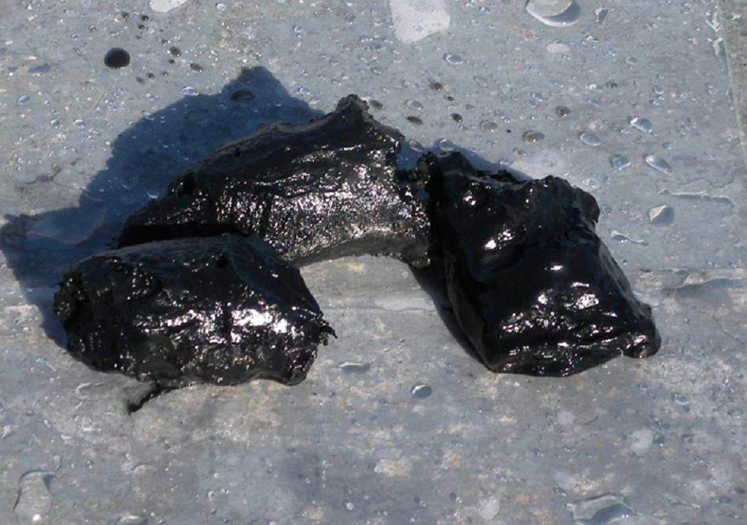

Source: Sullivan et al., 2006a.

The environmental setting of the sediments may also indicate the likelihood of the presence of MBOs. MBO accumulate in large quantities in locations with the appropriate conditions for their formation including waterways affected by one or a combination of acid sulfate soils (ASS), eutrophication or salinisation. These sites are usually dominated by low velocity flow conditions where there is an abundant supply of organic matter, iron and sulfate. Research by Wong et al. (2016) indicates accumulation of sulfidic materials (including monosulfidic materials) occurs preferentially downstream of channel obstructions, such as submerged logs or in scour pools. Interestingly, and for reasons not yet apparent, the accumulation of these sediments is not only limited to lower energy parts of the channel, as would be expected for fine-grained organic sediments.

#### Sampling techniques suitable for MBOs

A variety of sampling techniques are available for the collection of MBOs, depending on the amount of surface water present. Spades, soil augers, or both, are suitable where there is little surface water present. Intact MBO cores are best collected using polypropylene push-tube coring devices (Figure 5.2). Stainless steel push-tube coring devices are essential when testing for organics (such as pesticides, polynuclear aromatic hydrocarbons (PAHs), and total petroleum hydrocarbons (TPH)). The amount of sample required varies, depending on the number of analyses being undertaken and the sample moisture content. A minimum internal diameter of 5 cm should provide sufficient sample for replicate analysis. To prevent sediment loss during sampling, corers should be capped prior to extracting MBOs from shallow waterbodies; a water outlet at the top of the corer is recommended when collecting MBOs from deeper waterbodies (Figure 5.2). Compression of the sediment core can occur with push-tube coring devices. This can be reduced by using corers with sharpened edges (with the internal core edge as the cutting edge) and larger internal diameters.

Figure 5.2 Sampling MBOs using a sediment coring device.

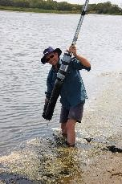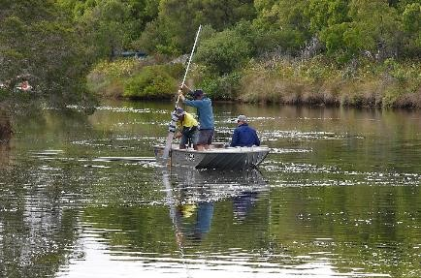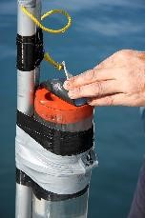

Note: Left and middle image of the coring device and right image of the water outlet at the top of the device.

Alternatively, sediment grab samplers can be used to collect representative surface sediments where surface waters are present (for example Eckman, Ponar and Van Veen grab samplers) (Figure 5.3). However, care needs to be taken when using grab samplers, as fine grained sediment is easily lost with this type of device.

As previously mentioned, the amount of MBO required for laboratory analysis depends on the number of physical/chemical properties measured and the sample moisture content. Table 5.1 gives the recommended amount of MBO required for various laboratory analyses. For MBOs with higher moisture contents greater masses may be required. Refer to the Analysis of MBOs section (Section 5.2.4) for further details of laboratory techniques.

Further guidance on the sampling of sediments can be found in AS/NZS 5667.12:1999 Guidance on sampling of bottom sediments (AS/NZS, 1999) and Simpson and Batley (2016). Guidance on sampling methods for dredge materials, and the amount of sample required for additional analyses, is given in the NAGD (Commonwealth Government, 2009).

Figure 5.3 Sampling MBOs using a Van Veen grab sampler.

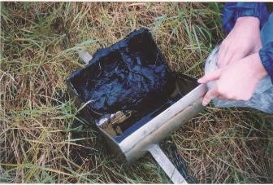

Source: D.M. Fyfe.

Table 5.1 Recommended amount of MBO required for various analyses.

|  |  |
| --- | --- |
| Analytical Parameter | Amount of MBO required (g, wet weight) 1 |
| Moisture content | 10–50 |
| Reduced inorganic sulfur (AVS, CRS, ES) 2 | 10–50 |
| Particle size analysis | 50–100 |
| Total organic carbon (TOC) | 10–50 |
| Metals/metalloids | 10–50 |
| Nutrients (for example NH4+, NO3-, PO43-) | 50–100 |
| Water extractable ions (for example SO42-, Cl-) | 50–100 |
| Elutriate testing (metals) | 200 3 |
| Organic compounds | 100 |
| Pore water analysis | 200 |

Note: adapted from Commonwealth Government, 2009).

1 For MBOs with higher than normal moisture contents, greater masses may be required.

2 The reduced inorganic sulfur species can be analysed sequentially.

3 Up to 1 litre of sediment may be required, plus four times the volume of seawater, from the disposal site (Commonwealth Government, 2009).

Appropriate Quality Assurance and Quality Control (QA/QC) procedures need to be followed when sampling MBOs. For example, sampling devices must be thoroughly cleaned between samples to avoid cross-contamination, and samples should be frozen as soon as possible following sampling (see Section 5.2.3). Health and safety considerations are also extremely important when conducting field MBO assessments. Ensure skin and eye contact with MBOs is avoided by wearing appropriate protective clothing and equipment (such as gloves, safety glasses and gumboots).

The properties of MBOs can vary markedly at even small spatial scales, so care should be exercised to ensure the sampling strategy is sufficient to ensure representative samples are gained from the area of interest.

#### Sample preservation techniques for MBOs

MBOs require special preservation and handling techniques to limit the oxidation of monosulfides. Monosulfides are highly reactive and rapidly oxidise (within minutes) at room temperature when exposed to the atmosphere.

A variety of sample preparation techniques can be used to reduce the potential for oxidation. Ideally, samples suspected of containing monosulfides should be immediately frozen on sampling. Samples can be frozen rapidly in the field by using either dry ice or liquid nitrogen; ensure appropriate health and safety procedures are followed if using either of these substances.

Alternatively, place MBO samples into screw-top plastic containers (for example 50 mL centrifuge tubes) with no headspace or into plastic bags with the air removed and place on ice. If storing MBO samples in plastic bags, double bagging is recommended to minimise the potential exposure to air. In addition, purging the storage containers with nitrogen will also minimise the potential for monosulfide oxidation.

Experience indicates that freeze drying of samples does not preserve monosulfides and this analysis pre-treatment should be avoided for MBOs.

#### Analysis of MBOs

The analysis of MBOs must be undertaken as soon as possible after sampling to minimise the potential for oxidation. MBOs have been observed to slowly oxidise even when stored in a frozen state. Instruct the laboratory to remove any brown oxidised material on the outside of the sample prior to analysis. All analyses should be carried out on wet MBO samples as oven drying will oxidise the monosulfides present. The moisture content must be measured, so results can be presented on an oven-dry weight basis.

A defining characteristic of a MBO is that it is enriched in monosulfides, and therefore the visual identification of MBO in the field must be regarded as only indicative: definitive identification of monosulfides requires laboratory analysis.

Iron monosulfides have been quantified operationally by their dissolution in concentrated hydrochloric acid (HCl) to yield hydrogen sulfide (H2S) gas: the sulfur in the evolved H2S gas is described as acid volatile sulfide (AVS). While measurement of the AVS fraction largely measures the iron monosulfide fraction, it is important to note it can also include considerable contributions of other sulfur species (for example H2S) in the quantification (Rickard and Morse, 2005, Ward et al. 2010a)

Determination of the monosulfide content of an MBO can be accomplished by use of the AVS procedure outlined in the National Acid Sulfate Soils Identification and Laboratory Methods Manual.

MBOs also often contain high concentrations of pyrite; more than 10% pyritic sulfur has been observed in some MBOs. The pyrite concentration should be determined using the chromium reducible sulfur (CRS) procedure (see the National Acid Sulfate Soils Identification and Laboratory Methods Manual for more details on analytical procedures).

The potential acidification hazard (that is net acidity) of the MBO can also be determined using the Acid Base Accounting approach (see the National Acid Sulfate Soils Identification and Laboratory Methods Manual (Sullivan et al., 2018) for more details on analytical procedures).

Other physical and chemical properties commonly analysed when assessing the properties of MBOs include:

* particle size analysis,
* total organic carbon (TOC),
* metal/metalloid content (for example 1M HCl extractable),
* nutrient content (for example ammonia, nitrate, phosphate),
* water extractable ions (for example sulfate, chloride),
* disulfide content, and
* elemental sulfur content.

The analysis of pore water concentrations in the MBO may also provide useful additional data. For example, a comparison of nutrient concentrations in the MBO pore waters to national water quality guidelines will give an indication of the potential hazard of MBOs to affect the properties of overlying waterways and waterbodies.

Elutriate testing can be performed to estimate the release of contaminants (for example metals, nutrients, organics) during the dredging or sea disposal of MBOs. Elutriate tests investigate desorption of contaminants from sediment particulates to waters and are used to simulate the maximum contaminant release (Commonwealth Government, 2009). The NAGD (Commonwealth Government, 2009) provides details of the elutriate test procedure.

#### Assessment of MBO accumulation in waterway

An assessment of the accumulation of MBO in a waterway and the hazards that the MBO poses requires an understanding of many of the following factors according to the particulars of the situation:

1. Areal extent of MBO
2. Depth and volume of MBO
3. Location of MBO within the waterway
4. Properties of the MBO including:
   1. Acid volatile sulfide (AVS) concentration
   2. Chromium reducible sulfur (CRS) concentration
   3. Metal and metalloid content
   4. Nutrient content
   5. Organic matter content
   6. Texture or particle size analysis.

The first step in undertaking an assessment of the accumulation of MBO in a waterway is to carry out a field investigation to gain an understanding of the spatial extent and depth of the MBO. While MBO is often found in distinct sediment layers (Figure 5.4), the depth as well as the properties of these materials can vary substantially over short distances within a waterway (Figure 5.5).

The sampling density needs to be sufficient to gain a good understanding of the distribution of MBO within the assessed waterway (more information on sampling needs can be found in the “Guidance for the Dredging of Acid Sulfate Soil Sediments and Associated Dredge Spoil Management” (Simpson, et al. 2017).

Waterways where the MBO is distributed relatively uniformly require a lower sampling density than waterways where there is an irregular distribution of MBOs. As well as providing a clear understanding of the spatial distribution of MBOs in a waterway, determining the areal extent and depth of the MBO will allow an estimation of the volume of MBO contained in the waterway.

The location of the MBO within the waterway should also be assessed as this can give an indication to how susceptible the MBO is to formation and accumulation, as well as to mobilisation. MBO in lower energy parts of the channel and those protected by channel obstructions and vegetation are usually less prone to mobilisation.

The other properties that may need to be documented when undertaking an assessment of MBOs in a waterway include the sulfide concentrations (AVS and CRS concentrations), contaminant contents (for example metals, metalloids, nutrients), organic matter content and texture (or particle size). The chemical properties can be used to assess the hazards that the accumulated MBO pose to the environment (these are discussed in detail later in this guidance).

The location of the MBO accumulations within the waterway, the water content and the texture (or particle size) can indicate the susceptibility of the MBO to disturbance and mobilisation. For example, ultra-fine grained MBO accumulations with very high moisture contents are usually more readily mobilised than MBO accumulations with coarser textures and lower moisture contents.

Figure 5.4 Core sample collected in the Vasse Estuary, Western Australia.

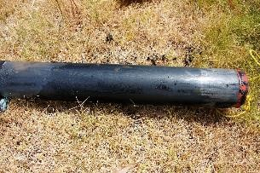

Note: A sharp black ooze/grey calcareous medium sand boundary at a depth of approximately 40 cm.

Source: Ward et al., 2009.

Figure 5.5 Sediment profiles showing variation in MBO thickness within waterways in the South Yunderup region, Western Australia.

 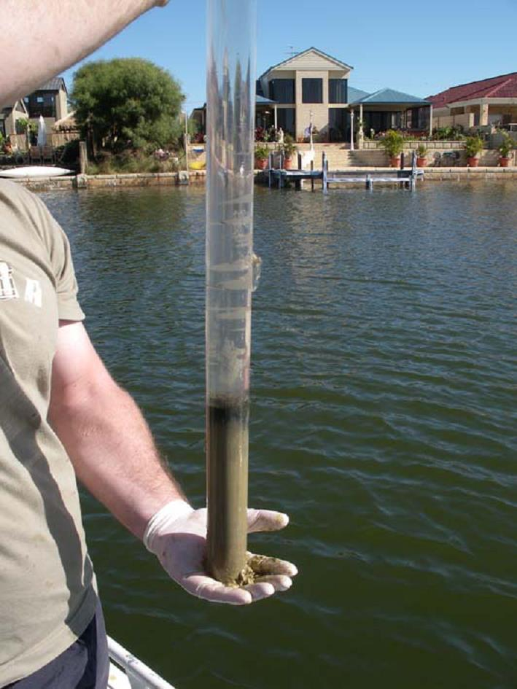

Note: The sediment profiles show variation in MBO thickness within waterways.

Source: Sullivan et al., 2006a.

#### Assessment of monosulfidic formation potential in inland areas

Studies have suggested that an inland water body with a sulfate concentration greater than 10 mg/L gives a strong indication that the soil materials underlying the water body is able to sulfidise, forming monosulfidic, sulfidic or both sediment types (Sullivan et al., 2002b, MDBA, 2010). Consequently, the availability of sulfate (as extracted from dry sediments) has been used to identify whether there is a potential for monosulfidic sediments to form in inland areas of Australia (MDBA, 2010). To create similar sulfate concentrations in overlying water bodies through inundation, a water extractable sulfate content of equal to or greater than 100 mg/L in a 1:5 soil:water extract, of dry surface soil layers, would be required (MDBA, 2010). The surface soil layers are considered to be the top 20 cm of the soil profile.

It is important to note, in addition to the presence of sulfate, other suitable conditions are also necessary for monosulfide formation (that is strongly reducing conditions arising from prolonged inundation, a supply of both iron and readily available organic matter).

A laboratory method is available to assess the potential for monosulfides to form. This method is known as the Monosulfidic Formation Potential Method (see MDBA (2010) for further details). In this method the monosulfide formation potential of a soil/sediment is assessed using a soil mesocosm approach. The soil/sediment is inundated with water containing an organic substrate (for example sucrose) to simulate the supply of organics associated with floodplain inundation. The surface water and solid phases are characterised after 7 weeks of inundation. The formation of monosulfides following this approach gives an indication to whether these minerals would form at a site under prolonged inundation.

### Assessment of hazard posed by MBO accumulations

The information obtained from the MBO accumulation assessment (Section 5.2) can be used to assess the potential hazard from MBO accumulation. The magnitude of the hazard posed by MBO accumulations will depend on the interaction between two components including: (i) the physical and chemical properties of the MBO, and (ii) the properties of receiving waters.

#### Properties of MBOs

The potential hazards associated with MBOs can be assessed separately, according to their potential to cause:

* Deoxygenation,
* Acidification,
* release of contaminants, and
* smothering.

The potential hazard of rapid deoxygenation can be assessed from the monosulfide content of the MBO and the volume of the MBO accumulation. Every mole of FeS can deoxygenate 2.25 moles of dissolved O2 from a waterbody (Equation 3.2 and Equation 3.3). The first 0.75 moles of dissolved O2 is removed rapidly (within minutes) due to purely chemical reactions (Equation 3.2). The chemical oxidation of iron monosulfides is the major contributor to rapid deoxygenation associated with MBOs. The higher the monosulfide content and the greater the volume of MBO, then the greater the potential deoxygenation hazard the MBO poses on disturbance.

As an example of the deoxygenation potential of MBO, based on the chemistry above, an accumulation of 1,000 m3 of MBO with an AVS content of 5% and bulk density of 0.1 tm-3, is capable of within an hour deoxygenating approximately 625,000 m3 of well-aerated water (8 mg O2. L-1) and in a few days of deoxygenating over 1,400,000 m3 of well-aerated water (8 mg O2. L-1).

Further deoxygenation may also occur from the breakdown of organic matter associated with the MBO, and from the biologically mediated oxidation of the elemental sulfur produced in the initial oxidation step (Equation 3.3), although these two processes are much slower than the initial MBO oxidation step, taking days.

The potential hazard of acidification associated with MBOs is primarily associated with the sulfidic acidity produced from the rapid oxidation of monosulfides and the slower oxidation of pyrite; MBOs often have a near-neutral pH and, therefore, usually no existing acidity. Some acidity may also be produced from the oxidation of other reduced species (that is elemental sulfur) and the hydrolysis of ferric iron often contained within MBO accumulations. The potential acidification hazard (that is net acidity) of the MBO can be determined using the Acid Base Accounting approach (see the National Acid Sulfate Soils Identification and Laboratory Methods Manual for more details on analytical procedures).

MBO accumulations, particularly those found in Western Australia, often have a considerable acid neutralising capacity that can offset the acidity produced from oxidation of the sulfides in MBOs, but this self-neutralising capacity is not uniform and assessment is required to confirm this behaviour.

The potential hazard associated with the release of contaminants (including heavy metals, metalloids and nutrients) can be assessed for many substances by comparing the concentrations measured against the relevant guidelines (ANZECC/ARMCANZ, 2000, Commonwealth Government, 2009, NEPC, 2013). All sediment analysis results should initially be compared to the Sediment Quality Guidelines Values (SQGVs) (ANZECC/ARMCANZ, 2000: Simpson et al 2013). SQGVs are available for a number of common metals and metalloids, as well as for organometallic contaminants and organics.

While there is no sediment quality guideline for nutrient concentrations, the concentrations can be compared to background levels and the pore water concentrations may also be compared to the water quality guidelines (ANZECC/ARMCANZ, 2000). Guidelines exist for porewater anoxia in marine but not freshwater sediments (Batley and Simpson, 2009).

For the disposal of MBOs onto land the concentrations need to be compared to the National Environment Protection (Assessment of Site Contamination) Measure (NEPM) Limits (that is Ecological Investigation/Screening Limits (EIL/ESL), Health Investigation Limits (HIL)) (NEPC, 2013). For dredged materials, the elutriate results may also need to be compared against the ANZECC water quality guidelines (ANZECC/ARMCANZ, 2000); elutriate testing is required for dredged materials where the levels exceed the Screening Level (Commonwealth Government, 2009).

Although the comparison of AVS concentration with the concentration of simultaneously extracted metal (SEM = ΣCd, Cu, Ni, Pb and Zn) is a useful indicator of the bioavailability of metals in sediments, given that these metals are released into the water column following mobilisation of MBOs, the AVS:SEM ratio technique is considered of limited use in the assessment of the hazard posed by MBO accumulations.

The potential hazard for smothering as a consequence of MBO disturbance is currently unknown, although this problem has been observed during flooding events (Bush et al., 2004b). The controls on monosulfidic sediment mobilisation and the critical thresholds for its scour and entrainment have not been established (Cheetham et al., 2012), and further information is required to assess the potential of MBO accumulations to degrade waterway environments by smothering.

#### Properties of receiving waters

The potential hazard that MBOs pose to waterways not only depends on the nature of the MBOs themselves, but also on the receiving waterbodies that the MBOs may be dispersed into upon disturbance. This is true regardless of whether the hazard is a deoxygenation, acidification or other contamination hazard. Tulau (2007) provides a detailed description of how receiving waters affect the impacts of inputs from ASS.

The three main factors that determine the receiving waters’ ability to counter the hazards posed by MBO mobilisation are:

1. **The volume of the waterbody receiving the MBOs.** Clearly, the larger the volume of the waterbody receiving the MBOs, the greater the ability of the waterbody to dilute any impacts arising from the mobilisation of MBOs.
2. **The exchange or replenishment of the waters in the waterbody.** Similarly, the greater the replenishment of the waters in the waterbody, whether the exchange be due to regular tidal exchange or to inflows and outflows of water by other means, the greater the dilution and reduction in impacts from MBOs dispersed into the waterbody.
3. **The resilience of waters in the waterbody.** The ability of receiving waters to resist or absorb changes to their properties caused by MBOs will vary greatly for some hazards (for example acidification and deoxygenation) and by much less for other hazards (for example nutrient contamination). For example, deoxygenation of receiving waters already depleted in dissolved oxygen will be far more susceptible to deoxygenation than well oxygenated waters. Similarly, receiving waters that have considerable acid buffering capacity, such as those with considerable inputs of seawater from estuaries, will generally be able to resist acidification arising from MBO oxidation. Receiving waters further away from estuaries with a greater freshwater input will generally have lower buffering capacity due to lower bicarbonate (HCO3-) contents.

### Management strategies

The key issues in the management of MBOs are to minimise the current and future rates of accumulation of MBOs and to managing existing MBO accumulations (Tulau, 2007). The following sections examine the strategies used to minimise the accumulation of MBOs (Section 5.4.1), and the options available for the removal and disposal of MBO accumulations (Section 5.4.2).

#### Strategies to minimise accumulation of MBOs

The accumulation of MBOs in waterways can be minimised by following one or more of four potential management strategies:

1. Maintain erosive flow rates (floodgate control, channel design).
2. Minimise organic matter accumulation.
3. Maintain regular wetting and drying cycles (in managed waterways and wetlands).
4. Minimisation of sources of sulfate.

The maintenance of erosive flow rates through either floodgate control, channel design, or both, can limit the accumulation of MBOs through regular scouring before they accumulate into volumes that pose a hazard. MBOs accumulate in sites usually dominated by low velocity flow conditions often in areas physically protected by natural channel obstructions, or behind floodgates, barrages and weirs.

Large volumes of MBO sediment can be mobilised and redeposited downstream, especially during floods (Bush et al., 2004b, Cheetham et al., 2012). However, the controls on monosulfidic sediment mobilisation and the critical thresholds for its scour and entrainment have not been established (Cheetham et al., 2012).

##### Minimisation of organic matter accumulation

The presence of aquatic vegetation in waterways is an important factor in maintaining the health and functioning of our rivers, streams and lakes. However, changed hydrological situations caused by interventions such as floodgates, canal developments, can lead to changes in both the nature and quantity of aquatic vegetation. These changes especially when the lead to a proliferation of aquatic weeds may also lead to over-accumulation of organic detritus and often as a result, the formation of MBOs.

The formation of MBO is made possible by the presence of readily decomposable organic materials so any strategy that minimises an over-abundant accumulation of organic matter should also minimise the accumulation of MBOs. Aquatic vegetation can be physically removed from waterbodies by using devices such as reed buckets (see Figure 5.6); however such mechanical disturbance has also been shown to disturb existing MBO accumulations causing water quality degradation during clearing.

In addition to providing a source of organic matter, a proliferation of aquatic weeds can also reduce the water flow within the channel. This reduction in flow can increase the rate of MBO accumulation by producing conditions that favour their formation and reduce their removal by hydraulic scouring.

Floodgate opening and the inflow of salt water into drainage channels can help control many aquatic weeds, although the vegetation response may depend on the species and salt concentrations of ingress water (Johnston et al., 2003). The build-up of organic matter within waterways can be minimised by the use of riparian vegetation to reduce the transport of organic debris into waterways and also to provide shading (Tulau, 2007).

##### Regular wetting and drying cycles

In managed waterways and wetlands the use of regular wetting and drying cycles can prevent the accumulation of MBOs. Monosulfides are quickly decomposed by desiccation (Bush and Sullivan, 1997), regular drying cycles in waterways prone to MBO formation will oxidise MBOs accumulations that have accumulated during prolonged wetting times (see Case Study 4. A1.4 Inland river: Talbragar River, central New South Wales). The reversion of artificially permanently inundated waterways and wetlands to their ‘normal’ wetting and drying cycles likewise can be used to prevent the accumulation of MBOs.

It is however, important to recognise that MBOs often contain pyrite that is not as quickly oxidized as monsulfides, and that the oxidation of MBOs also creates elemental sulfur. The fate and impact of these hazardous materials over the long term, when regular wetting and drying management practices are used, is not clear at present.

Furthermore, as Sommer (2006) demonstrated for wetlands on the Swan Coastal Plain in Western Australia, excessive drying of wetland sediments can change the physical and chemical properties of these materials, often increasing the bioavailability of organic matter and make it more susceptible for the formation of MBOs in the next wetting cycle.

##### Minimising of courses of sulfate

Freshwater environments whose sulfate salinities exceed 10 mg/L gives a strong indication that the soil materials underlying the water body is able to sulfidise, forming monosulfidic, sulfidic or both sediment types (Sullivan et al., 2002b, MDBA, 2010). In Florida (USA) a much lower sulfate limit (1 mg/L) has been used to indicate when the Florida Everglades will begin to be affected by sulfidisation (Corrales et al. 2001).

To help control MBO accumulation in freshwater environments that usually have sulfate salinities below these levels, it is important to minimise inputs of sulfate pollution from excessive fertiliser use, sewage, or from the disturbance of acid sulfate soil materials higher in the catchment.

#### Options for removal and disposal of MBOs

Accumulations of MBOs may need to be removed from waterways for a variety of reasons, including maintenance of navigational channels for vessels or the maintenance of the hydraulic functioning of critical delivery waterways for irrigation or flood prevention. The development of techniques for the management of MBOs is in its infancy. Proven techniques will need to be developed and tested over the long term to establish best management practices.

However it is clear that care needs to be taken when removing and disposing of MBOs as they can oxidise rapidly (with minutes) once exposed to air and develop a potential to release acidity and contaminants, and remove dissolved oxygen from waters. The following sub-section briefly examines the various techniques available to remove MBOs from waterways, and once removed the options available for their disposal.

More details on options for removal and disposal of MBOs arising from dredging operations can be found in the Guidelines for the Dredging of Acid Sulfate Soil Sediments and Associated Dredge Spoil Management (Simpson et al. 2018).

##### Techniques to remove MBOs from waterways

A variety of techniques are available to remove MBOs from waterways, although the amount of sediment disturbance that occurs during removal varies between techniques. The use of porous reed buckets (Figure 5.6) has been used to removing highly organic MBOs and aquatic plants from waterways over standard non-porous digging buckets. Reed buckets have successfully been used on the north coast of NSW to remove organic rich MBOs from drains, and are currently the preferred equipment for most drain cleaning maintenance programs (RRCC, 2015). However, they can also disturb existing MBO accumulations during these operations leading to adverse water quality conditions during the operations.

Figure 5.6 Example of a reed bucket used to remove MBOs from waterways.

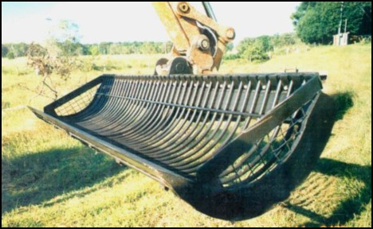

Source: RRCC, 2015.

Various dredging techniques (for example grab, buckets, suction) have also often used to remove MBOs from waterways. The use of a suction dredge has been the preferred option to remove MBOs in large quantities (that is greater than 400 m3/day) with apparently minimal disturbance to the surrounding waterbody (Figure 5.7).

Figure 5.7 A small-cutter suction dredge removing MBOs from the Peel-Harvey Estuary, Western Australia.

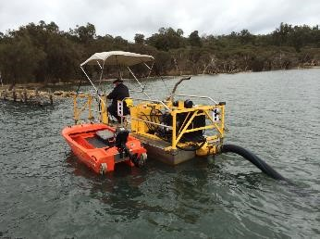

Source: G. Choppala.

This section outlines the main management techniques used to dispose of MBOs. The two commonly used techniques to dispose of MBOs include: a) above ground disposal, and b) within waterway disposal.

###### Land-based disposal of MBOs

It should be noted that current ASS guidance state it is not acceptable to stockpile untreated MBOs under any circumstances (Dear et al., 2014). Dear et al. (2014) also advise MBOs exposed to oxygen are generally not suitable for strategic reburial. In Western Australia it is advised that MBOs should not be stockpiled without a risk assessment and the implementation of strict environmental management protocols (DER, 2015).

Land-based disposal options for dredged MBO materials have been trialled, and are: containment ponds, landscape spreading and dewatering bags.

Containment ponds have been used with limited success for the disposal of MBOs. While there may be rapid oxidation of the MBOs at the surface in the containment ponds, the rate of oxidation has proven to be slow due to limited oxygen diffusion deep into the material. Of course, the containment ponds receiving the MBO materials must be constructed so as to ensure the secure containment of the MBO materials and their oxidation products. Further details of the use of containment ponds at the South Yunderup Dredge Spoil Disposal site is given in Appendix 1 (see A1.2 Dredge spoil (mainly MBO) containment dump: Peel region, Western Australia).

MBO accumulations removed from drainage channels and spread over the landscape are often limed (based on their net acidity) to prevent acidification. Current guidelines on this practice include those below (from the RRCC, 2015):

* Sediment and/or spoil excavated must be placed away from the drain and positioned to prevent runoff and/or leachate entering into watercourses. Excavated material must not be positioned below high water mark.
* Where possible, excavated sediment and/or leachate should be monitored to determine possible (based on results) management options.
* When possible, sediment control curtains should be positioned around excavated sediments. The curtain must be of suitable material with aperture size to retain clay particles preferred.
* Excavated sediments and vegetation shall not be placed in overland flow paths or areas where leachate can run back into watercourses. All effort is to be made to prevent placing spoil on ground with a surface slope greater than 10%.

Large geotextile dewatering bags have been successfully used in Western Australia to reduce the volume of MBO before its disposal on land (Figure 5.8). To accelerate the loss of water from the materials flocculants have been mixed in when the MBOs are transferred to the bags. This practice is best suited to situations where only relatively small amounts of MBO materials need to be treated.

Figure 5.8 Using dewatering bags with MBOs at the Peel-Harvey Estuary, Western Australia.

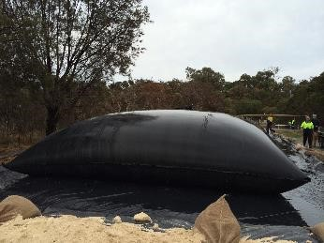

Source: G. Choppala.

###### Within waterway disposal of MBOs

Given the lack of proven best management practices for the land-based disposal of MBOs and the problems associated with that option, the disposal of MBO materials within waterways is often practiced.

Whether disposal of MBOS within waterways creates environmental issues will depend on a range of factors including: the volume and characteristics of the MBO mobilised (for example concentration of monosulfides, contaminant concentrations), and the volume and characteristics of the receiving waters (for example buffering capacity). Clearly it has been shown that deoxygenation and/or acidification does not always occur following the disposal of MBOs by this practice when the receiving waters can cope with the stresses placed upon it by the disposed MBO material (Morgan et al., 2010).

When this practice is being considered then assessments should be made to assess the hazard posed by the MBO materials to be disposed of in the waterway, and the capacity of the receiving waters to cope with those stresses.

During and after the disposal a rigorous water quality monitoring program with specified water quality targets should be implemented to ensure the predicted capacity of the receiving waters to cope with the MBOs materials is not exceeded. Prior to the works commencing a contingency plan should be established to provide an acceptable course of action should these targets not be met.

Consideration should also be given to ensure the location of MBO disposal sites are always submerged and will not be exposed during low tides, and that the disposed MBO materials do not cause unacceptable harm to the disposal sites via smothering.

### Framework to assess the potential for impact associated with MBO accumulation

The information obtained from the MBO accumulation assessment (Section 4.2) and the MBO hazard assessment (Section 5.3) can then be used to assess the potential for impact associated with disturbance of MBO accumulations. A general decision framework for such an assessment is provided in Figure 5.9 below.

Figure 5.9 General decision framework.

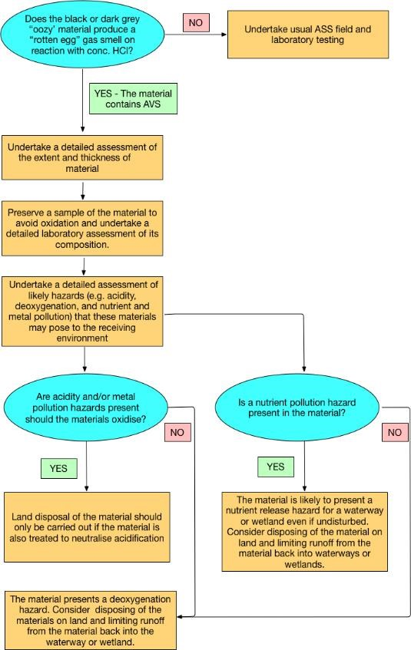

An outline of a simple assessment framework to assess the potential for impacts associated with MBO accumulation is given below:

1. Determine the potential for acidity generation from the MBO accumulations and the ability of the receiving waters to neutralise the potential acidity.
2. Determine the potential for dissolved oxygen depletion from the MBO accumulations and the ability of the receiving waters to maintain sufficient dissolved oxygen contents.
3. Determine the levels of contaminants (metals, metalloids and nutrients) and the ability of the receiving waters to dilute these contaminants to keep within water quality guidelines, background levels, or both.
4. Identify any other stressors likely to result from disturbance of the MBO accumulation (for example smothering) and assess whether the impacts of these stressors are likely to produce unacceptable environmental outcomes.

### Current gaps in our knowledge of MBO accumulations and their management

As mentioned previously, awareness of MBOs in the landscape and of their potential to pose environmental hazards has only developed in the last two decades (Sullivan and Bush, 2000, Sullivan et al., 2002b). Much of the effort has focused on assessment, characterisation and understanding of the behaviour of these materials. Acknowledged best management practices for the management of MBO accumulations in waterways have yet to be developed. This section outlines some of the remaining gaps in our knowledge that are needed in order to develop best management practices for these materials.

**Characterisation of MBOs and their hazards:** There is currently limited data available on the properties and behaviour of MBO materials encountered in different environmental settings. The research undertaken to date has shown properties of MBOs can vary significantly both within and between sites. While the nature of the hazards associated with MBOs are now reasonably well understood, the limited understanding of the variation in behaviour of MBO materials from different environmental setting also limits our understanding of their potential hazard. For example, the properties of MBOs located in tidally affected coastal waterways differ from MBOs located in inland waterways.

**Processes of accumulation:** While MBO accumulation has clearly been observed in a variety of environmental settings, there is currently limited data on both the processes controlling the rate of MBO accumulation and the factors limiting their formation. As minimising the rates of accumulation of MBO is considered a main management strategy for dealing with locations prone to MBO accumulation, this lack of knowledge impedes the formulation of preventative management techniques.

**Processes of mobilisation:** Recent findings have clearly shown large volumes of MBO sediment can be mobilised and redeposited downstream (Bush et al., 2004b, Cheetham et al., 2012). However, the controls on monosulfidic sediment mobilisation and the critical thresholds for its scour and entrainment for MBOs have not been established. These thresholds will no doubt vary for MBOs located in different environmental settings.

**Management approaches:** These guidelines have provided details of the current management approaches used with MBOs. Many of the management approaches mentioned (for example dewatering, liming and within waterway disposal) have only been undertaken at a limited number of sites and only with MBOs with certain properties. These management approaches may not be appropriate at different locations or for MBOs with different properties. For example, within waterway disposal of MBOs in the Peel-Harvey Estuary had minimal effect on the water quality in that estuary. This may not be the case when managing MBOs by within waterway disposal at other sites where MBOs, receiving waters, or both have different characteristics.

The development of a better understanding of the properties and behaviour of these materials, of the ability of receiving waters to cope with the effects of these materials, and of effective disposal or treatment techniques are required in order to develop best management practices for these materials.

## Appendix A: Case Studies

### A1.1 Floodgated drains in ASS landscapes: North Coast NSW

**Key references:**

Bush, RT, Fyfe, D & Sullivan, LA 2004a, ‘Occurrence and abundance of monosulfidic black ooze in coastal acid sulfate soil landscapes’, *Australian Journal of Soil Research*, vol. 42, pp. 609-616.

Bush, RT, Sullivan, LA, Fyfe, D & Johnston, SJ 2004b, ‘Redistribution of monosulfidic black oozes by floodwaters in a coastal acid sulfate soil floodplain’, *Australian Journal of Soil Research*, vol. 42, pp. 603-607.

Sullivan, LA & Bush, RT 2000, *The behaviour of drain sludge in acid sulfate soil areas: some implications for acidification of waterways and drain maintenance*, in: P Slavich, P (ed), Workshop on Remediation and Assessment of Broadacre Acid Sulfate Soils, 2000 Southern Cross University, Acid Sulfate Soil Management Advisory Committee (ASSMAC), Lismore, pp. 43-48.

Acid sulfate soils are commonly found on the low-lying coastal floodplains of the north coast of NSW. These areas have often been intensively drained: with drainage works commencing as early as the 19th Century and intensifying after major flooding in the 1950s (Tulau, 2007). Map A1 shows a typically high density drainage network in a low-lying coastal flood plain near Moto Swamp in NSW.

Map A1 Deep drainage network at Moto Swamp on the Lower Manning River floodplain.

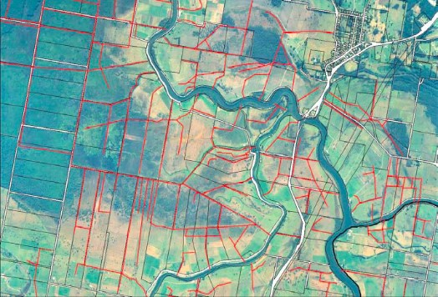

Deep drains outlined in red. The width across the image is approximately 5 km with the village of Coopernook in the upper right corner. Source: Tulau, 2007.

These drainage networks are characteristically controlled by floodgates at their exit points to prevent ingress of tidal waters into the network. In disturbed acid sulfate soil landscapes which supply high levels of sulfate and iron into the drainage waters and with appreciable organic matter inputs from both within and outside the drains, these floodgates create very low flow conditions within the drainage networks that provide ideal conditions for the accumulation of MBOs.

Map A3 shows the sampling sites for a study (Bush et al., 2004a) examining the distribution of MBOs in the Tuckean Swamp drainage network located on the NSW north coast near Ballina (Map A2). This study found thick layers of MBO up to 50 cm deep with no apparent relationship between water depth in the drains and the depth of MBO accumulation. Abundant decaying matter was observed in the drains and sediments above the floodgates in the study site. This organic matter was considered to be mainly derived from the prolific growth and then death of acid tolerant water lilies in these acidic drains.

The concentrations of monosulfides in the waterways sediments were greatly elevated behind the floodgates and persisted for a distance of approximately 8 km above the floodgate (Figure A1). Concentrations of monosulfides of up to 7% as acid volatile sulfide were found in these MBO accumulations: the concentrations of monosulfides in these sediments are extreme being generally an order of magnitude greater than has previously been recorded for natural sediments. The concentrations of monosulfide were generally greater in the surface layers of the MBO accumulations and considerable contents of pyrite were also found in the MBOs. Indeed in some MBO accumulations in the study site of Bush et al. (2004a) the concentration of pyritic sulfur exceeds those of monosulfidic sulfur.

Map A2 Location of the Tuckean Swamp drainage network study site.

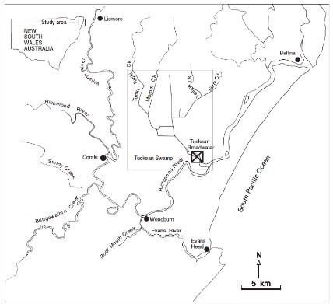

Source: Bush et al., 2004a.

Map A3 Location Sampling locations in Tuckean Swamp.

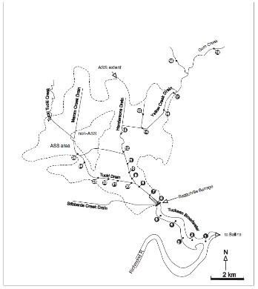

Source: Bush et al., 2004a.

Figure A1 Monosulfide sulfur contents in the transect to Yellow Creek.

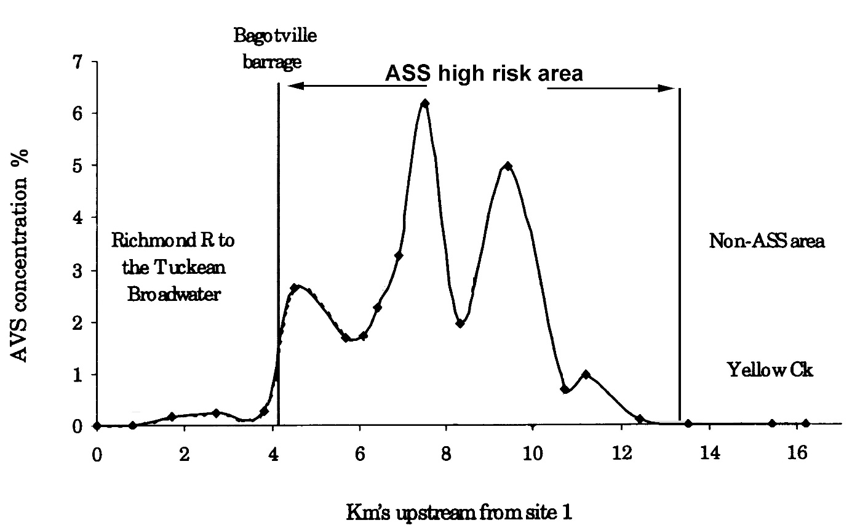

Note: Monosulfide sulfur contents measured by the concentration of acid volatile sulfide (AVS).

Source: Bush et al., 2004a.

The quantities of MBOs in these drainage networks are considerable and are considered to pose a substantial environmental hazard. For example, in the Tuckean Swamp drainage network there are 108 km of major drains and the volume of MBO accumulations within these drains was estimated to be 200,000 m3 of MBO prior to a flood (Sullivan and Bush, 2000). MBO mobilised from the Tuckean Swamp during a single flood in February 2001 was estimated to be capable of deoxygenating 200 mm of runoff from the 22,000 ha catchment of the Tuckean Swamp and areas upland.

The study of Bush et al. (2004b) showed that MBO accumulations in these drainage networks are readily mobilised during floods. Figure A2 shows MBOs formerly with drains being located after the floodwater have receded on top of a floodgate, as thin veneers across landscapes adjacent to the drains, and on top of logs.

Figure A2 Evidence for the mobilisation of MBO accumulations.

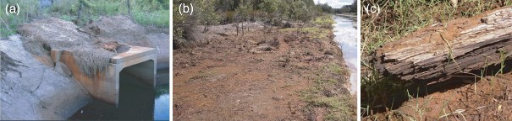

Note: The evidence can be observed after floodwaters have receded by deposits of oxidising (and hence red coloured) MBOs on: (a) a floodgate, (b) land adjacent the drains, and (c) on top of logs well away from the drains

Source: Bush et al., 2004b.

This demonstrates that MBO accumulations are mobilised and entrained in floodwaters. The rapid reaction of MBOs when dispersed in waters and their volumes indicates that accumulated MBOs may pose an environmental hazard for receiving waters even during periods of high flow such as floods.

The drains in these landscapes are regularly cleaned by farmers to preserve their hydraulic functioning. The sugar cane industry in NSW implemented best practice guidelines in 2005 for the management of this activity (NSW Sugar Milling Co-operative Ltd., 2005). These guidelines advise the following in relation to drain clearing in these landscapes:

* Mechanical weed removal should be by excavators equipped with slotted and raked buckets that minimise soil disturbance.
* Any mechanical clearing should not increase the depth of the drain.
* Mechanical maintenance in ASS areas creates an acid hazard in the freshly exposed sides and base of the drain and in the spoil from the drains. Lime should be applied to neutralise the acidity in both instances. The lime should be applied before or as soon as possible after drain maintenance. The rate will be determined by the degree of hazard indicated in the drainage management plan.
* Spoil should be placed so that any drainage will not carry acid into the drain. It should be neutralised by application and incorporation of lime, or it can be spread in fields and neutralized there. A band of lime between the spoil and the drain will provide some protection until spoil can be neutralised or removed.

In relation to the specific management of MBO accumulations in the drains the sugar cane guidelines (NSW Sugar Milling Co-operative Ltd., 2005) state that:

* Operators should spread drain sludge as a thin layer in cultivation paddocks, lime and incorporate into top soil when dry enough at an appropriate rate to neutralise acidity.
* In pasture areas, if black drain sludge is not being spread, ensure that the sludge is placed so as not to be flushed back into drains; bunding and liming may be necessary.

### A1.2 Dredge spoil (mainly MBO) containment dump: Peel region, Western Australia

**Key references:**

Sullivan, L, Bush R & Burton, E 2006a, *Acid Sulfate Soil Development Issues in the Peel Region*, a report produced for the Department of Environment, Western Australia, Southern Cross University, Lismore, New South Wales.

The South Yunderup Dredge Spoil containment dump was constructed to contain dredge spoil mainly MBOs during the maintenance excavation in 1999 of the adjacent South Yunderup channel, Murray Waters Western Australia, to maintain the function of this navigational channel for recreational vessels (Map A4). The dredge spoil dump was sampled in May 2006 and assessed for the oxidation of these MBOs spoils over the preceding 7 years of storage.

Map A4 South Yunderup Dredge Spoil dump location in relation to the navigation channel.

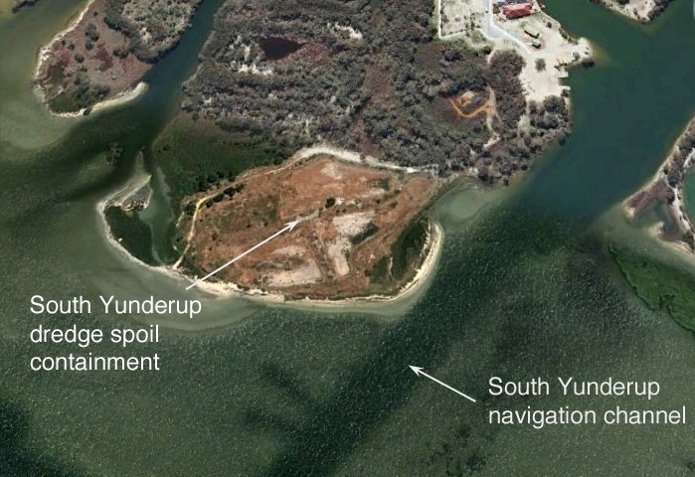

Source: Google Earth.

The data in Table A1 indicate that severe acidification (pH less than 4) has occurred since the dredge spoil sediments were deposited there in late 1999. This acidification has been relatively slow with only about 60 cm of advanced soil development as a result of (mainly) sulfide oxidation having taken place after 7 years of stockpiling (Figure A3); an average rate of 9 cm per year. Although there were relatively high contents of carbonate in the deposited MBOs, the observed acidification clearly demonstrates that this was insufficient to avoid severe acidification upon exposure to the atmosphere and the subsequent oxidation of the sulphides.

Table A1 Selected soil properties at the South Yunderup Dredge Spoil containment dump.

|  |  |  |  |  |
| --- | --- | --- | --- | --- |
| Soil Property | 0–10 cm | 10–32 cm | 32–60 cm | 60–75 cm |
| Description | Light grey clay with red mottles | Dark grey clay with red mottles | Dark grey clay with jarosite, gypsum and red mottles. Watertable at 42 cm depth. | Monosulfidic black ooze |
| pH (1:5 soil:water) | 3.91 | 3.79 | 4.32 | 8.13 |
| Soil Conductivity (1:5 water dS/m) | 5.40 | 11.61 | 13.81 | 16.96 |
| Titratable Actual Acidity (mol H+/tonne) | 100 | 105 | 55 | 0 |
| Reduced Inorganic Sulfur (%SCR) | 0.24 | 0.08 | 0.58 | 1.96 |
| % ANCBT (%CaCO3) | 0.00 | 0.00 | 0.00 | 2.75 |
| Net Acidity (Chromium Suite) (mol H+/tonne) | 252 | 156 | 419 | 855 |
| Chloride (mg/kg) | 16 434 | 33 272 | 36 621 | 12 926 |
| Chloride/Sulfate ratio | 2.69 | 2.49 | 2.65 | 1.91 |
| Total Carbon (%C) | 3.85 | 2.81 | 3.09 | 4.84 |
| Total Sulfur (%S) | 0.71 | 0.70 | 0.99 | 2.22 |
| Total Nitrogen (%N) | 0.62 | 0.43 | 0.46 | 0.68 |

Figure A3 Soil profile within the South Yunderup Dredge Spoil disposal site.

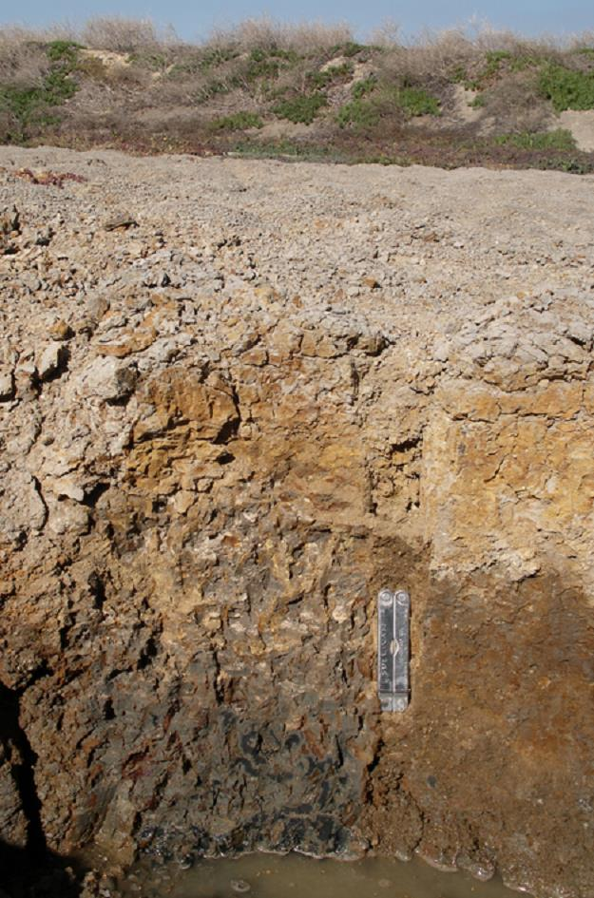

Note: Shows black monosulfidic sediments below 60 cm.

Source: Sullivan et al., 2006a.

Containment of dredge spoils within disposal sites is critical to ensure adjacent environments are not adversely impacted during treatment. However, Figure A4 adjacent the South Yunderup Spoil containment dump site indicated that appreciable seepage of MBO and its oxidation products had occurred outside the bund walls.

Figure A4 Pit outside bund wall showing sulfide oxidation products and an unoxidised monosulfidic layer.

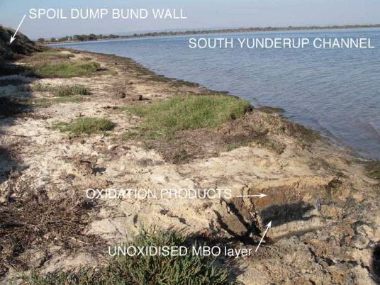

Note: At the South Yunderup Dredge Spoil Disposal site.

Source: Sullivan et al., 2006a.

### A1.3 Tidally affected coastal waterways: Geographe Bay area, Western Australia

**Key references**

Ward, NJ, Bush, RT, Burton, ED, Appleyard, S, Wong, S, Sullivan, LA & Cheeseman, PJ 2010a, ‘Monosulfidic black ooze accumulations in sediments of the Geographe Bay area, Western Australia’, *Marine Pollution Bulletin*, vol. 60, pp. 2130-2136.

This case study describes the nature and extent of MBO accumulation in tidally affected coastal waterways in the Geographe Bay area, Western Australia. The tides are minimal in this area but the waters are saline as a result of the tidal influence. Two areas were examined, including waterways surrounding Busselton (Port Geographe and Vasse Estuary) and Toby Inlet located west of Busselton (Map A5). Prior to this study some MBO materials had previous been reported in Toby Inlet (Pozzari, 2007), but their extent was unknown. It was thought that the build-up of organic matter (including aquatic weeds, seagrass and algae) in the tidal waterways flowing into Geographe Bay would lead to suitable conditions for substantial MBO accumulation.

Map A5 Location of sampling sites in the Geographe Bay area.

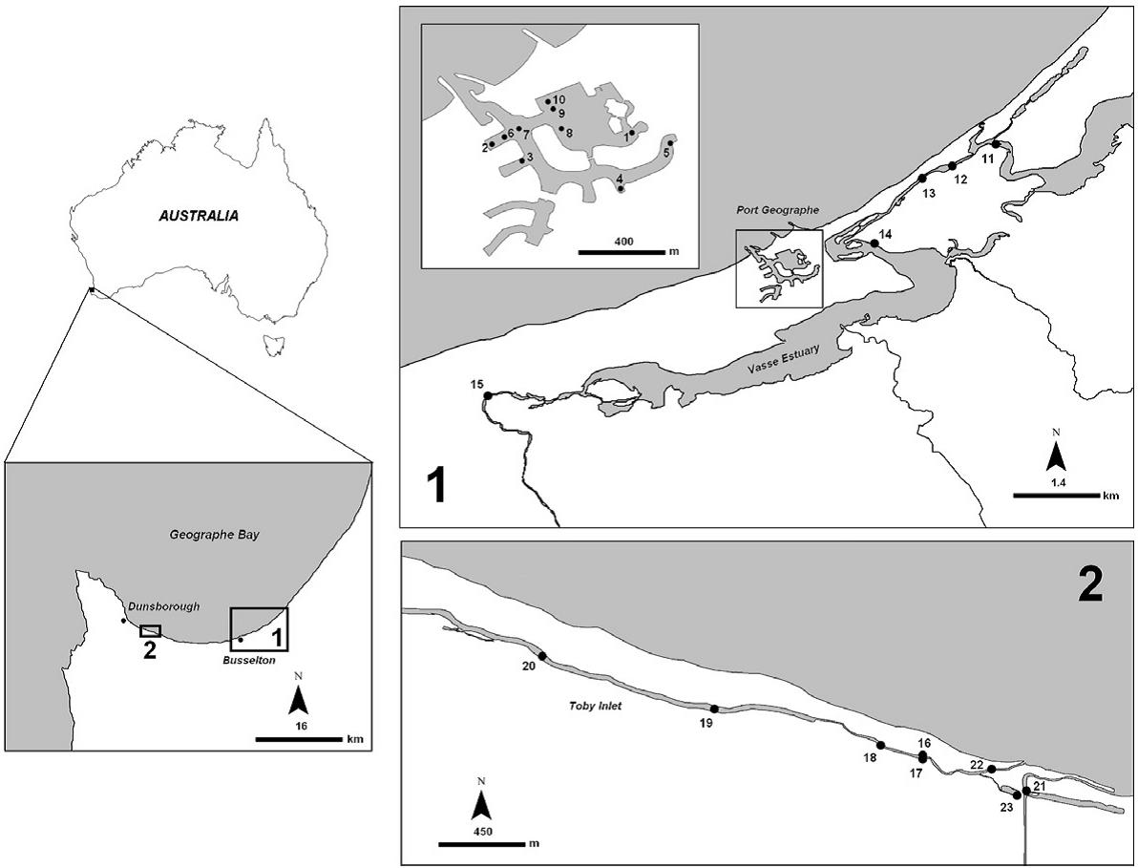

Source: Ward et al., 2010a.

Surface sediment cores were collected from 23 sites including Port Geographe (sites 1–10), the Vasse Estuary (sites 11–15) and Toby Inlet (sites 16–23) (Map A5). Intact sediment cores (10 cm in diameter) were retrieved at each site using a polypropylene push-tube coring device (Figure A5). Sediment samples were immediately placed into 50 mL air-tight centrifuge tubes. All tubes were filled with sediment and frozen to minimise potential sample oxidation. Surface water samples were also collected from each site. Refer to Ward et al. (2010a) for further details of field sampling, parameters measured and analytical methods used in this study.

The field pH of the sediments examined was near-neutral (pH 6.7–8.3), and the redox of the sediments ranged from suboxic to strongly reducing (Eh, -220 to +160 mV). Monosulfidic sediments (equal to or greater than 0.01% SAV) were found to be widespread, with AVS contents as high as 1.03% SAV (320 µmol g-1). The monosulfidic sediments also often observed to have a strong H2S odour.

Figure A5 Surface MBOs at Port Geographe (left and middle) and seagrass accumulation at Toby Inlet (right), Geographe Bay.

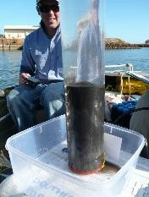 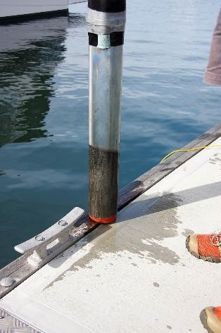 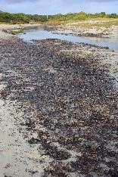

Source: Ward et al., 2009.

All the black surface gels and organic rich sands sampled (Figure A5) were found contain substantial AVS concentrations. The monosulfide-rich sediments typically had organic carbon contents of between 6 and 16%. While seagrass seemed to be the primary source of organic matter at many of the sites (Figure A5), the high levels of algae in water column at Toby Inlet indicated this was also an important source of organic matter.

Sediments with appreciable AVS concentrations often contained similar or greater concentrations of pyrite (up to 1.85% SCR), which usually increased with depth (Figure A6). Elemental sulfur (up to 0.16% S) was also detected in many of the monosulfidic sediments (Figure A6). Dissolved sulfide was also able to accumulate in some of the sediments due to the limited availability of iron, and sometime represented a substantial component of the AVS fraction; dissolved sulfide is also quantified with the AVS procedure. Previous studies have found the enrichment in pore water ferrous iron usually maintains low dissolved sulfide concentrations in MBO materials due to the precipitation of iron monosulfides (Burton et al., 2006c).

The availability of organic carbon and iron seems to have limited the accumulation of MBO at many of the sites examined in the Geographe Bay area. For further details of the sediment and pore water properties please refer to Ward et al. (2010a).

Figure A6 Reduce inorganic sulfide (RIS) content (µmol/g) of sediments at Site 14 in the Vasse Estuary.

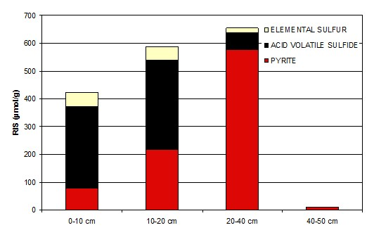

Source: Ward et al., 2009.

### A1.4 Inland river: Talbragar River, central New South Wales

**Key reference:**

Sullivan, LA, Bush, RT & Ward, NJ 2002b, ‘Sulfidic sediments and salinisation in the Murray-Darling basin’, in: BCT MacDonald, AF Keene, G Carlin & LA Sullivan (eds) *Sustainable Management of Acid Sulfate Soils*, Conference Abstracts, Proceedings of the 5th International Acid Sulfate Soils Conference. Poster Papers, Tweed Heads, New South Wales, 25-30 August 2002, Tweed Shire Council, Murwillumbah, New South Wales, pp. 196-197.

The Talbragar River is located near Dubbo in central NSW (Map A6). Research undertaken on this river was one of the first studies to link elevated sulfate concentrations as a result of salinisation and the formation of sulfidic sediments in inland waterways of the Murray-Darling Basin (Sullivan et al., 2002b, Sullivan et al., 2004, Sullivan et al., 2006b).

Map A6 Location of Talbragar River.

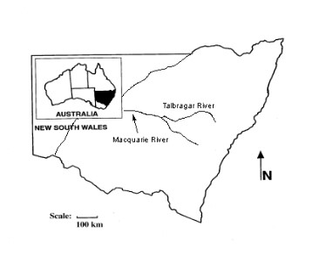

Source: Sullivan et al., 2002b.

The study by Sullivan et al. (2002b) found black monosulfide concentrations of up to 0.11% SAV (35 µmol S g-1) in freshwater sediments in the Talbragar River (Figure A7 and Figure A8). Accumulation of AVS was observed along the Talbragar River along with a general increase in sulfate concentration downstream from approximately 10 mg L-1 at Craboon to approximately 25 mg L-1, approximately 30 km downstream at Beni. The critical sulfate concentration in the overlying river waters required for the accumulation of monosulfides in these sediments was approximately 15 mg L-1 (Figure A8).

The texture of the sediments in riverbed were dominantly coarse sandy (Figure A7) but these sediments clearly were mobilised during flow events. The effect of the accumulated monosulfides in the Talbragar sediments on the subsequent deoxygenation of the river channel during a flow event in early February 2002 is shown in Figure A9. The dissolved oxygen contents observed in parts of the Talbragar River (that is less than 4 mg L-1) were low enough to cause a fish kill, and were attributed directly to the downstream mobilisation and oxidation of the accumulated monosulfides in the river bed sediments.

Figure A7 Black monosulfidic layer (approximately 8 cm thick) in Talbragar River bed sediments.

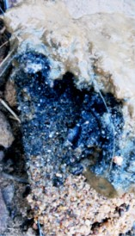

Source: Sullivan et al., 2002b.

Figure A8 AVS content in sediments and sulfate content of water in the Talbragar River.

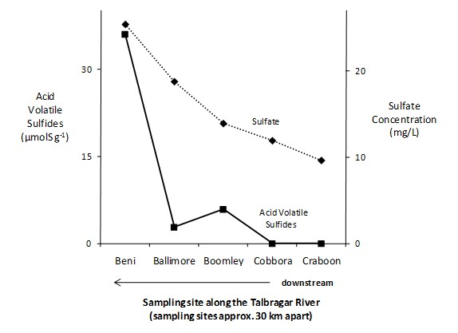

Note: AVS content in sediments as of 26/02/02) and sulfate content of water in the Talbragar River as of 15/02/02.

Source: Sullivan et al., 2002b.

A typical feature of many unregulated inland rivers is the natural wetting and drying cycles that are experienced. The Talbragar River is typical of these waterways. Regular observation and sampling of this river over periods of high and low rainfall demonstrates the ephemeral nature of these monosulfidic accumulations in these environments. Figure A10 shows this ephemeral nature with thick (approximately 10 cm deep) monosulfidic accumulations that have developed during wet times (Figure A10a) that have oxidised completely during periods of low rainfall (Figure A10b).

Figure A9 AVS content in sediments and dissolved oxygen content of water in the Talbragar River.

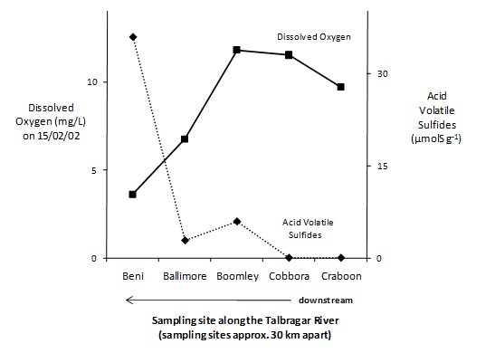

Note: AVS content in sediments as of 26/02/02) and dissolved oxygen content of water as of 15/02/02 during the tail end of a flow event.

Source: Sullivan et al., 2002b.

Figure A10 Vertical sections of Talbragar river sediments at the same site near Boomley.

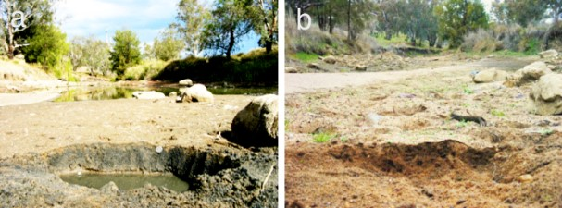

Note: During (a) a wet conditions after period of relatively high rainfall showing the development of a thick black monosulfidic surface layer approximately 10 cm thick (Australian dollar coin shown for scale), and (b) following dry period with complete oxidation of that monosulfidic layer.

Source: Sullivan et al., 2002b.

### A1.5 Saline water disposal basin: Loveday Basin, Lower River Murray Region

**Key references:**

Lamontagne, S, Hicks, WS, Souter, NJ, Walter, MJ & Wen, L 2009, ‘Water and salt balance of a saline water disposal basin during an experimental flooding and drying cycle (Loveday Disposal Basin, Australia)’, *Hydrological Processes*, vol. 23, pp. 3453-3463.

Wallace L, McPhail, B, Fitzpatrick, R, Welch, S, Kirste, D, Beavis, S & Lamontagne, S 2008, *Spatial Variability in the Storage of Sulfur, Carbon and Acid Generation Potential in an Inland Saline Sulfidic Wetland, Lower Murray River Floodplains, South Australia*, in: R Fitzpatrick and P Shand (eds) Inland Acid Sulfate Soil Systems Across Australia, CRC LEME Open File Report No. 249, (Thematic Volume) CRC LEME, Perth, Australia, pp 219-240.

Hicks, WS, Lamontagne S, Tuomi, S, & Ren, Y 2008, *Loveday Disposal Basin Odour Control Program – Laboratory Trial and Ambient Air Monitoring*, Department of Water Land and Biodiversity Conservation, Adelaide, South Australia.

Walters, M 2005, *Loveday Basin Conceptual Model and Rehabilitation Workshop*, Department of Water Land and Biodiversity Conservation, Adelaide, South Australia.

Loveday Disposal Basin is part of a wetland complex adjacent the Murray River in the Riverland region of South Australia (Map A7).

Map A7 Loveday Disposal Basin and nearby towns in the Riverland Region of South Australia.

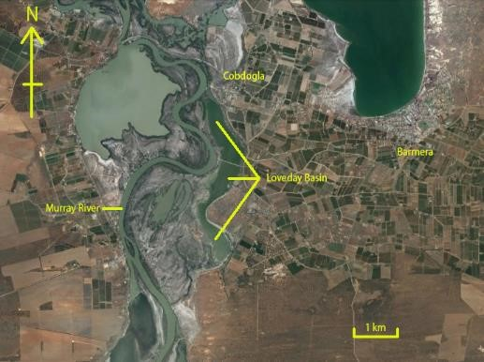

Source: Google Earth.

Loveday Disposal Basin has been used for the disposal of excess saline irrigation drainage water since the 1970s. The basin alternates between wet and dry conditions according to antecedent rainfall, season, and accessions of disposed irrigation water (Figure A11).

Figure A11 The alternating wetting and drying cycles Loveday Disposal Basin experiences creates deeply cracked sediments during dry times.

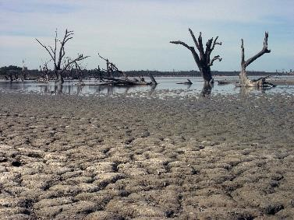

Source: L.A. Sullivan.

As a result of the accessions of irrigation water and the dominantly drying conditions this sump-like basin is often hypersaline (Lamontagne et al. 2009). The basin’s sediments are sulfidic, containing both black MBOs near the surface (unless in an excessively dry condition when the monosulfides oxidise) as well as disulfide minerals such as pyrite (Wallace et al. 2008). The black MBO-rich surficial layers can be seen in cross-section of the sediments (Figure A12).

Figure A12 Loveday Disposal Basin sediment profile showing surficial saline crust, a black underlying MBO layer overlying a sulfidic (pyritic) layer.

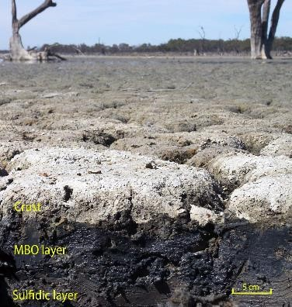

Source: L.A. Sullivan.

An issue of considerable concern arising from the geochemistry and hydrology of the basin’s sediments is the production of noxious odours. Indeed, the communities surrounding Loveday Disposal Basin have complained of foul odours especially during extended dry times when the basin’s sediments have been exposed to the atmosphere. The noxious gases venting from the wetland sediments under these conditions include hydrogen sulfide (H2S) and a range of volatile organic sulfur compounds including methyl bromide, phosphine, carbonyl sulfide, and dimethyl sulfide. Hicks et al. (2008) noted “concentrations of all these gases were at levels previously only thought to be associated with residues from their use as pesticides and fumigants”.

Options to manage the emissions of foul odours into the nearby communities seem to be limited apart from the standard practice of raising the water level within the basin to ensure that the most affected areas are permanently inundated (Walter, 2005). The use of potential chemical retardants of gas evolution including CaNO3 and CalSilt (a fine-sized calcium carbonate product) have been trialled but with limited success (Hicks et al. 2008).

## Glossary

| Term | Definition |
| --- | --- |
| Acid base account (ABA) | A simple equation used to combine the results of several laboratory soil tests to produce a consistent and comparable measure of net soil acidity. The accounting system includes measures of freely available (actual) acidity, acidity released from low solubility chemical compounds (retained acidity) and sulfides vulnerable to oxidation (potential acidity), balanced against any acid-neutralising capacity (ANC) if present in the soil. Except where the neutralising material in the soil is very fine, ANC on fine-ground laboratory samples is usually an overestimate of effective ANC compared to its field reactions and kinetics. Hence a compensating ‘fineness factor’ is employed in the equation. |
| Acid-neutralising capacity (ANC) | The ability of a soil to counteract acidity and resist the lowering of the soil pH. In an ASS context, acid-neutralising capacity is considered negligible if the soil’s pHKCl after processing (according to the latest Laboratory Methods Guidelines) is less than 6.5. Above pH 6.5, ANC is defined and measured according to the latest Laboratory Methods Guidelines (or AS 4969). |
| Acid sulfate soils (ASS) | Soils, sediments or other materials containing iron sulfides and/or acidity generated by their breakdown. These materials are environmentally benign when left undisturbed in an aqueous, anoxic environment but when exposed to oxygen the iron sulfides break down, releasing large quantities of sulfuric acid and soluble iron. |
| Actual Acidity | The soluble and exchangeable acidity already present in the soil, often as a consequence of previous oxidation of RIS. It is this acidity that will be most mobilised and discharged following a rainfall event. It is measured in the laboratory using the Titratable Actual Acidity method. It does not aim to include the less soluble acidity (that is Retained Acidity) held in hydroxy-sulfate minerals such as jarosite. |
| Algae | Aquatic plants that do not have root structures or flowers. Microalgae (also called phytoplankton) are microscopic. Macroalgae can be seen without magnification. |
| Algal bloom | A large population density of a phytoplankton. Such blooms are normal, but become of concern when the species in bloom is toxic. |
| ANCBT | Acid Neutralising Capacity by back-titration. Acid Neutralising Capacity measured by acid digest followed by back-titration of the acid that has not been consumed. |
| Anoxic | An environment where oxygen is intrinsically rare or absent. |
| ANZECC | Australian and New Zealand Environment and Conservation Council. |
| Aqueous | Composed of or pertaining to water. |
| ARMCANZ | Agriculture and Resource Management Council of Australia and New Zealand. |
| AVS | Acid volatile sulfides; the dilute acid-soluble sulfide concentration in an aquatic sediment. |
| Background | Environmental conditions that commonly occur, or concentration of a substance (ASS or contaminant) that is commonly found, in the local concentration environment at the site being considered. |
| Biodiversity | The variety and variability of living organisms and the ecological complexes in which they occur. |
| Buffering capacity | The ability of a mixture or solution to resist pH change ‒ in an ASS context, this may refer to surface or groundwaters, or to the soil solution, or to the soil itself. |
| Bulk density | The mass of an oven-dry soil material per unit volume of the soil material as found in the field. In an ASS risk assessment context, planned disturbance volumes can be converted to tonnage using the bulk density (volume x BD = tonnage). Expressed in units of g/cm3 or t/m3, which are numerically equivalent (that is 1.5 g/cm3 is the same as 1.5 t/m3). |
| Bund | A wall constructed to retain spoil, generally as an elongated earth mound used to direct and/or contain the flow of water. |
| Chromium suite | In acid sulfate soils analysis, a suite of tests used to characterise the net acidity of a soil. The suite centres on the use of the chromium-reducible sulfur measure for potential acidity, along with a number of tests for other forms of acidity depending on the soil pH (TAA for actual acidity, SNAS for retained acidity, and a choice of several ANC methods for acid neutralising capacity). See the latest version of the Laboratory Methods Guidelines or AS 4969 for further information. |
| Conceptual model | A simplified representation of how a real system is believed to behave based on a qualitative analysis of data. A quantitative conceptual model includes preliminary calculations for key processes. |
| Contaminants | Biological or chemical substances or entities, not normally present in a system, capable of producing an adverse effect in a biological system, seriously injuring structure or function. |
| Control | Part of an experimental procedure that is ideally exactly like the treated part except that it is not subject to the test conditions. It is used as a standard of comparison, to check that the outcome of the experiment is a reflection of the test conditions and not of some unknown general factor. |
| Dewatering | The process of extracting water from a saturated soil or sediment. |
| Diffusion | The transport of contaminants by random molecular motion and turbulence, usually from an area of high concentration to an area of low concentration. |
| Dissolution | In chemistry, the process by which a solid material forms a homogenous mixture with a solvent. |
| Disposal site or area | A precise geographical area within which disposal of dredged material occurs. |
| DO | Dissolved oxygen. |
| Dredged material | Material which has been dredged from a water body, while the term sediment refers to material in a water body prior to the dredging process. |
| Dredging | An excavation activity or operation usually carried out at least partly underwater (generally in shallow water areas) with the purpose of removing bottom sediments and relocating them. |
| Eh | Redox potential. |
| Existing acidity | In acid base accounting, a collective term that includes actual acidity and retained acidity. |
| Groundwater | Subsurface water in the zone of saturation, including water below the watertable and water occupying cavities, pores and openings in underlying soil and rock. |
| Guideline | Numerical concentration limit or narrative statement to support and maintain a designated water use. |
| Habitat | The specific area or environment in which a particular type of plant or animal lives. An organism's habitat provides all of the basic requirements for the maintenance of life. Typical coastal habitats include beaches, marshes, rocky shores, bottom sediments, mudflats, and the water itself. |
| Hydrogen sulfide | A gas with the formula H2S, released from anaerobic systems as a metabolic by-product. Commonly known as 'rotten egg gas' due to its smell. |
| Hydrology | The characteristics of water and the study thereof. |
| Hyposulfidic | In relation to ASS, refers to sulfidic soil material that is not capable of severe acidification (pH less than 4) as a result of oxidation of contained sulfides. Materials were previously referred to as potential acid sulfate soils (PASS) previously. |
| Impact | Environmental change (usually biological) that has occurred as a result of dredging activity. The extent of the change may be considered unacceptable and may require some intervention by regulatory authorities. |
| Indicator | Measurement parameter or combination of parameters that can be used to assess the quality of water. |
| Jarosite | An acidic, pale yellow (straw- or butter-coloured) iron hydroxysulfate mineral: KFe3(SO4)2(OH)6. Jarosite is a by-product of the ASS oxidation process, forms at pH less than 3.7, and is commonly found precipitated along root channels and other soil surfaces exposed to air. It is an environmentally important store of acidity as it can hydrolyse to release acidity relatively rapidly. |
| Leachate | Water or any other liquid that may contain dissolved (leached) soluble materials, such as organic salts and mineral salts, derived from a solid material. For example, rainwater that percolates through a confined disposal facility and picks up dissolved contaminants is considered leachate. |
| Lime | A general term for the various forms of calcium oxide and/or hydroxide. |
| Mackinawite | A monosulfide mineral with the formula Fe1+xS, where x = 0‒0.11. Mackinawite crystals can form in sedimentary reducing environments and their formation is bacterially mediated. |
| Maintenance dredging | Dredging that is required to maintain water depths in areas where sedimentation occurs (for example in ports and marinas to maintain safe, navigable channels and berths). It involves the removal of recent unconsolidated sediments, such as mud, sand and gravel. It generally consists of cycles or a series of repeat dredges. It is usually from an area where the level of the river or seabed to be achieved by the dredging proposed is not lower (relative to Ordnance Datum), than it has been at any time during the preceding 10 years; or from an area for which there is evidence that dredging has previously been undertaken to that level (or lower) during that period. |
| Measurement parameter | Any parameter or variable that is measured to find something out about an environment or ecosystem. |
| Mobilise (of metals) | Where the naturally occurring metals in soil or sediment are changed from an insoluble to a soluble state. |
| mol H+/tonne | A measure of acidity, expressed as the number of moles of hydrogen cations per tonne of oven-dry soil material. A mole is 6.022x1023 atoms of a given substance. The term can also be used as an 'equivalent acidity unit' when comparing the results of tests expressed in other units, such as when doing acid base accounting. |
| Monosulfides | The term given to highly reactive RIS compounds with the approximate cation:sulfur ratio of one. In ASS materials RIS includes iron monosulfide minerals, such as greigite and mackinawite, as well as aqueous FeS ad HS-. Monosulfides are operationally measured as Acid Volatile Sulfide (AVS). |
| Monosulfidic | In relation to ASS, refers to soil material containing greater than or equal to 0.01% acid volatile sulfide (AVS). |
| Monosulfidic black ooze (MBO) | Amorphous gels that contain high concentrations of iron monosulfide minerals (general formula FeS). These minerals form in the base of low-flow surface water bodies in acid sulfate soil‒influenced environments. MBOs are highly reactive in the presence of oxygen, breaking down in a matter of minutes to produce free iron and acidity. The reactions are controlled by the presence of oxygen in the water, and their disturbance can cause significant deoxygenation events in natural waters, killing aquatic life. MBOs may sometimes be referred to as iron monosulfides, monosulfides or acid volatile sulfides. MBO formation is considered a precursor to biogenic pyrite formation, and thus formation of ASS. |
| Neutralising | The process whereby acid produced (by the oxidation of iron sulfides) is counteracted by the addition of an ameliorant such as lime (CaCO3); there are formulae for calculating the amount of ameliorant needed. |
| NEPM | National environmental protection measure. |
| Net Acidity | The measure of the acidity hazard of ASS materials. Determined from laboratory analysis, it is the result obtained when the values for various components of soil acidity and Acid Neutralising Capacity (but only after corroboration of the ANC’s effectiveness) are substituted into the Acid Base Accounting equation. |
| Organism | Any living animal or plant; anything capable of carrying on life processes. |
| Overlying water | The water above the sediment at a collection site or in a test chamber. |
| Oxidation | The combination of oxygen with a substance, or the removal of hydrogen from it; or, more generally, any reaction in which an atom loses electrons. |
| Oxidised | A process of chemical change involving the addition of oxygen following exposure to air. |
| Pollution | Human introduction, directly or indirectly, of substances or energy into aquatice environments resulting in such deleterious effects as harm to living resources, hazards to human health, hindrance to marine activities such as fishing, the impairment of quality for use of the water and the reduction of amenities. |
| Potential acidity | Acidity associated with the complete oxidation of sulfides (mainly pyrite) – that is, the maximum theoretical amount of acidity that could be produced if all the pyrite in the soil oxidised. In an acid sulfate soils context, potential acidity is operationally defined by either the chromium-reducible sulfur method or the peroxide-oxidisable sulfur method. |
| Potential ASS (PASS) | See Hyposulfidic. |
| pH | The intensity of the acidic or basic character of a solution, defined as the negative logarithm of the hydrogen ion concentration of a solution. Used as a measure of the acidity of alkalinity of a soil of water body on a logarithmic scale of 0 to 14; a pH less than 7 is acid, pH 7 is neutral, and pH greater than 7 is alkaline. Note that one unit change in pH is a ten-fold change in acidity. |
| Phase | Distinct state of matter (solid, liquid or gas) which in aquatic systems comprises sediment, water and air. |
| Pore water | The water that occupies the space between and surrounding individual sediment particles in an aquatic sediment (often called interstitial water). |
| Pyrite | pale-bronze or brass-yellow, isometric mineral: FeS2; the most widespread and abundant of the sulfide minerals. |
| QA/QC | Quality assurance/quality control. |
| Quality assurance (QA) | The implementation of checks on the success of quality control (for example replicate samples, analysis of samples of known concentration). |
| Quality control (QC) | The implementation of procedures to maximise the integrity of monitoring data (for example cleaning procedures, contamination avoidance, sample preservation methods). |
| Redox | Simultaneous (chemical) reduction and oxidation; reduction is the transfer of electrons to an atom or molecule, whereas oxidation is the removal of electrons from an atom or molecule. |
| Redox potential | A measure of the oxidation–reduction potential (ORP) of sediments. The redox potential is often reported as Eh (versus the normal hydrogen electrode). |
| Reduced Inorganic Sulfur (RIS) | Inorganic sulfur compounds containing sulfur in a reduced state, that is, sulfur with an oxidation state of less than +6. In ASS materials this includes a wide variety of compounds, such as pyrite, marcasite, greigite, mackinawite, aqueous FeS, HS-. |
| Retained Acidity | The ‘less available’ fraction of the existing acidity (not measured by the TAA) that may be released into the environment by hydrolysis of relatively insoluble sulfate salts (such as jarosite, natrojarosite, schwertmannite and other iron and aluminium hydroxy-sulfate minerals). |
| Risk | A statistical concept defined as the expected frequency or probability of undesirable effects resulting from a specified exposure to known or potential environmental concentrations of a material, organism or condition. A material is considered safe if the risks associated with its exposure are judged to be acceptable. Estimates of risk may be expressed in absolute or relative terms. Absolute risk is the excess risk due to exposure. Relative risk is the ratio of the risk in the exposed population to the risk in the unexposed population. |
| Runoff | The liquid fraction of dredged material or the surface flow caused by precipitation on upland or nearshore dredged material disposal sites. |
| % S | A measure of reduced inorganic sulfur (using the SCR or SPOS methods) expressed as a percentage of the weight of dry soil analysed. Can also be used as an 'equivalent sulfur unit' when comparing the results of tests expressed in other units, or when doing acid base accounting. |
| Salinity | The presence of soluble salts in water or soils. |
| Schwertmannite | An iron oxy-hydroxysulfate mineral with the formula Fe8O8(OH)6SO4 that forms in low-pH, iron-rich waters. Schwertmannite is the major component of iron floc in such waters, and acts as a buffer to keep ASS-affected waters highly acidic. |
| Sediment | Unconsolidated mineral and organic particulate material that has settled to the bottom of aquatic environments. The term dredged material refers to material which has been dredged from a water body, while the term sediment refers to material in a water body prior to the dredging process. |
| Soil materials | The term soil material refers to both soil materials and sediments in this guideline. |
| Solubility | In chemistry, how easily a substance will dissolve into a homogeneous solution, and also how much of a substance can dissolve into a solvent before saturation is reached. Solubility in water is the most common measurement, and the most relevant to ASS management. |
| Speciation | Measurement of different chemical forms or species of an element in a solution or solid. |
| Species | Generally regarded as a group of organisms that resemble each other to a greater degree than members of other groups and that form a reproductively isolated group that will not normally breed with members of another group. (Chemical species are differing compounds of an element.). |
| Spoil | Material obtained by dredging. |
| Stressors | The physical, chemical or biological factors that can cause an adverse effect on an aquatic ecosystem as measured by the condition indicators. |
| Sulfide | A compound containing the –S functional group, or the S2- anion itself. The terms ‘sulfides’ and ‘sulfidic’ are used more generally throughout this document to refer to all the inorganic sulfur-containing minerals and precipitates involved in acid sulfate soils chemistry. |
| Sulfidic | In relation to ASS, refers to soils containing detectable sulfide, with the following sub-division. |
| Sulfuric | In relation to ASS, refers to soil material that has a pH less than 4 (1:1 by weight in water, or in a minimum of water to permit measurement) when measured in dry season conditions as a result of the oxidation of sulfidic materials. Materials were previously referred to as actual acid sulfate soils (AASS). |
| Sulfuric acid | A compound with the formula H2SO4. A strong mineral acid that is highly soluble in water, it is a principal breakdown product of the oxidation of pyrite. |
| TOC | Total organic carbon. |
| Toxicant | A chemical capable of producing an adverse response (effect) in a biological system, seriously injuring structure or function or producing death. Examples include pesticides, heavy metals and biotoxins. |
| Wetlands | Areas that are inundated or saturated by surface or groundwater at a frequency and duration sufficient to support and that, under normal circumstances, do support a prevalence of vegetation typically adapted for life in saturated-soil conditions. Wetlands generally include swamps, marshes, bogs, and similar areas. |

## References

ANZECC/ARMCANZ 2000, *Australian and New Zealand guidelines for fresh and marine water quality*, Australian and New Zealand Environment and Conservation Council, Agricultural and Resource Management Council of Australia and New Zealand, Canberra.

AS/NZS 1999, *Water Quality - Sampling - Guidance on Sampling of Bottom Sediments*, Australian/New Zealand Standard AS/NZS 5667.12:1998, Standards Australia, Homebush, New South Wales.

Bately, GE & Simpson, SL 2009, ‘Development of guidelines for Ammonia in Estuarine and Marine systems’, *Marine Pollution Bulletin*, vol. 58, pp. 1472-1476.

Burton, ED, Bush, RT & Sullivan, LA 2006a, ‘Acid-volatile sulfide oxidation in coastal floodplain drains: iron-sulfur cycling and effects on water quality’, *Environmental Science & Technology*, vol. 40, pp. 1217-1222.

Burton, ED, Bush, RT & Sullivan, LA 2006b, ‘Elemental sulfur in drain sediments associated with acid sulfate soils’, *Applied Geochemistry*, vol. 21, pp. 1240-1247.

Burton, ED, Bush, RT & Sullivan, LA 2006c, ‘Reduced inorganic sulfur speciation in drain sediments from acid-sulfate soil landscapes’, *Environmental Science & Technology*, vol. 40, pp. 888-893.

Burton, ED, Bush RT & Sullivan, LA 2006d, ‘Sedimentary iron geochemistry in acidic waterways associated with coastal lowland acid sulfate soils’, *Geochimica et Cosmochimica Acta*, vol. 70, pp. 5455-5468.

Burton, ED, Bush, RT, Sullivan, LA, Hocking, RK, Mitchell, DRG, Johnston, SG, Fitzpatrick, RW, Raven, M, McClure, S & Jang, LY 2009, ‘Iron-monosulfide oxidation in natural sediments: Resolving microbially mediated S transformations using XANES, electron microscopy, and selective extractions’, *Environmental Science & Technology*, vol. 43, pp. 3128-3134.

Bush, RT, Fyfe, D & Sullivan, LA 2004a, ‘Occurrence and abundance of monosulfidic black ooze in coastal acid sulfate soil landscapes’, *Australian Journal of Soil Research*, vol. 42, pp. 609-616.

Bush, RT & Sullivan, LA 1997, ‘Morphology and behaviour of greigite from a Holocene sediment in eastern Australia’, *Aust. J. Soil Res.*, vol. 35, pp. 853-861.

Bush, RT, Sullivan, LA, Fyfe, D & Johnston, SJ 2004b, ‘Redistribution of monosulfidic black oozes by floodwaters in a coastal acid sulfate soil floodplain’, *Australian Journal of Soil Research*, vol. 42, pp. 603-607.

Carbonaro, RF, Mahony, JD, Walter, AD, Halper, EB & Di Toro, DM 2005, ‘Experimental and modelling investigation of metal release from metal-spiked sediments’, *Environmental Toxicology and Chemistry*, vol. 24, pp. 3007-3019.

Cheetham, MD, Wong, VNL, Bush, RT, Sullivan, LA, Ward, NJ & Zawadzki, A 2012, ‘Mobilisation, alteration, and redistribution of monosulfidic sediments in inland river systems’, *Journal of Environmental Management*, vol. 112, pp. 330-339.

Commonwealth Government 2009, *National Assessment Guidelines for Dredging*, in: Department of the Environment, W., Heritage and the Arts (ed.), Canberra.

Corrales, J, Naja, GM, Dziuba, CM, Rivero, RG & Orem, W 2011, ‘Sulfate threshold target to control methylmercury levels in wetland ecosystems’, *Science of the Total Environment*, vol. 409, pp. 2156-2162.

Dear, S-E, Ahern, CR, O’Brien, LE, Dobos, SK, McElnea, AE, Moore, NG & Watling, KM 2014, *Queensland Acid Sulfate Soil Technical Manual: Soil Management Guidelines*, Department of Science, Information Technology, Innovation and the Arts, Queensland Government, Brisbane, Queensland.

DER 2015, *Treatment and management of soil and water in acid sulfate soil landscapes*, Acid Sulfate Soils Guideline Series, Department of Environment Regulation, Perth.

EPHC & NRMMC 2011, *National guidance for the management of acid sulfate soils in inland aquatic ecosystems*., Environment Protection and Heritage Council & Natural Resource Management Ministerial Council, Canberra, Australian Capital Territory.

Eyre, B, Kerr, G & Sullivan, LA 2006, ‘Deoxygenation potential of the Richmond River estuary floodplain, northern NSW, Australia’, *River Research and Applications*, vol. 22, pp. 981-992.

Fitzpatrick, R, Powell, B & Marvanek, S 2008, *Atlas of Australian Acid Sulfate Soils*, in: R Fitzpatrick & P SHAND (eds), *Inland Acid Sulfate Soil Systems Across Australia*, CRC LEME, Perth, Australia.

Fitzpatrick, R & Shand, P 2008, *Inland Acid Sulfate Soils: Overview and conceptual models*, in: R Fitzpatrick & P Shand (eds) *Inland Acid Sulfate Soil Systems Across Australia*, CRC LEME, Perth, Australia.

Hicks, W & Fitzpatrick, R 2008, *Greenhouse emissions and toxic gas emissions from soil organic matter and carbonates associated with acid sulfate soils*, in: R Fitzpatrick & P Shand (eds) *Inland Acid Sulfate Soil Systems Across Australia*, CRC LEME, Perth, Australia.

Johnston, S, Kroon, F, Slavich, P, Cibilic, A & Bruce, A 2003, *Restoring the balance: Guidelines for managing floodgates and drainage systems on coastal floodplains*, in: Agriculture (ed), Wollongbar, New South Wales.

Kraal, P, Burton, ED & Bush, RT 2013a, ‘Iron monosulfide accumulation and pyrite formation in eutrophic estuarine sediments’, *Geochimica et Cosmochimica Acta*, vol. 122, pp. 75-88.

Kraal, P, Burton, ED, Rose, AL, Cheetham, MD, Bush, RT & Sullivan, LA 2013b, ‘Decoupling between Water Column Oxygenation and Benthic Phosphate Dynamics in a Shallow Eutrophic Estuary’, *Environmental Science and Technology*, vol. 47, pp. 3114-3121.

MDBA 2010, *Detailed assessment of acid sulfate soils in the Murray-Darling Basin: Protocols for sampling, field characterisation, laboratory analysis and data presentation*, Murray-Darling Basin Authority (MDBA), Canberra.

MDBA 2011, *Acid sulfate soils in the Murray-Darling Basin*, MDBA Publication No. 147/11, Murray-Darling Basin Authority (MDBA), Canberra.

Morgan, B, Rate, AW, Burton, E & Sullivan, L 2010, *Marine disposal of monosulfide from a eutrophic estuary system and the impact on water chemistry*, in: RJ Gilkes & N Prakongkep (eds), *19th World Congress of Soil Science: Soil Solutions for a Changing World*, IUSS, Brisbane, Australia.

Morgan, B, Rate, AW & Burton, ED 2012, ‘Water chemistry and nutrient release during the resuspension of FeS-rich sediments in a eutrophic estuarine system’, *Science of The Total Environment*, vol. 432, pp. 47-56.

Morse, JW, Millero, FJ, Cornwell, JC & Rickard, D 1987, ‘The chemistry of the hydrogen sulfide and iron sulfide systems in natural waters’, *Earth-Science Reviews*, vol. 24, pp. 1-42.

NEPC 2013, *National Environment Protection (Assessment of Site Contamination) Measure 1999*, Schedule B1 - Guideline on Investigation Levels for Soil and Groundwater, National Environment Protection Council (NEPC).

NSW Sugar Milling Co-operative LTD 2005, *The NSW Sugar Industry Best Practice Guidelines for Acid Sulfate Soils*, March 2005 ed.

Pozzari, D 2007, *Toby Inlet, Dunsborough - Acid Sulfate Soil Investigation*, Report prepared for Toby Inlet Catchment Group, ENV Australia Pty Ltd, Perth.

Rickard, D & Morse, JW 2005, ‘Acid volatile sulfide (AVS)’, *Marine Chemistry*, vol. 97, pp. 141-197.

RRCC 2015, *Floodgate and drain management guidelines*, Richmond River County Council, Lismore, New South Wales.

Simpson, SL, Apte, SC & Batley, GE 1998, ‘Effect of short-term resuspension events on trace metal speciation in polluted anoxic sediments’, *Environmental Science and Technology*, vol. 32, pp. 620-625.

Simpson, SL 2001, ‘A rapid screening method for acid volatile sulfide in sediments’, *Environ. Toxicol. Chem.*, vol. 20, pp. 2657–2661.

Simpson, SL & Batley, GE 2016, *Sediment Quality Assessment: A Practical Guide*, CSIRO Publishing, Canberra.

Simpson, SL, Batley, GE & Chariton, AA 2013, *Revision of the ANZECC/ARMCANZ sediment quality guidelines*, CSIRO Land and Water Report 8/07.

Simpson, SL, Mosely, LM, Batley, GE & Shand, P 2018, *Guidelines for the Dredging of Acid Sulfate Soil Sediments and Associated Dredge Spoil Management*, Department of Agriculture and Water Resources, Canberra.

Smith, J & Melville, MD 2004, ‘Iron monosulfide formation and oxidation in drain-bottom sediments of an acid sulfate soil environment’, *Applied Geochemistry*, vol. 19, pp. 1837-1853.

Sullivan, L, Burton, E, Bush, R, Watling, K & Bush M 2008, *Acid, metal and nutrient mobilisation dynamics in response to suspension of MBOs in freshwater and to freshwater inundation of dried MBO and sulfuric soil materials*, Final Report, a report for "The acid, metal and nutrient mobilisation following rewetting of acid sulfate soils in the Lower Murray Project”, prepared for the South Australian Environmental Protection Agency, Centre for Acid Sulfate Soil Research, Southern Cross GeoScience, Southern Cross University, Lismore, New South Wales.

Sullivan, L, Bush, R & Burton, E 2006a, *Acid Sulfate Soil Development Issues in the Peel Region*, a report produced for the Department of Environment, Western Australia, Southern Cross University, Lismore, New South Wales.

Sullivan, LA & Bush, RT 2000, *The behaviour of drain sludge in acid sulfate soil areas: some implications for acidification of waterways and drain maintenance*, in: P Slavich, ed, Workshop on Remediation and Assessment of Broadacre Acid Sulfate Soils, Acid Sulfate Soil Management Advisory Committee (ASSMAC), Southern Cross University, Lismore, pp. 43-48.

Sullivan, LA & Bush, RT 2002, ‘Chemical behaviour of monosulfidic black oozes (MBOs) in water: pH and dissolved oxygen’, in: BCT MacDonald, AF Keene, G Carlin & LA Sullivan (eds) *Sustainable Management of Acid Sulfate Soils,* Conference Abstracts, Proceedings of the 5th International Acid Sulfate Soils Conference,Tweed Heads, New South Wales, 25-30 August 2002, Tweed Shire Council, Murwillumbah, New South Wales, pp. 14-15.

Sullivan, LA, Bush, RT & Burton, ED 2006b, *Contemporary iron stone formation due to acid sulfate soil processes*, Proceedings of the 18th World Congress of Soil Science, July 2006, Philadelphia, United States of America, International Union of Soil Sciences, pp. 336.

Sullivan, LA, Bush RT & Fyfe, D 2002a, *Acid sulfate soil drain ooze: distribution, behaviour and implications for acidification and deoxygenation of waterways*, in: C Lin, M Melville & LA Sullivan (eds) Acid sulfate soils in Australia and China, Science Press, Beijing.

Sullivan, LA, Bush, RT & Ward, NJ 2002b, ‘Sulfidic sediments and salinisation in the Murray-Darling basin’, in: BCT MacDonald, AF Keene, G Carlin & LA Sullivan (eds) *Sustainable Management of Acid Sulfate Soils*, Conference Abstracts, Proceedings of the 5th International Acid Sulfate Soils Conference. Poster Papers, Tweed Heads, New South Wales, 25-30 August 2002, Tweed Shire Council, Murwillumbah, New South Wales, pp. 196-197.

Sullivan, LA, Bush, RT & Ward, NJ 2004, ‘Sulfidic soils associated with salinity in the Murray-Darling Basin’, *SuperSoils 2004*, Third Soil Science Conference of the Australian and New Zealand Societies of Soil Science, 5-9 December 2004, Sydney, Australia, pp. 43.

Sullivan, LA, Bush, RT, Burton, ED, Ritsema, CJ & Van Mensvoort, MEF 2012, Acid Sulfate Soils, in: PM Huang, YC Li & ME Sumner (eds) Handbook of Soil Science, Volume II: Resource Management and Environmental Impacts, 2nd edn, Taylor & Francis, Boca Raton, Florida, pp. 21-1 – 21-26.

Sullivan, LA, Ward, NJ, Toppler, NR & Lancaster, G 2018, *National acid sulfate soils identification and laboratory methods manual*, Department of Agriculture and Water Resources, Canberra.

Tulau, MJ 2007, *Acid sulfate soils remediation guidelines for coastal floodplains in New South Wales*, Department of Environment and Climate Change.

Ward, N, Bush, R, Sullivan, L, Burton, E & Cheeseman, P 2009, *Study of Monosulfidic Black Ooze (MBO) in the Geographe Bay area, Western Australia*, prepared for Department of Environment and Conservation, Western Australia, Southern Cross GeoScience Report 909, Southern Cross University, Lismore, New South Wales.

Ward, NJ, Bush, RT, Burton, ED, Appleyard, S, Wong, S, Sullivan, LA & Cheeseman, PJ 2010a, ‘Monosulfidic black ooze accumulations in sediments of the Geographe Bay area, Western Australia’, *Marine Pollution Bulletin*, vol. 60, pp. 2130-2136.

Ward, NJ, Bush, RT, Clay, C, Wong, VNL & Sullivan, LA 2010b, *Distribution and ecological risk of reduced inorganic sulfur compounds in river and creek channels of the Murray-Darling Basin - Stage One: desktop assessment*, Southern Cross GeoScience Technical Report 110, Southern Cross University, Lismore, New South Wales.

Wong, VNL, Cheetham, MD, Bush, RT, Sullivan, LA & Ward, NJ 2016, ‘Accumulation of sulfidic sediments in a channelised inland river system, southern Australia’, *Marine and Freshwater Research*, vol. 67, pp. 1655-1666.

Wong, VNL, Johnston, SG, Bush, RT, Sullivan, LA, Clay, C, Burton, ED & Slavich, PG 2010, ‘Spatial and temporal changes in estuarine water quality during a post-flood hypoxic event’, *Estuarine, Coastal and Shelf Science*, vol. 87, pp. 73-82.

Younger, PL & Sapsford, DJ 2004, *Evaluating the Potential Impact of Opencast Coal Mining on Water Quality (Groundwater Regulations 1998): An Assessment Framework for Scotland*, report produced by the University of Newcastle on Tyne for the Scottish Environment Protection Agency, <www.sepa.org.uk/>.