# National Guidance on Acid Sulfate Soils

National guidance for the   
management of acid sulfate soils   
in inland aquatic ecosystems  
2011

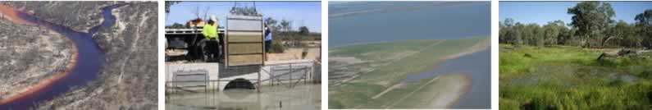

Web copy: ISBN 978-1-921733-08-6

Print copy: ISBN 978-1-921733-09-3

A publication of the Environment Protection and Heritage Council and the Natural Resource Management Ministerial Council.

© 2011

For bibliographic purposes this report may be cited as: Environment Protection and Heritage Council and the Natural Resource Management Ministerial Council (2011) National guidance for the management of acid sulfate soils in inland aquatic ecosystems, Canberra, ACT.

This work is copyright. You may download, display, print and reproduce this material in unaltered form only (retaining this notice) for your personal, non-commercial use or use within your organisation. Apart from any use as permitted under the Copyright Act 1968, all other rights are reserved. Requests and inquiries concerning reproduction and rights should be addressed to Commonwealth Copyright Administration, Attorney General’s Department, Robert Garran Ofﬁces, National Circuit, Barton ACT 2600 or posted at http://www.ag.gov.au/cca.

All images are copyright of the Department of Sustainability, Environment, Water, Population and Communities (and associated photographers) unless otherwise noted.

**Front cover images**

Acid sulfate soils in the Edward-Wakool River system  
(© Department of Environment, Climate Change and Water NSW, M Tulau)

Aerial view of Bottle Bend Lagoon, NSW after acidiﬁcation  
(© Murray-Darling Freshwater Research Centre, D Baldwin)

Managing water levels with a regulator (sluice gate), South Australia  
(© South Australian Murray-Darling Basin Natural Resources Management Board, C Nickolai)

Revegetation work, Lower Murray Lakes, South Australia  
(© Department of Environment and Natural Resources, SA)

Healthy inland aquatic ecosystem  
(© Murray-Darling Freshwater Research Centre, D Baldwin)

This document has been compiled using a range of source materials, and reasonable efforts have been made to ensure that its contents are factually correct. However, neither the member governments of the Environment Protection and Heritage Council and the Natural Resource Management Ministerial Council nor the organisations and individuals involved in compiling this document shall be liable for any loss or damage that may be occasioned, directly or indirectly, from the use of, or reliance on, the contents of this publication.

Your feedback on this guidance document is welcomed. Please e-mail Water.Quality@environment.gov.au and include ‘acid sulfate soils’ in the subject line of your e-mail.

Principal author—Dr Darren Baldwin, Murray Darling Freshwater Research Centre and CSIRO Land and Water

Edited by WordsWorth Writing Pty Ltd

Designed by Paper Monkey Graphic Design Pty Ltd

# Contents

Acknowledgements 2

Introduction 3

Overview of acid sulfate soils in inland aquatic ecosystems 6

How are they formed? 6

Why are they a problem? 7

Acidiﬁcation 7

Deoxygenation 7

Release of metals and metalloids 7

Damage to infrastructure 10

Impacts on people 10

How do we ﬁnd out if acid sulfate soils are present? 11

Rapid assessment 11

Detailed assessment 15

Distribution of acid sulfate soils in inland Australian aquatic ecosystems 17

New South Wales 17

Northern Territory 18

Queensland 18

South Australia 18

Tasmania 19

Victoria 19

Western Australia 20

Management and mitigation 21

Preliminary considerations 21

Adaptive management 22

Risk assessment 24

Management objectives 26

1. Minimising the formation of acid sulfate soils in inland aquatic ecosystems 27

2. Preventing oxidation of acid sulfate soils or controlled oxidation 28

3. Controlling or treating acidiﬁcation: neutralisation and/or bioremediation 29

4. Protecting connected ecosystems 35

5. Limiting further intervention 37

Communication 38

Aims 38

Key messages 38

Mechanisms for stakeholder engagement 39

Appendix 1: Terminology 40

Appendix 2: Resources 42

References 51

# Acknowledgements

**The Environment Protection and Heritage Council and the Natural Resource Management Ministerial Council acknowledge the contributions of the individuals listed below to the development of this guidance.**

**Chair**

Ms Chris Schweizer  
Department of Sustainability, Environment, Water, Population and Communities (Australian Government)

**Members**

Mr Col Ahern  
Department of Environment and Resource Management (Queensland)

Mr Dean Ansell   
Murray–Darling Basin Authority (Australian Government)

Dr Steve Appleyard  
Department of Environment and Conservation (Western Australia)

Dr Darren Baldwin   
Murray–Darling Freshwater Research Centre and CSIRO Land and Water

Dr Liz Barnett  
Department of Environment and Natural Resources (South Australia)

Ms Anthea Brecknell   
National Water Commission (Australian Government)

Dr Brad Degens  
Department of Water (Western Australia)

Mr Peter Donnelly  
Department of the Environment, Climate Change, Energy and Water (Australian Capital Territory)

Dr Rob Fitzpatrick   
CSIRO Land and Water

Mr Doug Fotheringham  
Department of Environment and Natural Resources (South Australia)

Ms Helen Gwilliam   
Department of Sustainability and Environment (Victoria)

Mr Rob Kingham   
Murray–Darling Basin Authority (Australian Government)

Mr Declan McDonald   
Department of Primary Industries, Parks, Water and Environment (Tasmania)

Mr Bernie Powell   
Department of Environment and Resource Management (Queensland)

Prof. Leigh Sullivan  
Southern Cross University

Mr John Williams   
Industry & Investment (New South Wales)

**Working Group**

Prof. Leigh Sullivan (Chair)  
Southern Cross University

Mr Dean Ansell Murray–Darling Basin Authority (Australian Government)

Dr Darren Baldwin  
Murray–Darling Freshwater Research Centre and CSIRO Land and Water

Dr Liz Barnett Department of Environment and Natural Resources (South Australia)

Ms Ebony Coote   
Department of Sustainability, Environment, Water, Population and Communities (Australian Government)

Ms Kim Forbes   
Department of Sustainability, Environment, Water, Population and Communities (Australian Government)

Mr Rob Kingham Murray–Darling Basin Authority (Australian Government)

Mr Bernie Powell   
Department of Environment and Resource Management (Queensland)

Ms Emma Warren   
Department of Sustainability, Environment, Water, Population and Communities (Australian Government)

**Peer review contributors**

Ms Chrisy Clay  
Southern Cross University

Mr Anthony Conallin  
Murray Catchment Management Authority

Dr David Jones  
Australian Government Environmental Research Institute of the Supervising Scientist

Dr Jodie Smith   
Geoscience Australia

Mr Phil Slessar   
North Central Catchment Management Authority

Mr Mitch Tulau   
Department of Environment, Climate Change and Water (New South Wales)

Dr Luke Wallace   
Geoscience Australia

Ms Kerry Whitworth   
Murray-Darling Freshwater Research Centre and LaTrobe University

The work of the National Water Commission in initiating research projects on wetland acidiﬁcation under the Raising National Water Standards Program is also acknowledged. In particular, the knowledge gained through the Minimising Environmental Damage from Water Recovery from Inland Wetlands project has contributed substantially to this national guidance.

# Introduction

This guidance document for the management of acid sulfate soils (ASS) in inland aquatic ecosystems is designed to guide the identiﬁcation and management of inland ASS to reduce or eliminate the risks they pose to the Australian environment and its economy.

The document has been developed in the context of the National Water Quality Management Strategy (NWQMS). The main objective of the NWQMS is to achieve sustainable use of the nation’s water resources by protecting and enhancing water quality while maintaining economic and social development.

The document is an authoritative reference for natural resource managers, planners, policy makers and other practitioners; it aims to help them understand the complexities associated with managing ASS, and describes how to manage ASS in a range of aquatic environments in a drying climate. The document should be considered in conjunction with relevant Commonwealth, state and territory legislation, policies and guidance.

ASS are soils or sediments that contain (or once contained) high levels of reduced inorganic sulfur (mostly as sulﬁde, elemental sulfur, or both); when exposed to oxygen, the soils or sediments undergo a chemical reaction that produces acid. Until recently, it had been assumed that ASS in Australia were largely restricted to the coastal regions. However, they have recently been identiﬁed in inland aquatic ecosystems, which include lakes, wetlands, creeks and rivers, and in drainage channels.

**Brief deﬁnition of terms used in connection with acid sulfate soils**

**Potential ASS (PASS**) —soils or sediments that contain sulﬁdes and with the potential to oxidise and become severely acidic

**Actual ASS (AASS)** —soils or sediments that once contained sulﬁdes but that have oxidised and become severely acidic

**Monosulﬁdic black oozes (MBOs)/monosulﬁdic materials**—readily mobilised and highly reactive sulﬁdic material

**Sulﬁdic sediments/material**—similar meaning to PASS, more precise deﬁnition

**Sulfuric material**—similar meaning to AASS, more precise deﬁnition

**Pyrite— (FeS2)** an iron sulﬁde mineral that is a common component of sulﬁdic material

*Complete definitions of these and other terms associated with ASS in aquatic ecosystems can be found in Appendix 1 (Terminology).*

If ASS are not managed appropriately, they may present a serious risk to the health of both the environment and humans and may affect other important assets (McCarthy et al. 2006; Baldwin and Fraser 2009; Ljung et al. 2009). For example, until this century, Bottle Bend Lagoon on the Murray River ﬂoodplain near Mildura was a typical, if slightly saline, billabong. In 2002, the wetland partly dried out. On reﬁlling, the pH of the water fell from about 8 to 3 (McCarthy et al. 2006), making it at least 3.5 pH units lower than is recommended for healthy aquatic ecosystems (ANZECC and ARMCANZ 2000). The pH in the wetland has remained extremely low, less than 3, ever since. The scientiﬁc consensus is that the severe decline in pH in the billabong was caused by the exposure and rewetting of ASS in the bed of the wetland.

ASS in inland aquatic ecosystems are an emerging issue of national importance. There are ASS in aquatic ecosystems in most Australian jurisdictions (see, for example, case studies in Fitzpatrick, Shand and Hicks 2010). Changes to land uses, hydrological regimes and the high demand for water are increasing the likelihood of the formation, accumulation, exposure and subsequent oxidation of sulﬁdes in ASS from inland aquatic ecosystems. If these soil materials or sediments remain under water and are not disturbed, there is a low risk of oxidation and subsequent impacts. However, if sulﬁdes in ASS are disturbed or oxidised, then acidiﬁcation, deoxygenation and the release of heavy metals may result. This in turn can result in negative impacts on:

* water quality
* biodiversity
* human health
* commercial and recreational ﬁsheries
* engineered structures
* community infrastructure
* agricultural productivity
* real estate values
* scenic amenity and tourism.

*See, for example, McCarthy et al. 2006; Hinwood et al. 2006; Groger et al. 2008; Ljung et al. 2009.*

The development and publication of the *National strategy for the management of coastal acid sulfate soils* (ARMCANZ, ANZECC and MCFFA 2000) and the *National cooperative approach to integrated coastal zone management framework and implementation plan* (NRMMC 2006) recognised that managing coastal ASS is an issue of national signiﬁcance.

However, by deﬁnition, the existing national strategy covers only the coastal zone and does not address the emerging problem of ASS in inland aquatic ecosystems. The difﬁculties in managing the complex problems associated with inland ASS, for example in the Lower Murray Lakes in South Australia and the Wheat Belt in Western Australia, have highlighted the need for appropriate guidance to better inform management and investment. In 2009, recognising the growing concern about the potential harmful effects of inland ASS and the lack of guidance on their management, the Environment Protection and Heritage Council and the Natural Resource Management Standing Committee endorsed the development of national guidance for inland aquatic ecosystems.

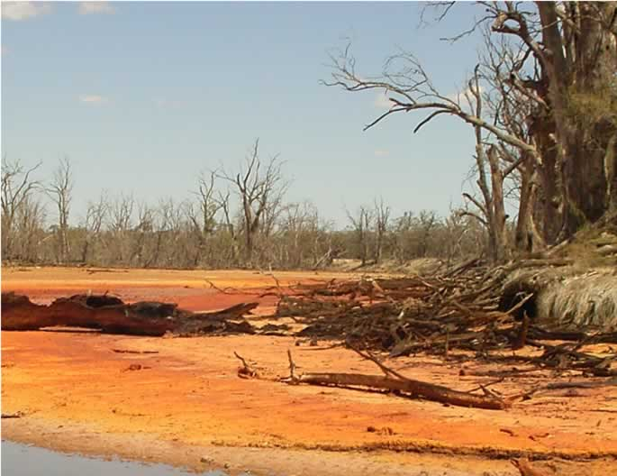

Bottle Bend Lagoon, NSW after acidification

© Murray-Darling Freshwater Research Centre, D.Baldwin

The Joint Steering Committee for Acid Sulfate Soils was established in 2009. It has jurisdictional and research institution representation and includes relevant policy and technical expertise. The committee, which is responsible for overseeing the development of national guidance on the assessment and management of ASS in inland aquatic ecosystems, commissioned this document. The document *Technical guidelines for assessment and management of inland freshwater areas impacted by acid sulfate soils* (Fitzpatrick, Shand and Hicks 2010) provided foundational information for this guidance document. This technical document provides a wide range of case studies summarising the available information on the properties and management of ASS and represents the spatial and temporal variability of ASS in inland Australian aquatic ecosystems.

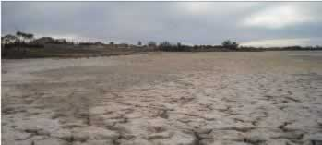

Lake Hawthorne, Victoria

(E. Coote)

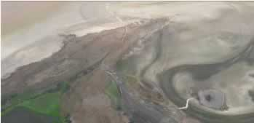

Management action at Currency Creek, Lower Murray Lakes, SA

© Department of Environment and Natural Resources SA

# Overview of acid sulfate soils in inland aquatic ecosystems

This section describes how ASS are formed, why they can be a problem, and how to identify them.

## How are they formed?

ASS formation requires a source of sulfate, metal ions and organic matter, inundation by water and low or no available oxygen.

Formation and accumulation of sulfides and extreme acidity in ASS are facilitated by land use and hydrology change.

A group of bacteria (sulfate reducing bacteria) use sulfate (SO4 2–) instead of oxygen in respiration, converting the sulphate to sulfide (S2–). The sulfide reacts with metal ions, especially iron, to produce a range of metal sulfide minerals, including mackinawite (FeS), greigite (Fe3S4) and pyrite (FeS2) (Rickard and Luther 2007).

This process, which can be described as sulfate reduction, occurs under anaerobic conditions—that is, in zones where there is no oxygen. Typically, submerged sediments in inland aquatic ecosystems have very little oxygen below the first few millimetres and can therefore be sites of sulfate reduction.

Until recently, it was assumed that the sulfate concentration in inland aquatic ecosystems was uniformly low. Therefore, sulphate reduction was not usually considered an important process in inland systems (Holmer and Storkholm 2001). However, seawater contains sulfate, and the salt found in the Australian landscape came mainly from ancient seawater brought inland with rain (Herczeg, Dogramaci and Leaney 2001).

Human activity, including land clearing and river regulation, has altered the hydrology and hydrogeology of many inland ecosystems.

Rising saline-groundwater tables, coupled with the mobilisation of salt in surface water flows, has led to the salinisation of many inland aquatic ecosystems. As saline groundwater naturally discharges to inland aquatic ecosystems, it is often the main source of salt entering these systems. Where there are high levels of salt in the landscape, we also find significant concentrations of sulfate and, in many cases, ASS (Sullivan, Bush and Ward 2002). Sources of sulfate in aquatic ecosystems include municipal wastewater, irrigation return water, groundwater and water from salt interception schemes. For the sulfate reduction process to occur, there also needs to be a source of organic matter. Therefore, ASS are most likely to be found in aquatic ecosystems that have an ample source of carbon, such as from riparian litter fall, algal blooms, aquatic plants or municipal wastewater.

(See Figure 1 and Figure 2 for conceptual models of these processes).

## Why are they a problem?

ASS pose a number of signiﬁcant risks such as those described below.

### Acidiﬁcation

When ASS are exposed to oxygen, they undergo a complex series of oxidation reactions that ultimately produces acid. If the amount of acidity produced by this oxidation process is greater than the system’s ability to absorb that acidity (the acid neutralising capacity) the pH of the system falls (for example, Bottle Bend Lagoon—see above).

### Deoxygenation

Because many aquatic ecosystems have a high capacity to neutralise acid, not all those containing sulﬁdic materials will acidify if the sediment is exposed to oxygen. However, this oxidation process consumes oxygen, and in extreme cases can remove all of the oxygen from the water column, resulting in the death of aquatic organisms. This is most likely to occur when highly reactive forms of sulﬁde, such as those found in monosulﬁdic black oozes, are physically disturbed and distributed throughout a water column (see, for example, Sullivan, Bush and Ward 2002; Sullivan, Bush and Fyfe 2002).

### Release of metals and metalloids

Oxidation of sulﬁdic materials may also lead to heavy metals (such as cadmium and lead) and metalloids (such as arsenic) becoming more available in the environment (Appleyard, Angeloni and Watkins 2006; Burton et al. 2008; Corkhill et al. 2008; Simpson et al. 2010). Many heavy metals and metalloids form sulﬁdic minerals. If those metal sulﬁdes are oxidised, the heavy metals or metalloids are released into the pore water or into the overlying water column, where they may be incorporated into animal or plant tissue and potentially into the food chain.

Alternatively, the acid produced by the oxidation of sulﬁde minerals can dissolve surrounding minerals, leading to the release of metals. For example, clays such as kaolinite can break down under acidic conditions to produce dissolved aluminium (Lottermoser 2007), which is toxic to many aquatic plants and ﬁsh (ANZECC and ARMCANZ 2000). Metal ﬂocs may also form, which are damaging or lethal to gilled organisms.

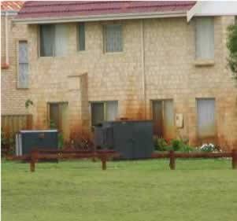

Metal release in the built environment, iron staining on house in Perth, WA

© Industry & Investment NSW, C.Clay

Figure Conceptual model of an inland aquatic ecosystem

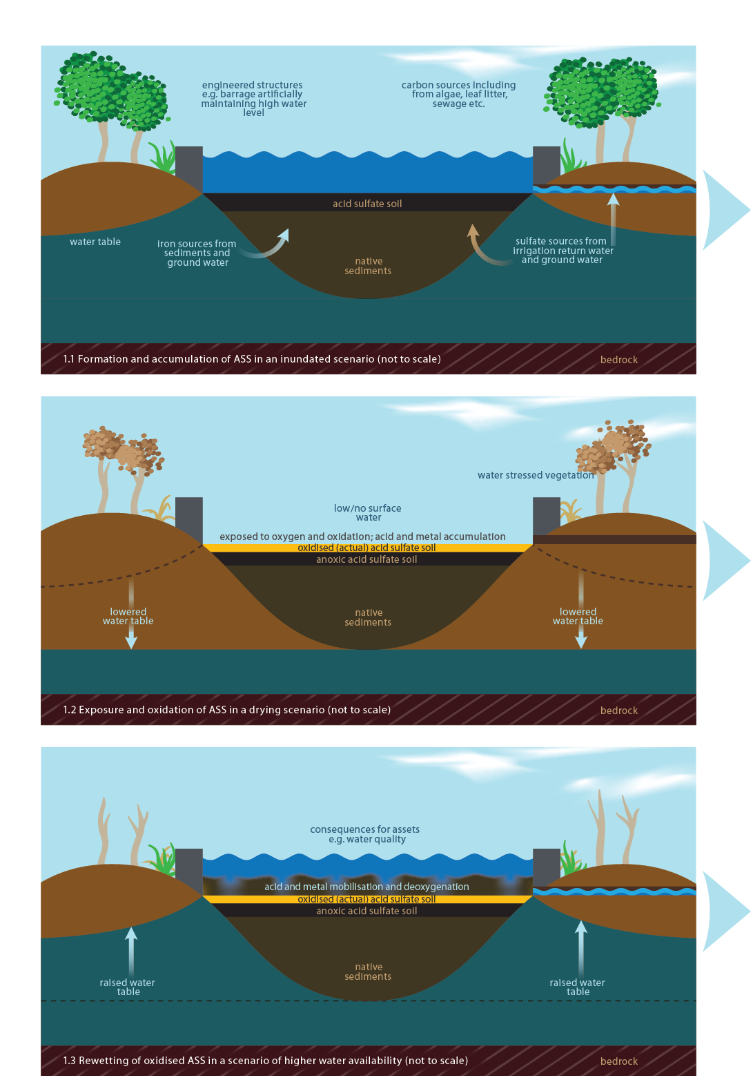

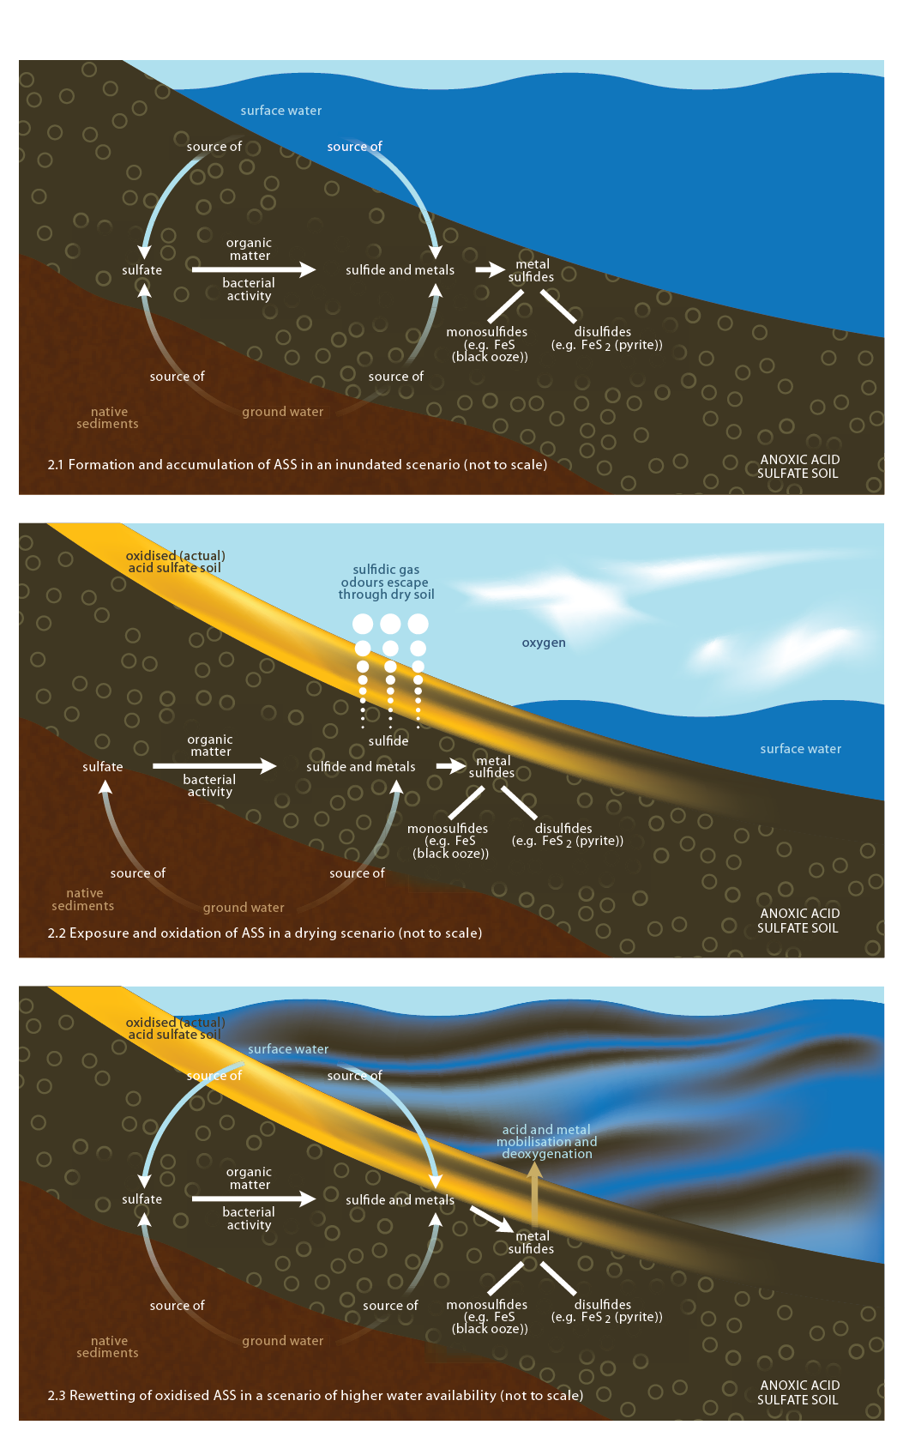Figure Conceptual model of an inland aquatic ecosystem (microscopic scale) with ASS in a consecutive sequence

### pic8

Concrete breakdown and iron corrosion on bridge abutment

Murray-Darling Freshwater Research Centre, D. Baldwin

### Damage to infrastructure

The integrity of concrete and steel structures such as weirs, bridge pylons and water regulators may be severely compromised as a result of the effects of ASS oxidation. Exposure to acid can lead to both metal corrosion and concrete dissolution (Groger, Harmer and Shultz 2008). Furthermore, if concrete is exposed to high levels of sulfate (the product of sulﬁde oxidation), formation of sulfate minerals in the concrete can cause cracking and spalling (breakdown) (Collepardi 2003) or loss of strength and potential ﬂuidisation (conversion from a solid to a ﬂuid-like state) (Macphee and Diamond 2003).

### pic9Impacts on people

The consequences of ASS oxidation may also have direct effects on people. The degradation of the environmental values of aquatic ecosystems due to ASS may limit their uses. The effects may include loss of amenity (preventing aquatic ecosystems being used for recreation), the generation of foul odours (including toxic hydrogen sulﬁde), and impaired drinking water quality (Hicks and Lamontagne 2006; Kinsela, Reynolds and Melville 2007; Ljung et al. 2009).

Public notification of risk

(E Coote)

## How do we ﬁnd out if acid sulfate soils are present?

The ﬁrst task in managing ASS is to determine whether they are present in a given aquatic ecosystem.

The level of detail required in the assessment process will be determined by such factors as:

* the extent of the hazard
* the potential or actual consequences of oxidation
* the importance of the aquatic ecosystem, connected aquatic ecosystems or the surrounding landscape or assets
* the availability of resources.

Conﬁrming that an aquatic ecosystem contains ASS can be expensive (thousands of dollars per site) and time consuming. Therefore, a two-stage approach is recommended for determining their presence or absence (Baldwin et al. 2007):

* a rapid assessment based on a number of simple observations and water quality analysis to determine the likelihood of an aquatic ecosystem containing ASS

and, if necessary

* a detailed assessment of those aquatic ecosystems that have a high likelihood of containing ASS, based on the rapid assessment.

### Rapid assessment

The rapid assessment phase for determining the presence of ASS in inland aquatic ecosystems is divided into two components:

a. a desktop assessment  
b. a site visit.

The ﬁrst part of the rapid assessment involves a desktop assessment of the aquatic ecosystem to identify whether the factors associated with the formation of ASS are likely to occur at that site. A desktop assessment requires recent knowledge of:

* *Water and sediment quality data*. If current water and/or sediment quality data is available, then screening criteria can be applied to determine if there is a likelihood of ASS presence (Table 1).
* *Flooding history*. If a wetland is known to undergo an annual wetting and drying cycle, there is a low likelihood that reduced inorganic sulfur in the sediment would build up enough to cause environmental damage if it were managed inappropriately (Figure 3). Therefore, such wetlands probably do not require detailed assessments.
* *Source of water.* Aquatic ecosystems that receive irrigation return water, municipal wastewater or water from a salt interception scheme are exceptions, as these sources of water all potentially contain high concentrations of sulfate.

Health and safety considerations are extremely important when conducting ASS assessments in the field.

Be aware of the possible presence of hazardous materials (for example, acid in the soil or water) and avoid skin and eye contact with them by wearing appropriate protective clothing and equipment (such as gloves, safety glasses or goggles, waders or gumboots) at all times.

**See also main ‘Health and safety’ section**.

Table Water and soil indicators of the potential for acid sulfate soils in inland aquatic ecosystems

| **Indicator** | **Value** |
| --- | --- |
| pH* | ‹ pH 4 in water and/or 1:5 soil:water extract |
| Conductivity (salinity) | › 1750 μScm–1 in water; › 400 μScm–1 in 1:5 soil:water extract |
| Sulfate | › 10 mg L-1 in water; › 100 mg L-1 in 1:5 soil:water extract for dry soil |

The second part of the rapid assessment involves a site visit. A site visit is *required* when there is not enough data of sufficient quality to make an assessment on the status of the aquatic ecosystem. A site visit is *recommended* to confirm the outcomes of the desktop assessment. Simple water and soil quality indicators (see also Table 1 and Figure 3) are used to screen aquatic ecosystems during the site visit:

***pH\****: If the pH measurement is less than 4 in the water or in dried exposed sediment, or a drop in the pH of freshly collected moist sediments to below pH 4 when kept moist and exposed to air (Sullivan et al. 2009a), there is a high likelihood of the presence of oxidised or oxidisable ASS.

*\* Measurement of pH may not necessarily be the best determinant of acidification—if practicable, field measurements of alkalinity or acidity should be under taken in conjunction with pH.*

***Conductivity (salinity)***: If salinity of the water column is greater than 1750 µS cm–1 or 400 µS cm–1 in a 1:5 water:soil extract, it has an increased likelihood of containing ASS (salt is a source of sulfate).

***Sulfate***: Sulfate in the water can also be measured directly. Aquatic ecosystems with more than about 10 mg L–1 of sulfate are more likely to contain ASS (Sullivan, Bush and Ward 2002). If the ecosystem is dry, any sulfide present when wet would have oxidised to sulfate during the drying process. To assess whether sulfides will re-form once the ecosystem is re-wet, the sulfate level in the exposed sediment should be assessed. If the concentration of sulfate in a 1:5 water:soil extract is greater than 100 mg L–1, sulfides are likely to re-form on inundation.

Other indicators may be useful in particular regions— for example, in the lower Murray River levels of alkalinity of less than 25 mg L–1 have been used to indicate disturbance of ASS in aquatic ecosystems (Fitzpatrick, Shand and Merry 2009). Similarly, in Western Australia, if an aquatic ecosystem has an acidity (measured by titration in the field) of greater than 40 mg L–1 as CaCO3 it is considered at risk (DEC 2009). This is because, while pH may remain constant, changes in these measures give an early warning that acidification processes are occurring.

The presence of ASS in aquatic ecosystems can also be indicated by either a salty or foul (rotten egg/metallic) odour or visual clues (see Figure 4).

The *Australian and New Zealand Guidelines for Fresh and Marine Water Quality* provide information on water quality trigger values for different regions of Australia, ecosystem types and uses of water and provide guidance on maintaining the environmental values of the area. Environmental values are particular values or uses of the environment that are important for a healthy ecosystem or for public benefit, welfare, safety or health and which require protection from the effects of pollution, waste discharges and deposits. See www.environment.gov.au/water/policy-programs/nwqms .

Figure Protocol for assessing the likelihood of an aquatic ecosystem containing acid sulfate soils

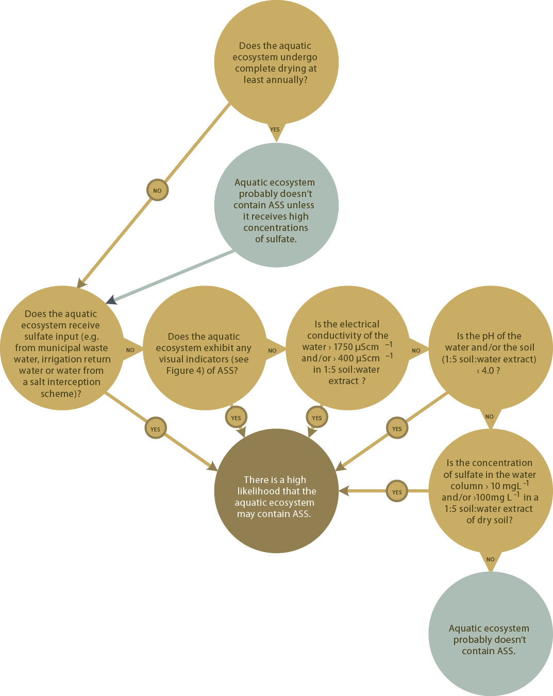

Source: Modified from Baldwin et al. 2007

Figure Visual indicators of oxidised acid sulfate soils

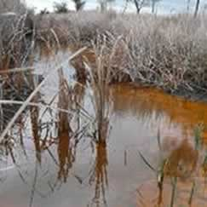

Vegetation changes— die-off, scalds, shift to only acid-tolerant species

(© South Australian Murray-Darling Basin Natural Resource Management Board, K Mason)

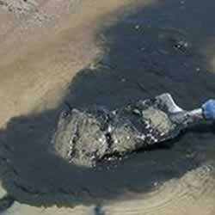

Subsurface black ooze

(© CSIRO, R Fitzpatrick)

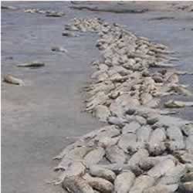

Lethal and sublethal effects on aquatic organisms (e.g. mass fish kills)

(© Murray-Darling Freshwater Research Centre, D Baldwin)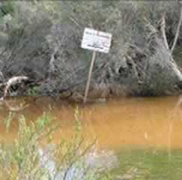

Water may have undergone a visible change to become murky and orange-brown, or less commonly, clear

(© Industry & Investment NSW, C Clay)

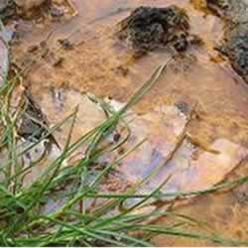

Oil-like slick on surface

(© CSIRO, R Fitzpatrick

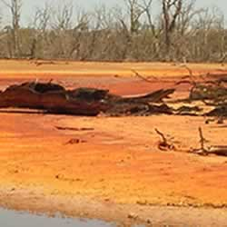

Exposed sediments are butter coloured or mottled yellow or orange

(© Murray-Darling Freshwater Research Centre, D Baldwin)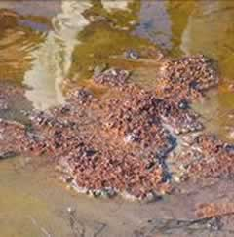

Deposit or coppery coloured scum covering edges / banks of aquatic ecosystem and debris

(E Coote)

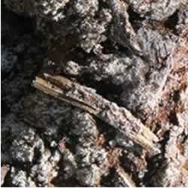

Salt crusts forming on surface

(© Industry & Investment NSW, C Clay)

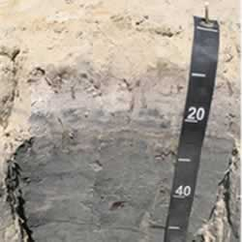

Underlying grey to black ASS under exposed sediments

(© CSIRO, R Fitzpatrick)

## Detailed assessment

If the results from the rapid assessment suggest a high likelihood of the aquatic ecosystem containing ASS, a detailed assessment is required to conﬁrm whether it contains ASS at levels that may cause harm if inappropriately managed.

A comprehensive framework exists for determining the extent and severity of ASS in coastal systems (see, for example, Ahern, Ahern and Powell 1998; Ahern, McElnea and Sullivan 2004; Tulau 2000); it can be adapted for application to inland aquatic ecosystems (Hall et al. 2006; MDBA 2010). The risk of acidiﬁcation of acid sulfate materials can be determined indirectly by an acid-base accounting approach (Ahern, McElnea and Sullivan 2004). Net acidity, a measure of the acid- producing capacity of the sediments (Ahern, McElnea and Sullivan 2004), is estimated as:

Net acidity = Potential sulﬁdic acidity + Actual acidity + Retained acidity – Acid neutralising capacity

Where:

* *Potential sulfidic acidity* is an estimate of the acidity that could be liberated after complete oxidation ofthe reduced inorganic sulﬁdes in the soil material.
* *Actual acidity* is current acidity and includes not only soluble acidity and acid adsorbed onto the soil particles (exchangeable acidity resulting fromoxidation of sulﬁdic materials), but also other sources of acidity such as organic acids.
* *Retained acidity* represents the ‘less available’ forms of the existing acidity that may be released by hydrolysis of relatively insoluble sulfate minerals, such as jarosite (Ahern, McElnea and Sullivan 2004).
* *Acid neutralising capacity* is the soil’s ability to neutralise the released acid. In practice,the measured acid neutralising capacity is modiﬁed by a fineness factor to discount the neutralising capacity of larger particles of carbonates such as shell fragments. In coastal systems, the measured acid neutralising capacity is usually divided by a *ﬁneness facto*r of ≥ 1.5.

Sediments with a net acidity of more than 18 moles of H+ t–1 of soil trigger the requirement for detailed ASS assessment, but only if that acidity is sulﬁde- related acidity and not simply naturally occurring organic acid acidity (Ahern, McElnea and Sullivan 2004). However, this value may not be applicable in all circumstances. For example, a lower net acidity trigger value is being canvassed in Western Australia due to that state’s poorly buffered sands, but further work is required to determine its practical application (B Powell, 2010, pers. comm.).

Before you undertake a detailed assessment of the presence of ASS in an inland aquatic ecosystem, you are strongly advised to seek advice on appropriatesampling design and analytical framework from a practitioner with ASS experience.

### Murray–Darling Basin Authority: Assessment of wetlands for acid sulfate soils

The Murray-Darling Basin Authority is currently assessing ASS in wetlands throughout the Murray–Darling Basin using a more comprehensive version of the two-stage approach, with the level of assessment for each wetland (or other type of selected inland aquatic ecosystem) determined through a prioritisation process ( MDBA 2010 ).

The project involves the selection of wetlands of environmental signiﬁcance, as well as those that may pose a risk to surrounding waters. These wetlands are then subjected to a tiered assessment program: a desktop assessment stage, followed by a rapid on-ground appraisal, and then a detailed on-ground assessment if the results of previous stages indicate an increased likelihood of occurrence of ASS.

The level of risk is then assessed at those wetlands where ASS are determined to be a priority concern at the wetland scale, and management and remediation options are identiﬁed. This approach aims to concentrate scientiﬁc effort and expertise on sites where ASS are present and pose the greatest risk.

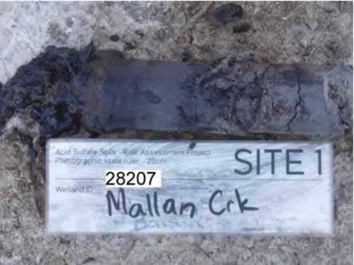

MDBA visual record of sampled site, soil profile Mallan Creek, NSW

(© Department of Environment, Climate Change and Water NSW, M. Tulau)

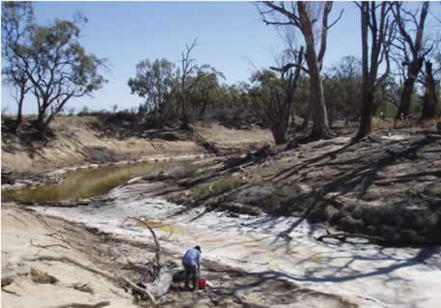

MDBA Rapid assessment in the Edward-Wakool River system, NSW

(© Department of Environment, Climate Change and Water NSW, M. Tulau)

# Distribution of acid sulfate soils in inland Australian aquatic ecosystems

ASS have been identified in inland aquatic ecosystems throughout Australia. They occur in inland ecosystems that have been affected by salt, either from groundwater or surface water.

Information about the occurrence of ASS in inland aquatic ecosystems in each state and territory is provided below. However, as more studies are undertaken, the recorded incidence of ASS is likely to increase. A key resource for managers interested in the distribution of ASS in inland Australia is the Atlas of Australian Acid Sulfate Soils. It is a web-based tool with a nationally consistent legend, which provides information about the distribution and properties of both inland and coastal ASS across Australia (Fitzpatrick, Powell and Marvanek 2008). The atlas, which is available on ASRIS (Australian Soil Resource Information System: [www.asris.csiro.au/](http://www.asris.csiro.au/) ) is a constantly evolving national map of available ASS information and is the product of contributions from all states and territories in Australia.

## New South Wales

ASS have previously been surveyed in New South Wales by Hall and others (2006), who surveyed 80 wetlands, confirmed that 10 definitely contained ASS, and found that 7 potentially contained ASS. Most of these wetlands were along the Murray River and its floodplains (including Bottle Bend Lagoon).

The Murray–Darling Basin Authority Acid Sulfate Soil Risk Assessment Project, carried out in 2008 and 2009, examined 444 wetland sites throughout New South Wales. That work confirmed that the highest concentration of ASS is along the Murray River and its floodplains, from Albur y, in New South Wales, to near the South Australian border. The project also identified ASS in Ramsar wetlands in New South Wales (MDBA 2010). However, their presence is limited, and only the Fivebough and Tuckerbil swamps are considered to contain enough ASS to warrant further investigations to determine the specific hazard and risk posed by them.

Substantial areas of the Edward–Wakool river system between Deniliquin and Kyalite in southern New South Wales have also been shown to contain ASS (Baldwin 2009; Gilligan, Vey and Asmus 2009); on partial drying, the pH in pools of the Wakool River fell to as low as 3.3 (Gilligan, Vey and Asmus 2009).

Isolated occurrences of ASS have also been identified in the Lachlan, Murrumbidgee and Darling River systems, particularly the Menindee Lakes and the Great Darling Anabranch.

## Northern Territory

In the Northern Territory, most rivers are ephemeral and sulfate levels are low, so there is little opportunity for any ASS formed to accumulate. There is an example of inland ASS for the Magela Creek ﬂoodplain in the Alligator Rivers Region of the Northern Territory (Willet 2008).

## Queensland

ASS do not appear to be widely distributed in inland Queensland. There is acidic shallow groundwater along the margins of the Griman Creek Formation in the Lower Border Rivers and Lower Balonne River catchments. This formation is predisposed to acid saline groundwater and ASS formation in the excavated channels. Although ASS have been identiﬁed in this region, the level of risk has not been quantiﬁed.

ASS have been found in efﬂuent ponds and in several north-draining streams and wetlands just north of the Granite Belt, in the uppermost reaches of the Condamine River catchment. Many wetlands in Queensland may contain ASS, but in small amounts compared with the neutralising capacity of the ecosystems. Furthermore, in more arid areas in western Queensland, the wetlands dry out regularly, so any accumulation of ASS would be temporary.

## South Australia



ASS appear to be widely distributed in aquatic ecosystems in South Australia, including river and creek channels (for example, the Murray and Finniss Rivers and Currency Creek), lakes (including Lake Alexandrina, Lake Albert and Lake Bonney), numerous wetlands and billabongs along the Murray River corridor, evaporation basins, seepages overlying mineralised zones, groundwater systems and drains (Fitzpatrick, Shand and Merry 2009; Fitzpatrick, Shand and Hicks, 2010).

Low water levels and subsequent exposure and oxidation of ASS have resulted in soil acidiﬁcation, and more localised water acidiﬁcation and metal mobilisation (see, for example, Fitzpatrick, Shand and Hicks 2010; Simpson et al. 2010), most notably in the Ramsar site that includes Lake Albert and Lake Alexandrina and its tributaries, Currency Creek and the Finniss River.

In Loveday Bay, a small bay in southern Lake Alexandrina, water levels in summer and autumn 2009 remained low enough to keep this area disconnected from the main lake body. However, from July 2009, with winter rains, water ﬂowed over and through the ASS and collected in the areas of depression, resulting in very acidic water (pH 2.5 to 2.8) covering more than 200 hectares (Fitzpatrick, Shand and Hicks 2010). Several hundred hectares of ASS in Currency Creek and wetlands of the Finniss River were exposed during the summer of 2009. Following rewetting in autumn and winter, acidic pools of water (pH ‹ 4) formed within Currency Creek and Finniss wetlands. To counter the acidiﬁcation risks, the South Australian Government, with investment from the Australian Government, has implemented several management actions, including managing water levels with temporary regulators and neutralising acidity via bioremediation and dosing acidic water with ultraﬁne limestone.

## 

## Tasmania

Monosulﬁdic black oozes have been observed in salt lakes in the southern midlands, and a few sites with sulfuric and sulﬁdic horizons have been found in inland peatlands and river ﬂoodplains in the north- east and north-west.

Current studies and mapping being undertaken by staff from Department of Primary Industries, Parks, Water and Environment (DPIPWE) have reﬁned and improved the previous inland Acid Sulfate Soil mapping by using more detailed base data sets and desktop geographic information system (GIS) techniques. Field investigations are currently underway to conﬁrm the ﬁndings of the GIS output and work to date has conﬁrmed that at least one highland Ramsar marshland site at Interlaken does contain sulﬁdic materials and qualiﬁes as an ASS.

Tasmania has deﬁned its inland ASS as those non-coastal ASS areas located above 20 m Australian Height Datum (AHD). This elevation limit reﬂects the known upper extent of coastal marine Holocene deposition in the state. The Atlas of Australian Acid Sulfate Soils uses a different methodology; it deﬁnes inland ASS as non-coastal landscapes located above 10 m AHD.

## Victoria

ASS have been identiﬁed in salt scalds in the Eastern Dundas Tablelands (Fawcett, Fitzpatrick and Norton 2008), in saline groundwater disposal basins and drainage basins including Psyche Bend Lagoon, Lake Ranfurly, and a number of the Kerang Lakes. ASS have also been identiﬁed in the Corangamite Catchment Management Authority region (Fitzpatrick et al. 2007).

Sulﬁdic sediments have been identiﬁed in salt lakes of inland Victoria including Lake Tyrrell (Welch, Beavis and Somerville 2004). Sulﬁdic, acidic groundwaters that outcrop at the land surface have also been identiﬁed in northern Victoria (Macumber 1991). More recently, sulfuric materials have been observed following exposure of sediments in drought-triggered acidiﬁcation events in the Loddon River and Burnt Creek in central Victoria during 2009 (Thomas et al. 2009).

The Murray-Darling Basin Authority Acid Sulfate Soil Risk Assessment Project (MDBA 2010) found sulﬁdic materials (generally in lesser quantities) in Victorian Ramsar-listed wetlands within the basin. While sulﬁdic sediments were found in some wetlands in the Kerang Lakes at levels that warrant further investigation, other Ramsar-listed wetlands have been wet and dried repeatedly in the past without obvious development of acidic conditions or other associated impacts.

As part of the MDBA’s project, rapid assessments were also conducted at 378 sites across northern Victoria. Detailed assessments are planned for 16 of these sites.

## Western Australia

ASS are an important management issue for the groundwater-dependent wetlands and damplands on the Swan and Scott coastal plains (Appleyard et al. 2004; Appleyard and Cook 2009; Hinwood et al. 2006; Degens and Wallace-Bell 2009). Although the sulfate in these systems is likely to have been derived from marine salts in the landscape, the distribution of ASS is governed by groundwater ﬂow patterns and biological processes at the water table (Appleyard et al. 2004).

ASS occur within sandy and peaty materials at or just below the water table in regionally extensive, shallow aquifers (see, for example, Degens and Wallace- Bell 2009) across more than 100 000 hectares of upland areas. Sandy soil materials, in particular, are very poorly buffered (that is, they have little acid neutralising capacity), and pyrite contents at or below current detection limits can trigger groundwater acidiﬁcation (a major issue for management).

There is some evidence on the Swan coastal plain that the deposition of sulfate aerosols from air pollution could be a signiﬁcant source of sulfate for the growth of pyrite in sediments. Groundwater contamination by arsenic has been recorded, resulting from the oxidation of arsenic-containing pyrite (Appleyard, Angeloni and Watkins 2006).

Signiﬁcant ASS accumulations are known to occur in some inland waterways in association with eutrophication issues (for example, the Avon River). Extensive areas of the wheat belt of Western Australia are affected by rising saline groundwater, some of which is acidic or can create the conditions for sulﬁde accumulation (Shand and Degens 2008).

Over a quarter of a million hectares of valley ﬂoors in the wheat belt are inﬂuenced by shallow saline groundwater that is acidic (pH ‹ 4 to as low as pH 2.8), but that acidity is caused by the oxidation of dissolved iron mobilised in the groundwater rather than ASS (Shand and Degens 2008). To mitigate the effects of rising saline groundwater, extensive deep drainage channels have been dug to intercept the groundwater and divert it from farmland to disposal lakes and drainage lines.

Secondary salinised waterways, lakes and wetlands have also been acidiﬁed in recent years by discharges of acidic saline groundwater as water tables continue to rise across most of the Western Australian wheat belt. At the time of publication, the acidity in groundwater and groundwater drain discharge affects baseﬂow water quality in over 300 km of inland waterways in Western Australia (Department of Water 2009).

Substantial amounts of ASS may be formed in drainage channels and receiving aquatic ecosystems, secondary salinised lakes and ﬂoodplains by acidic groundwater discharge if there is a source of iron from the surrounding landscape. This may result in substantially more acidity in the sediments of these aquatic ecosystems than in the overlying water column (Degens 2009). These ASS present a potentially increasing threat in a drying climate, when increased evaporation causes water tables to fall and exposes ASS to the atmosphere and oxidation.

# Management and mitigation

This section explores approaches that may be useful in mitigating the effects of ASS in inland aquatic ecosystems. However, these approaches may only be appropriate for a specific range of situations.

### National Water Commission: Minimising environmental damage from water recovery from inland wetlands

Recognising the significant issue of acidification in Australia’s inland wetlands, the National Water Commission, under the Raising National Water Standards program, is funding this three-year research project to determine appropriate management and mitigation strategies for inland wetlands.

The work, being undertaken by the NSW Murray Wetlands Working Group and the Murray–Darling Freshwater Research Centre, is determining the effectiveness of practical, cost- effective and sustainable remediation methods. This includes soil ripping, the introduction of aquatic vegetation, burning of organic material and chemical ameliorants. Additionally, at the national level, the project contributes substantial knowledge about the nature of ASS and explores best-practice approaches to minimisation and management of ASS in inland Australian wetlands.

The project outcomes, due for release in 2011, will include scientific and practical advice for a range of stakeholders. An action decision support tool is already available (see above) to guide stakeholders in selecting the most appropriate management options for their circumstances.

A particular approach or combination of approaches may be necessary, depending on the conditions in each aquatic ecosystem. Some tools are available to help with these choices, including a decision support tool for managing sulfidic sediments in inland aquatic ecosystems (see [www.mdfrc.org.au/resources/biogeochemistry/ActionSupportTool.Htm](http://www.mdfrc.org.au/resources/biogeochemistry/ActionSupportTool.Htm) ). This tool was developed as part of the National Water Commission’s Minimising Environmental Damage from Water Recover y from Inland Wetlands project (Baldwin 2010). Other relevant resources are listed in Appendix 2.

## Preliminary considerations

ASS in aquatic ecosystems and in some coastal environments (Rosicky, Sullivan and Slavich 2004; Burton, Bush and Sullivan 2006a) can form in situ over a relatively short period (months to years). In many cases, the formation of ASS will be a secondary symptom of a system already under stress, typically through elevated sulfate levels (from salinisation) and unnaturally long periods of inundation (Hall et al. 2006).

Therefore, restoration of the environmental values of ASS-affected aquatic ecosystems requires not only the alleviation of the symptoms, but also a substantial effort to address the underlying causes. In most instances, addressing the symptoms alone will result in only a short-term benefit—if the underlying causes are not addressed, the problem will recur. Therefore, in all cases where ASS are present, it is important to identify the source or sources of sulfate, as that understanding will underpin and inform long-term management.

The overall goals of restoration activity must be considered in any restoration work (Baldwin and Fraser 2009). Those goals can often be divided into two generic objectives:

* protection and/or restoration of the affected aquatic ecosystem to maintain or improve its environmental values
* protection of connected aquatic ecosystems (or other parts of the environment) from the adverse effects associated with disturbed ASS.

In many cases, achieving the ﬁrst objective may also achieve the second.

When considering the impacts on receiving waters or other parts of the environment, it is important to examine the potential for multiple interconnections, particularly the coupling between groundwater and overland ﬂows (Johnston, Slavich and Hirst 2004). This is especially relevant for aquatic ecosystems covered by international conventions, such as the Ramsar Convention, and state or Commonwealth legislation, such as the *Environment Protection and Biodiversity Conservation Act 1999*.

## Adaptive management

Any ASS management activity should be conducted within an adaptive management framework because of the uncertainties around the effective management of ASS in inland aquatic ecosystems. Adaptive management is ‘a systematic process for continually improving management policies and practices by learning from the outcomes of operational programs’ (Bennett and Lawrence 2002). The process involves a number of steps (see Figure 5):

* identifying the problem or potential threat through an assessment of current condition including potential for management action
* identifying appropriate management options or activities to avoid or mitigate the problem or potential threat
* predicting how management interventions will affect the current problem or threat
* implementing the activity
* monitoring the outcomes of the activity at the appropriate spatial and temporal scale
* evaluating the outcomes of the activity against the predicted responses
* reﬁning the management options based on the evaluation.

Figure Adaptive management framework

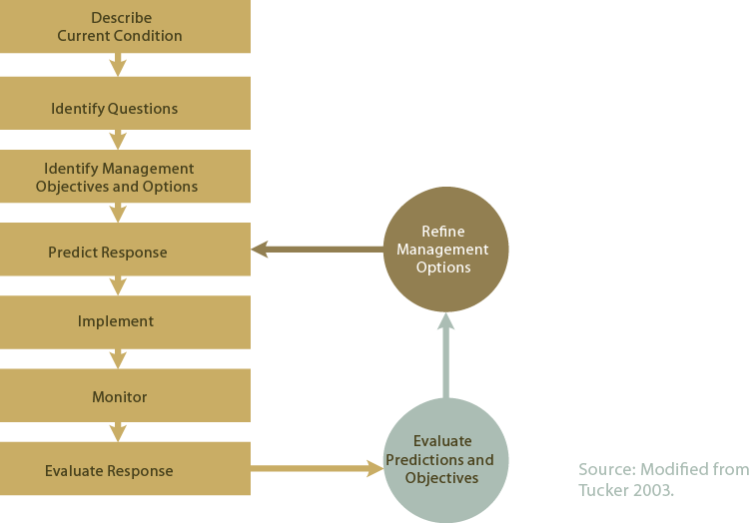

Research, monitoring and evaluation are important parts of the adaptive management cycle. Research and monitoring programs play a role both in describing the current condition of the environment of interest (that is, gathering baseline data to determine whether management intervention is required) and in determining the impact or otherwise of the management intervention. It is critical to clearly articulate research and monitoring objectives and questions, and to base programs on agreed conceptual models of how systems work and predicted responses to an imposed management action.

Each area of ASS may behave and respond differently to oxidation and consequent management action. Research and monitoring provide crucial information for the development of acidiﬁcation trigger levels on which to base risk assessments (see box ‘Real-time management strategy to avoid acidiﬁcation in the Lower Murray Lakes’ for trigger levels established for that aquatic ecosystem). Other examples of monitoring strategies following the disturbance of ASS in inland ecosystems are given in Fitzpatrick, Shand and Hicks (2010). *The Australian Guidelines for Water Quality Monitoring and Reporting* provide generic guidance on monitoring and reporting.

### Real-time management strategy to avoid acidiﬁcation in the Lower Murray Lakes

In November 2008, the Murray–Darling Basin Authority endorsed a real-time management strategy to avoid acidiﬁcation in the Lower Murray Lakes. The strategy is based on monitoring pH, alkalinity and water levels. Complex hydrodynamic and geochemical modelling (Hipsey and Salmon 2008 ; Hipsey et al. 2010) predicted that a water level in the range of 1.5 m below sea level for Lake Alexandrina and 0.5 m below sea level for Lake Albert would pose a high risk of acidiﬁcation.

Changes in alkalinity to below 25 mg L-1 (expressed as CaCO3) further indicate the need for a management response before pH of 6.5 is reached (the minimum NWQMS guideline value for aquatic ecosystems in South Australia).

Extensive research and monitoring is occurring in the Lower Murray Lakes with the results feeding back into an adaptive management framework (see Figure 5).

As a consequence, the Lower Murray Lakes management strategy can be reﬁned to consist of a combination of management actions if trigger levels are approached.

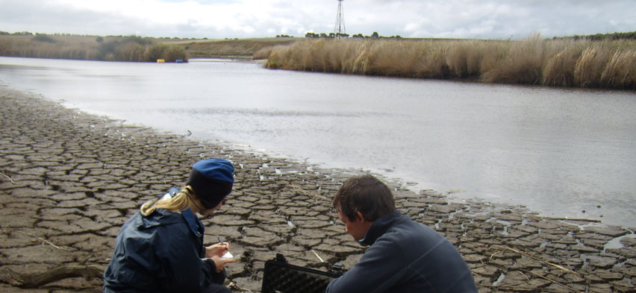

Monitoring at the Lower Murray Lakes, SA

(© Department for Environment and Natural Resources SA)

**Consequences**

|  |  |
| --- | --- |
| Descriptor | Deﬁnition |
| Extreme | Irreversible damage to the environmental values of an aquatic ecosystem and/or connected waters/other parts of the environment; localised species extinction; permanent loss of water supplies |
| Major | Long-term damage to environmental values and/or connected waters/ other parts of the environment; signiﬁcant impacts on listed species; signiﬁcant impacts on water supplies |
| Moderate | Short-term damage to environmental values and/or connected waters/ other parts of the environment; short-term impacts on species |
| Minor | Localised short-term damage to environmental values and/or connected waters/other parts of the environment; temporary loss of water supplies |
| Insigniﬁcant | Negligible impact on environmental values and/or connected waters/ other parts of the environment; no detectable impacts on species |

**Likelihood**

|  |  |
| --- | --- |
| Descriptor | Deﬁnition |
| Almost certain | Disturbance is expected to occur in most circumstances |
| Likely | Disturbance will probably occur in most circumstances |
| Possible | Disturbance might occur at some time |
| Unlikely | Disturbance could occur at some time |
| Rare | Disturbance may occur only in exceptional circumstances |

Modified from MDBA 2010

## Risk assessment

The appropriate management of ASS in inland aquatic ecosystems should involve and be guided by a risk assessment. The Murray–Darling Basin Authority has developed a risk assessment framework for ASS in inland wetlands through its Acid Sulfate Soils Risk Assessment Project (MDBA 2010). That protocol could be adopted for other inland aquatic ecosystems in Australia.

### Step 1: Deﬁne the hazards

Once ASS have been identiﬁed at a site, the ﬁrst step is to deﬁne the hazards posed by the material. Although we can describe generic hazards (such as acidiﬁcation and deoxygenation), the type and magnitude of the risk will vary between sites and will need to be assessed for each site. This can only be done through detailed ﬁeld and laboratory assessment of each site (MDBA 2010;Fitzpatrick, Shand and Hicks 2010).

### Step 2: Calculate the risk

After the hazards have been quantiﬁed, the risk posed by the hazards can be determined. Risk is a function of the consequences of a hazard’s occurrence and the likelihood of that occurrence. Consequences will vary according to the environmental values of the aquatic ecosystem. Once the consequences and likelihood of disturbance have been determined, it is possible to determine the risk associated with disturbance.

HAZARD —‘a situation that in particular circumstances could lead to harm’

RISK—‘the chance, within a time frame, of an adverse event with speciﬁc consequences occurring’

(Burgman 2005, pp. 437, 449)

#### Risk

|  |  |  |  |  |  |
| --- | --- | --- | --- | --- | --- |
| **Likelihood category** | **Consequence category** | | | | |
| **Extreme** | **Major** | **Moderate** | **Minor** | **Insignificant** |
| **Almost certain** | Very high | Very high | High | High | Medium |
| **Likely** | Very high | High | High | Medium | Medium |
| **Possible** | High | High | High | Medium | Low |
| **Unlikely** | High | Medium | Medium | Low | Low |
| **Rare** | High | Medium | Medium | Low | Low |

Source: MDBA 2010.

The assessed degree of risk inﬂuences what actions to take when:

* *High or very high risk*—needs immediate action and the development of an ASS management plan
* *Medium risk*—needs development of an ASS management plan and may need action
* *Low risk*—needs monitoring at appropriate intervals to determine whether the hazard is increasing.

**Assessing risks**

* What might happen?
* What is the likelihood that it will happen?
* How serious will it be if it does happen (that is, the consequence)?
* How can I plan to avoid or minimise any consequences?

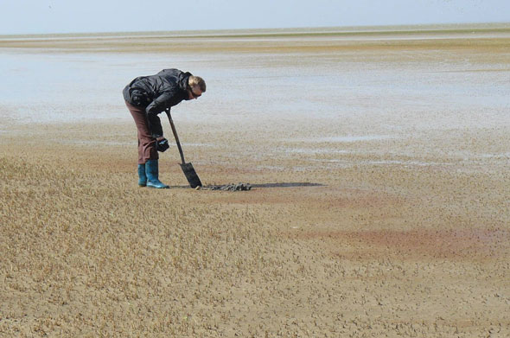**Health and safety**

Both you and your employer are responsible for occupational health and safety under relevant legislation, policy and procedure.

In assessing and managing ASS, you could be exposed to hazardous materials:

* ASS are hazardous materials
* Some management actions involve using hazardous materials such as caustic substances.

Lake Alexandrina, Lower Murray Lakes, SA

(© Department for Environment and Natural Resources SA)

You must follow safe work practices whenever you expect to come into contact with hazardous materials. Prevent hazardous materials coming into contact with skin or eyes by wearing appropriate protective clothing and equipment, including gloves, safety glasses or goggles, waders or gumboots, at all times.

You should identify any potential or actual risks to the public and minimise or avoid those risks through, for example, appropriate communication.

Other health and safety risks to you or the public may arise from digging soil inspection pits and from being exposed to hydrogen sulﬁde gas.

## Management objectives

In determining the most appropriate management objectives and activities for your circumstances, you must consider the environmental values of the area and seek appropriate advice and approvals (see Appendix 2). You should also conduct a risk assessment of any management action.

There is a hierarchy of management objectives for managing ASS in inland aquatic ecosystems:

1. Minimising the formation of ASS in inland aquatic ecosystems
2. Preventing oxidation of ASS, if they are already present in quantities of concern; or controlled oxidation to remove ASS if levels are a concern but the water and soil has adequate neutralising capacity
3. Controlling or treating acidiﬁcation if oxidation of ASS does occur
4. Protecting connected aquatic ecosystems/other parts of the environment if treatment of the directly affected aquatic ecosystem is not feasible.

Finally, in some instances it may not be practical or even sensible to undertake any active intervention (for example in a pond used as part of a salt interception scheme), in which case the management objective is:

1. Limited further intervention.

Table Summary of management objectives and possible activities

| **Management objective** | **Activities** |
| --- | --- |
| Minimising the formation  of ASS in inland aquatic  ecosystems | Reduce secondary salinisation through:   * Lowering saline water tables * Maintaining the freshwater lens between saline groundwater and the aquatic ecosystem * Stopping the deliver y of irrigation return water * Incorporating a more natural ﬂow regime |
| Preventing oxidation of ASS or controlled oxidation to  remove ASS | Preventing oxidation:   * Keep the sediments covered by water * Avoid ﬂow regimes that could re-suspend sediments   Controlled oxidation:   * Assess whether neutralising capacity of the sediments and water far exceeds the acidity produced by oxidation * Assess the risk of deoxygenation and metal release. Monitor intervention and have a contingency plan to ensure avoidance of these risks |
| Controlling or treating  acidiﬁcation | * Neutralise water column and/or sediments by adding chemical ameliorants * Add organic matter to promote bioremediation by micro-organisms * Use stored alkalinity in the ecosystem |
| Protecting adjacent or  downstream environments  if treatment of the  affected aquatic ecosystem  is not feasible | * Isolate the site * Neutralise and dilute surface water * Treat discharge waters by neutralisation or biological treatment |
| Limited further intervention | * Assess risk * Communicate with stakeholders * Undertake monitoring * Assess responsibilities and obligations and take action as required |

Note: The range of activities to be undertaken is dependent on the site and the risk it poses to the environment.

### 1. Minimising the formation of acid sulfate soils in inland aquatic ecosystems

Clearly, the best option for managing inland ASS is to prevent the build-up of harmful levels of ASS in the ﬁrst place. This requires either ensuring that conditions do not favour sulﬁde formation or ensuring that large stores of ASS are not allowed to accumulate in the aquatic ecosystem.

Sulﬁde formation in sediments is a natural process and occurs in a diverse range of undisturbed environments. What has changed in many of our inland aquatic ecosystems is their sulfate loading, their water ﬂow regime, or both. As we have increased the mobilisation of salts in the landscape, we have also increased the discharge of those salts (including sulfate) to surface environments. Therefore, any activity that reduces the risk or extent of secondary salinisation of an aquatic ecosystem will reduce the potential for the formation of ASS. Such activities can include lowering saline water tables, maintaining a freshwater lens between saline groundwater and the aquatic ecosystem, or stopping the deliver y of saline surface water (such as irrigation return water) to the aquatic ecosystem.

A complementary course of action to prevent the excessive build-up of sulﬁde in sediments is to reinstate a more natural ﬂow regime in the system— in particular, by allowing naturally ephemeral systems (including creeks and wetlands) to periodically dry out. More frequent wetting and drying cycles will limit the accumulation of sulﬁdic materials during wet phases and thereby reduce the environmental hazard. This approach presupposes that sulﬁdic material is not already present in quantities that can cause ecological damage if the material partially dries. To reinstate a more natural drying regime in creeks or wetlands, it may be necessary to install regulators to limit ﬂows from rivers into those systems. However, because river height can inﬂuence groundwater levels in adjacent wetlands, installing a regulator to stop surface water ﬂow while maintaining a high river level may not lead to complete drying of a wetland and may, in fact, lead to the incursion of saline groundwater into the wetland.

The frequency and duration of drying events required to limit the formation of ASS will depend on a number of factors, but mainly on the rate of formation of ASS in the aquatic ecosystem. That rate will be determined by such factors as the rate of delivery of sulfate and organic matter to the sediment. Laboratory tests suggest that, under ideal conditions, high levels of sulﬁdic material can be produced in sediments in less than one month (Mitchell 2002).

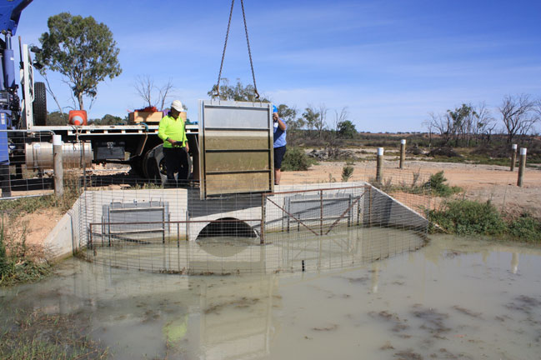

Managing water levels with a regulator (sluice gate), SA

(© South Australian Murray-Darling Basin Natural Resources Management Board, C Nickolai)

**Oxidation of sulﬁdes in sediments**

The rates and pathways for oxidation of sulﬁdes in sediments depend on the sediment mineralogy. For example, mackinawite (FeS) —the principal iron-sulﬁde phase associated with monosulﬁdic black ooze (Burton, Bush and Sullivan 2006b) —undergoes rapid oxidation (in hours) to elemental sulfur after dispersal in the water column.

This initial oxidation phase results in a substantial decrease in the oxygen concentration in the overlying water column, but has no effect on pH. The second oxidation phase, of the elemental sulfur to sulfate, is slightly slower (days) but produces substantial acidity.

The oxidation of iron pyrite (FeS2) also produces acid, but that process can be substantially slower (months or longer; see, for example, Ward, Sullivan and Bush 2002) than the oxidation of FeS following exposure to oxygen.

However, large reserves of acid in the sediments can be released if drying wetlands and waterways have incised channels into which acidic groundwaters seep. Acidic salts accumulate by evaporation on the banks of channels and can be readily dissolved and discharged into downstream waterways after rain.

### 2. Preventing oxidation of acid sulfate soils or controlled oxidation

Most of the environmental damage that can occur from ASS (such as acidiﬁcation, metal mobilisation, and deoxygenation) is caused when sulﬁdes are oxidised, so the simplest management option is to prevent the sulﬁde from oxidising.

One of the simplest ways of preventing oxidation is to maintain a sufﬁcient depth of water over the ASS materials. The low solubility of oxygen in water helps maintain a low-oxygen environment near the reactive mineral surfaces of ASS. For this to be effective, there should be little water turbulence. This avoids sediments on the bottom of the aquatic ecosystem being resuspended and exposed to the higher levels of dissolved oxygen present in the water column. This strategy is most effective when there is a plentiful and reliable supply of water. However, even where water is limited, oxidation of critical areas may be avoided or minimised by managing water levels with structures such as regulators. Note that construction of regulators will alter connectivity between aquatic habitats and may be detrimental to aquatic species (see, for example, Fairfull and Witheridge 2003).

Inundation inhibits further oxidation of sulﬁde and promotes anaerobic conditions for both sulfate and iron reductions—both of which are a source of alkalinity (see below). Keeping sediments inundated will also prevent the potential odour problems that may result if sediments are exposed. If inundation with surface water is not feasible, groundwater

may be a viable alternative. However, groundwater is a ﬁnite resource and can be exhausted over time. Furthermore, much of the groundwater in inland Australia is saline. While residual alkalinity in saline groundwater (if present) may help to reduce acidity upon inundation, sulfate in the groundwater may lead to the further accumulation of ASS in the sediments. In any case, the resulting increased salinisation may place additional stress on the ecosystem. Therefore, permanent ﬂooding of ASS in inland aquatic ecosystems may not necessarily be a long-term solution, especially in the light of predicted shifts to a drier climate in much of Australia, which is likely to further reduce water availability.

In some circumstances, controlled oxidation of the anaerobic sediments may be a viable way to restore the aquatic ecosystem, especially if there is also a possibility of removing the causes of the high levels of ASS. However, oxidation of the sediments should only be undertaken with a detailed knowledge of the underlying biogeochemistry of the aquatic ecosystem and the sediment. In particular, the neutralising capacity of the sediments and water should far exceed the amount of acid produced by oxidising the sediments. However, oxidation of ASS can also mobilise metals and deplete oxygen in the water, and these processes should be carefully monitored during any intervention using controlled oxidation. Total drying of the aquatic ecosystem could facilitate the implementation of other restoration options (see below).

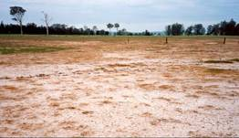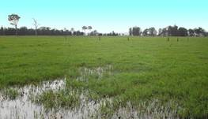

Recovery of scald after flooding with freshwater

(© Industry & Investment NSW, S Johnston)

### 3. Controlling or treating acidiﬁcation: neutralisation and/or bioremediation

One response to acidiﬁcation is to neutralise any acid already produced and to increase the neutralising capacity of the sediment or overlying water to accommodate additional incipient acidity (that is, to protect against subsequent oxidation). This approach has been used with some success to treat ASS in coastal environments (see, for example, Indraratna, Golab and Banaiak 2006; Fitzpatrick, Shand and Hicks 2010) and in acidiﬁcation associated with mining activities (Egiebor and Oni 2007; Lottermoser 2007). As with some other approaches, this is simply treating the symptom rather than the underlying cause, but there may be no other option available in the short term, especially for protecting particularly high-value ecosystems.

Approaches that can be used to neutralise actual acidity include:

* adding chemical ameliorants with high inherent neutralising capacity, such as agricultural lime, to the ecosystem
* creating alkalinity using microbial processes, including sulfate reduction
* using alkalinity stored in other parts of the aquatic ecosystem, including plant biomass and ﬁne-grained carbonates.

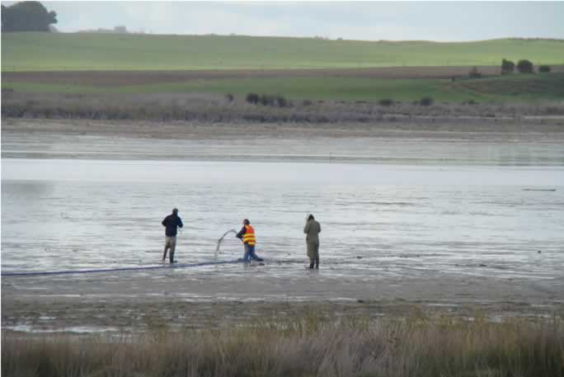

Applying limestone as a slurry, Lower Murray Lakes, SA

(© Department of Environment and Natural Resources SA)

#### Adding chemical ameliorants

The addition of chemical ameliorants to neutralise acidity is a well-established practice in the treatment of coastal ASS and acidity associated with mine wastes (Egiebor and Oni 2007; Green, Waite and Melville 2007). This technique has been recently used to treat acidiﬁcation in Currency Creek and the Finniss River, which ﬂow into Lake Alexandrina in South Australia (Fitzpatrick, Shand and Hicks 2010). Chemical ameliorants, compounds with a high acid neutralising capacity (also known as ‘pH buffering capacity’), are either applied to the overlying water or incorporated into the sediment bed. Acid produced by the oxidation of ASS is neutralised by the ameliorant. Often, the addition of chemical ameliorants may be the only suitable management option available, particularly in the short term. Ameliorants commonly used to treat acidity from ASS and acid mine drainage are listed in Table 3.

One of the main disadvantages of using any ameliorant in inland aquatic ecosystems is the difﬁculty of ensuring the effective application and full utilisation of the ameliorant.

First, large volumes of the material may be needed, and transporting it to the site can be very expensive.

Second, to be effective the ameliorant needs to be either incorporated into the sediment (generally the more effective option) or placed as a cap over the sediment (generally the less effective option). Apart from the potential impact of sediment disruption to species and habitats in aquatic ecosystems, mixing the ameliorant into soft, possibly even inundated, sediment poses a number of logistical problems—not the least of which is how to prevent the machinery spreading the ameliorant from becoming bogged. In the Lower Murray Lakes and tributaries in South Australia, limestone has also been applied as a slurry, and aerial dosing has been used for extensive coverage.

Third, neutralising the water column will cause the precipitation of any heavy metals dissolved during acidiﬁcation, leading to the sediment surface being coated with a sludge that is enriched by heavy metals.

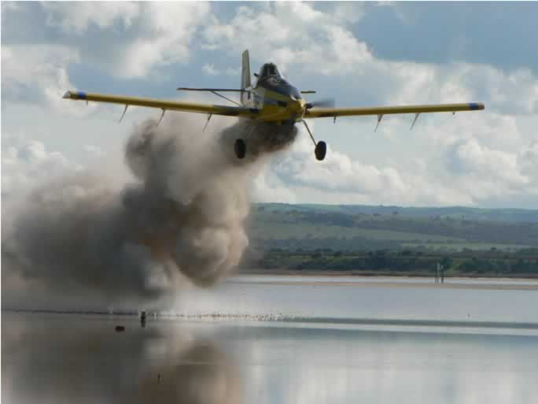

Aerial application of limestone in Currency Creek, SA

(© Department of Environment and Natural Resources SA)

This material could be incorporated into the food chain by bottom-feeding and ﬁlter-feeding organisms. Other impacts of the addition of industrial chemicals also need to be considered before introducing ameliorants into aquatic ecosystems, especially those that are high value ecosystems. For example, the purity of the reagent or product needs to be taken into account. While the active ingredient may be shown to pose little or no risk to the environment, concentrations of contaminants (such as heavy metals) in the ameliorant may be harmful.

In some cases, to overcome some of these drawbacks, coastal ASS have been dug up and transported to treatment pits before reburial (see, for example, Queensland Government 2001). The pits are lined to prevent leakage and can include a layer of limestone on the walls and ﬂoor of the pit to neutralise any leakage that does occur. However, this approach is quite expensive and may be useful for inland aquatic ecosystems only in very speciﬁc instances (for example, for aquatic ecosystems with small areas of sulﬁdic material, for aquatic ecosystems of high ecological or economic value, or for areas adjacent to those ecosystems).

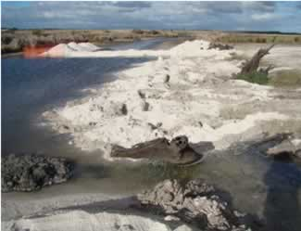

Treating acidification with limestone, Finniss River, Lower Murray Lakes, SA

(© Department for Environment and Natural Resources SA)

Table Chemical ameliorants

|  |  |  |  |
| --- | --- | --- | --- |
| **Ameliorant and composition** | **Source/production** | **Advantages** | **Disadvantages** |
| Calcium carbonate (CaCO3), also known as ag-lime or lime | Quarried limestone milled to various particle sizes. | Lower cost (currently $10–$20 per tonne at the mill gate) and very safe. | Slower rate of neutralising, as it has limited solubility in water (although the rate increases with decreasing particle diameter).  Quality of the product can vary from batch to batch and quarry source.  Particles are readily coated with iron oxides and gypsum, which limits their neutralising value.  The neutralising process produces carbon dioxide—a greenhouse gas. |
| Calcium oxide (CaO), also known as quicklime or lime | Produced by heating ground limestone in a kiln. | Reacts vigorously with water to produce calcium hydroxide, which has a high buffering capacity.  Good neutralising agent—reacts quickly with acid. | Much more expensive than calcium carbonate.  Consumes energy in its production.  Reacts violently when mixed with water. A very hazardous material that needs special handling. |
| Calcium hydroxide (Ca(OH)2), also known as hydrated lime or slaked lime | Made by reacting calcium oxide with water. | A good neutralising agent. | A hazardous material.  More expensive than limestone. |
| Lime kiln dust | Lower grade waste product of lime production. | A moderately good neutralising reagent—between limestone and calcium hydroxide in efficacy. | A lime kiln would probably need to be nearby for this product to compete on net cost with hydrated lime. |
| Magnesium oxide (MgO), also known as calcined magnesia | Made by heating crushed magnesium carbonate (magnesite) in a kiln. | Reacts similarly to CaO but can generate more alkalinity on a weight-for-weight basis (Douglas and Degens 2006), presumably because magnesium has a lower molecular weight than calcium. Not as subject to inactivation through coating—magnesium sulfate (MgSO4) is very soluble compared with gypsum (CaSO4). | A by-product of the reaction is MgSO4, which can be detrimental to livestock (Grout et al. 2006).  Typically higher cost than hydrated lime. |
| Sodium carbonate (Na2CO3), also known as soda ash | Occurs naturally, but most is produced industrially from sodium chloride and limestone. | Good neutralising capacity. | Very expensive compared with other ameliorants (current price $360–$470 per tonne). |
| Seawater neutralised red mud | By-product of bauxite extraction in the alumina industry. | High neutralising capacity.  Binds metal ions, so may alleviate heavy metal contamination associated with disturbing ASS. | Ecological consequences of application to inland water bodies are not known. |
| Fly ash (mixture of various minerals) | Residue from combustion of coal. | Has inherent alkalinity, mostly originating from calcium and magnesium oxides in coal.  Can neutralise acidic water and has been mixed with lime in lime slot treatment of acidic groundwaters (Indraratna, Golab and Banaiak 2006). | Although fly ash can bind many heavy metals at neutral pH, if it is added to acidic waters it has the potential to initially leach heavy metals, especially bioactive elements such as selenium and arsenic, increasing the metal burden in the aquatic ecosystem (Douglas and Degens 2006). |
| Biochar (a type of charcoal) | Produced by heating biomass (such as plant residues or chicken manure) in the absence of oxygen, resulting in chemical decomposition. | Has potential due to its inherent high alkalinity (Sohi et al. 2009). | Has not yet been tested for its suitability in treating ASS.  Currently, source materials are highly variable, so alkalinity would be highly variable. |

Choose the ameliorant most appropriate for your particular circumstances. The default option would be calcium carbonate (‘ag-lime’), the most commonly used chemical ameliorant for ASS issues.

#### Creating alkalinity using microbial processes

The principal aim of stimulating microbial respiration in sediments is to reinstate the conditions that formed the sulﬁde in the ﬁrst place. The microbial process that produces sulﬁde under anaerobic conditions also produces alkalinity, which can then be used to neutralise acidity in the system. (The alkalinity generated can be lost from the system if it is not trapped, which explains why acidiﬁcation can occur in open systems.) Microbially mediated iron reduction can also generate alkalinity (Frömmichen et al. 2004).

Reinstating sulfate and iron reduction is a technique often employed in the rehabilitation of acid mine lakes and in treating acid mine drainage. In these systems, microbially mediated reduction is invariably limited by carbon availability. Treatment involves the addition of organic matter into the system to remove oxygen (create anoxia, through microbial respiration) and then, following the onset of anoxia, to fuel iron and sulfate reduction. A wide variety of organic matter sources, alone or in combination, have been used to treat acid mine drainage in this way with varying success (see Neculita, Zagury and Bussière 2007 for a recent review).

One possibility for treating inland aquatic ecosystems, particularly wetlands, is to add organic matter as a thick mulch to the sediment surface, using plant material that is either imported or formed in situ (for example, macrophytes or algal detritus). Organic compounds leached from the mulch can help maintain anoxia, while the mulch itself can be a barrier to help retain moisture in the sediment. However, adding too much mulch to a system or adding mulch at the wrong time can lead to anoxia in the water column, which in turn can lead to adverse environmental outcomes, such as ﬁsh kills (Baldwin, Howitt and Edwards 2001). The nutrient content of added organic materials also needs to be considered, particularly since nutrients may be released rapidly under low-oxygen conditions into overlying waters after ﬂooding (Baldwin and Mitchell 2000).

One potential difﬁculty in using in situ planting to create a source of bioavailable organic matter is the choice of species. The plants must be able to grow in anaerobic sediments with high levels of sulﬁde, be salt tolerant and be able to grow under low pH conditions.

There appears to be one signiﬁcant drawback to using microbial activity, particularly sulfate reduction, to produce alkalinity: the material that is generated in this process (sulﬁde) is the material that caused the problem in the ﬁrst place. Therefore, it would only be useful as a stop-gap measure to treat acidity while alternative approaches are explored. Furthermore, an assumption inherent in this approach is that anoxia can be maintained in the sediments to prevent reoxidation of the created sulﬁdic material (by maintaining an adequate depth of water above the sediment, which may be difﬁcult during extended dry periods).

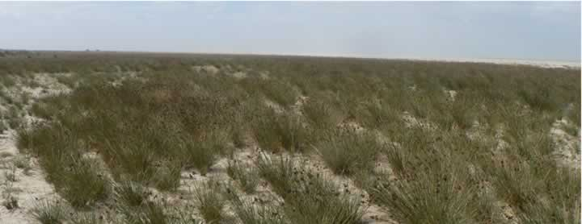

*Juncus acutus* regeneration, Lower Murray Lakes, SA

(© Department of Environment and Natural Resources SA)

#### Using buffering capacity already stored in the aquatic ecosystem

Two stores of alkalinity potentially already present in an aquatic ecosystem could be utilised to neutralise acidity:

* plant material
* sediment material.

##### Plant material

The method of incorporating existing or imported plant material into agricultural systems to treat soil acidity could be used to treat ASS in inland aquatic ecosystems. Stored alkali in plants can change soil pH, and can be made available through burning. Organic anions, such as citrate and oxalate, can help to increase soil pH after the addition of plant material to soil (Yan, Schubert and Mengel 1996; Pocknee and Sumner 1997). Salts from burnt plant material produced in an ash-bed can dissolve and leach into the soil proﬁle, increasing alkalinity (Raison 1979; Ohno 1992; Uler y, Graham and Amrhein 1993; Khanna, Ludwig and Raison 1996). For the treatment of ASS in inland aquatic systems, plant material may feasibly be added as either mulch (see above) or ash (for example, by burning and allowing the leaching of alkalinity from the ash-bed). A number of factors need to be considered before using revegetation as a means of introducing plant material to an ecosystem:

1. While wetlands can provide a suitable habitat for aquatic macrophytes (depending on ﬂow and depth), this is not necessarily the case for streams.
2. It may be difﬁcult to establish vegetation in ASS- affected ecosystems because of salt and acid in the sediments. Therefore, the choice of plant species may be restricted. Very acid- and/or salt-tolerant wetland plants that may be suitable candidates for restoring aquatic ecosystems include *Phragmites australis*, *Juncus* spp. and *Typha* spp. (Fyson 2000); however, the choice of species should be guided by species’ natural distribution ranges where possible.
3. Establishing vegetation stands could potentially exacerbate problems associated with ASS. Johnston, Slavich and Hirst (2003) noted increased acidity and heavy metal mobilisation in the groundwater and soils in parts of a wetland containing ASS and colonised by paperbarks (*Melaleuca quinquenervia*).
4. There is a risk of introducing weeds to an ecosystem.

##### Sediment material

Weathering (dissolution) of carbonates or aluminosilicate clays in sediments can consume acid (Lottermoser 2007), providing an inherent buffering capacity within the sediments. Exposing unreacted sediment material to acidic water, for example through deep ripping of the underlying sediments, may offer a pathway to restore surface water quality. While the ﬁnal pH levels produced by this tillage may still be too low for many aquatic organisms, sediment buffering could be used as part of an overall approach to wetland rehabilitation—for example, by raising the pH of the sediment to a level that would allow the establishment of acid-tolerant plant species such as *Phragmites* spp., which could be grown to produce alkalinity (see ‘Plant material’ above).

While there may be some merit to this approach, it is very disruptive to physical habitat and involves other risks. The release of metals (particularly aluminium) to the overlying water from the dissolution of aluminosilicate sediment minerals (such as clays) at pH values below 4.5 can pose a real risk to any biota still present in the aquatic ecosystem (WHO 1997).

### 4. Protecting connected ecosystems

If it is not feasible to restore a given aquatic ecosystem, the focus will then be on protecting the adjacent or downstream environments from adverse effects caused by the disturbance of ASS in that aquatic ecosystem.

When assessing connectivity between ecosystems, all potential pathways should be considered, including groundwater connectivity and overland ﬂows, not just connectivity through channels (Johnston, Slavich and Hirst 2004).

Three broad approaches can be used to protect downstream ecosystems:

* isolation of affected area
* neutralisation and dilution of surface water
* neutralisation or biological treatment of discharge waters.

#### Isolation of affected area

One effective approach in the treatment of aquatic ecosystems with elevated levels of ASS in their sediments is to physically isolate the affected aquatic ecosystem from connected ecosystems. However, this should be done only if the adverse effects of such isolation are not greater than the beneﬁts.

Many methods are available to isolate aquatic ecosystems. For wetlands, it may be possible to construct block banks or install regulators on feeder creeks.

For creeks, it may be possible to divert water around affected areas using artiﬁcial channels, especially in irrigation areas where water ﬂow can be regulated. Chemical ameliorants could be incorporated into the material used to isolate the aquatic ecosystem from receiving waters (for example, by using lime in sandbags). However, whichever technique is used, isolation will be effective only if the integrity of the barrier is maintained. Planning approval is almost universally required before works on aquatic ecosystems can be carried out.

The impact of isolation on the affected aquatic ecosystem should be considered. If it is to be isolated from its receiving waters, a decision should be made about whether to keep the ASS inundated to stop further oxidation. This might not be possible if water is scarce. If continuing inundation is not possible, isolating the aquatic ecosystem could lead to oxidation of the sediments and subsequent acidiﬁcation.

**Water ﬂow regulator: Paiwalla wetland, South Australia**

The installation of a water ﬂow regulator in the Paiwalla wetland in South Australia has enabled sulfuric soils and acidic waters to be managed satisfactorily. Controlled ponding of this wetland during the rewetting of sulfuric materials by a ﬂow regulator has minimised potential mobilisation and the return of acids, salts, metals and monosulﬁdic material to the river (Fitzpatrick, Shand and Hicks 2010).

**Wind mobilisation of acid sulfate soils**

Water movement is not the only pathway for the movement of ASS between ecosystems. When sediments are exposed, they may be transported by wind. Depending on the extent of ASS and wind force, this may be a serious problem, particularly at larger sites (such as at Lake Albert and Lake Alexandrina, South Australia). The management action selected in this instance has been to conduct extensive vegetation work to encourage plant establishment and growth.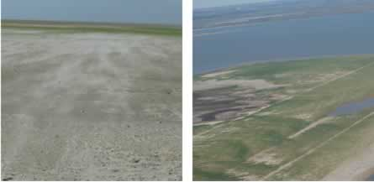

Wind mobilisation of sediments and vegetation work, Lower Murray Lakes, SA

(© Department of Environment and Natural Resources SA)

#### Neutralisation and dilution of surface water

Dilution has traditionally been one way of treating poor water quality: poor-quality water is mixed with higher quality water before release to reduce its impact on the environment. This approach can also be considered when exploring options for mitigating the impact of poor water quality resulting from the disturbance of ASS in sediments. For example, dilution using tidal exchange has been used successfully to improve water quality in coastal wetlands (Johnston, Slavich and Hirst 2005; Johnston et al. 2009). However, because of the relatively large volume of water required for effective dilution (up to 100 to 1000 times the volume of the system, depending on the inherent buffering capacity, or alkalinity, of the dilution water), coupled with the high cost of water, dilution as a mitigation option in inland aquatic ecosystems may be useful in only a few cases, such as when the volume of water in the affected system is small or during large unregulated ﬂoods.

Mixing efﬁciency should also be considered. Because aquatic ecosystems that contain ASS are usually saline and saline water is much denser than fresh water, it can take a large amount of energy to mix the water. If the water is not mixed well, a parcel of water of poor quality could move as a single ‘slug’ down a river system, causing environmental harm in transit. Similar behaviour has been observed in coastal regions where slugs of fresh but acidic water move through brackish rivers in a single pulse.

#### Neutralisation or biological treatment of discharge waters

Discharge waters can be treated by neutralisation or by biological treatments.

##### Neutralisation

Three approaches used to neutralise acid mine drainage or seepage from ASS are anaerobic lime drains, open limestone channels, and ‘lime slotting’:

* *Anaerobic lime drains* are buried trenches ﬁlled with limestone, through which the acidic drain water ﬂows.
* *Open limestone channels* are open to the air but lined with limestone. A variation of this approach is limestone sand treatment, in which limestone that has been ground to the particle size of sand is placed on the bed of streams affected by acid mine drainage. High concentrations of iron in acidic drain waters can coat grains of limestone and limit the effectiveness of this approach (Degens 2009).
* *Lime slotting* involves digging trenches across groundwater ﬂow paths and ﬁlling the trenches with limestone and possibly other ameliorants (Thomas et al. 2003; Indraratna, Golab and Banaiak 2006).

In all three treatments, the limestone neutralises acidity in the water and increases the alkalinity of the receiving water. The greatest effectiveness and duration of treatment is often achieved with the ﬂuidisation of limestone in pump-and-treat systems (Degens 2009). However, because the neutralising agent is consumed, such systems require periodic maintenance for successful long-term use (Price and Errington 1998). The most suitable approach will depend on the local setting and should be assessed on a case by case basis.

Furthermore, neutralisation will lead to the precipitation of metals from solution. Precipitation of metal compounds (such as iron oxides) and gypsum on the limestone surface (‘armouring’) reduces the limestone’s efﬁciency as a neutralising agent (Hammarstrom, Sibrell and Belkin 2003). Precipitation can also lead to the formation of a metal-enriched sludge that may adversely affect the receiving water.

##### Active and passive biological treatment

The alkalinity produced by sulfate reduction has been used to neutralise acidic run-off in acid mine drainage and acidic groundwaters. Generally, the approach has been to direct the acidic stream through a barrier made up of compostable material (Blowes et al. 2000) or into an artiﬁcial wetland (Kalin, Cairns and McCready 1991; Younger et al. 1997) or constructed bioreactor (Neba 2006). Organic matter is then added in one form or another as its decomposition removes oxygen and it fuels sulfate reduction.

These systems can work only if the sulﬁde produced during the reaction is removed from the system. For example, in bioreactors used in the Rhodes Biosure process (Neba 2006), which uses primary sewage as its carbon source, some of the sulﬁde produced is redirected into the waste stream to precipitate heavy metals (which are collected separately), but most sulﬁdes are oxidised to elemental sulfur using a novel bioreactor (Neba 2006) and are subsequently harvested.

The use of artiﬁcial wetlands is often erroneously considered as a ‘walk-away’ approach to treating acid mine drainage because, once established, the wetland is self-sustaining (Younger, Banwart and Hedin 2002). In these systems, sulﬁdes and heavy metal precipitates (whether precipitated as sulﬁdes or other minerals) are allowed to accumulate in the wetland.

Pilot anaerobic composting systems developed to treat acidic drain waters in the Western Australian wheatbelt have been found to be highly effective, even when based on simple designs and limited organic matter mixtures (Degens 2009).

However, it is not possible to ‘walk away’ from these systems, as they create a new source of potential acidity that will need to be dealt with at some time in the future. Therefore, it is not surprising that their utility in treating acid mine drainage has been questioned (McGinness, Sanger and Atkinson 1997; Rose et al.1998).

### 5. Limiting further intervention

The risk assessment may lead to a decision not to take any further action or to take only limited action in particular cases. Assess what the relevant responsibilities and obligations are in these circumstances and conduct any follow-up actions as required. Recommended activities include:

* active stakeholder liaison and communication, to ensure that all stakeholders, including the broader community, understand why further actions are not being taken
* detailed assessments of the risk to both adjacent ecosystems and landholders as a consequence of the decision not to take further action
* ongoing monitoring where required, of the affected aquatic ecosystem and connected waters (including groundwater) and areas, to assess changes in condition.

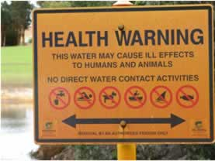

Public notification of risk, Perth, WA

(© Industry & Investment NSW, C Clay)

# Communication

Good communication is important in ASS management as the issues may not be well understood, or there may be potential or actual risks to different sectors of the community, important assets and planning. Some initial planning and analysis to develop a suitable communication strategy for stakeholders is valuable. A successful communication strategy is based on a sound understanding of aims, key messages and target audiences. It should facilitate the timely and effective sharing of knowledge and decisions.

## Aims

* Facilitate the development and communication of a clear and consistent message.
* Develop evidence-based messages to raise awareness of the issue and improve take-up of guidance by stakeholders dealing with ASS issues.
* Be proactive in sharing information—avoid delays in passing on information.
* Identify the target audiences.
* Identify speciﬁc information gaps and create plans to address them.
* Address other sources of information, particularly misleading or incorrect information, that the audiences may be receiving.
* Transmit key messages through suitable methods of communication.
* Provide adequate opportunities for consultation to build and enhance partnerships.
* Identify speciﬁc roles and responsibilities for key contact people and timelines for action.

## Key messages

* ASS may threaten both ecosystems and infrastructure and are not restricted to the coastal areas of Australia.
* ASS are not ubiquitous in inland Australian aquatic ecosystems.
* Resources are available to assist stakeholders to identify and manage ASS.
* Australian governments are collaborating to develop national guidance on ASS and collective understanding of the issue will grow over time.
* More frequent wetting and drying cycles may help prevent the build-up of ASS.

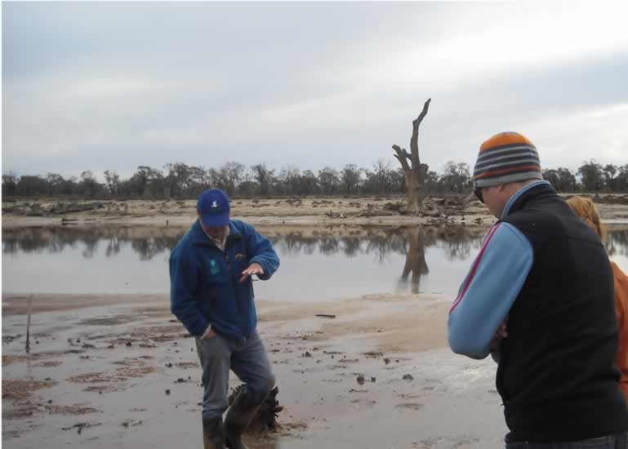

Field day, Psyche Bend, Victoria

(E Coote)

## Mechanisms for stakeholder engagement

* Use links to other publications to increase reach and understanding in different situations and environments.
* Communicate with key interested parties through newsletters and media releases.
* Consult stakeholders according to their preferences, for example through meetings and workshops.
* Produce communication materials for seminars, conferences and ﬁeld days.
* Encourage and record feedback on key reports published on websites, including key data and mapping.

Note: A decision not to undertake intervention will pose special communication issues.

### Case study: Communication of management options

A manual was developed in consultation with farmers in the Eastern Mount Lofty Ranges in South Australia (Fitzpatrick, Cox and Bourne 1997; Fitzpatrick et al. 2003) and the Woorndoo district in Victoria (Cox et al. 1999) to assist them in recognising, mapping and managing ASS features on their properties. The manual includes a diagnostic ﬁeld key of visual indicators with on-farm management options and is designed to be a useful tool to support farmers in assessment and decision making (Cox et al. 1999). ASS seminars and ﬁeld days for farmers were held to build their capacity to effectively assess and manage ASS and to demonstrate how they could use the manual in their own situations.

# Appendix 1: Terminology

In Australia, most of our previous experience of high levels of sulﬁdes in the environment has come from waterlogged soils in coastal regions. Therefore, when acid sulfate soils were ﬁrst identiﬁed in inland aquatic ecosystems, the nomenclature (soil taxonomy) that had been developed for coastal acid sulfate soils was adapted as detailed in this appendix.

*Acid sulfate soils* includes all soils in which sulfuric acid is produced, may be produced or has been produced in quantities that can affect the soil properties (Fanning 2006).

*Potential acid sulfate soils* are soils that can contain signiﬁcant sulﬁdic material, which on oxidation can cause the pH of the soil to fall to very low levels (Fanning 2006).

Active (or actual) acid sulfate soils are soils in which the sulﬁdic minerals have oxidised and the pH has fallen to very low levels (Fanning 2006).

*Sulfuric material* is identiﬁed where the pH is less than 4 (Isbell 1996).

*Sulfidic material* is identiﬁed where soil materials contain detectable sulﬁde minerals (greater than or equal to 0.01% sulﬁdic sulfur). This term is intended to be used in a descriptive context (for example, ‘sulﬁdic soil material’) and to align with general deﬁnitions applied in other scientiﬁc disciplines, such as geology and ecology (for example, ‘sulﬁdic sediment’). The term differs from previously published deﬁnitions in various soil classiﬁcations (see, for example, Isbell 1996).

Recently, the Acid Sulfate Soils Working Group of the International Union of Soil Sciences agreed to adopt in principle the ﬁve descriptive terms and classiﬁcations of acid sulfate soil materials proposed by Sullivan and others at the 6th International Acid Sulfate Soil and Acid Rock Drainage Conference in September 2008 in Guangzhou, China.

In October 2008, this new classiﬁcation system (Sullivan et al. 2009b) was also adopted by the Scientiﬁc Reference Panel of the Murray–Darling Basin Acid Sulfate Soil Risk Assessment Project for use in the detailed assessment of acid sulfate soils in the Murray– Darling Basin. The criteria to deﬁne the soil materials are as follows:

*Sulfuric materials* are soil materials currently deﬁned as sulfuric by the Australian Soil Classiﬁcation (Isbell 1996). Essentially, these are soil materials with a pH ‹ 4 as a result of sulﬁde oxidation.

*Sulfidic materials* are soil materials containing detectable sulﬁde minerals (deﬁned as greater than or equal to 0.01% sulﬁdic sulfur). This term is intended to be used in a descriptive context (for example, ‘sulﬁdic soil material’ or ‘sulﬁdic sediment’) and to align with general deﬁnitions applied in other scientiﬁc disciplines, such as geology and ecology (for example, ‘sulﬁdic sediment’). The method with the lowest detection limit is the chromium-reducible sulﬁde method, which currently has a detection limit of 0.01%; other methods (for example, X-ray diffraction, visual identiﬁcation, Raman spectroscopy or infrared spectroscopy) can also be used to identify sulﬁdic materials. This term differs from previously published deﬁnitions in various soil classiﬁcations (see, for example, Isbell 1996).

*Hypersulfidic material* is sulﬁdic material that has a ﬁeld pH of 4 or more and is identiﬁed by detecting a substantial[1] drop in pH to 4 or less (1:1 by weight in water, or in a minimum of water to permit measurement) when a 2-10 mm thick layer is incubated aerobically at ﬁeld capacity. The duration of the incubation is either:

* until the soil pH changes by at least 0.5 pH unit to below pH 4  
  or
* until a stable pH[2] is reached after at least 8 weeks of incubation.

*Hyposulfidic material* is sulﬁdic material that has a ﬁeld pH of 4 or more and for which a substantial* drop in pH to 4 or less is detected (1:1 by weight in water, or in a minimum of water to permit measurement) when a 2-10 mm thick layer is incubated aerobically at ﬁeld capacity. The duration of the incubation is until a stable** pH is reached after at least 8 weeks of incubation.

*Monosulfidic materials* are soil materials with an acid volatile sulfur content of 0.01% or more.

*Sulfidic sediments* is another term that may be found in the literature (especially in the aquatic sciences). This term relates to the material found at the bottom of aquatic ecosystems such as rivers, creeks and wetlands that contain signiﬁcant pools of reduced inorganic sulfur at levels that will cause environmental damage if mismanaged (modiﬁed from Baldwin and Fraser 2009).

# Appendix 2: Resources

ASS in inland aquatic ecosystems were recognised as an important issue only relatively recently. Therefore, there has been little government response in the form of legislation, policy and scientiﬁc, technical, and management guidance on assessing and managing them in inland aquatic ecosystems.

By contrast, there has been a far greater government response to coastal ASS problems, which have been identiﬁed and understood for a longer time period. In some situations, documents on coastal ASS have been used in the absence of more appropriate information. It should be noted that the management requirements for ASS in inland aquatic ecosystems will often be quite different from those required for similar materials in coastal areas.

## General resources and links

|  |  |
| --- | --- |
| Technical guidelines for assessment and management of inland freshwater areas impacted by acid sulfate soils (CSIRO) | www.csiro.au |
| An introduction to sulfidic sediments in the waterways of inland Australia (Murray–Darling Freshwater Research Centre) | www.mdfrc.org.au/resources/biogeochemistry/ SulfidicSediments/ssdefault.html |
| Action support tool for managing sulfidic sediments in inland water bodies (Baldwin 2010) | www.mdfrc.org.au/resources/biogeochemistry/ ActionSupportTool.htm |
| Inland acid sulfate soil systems across Australia (CSIRO) | www.clw.csiro.au/acidsulfatesoils/documents/assbook/ Inland-ASS-book-web.pdf |
| Detailed assessment of acid sulfate soils in the Murray–Darling Basin: protocols for sampling, field characterisation, laboratory analysis and data presentation (Murray–Darling Basin Authority) | www.mdba.gov.au |
| Minimising environmental damage from water recovery in inland wetlands: determining water regimes to minimise the impact of sulfidic sediments (potential acid sulfate soils) (National Water Commission) | www.nwc.gov.au/www/html/451-minimisingenvironmental- damage-from-wetland-recovery-frominland- wetlands.asp?intSiteID=1 |
| Queensland acid sulfate soils technical manual (Queensland) | www.derm.qld.gov.au/land/ass/pdfs/soil_mgmt_ guidelines_v3_8.pdf |
| *Acid sulfate soils* (New South Wales) | www.dpi.nsw.gov.au/agriculture/resources/soils/ass |
| Coastal acid soils (Victoria) | www.dpi.vic.gov.au/dpi/vro/vrosite.nsf/pages/soil_ acid_sulfate_soils |
| General guidance on managing acid sulfate soils (Western Australia) | http://portal.environment.wa.gov.au/pls/portal/docs/ PAGE/DOE_ADMIN/GUIDELINE_REPOSITORY/ GENERAL%20GUIDANCE%20ON%20 MANAGING%20ACID%20SULFATE%20SOILS.PDF |
| Management of acid sulfate soils in the Lower Murray Lakes (South Australia) | www.environment.sa.gov.au/Conservation/Rivers_ Wetlands/Coorong_Lower_Lakes_Murray_Mouth/ The_environment/Acid_sulfate_soils |
| ABC Catalyst story on acid mud | www.abc.net.au/catalyst/stories/2232992.htm |
| *Lower Lakes Water Quality Monitoring* Program (South Australia)—monitoring and reporting example | www.epa.sa.gov.au/environmental_info/water_ quality/lower_lakes_water_quality_monitoring |
| *ASSAY*-national newsletter about current acid sulfate soil issues | www.dpi.nsw.gov.au/aboutus/resources/periodicals/ newsletters/assay |
| Atlas of Australian Acid Sulfate Soils (CSIRO) | www.asris.csiro.au/index_ie.html |
| Modifications to the classification of acid sulfate soil materials (Southern Cross University) | www.scu.edu.au/geoscience/index.php/55 |
| Handbook for sediment quality assessment | www.csiro.au/resources/Handbook-sedimentquality- assessment.html |

## Websites

|  |  |
| --- | --- |
| CSIRO Land and Water | www.clw.csiro.au/acidsulfatesoils |
| Department of Sustainability, Environment, Water, Populations and Communities | www.environment.gov.au/water/topics/acidsulfate-soils.html |
| International Network for Acid Protection GARD Guide | www.gardguide.com |
| Murray–Darling Freshwater Research Centre | www.mdfrc.org.au |
| Southern Cross GeoScience | www.scu.edu.au/geoscience/index.php/4 |

## Guidance, obligations and institutional arrangements

This section lists legislation, regulations, policy and other guidance administered by Australian governments. Table 4 shows current institutional arrangements and responsibilities.

### National

#### The Ramsar Convention

The 1971 *Convention on Wetlands of International Importance especially as Waterfowl Habitat* (Ramsar Convention) is an international intergovernmental treaty that provides the framework for national action and international cooperation for the conservation and wise use of wetlands and their resources. Australia currently has 64 Wetlands of International Importance, or Ramsar sites, listed under the Ramsar Convention. The Department of Sustainability, Environment, Water, Population and Communities or the relevant department in your jurisdiction are be able to advise you of your responsibilities and obligations under this Convention if your work involves, or may involve, a Ramsar site.

www.environment.gov.au/water/topics/wetlands/database/index.html

www.environment.gov.au/water/topics/wetlands/ramsar-convention/index.html

#### National Water Quality Management Strategy

The National Water Quality Management Strategy (NWQMS) provides a coordinated national approach to improving water quality in Australia’s aquatic ecosystems. The main objective of the strategy is to achieve sustainable use of the nation’s water resources by protecting and enhancing water quality while maintaining economic and social development. The NWQMS provides national policies, guidelines, information and tools to help governments and communities manage their water resources to meet current and future needs. The strategy currently includes 24 nationally endorsed but non- mandatory guideline documents.

Water quality improvement plans may be prepared as part of the implementation process for the NWQMS. The plans address water quality and environmental flow management and two regional acid sulfate soils water quality improvement plans have been produced for the Great Barrier Reef lagoon catchment.

www.environment.gov.au/water/quality/nwqms/index.html

### Australian Government

Commonwealth programs to recover water for the environment will also help achieve more natural wetting and drying cycles, with the ability to provide more water for environmental flows. The Intergovernmental Agreement on the Murray-Darling Basin provides for State Priority Projects (SPPs) which may address issues in critical locations (for example, South Australian SPPs have been allocated $200 million for the Coorong and Lower Lakes, and up to $100 million for Riverine Recovery).

#### Environment Protection and Biodiversity Conservation Act 1999

The *Environment Protection and Biodiversity Conservation Act 1999* (EPBC Act) provides a legal framework to protect and manage Matters of National Environmental Significance, including threatened species and ecological communities, migratory species, Ramsar wetlands of international importance, the Commonwealth marine environment, World and National Heritage sites, the Great Barrier Reef Marine Park and nuclear actions. If a proposed action is likely to have a significant impact on any of these matters, it must be referred to the Minister for Sustainability, Environment, Water, Population and Communities for a decision on whether further assessment and approval are required under the EPBC Act.

Projects intended to address threats to the environment, such as actions to manage acid sulfate soils, are not excluded from the referral process. Such projects may require further assessment if simultaneous negative impacts on Matters of National Environmental Significance arise. Some important considerations are:

* whether the project is within a Ramsar-listed wetland, or is likely to have an impact on a Ramsar wetland downstream or nearby; if so, whether the project will affect the wetland’s ecological character (for example, if it causes a substantial change in the hydrological regime of the wetland, negative impacts on the habitat or lifecycle of native species dependent on the wetland, the establishment or spread of an invasive species, or changes in water quality in the wetland)
* whether any species or ecological communities listed as threatened or migratory under the EPBC Act present on the site or nearby are likely to be affected
* whether the project will adversely affect habitat and food availability for these species, for example through changed water levels, water quality (for example, pH, salinity, nutrient and heavy metal concentrations) and wetland-dependent vegetation, either within the project area or downstream or upstream of it
* whether the project may isolate populations of a listed threatened species, or otherwise adversely affect habitat connectivity.

www.environment.gov.au/epbc

Guidelines for deciding whether a project is likely to have a significant impact on Matters of National Environmental Significance are available at

www.environment.gov.au/epbc/publications/nes-guidelines.html

#### Water Act 2007

The *Water Act 2007* implements a number of key reforms to improve water management in Australia. The Act establishes the independent Murray–Darling Basin Authority, which is charged with ensuring that the water resources of the Murray–Darling Basin are managed in a sustainable way in the national interest. The Authority is responsible for the preparation and enforcement of the Basin Plan for water resource management (which sets sustainable and enforceable diversion limits on both surface and groundwater), the management of salinity and water quality, water trading rules, and arrangements for the management of storages in the Murray-Darling Basin.

www.comlaw.gov.au/Series/C2007A00137

### New South Wales

New South Wales policy, guidance and legislation relevant to ASS in inland aquatic ecosystems include the following:

* NSW State Rivers and Estuaries Policy (1992): Wetlands Management Policy and Estuary Management Policy. This policy supports the active rehabilitation of wetlands and estuaries affected by acid sulfate soils.
* NSW State Rivers and Estuaries Policy (1992): Weirs Policy. This policy includes an audit of all weirs, floodgates and related structures against a set of criteria, including the presence of ASS and scalding. The policy encourages the removal of weirs and associated structures, especially in areas of ASS, and discourages the future construction of such structures.
* *Acid sulfate soils manual* (NSW Acid Sulfate Soils Management Advisory Committee, 1998) for coastal ASS. The full manual is not freely available online. However, chapters 1 and 2 are on the Department of Planning’s guidelines register.

- Chapter 1, ‘Acid sulfate soils planning guidelines’ www.planning.nsw.gov.au/rdaguidelines/documents/NSW%20Acid%20Sulfate%20Soils%20Assessment%20Guidelines.pdf

- Chapter 2, ‘Acid sulfate soils assessment guidelines’ - www.planning.nsw.gov.au/rdaguidelines/documents/NSW%20Acid%20Sulfate%20Soils%20Assessment%20Guidelines.pdf

* Acid sulfate soils planning maps - http://canri.nsw.gov.au/download
* *NSW State Groundwater Quality Protection Policy* (1998) —Management of acid leachate impacts on groundwater.
* *Acid sulfate soils manual* (Stone, Ahern and Blunden 1998) —a key operational document providing details of assessment methods, management, laboratory methods, drainage guidelines and trigger values.

Acidity is something to be considered under the principles of the *Water Management Act 2000*, but nothing else specifically on ASS is listed in the Act.

However, section 16 of the Act indicates that management plans must be consistent with other instruments such as the *State Water Management Outcomes Plan*, environmental planning and protection policy, water quality policy, various water regulations and other ‘state government policy’.

State government policy’ includes matters declared as such in regulations, so where there is current New South Wales policy or legislation on ASS, the development of a water sharing plan (or other water management activities) must consider such factors.

### Victoria

Victoria’s policies, guidance and legislation are mainly focused on coastal ASS. However, the Victorian Strategy for Healthy Rivers, Estuaries and Wetlands, which is being developed, will recognise the issue of inland ASS and will build on the *Victorian Coastal Acid Sulfate Soils Strategy*.

### South Australia

Relevant South Australian policy, guidance and legislation include:

* *Wetlands strategy for South Australia* (2003). This details a strategy for the protection of South Australia’s wetlands but does not identify ASS as a potential issue or threat to wetlands - www.environment.sa.gov.au/Conservation/Rivers_ Wetlands/Wetlands_of_SA
* *Environment Protection (Water Quality) Policy and Explanatory Report* (2003). This covers diffuse water pollution, such as acid discharge. www.epa.sa.gov.au/xstd_files/Water/Report/epwq_ report.pdf
* *SA Murray-Darling Basin Natural Resource Management Plan*. This whole-of-government plan recognises inland ASS issues in the region due to drought conditions. It sets water targets that would help to deal with ASS issues along the Murray and the Lower Murray Lakes - www.samdbnrm.sa.gov.au/Portals/9/PublicationsandResources/Reports,Plans&Policies/Strategicplan.pdf

### Western Australia

Policy instruments for the mitigation of ASS risk and the management of acidic saline groundwaters in inland areas are currently in the developmental stage. The main government responses enacted by the Western Australian Government are as follows:

* The *Proposed Framework for managing acid sulfate soils* (2004).
* *Policy position—ASS and the Contaminated Sites Act 2003*.
* *Draft treatment and management of soils and water in ASS landscapes* and *draft identification and investigation of ASS*. These are available at www.dec.wa.gov.au
* *Policy position—Wheatbelt Drainage Council Policy Framework* (2009). This was developed by an independent council endorsed by the state government and provides a foundation for the management of drainage in the wheat belt, including identifying and managing acidic groundwater discharge from drains. The main mechanism for delivery is the *Soil and Land Conservation Act 1945*. Regulations under the Act require that any drainage of saline land be notified to the Commissioner of Soil and Land Conservation so that consideration can be given to the acidity discharge associated with the drainage.
* Acid saline water treatment—The Department of Water (www.water.wa.gov.au) has recently developed proposed guidelines for treating acidic drain waters. Acidic saline waters are considered along with inland ASS because their disposal and the natural discharge of acidic groundwaters results in the formation of soils and sediments with inland ASS type characteristics.

### Tasmania

Currently, no legislation in Tasmania deals specifically with ASS, their disturbance or remediation. However, several state policies and Acts are indirectly relevant to ASS.

The *Environmental Management and Pollution Control Act 1994* sets out protocols and procedures to protect the environment from mismanagement and pollution—of which ASS could be one source. However, this Act is more about penalties for mismanagement than identification and prevention.

The Tasmanian State Policy on Water Quality Management (1997) specifically identified acid soils as a significant diffuse source of aquatic pollution. To combat that pollution, the policy identified several precautionary actions, outlined in Appendix 3 to the policy.

The *Tasmanian Acid Sulfate Soil* *Guidelines* (Department of Primary Industries, Parks, Water and Environment 2009) provides technical and procedural advice to avoid environmental harm from ASS and to assist in achieving *best practice environmental* management through the use of six management principles. The guidelines have also been designed to assist decision making and provide greater certainty to the construction and agricultural industries, state and local governments and the community in carrying out planning for activities that may disturb ASS. The guidelines will be used by consultants, earthmoving contractors, developers, agricultural and aquaculture producers, sand and gravel extraction operators, community groups and administering authorities from state and local government. While the guidelines focus on developments below 20 m Australian Height Datum, the requirement for a management plan should apply wherever significant disturbance of ASS occurs in the state.

### Northern Territory

The policy and guidance focus in the Northern Territory has been on coastal ASS.

### Queensland

Queensland has substantial policies and guidelines in place for coastal ASS (www.derm.qld.gov.au/land/ ass/products.html) but not for inland forms. In irrigation areas, it is possible that the requirements for land and water management plans by irrigators under the *Water Act 2000* could apply where it can be confidently confirmed that irrigation management and ASS risks to water and wetlands are linked. Under the *Vegetation Management Act 1999*, management of ASS is one of the performance requirements for clearing under a regional vegetation management code.

The *Acid sulfate soils laboratory methods* guidelines (Queensland Department of Natural Resources 2004) and other publications on ASS are available at www.derm.qld.gov.au/land/ass/pdfs/lmg.pdf.

Table Agencies responsible for information and direction on acid sulfate soils

|  |  |  |
| --- | --- | --- |
| **Agency** | **Role** | **Contact details** |
| **Australian Government** | | |
| Department of Sustainability, Environment, Water, Population and Communities | Develops and implements national policy, programs and legislation to protect and conserve Australia’s environment and heritage. | www.environment.gov.au |
| Murray-Darling Basin Authority | Develops and implements plans for the integrated management of water resources of the Murray-Darling Basin. | www.mdba.gov.au |
| National Water Commission | Drives progress towards the sustainable management and use of Australia’s water resources under the National Water Initiative. | www.nwc.gov.au |
| Department of Agriculture, Fisheries and Forestry | Develops and implements policies and programs for Australia’s agricultural, fisheries, food and forestry industries. | www.daff.gov.au |
| CSIRO | National science agency. Undertakes research and delivers science and solutions for industry, science and the environment. | www.csiro.au |
| Geoscience Australia | Provides geoscientific information and knowledge to support decision making. | www.ga.gov.au |
| **New South Wales** | | |
| Department of Environment, Climate Change and Water | Develops programs and policies to manage NSW’s natural resources, natural and cultural heritage and climate change. | www.environment.nsw.gov.au |
| Industry & Investment NSW | Encourages investment in NSW and supports innovative, sustainable and globally competitive industries through technical knowledge and scientific capabilities. | www.industry.nsw.gov.au |
| **Victoria** | | |
| Department of Sustainability and Environment | Develops policy direction for land, water, catchment and coastal management.  Administers approvals for the use and/or development of coastal, Crown land.  Administers approvals for the use and/or development of Crown land reserves.  Administers the Flora & Fauna Guarantee and Victoria’s Native Vegetation Management: A Framework for Action. | www.dse.vic.gov.au |
| Department of Primary Industries | Designs and delivers government policies and programs that enable Victoria’s primary and energy industries to sustainably maximise the wealth and wellbeing they generate.  Develops policy direction for Agriculture and Fisheries and houses primary industries data bases, intellectual knowledge and property and soil science expertise and research for Victoria. | new.dpi.vic.gov.au/ |

Table Agencies responsible for information and direction on acid sulfate soils (continued)

|  |  |  |
| --- | --- | --- |
| **Agency** | **Role** | **Contact details** |
| **South Australia** | | |
| Department of Environment and Natural Resources | Protects South Australia’s environment and natural resources.  Collects and provides information and knowledge about the state’s environment and advises on environmental policy.  Manages the state’s public land, including national parks, marine parks, botanic gardens and the coastline. | www.environment.sa.gov.au |
| Environment Protection Authority | The Environment Protection Authority (EPA) influences and regulates human activities to protect and restore the state’s environment and is responsible for the protection of air and water quality, and the control of pollution, waste, noise and radiation.  The EPA is responsible for administration of the *Environment Protection Act 1993* and the *Radiation Protection and Control Act 1982* and also exercises responsibilities under other South Australian planning and environmental legislation. | www.epa.sa.gov.au |
| **Western Australia** | | |
| Department of Environment and Conservation | Protects and conserves the Western Australian environment. | www.dec.wa.gov.au |
| Department of Water Manages Western. | Australia’s groundwater and surface water resources and ensures adequate water services | www.water.wa.gov.au |
| **Tasmania** | | |
| Department of Primary Industries, Parks, Water and Environment | Guides and supports the use and management of Tasmania’s land and water resources and protects and promotes its natural, built and cultural assets. | www.dpiw.tas.gov.au |
| **Northern Territory** | | |
| Department of Natural Resources, Environment, the Arts and Sport | Conserves, enhances and ensures access to, and enjoyment of, the Territory’s natural and cultural assets. | www.nt.gov.au/nreta |
| **Queensland** | | |
| Department of Environment and Resource Management | Conserves and manages Queensland’s natural environment. | www.derm.qld.gov.au |
| Queensland Acid Sulfate Soils Investigation Team (QASSIT) | Provides general and technical advice on acid sulfate soils. | www.derm.qld.gov.au/land/ ass/qassit.html |
| **Other useful points of contact** | | |
| * Environmental protection agencies * Water authorities * Local government * Catchment management authorities. | | |

# References

Ahern C, Ahern M and Powell B (1998 ). *Guidelines for sampling and analysis of lowland acid sulfate soils (ASS) in Queensland*. Queensland Acid Sulfate Soils Investigation Team (QASSIT), Department of Natural Resources, Resource Science Centre, Indooroopilly, Queensland.

Ahern C, McElnea A and Sullivan L (2004).   
*Acid sulfate soils laboratory methods guidelines*. Queensland Department of Natural Resources, Mines and Energy, Indooroopilly, Queensland.

ANZECC and ARMCANZ (Australia and New Zealand Environment and Conservation Council and Agriculture and Resource Management Council of Australia and New Zealand) (2000). *National Water Quality Management Strategy.* ANZECC and ARMCANZ, Canberra.

Appleyard S, Wong S, Willis-Jones B, Angeloni J and Watkins R (2004). Groundwater acidification caused by urban development in Perth, Western Australia: source, distribution and implications for management. *Australian Journal of Soil Research* 42:579–585.

Appleyard S, Angeloni J and Watkins R (2006). Arsenic-rich groundwater in an urban area experiencing drought and increasing population density, Perth, Australia. *Applied Geochemistry* 21:83–97.

Appleyard S and Cook T (2009). Reassessing the management of groundwater use from sandy aquifers: acidification and base cation depletion exacerbated by drought and groundwater withdrawal on the Gnangara Mound, Western Australia. *Hydrogeology Journal*17:579–588.

ARMCANZ, ANZECC and MCFFA (Agriculture and Resource Management Council of Australia and New Zealand, Australia and New Zealand Environment and Conservation Council and Ministerial Council on Forestry, Fisheries and Aquaculture) (2000).   
*National strategy for the management of coastal acid sulfate soils.* National Working Party on Acid Sulfate Soils, ARMCANZ, NZECC and MCFFA. www. mincos.gov.au/—data/assets/pdf_file/0003/316065/ natass.pdf (accessed 6 Februar y 2010).

Baldwin D (2009 ). *Knowledge needs to minimise adverse water quality events in the Edward–Wakool River system*. Consultancy report for New South Wales Office of Water, Murray–Darling Freshwater Research Centre.

Baldwin D (2010). Action support tool for managing sulfidic sediments in inland water bodies. www.mdfrc.org.au/resources/biogeochemistr y/ ActionSupportTool.htm

Baldwin D and Mitchell A (2000). Effects of dr ying and re-flooding on the sediment/soil nutrient-dynamicsof lowland river floodplain systems—a synthesis. *Regulated Rivers: Research and Management*16:457–467.

Baldwin D, Howitt J and Edwards M (2001). Blackwater event. *Austasia Aquaculture* 15:21.

Baldwin D, Hall K, Rees G and Richardson A (2007). Development of a protocol for recognising sulfidic sediments (potential acid sulfate soils) in inland wetlands. *Ecological Management and Restoration* 8:56–60.

Baldwin D and Fraser M (2009). Rehabilitation options for inland waterways impacted by sulfidic sediments. *Journal of Environmental Management* 91:311–319.

Burgman M (2005). *Risks and decisions for conservation and environmental management.* Cambridge University Press, Cambridge.

Burton E, Bush R and Sullivan L (2006a).  
Reduced inorganic sulfur speciation in drain sediments from acid-sulfate soil landscapes. *Environmental Science and Technology* 40:888–893.

Burton E, Bush R and Sullivan L (2006b). Sedimentary iron geochemistr y in acidic waterways associated with coastal lowland acid sulfate soils. *Geochimica et Cosmochimica Acta* 70:5455–5468.

Burton E, Bush R, Sullivan L, Johnston S and Hocking R (2008). Mobility of arsenic and selected metals during reflooding of iron and organic rich acid-sulfate soil. *Chemical Geology* 253: 64-73.

Butler B (1950). Theor y of prior streams as a causal factor in soil occurrence in the Riverine Plain of southeastern Australia. *Australian Journal of Agricultural Research* 1:231–252.

Collepardi M (2003 ). A state-of-the-art review on delayed ettringite attack on concrete. *Cement and Concrete Composites* 25:401–407.

Corkhill C, Wincott P, Lloyd J and Vaughan D (2008). The oxidative dissolution of arsenopyrite (FeAsS) and enorite (Cu3AsS4) by Leptospirrilium ferrooxidans. *Geochimica et Cosmochimica Acta* 72:5616–5633.

Cox J, Fitzpatrick R, Mintern L, Bourne J and Whipp G (1999). *Managing waterlogged and saline catchments in south-west Victoria*: *A soil-landscape and vegetation key with on-farm management options*. Woorndoo Land Protection Group Area Case Study. Catchment Management Series No. 2. CSIRO Publishing, Melbourne.

Degens B (2009 ). *Proposed guidelines for treating acidic drain water in the Avon catchment: adapting acid mine drainage treatment systems for saline acidic drains, Western Australia*. Salinity and land use impacts series, report no. SLUI 54, Department of Water.

Degens B and Wallace-Bell P (2009). *Acid sulfate soil survey of shallow regolith on the Scott Coastal Plain*. Department of Water, Government of Western Australia, Hydrogeological record series, report no. HG24.

Department of Water (2010). *Avon River catchment water quality and nutrient monitoring program for 2008*. Department of Water, Government of Western Australia.

Douglas G and Degens B (2006). *A synopsis of potential amendments and remediation techniques for the neutralization of acidic drainage waters in the Western Australian Wheatbelt*. CSIRO Land and Water Science Report No. 46/06 and CRC LEME Open File Report 209. CSIRO, Perth. www.clw.csiro.au/publications/science/2006/sr46-06.pdf (accessed October 2008).

Egiebor N and Oni B (2007). Acid rock drainage formation and treatment: a review. Asia Pacific *Journal of Chemical Engineering* 2:47– 62.

Fanning D (2006 ). Acid sulfate soils. In Lal R (ed.) *Encyclopedia of Soil Science*, vol. 1. CRC Publishing, Batton-Rouge, 11–14.

Fairfull S and Witheridge G (2003). *Why do fish need to cross the road? Fish passage requirements for water way crossings*. NSW Fisheries, Cronulla. http://www.dpi.nsw.gov.au/—data/assets/pdf_ file/0004/202693/Why-do-fish-need-to-cross-the-road_booklet.pdf

Fawcett J, Fitzpatrick R and Norton R (2008).  
Inland acid sulfate soils of the spring zones across the East Dundas Tableland, south-eastern Australia. In Fitzpatrick R and Shand P (eds), *Inland acid sulfate soil systems across Australia*, CRC LEME Open File Report 249. www.clw.csiro.au/acidsulfatesoils/ documents/ass-book /Inland-ASS-book-web.pdf (accessed 10 January 2010).

Fitzpatrick R, Cox J and Bourne J (1997).  
*Managing Waterlogged and Saline Catchments in the Mt Lofty Ranges, South Australia: a Soil-Landscape and Vegetation Key with On-Farm Management Options*. Catchment Management Series No. 1. CSIRO Publishing, Melbourne.

Fitzpatrick R, Cox J, Munday B and Bourne J (2003). Development of soil-landscape and vegetation indicators for managing waterlogged and saline catchments. *Australian Journal of Experimental Agriculture* 43, 245–252.

Fitzpatrick R, Hicks W, Marvanek S, Raven M, Dahlhaus P and Cox J (2007). *Scoping study of coastal and inland acid sulfate soils in the Corangamite CMA.* Report to Department of Primary Industries and Corangamite Catchment Authority. CSIRO Land and Water Science Report 28/07. CSIRO, Adelaide. www.clw.csiro.au/acidsulfatesoils/documents/ass-book /Inland-ASS-book-web.pdf

Fitzpatrick R, Powell B and Marvanek S (2008). Atlas of Australian Acid Sulfate Soils. In Fitzpatrick R and Shand P (eds), *Inland acid sulfate soil systems across Australia*, 63–77. CRC LEME Open File Report 249 (thematic volume). CRC LEME, Perth.

Fitzpatrick R, Shand P and Merr y R (2009). Acid sulfate soils. In Jennings J (ed.). *Natural history of the Riverland and Murraylands.* Royal Society of South Australia (Inc.), Adelaide, 65–111.

Fitzpatrick R, Shand P and Hicks W (2010). *Technical guidelines for assessment and management of inland freshwater areas impacted by acid sulfate soils*. CSIRO: Water for a Healthy Country National Research Flagship. CSIRO, Adelaide.

Frömmichen R, Wendt-Potthoff K, Friese K and Fisher R (2004). Microcosm studies for neutralisation of hypolimnic acid mine pit lake water (pH 2.6).   
*Environmental Science and Technology* 38:1877–1887.

Fyson A (2000). *Angiosperms in acidic waters at pH 3 and below*. Hydrobiologia 433:129–135.

Gilligan D, Vey A and Asmus M (2009 ). *Identifying drought refuges in the Wakool system and assessing status of fish populations and water quality before, during and after the provision of environmental, stock and domestic flows*. Report to the Murray–Darling Basin Authority.

Green R, Waite T and Melville M (2007). Treatment of acid sulfate soil drainage by direct application of alkaline reagents.   
*Water, Air, and Soil Pollution* 178:59–68.

Groger J, Harmer K and Shultz H (2008). Das Angriffspotential sulfatsaurer Böden in Norddeutschland: der kombinierte Säure- und Sulfatangriff auf Beton. [The potential for chemical attack by acid sulfate soils in Northern Germany: combined acid and sulfate attack on concrete.] *Beton- und Stahlbetonbau* 103:563–569.

Grout A, Veira D, Weary D, von Keyserlingk M and Fraser D (2006). Differential effects of sodium and magnesium sulfate on water consumption by beef cattle. *Journal of Animal Science* 84:1252–1258.

Hall K, Baldwin D, Rees G and Richardson A (2006 ). Distribution of inland wetlands with sulfidic sediments in the Murray–Darling Basin, Australia. *Science of the Total Environment* 370:235–244.

Hammarstrom J, Sibrell P and Belkin H (2003). Characterization of limestone reacted with acid-mine drainage in a pulsed limestone bed treatment system at the Friendship Hill National Historical Site, Pennsylvania, USA.   
*Applied Geochemistry* 18:1705–1721.

Herczeg A, Dogramaci S and Leaney F (2001). Origin of dissolved salts in a large, semi-arid groundwater system: Murray Basin. *Journal of Australian Marine and Freshwater Research* 52:41–52.

Hicks W and Lamontagne S (2006). *A guide to sulfur gas emissions from wetlands. and disposal basins: implications for salinity management*. Scientific report 37–06, CSIRO Land and Water. www.clw.csiro.au/publications/science/2006/sr37-06.pdf (accessed 10 April 2009).

Hinwood A, Horwitz P, Appleyard S, Barton C and Wajrak M (2006). Acid sulphate soil disturbance and metals in groundwater: implications for human exposure through home grown produce. *Environmental Pollution* 143:100–105.

Hipsey M and Salmon S (2008). *Numerical assessment of acid-sulfate soil impact on the River Murray Lower Lakes during water level decline,* Final Report, Centre for Water Research, The University of Western Australia.

Hipsey M, Busch, B, Coletti J and Salmon S (2010). *Geochemical and hydrological modelling of acid sulfate soil impact on the River Murray Lower Lakes*, University of Western Australia.

Holmer M and Storkholm P (2001). Sulfate reduction and sulfur cycling in lake sediments: a review. *Freshwater Biology* 46:431–451.

Indraratna B, Golab A, and Banaiak L (2006 ). Installation of a lime injection barrier for the remediation of acid sulphate soil problems. *Quarterly Journal of Engineering Geology and Hydrogeology* 39:391–401.

Isbell R (1996). *The Australian soil classification.* CSIRO, Melbourne.

Johnston S, Slavich P and Hirst P (2003 ). Alteration of groundwater and sediment geochemistry in a sulfidic backswamp due to *Melaleuca quinquenervia* encroachment. *Australian Journal of Soil Research* 41:1343–1367.

Johnston S, Slavich P and Hirst P (2004). The acid flux dynamics of two artificial drains in acid sulfate soil backswamps on the Clarence River floodplain, Australia. *Australian Journal of Soil Research* 42:623–637.

Johnston S, Slavich P and Hirst P (2005). The effects of controlled tidal exchange on improving drainage water quality in acid sulfate soil backswamps. *Agricultural Water Management* 73:87–111.

Johnston S, Keene A, Bush R, Burton E, Sullivan L, Smith D, McElnea A, Martens M and Wilbraham S (2009). Contemporar y pedogenesis of severely degraded tropical acid sulfate soils after introduction of regular tidal inundation. *Geoderma* 149:335–346.

Kalin M, Cairns J and McCready R (1991). Ecological engineering methods for acid mine drainage treatment of coal wastes. *Resources Conservation and Recycling* 5:265–275.

Khanna P, Ludwig B and Raison R (1996). Comparing modelled and observed effects of ash additions on chemistry of a highly acid soil. *Australian Journal of Soil Research* 34:999–1013.

Kinsela A, Reynolds J and Melville M (2007). Agricultural acid sulfate soils: a potential source of volatile sulfur compounds? *Environmental Chemistry* 4:18–25.

Ljung K, Maley F, Cook A and Weinstein P (2009). Acid sulfate soils and human health—a millennium ecosystem assessment. *Environment Internationa*l 35:1234–1242.

Lottermoser B (2007). *Mine wastes: characterization, treatment and environmental impacts*. Springer, Berlin.

Macphee D and Diamond S (2003 ). Thaumasite in cementious materials. *Cement and Concrete Composites* 25:805–807.

McCarthy B, Conalin A, D’Santos P and Baldwin DS (2006). Acidification, salinisation and fish kills at an inland wetland in south-eastern Australia following partial drying. *Ecological Management and Restoration* 7:218–223.

Macumber PG (1991) *Interactions between groundwater and surface systems in northern Victoria*. Department of Conservation and Environment Victoria, Australia.

McGinness S, Sanger L, and Atkinson K (1997). The care and feeding of wetlands. In Younger L (ed.) Mine water treatment using wetlands. *Proceedings of a CIWEM National Conference* University of Newcastle 123–131.

MDBA (Murray–Darling Basin Authority) (2010). *Detailed assessment of acid sulfate soils in the Murray–Darling Basin: protocols for sampling, field characterisation, laboratory analysis and data presentation*. MDBA Publication 57/10.

Mitchell A (2002). *Anaerobic nutrient cycles in freshwater sediments*. PhD thesis, Charles Sturt University, Wagga Wagga, Australia.

Neba A (2006 ). *The Rhodes Biosure process and the use of sustainability indicators in the development of biological mine water treatment.* PhD thesis, Rhodes University, South Africa.

Neculita C-M, Zagury G and Bussière B (2007). Passive treatment of acid mine drainage in bioreactors using sulfate-reducing bacteria: critical review and research needs. *Journal of Environmental Quality* 36:1–16.

NRMMC (Natural Resource Management Ministerial Council) (2006). *National cooperative approach to integrated coastal zone management: framework and implementation plan.* NRMMC.

Ohno T (1992). Neutralisation of soil acidity and release of phosphorus and potassium by wood ash. *Journal of Environmental Quality* 21:433–438.

Pocknee S and Sumner M (1997). Cation and nitrogen contents of organic matter determine its soil liming potential. *Soil Science Society of America Journal* 61:86–92.

Price W and Errington J (1998 ). *Guidelines for metal leaching and acid rock drainage at mine sites in British Columbia*. Ministry of Energy and Mines, British Columbia.

Queensland Government (2001). I*nstructions for the treatment and management of acid sulfate soils*. http://www.derm.qld.gov.au/register/p01203aa.pdf (accessed 18 February 2010).

Raison R (1979 ). Modification of the soil environment by vegetation fires, with particular reference to nitrogen transformations: a review. *Plant and Soil* 51:73–108.

Rickard D and Luther G (2007). Chemistry of iron sulfides. *Chemical Reviews* 107:514–562.

Rose P, Boshoff G, Van Hill R, Wallace L, Dunn K and Duncan R (1998). An integrated algal sulphate reducing high rate ponding process for the treatment of acid mine drainage wastewaters. *Biodegradation* 9:247–257.

Rosicky M, Sullivan L and Slavich P (2004). Soil properties in and around acid sulfate soil scalds in the coastal floodplains of New South Wales, Australia. *Australian Journal of Soil Research* 42:595–603.

Shand P and Degens B (2008 ). *Avon catchment acid ground-water: geochemical risk assessment*. CRC LEME Open File Report 191. CSIRO Exploration and Mining, Bentley, Western Australia.

Simpson S, Fitzpatrick R, Shand P, Angel B, Spadaro D and Mosley L (2010). Climate-driven mobilisation of acid and metals from acid sulfate soils: seasonal trends in soil electrical conductivity to better distinguish salinity types in the Mount Lofty Ranges, South Australia. *Marine and Freshwater Research* 61(1): 129–138

Sohi S, Lopez-Capel E, Krull E and Bol R (2009). *Biochar, climate change and soil: a review to guide future research*. CSIRO Land and Water Science Report 05/09. 64.

Stone Y, Ahern C and Blunden B (1998). *Acid sulfate soils manual*. Acid Sulfate Soil Management Advisory Committee, Wollongbar, New South Wales.

Sullivan L, Bush R and Ward N (2002). Sulfidic sediments and salinisation in the Murray– Darling Basin. In Macdonald B, Keene A, Carlin G and Sullivan L (eds), *Sustainable management of acid sulfate soils*: Fifth International Acid Sulfate Soil Conference, 25–30 August 2002, Tweed Heads, NSW. Acid Sulfate Soil Working Group, International Union of Soil Sciences, Part I, 196–197.

Sullivan L, Bush R and Fyfe D (2002). Acid sulfate soil drain ooze: distribution, behaviour and implications for acidification and deoxygenation of waterways. In Lin C, Melville M and Sullivan L (eds), *Acid sulfate soils in Australia and China*. Science Press, Beijing, 91–99.

Sullivan L, Fitzpatrick R, Burton E, Bush R and Shand P (2008). *Assessing environmental hazards posed by acid sulfate soil materials and other inorganic sulfide-containing soil materials: classification issues.* Plenar y Paper, Joint Conference of the Detailed Assessment of Acid Sulfate Soils in the Murray–Darling Basin: Protocols, 6th International Symposium in Acid Sulfate Soils and the Acid Rock Drainage Symposium, Guangzhou, China, 16–20 September 2008.

Sullivan L, Ward N, Bush R and Burton E (2009a). Improved identification of sulfidic soil materials by a modified incubation method. *Geoderma* 149:33–38.

Sullivan L, Fitzpatrick R, Bush R, Burton E, Shand P and Ward N (2009b). *Modifications to the classification of acid sulfate soil materials*. Southern Cross GeoScience Technical Report No. 309. Southern Cross University, Lismore, NSW, Australia. http://www.scu.edu.au/geoscience/index.php/55

Thomas B, Fitzpatrick R, Merry R and Hicks W (2003 ). *Acid sulfate soil technical manual: coastal acid sulfate soils management guidelines*, Barker Inlet, SA. CSIRO Land and Water.

Thomas B, Merry R, Creeper N, Fitzpatrick R, Shand P, Raven M and Jayalath N (2009). *Acid sulfate soil assessment of the Lower Loddon River and Burnt Creek, Central Victoria*. CSIRO Land and Water Science Report, CLW 18/09.

Tucker P (2003). *Your wetland: monitoring manual, River Murray South Australia*. River Murray Catchment Water Management Board, Berri and Australian Landscape Trust, Renmark.

Tulau M (2000). *Acid sulfate soils remediation guidelines*. New South Wales Department of Land and Water Conservation.

Ulery A, Graham R and Amrhein C (1993 ). Wood- ash composition and soil pH following intense burning. *Soil Science* 156:358–364.

Ward N, Sullivan L and Bush R (2002).Sulfide oxidation and acidification of acid sulfate soil materials treated with CaCO3 and seawater-neutralised bauxite refiner y residue. *Australian Journal of Soil Research* 40:1057–1067.

Welch S, Beavis S and Sommerville P (2004). *Biogeochemistry at Lake Tyrrell.* In Roach IC (ed.), Regolith 2004, CRC LEME, 391–393.

WHO (World Health Organization) (1997). *Environmental health criteria 194: aluminium.* www.inchem.org/documents/ehc/ehc/ehc194.htm (accessed 10 Januar y 2010).

Willett I (2008). Case Study: Acid Sulfate Soils of the Magela Creek Plain, East Alligator River, NT. In Fitzpatrick R and Shand P (eds), *Inland acid sulfate soil systems across Australia*. CRC LEME Open File Report 249, 294–300 (thematic volume), CRC LEME, Perth.

Yan F, Schubert S and Mengel K (1996 ). Soil pH increase due to biological decarboxylation of organic anions. *Soil Biology and Biochemistry* 28:617–624.

Younger P, Curtis T, Jarvis A and Pennell R (1997). Effective passive treatment of aluminium-rich acidic collier y spoils drainage using a compost wetland at Quaking Houses, County Durham. Water and   
*Environment Journal* 11:200–208.

Younger P, Banwart S and Hedin S (2002). *Mine water: hydrology, pollution, remediation*. Kluwer Academic Publishers, London.

1. A substantial drop in pH arising from incubation is regarded as an overall decrease of at least 0.5 pH unit.
2. A stable pH is assumed to have been reached after at least 8 weeks of incubation when either the decrease in pH is < 0.1 pH unit over at least a 14 day period, or the pH begins to increase.