# Indigenous cultural & spiritual values in water quality planning

Prepared by Neva Collings

21 May 2012

© Commonwealth of Australia 2017

**Ownership of intellectual property rights**

Unless otherwise noted, copyright (and any other intellectual property rights, if any) in this publication is owned by the Commonwealth of Australia (referred to as the Commonwealth).

**Creative Commons licence**

All material in this publication is licensed under a Creative Commons Attribution 4.0 Licence, save for content supplied by third parties, photographic images, logos and the Commonwealth Coat of Arms.

by

Creative Commons Attribution 4.0 Licence is a standard form licence agreement that allows you to copy, distribute, transmit and adapt this publication provided you attribute the work. See the [summary of the licence terms](https://creativecommons.org/licenses/by/4.0/) or the [full licence terms](https://creativecommons.org/licenses/by/4.0/legalcode).

Inquiries about the licence and any use of this document should be emailed to [copyright@agriculture.gov.au](mailto:copyright@agriculture.gov.au).

**Cataloguing data**

This publication (and any material sourced from it) should be attributed as: Collings, N for the Department of Sustainability, Environment, Water, Population and Communities 2012, *Indigenous cultural & spiritual values in water quality planning*, Australian Department of Agriculture and Water Resources, Canberra. CC BY 4.0.

This publication is available at waterquality.gov.au.

Australian Government Department of Agriculture and Water Resources

GPO Box 858 Canberra ACT 2601

Switchboard +61 2 6272 3933 or 1800 900 090

Email [waterquality@agriculture.gov.au](mailto:waterquality@agriculture.gov.au)

**Liability**

The Australian Government acting through the Department of Agriculture and Water Resources has exercised due care and skill in preparing and compiling the information in this publication. Notwithstanding, the Australian Government Department of Agriculture and Water Resources, its employees and advisers disclaim all liability, including liability for negligence and for any loss, damage, injury, expense or cost incurred by any person as a result of accessing, using or relying on any of the information or data in this publication to the maximum extent permitted by law.

Contents

Summary 4

Conclusions 6

Glossary 7

A. ADELAIDE COASTAL WATER QUALITY IMPROVEMENT PLAN 9

B. POLICE LAGOONS WETLAND CONCEPTUAL MODEL, QUEENSLAND 13

C. Engaging with and incorporating the views of the queensland far south west aboriginal natural resource management group in water quality management planning 19

D. Prioritising rock-holes of aboriginal and ecological significance in the Gawler Ranges, South Australia 22

E. Recognising indigenous cultural and spiritual values: maintaining river health of the Daly River (NT) 28

F. Kungun Ngarrindjeri Yunnan engagement with natural resource management 34

Resources and Literature 39

## Summary

This report presents a suite of case studies demonstrating water quality management that takes into account Indigenous cultural and spiritual values.

The project has been commissioned by the Department of Sustainability, Environment, Water, Population and Communities to contribute to the workplan to revise the National Water Quality Management Strategy (NWQMS) Guideline 4 – Australian and New Zealand Guidelines for Fresh and Marine Water Quality 2000 (Fresh and Marine Water Quality Guidelines).

On 16 November 2011, the Senior Officials Committee, under the Standing Council on Environment and Water, endorsed a work plan for Phase 2 of the revision of Guideline 4 of the NWQMS. The workplan outlines a suite of revision tasks, including the development of case studies to inform guidance on managing water quality in a manner that accounts for Indigenous cultural and spiritual values, as outlined in section 6.

### Cultural and spiritual values (Section 6)

Case studies for incorporating cultural and spiritual values

Australia and New Zealand are committed to providing end users with additional guidance on managing and assessing water quality in a manner that accounts for Indigenous cultural and spiritual values.

It is proposed the advice be informed by a series of case studies that span different cultural groupings, issues, and / or geographical locations. Funding for the case studies will be provided by Australian and New Zealand governments as support-in-kind, outside of the total budget proposed for Phase 2.

Cultural and spiritual values are currently recognised as Environmental Values under the NWQMS Fresh and Marine Water Quality Guidelines. Environmental Values, as defined in the NWQMS include: aquatic ecosystems; primary industries; recreation and aesthetics; drinking water; industrial water; and cultural and spiritual values. In Australia, Indigenous cultural and spiritual values may relate to a range of uses and issues including spiritual relationships, significant sites in the landscape, customary use, plants and animals associated with water, drinking water or recreational activities.

Reflecting this diversity, the case studies represent a broad range of water quality management contexts: lagoon, lakes, wetlands, inland rivers and ground water, coastal and arid land rock holes. Each context raises unique planning, consultation and implementation issues to maintain and/or improve water quality.

The case studies are:

* Adelaide Coastal Water Quality Improvement Plan, South Australia;
* Police Lagoons Conceptual Model, Queensland;
* Engaging With and Incorporating The Views of The Queensland Far South West Aboriginal Natural Resource Management Group in Water Quality Management Planning, Queensland;
* Prioritising Rock-Holes of Aboriginal And Ecological Significance in The Gawler Ranges, South Australia;
* Recognising Indigenous Cultural and Spiritual Values in Maintaining River Health Of The Daly River, Northern Territory; and
* Kungun Ngarrindjeri Yunnan Engagement with Natural Resource Management.

As at April 2012, there is no guidance within the NWQMS for recognising cultural and spiritual values in either Australia or New Zealand. Until further work is undertaken to better define cultural and spiritual values for users the current advice for water quality managers entails the following:

in full consultation and co-operation with Indigenous peoples, [managers] will need to decide how best to account for cultural values within their own management frameworks. They will need to take account of existing legislation, regulations and guidelines (ANZECC and ARMCANZ, 2000).

On 14 April 2010, the Fresh and Marine Water Quality Joint Steering Committee (JSC) endorsed a set of Guiding Principles for Indigenous Cultural and Spiritual Values on Water. These were developed by Roku Mihinui and Bradley Moggridge (in consultation with their respective Iwi and Indigenous Elders) to ensure that Indigenous water quality values are respected and adequately incorporated into the work of the JSC.

The case studies in this report were selected on the basis of extensive literature review and consultation with relevant state agencies and some Indigenous stakeholder representatives. The nominated case studies provide examples of active Indigenous engagement in water quality management and planning, demonstrating a largely successful integration of values and providing for on-going participation and monitoring.

## Conclusions

Integrating the cultural and spiritual values of Indigenous people into water quality management requires careful and considered planning and follow-up, as well as due respect for Indigenous law, custom and traditional knowledge.

Early engagement with all relevant stakeholders is imperative and should occur prior to project commencement, during pre-planning and project scoping, with correctly identified Indigenous people who are best placed to represent Indigenous nations, communities, groups and elders throughout the process. Sufficient time should be provided to accommodate appropriate decision-making through Indigenous representative bodies.

Engagement and knowledge protocols or guidelines provide a positive foundation of trust and goodwill. These protocols can help protect traditional knowledge, where it is culturally sensitive, as well as controlling access to the knowledge, if necessary.

Information should be developed with the target audience in mind in an accessible format which may include illustrated models, booklets and stories to complement written material, verbal presentations and workshops. It is equally important to relay information and updates back to stakeholders, Indigenous and non-Indigenous, to improve implementation of strategies developed and maintain goodwill.

Cultural awareness and open communication amongst persons carrying out consultations is important to enable fieldwork to be conducted in a respectful manner.

It is also important to develop positive relationships between Indigenous people and other stakeholders throughout the process (for example: farmers, government agency officers, conservationists, industry representatives and the scientific community).

The integration of science and traditional knowledge to enhance understanding and improve management decision-making is a key feature across the case studies, as is the importance of fieldwork and on-ground inventory work.

Opportunities should be provided for Indigenous people to showcase their knowledge of water sources, as well as the cultural and spiritual values they attach to these places through fieldwork and on-ground inventory work.

There is a need for baseline water quality information, as well as water quality objectives to provide a reference point for the relationship between water quality and Indigenous cultural and spiritual values and ensure that these values do not diminish over the long term. Indigenous cultural and spiritual values should be integrated into water planning (including monitoring and reporting with active Indigenous participation).

Case studies demonstrated the benefits of including capacity building measures and employment opportunities for Indigenous participants in project design and funding considerations.

## Glossary

### Adaptive Management

The adaptive management framework is a systematic process for continually improving management policies and practices by learning from the outcomes of operational programs.

### CLLMM

Coorong, Lower Lakes and Murray Mouth.

### Ecological Indicator

Plant or animal species, communities, or special habitats with a narrow range of ecological tolerance, which serve as a barometer for ecological conditions.

### Environmental flow

Describe the quantity, timing, and quality of water flows required to sustain freshwater and estuarine ecosystems and the human livelihoods and wellbeing that depend on these ecosystems.

### Conceptual Model

Conceptual models are concise and visually stimulating illustrations that use symbols or drawings to depict the important features, processes and management challenges in particular environments. These models use the most current knowledge or understanding of an environment, presented in a way that is easy to understand.

### Indigenous Ecological Knowledge

Indigenous ecological knowledge, also known as traditional ecological knowledge, refers to ‘a cumulative body of knowledge and beliefs handed down through generations by cultural transmission about the relationship of living beings (including humans) with one another and with their environment’ (Berkes, 1993).

### Keystone species

A species that has a disproportionately large effect on its environment relative to its abundance and play a critical role in maintaining the structure of an ecological community, affecting many other organisms in an ecosystem and helping to determine the types and numbers of various other species in the community.

### KNY Agreement

Kungun Ngarrindjeri Yunnan Agreement.

### Kungari

Black swan.

### Mulloway

Jew fish.

### Pondi

Murray Cod.

### Rock-hole

Rock-holes are ephemeral and perennial holes/pools that contain water and are commonly found in granite outcrops, especially on the top of granite domes across Australia.

### Totem

An animal, plant, or natural object serving among certain tribal or traditional peoples as the emblem of a clan or family and sometimes revered as its founder, ancestor, or guardian.

### Tjukurrpa

Indigenous law/lore and custom.

### TRaCK

Tropical Rivers and Coastal Knowledge Research Hub.

### Water Sharing Plan

Water sharing plans are legal documents that establish rules for sharing water between the environmental needs of a river or aquifer and water users, and also between different types of water use such as town supply, rural domestic supply, stock watering, industry and irrigation.

### Yellow Belly

Golden Perch.

## A. ADELAIDE COASTAL WATER QUALITY IMPROVEMENT PLAN

### Background

Figure 1 Adelaide Coastal Zone for the Adelaide Coastal Water Quality Improvement Plan 2011, Environment Protection Authority, South Australia (EPA South Australia, 2011d).

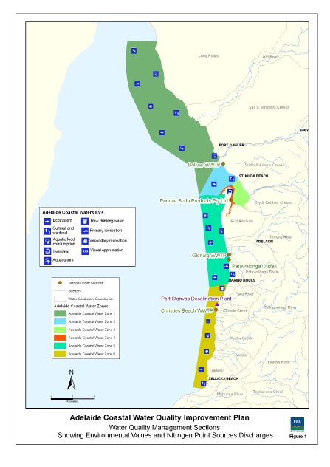

The Adelaide Coastal zone, the subject of the draft Adelaide Coastal Water Quality Improvement Plan (draft ACWQIP), extends from Port Gawler in the north to Sellicks Beach in the south. These are the lands and waters of the Kaurna Nation.

The draft ACWQIP was developed in response to long-held community concerns about the loss of sea-grass off the coast of Adelaide.

An initial study was carried out to investigate the causes of the seagrass loss, declines in water quality and sea floor instability for Adelaide’s coast. The Adelaide Coastal Waters Study (2008) concluded that solutions to the problems required a strategic and integrated response from the whole community.

This led to the development of the draft ACWQIP, a long-term strategy to restore and maintain specified water quality parameters in Adelaide’s coastal waters, consistent with community expectations and including on-going monitoring of implementation.

The draft ACWQIP has been finalised and it is anticipated it will be adopted by the South Australian government later in 2012.

### Community Engagement and Consultation Process

In developing the draft ACWQIP, the South Australian Environmental Protection Authority (EPA) carried out broad community consultation in order to identify Environmental Values, including cultural and spiritual values, and water quality objectives with specific water quality conditions.

The overall community vision for Adelaide’s coastal waters is summarised as:

Healthy aquatic ecosystems where environmental, social and economic values are considered in a balanced management approach that aims to see ‘the return of the blue line of seagrass closer to shore (EPA South Australia, 2011d).

The EPA convened a series of community workshops including targeted Indigenous Community Workshops with the Kaurna people, members of the Four Nations Group and the Kaurna Heritage Board. The workshops were designed to identify cultural and spiritual values in connection with the Adelaide Coast and inform the development of strategies and targets to integrate into the draft ACWQIP. It became apparent after the completion of the draft ACWQIP that the Ramindjeri Nation identify themselves as a separate Aboriginal group to be consulted for the Adelaide Plains.

Consultation was undertaken in accordance with the Four Nations Natural Resource Management (NRM), Governance Consultation and Engagement Protocols (Four Nations NRM Governance Group 2007) and Four Nations NRM Group Strategic Plan 2006–2010 (Four Nations NRM Governance Group 2006).

The Four Nations Group were elected members from the Kaurna, Ngadjuri, Ngarrindjeri and Peramangk people, who worked together to support each others’ natural resource management aspirations. However, the Four Nations Governance Group is no longer in operation as one formal group in the Adelaide and Mount Lofty Ranges NRM region of South Australia.

Personal communication with stakeholders, including EPA and Department of Water officials, indicates that Indigenous communities are broadly satisfied with the consultative process and provisions for ongoing participation in the implementation and monitoring of the water quality improvement plan.

### Values identified

The cultural and spiritual values for Adelaide’s coastal waters were identified through a series of community workshops and can be summarised as “water-dependent places, ecosystems or species with special significance for Aboriginal and non-Indigenous communities” (EPA South Australia, 2011a).

A broad range of Indigenous cultural and spiritual values were identified during Indigenous community consultations, largely related to biological considerations and stewardship responsibilities (EPA South Australia, 2011c).

For Indigenous people, the coast is an integral part of the landscape that cannot be assessed and/or managed in isolation from seasonal change (EPA South Australia, 2011c). All of the coast has cultural and ecological significance and cannot easily be simplified to a range of geographical locations (EPA South Australia, 2011d). A range of highly valued Indigenous cultural heritage sites were identified along the entire length of the Adelaide metropolitan coastline (EPA South Australia, 2011d).

### Integration of Indigenous cultural and spiritual values in water quality plans

The draft ACWQIP sets out eight strategies to implement the 14 recommendations of the Adelaide Coastal Waters Study. Each strategy has been designed to meet the 2030 water quality improvement targets outlined in the ACWQIP, and to achieve the community vision outlined previously.

Strategy eight of the draft ACWQIP is to build community capacity to improve coastal water quality, to develop linkages with Kaurna and Ramindjeri people regarding community water quality messages EPA South Australia, 2011d). It also aims to use Healthy Waters networks and local government to involve the community in water quality improvement activities. Healthy Waters is a project focusing on water quality and the need to protect it for health, environment, economy and way of life. It involves local communities, industry and government working together to look at the quality of water in rivers and creeks, wetlands, groundwater in underground aquifers and marine waters across the Adelaide and Mount Lofty Ranges region.

The Kaurna and Ramindjeri Nations, Adelaide and Mount Lofty Ranges Natural Resources Management Board (AMLR NRM Board), and South Australian Department for Water are all involved in carrying out a range of specific actions to implement the ACWQIP.

During community consultations, there were several proposals for integrating Indigenous cultural and spiritual values into water planning. Proposals included undertaking cultural mapping of Country, opportunities for involvement in establishing a dolphin sanctuary and increasing training and employment of Kaurna people in natural resource management roles such as water audits (EPA South Australia, 2011c).

### Results

It is expected that the South Australian Government will endorse the draft ACWQIP in 2012. The aim is to implement the plan adaptively so that “as more is learnt about the coastal system through monitoring, management strategies can be reassessed in the light of further knowledge” (EPA South Australia, 2011d).

The document recommends on-going engagement with the Indigenous community. The draft ACWQIP incorporates a comprehensive monitoring program to assess both water quality and whether the management plan itself is successful.

It will be reviewed annually and every five years from 2010 to 2030 (EPA South Australia, 2011d). Monitoring will involve participation by Indigenous and non-Indigenous stakeholders and natural resource managers to evaluate changes in the coastal marine environment over time and any inter-agency issues that may impact on the implementation of specific strategies.

The five-yearly review will report on progress towards achieving longer-term ecological goals, long‑term pollutant reduction targets, ambient water quality objectives and resource allocation.

Implementation of the draft ACWQIP provides for ongoing Indigenous community engagement in connection with program development, and review and monitoring.

### Lessons learnt

During the development phase of the draft ACWQIP, the SA EPA reports that stakeholders have been generally satisfied with the consultation and engagement processes. A key lesson is to ensure early engagement with Kaurna People to help achieve effective outcomes. The correct people need to be identified from the outset of such processes (EPA South Australia, 2011c).

## B. POLICE LAGOONS WETLAND CONCEPTUAL MODEL, QUEENSLAND

The majority of the information presented in this case study has been sourced from the Department of Environment and Heritage Protection (2010) Queensland Conceptual Model Case Study Series: Police Lagoons (DERM, 2010).

### Background

Figure 2 Map of Police Lagoons, Queensland (not to scale), Department of Environment and Heritage Protection, Queensland.

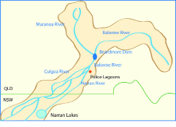

Police Lagoons ring the town of Dirranbandi in South-west Queensland (depicted in Figure 2). Some of the lagoons are adjacent to the Town Common where, in the past, police horses were grazed and watered giving rise to their current name. This part of the Murray–Darling Basin has seen the rapid development of broad scale cropping especially cotton growing. Dirranbandi has a population of around 437 people.

Police Lagoons are part of the traditional lands and waters of the Kamilaroi and Kooma Indigenous people.

Police Lagoons, located south of Beardmore Dam and upstream of Narran Lakes are a series of connected semi-arid floodplain tree swamps on the Lower Balonne River floodplain in the   
Murray–Darling Basin.

The Police Lagoons are ephemeral wetlands that have a natural cycle of flooding and periods of complete drying out. Under natural conditions they are dry until the Lower Balonne River breaks its banks and fills the lagoons. The lagoons are therefore heavily reliant on the flow levels of the Balonne River, particularly the peak flood events.

The Police Lagoons Wetland Conceptual Models document the cultural, spiritual and historical significance of Police Lagoons for Indigenous people. The Lagoons are habitat for species such as the yellowbelly and crustacean species, which are food sources for Indigenous people.

Before regulation of the Balonne River, the Police Lagoons tended to fill more regularly and required lower amounts of rainfall to do so, as the runoff and river flow was more likely to reach the lagoons (DERM, 2010).

Records show that before regulation, Police Lagoons filled once a year on average, while under the current water extraction rates, they fill every 1.4 years on average (DERM, 2010) (the chance of the lagoons filling has decreased by about 27 per cent under the current level of extraction).

The Police Lagoons Wetland Conceptual Models described in Figures 3 and 4 commenced in 2010 and are among several developed as part of the Police Lagoons conceptual model project, which documents the values of lagoons, including Indigenous cultural and spiritual values, and develops wetland management actions.

The Police Lagoons Wetland Conceptual Models were created by the Department of Environment and Heritage Protection (DEHP) Aquatic Ecosystem Health Science Integration Team as part of the Queensland Wetlands Program in partnership with the Queensland Murray–Darling Committee (QMDC) and local Indigenous Traditional Owner groups.

The objective is to synthesise information on the cultural, spiritual, hydrological and ecological values of the Police Lagoons and the existing pressures, particularly on native fish like the yellowbelly that are culturally significant to Indigenous people as a food source, and as an indicator of ecosystem health. The values are illustrated in Figures 3 and 4.

Figure 3 Police Lagoons, dry, Department of Environment and Heritage Protection, Queensland (DERM, 2010).

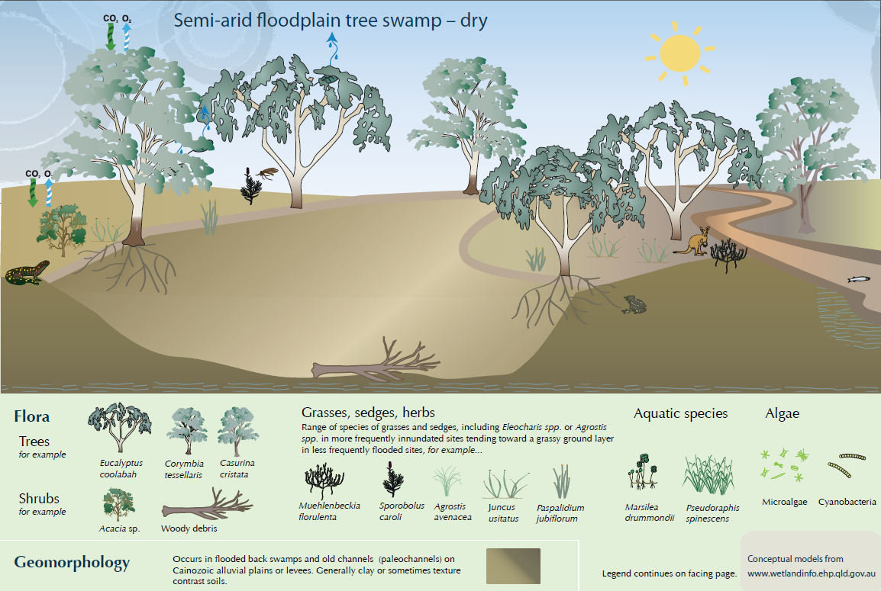

Figure 4 Police Lagoons, wet, Department of Environment and Heritage Protection, Queensland (DERM, 2010)

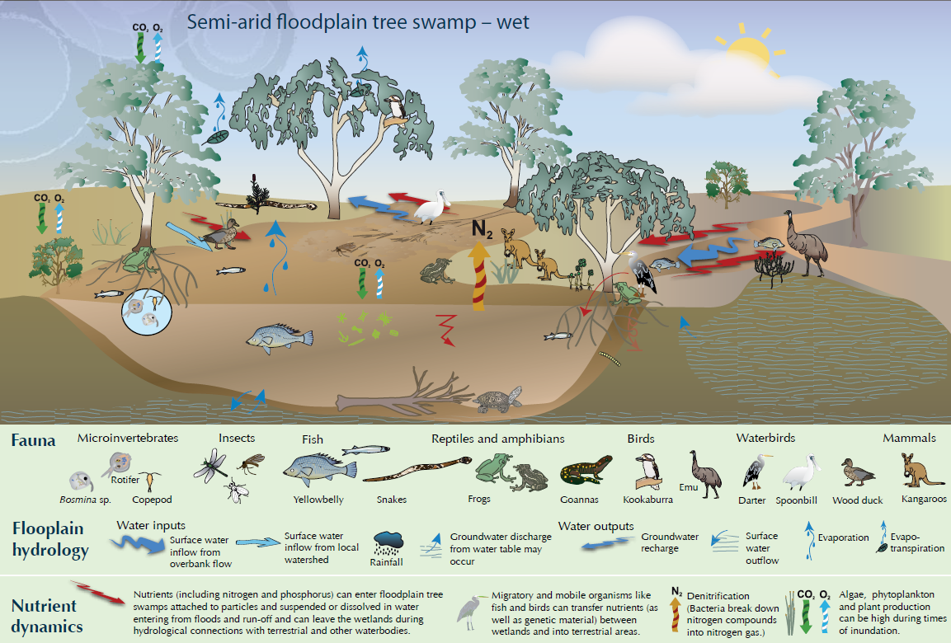

Having documented the values of Police Lagoons, the next phase is to develop and implement a plan of management and archaeological survey of the entire site.

### Community Engagement and Consultation Process

DEHP initially contacted the QMDC Water team asking if they would be interested in a case study involving wetland conceptual modeling. From that point onwards the DEHP project team and the QMDC Aboriginal Program team worked together on the project.

Members of the Regional Aboriginal Advisory Group, which provides cultural and technical advice to the QMDC, were invited to participate in the conceptual model project. The invitation to participate was open-ended and included all Indigenous persons in the community. Representatives of the Regional Aboriginal Advisory Group who are Traditional Owners were also involved.

There were two site visits to Police Lagoons and Indigenous elders who have maintained connections with the Lagoons for many years shared their stories and their knowledge of the condition of the wetland over the long term.

The QMDC supported formal Traditional Owner engagement via two workshops held in Dirranbandi to discuss the Police Lagoons Wetland Conceptual Model and to identify their cultural and spiritual values associated with the water body.

The workshops and site visits were facilitated through the QMDC Aboriginal Program and led by a Traditional Owner of Police Lagoons with the engagement of DEHP. The upfront involvement of the Traditional Owner was essential to building trust and legitimacy during discussions about peoples’ knowledge and values.

### Values Identified

The Lagoons have a range of cultural, spiritual and ecological values that are inter-linked. Indigenous knowledge of the Lagoons and the evidence of long-term use and occupation demonstrate their cultural, spiritual and social importance.

During consultations, the Police Lagoons were identified as a functioning wetland, meeting place, swimming hole, campsite, bora ring, and burial site. Indigenous elders recalled Police Lagoons as a healthy and frequently inundated wetland where Indigenous people would regularly gather, with an abundance of fish such as yellowbelly and crustaceans. In recent years the lagoons have been impacted by increasing water extraction and large-scale changes in catchment use.

Under the regional ecosystem classification, the Police Lagoons are mapped as Eucalyptus coolabah woodlands on alluvial plains. This habitat is classified as ‘Of Concern’ (only 10 to 30 per cent remains of the pre-clearing extent of this particular regional ecosystem) under the Queensland Vegetation Management Act, 2009 due to its importance in maintaining diverse habitat. Coolabah trees supplied material for manufacturing canoes, containers and weapons.

### Integration of Indigenous Cultural and Spiritual Values in Water Quality Plans

The conceptual models for Police Lagoons integrate science with cultural, spiritual and ecological values in order to inform integrated natural resource management of the lagoons. The objective is to support community goals to maintain and improve the wetland’s values.

The conceptual models summarise pressures effecting the habitats and water quality of the lagoons. These include invasion by pest species, erosion, loss of habitat and changes in the filling regime of the wetlands that are dependent on regular moderate level flooding. This information will help the community to contribute to future management of the area including contributing to future water planning.

### Results

#### Implementation

The conceptual model facilitates improved awareness of the range of values associated with Police Lagoons by utilising a user-friendly visual approach (using pictures, diagrams and descriptions) to map the wetland values and ecology, as well as site-specific, synthesised science and text to support and inform water management and cover a wide variety of wetland issues and types. It is a tool for combining sources of knowledge and information, communicating with target audiences and developing management approaches with a view to maintaining wetland integrity.

Indigenous elders and youth can use the conceptual model, which uses Indigenous language, to improve their understanding of the ecology, water quality, cultural and spiritual values and recorded knowledge of Police Lagoons, some of which are listed in the table at Figure 5.

Figure 5 Kamilaroi language associated with Police Lagoons wetland, Department of Environment and Heritage Protection, Queensland.

Figure 5 lists some examples of the Kamilaroi language:
• Coolabah tree - Gulubaa
• Emu - Dhinawan
• Frog - Gindjurra
• Kangaroo - Bandaa
• Kookaburra - Gugurrgaagaa
• Long ago - Yilambu
• Long necked turtle - Maliyan
• Short necked turtle - Waraba
• Yellowbelly - Thagaay
• Rain - Gali
• River - Bagaay
• Lagoon - Gaawa

The techniques and processes used for developing the conceptual models can be implemented by local wetland managers anywhere. A guide to conceptual modeling can be downloaded from the Queensland Wetland Program “Wetlandinfo” website (DEHP, 2017).

The broader Indigenous community has responded positively to the conceptual model approach, which enables two-way learning between ecologists and Indigenous people. For example, sharing the knowledge that crustaceans are both a food source for the local Indigenous community as well as a staple of yellowbelly. The need to sustainably harvest crustaceans is acknowledged by the Indigenous community as being important to ensure regeneration of yellowbelly.

Maintaining the integrity of Police Lagoons and water quality of the wetland to sustain the habitat of species such as yellowbelly and endangered Coolabah vegetation communities will require government, NRM bodies, property owners and managers to work together.

A range of initiatives, proposed by the QMDC Aboriginal Program to manage the lands around the lagoons including the Town Common, are being articulated in the Police Lagoons NRM Management Plan during 2012. The proposed management plan will involve local government and DEHP.

The Management Plan will inform management priorities and the activities of the QMDC Aboriginal Ranger Program, Aboriginal Traditional Owners and the local community.

### Monitoring

Managing the impact of catchment pressures is important for Police Lagoons, as it is for all floodplain wetlands. To achieve this, QMDC is undertaking pest and weed management, erosion control projects, a biodiversity audit and Water Quality Monitoring.

The presence of yellowbelly is being recorded as part of the carp management program, as health of yellowbelly is an important water quality indicator. According to Indigenous elders, if the yellowbelly are ragged with sores this is an indication the water quality is poor.

The QMDC is providing ongoing support and coordination of the management of Police Lagoons. The next stage is the development of a plan of management for Police Lagoons in partnership with Indigenous people. This will involve a cultural survey of the whole area that will be incorporated into the management plan and will require on-going engagement of Indigenous people in managing the lagoons.

Police Lagoons was the first local conceptual model case study and wetland guide to be developed through the DEHP Queensland Wetland Program and it has been a success with significant learning for all involved.

## C. Engaging with and incorporating the views of the queensland far south west aboriginal natural resource management group in water quality management planning

### Background

Figure 6 Lower Paroo River, subregion P2, South West NRM Ltd.

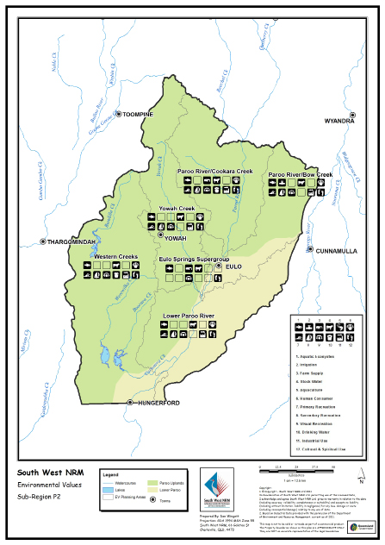

Engaging with Indigenous stakeholders is an integral part of community consultation in the development of environmental values, water quality objectives and Healthy Waters Management Plans under Queensland environmental legislation.

The community consultation process to develop environmental values, water quality objectives and a Healthy Waters Management Plan for the waters of south west Queensland, under the Environmental Protection (Water) Policy 2009, is part of a two year joint project between South West Natural Resource Management Ltd (South West NRM Ltd) and the Department of Environment and Heritage Protection.

The South West NRM Ltd is the designated regional body for natural resource management for the south west Queensland region that includes the Bulloo, Paroo and Warrego river basins and the Nebine-Mungallala-Wallam catchments of the Balonne-Condamine river basin. The region covers 187,000 square kilometres and includes catchments within the Murray–Darling Basin system. The region is characterised by extremely variable rainfall and is dominated by Mulga (Acacia aneura) vegetation. Cattle and sheep grazing is the predominant industry. A number of rural towns are located in the region including Augathella, Charleville, Cunnamulla, Quilpie and Thargomindah.

### Community Engagement and Consultation Process

There are six Indigenous groups located within the region, including the Kooma, Bidjara, Kunja, Mardigan, Budjiti, and Kullilli people. With the assistance of South West NRM Ltd, the Far South West Aboriginal Natural Resource Management Group was formed in 2004 to provide advice and assistance to all community members and undertake on-ground projects that achieve environmental outcomes while enhancing culturally significant values. Two representatives from each local Indigenous group participate and are Native Title claimants or community members nominated by claimants to represent their group.

Through a number of workshops, the Far South West Aboriginal Natural Resource Management Group provided input on environmental values, water quality and aquatic ecosystem issues and desired management outcomes for the surface waters and ground waters of the region. The workshops involved a mixture of presentations, interactive mapping and water quality discussions.

### Values Identified

Key outcomes from these workshops included the refinement of ‘Cultural and Spiritual’ values to include ‘Ceremonial’ values; the determination of environmental values across the region with the ‘Cultural, Ceremonial and Spiritual’ value applicable to all waters; and the identification of water quality related issues.

### Integration of Indigenous Cultural and Spiritual Values in Water Quality Plans

The aims of the Far South West Aboriginal Natural Resource Management Group in managing water quality to achieve environmental values, addressing the risks to environmental values in the management of water quality and opportunities to strengthen the protection of environmental values, were articulated and will be addressed in the management issues and responses in the Healthy Waters Management Plan currently being developed for the south west Queensland region.

The Far South West Aboriginal Natural Resource Management Group’s values for the waters within the region will be incorporated into the future statutory environmental values and water quality objectives for the waters of south west Queensland under the Environmental Protection (Water) Policy 2009. The establishment of water quality objectives to protect aquatic ecosystem environmental values is considered to generally afford protection of the cultural and spiritual values for the waters of the region.

The environmental values developed from the community engagement process, including Indigenous input, for the lower Paroo river basin within the South West Natural Resource Management region are shown in Figure 6.

When making an environmental management decision about an activity, either as part of a development assessment or an environmental authority, under the Environmental Protection Act 1994 the administering authority must consider the environmental values and water quality objectives for the waters and the management intent for different levels of aquatic ecosystems protection. Additionally the protection of environmental values that may be adversely affected by the activity must be considered in imposing conditions on development approvals.

## D. Prioritising rock-holes of aboriginal and ecological significance in the Gawler Ranges, South Australia

### Background

Figure 7 Fieldwork locations and project area for Gawler Ranges rock-hole project, 2008–2011 (Jenkin, 2011)

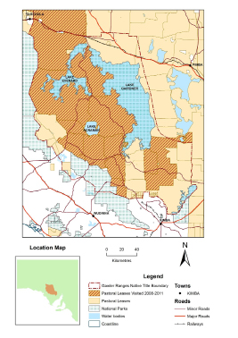

The Gawler Ranges in South Australia encompass the recognised native title lands of the Kokatha, Barngarla and Wirangu people depicted in Figure 7. Native title (non-exclusive) was conferred on 19 December 2011 (McNamara on behalf of the Gawler Ranges People v State of South Australia [[2011] FCA 1471](http://www.austlii.edu.au/au/cases/cth/FCA/2011/1471.html)).

The Gawler Ranges rock-holes are a series of water bodies, holes or depressions on the surface of granite domes and outcrops. They are prominent features in the landscape and have significant cultural, spiritual and ecological values for the Kokatha, Barngarla, and Wirangu people.

However the availability of cultural and ecological information regarding the rock-holes across the South Australian Arid Lands Natural Resource Management (SAAL NRM) region is limited. The Gawler Rangers Rock-Holes Project is intended to bridge that knowledge gap and thereby enable improved management of the rock-holes for the range of values identified.

The Gawler Ranges rock-holes provide habitat for culturally significant species and contain culturally significant medicinal plants and a source of food (for example, bush tomato). They also provide a crucial water supply for Indigenous people who live in the Gawler Ranges and traverse arid lands where there is limited permanent fresh water (springs and soaks) and no permanent flowing rivers. Indigenous routes in arid areas are to a large extent determined by the occurrence and distribution of rock-holes with tracks radiating out from them and which are connected through story and songlines.

The water quality of the rock-holes varies. Some have good water quality while some are degraded due in part to neglect and animal defecation resulting in sedimentation and eutrophication. It has also been difficult to access some of the sites to look after them.

The Prioritising rock-holes of Aboriginal and Ecological Significance in the Gawler Ranges Project (Gawler Ranges Rock-Holes Project) was initiated by the Kokatha, Barngarla and Wirangu people who wanted to “get out on country and care for important places and maintain cultural knowledge” (Jenkin et al, 2011).

The project commenced in 2008 with funding from the Commonwealth Caring for Our Country program and delivered through a partnership between the SAAL NRM Board, the Gawler Ranges native title claim group, the South Australian Native Services Ltd, and the former SA Department of Water, Land and Biodiversity Conservation (DWLBC). Ecologists from the SA Department of Water were also involved in an effort to bring together traditional and western science.

The objective was to develop an inventory of rock-holes across the Gawler Ranges with a view to:

* enhance knowledge and understanding of the cultural, ecological and pastoral value of rock-holes;
* raise awareness to allow for protection and management of culturally significant rock-holes;
* increase stakeholder engagement in rock-hole management; and
* identify and document the specific principles or protocols for engaging the Aboriginal community in such projects.

The project combines ecological field assessments with cultural assessments to identify values, condition and threats and establish future management strategies and priorities. Since 2008 the project has continued through successful competitive Commonwealth grants with an increasing focus on implementation and management strategies with ongoing cultural and ecological assessments of unrecorded rock-holes. Renewed funding has been secured through to June 2013.

### Community Engagement and Consultation Processes

At the outset in 2008 a pilot cultural assessment was carried out with the Gawler Ranges native title claim group which identified the opportunity to improve management of rock-holes through a partnership approach. The Gawler Ranges native title claim group approached the SAAL NRM Board to further develop the project with a view to ensuring the rock-holes are looked after and maintained. This led to a pilot phase that was funded by the SAAL NRM Board.

Fieldwork was carried out in two stages to assess the cultural and ecological values of identified rock-holes and establish monitoring and management actions. During the first year of the project, fieldwork was carried out in two parts on two pastoral leases. The first, a smaller group to locate the rock-holes and document access arrangements to ensure vehicular access. The second, a larger group (i.e., all of the project team and 8 members of the Gawler Ranges native title claim group) to undertake cultural and ecological assessments of ten rock-holes (Jenkin et al, 2009). From 2008 to 2010, the project team visited 21 sites across seven pastoral leases (Jenkin et al, 2009).

During 2009/2010 fieldwork assessment expanded to more stations and incorporated the establishment of a cultural and ecological database and whole of country plan. This was enabled by base funding investment through the SAAL NRM Board.

In 2010/2011 South Australian Native Title Services (SANTS) managed the project through Caring for Our Country Funding and SAAL had less direct input into the project, with continued assessment of rock-holes. There was a stronger focus on identification and implementation of management strategies including monitoring. During 2011/2012 SANTS continued managing the project with a strong focus on on-ground works to address critical threats with on-going assessment of rock.

The project was guided by a steering committee with representatives from each partner or stakeholder group including members from the Pastoral Board and the Aboriginal Affairs and Reconciliation Division (Aboriginal Heritage Branch). The steering committee assisted with project direction, resolved any issues and used its members to communicate project updates and findings back to each of the stakeholder groups.

This project methodology complied with the NRM engagement protocols set out in Engaging South Australian Aboriginal Communities in Natural Resources Management - A Practical Resource Manual. The NRM manual sets out five levels of engagement: information sharing, consultation, involvement, collaboration and partnerships (Jenkin et al, 2011).

In practical terms this involved spending time building relationships and understandings between project team and Gawer Ranges native title management committee members, and respecting decision-making processes including in relation to timing and the authority of some members (Jenkin et al, 2009). It also involved developing clear and appropriate communication material, for example: powerpoint and verbal presentations.

The Gawler Ranges native title management committee convened on several occasions to identify the right people to participate in fieldwork, to establish priority sites for the project within the Gawler Ranges native title claim area, and to ensure community support for the project. The management committee is elected by the broader Gawler Ranges Aboriginal community and authorised to make various decisions on the community’s behalf. The support and input of this group has been critical to the success of the project. Since the native title determination the native title management committee has been replaced with the Board of Directors of the Gawler Ranges Aboriginal Corporation.

The Gawler Ranges native title management committee (NTMC) appointed a mixture of elders and younger members to the fieldwork team. The selection of rock-holes for each fieldwork activity was dependent on vehicle accessibility to enable elders to visit the sites (Jenkin et al, 2011).

An important stage of the project was the development of protocols to safeguard the exchange of knowledge and culturally sensitive information. This allowed the project to be undertaken within a framework that met the needs of the Aboriginal community and individual pastoralists, as well as protecting culturally sensitive information. For example, in the 2009/10 stage of the project the protection of intellectual cultural property was built into the funding agreement with the SAAL NRM Board, and the development of a Cultural and Ecological Information Management System ensures that the recorded knowledge of elders has restricted access (Environmental Systems Solutions, 2012). All project partners had a shared understanding of the need to ensure that cultural information was protected and that may extend to the exact location of rock-holes.

Steering committee meetings, field trips and annual reports were utilised to communicate the project direction and accomplishments to all parties and stakeholders (Jenkin et al, 2011). Other communication tools were developed during the project such as scientific presentations at community native title meetings, publishing a brochure, development of a heritage database, and through a community land management workshop.

### Values Identified

Rock-holes have significant values for Indigenous people of the Gawler Ranges however the cultural and scientific understanding of rock-holes in arid areas of Australia is ‘still very limited’ with no prior studies conducted within the Gawler Ranges” (Jenkin et al, 2011).

Gawler Ranges rock-holes were traditionally the main source of water for Indigenous people moving across the arid landscape and careful management of the rock-holes has been vital to Indigenous occupation within these areas.

Each rock-hole complex is ‘characterised by complex value systems’ (Jenking et al, 2009). Indigenous law (Tjukurrpa) and custom determines how rock-holes are used and looked after, which is passed from generation to generation through story and song. Named rock holes are recorded in song and story and mapped as part of a “complex cultural and ecological knowledge system” (Jenkin et al, 2009).

Customs associated with the rock holes include ‘talking to country’, restricting behaviours and access, collecting bush medicines and bush tucker, introducing and protecting strangers and looking after places (Jenkin et al, 2009). Rock-holes continue to play a significant role in lore, ceremony and cultural responsibility.

The depth of Indigenous knowledge and connection to the rock-holes was evidenced during field‑work. The more important water supplies usually have totemic significance and play an important role in Indigenous ceremonial and social life, and were often central trading locations. Rock-holes have traditional productive values and provide important resources such as bush tucker and bush medicines.

There is a ‘cultural responsibility, a duty,’ to look after watering holes that ‘requires traditional knowledge and authority’ (Jenkin et al, 2009). This knowledge forms part of a broader, holistic belief system connecting all aspects of culture, country and life.

In relatively recent years the water quality of some rock holes has declined as a result of siltation, feral and domestic animal defecation, and neglect. Traditional management practices to maintain water quality were described by Indigenous elders for a number of rock-holes.

At the Meelera Rockholes, located on the Meelera granite outcrop, Indigenous management practices include removing dead animals and sometimes silt, and then placing a stick into the holes to allow small birds and animals to escape if they fall in. At the Tunkillia rock-hole, which is of great cultural significance as being part of the Seven Sisters dreaming, water quality continues to be spoiled through defecation by stock and native fauna. Greater protection for Tunkillia rock-hole is seen as a priority by senior Aboriginal men in order to protect its cultural heritage values. At the Darebin rock-hole, cleaning out the rock-holes was considered important by Indigenous men to reduce sediment and improve water quality. Darebin rock-hole is a restricted Tjukurrpa men’s site that contains a large amount of water and hosts a number of aquatic invertebrates. Its significance is supported by archaeological material. At the time of the site visit it was considered to be in good condition with culturally significant plants and bush foods identified around the rock hole, however there was also some evidence of sedimentation and fouling of water from native and introduced animals.

### Integration of Indigenous Cultural and Spiritual values in Water Quality Plans

As a collaborative project, one of the objectives from the outset was to bring together traditional and western knowledge and science to enhance understandings and improve management decision‑making and outcomes. The region is not subject to a water allocation plan being a prescribed region and therefore subject to a SAAL regional plan.

The next stage is the development and implementation of a plan of management.

The project in 2009/10 developed a whole of country management plan for the Gawler Ranges native title claim area through the SAAL NRM Board and the NTMC with measures to protect the rock-holes as culturally significant places and important freshwater refuge habitats. The management actions will combine traditional Indigenous knowledge, local knowledge from pastoralists and ecological knowledge to protect, restore and better manage the identified rock-hole sites.

### Results

The Project has been described as an ‘evolving and promising partnership’ (Jenkin et al, 2009) by enabling Indigenous people to access the rock-holes to maintain and look after the rock-holes and thereby maintain cultural and spiritual values as living cultural traditions. This involved documenting the extent, distribution and current condition of rock-hole water resources across the Gawler Ranges, as well as identifying the cultural, ecological and productive values of important rock-holes in the Gawler Ranges native title claim area.

The combined knowledge will contribute to understanding the ecological, cultural and spiritual significance of rock-holes in the arid landscape and what changes may have happened at some sites over time, and the need to secure ongoing engagement of Indigenous people in future management approaches.

The Gawler Ranges Rock-holes Project has developed a methodology for recording the cultural and ecological value of rock-holes, and developed relationships between community and government that would enable the project to be expanded over the entire region (Jenkin et al, 2011). The support from the Commonwealth through the competitive Caring for Our Country program has meant that the project will be able to deliver this across most of the claim/determined area.

A workshop was convened in 2011 to develop and implement agreed management strategies which include the establishment of thirteen monitoring sites (Aboriginal way, 2011). Each rock-hole site assessment provides information for future monitoring and management considerations which are rated under each of the following criteria: current management; restoration potential; ecological investment priority; and cultural investment priority.

State-wide coverage and integration of Indigenous management of this water resource will be valuable in not only ensuring preservation of these rock-hole ecosystems but will also protect and respect Indigenous cultural heritage.

The development of a manual on rock-hole cleaning will be developed along with a pictorial education booklet about rock-hole sites and their corresponding stories for the broader community. A DVD has been developed to showcase the project and project outcomes.

### Lessons learnt

The success of the project to document the cultural and spiritual values of the Gawler Ranges rock‑holes has hinged on the support and participation of a wide range of key stakeholders including the Gawler Ranges native title claim group, pastoral lessees and station managers (Jenkin et al, 2011). The negotiation of an Indigenous Land Use Agreement with a number of pastoral lessees also helped support the development of the project through establishing relationships and understandings between claimants and pastoralists and establishing access protocols prior to the native title determination.

It appears that, while stakeholders are generally satisfied with the project, there are still some members of both the Indigenous and pastoral community who remain uncertain about the role and outcomes of the project. One of the lessons learnt is that for projects like this, with a range of stakeholders from diverse backgrounds, it is very important to develop, implement and maintain a comprehensive communication/stakeholder engagement strategy prior to project initiation that continues throughout the project including follow-up (Jenkin et al, 2011).

## E. Recognising indigenous cultural and spiritual values: maintaining river health of the Daly River (NT)

### Background

Figure 8 Map of the Daly River catchment showing the study sites sampled during 2006, Dr Mark Kennard, Australian Rivers Institute, Griffith University (CDU, 2007).

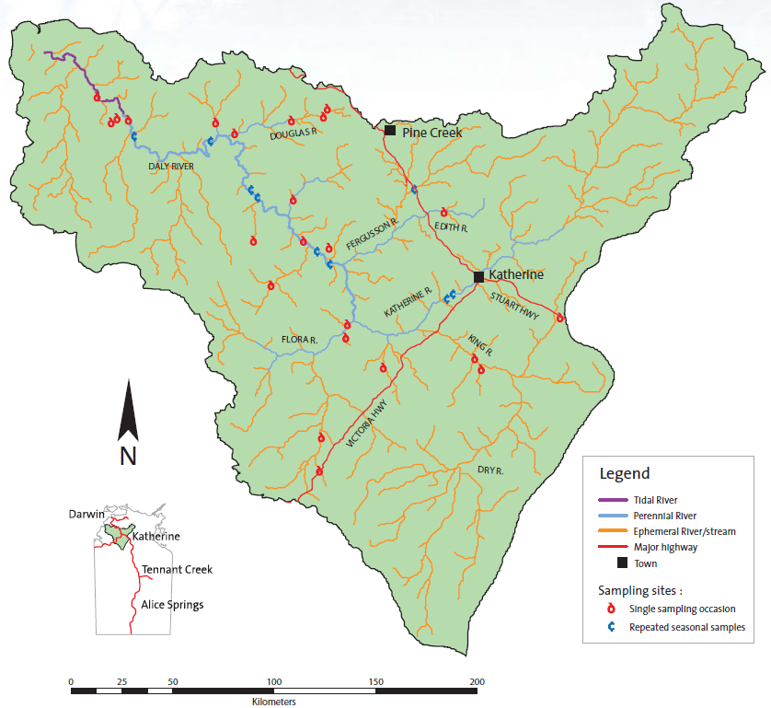

The Daly River catchment is the third largest in the Northern Territory and has the largest flow of any river in the Northern Territory depicted in Figure 8. The river has constant flow, fed by significant groundwater-dependent ecosystems that provide breeding areas and habitat for culturally significant species of fish, long necked turtle, magpie geese, lotus lily and short-necked turtle (Jackson et al, 2011). The freshwater fish population is one of the most diverse in the northern rivers, with 98 different species recorded (NWC, 2011a). Good water quality and reliability of flow is dependent on year-round water flows fed from groundwater. Differences in flow regimes has resulted in differences in harvesting efforts with Indigenous people reporting that fishing was affected because “‘the water is too high’, it is ‘too boggy’ or the river was ‘running too hard’”(Jackson et al, 2011).

Proposals for major agricultural developments adjacent to the Daly River will require the allocation of water resources through water sharing plans. The impact of reduced dry season flows on water quality and freshwater fish in the Daly River as a result of water resource development is poorly understood due to a lack of baseline data and systematic monitoring (Jackson et al, 2011), however this remains the subject of on‑going investigation and research (CDU, 2009; Finn and Jackson, 2011). Preliminary research suggests there may be negative impacts on flow‑dependent species and increased turbidity in what is currently a clear-water river in the dry season (Georges et al, 2002).

Over-extraction can reduce flows, affect water quality and reduce habitat availability for native fish and aquatic plants. Some fish, including barramundi and sooty grunter, are amongst the species at highest risk from potential reductions in dry season flows (Schult and Townsend, 2012). The latter, a widespread and common species, is highly valued by Indigenous people who place importance on a different suite of attributes to those valued by other stakeholders (Finn and Jackson, 2011).”

A number of studies have been undertaken in the past decade involving Aboriginal people to gain an understanding of Indigenous values relating to water planning. These were largely funded by the Australian Government, with some funding from the Northern Territory Government. The studies involved local researchers working with Traditional Owners to increase understanding of Indigenous knowledge related to water planning. These studies were:

* Preliminary report on Aboriginal perspectives on land-use and water management in the Daly River region, Northern Territory (Jackson, 2004)
* Water Regime Dependence of Fish in the Wet-dry Tropics Project
* River Health in the Daly Catchment (Schult and Townsend, 2012)

The Preliminary Report on Aboriginal Perspectives on land-use and Water Management in the Daly River Region was commissioned by the Northern Land Council. The Water Regime Dependence of Fish in the Wet-dry Tropics Project (2009) (Daly River Fish and Flows Project) commenced in 2005, funded by the Australian Government Land and Water Australia until 2009, and now continues under the Tropical Rivers and Coastal Knowledge (TRaCK) research hub. The project identified the environmental water requirements of keystone fish species in the Daly River which provides a ‘tangible link’ between flow patterns and cultural values (Land & Water, 2009).

The broad aims of the Daly River Fish and Flows Project were to:

investigate variation in fish distribution and ecological requirements in the Daly River, as well as to document Indigenous knowledge and learn about the cultural significance of fish. This information will be combined to produce models relating fish ecology and flow, which can be used in water planning. The knowledge gained will also be applicable to other river systems in northern Australia and for future planning processes (Douglas and Kennard, 2007).

Project partners were the Tropical Rivers and Coastal Knowledge (TRaCK) research hub, Charles Darwin University (NT), Griffith University (QLD), CSIRO, Wagiman Guwardugan Rangers, Wardaman Aboriginal Corporation, the Northern Territory Government and University of Washington. The Wagiman Rangers are a group of full time rangers established by the Wagiman people in 2003 who are training in natural resource management to look after the land and develop enterprises for the future. The Wagiman Rangers are currently funded through the department’s Working On Country program to undertake environmental activities.

Since this time further research and modeling has been carried out to identify Indigenous cultural values in connection with river health: the Indigenous Socio-Economic Values and River Flows project ran from 2008 – 2010; the NT Government River Health in the Daly Catchment Report in 2012 (Schult and Townsend, 2012); and the TRaCK Integrating Knowledge to Support Adaptive Management Project which is developing management strategies to incorporate identified values.

### Community Engagement and Consultation Process

There are around 12 indigenous language groups that have close cultural connections to the Daly River and its catchment and who have participated in a range of studies including the Daly River Fish and Flows Project and the Indigenous Socio-Economic Values and River Flows Project amongst others.

The Daly River Fish and Flows Project involved active participation of Wagiman and Wardaman people of the mid to upper region of the Daly River who shared their knowledge of fish, fishing and hydrological matters for the study area and assisted with fish sampling. The locations of the sampling sites are identified in Figure 8. Two representatives of each language group were members of the Project Steering Committee and contributed to oversight of the entire project.

There was a strong capacity building component to improve the capacity of Indigenous people to participate in water management and research. Capacity building also improved understanding of the contemporary water resource management regime, especially the implications of water allocation planning for Indigenous people.

A research agreement was negotiated with the Wagiman Guwardugan Rangers in 2006 and with the Wardaman Association in 2007 to guide the conduct of research activities, communication of results and protection of intellectual property (CSIRO, 2007).

Consultations included face-to-face meetings and small discussion groups with Wagiman and Wardaman people who use rivers and have knowledge of fish through their hunting and collecting activities. They were able to provide a good picture of seasonal variations in terms of the places people visit and quantities of bush tucker collected.

Information was presented to project participants in a user friendly and culturally appropriate booklet format to ensure a good understanding of the research and its management context. Regular communication was maintained with Traditional Owners and with representatives of Aboriginal organisations such as the Northern Aboriginal Land Council and the Daly River Aboriginal Reference Group (ARG).

The consultation process for the TRaCK Indigenous Socio-Economic Values and River Flows Project involved working with a number of Indigenous language groups from the Daly River region to document Indigenous social, cultural and economic values related to water. This research included a two year intensive survey to determine how Indigenous residents use the river, floodplains and other aquatic habitats to fish, hunt and gather a diversity of aquatic species. The aim was to understand the relationship between indigenous values and river flows and to assess impacts of flow regime changes on those values.

### Values Identified

The 2012 Report on River Health recognises the Daly River as having special cultural significance and values for Indigenous people, as well as a range of other values, which “can only be sustained when the river system is healthy” (Schult and Townsend, 2012). Cultural values depend on “a healthy river which is more than just the quality of the water or the plants and animals that live in it, and includes the diversity of habitats, the linkages between the river and the land, its floodplains and groundwater sources, and the maintenance of ecological processes” (Schult and Townsend, 2012).

The impetus for the Daly River Fish and Flows Project and the Indigenous Socio-Economic Values and River Flows is in recognition that the knowledge base to inform water planning decision making in the Daly River catchment is incomplete. Knowledge gaps include the relationship between groundwater, surface water and the values Indigenous people attach to land and water (Daly River Community Reference Group, 2004).

The Daly River Fish and Flows Project aimed to improve understanding of the social and cultural significance of fish to Indigenous people in the region, recognising that fish are keystone species and “important to Aboriginal people who have a special interest in their behavior and movement” (CSIR, 2007). River flow is considered vital to the character of the river and the dependent species, and activities that might stop river flow and disturb movement of fish and turtles are seen in a negative light (Jackson, 2006).

Indigenous Ecological Knowledge was documented during both projects, particularly seasonal “knowledge of resource harvesting and the environmental cues and indicators used to target specific species” (Woodward et al, 2011). This provides an insight into the resource management strategies of Indigenous people, and identifies priorities for water planning and management (Woodward et al, 2011).

During fieldwork carried out for the Daly River Fish and Flows Project, Wagiman and Wardaman Traditional Owners identified the language names for fish, including fish species at particular locations, and shared their knowledge of fish behavior, fish movement and stories about the role of fish in creating the landscape and social arrangements (CSIRO, 2007). A range of aquatic species, such as the sooty grunter (also known as black bream) identified as being both culturally significant and a bio‑indicator for water quality (Metcalfe, 2009). Billabongs are reliant on groundwater to stay full all year around (Jackson, 2004) and are perceived by Wardaman and Wagiman Traditional Owners to be particularly sensitive to changes in groundwater levels from water abstraction.

The recent TRaCK Indigenous Socio-Economic Values and River Flows Project (Jackson et al, 2011) focused on the significance of water and river systems (including groundwater) to Indigenous communities and their Indigenous belief systems and environmental philosophy. It found that the most commonly caught and harvested species in the Daly River are the long-necked turtle, lotus lily, black bream, magpie goose and short-necked turtle, which reflect the widespread use of billabong habitat in the catchment. It also found that differences in flow regimes impacts on seasonal patterns of harvesting efforts of identified species (Jackson et al, 2011).

### Integration of Indigenous Cultural and Spiritual Values in Water Quality Plans

The Daly River Fish and Flows Project documented Indigenous ecological knowledge and values of keystone species in the Daly River with a view to integrating the findings into water resource planning. An objective was to develop conceptual models to assess the impact of different water allocation scenarios on freshwater fish in the mid to upper region of the Daly River catchment. According to the director of TRaCK, “information gathered through the project is being used by the Northern Territory Government and results from the fish surveys will be used to monitor changes in the river over time” (TRaCK, 2011).

A scientific paper co-authored by the traditional owners and scientists involved in the project explains the importance of indigenous knowledge to water planning (Jackson et al., forthcoming).

More recently, the Indigenous Socio-Economic Values and River Flows Project documented seasonal patterns of resource-use that resulted in the creation of Indigenous Seasonal calendars. These calendars were seen as important projects by Traditional Owners as they documented knowledge including Indigenous language and are now being used by local schools.

TRaCK is developing mechanisms to incorporate cultural and spiritual values and associated knowledge into emerging adaptive management frameworks. The TRaCK Integrating Knowledge to Support Adaptive Management Project will focus on the Daly River catchment which has ‘the most knowledge available’ in the Northern Territory which makes it a ‘good case study’ that can be adapted to other catchments in the future (TRaCK, n.d). Knowledge from a range of TRaCK studies including the Daly River Fish and Flows Project and the Indigenous Socio-Economic Values and River Flows Project (2011) will feed into the adaptive management responses i.e. what stakeholders value in a catchment, how ecosystems and people respond to management actions, and results from fish surveys and monitoring programs. This could include information like the relationship between river flows and fish numbers (TRaCK, n.d).

### Results

The Daly River Fish and Flows project is regarded as a “breakthrough in terms of combining Indigenous and western science knowledge and giving recognition to and getting greater appreciation for the value of Indigenous knowledge” (TRaCK, 2011).

Specific project outcomes are the identification of new knowledge about fish, their flow requirements and cultural values, and improved understanding of the risks of impacts due to changes in flow regime. Indigenous knowledge of fish behavior influenced the risk assessment model that was used to inform the Oolloo Aquifer Water Allocation Plan (Jackson et al. forthcoming). In October 2011 a poster was launched by the Wagiman people in partnership with TRaCK which, for the first time, records Wagiman language names alongside scientific and common names.

The enhanced capacity for collaborative fish research & monitoring in the Northern Territory and Indigenous people participating in research, planning and decision-making processes is significant. The increased capacity for the Wagiman Rangers to undertake monitoring and other water management activities is also a key positive outcome of the project.

During the Fish and Flows Project, fish sampling and surveys were carried out in association with 20 Indigenous Wagiman Guwardagun Rangers and staff from the Northern Territory Department of Primary Industry, Fisheries and Mines. Training was provided for fish sampling and explanations on site during fieldwork. TRaCK has continued fish surveys twice a year and aims to continue the work to provide a long-term data set for the Daly River with the active participation of the Wagiman Rangers. The results will be used to monitor changes in the river over time (TRaCK, 2011).

Monitoring was also carried out by Indigenous rangers in connection with the Indigenous Socio‑Economic Values and River Flows Project (2011). Indicators were chosen by the Indigenous rangers based on their interests and concerns for river country, and various techniques were trialed to measure change. This information will be useful for water management plans (Jackson et al, 2011a).

On-going monitoring by Indigenous people in the Daly River catchment is via the Daly River Aboriginal Reference Group (Daly River ARG) which has an ongoing role monitoring water quality in the Daly River. Two nominated representatives of the Daly River ARG represent the interests of Traditional Owners in any proposed or planned development in the Daly River.

Broad participation in catchment management and monitoring is continuing through the Daly River Indigenous Advisory Committee and the Daly River Management Advisory Committee (DRMAC). The role of the DRMAC is to put in place monitoring systems “to measure changes in the values of the Daly such as the availability of fish, clean unpolluted water and water flows that protect wildlife and future development options, and to gather and analyse scientific and local knowledge of the Daly River. The NT Government has approved new funding of $3.5 million over four years to implement the adaptive management framework. Much of this funding will be used to substantially upgrade our knowledge and monitoring capacity for water resources.

### Lessons learnt

Indigenous people possess intimate knowledge of their local environment and have complex value systems in connection with water and biodiversity. This knowledge is integral to holistic management and planning to maintain river and ecosystem health.

It is important to establish research protocols in consultation with Indigenous stakeholders prior to the development of the project methodology to ensure traditional knowledge is respected and valued, the consultative processes are culturally appropriate, and information is presented in a suitable format taking into consideration numeracy and literacy capabilities of participants.

## F. Kungun Ngarrindjeri Yunnan engagement with natural resource management

### Background

Figure 9 Ngarrindjeri Native Title Claim area, Ngarrindjeri Regional Authority. The Ngarrindjeri Native Title Claim as detailed in the map was lodged in 1998, and was registered by the National Native Title Tribunal in 2000 (See Tribunal File No. SC98/4).

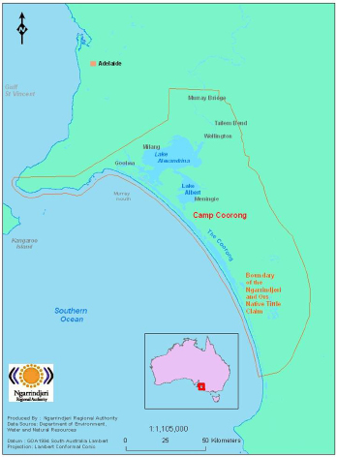

The Coorong, Lower Lakes and Murray Mouth (CLLMM) covers an area of 140,000 hectares and is of “central significance to the life and culture of the Ngarrindjeri people, who continue to live on their traditional country” depicted in Figure 9 (Murray Futures, 2008). The CLLMM is internationally recognised as a breeding ground for numerous species of water birds and native fish, and one of ten major havens for wading birds in Australia comprising 23 different types of wetlands.

The water quality of the CLLMM site has been degraded due to a number of factors, including high salinity and the response to the potential for exposure to acid sulfate soils. This is attributed to record low river flows attributed to drought and the over-allocation of water across the Murray–Darling Basin (DEH, 2010). As water levels fell, water quality declined and serious land and water management issues emerged. Wetlands dried out, previously submerged sulfidic soils were exposed, and different elements of the system became disconnected.

Recent reports indicate an improvement in water quality with the increased water flows that have occurred as a result of heavy rains since 2010 in the upper reaches of the Murray–Darling Basin. In the long-term, sufficient water would need to flow in order to meet water quality for cultural and spiritual health of the Ngarrindjeri Nation and their lands and waters.

The Coorong and Lower Lakes Recovery Plan (Long Term Plan) of 2009 acknowledges the CLLMM is “acutely sensitive to both climate and water management throughout the entire Murray–Darling Basin” (DEH, 2010). Given the decline in water quality and impacts of salinity the planning process toward remediation is complex and long term, with multiple and competing stakeholders, and inter-jurisdictional considerations.

The Ngarrindjeri strategy has been to engage with the South Australian Government on Ngarrindjeri terms which has required a considerable amount of negotiation over a number of years. As a result of these negotiations, the South Australian Government, through the Department of Environment and Natural Resources (DENR), has come to understand and support the Ngarrindjeri’s position and ideas.

The Ngarrindjeri Regional Authority (NRA) is the regional governance structure that makes decisions on behalf of the Ngarrindjeri people. NRA members represent a range of Ngarrindjeri community organisations, including four elected community representatives.

The partnership between the South Australian Government and the NRA is guided by the Whole‑of‑Government Kungun Ngarrindjeri Yunnan (KNY) Agreement, 2009, which translates to ‘listening to Ngarrindjeri speaking’. It is a consultation and negotiation agreement that supports full participation of Ngarrindjeri in government-led environmental management projects in the region and surrounding areas. Preceding the KNY Agreement, the Ngarrindjeri Yarluwar-Ruwe Plan (Sea Country Plan) was prepared by Ngarrindjeri people in 2006.

The KNY Agreement details the responsibilities and obligations of the South Australian Government and the Ngarrindjeri people. Under the KNY Agreement, a KNY Agreement Taskforce was established comprising key members of the NRA and senior departmental representatives from a range of state government agencies. The taskforce meets monthly and is responsible for ensuring that clear communication occurs between Ngarrindjeri and the government and that timely, well informed decisions are made with and on behalf of Ngarrindjeri by the government. The KNY Agreement also ensures that the Ngarrindjeri’s traditions and cultural beliefs are considered before projects are‑commenced in the region.

At a higher level, bi-monthly Leaders to Leaders meetings are held between Ngarrindjeri Elders and Government Ministers to further strengthen and improve relationships and decision making processes for Ngarrindjeri, and most importantly to overcome any obstacles encountered in dealing with Government at a bureaucratic level.

The recent development of a cultural knowledge clause, which has been included in a range of documents and agreements, ensures the protection of Ngarrindjeri Cultural Knowledge and the recognition of their sovereignty within the region of their lands and waters. The Cultural Knowledge clause is an essential part of the overall strategy that enables Ngarrindjeri to work with the Government in a “safe” environment free from the fear of cultural appropriation, interference or‑invasion or the potential to be tested on their cultural authenticity at any time.

### Community Engagement and Consultation Process

The CLLMM are the traditional lands and waters of the Ngarrindjeri people. The KNY Agreement and the Sea Country Plan are the primary mechanisms for engagement with Ngarrindjeri people in the CLLMM, working through the NRA.

The KNY Agreement is a consultation and negotiation framework intended to support Ngarrindjeri participation in natural and cultural resource management in the Ngarrindjeri Native Title Claim area. It recognises that the “Ngarrindjeri are the Traditional Owners of, and assert control under customary laws over their land and waters.” (Kungun Ngarrinjeri Yunnan Agreement, 2009). A key commitment under the KNY Agreement is to ensure Ngarrindjeri interests are included in the planning, development and allocation of funding by the South Australian Government for the CLLMM Program, a part of the Australian Government’s Water for the Future program.

In recognition of the commitments made under the KNY Agreement, the development of the CLLMM Long Term Plan is built on consultation with the Ngarrindjeri people and extensive discussions with the NRA (Murray Futures, 2008). The NRA and DENR collaborated to develop the Ngarrindjeri Partnerships Project, which is aimed at building core capacity within the NRA to support Ngarrindjeri involvement in the CLLMM program and to progress their Caring for Country aspirations.

The CLLMM Long Term Plan is described as founded in science and interpreted with local knowledge and responsive to cultural and community guidance and oversight (Murray Futures, 2008). This includes consideration of “new forms of governance, such as the developing relationship with the new NRA” (Murray Futures, 2008).

While the Ngarrindjeri people are generally satisfied with the processes in place under the KNY Agreement, they are nevertheless committed to continuous improvement and the establishment of best cultural practices regarding the management of their lands and waters.

### Values Identified

The CLLMM is an area of high cultural, spiritual, economic and social value to the Ngarrindjeri people. Ngarrindjeri culture and traditions and the CLLMM region are inextricably linked. The wetlands of the CLLMM region have a high cultural value for Ngarrindjeri people, regarded as a part of the system that cleanses the land and providing nurseries for Ngarrindjeri totems that are also bio-indicators of water quality.

The Ngarrindjeri vision for Country is expressed in the following excerpt from the Sea Country Plan:

We long for sparkling, clean waters, healthy land and people and all living things. We long for the Yarluwar-Ruwe (Sea Country) of our ancestors. Our vision is all people Caring, Sharing, Knowing and Respecting the land, the waters and all living things (Ngarrindjeri Regional Authority, 2009).

The Sea Country Plan recognises the spiritual beliefs of the Ngarrindjeri people expressed through Creation stories which reveal the significance of the relationship between the country and the people, both practically and spiritually (Ngarrindjerri Tendi et al, 2006). The Sea Country Plan is a vision for caring for the lands and waters of Ngarrindjeri people (Ngarrindjerri Tendi et al, 2006).

The Sea Country Plan further recognises that Ngarrindjeri people hold cultural and spiritual connections to particular places, to particular species of animals and plants that are the Ngartji (totem or special friend) of the Ngarrindjeri people, who have special responsibility to care for their Ngartji. To care for Ngartji is to care for country (Ngarrindjerri Tendi et al, 2006).

Pondi, the Murray Cod, are regarded by Ngarrindjeri people as the first fish in the Kaldowinyeri (the Creation). Important cultural and spiritual values are associated with Pondi (Ngarrindjerri Tendi et al, 2006).

Mulloway (Jewfish) are an important food source for Ngarrindjeri people which used to be plentiful in the Coorong (Birckhead et al, 2011). However, the abundance and size of mulloway have declined significantly, which is attributed to fundamental changes in the mulloway habitat. These environmental changes have also reduced the opportunity for Ngarrindjeri people to use traditional fishing methods for catching mulloway such as stone fish traps and spear fishing.

The Coorong and Lower Lakes Ramsar site is a nesting place for Kungari, the black swan, whose eggs are a regular part of the diet of many Ngarrindjeri people. Poor water quality in the Lower Lakes has impacted on the breeding cycle of Kungari, a totemic species for the Ngarrindjeri people, which no longer breed with seasonal predictability. Kungari are not only culturally significant to the Ngarrindjeri people but also an indicator of ecosystem health and water quality.

### Integration of Indigenous Cultural and Spiritual Values in Water Quality Planning

The Ngarrindjeri people strongly advocate for improving the water quality and overall health of the CLLMM environment. The primary mechanism for integrating and recognising cultural and spiritual values in water quality outcomes is through the KNY Agreement which ensures appropriate engagement in the development of a range of measures aimed at improving water quality.

The CLLMM Long Term Plan proposes a range of enabling measures for the CLLMM region, taking into account Ngarrindjeri cultural and spiritual values.

The CLLMM Recovery Project supports the implementation of the CLLMM Long Term Plan and is jointly funded between the Australian and the South Australian governments. The Project is managed through DENR with the Coorong and Lower Lakes Recovery Team taking on a lead role on behalf of the South Australian Government to implement the KNY Agreement and “seeks appropriate ways of integrating Ngarrindjeri cultural values into planning and management activities including water quality management and land management.” (Kungun Ngarrinjeri Yunnan Agreement, 2009).

The CLLMM is one of six environmental ‘icon sites’ within the Murray-Darling Basin, and is managed through the Lower Lakes, Coorong and Murray Mouth Icon Site Environmental Water Management Plan (EWM Plan) to protect and restore and protect natural habitats, restore viable populations of native species, improve water quality and increase flows through the wetlands. A large proportion of the area is listed as wetlands of international significance under the Ramsar Convention. The EWM Plan recognises the Ngarrindjeri cultural and spiritual values within the area. Through the EWM Plan, Ngarrindjeri Elders worked closely with DENR and actively participated in the bioremediation and revegetation around the Lower Lakes to manage acid sulfate soils and, in recognition of their work, were awarded the 2010 South Australian Environment Award.

### Results

The CLLMM Long Term Plan is a 20 year road map for the future management of the CLLMM region as a healthy, productive and resilient wetland of international importance. Governance measures will ensure that there is clear and transparent accountability for the delivery of the project. This will build on the relationships already established with the Ngarrindjeri people, the community, and with the South Australian Government.

A combined allocation by the Australian and South Australian governments of up to $7.8 million has been made to build capacity in the region by supporting Ngarrindjeri Partnerships to use their long-term knowledge and traditions for restoring the health of the region, the continuation of the Lakes Hubs, and the establishment of a regional Community Advisory Panel to provide for community representation to inform planning and on-ground works.

Implementation of the KNY Agreement is monitored by the KNY Taskforce. The taskforce includes representatives from the NRA and South Australian Government agencies that work in the Coorong and Lower Lakes region. The KNY Taskforce has an ongoing role to coordinate, through the NRA, program development for water quality improvement in the CLLMM.

### Lessons learnt

Protocols of engagement provide an important framework to recognise the values and status of Indigenous people in managing natural resources. The KNY Agreement provides a framework to assist and guide interactions with Ngarrindjeri people and for the most culturally appropriate and sensitive way of doing business on Ngarrindjeri traditional lands and waters.

## Resources and Literature

Aboriginal Way (2011) “Caring for Rock-Holes in the Gawler Ranges” in, Issue 47, December 2011.

ANZECC and ARMCANZ (2000) Australian and New Zealand Guidelines for Fresh and Marine Water Quality, The Guidelines, vol 1

Berkes, F. (1993) Traditional ecological knowledge in perspective. Traditional ecological knowledge: Concepts and cases:1–9.

Birckhead J., Greiner R., Hemming S., Rigney D., Rigney M., Trevorrow G. and Trevorrow T. (2011) Economic and Cultural Values of Water to the Ngarrindjeri People of the Lower Lakes, Coorong and Murray Mouth. River Consulting: Townsville.

CDU (2007) Daly Fish Flows. Accessed: http://www.cdu.edu.au/ser/documents/DalyFishFlows_A4newsletterforwebMay07.pdf as at 12 April 2012

CDU (2009) Water Regime Dependence of Fish in the Wet-Dry Tropics. Accessed: http://www.cdu.edu.au/ser/ImpactsofHumanActivityandCilmateChange.htm#regime as at 12 April 2012

CSIRO (2006) A report from a workshop held at CSIRO in Darwin, 2006, “Recognising and Protecting Indigenous Values in Water Resource Management - at http://www.csiro.au/Outcomes/Water/Water-information-systems/~/media/CSIROau/Divisions/CSIRO%20Sustainable%20Ecosystems/RecognisingAndValuing_CSE_pdf%20Standard.pdf.

CSIRO (2007) Daly River Fish Flows Project. Accessed: http://www.csiro.au/Outcomes/Water/Water-for-the-environment/Fish-River-Flows-NT.aspx at 12 April 2012.

Daly River Community Reference Group (2004) — Daly River Community Reference Group Report, http://www.nretas.nt.gov.au/__data/assets/pdf_file/0017/13742/execsummvfinalwithscans.pdf as at 12 April 2012

DEH (2010) Coorong Lower Lakes Murray Mouth. Accessed: http://www.environment.sa.gov.au/Conservation/Rivers_wetlands/Coorong_Lower_Lakes_Murray_Mouth as at 12 April 2012.

DEHP (2017) Pictorial conceptual models, WetlandInfo, updated 21 June 2017, <<https://wetlandinfo.ehp.qld.gov.au/wetlands/resources/pictorial-conceptual-models.html> (updated) as at 21 June 2017

DERM (2017) Conceptual model case study series: Police Lagoons. Accessed: <https://wetlandinfo.ehp.qld.gov.au/resources/static/pdf/resources/tools/conceptual-model-case-studies/cs-police-lagoons-22-april-2013.pdf> (updated) as at 21 June 2017

Douglas, M., & Kennard, M. (2007) Daly River and Fish Flows Project: An Environmental Flows Study, Newsletter, track166, at p.3., http://www.track.gov.au/publications/registry/166

Douglas, M., Pusey, B., Kennard, M. & Jackson, S. (2009) Water regime dependence of fish in the Wet-Tropics, Land and Water Australia.

Douglas. M., Kennard, M., B. Pusey, Jackson, S., & Olden, J., (n.d) Daly River Fish & Flows Project: Summary of key findings.

Environmental Systems Solutions (2012) Gawler Ranges Cultural and Ecological Information Management System (CEIMS). Accessed: <http://www.essolutions.com.au/Projects/Gawler.aspx>

EPA South Australia (2007) The Adelaide Coastal Waters Study - Final Report Volume 1 — Summary of Study Findings, November 2007. http://www.epa.sa.gov.au/xstd_files/Water/Report/acws_report.pdf as at 25 March 2012.

EPA South Australia (2011a) Adelaide Coastal Water Quality Improvement Information Sheet: Community vision and Environmental Values for Adelaide’s coastal water, SA Environment Protection Authority, September 2011.

EPA South Australia (2011b) Adelaide Coastal Water Quality Improvement Information Sheet: Strategies for water quality improvement for Adelaide’s coastal waters, SA Environment Protection Authority, October 2011.

EPA South Australia (2011c) Background report for the Adelaide Coastal Water Quality Improvement Plan — Report 1 Community consultation executive summaries – 2011.

EPA South Australia (2011d) Draft Adelaide Coastal Water Quality Improvement Plan (ACWQIP), SA Environment Protection Authority, Adelaide, September 2011

Fact Sheet: Caring for Rock-holes in the Gawler Ranges – Looking After Country and Culture – 17/09/2010 at http://www.nativetitlesa.org/news-article5/detail/caring-for-rock-holes-in-the-gawler-ranges/

Fact Sheet: Protecting Rock Holes in the Gawler Ranges Rock Holes Project - 02/12/2010 at   
http://www.nativetitlesa.org/news-article17/detail/protecting-rock-holes-in-the-gawler-ranges/

Finn, M. & Jackson, S. (2011) Protecting Indigenous Values in Water Management: A Challenge to Conventional Environmental Flow Assessments, in “Ecosystems”, Vol. 14, (8), Springer, New York.

Georges, A., Webster, I., Guarino, F., Jolly, P., Thoms, M. & Doody, S., (2002) Modelling Dry Season Flows and Predicting the Impact of Water Extraction on a Flagship Species — National River Health Program (2002) CRC for Freshwater Ecology and the Applied Ecology Research Group, University of Canberra.

Jackson, S. (2004) Preliminary report on Aboriginal perspectives on land-use and water management in the Daly River region, Northern Territory- A Report to the Northern Land Council http://www.terc.csiro.au/resources%5CCSIRO%20-%20Daly%20River%20Cultural%20Values%20Report.pdf

Jackson, S. (2006) Compartmentalising culture: the articulation and consideration of Indigenous values in water resource management, ‘Australian Geographer’ 37(1): 19-32

Jackson, S., Finn, M., Woodward, E., and Featherston, P. (2011) Indigenous Socio-economic and river flows- A Summary of Research Results: 2008-2010, CSIRO Ecosystem Sciences, Darwin, NT, p. 11., http://www.csiro.au/Organisation-Structure/Flagships/Water-for-a-Healthy-Country-Flagship/~/media/CSIROau/Flagships/Water%20for%20a%20Healthy%20Country%20Flagship/Indigenous-socio-economic-values-and-river-flows-research-summary.pdf

Jackson, S., Finn, M., Woodward, E. and Featherston, P. (2011a) Indigenous socio-economic values and river flows. CSIRO Ecosystem Sciences, Darwin, NT.

Jackson, S., Finn, M., Woodward, E. and Featherston, P. (2011b) Indigenous socio-economic values and river flows — A Summary of Research Results: 2008–2010. CSIRO Ecosystem Sciences, Darwin, NT TRaCK Assets and Values Fact Sheet 2, “Indigenous Values and River Flows”.

Jenkin, T., Ackland, A., Muller, S., (2009) Towards a cooperative approach to the cultural and ecological assessment and management of rock-holes in the Gawler Ranges native title claim area, South Australian Arid Lands Natural Resources Management Board, Port Augusta.

Jenkin, T., White, M., Ackland, L., Scholz, G., and Starkey, M., (2011) Partnerships in Protecting Rock-holes: Project Overview, South Australian Research Native Title Services (SANTS) Department for Water (DFW) A report to the South Australian Arid Lands Natural Resources Management Board, September 2011.

Kungun Ngarrinjeri Yunnan Agreement (2009) <https://www.google.com.au/?gfe_rd=cr&ei=if9JWcveLrDM8gem-bi4Bw&gws_rd=ssl#q=Kungun+Ngarrinjeri+Yunnan+Agreement,+2009&spf=1498021769612>

Land & Water Australia (2009) Addressing Indigenous Cultural Values in Water Allocation Planning. [Online] (Updated July 30th, 2009)   
Available at: http://lwa.gov.au/node/3652 [Accessed Saturday 16th of November 2013 11:37:24 PM].

Liddy, M. Douglas, M., Huddleston, J., Harney, B., Sulivan, L., Jackson, S., Kennard, M & Pusey, B. Multiple values, multiple knowledge sources: Observations from the Daly River Fish and Flows project - powerpoint presentation – http://archive.riversymposium.com/index.php?element=B4C+LIDDY_SULLIVAN.pdf

Lower Lakes and Coorong Recovery Plan, South Australian Department of Environment and Natural Resources: http://www.environment.sa.gov.au/Conservation/Rivers_wetlands/Coorong_Lower_Lakes_Murray_Mouth/Lower_Lakes_Coorong_recovery_plan

Murray Futures (2008) Lower Lakes & Coorong Recovery: Securing the Future, A Long Term Plan for the Coorong, Lower Lakes and Murray Mouth, December 2008.

McNamara on behalf of the Gawler Ranges People v State of South Australia [[2011] FCA 1471](http://www.austlii.edu.au/au/cases/cth/FCA/2011/1471.html) <http://www.austlii.edu.au/au/cases/cth/FCA/2011/1471.html>

Metcalfe, J (2009) Finding Fishy Facts About Flows, in On Track Issue 2 June 2009.

Ngarrindjeri Tendi, Ngarrindjeri Heritage Committee, Ngarrindjeri Native Title Management Committee (2006) Ngarrindjeri Nation Yarluwar-Ruwe Plan - Caring for Ngarrindjeri Sea Country and Culture, 2006

Ngarrindjeri Regional Authority (2009) Ngarrindjeri Murrundi Management Plan No.1, 2009.

NWC, (2011a). Findings from the Daly River fish and flows project, National Water Commission Science Seminar – 20 May 2010 – http://nwc.gov.au/media/events/commission-sponsored-water-seminar-series/2011/findings-from-the-daly-river-fish-and-flows-project as at 17 April 2012.

NWC (2011b). National Water Commission power-point presentation of Michael Douglas, Director of TRaCK - http://nwc.gov.au/media/events/commission-sponsored-water-seminar-series/2011/findings-from-the-daly-river-fish-and-flows-project

Schult, J. and Townsend, S. (2012) River health in the Daly catchment. A Report to the Daly River Management Advisory Committee. Report 03/2012D. Department of Natural Resources, Environment, The Arts and Sport, Darwin.

TRaCK (n.d) Scenario Evaluation – Fact Sheet No. 3, Integrating Knowledge to Support Adaptive Management, TRaCK – at http://www.track.gov.au/sites/track.boab.info/files/uploads/TRaCK_1.4_IntegratingKnowledge_AdaptiveManag_web.pdf as at 12 April 2012.

TRaCK (2011), Traditional owners share knowledge about Daly River fish, Media Release, October, 2011.

White, M, (2009) Prioritising Rock-holes of Aboriginal and ecological significance in the Gawler Ranges, DWLBC Report 2009/08 Version 1, Government of South Australia, through Department of Water, Land and Biodiversity Conservation, Adelaide

Woodward, E., Jackson, S, Finn, M and Marrfurra McTaggart, P (2011) Utilising Indigenous seasonal knowledge to understand aquatic resource use and inform water resource management in northern Australia, “Ecological Management and Restoration”, 13 (1) at p. 59.