# National Acid Sulfate Soils Guidance

National acid sulfate soils identification and laboratory methods manual

June 2018

© Commonwealth of Australia 2018

**Ownership of intellectual property rights**

Unless otherwise noted, copyright (and any other intellectual property rights, if any) in this publication is owned by the Commonwealth of Australia (referred to as the Commonwealth).

**Creative Commons licence**

All material in this publication is licensed under a Creative [Commons Attribution 4.0 International Licence](https://creativecommons.org/licenses/by/4.0/legalcode) except content supplied by third parties, logos and the Commonwealth Coat of Arms.

Inquiries about the licence and any use of this document should be emailed to [copyright@agriculture.gov.au](mailto:copyright@agriculture.gov.au).

by

**Cataloguing data**

This publication (and any material sourced from it) should be attributed as: Sullivan, L, Ward, N, Toppler, N and Lancaster, G 2018, *National Acid Sulfate Soils Guidance: National acid sulfate soils identification and laboratory methods manual,* Department of Agriculture and Water Resources, Canberra, ACT. CC BY 4.0.

This publication is available at waterquality.gov.au.

Australian Government Department of Agriculture and Water Resources

GPO Box 858 Canberra ACT 2601

Switchboard +61 2 6272 3933 or 1800 900 090

Email [waterquality@agriculture.gov.au](mailto:waterquality@agriculture.gov.au)

**Liability**

The Australian Government acting through the Department of Agriculture and Water Resources has exercised due care and skill in preparing and compiling the information in this publication. Notwithstanding, the Australian Government Department of Agriculture and Water Resources, its employees and advisers disclaim all liability, including liability for negligence and for any loss, damage, injury, expense or cost incurred by any person as a result of accessing, using or relying on any of the information or data in this publication to the maximum extent permitted by law.

**Acknowledgments**

The authors would like to acknowledge Queensland Acid Sulfate Soils Investigation Team, Queensland Acid Sulfate Soil Management Advisory Committee, NSW Acid Sulfate Soils Management Advisory Committee, National Committee for Acid Sulfate Soils, Southern Cross University and Federation University Australia for producing the guidelines and manuals that were used in the development of this guidance.

The authors would like to thank the reviewers for their comments and suggestions on the draft report, including Dr Steve Appleyard and Dr Bill Richmond (Department of Environment Regulation, Western Australia) and Laurence Fox (Fox Environmental Consulting). The authors also wish to thank Dr Stuart Simpson for permission to include his rapid AVS method in this manual (Reproduced with permission from Sediment Quality Assessment by S. Simpson and G. Batley (Eds). Published by CSIRO Publishing 2016).



Contents

1 Introduction 1

1.1 The purpose of the guidance 1

1.2 Defining acid sulfate soils 2

1.3 Classification 2

1.4 Action criteria triggering the need for an ASS management plan 2

1.5 Environmental hazards 3

Part 1 - Identification and analysis of acid sulfate soils 5

2 General properties of acid sulfate soil materials 6

2.1 Acidity hazard 7

2.2 Deoxygenation hazard 7

2.3 Metals and metalloid mobilisation hazard 7

3 Overview of acid sulfate soil analyses 8

3.1 Hazard assessment 8

3.2 Analysis of wet or dried soil materials? 11

4 Sample preparation and storage for analysis 13

4.1 Soil sample preparation 13

4.2 Storing and retaining samples for audit purposes 14

Part 2 – Laboratory methods 15

Introduction 15

5 Physical properties 16

5.1 Introduction 16

5.2 Soil moisture content 16

5.3 Soil bulk density 17

6 Chemical analysis for acidity hazards 19

6.1 Introduction 19

6.2 Potential Sulfidic Acidity 20

6.3 Actual Acidity 31

6.4 Retained Acidity 35

6.5 Acid Neutralising Capacity 38

7 Chemical analysis for deoxygenation and metals and metalloid mobilisation 43

7.1 Introduction 43

7.2 Deoxygenation 43

7.3 Metal and metalloid mobilisation 52

Part 3 - Interpretation of laboratory results 59

Introduction 59

8 Data review and presentation 61

8.1 Review of data quality 61

8.2 Presentation of results 62

9 Interpretation of laboratory results 64

9.1 Acidity hazard 64

9.2 Other hazards 64

9.3 ASS investigation report 65

10 Further information 66

Appendix A: Case studies 67

Case study 1: Effect of organic matter (SCR vs SPOS) 67

Case study 2: ‘Acid’ soil vs ‘acid sulfate’ soil 68

Case study 3: ASS material recognition, liming requirement and verification testing 71

Appendix B: Recent developments in laboratory method guidelines 76

Appendix C: Laboratory incubation 77

Introduction 77

Slab Incubation – NLM-8.1 78

Chip-tray Incubation – NLM-8.2 78

Appendix D: Laboratory method codes and standards 82

Appendix E: Conversion of units 84

Converting % S to mol H+/t 84

Appendix F: ASS investigation reporting checklist 86

Glossary 91

References 94

Figures

Figure 3.1 Flow chart showing ASS analyses required. 11

Figure 3.2 Flow chart for the analysis of dry and wet soil samples. 12

Figure 6.1 Schematic representation of the apparatus used in the chromium reduction method. 23

Figure 8.1 Steps to determine whether the management of an ASS acidity hazard is required. 60

Figure 8.2 Example ASS report format. 63

Figure A1 Effect of organic matter on estimation of Reduced Inorganic Sulfur content by SPOS method. 68

Figure A2 ASS results for an example soil profile. 70

Figure A3 Soil profile for Core 1 (C1). 72

Figure A4 ASS material assessment results for proposed infrastructure site (Core 1). 73

Figure C1 Illustration of an empty chip-tray and photograph of chip-trays filled with soil samples. 79

Figure C2 Flow chart of the Chip-tray Incubation method. 81

Tables

Table 1.1 Action criteria based on the texture and volume of material disturbed. 3

Table 5.1 Default bulk densities based on soil texture. 18

Table 7.1 The Sequential Metals and Metalloid Extraction procedure. 53

Table D1 Summary of National Laboratory Method codes, QASSIT Laboratory Methods Guidelines method codes and Australian Standards. 82

Table D2 Summary of ISO 14388: Acid Base Accounting procedure for ASS materials. 83

Table E1 Conversions of units used in the reporting of ASS analyses and calculations. 84

Equations

Equation 2.1 Complete oxidisation of pyrite. 6

Equation 3.1 Net Acidity whereby ANC has been corroborated by other data. 8

Equation 3.2 Net Acidity whereby ANC has not been corroborated by other data. 8

Equation 3.3 Verification Net Acidity. 8

Equation 3.4 Retained Acidity. 9

Equation 5.1 Bulk density. 17

Equation E1 84

Equation E2 85

## Introduction

### The purpose of the guidance

The development of sound management plans, for projects that may disturb acid sulfate soil (ASS) materials, must be based on laboratory data produced with current best practice methods. While field tests are useful exploratory tools, they are indicative only and cannot be substituted for laboratory data to determine the presence or absence of ASS materials, nor to quantify the hazards they pose.

This national guideline sets out the current best practice ASS laboratory analytical methods for soil samples that are used to:

1. conclusively identify the presence or absence of ASS, and
2. to quantitatively assess the associated hazards.

Acid sulfate soil materials are most commonly assessed for their acidity hazard. The Net Acidity of the soil is a measure of this hazard and is used to determine whether an ASS management plan should be developed. The Net Acidity is quantified in this national guideline using an Acid Base Accounting (ABA) approach.

The deoxygenation and the metals and metalloid mobilisation hazards of ASS materials are also becoming routine assessments in the development of ASS management plans. The current best practice laboratory analytical methods for their assessment are also included.

The *National acid sulfate soils sampling and identification manual* Sullivan et al. (2018b) outlines the first three stages of an ASS investigation process – desktop assessment (Stage 1), site inspection (Stage 2) and soil sampling (Stage 3). This manual covers the two final stages of an ASS investigation process including laboratory analysis (Stage 4) and reporting of results (Stage 5).

This manual has been divided into three sections:

1. Identification and analysis of acid sulfate soils,
2. Laboratory methods, and
3. Interpretation of laboratory results.

Case studies are included in Appendix A to provide examples of how this guideline should be used.

Further national guidance in relation to ASS assessment and management can be found in the following related documents:

* National Acid Sulfate Soils Sampling and Identification Manual
* Overview and Management of Monosulfidic Black Ooze (MBO) Accumulation in Waterways and Wetlands
* Guidelines for the Dredging of Acid Sulfate Soil Sediments and Associated Dredge Spoil Management
* Guidance for the Dewatering of Acid Sulfate Soils in Shallow Groundwater Environments.

Appendix B details the recent developments in ASS material laboratory assessment.

**It is essential that the reader consult relevant jurisdictional guidance and regulations and contact the relevant state or territory government department for specific local and regional information and advice.**

### Defining acid sulfate soils

Acid sulfate soil (ASS) materials are distinguished from other soil or sediment materials (referred to as ‘soil materials’ throughout this guideline) by having properties and behaviour that have either:

1. been affected considerably by the oxidation of Reduced Inorganic Sulfur (RIS), or
2. the capacity to be affected considerably by the oxidation of their RIS constituents.

The factor common to all ASS materials is that RIS components have either had, or may have, a major influence on the properties or behaviour of these soil materials.

### Classification

Several schema have been developed to classify ASS materials. Some of these schema are more conceptually than technically defined and are useful for communication and general management purposes, whereas other more stringently defined schema provide a higher level of precision and are better suited for highly technical purposes that require the highest level of accuracy of classification.

Commonly used examples in Australia from the less technical schema are the terms:

* non ASS (NASS)
* Actual ASS (AASS: ASS materials that have been oxidised and are severely acidic), and
* Potential ASS (PASS: ASS materials that would become severely acidic if allowed to oxidise completely).

Examples of terms used to classify ASS materials from the more stringently defined schema include:

* sulfuric (synonymous with AASS, that is, ASS materials that have been oxidised and are severely acidic with pH less than 4)
* sulfidic (essentially soil material containing greater than or equal to 0.01% RIS by mass)
* hypersulfidic (synonymous with PASS and essentially sulfidic soil materials that would become severely acidic if allowed to oxidise completely)
* hyposulfidic (essentially sulfidic soil materials that would not become severely acidic if allowed to oxidise completely), and
* monosulfidic (soil material containing greater than or equal to 0.01% Acid Volatile Sulfide).

The laboratory methods described in this manual allow the identification of any soil material into one of the classes previously mentioned, whether from the less technical or the more technical schemas.

A detailed examination of ASS material classification can be found in Sullivan et al. (2012).

### Action criteria triggering the need for an ASS management plan

The action criteria in Table 1.1 trigger the need to prepare an ASS management plan. They are based on Net Acidity. As clay content tends to influence a soil’s natural buffering capacity, the action criteria are grouped by three broad texture categories – coarse, medium and fine. If the Net Acidity of any individual soil material tested is equal to or greater than the action criterion a detailed ASS management will need to be prepared.

Table . Action criteria based on the texture and volume of material disturbed.

|  |  |  |  |  |  |
| --- | --- | --- | --- | --- | --- |
| Type of material | | Net Acidity# | | | |
| Texture range*  (NCST 2009) | Approximate clay content (%) | 1–1000 t materials disturbed | | > 1000 t materials disturbed | |
| % S-equiv. (oven-dried basis) | mol H+/t (oven-dried basis) | % S-equiv. (oven-dried basis) | mol H+/t (oven-dried basis) |
| Fine: light medium to heavy clays | > 40 | ≥ 0.10 | ≥ 62 | ≥ 0.03 | ≥ 18 |
| Medium: clayey sand to light clays | 5–40 | ≥ 0.06 | ≥ 36 | ≥ 0.03 | ≥ 18 |
| Coarse and Peats: sands to loamy sands | < 5 | ≥ 0.03 | ≥ 18 | ≥ 0.03 | ≥ 18 |

* If bulk density values are not available for the conversion of cubic meters to tonnes of soil, then the default bulk densities, based on the soil texture in Table 5.1, may be used.

# Net Acidity can only include a soil material’s measured Acid Neutralising Capacity where this measure has been corroborated by other data (for example slab incubation data) that demonstrates the soil material does not experience acidification during complete oxidation under field conditions (Equation 3.1). Where the Acid Neutralising Capacity has not been corroborated, the Net Acidity must be determined using Equation 3.2.

Source: Adapted from Dear et al. 2014.

However, it is important to note the acidity hazard of soil materials that are strongly acidic due to processes other than RIS oxidation, are not considered an ASS acidity hazard. Actual ASS are acid soil materials, but not all acid soil materials are Actual ASS. Naturally-occurring acidic soils are not uncommon and are not considered an environmental hazard that require management to change their acidity. Indeed, these naturally-occurring acidic soils are usually part of acidophilic ecosystems whose health depends on maintaining the acidic environment.

Accordingly, the trigger values in Table 1.1 apply only to ASS materials and not to other acidic soils. As an example, many soil materials in naturally acidic landscapes, such as acidic peatlands and coastal heaths, often have Net Acidities exceeding the action criteria in Table 1.1. Liming of naturally acidic ecosystems, leading to unnaturally alkaline environments, can result in ecological damage to the acidophilic organisms that relied on the acidic nature of these ecosystems.

If bulk density values are not available for the conversion of cubic meters (m3) of soil to tonnes (t) of soil, then the default bulk densities, based on the soil texture in Table 5.1, may be used.

### Environmental hazards

Acid sulfate soil materials pose a wide range of environmental hazards including:

1. severe acidification of soil and drainage waters (below pH 4)
2. mobilisation of metals (for example iron, aluminium), metalloids (for example arsenic), nutrients (for example phosphate), and rare earth elements
3. deoxygenation of waterways and wetlands
4. the production of noxious gases including hydrogen sulfide (H2S)
5. the production of greenhouse gases, and
6. scalding of landscapes.

The first of the environmental hazards listed previously, the acidity hazard, when realised can impact on a broad range of infrastructure including bridges, drains, pipes and roads.

Waters draining from landscapes containing mismanaged ASS materials may be contaminated by a wide range of potential toxicants, including acidity, metals and metalloids, and thus cause risks to aquatic life and public health.

Both agriculture and aquaculture may also be severely affected by the mismanagement of ASS materials.

Best practice management of ASS is to a large degree dependent on both the correct identification of ASS materials, and on the accurate quantification of the hazards these materials pose to environments and the communities that depend on these environments.

This guidance document, by presenting the current best practice methods available to definitively identify ASS materials and quantitatively assess their associated hazards, forms the basis from which to develop best practice management of sites containing ASS materials.

## Part 1 - Identification and analysis of acid sulfate soils

## General properties of acid sulfate soil materials

The defining characteristic of Potential ASS is the presence of Reduced Inorganic Sulfur (RIS) at concentrations sufficient to affect behaviour should these materials be disturbed sufficiently to cause oxidation of the RIS. Reduced Inorganic Sulfur includes iron disulfides (FeS2), most commonly pyrite but also marcasite, and lower amounts of other compounds such as monosulfides (for example FeS) and elemental sulfur (S8).

Reduced Inorganic Sulfur forms readily in landscapes under waterlogged, anoxic conditions where there is a ready supply of organic matter, sulfate and iron. Under such conditions, the formation of RIS occurs via microbially-mediated processes.

Pyrite and other RIS minerals and compounds generally persist in soil materials only under anoxic, waterlogged conditions. However, if these conditions are altered to more oxic conditions these RIS phases may undergo oxidation resulting in the formation of acidity.

For example, in the presence of oxygen (and water) pyrite oxidises to ultimately yield acidity (H+), sulfate and iron precipitate as follows:

Equation . Complete oxidisation of pyrite.

$${FeS}_{2}+{3.75O}_{2}+3.5H_{2}O→Fe{(OH)}_{3}+{4H}^{+}+{{2SO}_{4}}^{2-}$$

Equation 2.1 provides a general representation of the complete oxidation of pyrite. This equation does not describe the complex intermediate reaction steps involved in the overall pyrite oxidation process.

This complexity includes a number of possible intermediate iron-containing mineral oxidation products, such as schwertmannite and jarosite, as well as the Fe(OH)3 minerals. If for example, jarosite or schwertmannite are formed during pyrite oxidation rather than Fe(OH)3, then less acidity is produced than that shown in Equation 2.1.

Actual ASS materials are severely acidic (that is pH less than 4) as a result of RIS oxidation. Actual ASS materials generally also exhibit iron-containing mineral oxidation products of RIS such as schwertmannite and jarosite as well as other iron oxide or oxyhydroxide minerals. These minerals are often responsible for the brightly coloured coatings or segregations that range from straw yellow (indicative of jarosite), through orange, through to red and browns. Actual ASS materials are often found above Potential ASS materials in the soil or sediment profile.

Monosulfidic Black Oozes (MBOs) are materials found in soil materials that contain monosulfides (predominantly iron monosulfides, but also consisting of other compounds including H2S) in sufficient concentration to affect the properties and behaviour of those soil materials. In soil materials, contents of greater than or equal to 0.01% Acid Volatile Sulfide (AVS) are sufficient for these materials to be classified as ‘monosulfidic’ (Sullivan et al. 2012). Details of the properties of MBOs are described in the Overview and management of monosulfidic black ooze (MBO) accumulation in waterways and wetlands (Sullivan et al. 2018a).

ASS materials found in waterlogged anoxic conditions are often saturated, anoxic and prone to oxidation after sampling. Precautions must be used to prevent oxidation of these samples before analysis to ensure that the analytical results gained in the laboratory reflect field conditions. Such precautionary techniques are described in the National acid sulfate soils sampling and identification manual (Sullivan et al. 2018b).

### Acidity hazard

Disturbance of PASS materials often causes oxidation of RIS and consequential dramatic changes in the properties of these soil materials, most notably by rapid and substantial decreases in pH to below 4, whereupon they are considered Actual ASS materials.

This profound development and expression of acidity in Actual ASS materials can have a significant detrimental effect on receiving ground and surface waters, and the ecosystems that relied on formerly non-acidified environments. The degradation of these soil materials can also pose health concerns.

### Deoxygenation hazard

Monosulfides when dispersed into a well-aerated waterbody can cause rapid deoxygenation of that waterbody. One unit of iron monosulfide (FeS) can deoxygenate 2.5 units of dissolved oxygen (O2) from a waterbody within minutes of mixing.

Further details of the deoxygenating properties of MBOs are described in the Overview and management of monosulfidic black ooze (MBO) accumulation in waterways and wetlands (Sullivan et al. 2018a).

### Metals and metalloid mobilisation hazard

Oxidation and acidification of ASS materials results in the release of metals and metalloids previously associated with pyrite as well as metals and metalloids associated with other components in these materials (for example organic matter, exchangeable cations).

The release of these metals and metalloids from ASS materials is dependent upon both the geochemical regime (for example pH, redox potential, soil solution composition), and the components of the soil matrix with which the metals and metalloids are associated.

A recently developed sequential extraction method (Claff et al. 2010) has been included in this guideline (see Section 6). It was specifically designed for assessing metals and metalloid mobility in ASS materials and is capable of assessing the partitioning of metals and metalloids into ASS material fractions that 1) get mobilised under different environmental conditions and 2) are affected by different management practices.

## Overview of acid sulfate soil analyses

### Hazard assessment

For the assessment and management of ASS materials the hazard of most concern is usually the acidification hazard. Other hazards, such as deoxygenation and metal and metalloid mobilisation, are increasingly being considered in assessment and management of ASS materials; especially when the potential receiving waters are considered of high value.

Net Acidity is the quantitative measure of the acidity hazard of ASS materials. It is determined from an Acid Base Accounting (ABA) approach using either:

* Equation 3.1 - when the effectiveness of a soil material’s measured Acid Neutralising Capacity has been corroborated by other data demonstrating the soil material does not experience acidification during complete oxidation under field conditions, or
* Equation 3.2 - when the effectiveness of a soil material’s measured Acid Neutralising Capacity has not been corroborated by other data, or
* Equation 3.3 – when the effectiveness of a management approach involving the addition of liming materials is being verified post treatment via calculation of the Verification Net Acidity.

Equation . Net Acidity whereby ANC has been corroborated by other data.

$$Net Acidity=Potential Sulfidic Acidity+Actual Acidity+Retained Acidity-Acid Neutralising Capacity$$

Equation . Net Acidity whereby ANC has not been corroborated by other data.

$$Net Acidity=Potential Sulfidic Acidity+Actual Acidity+Retained Acidity$$

Equation . Verification Net Acidity.

$$Verification Net Acidity=Potential Sulfidic Acidity+Actual Acidity+Retained Acidity-(post treatment Acid Neutralising Capacity-initial Acid Neutralising Capacity)$$

The approach to determining Net Acidity used in this manual differs from previous approaches in that Acid Neutralising Capacity is only included in the quantification of Net Acidity (that is Equation 3.1) when the effectiveness of a soil material’s measured Acid Neutralising Capacity has been corroborated by other data that demonstrates the soil material does not experience acidification during complete oxidation under field conditions. If such corroboration of the measured Acid Neutralising Capacity is not available, then Equation 3.2 should be used to calculate Net Acidity for that soil material.

Acid Neutralising Capacity is routinely measured for soil samples (regardless of whether the measured Acid Neutralising Capacity is corroborated by other data) as this information is necessary should the verification of liming quantities be required post treatment via calculation of the Verification Net Acidity (Equation 3.3).

One of the benefits of the ABA approach is that it provides quantitative data on the acidification hazard suitable for purposes such as acidity hazard prioritisation, determination of liming requirements prior to oxidation, and verification of liming quantities post treatment.

Potential Sulfidic Acidity refers to the potential for acidity to develop from oxidation of pyrite and is estimated from the RIS determination. The quantification of Potential Sulfidic Acidity assumes: 1) the RIS is totally pyritic sulfur, and 2) that the oxidation reaction (Equation 2.1) occurs to completion [that is 1 mole of pyrite produces 4 moles of acidity (H+)].

Potential Sulfidic Acidity is measured using either the Chromium Reducible Sulfur (SCR) method or the Peroxide Oxidisable Sulfur (SPOS) method. The Chromium Reducible Sulfur (SCR) method is recommended for all soil materials. However, the SPOS method is not recommended for soil materials with organic matter contents greater than 0.6% organic carbon, as the organic matter in many soil materials with organic carbon contents greater than 0.6 % is capable of producing false positive identifications when using the SPOS method. The sulfur from organic matter, even at these relatively low concentrations, can be erroneously included in the SPOS determination at levels that exceed action criteria. Furthermore, if SPOS is used to quantify the Potential Sulfidic Acidity of soil materials, it is recommended at least 15% of samples are also analysed by the SCR method to allow verification of the SPOS values.

Case Study 1 (Appendix A) provides more information on the effect of organic matter on the determination of Potential Sulfidic Acidity. The results of which clearly show the importance of using the SCR method for soil materials with even relatively low organic matter contents and for those with sulfide levels close to the action criteria.

Actual Acidity is a measure of the readily available soluble and exchangeable acidity in the soil material. Actual Acidity is quantified using the Titratable Actual Acidity (TAA) method.

Retained Acidity is a measure of the more slowly released (cf. Actual Acidity), but still available acidity, contained within minerals such as jarosite and schwertmannite. The acidity in these minerals represents incomplete oxidation when compared with pyrite oxidation (Equation 2.1). This ‘stored’ acidity is released whenever these minerals experience conditions that promote their hydrolysis. One mole of jarosite can releases 3 moles of acidity, as described by the following reaction:

Equation . Retained Acidity.

$$K{Fe}_{3}{\left({SO}_{4}\right)}_{2}{(OH)}_{6}+3H_{2}O→3Fe{(OH)}_{3}+2{{SO}_{4}}^{-2}+{3H}^{+}+K^{+}$$

Retained Acidity is estimated using the Net Acid Soluble Sulfur (SNAS) method.

Acid Neutralising Capacity (ANC) is a measure of the ability of the ASS material to neutralise acidity. Acceptable sources of ANC include calcium and magnesium carbonates, exchangeable alkalinity and organic matter, but sources of buffering that do not act above pH 6.5 are usually considered ineffective in preventing environmental harm (Ahern et al. 2004). The alkalinity that arises from the dissolution of aluminosilicate minerals is not considered an acceptable source of ANC, as some of these dissolution products (for example soluble Al compounds) can be toxic in the environment.

The ANC of a soil material can be determined by Total Inorganic Carbon (CIN) and back-titration (ANCBT) methods. These ANC methods often do not measure the effectiveness of this material in neutralising acidity when RIS oxidises, as these soil materials often contain biogenic shells and large shell fragments (for example greater than 1 mm). Yet these ineffective shells are measured as ANC when the soil materials are oven-dried, finely ground and analysed by standard ANC methods.

Laboratory determinations of ANC need to be corroborated by evidence of the effectiveness of the measured ANC (for example by incubation). Therefore, unless corroborated, the results of ANC testing should be discounted when determining Net Acidity for comparison with action criteria, or for the determination of the acidity hazard and required liming amounts.

Where liming is a possible option for management of an acidity hazard, it is recommended ANC is measured, even if the lack of corroborating evidence prevents its inclusion in the calculation of Net Acidity. This is because the ANC of the untreated soil materials may later be required for verification testing to determine whether sufficient quantities of additional liming materials were applied to treat these ASS materials.

Net Acidity is calculated using the ABA approach. The flow of laboratory analyses required for calculation of Net Acidity is provided in Figure 3.1. It outlines the sequence of required analyses, as informed by the results of the pHKCl measurement. For example, the determination of TAA is only required where the pHKCl of a sample is less than 6.5.

Figure . Flow chart showing ASS analyses required.

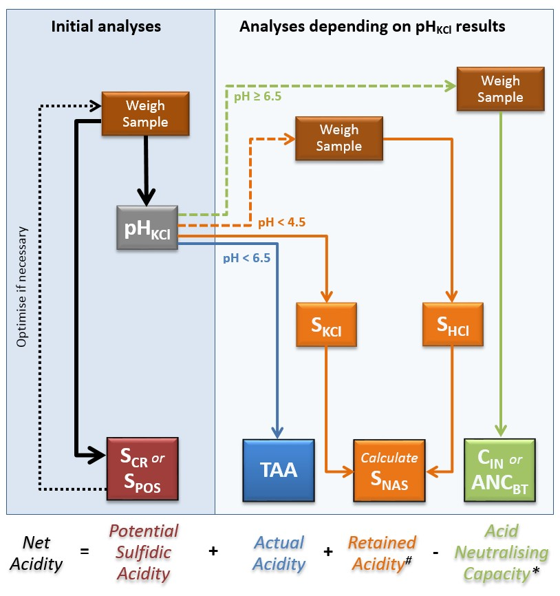

# Retained Acidity must be determined when the pHKCl less than 4.5 or where jarosite has been visually observed in the soil material.

* ANC can only be included in Net Acidity calculation if its effectiveness has been corroborated by other data (for example incubation data) that demonstrate acidification is not experienced by the soil material during complete oxidation under field conditions. If corroboration of a measured ANC is not available, then the ANC must not be used for the determination of Net Acidity of that soil material (that is Equation 3.2 must be used). Regardless of whether ANC measurements are allowed for the calculation of Net Acidity, ANC measurements will be required on soil materials for verification purposes should lime be used for management (Equation 3.3).

### Analysis of wet or dried soil materials?

The acidity hazard is usually measured on oven-dried (80–85 °C) and finely-ground soil material (Figure 3.2). This is recommended as some methods require very small quantities of soil material (that is sometimes only 0.05 g) and must be analysed on homogenous samples to ensure representative results.

For determinations of physical properties, monosulfide content, incubation behaviour, and metal and metalloid mobilisation, soil materials must be preserved and analysed in their field condition to ensure laboratory results are representative of the soil materials in the field (Figure 3.2).

For example, the results of metal mobilisation vary greatly if ASS materials have been oven dried compared with field condition analysis. Many of the components in ASS materials are highly redox sensitive (for example Acid Volatile Sulfide) and failure to adequately preserve these components for analysis in the laboratory will often result in invalid analytical determination of these components.

The inherent variability of RIS content, on micro- and meso-scales within many ASS materials under field conditions, even when mixed thoroughly, necessitates Acid Volatile Sulfide determinations on wet samples be at least duplicated to ensure sample variability is assessed and representative values measured.

Figure . Flow chart for the analysis of dry and wet soil samples.

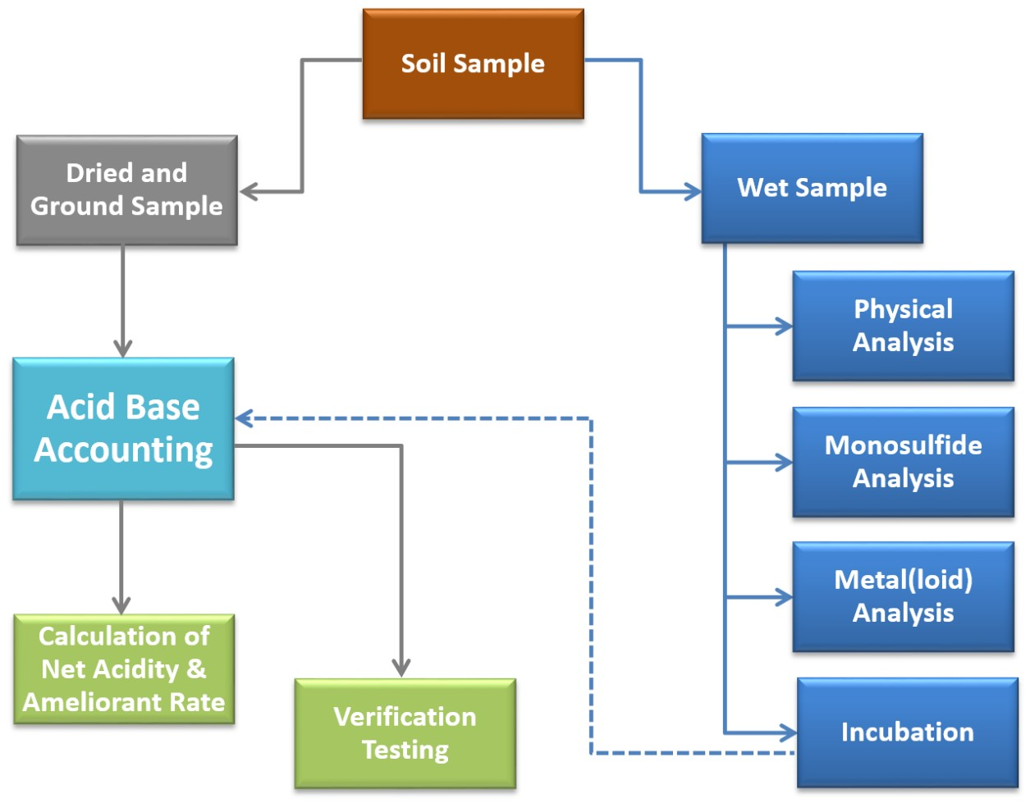

## Sample preparation and storage for analysis

### Soil sample preparation

On arrival at the laboratory, the required sample analyses should be considered and samples separated for wet and dry procedures (Figure 3.2). Samples for MBO and metals and metalloid analysis should be immediately frozen. Samples requiring incubation should be refrigerated, but not frozen; freezing changes the structure of the soil.

Samples submitted for Net Acidity quantification should be dried (preferably in a quick-drying, fan-forced, air-extracting oven) at 80–85 °C to a constant weight (or if this is not measured, for at least 48 h) to kill bacteria and rapidly remove water to minimise oxidation of pyrite (Ahern et al. 1996). Freeze-drying of the samples may also be undertaken, however, experience indicates this procedure does not preserve monosulfides in soil samples and should be avoided for MBOs. Samples should be spread out in trays to no more than 2–3 cm depth to allow rapid drying. Where possible, cloddy or plastic clay samples should be broken into lumps no more than 1–2 cm in diameter.

For the determination of field moisture, a representative portion of soil should be sealed in a HDPE plastic bag or ‘moisture container’ for ‘as received moisture’ determination. Further details on the methods used to determine the soil moisture content are presented in Section 4 – Physical properties.

Laboratories should take care not to overload their ovens. If an oven is overloaded with large frozen samples, or too many very wet samples, the oven’s drying efficiency may be decreased. As a result, oxidation of RIS and a substantial drop in pH may occur.

After drying, coarse material not previously removed, such as shell and gravel, should be picked out or removed by preliminary sieving (2 mm). The amount of residual coarse material (greater than 2 mm) should be weighed and calculated as a percentage of the total sample weight.

The gravel component may need to be analysed as a separate sample as gravels in ASS materials can contain sulfides in the weathered rind or as a total component of the rock (Saffigna et al. 1996).

Soil samples that do not easily break up after oven-drying (such as dried heavy clay), should be rolled, crushed or ground to pass through a 2 mm sieve.

A representative sub-sample of at least 50 g, sufficient for all analyses including repeats, should be ground to a powder. Fine grinding using a ring mill is required to ensure a homogeneous representative sample. This is particularly important for optimum recovery of pyrite by the Chromium Reducible Sulfur method which can use as little as 0.05 g of sample for highly sulfidic materials.

Dried ASS materials may contain dusty, strongly acidic substances such as jarosite. Workers involved in grinding these soils should take appropriate health and safety precautions such as using appropriate personal protective equipment including eye protection, a dust mask and an efficient dust extraction cabinet.

Dried ground samples should be stored in a cool dry location in airtight plastic or other inert containers, or vacuum sealed for subsequent laboratory use.

Sample analyses should be completed within a short time-frame.

If analysis is to be delayed by more than a few months, or is required to be stored for similar durations, then dried and ground samples should be purged with an inert gas (for example N2) and vacuum sealed in multi-ply gas-impermeable plastic bags, and then stored in a moisture-free environment under refrigeration.

### Storing and retaining samples for audit purposes

Representative soil samples collected for ASS investigations should be well marked and retained for possible future call or audit purposes. Storage by vacuum sealing, in an oven-dried state, to prevent absorption of moisture and diffusion of atmospheric oxygen into the sample is the preferred approach.

Experience indicates that RIS will oxidise over time, regardless of the preservation method used. However, Net Acidity is unlikely to reduce as quickly over time as oxidation of RIS will result in an increase in other acidity pools included in the Net Acidity value.

Accredited laboratories (for example NATA-registered, Certified Laboratory Practice and ISO 9000) provide traceability through laboratory information systems. As most commercial laboratories discard samples about a month after results are reported, special arrangements with the chosen laboratory need to be made to ensure that at least 50 g of sample is retained until approvals have been finalised. Most laboratories will charge a fee for sample storage.

When the retention of representative samples has become what is considered an unreasonable impost, the appropriateness of discarding samples should be discussed with the regulatory authority.

It is important to be aware that stored samples may assume considerable importance should any subsequent legal issue regarding management approaches reliant on laboratory analytical data arise.

## Part 2 – Laboratory methods

### Introduction

The second part of this document (Sections 4, 5 and 6) sets out the methods of laboratory analysis of soil samples to provide information for the assessment and management of ASS materials. Standard physical and chemical methods are provided for the routine laboratory analysis of ASS materials. Laboratory incubation methods for the identification and assessment of the acidification potential of ASS materials are also included in Appendix C.

A list of the National Laboratory Method (NLM) codes for all the physical and chemical methods presented in this document is presented in Table D1 (see Appendix D). Many of the laboratory methods outlined in this manual are based on the procedures presented in the QASSIT *Acid Sulfate Soil* *Laboratory Methods Guidelines* (Ahern et al. 2004). In addition, the analytical suites for laboratory analysis of ASS materials have been formalised into *Australian Standard® 4969: Analysis of acid sulfate soil - Dried samples - Methods of test* (Standards Australia 2008). The corresponding QASSIT and Australian Standard® method codes are also included in Table D1.

The chemical analysis of samples should be conducted by laboratories which hold National Association of Testing Authorities (NATA) accreditation for the particular parameters and methodologies required. Quality control procedures should include laboratory control standards (LCS) and duplicate analyses (for example 10% of samples duplicated). Laboratories that undertake ASS proficiency trials, such as those run by the Australasian Soil and Plant Analysis Council (ASPAC), can provide further assurance on the quality of their data.

The laboratory methods in this manual are not the only tools available for assessing ASS materials. It is acknowledged that there are many variations of these methods, plus more complex or costlier ‘research methods’ available for analysing ASS material*s*. Some of these other methods may be equally suitable or more appropriate in some circumstances.

However, unless otherwise negotiated initially with the approving authorities, the laboratory analysis results submitted as part of any site assessment or investigation for ASS materials should use at least one, and in many cases a combination, of the national standard methods listed in this manual.

Other analytical methods may supplement the standard ones contained in this guidance document, but full explanations of the need to use any ‘non-standard method’ over equivalent methods contained in this guidance document, together with their interpretation and correlations with standard approaches will normally be necessary. Provided such submissions clearly demonstrate that they are based on rational soil science, sedimentological, hydrological and geomorphological principles, assessors and regulators should judge each submission on its merit. It is recommended that non-standard methods be approved by the regulatory agencies prior to their use.

## Physical properties

### Introduction

This section outlines the commonly used laboratory methods to determine the physical properties of ASS materials. The methods for two physical properties are described further on including soil moisture content and bulk density.

The moisture content must be determined when quantifying the chemical composition of any soil materials. The bulk density of the soil needs to be considered when determining the amount of soil being disturbed and for calculating the amount of lime needed to treat a given volume of soil.

Please note there are risks inherent in performing any physical method. It is the responsibility of any laboratory that performs these methods to minimise these risks by putting in place appropriate safeguards and following good laboratory practice.

A summary of the physical methods presented in this section are:

* Soil moisture content
  + ‘As received’ Moisture Content dried at 105 °C (NLM-1.1)
  + ‘As received’ Moisture Content dried at 85 °C (NLM-1.2).
* Soil bulk density
  + Steel Core Ring Bulk Density (NLM-1.3)
  + Syringe Bulk Density (NLM-1.4).

### Soil moisture content

#### Introduction

On arrival at the laboratory, a sub-sample of the soil should be set aside for moisture content determination, unless a separate sample has been supplied. The moisture content must be determined when quantifying the chemical composition of any soil materials (for example Net Acidity, Acid Volatile Sulfide content, or Sequential Metals and Metalloid Extraction).

The moisture content is required to allow results to be reported on a dry weight basis.

#### ‘As received’ Moisture Content dried at 105 °C – NLM-1.1

The as received Moisture Content dried at 105 °C method is adapted from the procedure outlined in Rayment and Lyons (2010).

##### Apparatus

Laboratory oven (preferably in a quick-drying, fan-forced, air-extracting oven) set at 105 °C; moisture tins; desiccator; electronic balance.

##### Procedure

* Weigh each dry clean weighing container and record the weight (W1 g).
* Weigh accurately between 10 and 50 g of soil into each container. Soil samples should be spread out in containers to no more than 2–3 cm depth to allow rapid drying. Where possible, cloddy or plastic clay samples should be broken into lumps no more than 1–2 cm in diameter.
* Record the weight of container and soil (W2 g).
* With lids removed, dry to constant weight at 105 °C and then quickly transfer to a dry desiccator (no desiccant) to cool.
* When cool, replace relevant lids and reweigh (W3 g) to determine weight of moisture (W4 g).

##### Calculations

$$Wt. of moisture, W_{4}(g)=\left[\left(W_{2}-W_{1}\right)-\left(W_{3}-W_{1}\right)\right]$$

$$W_{105}\left(\%\right)=\frac{Wt. of moisture \left(g\right)×100\%}{Wt. of oven dry soil \left(g\right)}=\frac{W_{4}×100\%}{W_{3}-W_{1}}$$

Report as received Moisture Content (105 °C).

#### ‘As received’ Moisture Content dried at 85 °C – NLM-1.2

The as received Moisture Content dried at 85 °C method follows the same procedure as outlined previously, except the laboratory oven is set at 85 °C instead of 105 °C. If the as received moisture content at 85 °C of the soils is required, take the entire sample and place in a large dish of known mass and proceed as outlined in the as received Moisture Content dried at 105 °C method (NLM-1.1) above with the oven set at 85 °C. Unlike samples dried at 105 °C, samples dried at 85 °C can be used for routine ASS analysis.

### Soil bulk density

#### Introduction

The bulk density of the soil materials is needed to convert volume-based measurements to mass-based measurements. One use is when calculating the amount of lime needed to treat a given volume of soil.

Many laboratories assume a bulk density of 1.0 g/cm3, however, values between 0.7 g/cm3 and 2.0 g/cm3 are common; the bulk density may be as low as 0.2 g/cm3 for peats. The bulk density can be calculated following weighing a known volume of soil before and after oven-drying at 105 °C.

The two recommended methods for determining the bulk density of ASS materials are from Melville (1998) and are: (i) using a steel core ring, and (ii) using a push sampler of known volume (for example plastic syringe with the end cut off).

#### Steel Core Ring Bulk Density – NLM-1.3

Steel coring rings are suitable when determining the bulk density of surface soils or soils from a pit. In this bulk density method a known volume and mass of moist soil is oven-dried at 105 °C to constant mass (normally 48 h), and then re-weighed. The bulk density can then be calculated using the simple equation as follows.

Equation . Bulk density.

$$Bulk density (g/{cm}^{3} or t/m^{3})=\frac{oven dry mass of sample}{volume of sample}$$

#### Syringe Bulk Density – NLM-1.4

An estimate of the bulk density can be obtained by collecting a known volume of sample in the field with a cut off syringe or other suitably designed instrument. This method works extremely well with saturated clay gels and sands. The syringe bulk density method follows the same procedure as outlined in Soil bulk density (see NLM-1.3).

##### Notes

Default bulk density values used in the absence of site-specific data for soil materials are given in Table 5.1. It is important to note these default values are conservative and if used in place of site-specific bulk density values, will usually overestimate the amount of lime required for treatment.

The process of sampling at depth (for example from coring equipment) may result in compaction or expansion of the sample.

Table . Default bulk densities based on soil texture.

|  |  |
| --- | --- |
| Texture | Bulk density (t/m3) |
| Sand | 1.8 |
| Loamy sand | 1.8 |
| Sandy loam | 1.7 |
| Loam | 1.6 |
| Silty loam | 1.5 |
| Clay loam | 1.5 |
| Clay | 1.4 |
| Peat | 1.0 |

Source: USDA-NRCS 1999.

## Chemical analysis for acidity hazards

### Introduction

This section presents standard chemical methods for the routine laboratory analysis of the Net Acidity of ASS including potential acid production from the oxidation of iron sulfides (that is Potential Sulfidic Acidity), Actual Acidity, Retained Acidity (for example jarosite) and Acid Neutralising Capacity.

Additional standard chemical methods that may be required when assessing the deoxygenation and metals and metalloid mobilisation hazards of ASS materials are presented in Section 6.

Chemical properties determined in the field, including pH (pHF; NSM-1.1), pH after oxidation with hydrogen peroxide (pHFOX; NSM-1.2), and a field carbonate test (NSM-2.1) are outlined in the National acid sulfate soil sampling and identification manual (Sullivan et al. 2018b).

Please note there are risks inherent in performing any chemical method. It is the responsibility of any laboratory that performs chemical methods to minimise these risks (to persons, property and the environment) by putting in place appropriate safeguards and following good laboratory practice.

Relevant Safety Data Sheets (SDS) should be at hand for all chemicals and reagents used. Analysts must wear protective equipment appropriate to the method being performed (for example safety glasses/goggles/face shield/face mask, gloves, covered shoes, laboratory coat). Where indicated in particular methods, fume hoods that comply with appropriate Australian Standards need to be used due to the generation of toxic, carcinogenic and potentially flammable gases. Laboratories should provide adequate training of analysts in performing analytical methods including an explanation of the risks involved.

In this section and Section 6, the attention of operators is drawn to the most acute risks associated with particular methods. However, the stated risks and warnings are not comprehensive and operators should be cognisant of other more general risks associated with particular methods (for example from concentrated acids or alkalis).

Finally, it is the duty of laboratories that any wastes generated from these methods are disposed of in an environmentally responsible manner.

A summary of the chemical methods presented in this section are:

* Potential Sulfidic Acidity
  + Chromium Reducible Sulfur (SCR; NLM-2.1)
  + Peroxide Oxidisable Sulfur (SPOS; NLM-2.2).
* Actual Acidity
  + KCl Extractable pH (pHKCl; NLM-3.1)
  + Titratable Actual Acidity (TAA; NLM-3.2).
* Retained Acidity
  + Net Acid Soluble Sulfur (SNAS; NLM-4.1).
* Acid Neutralising Capacity
  + Total Inorganic Carbon (CIN; NLM-5.1)
  + Back-titration (ANCBT; NLM-5.2).

### Potential Sulfidic Acidity

#### Introduction

The Potential Sulfidic Acidity is a component of the ABA and needs to be measured irrespective of the pH value of the soil material (Figure 3.1).

Potential Sulfidic Acidity is calculated from the RIS content assuming all RIS is in the form of pyrite and has the potential to be completely oxidised.

There are two approaches to the measurement of RIS:

1. the Chromium Reducible Sulfur (SCR) method (NLM-2.1) (or similar methods based on the quantification of the Chromium Reducible Sulfur), or
2. the Peroxide Oxidisable Sulfur (SPOS) (NLM-2.2).

The Chromium Reducible Sulfur method is recommended for all soil materials.

The Peroxide Oxidisable Sulfur method is not recommended for soil materials with organic matter contents greater than 0.60% organic carbon as the SPOS method can result in false positive identification of ASS even at these relatively low organic carbon contents.

Peroxide Oxidisable Sulfur results need corroboration by Chromium Reducible Sulfur results regardless of the soil organic matter content.

Procedures for these two methods are as follows.

#### Chromium Reducible Sulfur (SCR) – NLM-2.1

##### Introduction

The Chromium Reducible Sulfur method measures the concentration of RIS compounds present in the soil. This method is not subject to significant interferences from the sulfur in either organic matter or sulfate minerals (for example gypsum) (Sullivan et al. 1999).

The use of the Chromium Reducible Sulfur method to measure RIS compounds in sediments was proposed by Zhabina and Volkov (1978), evaluated for its efficacy and selectivity by Canfield et al. (1986) and Morse and Cornwell (1987), and has since been widely used in research (for example Raiswell et al. 1988; Luther III et al. 1992; Rice et al. 1993; Holmer et al. 1994; Moeslund et al. 1994; Wilkin & Barnes 1996; Habicht & Canfield 1997; Rickard 1997; Ward 2004; Sullivan et al. 2009). Reduced Inorganic Sulfur compounds are the constituents of ASS materials that are of environmental concern due to their acid-generating potential. This procedure has been evaluated for ASS materials in Australia and is specific to these compounds.

The Chromium Reducible Sulfur method is based on the conversion of RIS to H2S by a hot acidic CrCl2 solution. The H2S evolved can be measured by several approaches. The method presented here is from Sullivan et al. (2000) and is based on quantifying evolved H2S by iodometric titration. The RIS compounds measured by this method are: 1) pyrite and other iron disulfides, 2) elemental sulfur, and 3) acid volatile sulfides (for example greigite and mackinawite).

##### Reagents

###### Reagent warning

All chemicals can be hazardous and appropriate care must be taken when handling and using these substances.

Solid zinc acetate is hazardous. Contact with skin and eyes should be avoided by wearing appropriate safety equipment (for example gloves, safety glasses and laboratory coat).

Solid sodium hydroxide is caustic and deliquescent. Contact with skin and eyes should be avoided by wearing appropriate safety equipment (for example gloves, safety glasses and laboratory coat).

Ammonia solution is highly alkaline. Contact with skin and eyes should be avoided by wearing appropriate safety equipment (for example gloves, safety glasses and laboratory coat).

Concentrated or 6 M hydrochloric acid is hazardous. Contact with skin and eyes should be avoided by wearing appropriate safety equipment (for example gloves, safety glasses and laboratory coat). Acid fumes should be avoided by handling the concentrated acid in a fume hood and/or by wearing a suitable gas mask.

Ethanol is hazardous and highly flammable. Contact with skin and eyes should be avoided by wearing appropriate safety equipment (for example gloves, safety glasses and laboratory coat). Inhalation should be avoided by handling in a fume hood and/or by wearing a suitable gas mask.

Chromium powder is hazardous. Inhalation should be avoided by handling in a fume hood and/or by wearing a suitable gas mask.

Solid iodine is hazardous. Contact with skin and eyes should be avoided by wearing appropriate safety equipment (for example gloves, safety glasses and laboratory coat). Vessels containing iodine solution should be sealed or kept in a fume hood as there can be significant vapour pressure above solutions of aqueous I3-.

###### Reagent preparation

Unless otherwise specified, reagents should be of analytical reagent (AR) grade and deionised water of conductivity less than 5 µS/cm.

Zinc acetate solution: Dissolve 60 g of zinc acetate in approximately 1.5 L of deionised water. Add 200 mL of 28% ammonia solution and make up to 2 L with deionised water.

6 M sodium hydroxide (NaOH): Dissolve 480 g of NaOH pellets in approximately 1.5 L of deionised water. Make up to 2 L at 20 °C with deionised water.

Note: Solid NaOH is caustic and deliquescent and should be stored away from water. Dilute NaOH solutions absorb CO2. Avoid unnecessary contact of this solution with the atmosphere. Solutions should be prepared fresh each day, or alternatively, stored in apparatus capable of excluding CO2 and standardised daily.

Standard 0.025 M sodium thiosulfate solution: This solution may be obtained commercially or prepared by dissolving 6.205 g of Na2S2O3.5H2O in deionised water, then making up to 1 L in a volumetric flask. Add 1.5 mL of 6 M NaOH and make to volume with deionised water.

Note: Na2S2O3.5H2O is not pure enough to be used as a primary standard. The solution should be standardised with a fresh solution of I3- prepared from KIO3 and KI, or against I3- standardised with As4O6. Alternatively, anhydrous sodium sulfate can be prepared from the pentahydrate which is suitable for use as a primary standard.

Starch solution: Dissolve 2 g arrowroot starch and 0.2 g salicylic acid in 100 mL of hot deionised water.

Iodine solution: Dissolve 22.50 g of potassium iodide in approximately 900 mL of deionised water; add 3.20 g of iodine. After the iodine has dissolved, dilute to 1 L with deionised water and standardise against the standard 0.025 M Na2S2O3 solution using the starch solution as an indicator. Record volume (D) of standardised Na2S2O3 used in titration and the volume (E) of iodine solution titrated. Standardisations should be performed daily.

95% Ethanol (C2H6O)

Chromium powder (Technical grade)

6 M Hydrochloric acid (HCl): While stirring, slowly add approximately 585 mL of concentrated (ρ = 1.16 g/cm3, 31.5–33% w/V) HCl to 400 mL of deionised water. Make up to 1 L at 20 °C using deionised water. Some chemical producers supply concentrated HCl of density 1.18 g/cm3 (approximately 12.3 M or 38% w/V), in which case approximately 488 mL of acid should be added to 500 mL of deionised water.

##### Apparatus

The apparatus is shown diagrammatically in Figure 6.1.

##### Amount of soil material to digest

The optimum weight of soil material to digest depends on the RIS content and is a compromise between:

* too much RIS, resulting in too much H2S supplied to the trapping solution. The H2S may exceed the capacity of the ZnS trap resulting in an underestimation, or more likely, the titration will use a large amount of iodine. A large volume of iodine can make the permanent blue endpoint difficult to distinguish. It also lengthens the time of titration which can result in loss of H2S.
* too little RIS, resulting in only very small quantities of H2S (if any) supplied to the trapping solution. In samples with very low RIS contents, insufficient quantities of soil material will result in very small quantities of iodine titrant and low analytical precision.

Where the maximum likely RIS content can be assessed (such as by a screening analysis of total sulfur), the following guidelines are useful for determining the optimum dry powdered sample weights:

* for samples with a likely SCR content less than 0.5%, 3 g of sample is recommended
* for samples with a likely SCR content less than 1% but greater than 0.5%, 0.5 g of sample is recommended
* for samples with a likely SCR content greater than 1%, but less than 3%, 0.1 g of sample is recommended
* for samples with a likely SCR contents greater than 3%, 0.05 g of sample is recommended

If the likely SCR content is not known, then at least 0.5 g of sample should be used to ensure adequate analytical precision.

Figure . Schematic representation of the apparatus used in the chromium reduction method.

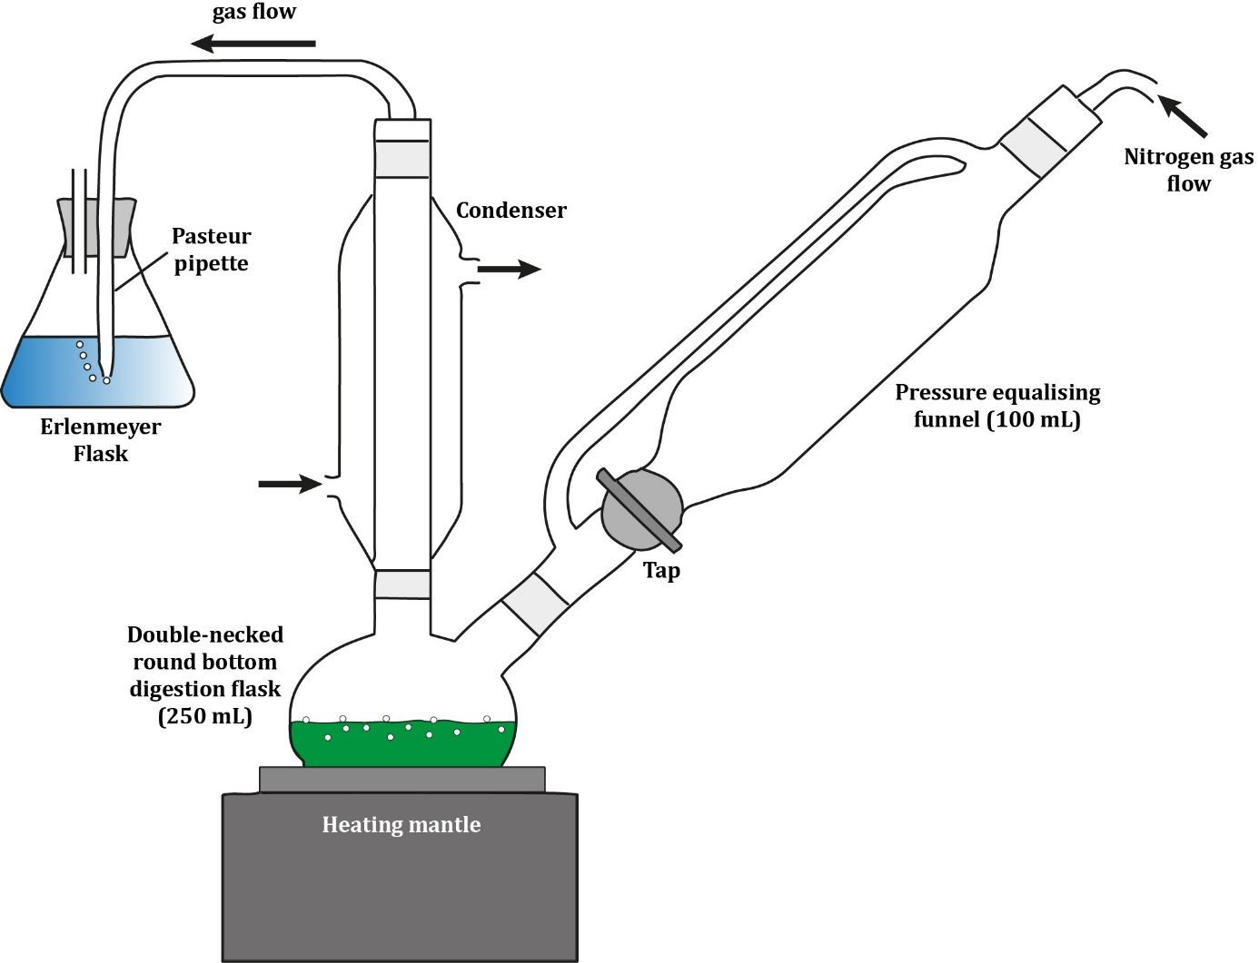

Note: For determining Scr.

##### Procedure

* Weigh accurately (to the nearest 0.001 g) between 0.495 g and 0.525 g (m) of finely ground (for example ring mill ground) oven-dried (80–85 °C) soil (or other appropriate weight as described in the introduction) into a double-neck round-bottom digestion flask. Include a solution blank in each batch and subject it to the same procedure as the soil.
* Add 2.0 g of chromium powder and then 10 mL ethanol (95% concentration) to the digestion flask and swirl to wet the sample.

Caution: Chromium dust may be toxic if inhaled and may represent a combustion risk. Avoid the use of very fine chromium powder.

* Place the digestion flask in the cold heating mantle and connect to the condenser. The digestion apparatus should be set up in a fume hood.
* Attach the pressure equalising funnel making sure the gas flow arm is facing the condenser and that the solution tap is shut. Attach a Pasteur pipette to the outlet tube at the top of the condenser and insert it into a 100 mL Erlenmeyer flask containing 40 mL zinc acetate solution.
* Turn on the water flow around the condenser and make sure that all ground glass fittings are tight. Add 60 mL of 6 M HCl to the glass dispenser in the pressure equalising funnel.
* Connect the N2 flow to the pressure equalising funnel and adjust the flow to obtain a bubble rate in the zinc acetate solution of about 3 bubbles per second. Allow the N2 gas to purge the system for about 3 min.
* Slowly release the 6 M HCl from the dispenser.

Caution: The 6 M HCl should be added to the soil material and chromium powder very slowly in a fume hood.

* Wait for 2 min before turning on the heating mantle and adjust the heat so that a gentle boil is achieved. Check for efficient reflux in the condenser. Allow to digest for at least 20 min. Please note that heating for 20 min alone is not sufficient.

Caution: H2S gas (a hazardous gas) can be evolved during this digest. Consequently, this part of the procedure should be undertaken in a fume hood.

* Remove the Erlenmeyer flask and wash any ZnS on the Pasteur pipette into the Erlenmeyer flask with a wash bottle containing deionised water. Add 1 mL of the starch indicator solution and 20 mL of 6 M HCl to the zinc acetate solution and gently mix by swirling or placing on a relatively slow magnetic stirrer.

Note: If a large amount of ZnS has formed on the tip of the Pasteur pipette (and is not easily removed by washing with deionised water, the pipette can be left in the Erlenmeyer flask (and trapping solution), washed with a small amount of 6 M HCl and remain there during the titration.

* Whilst stirring, titrate the zinc acetate trapping solution with the iodine solution to a permanent blue end-point. Record the volume of titrant (A) in mL. Perform the same titration on the blank sample and record the volume of titrant (B) in mL.

Warning: H2S gas (a hazardous gas) can be evolved after the acid is added to the zinc acetate trapping solution. Consequently, this part of the procedure should be: 1) carried out with a minimum of delay after the acid has been added, and 2) undertaken in a fume hood or with the aid of a fume extractor. It is recommended laboratories be equipped with suitable gas monitors to guard against accidental exposure to H2S.

Caution: The acidic chromium digest solution (in the round-bottomed flask) generated by this procedure must not be disposed of down the sink. Consult local or state regulatory authorities for its safe disposal.

##### Calculation

The concentration of Chromium Reducible Sulfur (SCR) in % S and mol H+/t are calculated as follows:

$$S_{CR}(\%)=\frac{(A-B)×C×3.2066}{m}$$

$$S_{CR}(mol H^{+}/t)=S_{CR}(\%)×623.7$$

Where:

A = The volume of iodine (in mL) used to titrate the zinc acetate trapping solution following the soil digestion

B = The volume of iodine (in mL) used to titrate the zinc acetate trapping solution following a blank digestion

C = The molarity of the iodine solution (in M) as determined by titration of this solution with the standard 0.025 M Na2S2O3 solution

$$C=\frac{0.025×D}{2×E}$$

D = Titration volume of standard Na2S2O3 solution (in mL)

E = Volume of iodine solution titrated (in mL)

m = The mass of the soil weighed (in g)

#### Peroxide Oxidisable Sulfur (SPOS) – NLM-2.2

##### Introduction

Peroxide Oxidisable Sulfur (SPOS) is the difference between the sulfur determined in the peroxide digest (SP) and the sulfur extracted by 1 M KCl (SKCl). The SPOS result provides a measure of the oxidisable sulfur content of ASS materials. The SPOS determinations suffer from organic matter interference and can substantially overestimate RIS in soil materials with even relatively low organic matter contents (that is contents as low as 0.60% organic carbon). Accordingly, SPOS results need to be corroborated with SCR (for example by analysing 15% of samples by both methods if SPOS is chosen to determine RIS, to verify the validity of the SPOS results).

The SKCl method is outlined in the Retained Acidity section.

A procedure for quantifying the Peroxide Oxidisable Sulfur (SPOS) content of a soil is outlined further on. The procedure includes sample digestion and titration (step 1), the determination of peroxide sulfur (SP) content (step 2), and the calculation of Peroxide Oxidisable Sulfur (SPOS) (step 3; SP - SKCl).

##### (1) Digestion and titration for peroxide sulfur (SP)

###### Introduction

This method is used to digest the sample for determination of peroxide sulfur (SP) (Latham et al. 2002; McElnea et al. 2002b, 2002a). This is a multi-step process and all steps must be undertaken for accurate determination of SP. The titrated digestion extract is retained for SP determination.

###### Reagents

Reagent warning

All chemicals can be hazardous and appropriate care must be taken when handling and using these substances.

Hydrogen peroxide (30%) is hazardous. The principal routes of exposure are usually by contact of the liquid with the skin or eye. Accordingly, analysts should wear appropriate gloves and safety glasses at all times when using this chemical.

Solid sodium hydroxide is caustic and deliquescent. Contact with skin and eyes should be avoided by wearing appropriate safety equipment (for example gloves, safety glasses and laboratory coat).

Concentrated hydrochloric acid is hazardous. Contact with skin and eyes should be avoided by wearing appropriate safety equipment (for example gloves, safety glasses and laboratory coat). Acid fumes should be avoided by handling the concentrated acid in a fume hood and/or by wearing a suitable gas mask.

Reagent preparation

Unless otherwise specified, reagents should be of analytical reagent (AR) grade and deionised water of conductivity less than 5 µS/cm.

Approximately 2.66 M potassium chloride (KCl): Dissolve 198.81 g KCl in approximately 700 mL of deionised water. Make up to 1 L at 20 °C using deionised water.

Standardised approximately 0.25 M sodium hydroxide (NaOH): Dissolve 10.1 ± 0.1 g of NaOH pellets in approximately 700 mL of CO2-free deionised water. Make up to 1 L at 20 °C using deionised water. Standardise against potassium hydrogen phthalate (C6H5O4K) by accurately weighing (to 0.0001 g) 0.25 ± 0.05 g of dried potassium hydrogen phthalate into a container and dissolving in deionised water. Titrate phthalate solution with NaOH solution using a pH meter or appropriate pH indicator. Determine the equivalence/endpoint volume and calculate the molarity of the NaOH solution. When the concentration of the standardised NaOH solution is not exactly 0.25 M, then the exact concentration of the NaOH should be used in calculations.

Note: Solid NaOH is caustic and deliquescent and should be stored away from water. Dilute NaOH solutions absorb CO2. Avoid unnecessary contact of this solution with the atmosphere. Solutions should be prepared fresh each day, or alternatively stored in apparatus capable of excluding CO2 and standardised daily.

Standardised approximately 0.05 M sodium hydroxide (NaOH): Dissolve 2.05 ± 0.05 g of NaOH pellets in approximately 700 mL of CO2-free deionised water. Make up to 1 L at 20 °C using deionised water. Standardise against potassium hydrogen phthalate (C6H5O4K) by accurately weighing (to 0.0001 g) 0.10 ± 0.02 g of dried potassium hydrogen phthalate into a container and dissolving in deionised water. Titrate phthalate solution with NaOH solution using a pH meter or appropriate pH indicator. Determine the equivalence/endpoint volume and calculate the molarity of the NaOH solution. Where the concentration of the standardised NaOH solution is not exactly 0.05 M, then the exact concentration of the NaOH should be used in calculations.

Note: Solid NaOH is caustic and deliquescent and should be stored away from water. Dilute NaOH solutions absorb CO2. Avoid unnecessary contact of this solution with the atmosphere. Solutions should be prepared fresh each day, or alternatively stored in apparatus capable of excluding CO2 and standardised daily.

Standardised approximately 0.5 M hydrochloric acid (HCl): While stirring, slowly add 50 mL of concentrated (31.5–33% w/V) HCl to 700 mL of deionised water. Make up to 1 L at 20 °C using deionised water. Standardise against disodium tetraborate decahydrate (Na2B4O7.10H2O) or recently standardised approximately 0.25 M NaOH solution. Calculate molarity of HCl solution (c3). Where the concentration of the standardised HCl solution is not exactly 0.5 M then the exact calculated molarity should be used in calculations.

Note: Solutions of 0.5 M HCl made by diluting commercially available ampoules may also be used.

30% w/w AR grade hydrogen peroxide (H2O2): Use only AR grade hydrogen peroxide. Check the pH of the peroxide. Include a digestion blank with each run. Technical grade peroxides are not recommended as they are usually acid stabilised and vary considerably between bottles in both sulfur content and pH.

30% w/w AR grade hydrogen peroxide (H2O2) (pH adjusted): Adjusted to pH 5.5 with dilute (0.05 M) NaOH solution for use in the ‘final oxidation’ step.

6.30 × 10-3 M copper(II) chloride (CuCl2.2H2O) (400 mg Cu/L): Dissolve 1.073 g of CuCl2.2H2O in approximately 700 mL of deionised water. Make up to 1 L at 20 °C using deionised water.

Potassium hydrogen phthalate (C6H5O4K): Dry at 105 °C for 4 h and store in desiccator prior to use.

Sodium tetraborate (Na2B4O7.10H2O)

###### Apparatus

Electronic balances (500 ± 0.01 g and 100 ± 0.0001 g); 250 mL tall-form borosilicate (‘Pyrex’) glass beakers (with 50 mL volume accurately marked); wash bottle for deionised water; electric hotplate or steam bath (able to keep beaker and contents at 80–90 °C); fume hood; adjustable dispensing pipette (1–10 mL, or separate 1 mL and 10 mL pipettes); manual or automatic volumetric dispenser (capable of dispensing 30 ± 0.25 mL); auto-titrator or other appropriate titration apparatus (for example pH meter, magnetic stirrer plate, Teflon®-coated magnetic stirrer bar and 2 × 10 mL A-grade 0.02 mL graduated burette or digital burettes of similar accuracy); titration vessel (of at least 100 mL capacity made of polyethylene or similar inert material).

###### Procedure

Peroxide digest (oxidation)

* Weigh accurately (to the nearest ± 0.01 g) between 1.9 and 2.1 g of finely-ground (for example in a ring mill) oven-dried (80–85 °C) soil into a suitably labelled, tared flask (for example 250 mL tall-form borosilicate glass beaker) on which the 50 mL level is accurately marked, and record soil mass (m). In each analytical run, perform a minimum of two solution blanks and subject them to the same procedure as the soil. (If one or more samples in the run undergo the carbonate modification, then subject one of the blanks to this procedure).
* In a fume hood (and wearing safety-glasses, laboratory coat and gloves), add 10 mL analytical reagent grade 30% H2O2 to each flask and swirl to mix. Soils high in pyrite (or manganese) have the potential to react violently at this stage. At the first sign of a vigorous reaction, add deionised water to moderate the reaction.
* If the reaction becomes overly vigorous at this stage and any loss of digest material occurs, the sample must be repeated with greater care and/or with a lesser sample weight (that is 1 g). When analysing soil of known high sulfide content also use this lesser sample weight. For such repeats, add approximately 10 mL of deionised water to the soil prior to an incremental addition of the 10 mL of H2O2. The exact mass weighed (m) must be used in the calculation of SP.
* After 30 min, add deionised water with swirling to make the total volume of suspension in the beaker between 45 and 50 mL. Swirl digest solution to give a homogeneous suspension, then rinse the inside wall of the beaker with deionised water.

Note: It is important to maintain this volume throughout the remaining digestion by regular addition of deionised water, and also to periodically swirl the sample to prevent soil from settling on and adhering to the bottom of the beaker during the subsequent hotplate heating stages. Rinsing the inside wall of the beaker with small squirts of deionised water also serves to dissolve any salts that may have accumulated there.

* Place the beaker on a hotplate (or steam bath) for a maximum of 30 min and maintain sample at 80–90 °C. Swirl samples periodically (for example every 10 min) and add deionised water as required to maintain volume between 45 and 50 mL, and to wash soil residue from the inside of the beakers.
  + 1. If a digest reacts vigorously after being placed on the hotplate, temporarily remove it from the hotplate and/or moderate the vigour of the reaction by adding small amounts of deionised water. Replace digest solution on hotplate when reaction has moderated. When the digest solution stops reacting while on the hotplate (for example typically effervescent bubbling has ceased, soil settles and supernatant clears), remove from hotplate. If the digest solution continues to react whilst on the hotplate, remove after 30 min has elapsed.
    2. For a digest that reacts only slowly or moderately while on the hotplate, remove only after reaction ceases. If the reaction on the hotplate is continuing after 30 min has elapsed, remove the digest solution from the hotplate.
    3. For a digest that showed no obvious reaction after peroxide addition prior to being put on the hotplate and that failed to subsequently react while on the hotplate, remove from the hotplate after 30 min has elapsed.
    4. For a digest that reacts vigorously after initial peroxide addition (before being put on the hotplate), but does not react further whilst on the hotplate for 10 min (indicating that the added peroxide may have already been consumed), remove at this stage.
* Allow samples to cool to near room temperature.
* Add a second 10 mL aliquot of H2O2, waiting 10 min before returning flask to the hotplate for a maximum of 30 min, adopting the procedure outlined earlier.
* Allow samples to cool to room temperature and make volume to 50 mL with deionised water.
* Measure the pH of the suspension (pHOX) while stirring using a suitably calibrated pH meter and electrode. Use the appropriate option, depending on the measured pHOX.

i) If pHOX is less than or equal to 2 (indicative of high sulfide levels), repeat digest using half the initial mass.

ii) If pHOX is greater than 2 but less than or equal to 6.5, continue from the peroxide decomposition step.

iii) If pHOX is greater than 6.5 (meaning the soil may contain excess carbonates), undertake the carbonate modification step before continuing with the peroxide decomposition step.

Carbonate modification (HCl titration to pH 4)

* For soil with pHOX greater than 6.5, quantitatively transfer suspensions to titration vessels (if not titrating in digest beaker) with deionised water.
* While stirring perform a slow titration (typically 10–30 min duration, if using an auto-titrator) to pH 4 with standardised 0.5 M HCl.

Note: Do not titrate solution blank with HCl.

Note: This titration with dilute HCl is designed to dissolve excess carbonate, which interferes with the efficiency of peroxide oxidation. The reaction between solid carbonate and soil solution as the acid is added is slow. The pH tends to oscillate near the pH 4 endpoint, so a slow titration is necessary to ensure maximum recovery of carbonate. The conditions of this titration are difficult to standardise and make consistent without the use of an auto-titrator. Addition of a set aliquot of HCl at a fixed time interval may be the best approach to standardising the titration if titrating manually. If the endpoint (pH 4.0) is slightly overshot, do not calculate the volume of titrant added to reach the endpoint, instead use the total volume of HCl solution added in subsequent calculations. However, if the pH of the suspension stabilises below 3.5, repeat the analysis.

* Quantitatively transfer contents of titration vessel to original digestion beaker (if not titrating in digest beaker).
* Add 25 mL 30% H2O2 and place on hotplate for a maximum of 1 h. Swirl digest periodically (for example every 10 min) and then wash the soil residue from the walls of the beaker with a small amount of deionised water, following the appropriate option:
  + 1. If a digest reacts vigorously after being placed on the hotplate, temporarily remove it from the hotplate and/or moderate the vigour of the reaction by adding small amounts of deionised water. Replace digest solution on hotplate when reaction has moderated. When the digest solution stops reacting while on the hotplate (for example typically effervescent bubbling has ceased, soil settles and supernatant clears), remove from hotplate. If the digest solution continues to react whilst on the hotplate, remove after 1 h has elapsed.
    2. For a digest that reacts only slowly or moderately while on the hotplate, remove only after reaction ceases. If the reaction on the hotplate is continuing after 1 h has elapsed, remove the digest solution from the hotplate.
    3. For a digest that showed no obvious reaction after peroxide addition prior to being put on the hotplate, and that failed to subsequently react while on the hotplate, remove from the hotplate after 30 min has elapsed.

Peroxide decomposition step

* Add 1 mL of 6.30 × 10-3 M CuCl2.2H2O (400 mg Cu/L) to digest solution to decompose any remaining peroxide.
* Return digests to hotplate and allow samples to reach between 80 and 90 °C (by which time peroxide decomposition should be occurring). Remove digest from hotplate when peroxide decomposition has ceased (for example effervescent bubbling has stopped and usually supernatant has cleared. If peroxide decomposition has not ceased after 30 min, then remove digest solutions from hotplate. Maintain digest volume at between 45 and 50 mL during this time (adding deionised water as necessary).
* Where the volume of the digest is greater than 50 mL after peroxide decomposition (for example in samples that underwent the carbonate modification), decrease volume to between 45 and 50 mL on the hotplate.
* When samples have cooled to near room temperature, quantitatively transfer beaker contents to a titration vessel using 30 mL of approximately 2.66 M KCl.
* Give the digest beaker a final rinse with no more than 5 mL of deionised water (into titration vessel), giving a suspension of approximately 80 mL, 1 M in KCl (that is for 2 g samples a final soil:solution extraction ratio of 1:40).

Titration

All samples with pH less than 5.5 are first titrated to pH 5.5 with either 0.05 M or 0.25 M NaOH (depending on the initial pH of the suspension). Subsequently all samples are titrated to pH 6.5 using 0.05 M NaOH.

* Measure and record pH of suspension using a suitably calibrated pH meter and electrode prior to titration. Use the appropriate option, depending on the measured pH.
  + 1. If pH is less than or equal to 3, titrate with stirring to pH 5.5 using standardised approximately 0.25 M NaOH.
    2. If pH is greater than 3 but less than or equal to 5.5, titrate with stirring to pH 5.5 using standardised approximately 0.05 M NaOH.
    3. If pH is greater than 5.5 but less than 6.5, go to final oxidation step.
    4. If pH is greater than or equal to 6.5 then no titration is required. Do not perform final oxidation.
* If the blank has a pH less than 5.5, titrate it to pH 5.5 using 0.05 M NaOH.
* Perform a ‘final oxidation’ on all samples where pH is now less than 6.5 by adding 1 mL of pH adjusted 30% H2O2. Allow pH to stabilise then measure.
* While stirring, titrate those suspensions with pH less than 6.5 to pH 6.5 using 0.05 M NaOH.

Note: The titre volume depends somewhat on the rate of titrant addition during titration. When titrating manually, the following procedure may be used as a guide. Add titrant at a slow constant rate (for example drop-wise every 1 to 2 s), allowing the increase in pH to keep pace with NaOH addition. When within 1 pH unit of endpoint (for example pH greater than 5.5), cease titrant addition and allow pH to stabilise. Recommence titration at a slower rate and bring pH to just below endpoint (for example 6.3), recording pH and corresponding volume of titrant at this point. Titrate to endpoint (pH 6.5) and wait for 20 s. If pH drops by greater than 0.1 pH units in this time (and pH endpoint was not originally overshot by more than 0.1 pH units) titrate back up to pH 6.5 and wait 20 s. Repeat process until pH remains above 6.5 after 20 s. Titrations may take as long as 5 min, depending on how far the pH dropped in the double oxidation.

Note: If an auto-titrator is being used, titrant addition should be dynamic (that is with titrant volume increment decreasing as the endpoint is approached) and the manufacturer’s operator’s manual followed.

Measurement of peroxide sulfur (SP)

* Retain the titrated suspension for measurement of peroxide sulfur (SP) as outlined in step 2 of the procedure.

#### (2) Peroxide sulfur (SP)

##### Introduction

This method determines peroxide sulfur (SP) after digestion and titration. Peroxide sulfur represents soluble and exchangeable sulfur, sulfate from gypsum, sulfate from oxidation of sulfides and sulfur released by breakdown of organic matter. It is used in conjunction with SKCl to calculate SPOS. Sulfate from jarosite and iso-structural minerals is not recovered to any significant degree.

##### Reagents

Not applicable.

##### Apparatus

Analytical balance (500 ± 0.01 g); thick medium speed high retention filter paper (for example Whatman #3 paper); beakers or plastic containers (greater than 400 mL capacity).

##### Procedure

Proceed from the end of the digestion and titration procedure as seen in section (1) Digestion and titration for peroxide sulfur (SP).

* Quantitatively transfer contents of titration vessels to tared or weighed beakers with deionised water. Subject the solution blanks to the same procedure.
* Make suspensions to 400 mL (V) and 0.2 M in KCl with deionised water on a balance. The weight of suspensions should be 403.5 g plus the weight of original soil.
* Stir suspensions to homogenise and filter through thick, medium speed high retention paper.
* Analyse filtrate for sulfur (S1) (mg S/L) by a suitable analytical instrument with an appropriate range of standards. Determine the sulfur content of the blank (S2). For sulfur measurement, instrumentation that specifically determines sulfate is preferable to that which measures total sulfur in solution.

Note: An example of an instrument that is specific to sulfate is Ion Chromatography (IC). It is necessary to have an appropriate resin that will handle high levels of chloride introduced by the KCl solution matrix to obtain accurate and reproducible results. Instruments that determine total sulfur in solution (for example ICP-AES) may measure non-sulfate sulfur species which may give a higher result. This is particularly the case in soil that contains a high concentration of organic sulfur.

##### Calculations

* Calculate peroxide sulfur (SP) as % S on a dry soil weight basis as shown:

$$S_{p}\left(\%\right)=\frac{S_{1}-S_{2}×\left(\frac{V}{m}\right)}{10 000} [V in mL and m in g]$$

When there is zero blank, m = 2 g, and V= 400 mL this simplifies to:

$$S_{p}\left(\%\right)=\frac{S_{1}}{50}$$

#### (3) Peroxide Oxidisable Sulfur (SPOS)

##### Introduction

The Peroxide Oxidisable Sulfur (SPOS) content of the soils is calculated from the difference between the sulfur determined in the peroxide digest (SP) (step 2) and the sulfur extracted by 1 M KCl (SKCl) (step 1).

##### Calculation

The concentration of Peroxide Oxidisable Sulfur (SPOS) in % S and mol H+/t are calculated as follows:

$$S_{POS}(\%)=S_{P}-S_{KCl}$$

$$S_{POS}(mol H^{+}/t)=S_{POS}(\%)×623.7$$

### Actual Acidity

#### Introduction

Actual Acidity consists of the soluble and exchangeable acidity in the soil. Actual Acidity is quantified using the Titratable Actual Acidity (TAA) method, and is considered absent (that is it has a value of zero) when the KCl Extractable pH (pHKCl) is greater than or equal to 6.5 (Figure 3.1).

Procedures for determining pHKCl (NLM-3.1) and TAA (NLM-3.2) are outlined as follows.

#### KCl Extractable pH (pHKCl) – NLM-3.1

##### Reagents

###### Reagent warning

All chemicals can be hazardous and appropriate care must be taken when handling and using these substances.

###### Reagent preparation

Unless otherwise specified, reagents should be of analytical reagent (AR) grade and deionised water of conductivity less than 5 µS/cm.

1 M potassium chloride (KCl): Dissolve 74.55 g KCl in approximately 700 mL of deionised water. Make up to 1 L at 20 °C using deionised water.

##### Apparatus

Electronic balances (100 ± 0.01 g and 100 ± 0.0001 g); sample shaker (able to keep soil particles continuously in suspension); plastic extraction container with stopper (not containing sulfur); magnetic stirrer plate; Teflon®-coated magnetic stirrer bar; titration vessel (of at least 100 mL capacity, made of polyethylene or similar inert material); calibrated pH meter.

##### Procedure

* Weigh accurately (to the nearest 0.01 g) between 1.9 g and 2.1 g (m) of finely ground (for example in a ring-mill), oven-dried (80–85 °C) soil into a suitable extraction container and make a 1:40 suspension with 80 mL aqueous 1 M KCl solution. (Include a solution blank in each batch and subject it to the same procedure as the soil).

Note: A different sample weight can be used, providing the soil solution ratio remains at 1:40. Use the exact mass weighed (m) in subsequent calculations.

* Stopper the container and extract soil on a sample shaker for 4 h (± 0.25 h), keeping container sealed until just prior to titration. Allow bottle and contents to stand overnight (for at least 12 h but no more than 16 h).
* Resuspend contents after standing by briefly shaking container (approximately 5 min) before quantitatively transferring its contents to a separate titration vessel (if not titrating in extraction container) using a minimum volume of deionised water.

Note: The time between resuspension and titration should be minimised to limit possible oxidation.

* While stirring, measure and record the pH of the suspension (pHKCl) using a calibrated pH meter.
* If the pHKCl is less than 6.5 retain the sample for immediate titration of the suspension according to the Titratable Actual Acidity (TAA) method (NLM-3.2) as follows.

#### Titratable Actual Acidity (TAA) – NLM-3.2

##### Introduction

This method is used to determine the soluble and exchangeable acidity in the soil. Titratable Actual Acidity (TAA) is only determined when the pHKCl extract is less than 6.5. The TAA measured immediately after determination of pHKCl. Where the pHKCl is greater than or equal to 6.5 the TAA is zero.

##### Reagents

###### Reagent warning

All chemicals can be hazardous and appropriate care must be taken when handling and using these substances.

Solid sodium hydroxide is caustic and deliquescent. Contact with skin and eyes should be avoided by wearing appropriate safety equipment (for example gloves, safety glasses and laboratory coat).

###### Reagent preparation

Unless otherwise specified, reagents should be of analytical reagent (AR) grade and deionised water of conductivity less than 5 µS/cm.

Standardised approximately 0.25 M sodium hydroxide (NaOH) (c1): Dissolve 10.1 ± 0.1 g of NaOH pellets in approximately 700 mL of CO2-free deionised water. Make up to 1 L at 20 °C using deionised water. Standardise against potassium hydrogen phthalate (C6H5O4K) by accurately weighing (to 0.0001 g) 0.25 ± 0.05 g of dried potassium hydrogen phthalate into a container and dissolving in deionised water. Titrate phthalate solution with NaOH solution using a pH meter or appropriate pH indicator. Determine the equivalence/endpoint volume and calculate the molarity of the NaOH solution. When the concentration of the standardised NaOH solution is not exactly 0.25 M, then the exact concentration of the NaOH should be used in calculations.

Note: Solid NaOH is caustic and deliquescent and should be stored away from water. Dilute NaOH solutions absorb CO2. Avoid unnecessary contact of this solution with the atmosphere. Solutions should be prepared fresh each day, or alternatively stored in apparatus capable of excluding CO2 and standardised daily.

Standardised approximately 0.05 M sodium hydroxide (NaOH) (c2): Dissolve 2.05 ± 0.05 g of NaOH pellets in approximately 700 mL of CO2-free deionised water. Make up to 1 L at 20 °C using deionised water. Standardise against potassium hydrogen phthalate (C6H5O4K) by accurately weighing (to 0.0001 g) 0.10 ± 0.02 g of dried potassium hydrogen phthalate into a container and dissolving in deionised water. Titrate phthalate solution with NaOH solution using a pH meter or appropriate pH indicator. Determine the equivalence/endpoint volume and calculate the molarity of the NaOH solution. Where the concentration of the standardised NaOH solution is not exactly 0.05 M, then the exact concentration of the NaOH should be used in calculations.

Note: Solid NaOH is caustic and deliquescent and should be stored away from water. Dilute NaOH solutions absorb CO2. Avoid unnecessary contact of this solution with the atmosphere. Solutions should be prepared fresh each day, or alternatively stored in apparatus capable of excluding CO2 and standardised daily.

Potassium hydrogen phthalate (C6H5O4K): Dry at 105 °C for 4 h and store in a desiccator prior to use.

##### Apparatus

Auto-titrator or other appropriate titration apparatus (for example pH meter, magnetic stirrer plate, Teflon®-coated magnetic stirrer bar and 2 × 10 mL A-grade 0.02 mL graduated burettes, or digital burettes of similar accuracy); titration vessel (of at least 100 mL capacity, made of polyethylene or similar inert material).

##### Procedure

* Immediately following pHKCl determination perform a titration to pH 6.5 with standardised NaOH solution using a calibrated auto-titrator or pH meter and burette. Use the appropriate option, depending on the measured pHKCl.
  + 1. If pHKCl is less than 4.0, titrate the suspension with stirring to pH 6.5 using standardised 0.25 M NaOH (c1) and record titre volume (V1).
    2. If pHKCl is greater than or equal to 4.0 but less than6.5, titrate the suspension with stirring to pH 6.5 using standardised 0.05 M NaOH (c2) and record titre volume (V1).
    3. If pHKCl is greater than or equal to 6.5, no titration is required and TAA is zero.

Note: The titre volume depends somewhat on the rate of titrant addition during titration. When titrating manually, the following procedure may be used as a guide. Add titrant at a slow constant rate (for example drop-wise every 1 to 2 s), allowing the increase in pH to keep pace with NaOH addition. When within 1 pH unit of endpoint (for example pH greater than 5.5), cease titrant addition and allow pH to stabilise. Recommence titration at a slower rate and bring pH to just below endpoint (for example 6.3), recording pH and corresponding volume of titrant at this point. Titrate to endpoint (pH 6.5) and wait for 20 s. If pH drops by greater than 0.1 pH units in this time (and pH endpoint was not originally overshot by more than 0.1 pH units) titrate back up to pH 6.5 and wait 20 s. Repeat process until pH remains above 6.5 after 20 s. As a guide, an average time for a manual titration (for a TAA of 100 mol H+/t) would be 5 min. If an auto-titrator is being used, the volume of titrant added in each increment should decrease as the endpoint is approached. Follow the instructions in the auto-titrator manufacturer’s operating manual.

* Titrate a blank sample using 0.05 M NaOH (c2) and record titre volume (V2), in mL.
* If SPOS (NLM-2.2) is being determined, the pHKCl is less than 4.5, or both, retain the titrated suspension for SKCl analysis. The SKCl method is outlined in the Net Acid Soluble Sulfur (SNAS; NLM-4.1) section.

##### Calculations

* Calculate Titratable Actual Acidity (TAA) (expressed in mol H+/t oven-dry soil).

If 0.25 M NaOH is used:

$$TAA (mol H^{+}/t)=\left(V_{1}×c_{1}-V_{2}×c_{2}\right)×\left(\frac{1000}{m}\right) [m in g, V_{1} and V_{2} in mL, c_{1} and c_{2} in mol/L]$$

If 0.05 M NaOH is used:

$$TAA (mol H^{+}/t)=\left[\left(V_{1}-V_{2}\right)×c_{2}\right]×\left(\frac{1000}{m}\right) [m in g, V_{1} and V_{2} in mL, c_{2} in mol/L]$$

For NaOH molarity c2 = 0.05 M, zero blank and suggested weights/volumes as previously mentioned, this simplifies to:

$$TAA (mol H^{+}/t)=25×V_{1}$$

### Retained Acidity

#### Introduction

Retained Acidity is the acidity retained in poorly soluble iron and aluminium hydroxy sulfate minerals (for example jarosite, schwertmannite). Retained Acidity must be determined when the pHKCl of a TAA extract is less than 4.5 (Figure 3.1) or where jarosite has been observed in the soil layer/horizon from which the sample was taken. The Retained Acidity is estimated using the Net Acid Soluble Sulfur (SNAS) method (NLM-4.1), and is the difference between sulfur extracted by 4 M HCl (SHCl) and sulfur measured in a titrated TAA suspension (SKCl).

Considerable Retained Acidity may be stored in ASS in the form of jarosite, schwertmannite and similar relatively insoluble iron and aluminium hydroxy sulfate compounds. These compounds are highly soluble in 4 M HCl, as are all other sulfate species. However, recent research by Vithana et al. (2013) found that 4 M HCl only recovered 50–60% of jarositic sulfur when added to some soil materials. While further work on a broader range of jarositic soils is still needed to determine whether this correction factor has universal applicability, it is recommended that the SHCl concentration for any soil material with a pHKCl less than 4.5, or where jarosite has been recorded in the soil description, be multiplied by a factor of 2.0 to ensure the Retained Acidity content of analysed soil materials is not underestimated.

The procedure for determining Retained Acidity is outlined further on. Please note on highly organic samples, 4 M HCl may extract appreciable organic sulfur and may inflate the SNAS result unless a sulfate specific technique, such as ion chromatography is used.

#### Net Acid Soluble Sulfur (SNAS) – NLM-4.1

##### Introduction

The Retained Acidity method determines Net Acid Soluble Sulfur (SNAS). The SNAS concentration must be determined when the pHKCl of a TAA extract is less than 4.5 or where jarosite has been visually observed.

A three-step procedure for quantifying the Retained Acidity is outlined further on. The procedure includes the determination of HCl-extractable sulfur (SHCl) content (step 1), KCl-extractable sulfur (SKCl) content (step 2), and by calculation Net Acid Soluble Sulfur (SNAS) content (step 3).

##### (1) HCl-extractable sulfur (SHCl)

###### Introduction

This method determines HCl-extractable sulfur (SHCl) and recovers soluble and exchangeable sulfate, sulfate from gypsum and a large proportion of the relatively insoluble iron and aluminium hydroxy sulfate compounds (for example jarosite, natrojarosite, schwertmannite), as well as some sulfur from organic matter, but not pyrite sulfur.

###### Reagents

Reagent warning

All chemicals can be hazardous and appropriate care must be taken when handling and using these substances.

Concentrated or 4 M hydrochloric acid is hazardous. Contact with skin and eyes should be avoided by wearing appropriate safety equipment (for example gloves, safety glasses and laboratory coat). Acid fumes should be avoided by handling the concentrated acid in a fume hood and/or by wearing a suitable gas mask.

Reagent preparation

Unless otherwise specified, reagents should be of analytical reagent (AR) grade and deionised water of conductivity less than 5 µS/cm.

All reagents added to samples should be free from sulfur (or accounted for by blank determination). Reagents should be tested for the presence of sulfur whenever a change in source is made (for example brand or batch).

4 M hydrochloric acid (HCl): While stirring, slowly add approximately 390 mL of concentrated (31.5–33% w/V) HCl to 400 mL deionised water. Make up to 1 L at 20 °C using deionised water.

###### Apparatus

Electronic balance (100 ± 0.01 g); fume hood, plastic extraction bottle with sulfur-free stoppers; sample shaker; thick medium speed high retention filter paper (for example Whatman #3 paper).

###### Procedure and calculations

* Weigh accurately (to the nearest 0.01 g) between 1.9 g and 2.1 g of finely ground (for example ring mill) oven-dried (80–85 °C) soil into plastic extraction container. Include a solution blank with each analysis batch.
* In a fume hood, add 80 mL of 4 M HCl to make a 1:40 soil suspension and stopper bottle.

Note: Soils high in carbonates can react vigorously when HCl is added and generate CO2 gas. Wait until this initial reaction subsides before stoppering sample bottle.

* Stopper bottle and extract overnight (16 ± 0.5 h) on reciprocal or end-over-end shaker.
* Centrifuge or filter through thick, medium speed, high retention filter paper to obtain a clear extract.
* Determine SHCl (after appropriate dilution) using an appropriate finishing step and range of standards. Report SHCl in units of % S on an oven-dry soil basis. For sulfur measurement, instrumentation that specifically determines sulfate is preferable to that which measures total sulfur in solution.

Note: An example of an instrument that is specific to sulfate is Ion Chromatography (IC). It is necessary to have an appropriate resin that will handle high levels of chloride introduced by the KCl solution matrix to obtain accurate and reproducible results. Instruments that determine total sulfur in solution (for example ICP-AES) may measure non-sulfate sulfur species which may give a higher result. This is particularly the case in soil that contains a high concentration of organic sulfur.

##### (2) KCl-extractable sulfur (SKCl)

###### Introduction

This method measures KCl-extractable sulfur (SKCl) following determination of pHKCl and TAA on a 1:40 1 M KCl soil suspension. The SKCl result represents soluble plus exchangeable sulfur, sulfate from gypsum, as well as some sulfate from aluminium hydroxy sulfate compounds (for example schwertmannite, basaluminite).

###### Reagents

Not applicable.

###### Apparatus

Analytical balance (500 ± 0.01 g); thick medium speed high retention filter paper (for example Whatman #3 paper); beakers or plastic containers (greater than 400 mL capacity).

###### Procedure

* For all pHKCl suspensions less than 4.5, following TAA determination, quantitatively transfer contents to tared or weighed beakers with deionised water. Subject the solution blanks from TAA method to the same procedure.
* Make suspensions to 400 mL (V) and 0.2 M in KCl with deionised water on a balance. The weight of suspensions should be 403.5 g plus the weight of original soil. (This final volume may be varied to suit your technique and/or equipment used for determining sulfur).
* Stir suspensions to homogenise and filter through thick, medium speed high retention paper.
* Analyse filtrate for sulfur (S1) (mg S/L) by a suitable analytical instruments and appropriate range of standards. Determine sulfur on the blank (S2). For sulfur measurement, instrumentation that specifically determines sulfate is preferable to that which measures total sulfur in solution.

Note: An example of an instrument that is specific to sulfate is Ion Chromatography (IC). It is necessary to have an appropriate resin that will handle high levels of chloride introduced by the KCl solution matrix to obtain accurate and reproducible results. Instruments that determine total sulfur in solution (for example ICP-AES) may measure non-sulfate sulfur species which may give a higher result. This is particularly the case in soil that contains a high concentration of organic sulfur.

###### Calculations

• Calculate KCl extractable sulfur (SKCl):

When there is zero blank, m = 2 g, and V = 400 mL this simplifies to:

$$S_{KCl}(\%)=\frac{S_{1}}{50}$$

##### (3) Net Acid Soluble Sulfur (SNAS)

###### Introduction

The Net Acid Soluble Sulfur (SNAS) content of the soil is calculated from the difference in the sulfur extracted by 4 M HCl (SHCl) (step 1) and 1 M KCl (SKCl) (step 2). As discussed earlier, the SHCl concentration needs to be multiplied by 2.0 to account for incomplete recovery of jarosite in 4 M HCl.

###### Calculations

The Retained Acidity in mol H+/t can be estimated by assuming 1 mole of Net Acid Soluble Sulfur produces 3 moles of acidity (as is the case for jarosite or natrojarosite).

$$S_{NAS}(\%)=\left(S_{HCl}×2.0\right)-S_{KCl}$$

$$S_{NAS} (mol H^{+}/t)=S_{NAS}(\%)×623.7×0.75$$

### Acid Neutralising Capacity

#### Introduction

The Acid Neutralising Capacity (ANC) is a measure of a soil’s inherent ability to buffer acidity and resist the lowering of the soil pH. In the analysis of ASS materials, ANC is only considered to be effective when the pHKCl of the TAA extract is greater than or equal to 6.5. Therefore, when the pHKCl of the TAA extract is less than or equal to 6.5, ANC automatically equals zero for the purpose of determining Net Acidity in the ABA approach.

Methods for measuring carbonate content in soil materials are relatively well established, however, those measuring effective ANC in soil materials require further development before they can be reliably used without corroboration by other approaches. The difficulties associated with determining an accurate and realistic value for a soil material’s effective ANC have been discussed earlier in this manual.

The difficulty in quantifying effective ANC has resulted in the ANC being automatically regarded as zero in the Net Acidity equation (that is Equation 3.2), unless the ANC’s effectiveness has been corroborated by other data (for example incubation tests NLM-8.1 and 8.2) that demonstrates the soil material does not experience acidification during complete oxidation under field or closely-simulated field conditions, as described in Appendix C.

While the ANC of the soil material may not be included in the Net Acidity calculation, it must be measured for future use should the site require verification testing post liming.

The available methods for determination of ANC include Total Inorganic Carbon (CIN; NLM-5.1) and back-titration (ANCBT; NLM-5.2) methods outlined as follows.

#### Total Inorganic Carbon – NLM-5.1

##### Introduction

Total Inorganic Carbon (CIN) is determined as the difference between Total Carbon (CT) and Total Organic Carbon (CTO) after mineral acid treatment using a combustion furnace. If this inorganic carbon is assumed to be carbonate, then CIN can be converted to equivalent acid neutralising units (mol H+/t). The method has been derived from procedures in Nelson and Sommers (1982), Yeomans and Bremmer (1991) and Matejovic (1997).

An indication of the presence of carbonate in the soil material may be undertaken in the field using the field carbonate test (NSM-2.1; commonly referred to as the ‘fizz test’). Details of the field carbonate test are available in the National acid sulfate soil sampling and identification manual (Sullivan et al. 2018b).

##### Reagents

###### Reagent warning

All chemicals can be hazardous and appropriate care must be taken when handling and using these substances.

###### Reagent preparation

Unless otherwise specified, reagents should be of analytical reagent (AR) grade and deionised water of conductivity less than 5 µS/cm.

5–6% Sulfurous acid (H2SO3).

##### Apparatus

Combustion furnace and associated consumables (for example sample boats and liners, calibrant standards, et cetera); analytical balance (100 ± 0.0001 g); Pasteur pipettes.

##### Procedures

1. Total Carbon (CT) by combustion furnace (using an IR CO2 detection system)

* Weigh an appropriate mass (m1) of finely ground sample (that is ground to less than 75 µm) into a combustion boat. The mass will depend on the carbon content of the soil and the range of the calibration curve used. Typically, a mass of 0.5 g is used. For soil with a carbon content of less than 0.5% a larger sample mass is desirable and for those with a carbon content of greater than 3.5% a lower sample weight is preferable.

Note: Selecting a very wide calibration range can compromise the accuracy of determinations, particularly for samples with very high and very low levels of carbon.

* Determine Total Carbon (CT) as per manufacturer’s instructions.

1. Total Organic Carbon (CTO)

* Weigh a separate sub-sample (approximately 0.5 g) in a combustion boat containing a nickel liner and record the mass (m2).
* In a fume hood, place the combustion boat on electric hotplate set at between 100 and 120 °C.
* Wearing appropriate safety gear (for example laboratory coat, safety glasses) treat sample with sulfurous acid (5–6%) by adding slowly to boat using a Pasteur pipette, taking care to avoid excessive effervescence.

Note: Effervescence must not carry sample out of the boat.

* Repeat addition until there is no evidence of CO2 evolution (for example effervescence of sample).
* After acid pre-treatment, leave boat on hotplate until it is dry (for example hotplate may be turned off after pre-treatment and the boats left there overnight to completely dry the sample).
* Analyse the treated sample using a combustion furnace, following the manufacturer’s instructions.

Note: The acid treatment may not quantitatively remove dolomite.

1. Total Inorganic Carbon (CIN)

* The Total Inorganic Carbon (CIN) content is calculated from the difference between Total Carbon (CT) and Total Organic Carbon (CTO) after mineral acid treatment (see the following calculation).

##### Calculations

* Calculate Total Inorganic Carbon (CIN)

#### Acid Neutralising Capacity back-titration (ANCBT) – NLM-5.2

##### Introduction

This acid reacted and back-titration method is the only recommended back-titration method for determination of ANC in ASS materials.

##### Reagents

###### Reagent warning

All chemicals can be hazardous and appropriate care must be taken when handling and using these substances.

Solid sodium hydroxide is caustic and deliquescent. Contact with skin and eyes should be avoided by wearing appropriate safety equipment (for example gloves, safety glasses and laboratory coat).

Concentrated hydrochloric acid is hazardous. Contact with skin and eyes should be avoided by wearing appropriate safety equipment (for example gloves, safety glasses and laboratory coat). Acid fumes should be avoided by handling the concentrated acid in a fume hood and/or by wearing a suitable gas mask.

###### Reagent preparation

Unless otherwise specified, reagents should be of analytical reagent (AR) grade and deionised water of conductivity less than 5 µS/cm.

Standardised 0.10 M hydrochloric acid (HCl) (c1): While stirring, slowly add 10 mL of concentrated HCl (31.5–33% w/V) to 700 mL of deionised water. Make up to 1 L at 20 °C using deionised water. Standardise against disodium tetraborate decahydrate (Na2B4O7.10H2O) or recently standardised 0.10 M NaOH solution. Calculate molarity of HCl solution (c1). Where the concentration of the standardised HCl solution is not exactly 0.10 M then the exact calculated molarity should be used in calculations.

Note: Solutions of 0.1 M HCl made by diluting commercially available ampoules may also be used.

Standardised 0.1 M sodium hydroxide (NaOH) (c2): Prepare 1 L by dissolving 4.10 ± 0.10 g of NaOH pellets in CO2-free deionised water, then diluting to 1000 mL at 20 °C using deionised water. Standardise against potassium hydrogen phthalate (C6H5O4K) by accurately weighing (to 0.0001 g) 0.20 ± 0.04 g of dried potassium hydrogen phthalate into a container and dissolving in deionised water. Titrate phthalate solution with NaOH solution using a pH meter or appropriate pH indicator. Determine the equivalence point volume and calculate the molarity of the NaOH solution. Where the concentration of the standardised NaOH solution is not exactly 0.10 M, then the exact concentration of the NaOH should be used in calculations.

Note: It is acceptable to use standardised 0.25 M NaOH (for example prepared for the TAA and SP titrations) instead of 0.1 M, provided calculated are adjusted accordingly.

Note: Solid NaOH is caustic and deliquescent and should be stored away from water. Dilute NaOH solutions absorb CO2. Avoid unnecessary contact of this solution with the atmosphere. Solutions should be prepared fresh each day, or alternatively, stored in apparatus capable of excluding CO2 and standardised daily.

Potassium hydrogen phthalate (C6H5O4K): Dry at 105 °C for 4 h and store in desiccator prior to use.

Sodium tetraborate (Na2B4O7.10H2O)

Calcium carbonate (CaCO3): Dry at 105 °C for 4 h and store in desiccator prior to use.

##### Apparatus

Analytical balance (500 ± 0.01 g and 100 ± 0.0001 g); 250 mL borosilicate (‘Pyrex’) glass beakers or flasks; electric hotplate or steam bath (able to boil contents of beakers or flasks); fume hood; manual or automatic volumetric dispenser pipette (capable of dispensing 50 mL); A-grade 25 mL volumetric pipette; auto-titrator or other appropriate titration apparatus (for example pH meter, magnetic stirrer plate, Teflon®-coated magnetic stirrer bar and 2 × 10 mL A-grade 0.02 mL graduated burette or digital burettes of similar accuracy); titration vessel (varies depending on whether titrating manually or using an auto-titrator).

##### Procedure

This procedure is based on that developed by Lewis and McConchie (1994) and modified by the use of weaker acid.

* Weigh 1.0 g of finely ground soil into a 250 mL flask and record mass (m).
* Add 50 mL of deionised water and 25 mL (VHCl) of standardised 0.1 M HCl solution (c1) to each flask.
* Prepare two blank samples containing only deionised water and acid.
* Prepare three reference samples containing 0.100 g of AR grade CaCO3.
* Place flasks on a hotplate and allow to boil for two minutes, then cool to room temperature.
* Using a calibrated pH meter, check to see if the sample is acidic (pH less than 3). If the pH is greater than or equal to 3, add further 25 mL aliquots of 0.1 M HCl and repeat procedure until pH is less than 3.
* Titrate the unreacted acid in the flasks with standardised 0.1 M NaOH solution (c2) to pH 7 with stirring using a pH meter. If titrating with an auto-titrator, transfer digested solution to titration vessel with a minimum quantity of deionised water and titrate to a pH 7 endpoint with standardised 0.1 M NaOH solution.
* Record the volume of NaOH (VB) added.

Note: The volume of 0.1 M NaOH solution used for the blank (VBL) should be 25.0 mL (if concentrations of HCl and NaOH are exactly 0.1 M). If exactly 0.1 g of CaCO3 is used as the reference it should require 5.02 mL of 0.1 M NaOH solution.

##### Calculations

* Determine the volume of acid consumed (VA) by the sample as:
$$V_{A}=25-V_{B} \left[V_{B} in mL\right].$$

* Calculate the equivalent calcium carbonate content of the sample as:

$${ANC}_{BT}(\% Ca{CO}_{3} equivalent)=\frac{5.004×V_{A}\left(mL\right)}{m\left(g\right)}$$

These calculations assume NaOH and HCl solutions of exactly 0.1 M, and a 25 mL volume titration for the blank (VBL). If this is not the case, substitute into the equation as follows:

$${ANC}_{BT}(\% Ca{CO}_{3} equivalent)=\frac{5.0043675×\left[\left(V_{BL}-V_{B}\right)×c_{2}\right]}{m}$$

$${ANC}_{BT}\left(mol H^{+}/t\right)={ANC}_{BT}\left(\% Ca{CO}_{3} equivalent\right)×199.8$$

Note: The CaCO3 reference samples should yield a value of 100 ± 0.5% CaCO3 equivalent.

Note: The decreased acid strength compared to previous ANCBT methods allows a lower detection limit of 0.05% CaCO3 equivalent, but restricts the upper determination limit to approximately 10% CaCO3 equivalent for a 1 g sample mass. For samples with higher equivalent % CaCO3 contents (or those that are expected to be high), the quantity of acid used should be increased until an excess of acid is demonstrated by a pH less than 3, or alternatively (and more easily) the sample weight decreased.

## Chemical analysis for deoxygenation and metals and metalloid mobilisation

### Introduction

This section of the manual presents some standard chemical methods that can be used for assessing the deoxygenation and metals and metalloid mobilisation hazards of ASS materials. The methods outlined include Acid Volatile Sulfide (SAV and SRAV) and a Sequential Metals and Metalloid Extraction procedure. Elutriate Testing commonly used to assess the metals and metalloid availability in dredged sediment is also included.

As discussed in the previous section there are risks inherent in performing any chemical method. It is the responsibility of any laboratory that performs chemical methods to minimise these risks (to persons, property and the environment) by putting in place appropriate safeguards and following good laboratory practice.

A summary of the chemical methods presented in this section are:

* Deoxygenation
  + Acid Volatile Sulfide, diffusion (SAV; NLM-6.1)
  + Acid Volatile Sulfide, rapid (SRAV; NLM-6.2).
* Metal and metalloid mobilisation
  + Sequential Metals and Metalloid Extraction (NLM-7.1)
  + Elutriate Testing (NLM-7.2).

### Deoxygenation

#### Introduction

The oxidation of monosulfidic black oozes (MBOs) containing high concentrations of monosulfides is known to result in the deoxygenation of water bodies in ASS landscapes (for example Sullivan et al. 2018a). Monosulfide content is determined by measuring Acid Volatile Sulfide (AVS) concentration.

Acid Volatile Sulfide is far more reactive than pyrite (Bloomfield 1972) and its presence in ASS materials has important implications for soil and land management (Bush & Sullivan 1998b). Additionally, AVS minerals such as greigite (Fe3S4) and mackinawite (FeS0.94) have been considered important in the formation of pyrite (FeS2) (Sweeny & Kaplan 1973; Rickard 1975; Schoonen & Barnes 1991; Wang & Morse 1996) and the oxidation of ASS materials (Bloomfield 1972; Burton et al. 2006).

Monosulfidic black oozes containing high concentrations of AVS have been observed to accumulate in large quantities in slow flowing waterways affected by one or a combination of ASS processes, eutrophication and salinisation (Sullivan et al. 2018a). Further details on the characteristics and properties of MBOs are given in Sullivan et al. (2018a).

The sulfur in AVS minerals and compounds is readily reduced to hydrogen sulfide (H2S) by hydrochloric acid, whereas a stronger reducing reagent like acidified chromous chloride, is required to substantially reduce pyrite and elemental sulfur (S8). Most AVS methods are based on the decomposition of sulfur to H2S by an HCl solution; the evolved H2S is precipitated as a metal sulfide into a trapping solution. The metal sulfide in the trapping solution is quantified by iodometric titration, potentiometric titration, colorimetric spectrophotometry, or gravimetrically.

Morse and Cornwell (1987) examined the selectivity of numerous AVS distillation procedures for synthetic minerals and found cold 6 M HCl best discriminated pyrite. They favoured this technique because stronger reducing procedures (for example heating with HCl and/or the addition of catalysts) resulted in some pyrite reduction (that is less than 5% total pyrite).

In soils with high pyrite and low AVS concentrations, the contribution of sulfur from even a small fraction of pyrite may result in a significant over-estimation of AVS. The measurement of the AVS fraction using these methods largely measures the iron monosulfide fraction, although it is important to note it can also include certain dissolved sulfur species (for example dissolved sulfide and aqueous FeS) in the quantification (Rickard & Morse 2005).

An alternative method with fast analysis times has frequently been used to determine the AVS concentration in sulfidic sediments (for example Simpson 2001; Burton et al. 2005; Simpson et al. 2005; Simpson & Batley 2016). This AVS method, originally developed by Simpson (2001), involves the direct reaction of Cline’s reagent (methylene blue) with small amounts of sediment, followed by colorimetric determination of the reactive sulfide.

The advantage of this method over other AVS methods is in the number of samples that can be analysed over a given timeframe, allowing for a greater sampling density, reflecting the variability in AVS concentrations. For example, the sample throughput is more than 10 times that of purge-and-trap methods (Simpson 2001). However, this rapid method has been found to underestimate the AVS concentration compared with a purge-and-trap method (Simpson 2001).

The determination of AVS requires special pre-cautions to ensure the preservation of these materials during sampling and sample preparation. Freezing samples immediately on sampling is recommended to limit the potential for oxidation (see Section 3 for further details). Oven-drying procedures recommended for pyrite preservation enhance the oxidation of AVS minerals and compounds (Bush & Sullivan 1998a), and must be avoided.

Two methods for the determination of the AVS content of a sample are presented in this manual. The diffusion method (SAV; NLM-6.1) is suited to soil materials that are not carbonate-rich; the reaction of HCl with carbonate results in excessive effervescence that can interfere with the integrity of the diffusion chamber.

The rapid method (SRAV; NLM-6.2) should be used to determine the AVS content of carbonate-rich soil materials. Other purge-and-trap methods are also available for AVS analysis (for example Bush & Sullivan 1998a; Simpson et al. 2005; Simpson & Batley 2016) and these are also suitable for the determination of AVS in soil materials.

#### Acid Volatile Sulfide, diffusion (SAV) – NLM-6.1

The following diffusion AVS method is based on the method described by Hsieh et al. (2002). In the method presented the reaction and trapping of AVS is carried out in a centrifuge tube as described by Burton et al. (2007). Burton et al. (2007) found that the recovery of AVS using this diffusion procedure was 96 ± 4%. The quantitative recovery of AVS can be verified with the use of standardised sulfide (S-II) solutions [for example prepared from sodium sulfide (Na2S.9H2O)] or freshly prepared suspensions of nanoparticulate mackinawite (Burton et al. 2007).

##### Reagents

###### Reagent warning

All chemicals can be hazardous and appropriate care must be taken when handling and using these substances.

Concentrated or 6 M hydrochloric acid is hazardous. Contact with skin and eyes should be avoided by wearing appropriate safety equipment (for example gloves, safety glasses and laboratory coat). Acid fumes should be avoided by handling the concentrated acid in a fume hood or by wearing a suitable gas mask.

Solid zinc acetate is hazardous. Contact with skin and eyes should be avoided by wearing appropriate safety equipment (for example gloves, safety glasses and laboratory coat).

Solid sodium hydroxide is caustic and deliquescent. Contact with skin and eyes should be avoided by wearing appropriate safety equipment (for example gloves, safety glasses and laboratory coat).

Solid iodine is hazardous. Contact with skin and eyes should be avoided by wearing appropriate safety equipment (for example gloves, safety glasses and laboratory coat). Vessels containing iodine solution should be sealed or kept in a fume hood as there can be significant vapour pressure above solutions of aqueous I3-.

Solid ascorbic acid is hazardous and highly flammable. Contact with skin and eyes should be avoided by wearing appropriate safety equipment (for example gloves, safety glasses and laboratory coat). Inhalation should be avoided by handling in a fume hood or by wearing a suitable gas mask.

###### Reagent preparation

Unless otherwise specified, reagents should be of analytical reagent (AR) grade and deionised water of conductivity less than 5 µS/cm.

6 M Hydrochloric acid (HCl): While stirring, slowly add approximately 585 mL of concentrated (ρ = 1.16 g/cm3, 31.5–33% w/V) HCl to 400 mL of deionised water. Make up to 1 L at 20 °C with deionised water. Some chemical producers supply concentrated HCl of density 1.18 g/cm3 (approximately 12.3 M or 38% w/V), in which case approximately 488 mL of acid should be added to 500 mL of deionised water.

20% Zinc acetate solution: Dissolve 200 g of zinc acetate in approximately 600 mL of deionised water. Make up to 1 L with deionised water.

2 M sodium hydroxide (NaOH): Dissolve 160 g of NaOH pellets in approximately 1.5 L of deionised water. Make up to 2 L at 20 °C with deionised water.

Note: Solid NaOH is caustic and deliquescent and should be stored away from water. Dilute NaOH solutions absorb CO2. Avoid unnecessary contact of this solution with the atmosphere. Solutions should be prepared fresh each day, or alternatively, stored in apparatus capable of excluding CO2 and standardised daily.

Sodium hydroxide buffered zinc acetate trapping solution: Slowly add 20% zinc acetate solution to 2 M NaOH in the ratio of 15:85. Calculate the volume required and mix the solutions on the day.

Starch solution: Dissolve 2 g arrowroot starch and 0.2 g salicylic acid in 100 mL of hot deionised water.

Iodine solution: Dissolve 22.50 g of potassium iodide in approximately 900 mL of deionised water; add 3.20 g of iodine. After the iodine has dissolved, dilute to 1 L with deionised water and standardise against the standard 0.025 M Na2S2O3 solution using the starch solution as an indicator. Record volume (D) of standardised Na2S2O3 used in titration and the volume (E) of iodine solution titrated. Standardisations should be performed daily.

1 M Ascorbic acid solution (C6H8O6): Dissolve 17.61 g of ascorbic acid in approximately 80 mL of deionised water. Make up to 100 mL with deionised water.

Standard 0.025 M sodium thiosulfate solution (Na2S2O3.5H2O): This solution may be obtained commercially or prepared by dissolving 6.205 g of Na2S2O3.5H2O in deionised water, then making up to 1 L in a volumetric flask. Add 1.5 mL of 6 M NaOH and make to volume with deionised water.

Note: Na2S2O3.5H2O is not pure enough to be used as a primary standard. The solution should be standardised with a fresh solution of I3- prepared from KIO3 and KI, or against I3- standardised with As4O6. Alternatively, anhydrous sodium sulfate can be prepared from the pentahydrate which is suitable for use as a primary standard.

##### Apparatus

Nitrogen (N2) gas-filled glove box; fume hood; analytical balance (± 0.0001 g); Teflon® spatula; 50 mL centrifuge tubes; 10 mL acid resistant, conical bottom plastic vials; manual or calibrated automatic volumetric pipettes capable of dispensing 10 mL; orbital shaker; 100 mL Erlenmeyer flasks; magnetic stirrer and Teflon®-coated magnetic stir bar; 2 × 10 mL A-grade 0.02 mL graduated burette or digital burettes of similar accuracy.

##### Procedure

* Place frozen soil material in a nitrogen (N2) gas-filled glove box and allow samples to thaw.
* Homogenise the samples in the glove box by mixing with a Teflon® spatula.
* Accurately weigh (to the nearest 0.001 g) approximately 2.0 g of wet soil into a 50 mL centrifuge tube and record mass (m). Duplicate analyses are recommended to minimise error due to heterogeneous AVS distribution.
* Add 7 mL of NaOH buffered zinc acetate trapping solution to a 10 mL vial.
* Add 2 mL of 1 M ascorbic acid to the centrifuge tube.
* Place the 10 mL vial containing the zinc acetate trapping solution into the centrifuge tube.
* In a fume hood add 10 mL of 6 M HCl to the centrifuge tube and place lid on centrifuge tube, tightening immediately (to prevent loss of H2S). Alternatively, to minimise the potential loss of H2S, inject the 6 M HCl into a centrifuge tube with an inlet and outlet tube; both tubes must be open when the acid is added and then immediately closed.

Caution: H2S gas (a hazardous gas) can be evolved during this digest. Consequently, this part of the procedure should be undertaken in a fume hood.

* Place the centrifuge tube upright on an orbital shaker for 18 h at 150 rpm.
* After the 18 h shake, prepare a 100 mL Erlenmeyer flask by adding 1 mL of starch indicator solution and a magnetic stir bar.
* Remove the 10 mL vial from the centrifuge tube, wipe the tube of excess acid and pour the trapping solution into a 100 mL Erlenmeyer flask. Rinse the vial with 10 mL of deionised water five times, adding each rinsate to the Erlenmeyer flask.
* In a fume hood add 10 mL of 6 M HCl into the 10 mL tube and immediately pour into the stirring Erlenmeyer flask.

Warning: H2S gas (a hazardous gas) can be evolved after the acid is added to the zinc acetate trapping solution. Consequently, this part of the procedure should be: 1) carried out with a minimum of delay after the acid has been added, and 2) undertaken in a fume hood or with the aid of a fume extractor. It is recommended laboratories be equipped with suitable gas monitors to guard against accidental exposure to H2S.

* Whilst stirring, titrate the zinc acetate trapping solution with the iodine solution to a permanent blue end-point. Record the volume of titrant (A) in millilitres. Perform the same titration on the blank sample and record the volume of titrant (B) in millilitres.
* A soil moisture content measurement at 105 °C (NLM-1.1) must be undertaken.

##### Calculations

The concentration of Acid Volatile Sulfide (SAV) in % S is calculated as follows:

$$S_{AV}(\%)=\frac{(A-B)×C×3.2066}{m}$$

Where:

A = the volume of iodine (in mL) used to titrate the zinc acetate trapping solution following the soil digestion

B = the volume of iodine (in mL) used to titrate the zinc acetate trapping solution following a blank digestion

C = the molarity of the iodine solution (in M) as determined by titration of this solution with the standard 0.025 M Na2S2O3 solution

$$C=\frac{0.025×D}{2×E}$$

D = titration volume of standard Na2S2O3 solution (in mL)

E = volume of iodine solution titrated (in mL)

m = the mass of wet soil (in g)

The AVS concentrations should be reported on a dry-weight basis following determination of the moisture content (NLM-1.1) of the sample.

#### Acid Volatile Sulfide, rapid (SRAV) – NLM-6.2

The rapid AVS method has been reproduced with permission from Sediment Quality Assessment by S. Simpson and G. Batley (Eds). Published by CSIRO Publishing 2016.

This alternative method of AVS analysis is applicable to soil materials having AVS concentrations in the range 0.5–300 mmol S/kg (soil material, dry weight) (Simpson 2001). The limit of determination is approximately 0.5 mmol S/kg.

The method uses the direct reaction of ‘Cline’s reagent’ (methylene blue) (Cline 1969) with small amounts of soil material followed by colorimetric determination of AVS, and it offers fast analysis times without the need for specialised glassware or equipment.

A comparison between AVS measured by this method and that measured using a purge-and-trap AVS method shows a linear relationship, although the rapid method can underestimate the AVS concentration as measured by the purge-and-trap method.

As monosulfides are very unstable in the presence of oxygen it is necessary to protect samples from exposure to air. Accordingly, it is recommended that samples be frozen immediately after collection, and that all subsequent manipulations (including thawing) are carried out in a nitrogen or argon atmosphere (glove box or bag).

##### Reagents

###### Reagent warning

All chemicals can be hazardous and appropriate care must be taken when handling and using these substances.

Concentrated hydrochloric acid is hazardous. Contact with skin and eyes should be avoided by wearing appropriate safety equipment (for example gloves, safety glasses and laboratory coat). Acid fumes should be avoided by handling the concentrated acid in a fume hood and/or by wearing a suitable gas mask.

Concentrated sulfuric acid is hazardous. Contact with skin and eyes should be avoided by wearing appropriate safety equipment (for example gloves, safety glasses and laboratory coat). Acid fumes should be avoided by handling the concentrated acid in a fume hood and/or by wearing a suitable gas mask.

N-N-dimethyl-p-phenylenediamine oxalate salt is hazardous. Contact with skin and eyes should be avoided by wearing appropriate safety equipment (for example gloves, safety glasses and laboratory coat). Inhalation should be avoided by handling in a fume hood and/or by wearing a suitable gas mask.

Methylene blue reagent (MBR, Cline’s reagent) is toxic. Contact with skin and eyes should be avoided by wearing appropriate safety equipment (for example gloves, safety glasses and laboratory coat). Inhalation should be avoided by handling in a fume hood and/or by wearing a suitable gas mask.

Solid sodium hydroxide is caustic and deliquescent. Contact with skin and eyes should be avoided by wearing appropriate safety equipment (for example gloves, safety glasses and laboratory coat).

Solid ferric chloride is hazardous. Contact with skin and eyes should be avoided by wearing appropriate safety equipment (for example gloves, safety glasses and laboratory coat). Contact with water liberates a toxic gas. Fumes should be avoided by handling in a fume hood and/or by wearing a suitable gas mask.

Solid sodium sulfide is hazardous and highly flammable. Contact with skin and eyes should be avoided by wearing appropriate safety equipment (for example gloves, safety glasses and laboratory coat). Contact with water liberates a toxic gas. Fumes should be avoided by handling in a fume hood and/or by wearing a suitable gas mask.

###### Reagent preparation

All water and reagents must be free of dissolved oxygen and sulfides. Only deionised water (for example Milli-Q® water) that has been purged by nitrogen for at least three hours should be used.

H2S trapping solution, 0.5 M sodium hydroxide (NaOH): Trapping solution consists of 20 g sodium hydroxide (NaOH) in 1 L of deoxygenated deionised water, and is prepared daily.

Methylene blue reagent (MBR): The methylene blue reagent is prepared by mixing components A and B. This reagent should be stored in an amber glass bottle. It is stable for at least one month.

Component A: Concentrated sulfuric acid (660 mL) is added to 340 mL of deoxygenated deionised water. After the solution cools, 2.5 g N-N-dimethyl-p-phenylenediamine oxalate is added (store in a freezer) and mixed until it has dissolved. (Note: replace N-N-dimethylp-phenylenediamine oxalate every 6 months.)

Component B: Ferric chloride hexahydrate (FeCl3.6H2O) (5.4 g) is dissolved in 100 mL concentrated hydrochloric acid and diluted to 200 mL with deionised water.

6.0 M Hydrochloric acid (HCl): Concentrated HCl (500 mL of 12 M HCl, analytical reagent grade or better) is diluted with deionised water to 6 M HCl in a 1 L volumetric flask. This solution is deaerated as required by bubbling deoxygenated nitrogen through for at least 30 min before use. If ICP-AES blanks are unacceptable, a better grade of acid should be used.

0.5 M Sulfuric acid: Concentrated sulfuric acid (28 mL of 18 M H2SO4) is diluted with deionised water to 0.5 M H2SO4 in a 1 L volumetric flask.

Starch indicator: Soluble starch (1.0 g) is dissolved in 100 mL hot water.

0.025 M Standard sodium thiosulfate solution: A 0.1 M sodium thiosulfate solution is prepared by diluting 250 mL of 0.2 M standard sodium thiosulfate (for example Volucon, BDH ampoule) with deionised water to make 500 mL (or as specified in the instructions). This solution is then further diluted to prepare a working stock solution of 0.025 M by transferring 250 mL to a 1 L volumetric flask and filling to 1 L with deionised water.

0.025 M Standard iodine solution: A 0.025 M iodine solution is prepared by diluting 250 mL of 0.1 M standard iodine solution (for example Volucon, BDH ampoule) with deionised water to make 1 L (or as specified in the instructions).

Approximately 0.05 M Sulfide stock solution: The sulfide stock solution is prepared by weighing out approximately 5 g of Na2S.9H2O (Sigma, ACS), rinsing it quickly (to remove adsorbed impurities) and dissolving it in 500 mL of deoxygenated deionised water. This concentrated sulfide stock solution should be stored in the nitrogen-filled glove box. The sulfide stock solution is standardised by adding an excess of 0.025 M iodine solution, then titrating the excess iodine with 0.025 M thiosulfate solution using starch as an indicator (APHA/AWWA/WEF 2012). The sulfide stock solution should be restandardised every 2 weeks. It has a storage life of up to 6 months if kept in the nitrogen-filled glove box. For the standardisation, 10.0 mL of 0.025 M standard iodine solution is pipetted into each of two 125 mL Erlenmeyer flasks. Sulfide stock solution (2.0 mL) is pipetted into one flask and 2.0 mL of deionised water is pipetted into the other flask as a reagent blank. To each flask, 5.0 mL of 6 M HCl is added. The flasks are swirled slightly, then covered with laboratory paraffin film and placed in the dark for 5 min. Each flask is titrated with the standard 0.025 M thiosulfate solution, adding soluble starch indicator when the yellow iodine colour fades. The endpoint is reached when the blue colour disappears. The sulfide concentration is calculated as shown further on.

##### Apparatus

Centrifuge capable of 2500 rpm and housing 50 mL polycarbonate centrifuge tubes; nitrogen-filled glove box for sample handling – desirable but not mandatory; drying oven (110 °C); analytical balance capable of measuring to ± 3 mg (that is to 0.001 g); spectrophotometer (single or double beam) to measure at 670 nm; laboratory paraffin film (for example Parafilm® M).

##### Procedure

###### AVS procedure

* The frozen sediment sample is thawed in a nitrogen gas-filled glove box.
* The analysis sample is homogenised in the glove box by mixing with a Teflon® spatula.
* A small square (1.5 cm × 2 cm) of laboratory paraffin film is tared on an analytical balance (accuracy ± 0.001 g).
* The weighed square of laboratory paraffin film is carefully transferred to the glove box, and after a small sample of sediment (0.02–0.10 g dry weight) has been smeared onto its surface it is accurately weighed (3 mg) and immediately transferred to a 50 mL centrifuge tube (in a glove box if possible).
* The process is repeated in triplicate for each sediment sample.
* To each centrifuge tube, 50 mL of deoxygenated deionised water (volumetrically) is added from a wash bottle in the glove box, trying not to disturb the sediment on the laboratory paraffin film too much.
* Methylene blue reagent (MBR) (5 mL) is pipetted into each water-filled tube (using a calibrated 5 mL pipette); the tube is capped and inverted five times to mix.

Caution: MBR is toxic.

* After 5 min, the tube is centrifuged at 2500 rpm for 2 min.
* The tubes are allowed to sit in the dark for 90 min for the methylene blue colour development.

Attention: During this period, care must be taken to avoid significantly disturbing the sediment (that is no further shaking) because the MBR adsorbs to sediment particles.

###### AVS determination

Sulfide standards

A working sulfide standard (approximately 2 mM) should be prepared by diluting a 50 mM sulfide stock solution into a 50 mL volumetric flask and making it up to volume with deoxygenated 0.5 M NaOH (made in deoxygenated deionised water).

The working standard and all dilutions should be prepared on a daily basis and stored refrigerated (or in the nitrogen-filled glove box).

Quantities (0, 50, 100, 200, 300, 500 μL) of working sulfide standard are pipetted into a series of 30 mL polycarbonate vials each containing 10 mL 0.5 M NaOH. The resulting standards have concentrations in the range 0–0.2 mm. The exact concentrations of the standards should be calculated from the standardisation data.

Sulfide analyses of standards and samples

Following colour development of standards and samples, dilution is achieved by pipetting 1 mL of the standard or sample into a 30 mL polycarbonate vial containing 9 mL of 1 M H2SO4.

The solution absorbance is measured at 670 nm using a UV-visible spectrophotometer.

For this method, if the absorbance of the sample is greater than that of the standard with the highest sulfide concentration, then the sample should be re-analysed using a smaller amount of sediment (per unit volume). This is in preference to further dilution of the sample.

##### Calculations

###### Calculation of concentration of sulfide stock solution

$$\left[S^{2-}\right]=\frac{\left(T_{b}-T_{s}\right)×{MS}_{2}{O_{3}}^{2-}×500}{V_{s}}=\left(T_{b}-T_{s}\right)×12.5/V_{s}$$

Where:

$\left[S^{2-}\right]$ = the sulfide concentration (mm)

$T_{s}$ = volume (mL) of thiosulfate solution used up by the sulfide

$T_{b}$ = volume (mL) of thiosulfate solution used up by the blank

${MS}_{2}{O_{3}}^{2-}$ = molarity of the thiosulfate solution (0.025 M)

$V_{s}$ = volume of sulfide standard used (2.0 mL).

###### Calculating the AVS concentration

The AVS concentration is calculated by regression analysis of the absorbances of the standard solutions (y-axis) against the concentration of standards in μmol/L. The resulting slope and the y-intercept are used to calculate the AVS concentration in the sample. The AVS concentrations should be reported on a dry-weight basis following determination of the moisture content (NLM-1.1) of the sample.

### Metal and metalloid mobilisation

#### Introduction

The oxidation and acidification of ASS materials can lead to substantial changes in metal and metalloid mobility (Claff et al. 2011). Metals and metalloids have been reported at levels exceeding accepted environmental protection thresholds in ASS materials (for example Åström 2001; Macdonald et al. 2004; Burton et al. 2006; Simpson et al. 2010). The mobilisation of metals and metalloids to soil pore-waters in ASS materials can constitute an environmental hazard (for example Åström 2001; Burton et al. 2006; Burton et al. 2008).

Metals in soils occur mainly within mineral phases or as charged ions or ionic complexes sorbed to reactive surfaces (Åström 1998; Faltmarsch et al. 2008; Claff et al. 2010). Trace metals are commonly associated with iron sulfides (Huerta-Diaz & Morse 1992), and the occurrence of iron monosulfides is well known to control the bioavailability of many metals (for example Simpson et al. 2005).

Acidification can greatly enhance the solubility of metals, promoting their release from mineral phases by dissolution or cation exchange. Metals can also be mobilised under anoxic reducing conditions when ASS materials are subject to prolonged inundation (for example Sullivan et al. 2010a; Ward et al. 2014).

Two methods for the determination of metal and metalloid mobilisation hazard are presented in this manual, including Sequential Metals and Metalloid Extraction (NLM-7.1) and Elutriate Testing (NLM-7.2). Elutriate Testing is commonly used to assess the metals and metalloid availability in dredged sediment.

#### Sequential Metals and Metalloid Extraction – NLM-7.1

Sequential extractions, involving the addition of a series of reagents to a single soil material sample, have been extensively used to assess the geochemical partitioning and mobility of metals in soil materials. Claff et al. (2010) developed a sequential extraction procedure to determine the partitioning and mobility of metals and metalloids in ASS materials.

A primary aim of the Claff et al. (2010) procedure was to differentiate iron bound in pyrite from iron contained in other fractions. This sequential extraction procedure employs six steps to quantify:

1. exchangeable (magnesium chloride extractable)
2. acid soluble (hydrochloric acid)
3. reactive organic-bound (pyrophosphate extractable)
4. crystalline oxide extractable [citrate buffered dithionite (CBD)]
5. pyrite-bound (nitric acid extractable), and
6. residual forms of iron (acid/peroxide digestible).

A summary of the iron phases targeted in each of the extraction steps is given in Table 7.1. In addition to iron, the procedure (and slightly modified versions of the procedure) has been used to examine the partitioning and potential mobility of other metals (for example Co, Cr, Cu, Mn, Ni and Zn) and metalloids (for example As) in ASS materials (for example Claff et al. 2011; Shand et al. 2012; Ward et al. 2014).

Table . The Sequential Metals and Metalloid Extraction procedure.

|  |  |  |
| --- | --- | --- |
| Extraction step | Extractant | Phase justification |
| 1 | 1 M magnesium chloride (MgCl2), extracted for 1 h | Targets readily soluble iron salts and exchangeable iron |
| 2 | 1 M hydrochloric acid (HCl) extracted for 4 h | Dissolves minerals sensitive to low pH, including carbonates and poorly ordered sulfides and oxides |
| 3 | 0.1 M sodium pyrophosphate(Na4P2O7), pH 10.4, extracted for 16 h | Extracts iron bound to the more readily available, ‘reactive’ organic components |
| 4 | 0.35 M acetic acid/0.2 M sodium citrate buffer with 50 g/L sodium dithionite (CBD), extracted for 4 h | A strong reducing agent which dissolves the broadest range of crystalline iron oxide minerals |
| 5 | Concentrated nitric acid (HNO3), extracted for 2 h | Targets pyrite |
| 6 | Nitric acid (HNO3)/hydrochloric acid (HCl)/peroxide (H2O2) hot digest | Removes most of the iron present |

Source: Claff et al. 2010.

The initial extraction step extracts the potentially labile pool of metals and metalloids from the soils, and combined with the second step can recover those considered to be ‘environmentally significant’ (for example Claff et al. 2011).

The procedure can also be modified depending on the fraction(s) of interest. For example, if only interested in the environmentally significant metals and metalloid fraction the second step can be undertaken independently. Whereas, assessment of total metals and metalloid concentrations against the Interim Sediment Quality Guidelines (ISQG) (ANZECC/ARMCANZ 2000), would only require the final step.

The Sequential Metals and Metalloid Extraction method outlined further on is based on the procedure presented in Claff et al. (2010).

##### Reagents

###### Reagent warning

All chemicals can be hazardous and appropriate care must be taken when handling and using these substances.

Solid magnesium chloride is hazardous. Contact with skin and eyes should be avoided by wearing appropriate safety equipment (for example gloves, safety glasses and laboratory coat).

Concentrated nitric acid is hazardous. Contact with skin and eyes should be avoided by wearing appropriate safety equipment (for example gloves, safety glasses and laboratory coat). Acid fumes should be avoided by handling the concentrated acid in a fume hood and/or by wearing a suitable gas mask.

Concentrated hydrochloric acid is hazardous. Contact with skin and eyes should be avoided by wearing appropriate safety equipment (for example gloves, safety glasses and laboratory coat). Acid fumes should be avoided by handling the concentrated acid in a fume hood and/or by wearing a suitable gas mask.

Glacial acetic acid is hazardous and flammable. Contact with skin and eyes should be avoided by wearing appropriate safety equipment (for example gloves, safety glasses and laboratory coat). Acid fumes should be avoided by handling the concentrated acid in a fume hood and/or by wearing a suitable gas mask.

Solid sodium hydroxide is caustic and deliquescent. Contact with skin and eyes should be avoided by wearing appropriate safety equipment (for example gloves, safety glasses and laboratory coat).

Solid citrate dithionate is hazardous and flammable. Contact with skin and eyes should be avoided by wearing appropriate safety equipment (for example gloves, safety glasses and laboratory coat). Potential fumes should be avoided by handling the substance in a fume hood and/or by wearing a suitable gas mask.

Ethanol is hazardous and highly flammable. Contact with skin and eyes should be avoided by wearing appropriate safety equipment (for example gloves, safety glasses and laboratory coat). Inhalation should be avoided by handling in a fume hood and/or by wearing a suitable gas mask.

Hydrogen peroxide (30%) is hazardous. The principal routes of exposure are usually by contact of the liquid with the skin or eye. Accordingly, analysts should wear appropriate gloves and safety glasses always when using this chemical.

###### Reagent preparation

Unless otherwise specified, reagents should be of analytical reagent (AR) grade and deionised water of conductivity less than 5 µS/cm.

1.0 M Magnesium chloride (MgCl2): Dissolve 95.21 g of MgCl2 in approximately 700 mL of deionised water. Make up to 1 L with deionised water.

1.0 M Hydrochloric acid (HCl): While stirring, slowly add 100 mL of concentrated HCl (31.5–33% w/V) to 700 mL of deionised water. Make up to 1 L at 20 °C using deionised water.

0.1 M Sodium pyrophosphate (Na4P2O7): Dissolve 26.59 g of Na4P2O7 in approximately 900 mL of deionised water. Adjust the pH of the solution to pH 10.4 by adding small amounts of 1 M NaOH. Make up to 1 L with deionised water.

1 M Sodium hydroxide (NaOH): Dissolve 10 g of NaOH pellets in approximately 200 mL of deionised water. Make up to 250 mL at 20 °C using deionised water.

Note: Solid NaOH is caustic and deliquescent and should be stored away from water. Dilute NaOH solutions absorb CO2. Avoid unnecessary contact of this solution with the atmosphere. Solutions should be prepared fresh each day, or alternatively stored in apparatus capable of excluding CO2 and standardised daily.

0.35 M Acetic acid (CH3COOH)/0.2 M sodium citrate (Na3C6H5O7.2H2O) buffer solution: Dissolve 58.82 g of hydrous sodium citrate (Na3C6H5O7.2H2O) in approximately 700 mL of deionised water. Add 20 mL of glacial acetic acid (CH3COOH) and make up to 1 L with deionised water. This solution is stable for approximately 1 week. Immediately prior to use, add 50 g/L of sodium dithionite (Na2S2O4) to the volume of buffer solution required.

Concentrated nitric acid (HNO3)

1:1 Concentrated nitric acid (HNO3) (vol/vol conc. HNO3/H2O)

Concentrated hydrochloric acid (HCl)

1:100 Concentrated hydrochloric acid (HCl) (vol/vol conc. HCl/H2O)

100% Ethanol (C2H6O)

30% w/w AR grade hydrogen peroxide (H2O2)

##### Apparatus

Centrifuge tubes (50 mL; acid washed); end-over-end tumbler (or shaking table); centrifuge; 10 mL syringes; 0.45 μm acid resistant acetate membrane filters; 125 mL conical beakers; watch glasses or small glass funnel for refluxing; hot plate; acid washed filter paper (Whatman no. 41 or equivalent); filter funnels; 50 mL volumetric flask.

##### Procedure

* Acid wash all centrifuge tubes and glassware by soaking in 10% (v/v) HNO3 for 24 h, followed by rinsing 3 times in deionised water.
* Make sure you have sufficient quantities of reagent for the number of samples to be analysed. Except for the residual step, each sample requires 40 mL of reagent.
* Weigh 1 ± 0.05 g of wet soil into an acid washed 50 mL centrifuge tube and record mass. Freeze the sample if the initial extraction step is not going to take place immediately after weighing to prevent oxidation of the soils. For monosulfidic materials, sample weighing and the first two steps should be carried out in a nitrogen glovebox using deoxygenated solutions.
* A soil moisture content measurement at 105 °C (NLM-1.1) will also be needed.
* For each batch of samples to be analysed following this procedure it is necessary to prepare at least one blank sample for each extraction to confirm the absence of contamination, and include a laboratory control standard (LCS).
* It is recommended that the final extraction step targeting the residual fraction should also be undertaken separately on at least 10% samples to confirm the extraction procedures have been successful.

###### a) Labile fraction (1.0 M MgCl2 extraction)

* Add 40 mL of 1.0 M MgCl2 to each sample.
* Place samples on an end-over-end tumbler at 15 rpm for 1 h at room temperature.
* Centrifuge samples for 10 min at 4000 rpm.
* Filter 10 mL of supernatant through a 0.45 μm syringe filter and acidify to below pH 2 with concentrated HNO3.
* Decant the supernatant and add 40 mL of deionised water.
* Shake for 10 min, centrifuge for 10 min at 4000 rpm, and decant the deionised water.
* Freeze sample if not immediately proceeding to the next step.

###### b) Acid soluble fraction (1.0 M HCl extraction)

* Add 40 mL of 1.0 M hydrochloric acid to each sample.
* Place samples on an end-over-end tumbler at 15 rpm for 4 h at room temperature.
* Centrifuge samples for 10 min at 4000 rpm.
* Filter 10 mL of supernatant through a 0.45 μm syringe filter and acidify to below pH 2 with concentrated nitric acid.
* Decant the supernatant and add 40 mL of deionised water.
* Shake for 10 min, centrifuge for 10 min at 4000 rpm, and decant the deionised water.
* Freeze sample if not immediately proceeding to the next step.

###### c) Organic fraction (0.1 M Na-pyrophosphate extraction)

* Add 40 mL of 0.1 M Na-pyrophosphate to each sample.
* Place samples on an end-over-end tumbler at 15 rpm for 16 h at room temperature.
* Centrifuge samples for 10 min at 4000 rpm.
* Filter 10 mL of supernatant through a 0.45 μm syringe filter and acidify to below pH 2 with concentrated nitric acid.
* Decant the supernatant and add 40 mL of deionised water.
* Shake for 10 min, centrifuge for 10 min at 4000 rpm, and decant the deionised water.
* Freeze sample if not immediately proceeding to the next step.

###### d) Crystalline oxide fraction (CDB extraction)

* Add 40 mL of 0.35 M acetic acid/0.2 M sodium citrate buffer solution to each sample.
* Place samples on an end-over-end tumbler at 15 rpm for 4 h at room temperature.
* Centrifuge samples for 10 min at 4000 rpm.
* Filter 10 mL of supernatant through a 0.45 μm syringe filter and acidify to below pH 2 with concentrated nitric acid.
* Decant the supernatant and add 40 mL of deionised water.
* Shake for 10 min, centrifuge for 10 min at 4000 rpm, and decant the deionised water.
* Freeze sample if not immediately proceeding to the next step.

###### e) Pyrite fraction (HNO3 extraction)

* Add 40 mL concentrated HNO3 to each sample.
* Place samples on an end-over-end tumbler at 15 rpm for 4 h at room temperature.
* Centrifuge samples for 10 min at 4000 rpm.
* Decant supernatant retaining 10 mL for analysis.
* Add 40 mL of deionised water.
* Shake for 10 min, centrifuge for 10 min at 4000 rpm, and decant the deionised water.
* Freeze sample if not immediately proceeding to the next step.

###### f) Residual fraction (HNO3/HCl/H2O2 extraction)

The following procedure is from Amacher (1996) and is based on the USEPA SW-846, Method 3050.

* Wash samples into a 125 mL conical beaker using minimal 100% ethanol.
* Add 10 mL of 1:1 HNO3, mix the slurry and cover with a watch glass.
* Heat on a hot plate to 95 ± 5 °C and reflux for 15 min without boiling.
* Cool, add 5 mL of concentrated HNO3, cover with a watch glass, and reflux for 30 min.
* Add a further 5 mL of concentrated HNO3 and reflux for 75 min.
* Evaporate the solution to 5 mL without boiling. Do not allow the solution to dry out.
* Cool, add 2 mL of deionised water and 3 mL of 30% H2O2, and cover with a watch glass.
* Warm until reaction with H2O2 subsides and then cool.
* Continue to add 30% H2O2 in 1 mL aliquiots and warm until reaction with H2O2 is minimal (that is effervescence ceases) or sample appears unchanged. Do not add more than 10 mL of 30% H2O2.
* Add 5 mL of concentrated HCl and 10 mL of deionised water, and cover with a watch glass. Reflux for 15 min.
* Cool and filter through quantitative, acid-washed filter paper into a 50 mL volumetric flask. Rinse conical beaker and filter paper with small volumes of 1:100 HCl, dilute to volume, and mix.
* Retain the solution for metals and metalloid analysis.

###### g) Metals and metalloid analysis

* Determine metals and metalloid concentration using appropriate instrumentation (for example AAS, ICP-OES, ICP-MS) and range of standards. The concentration of iron can also be determined spectrophotometrically with the first four steps using the 1–10, Phenanthroline method (APHA/AWWA/WEF 2012), although care needs to be taken not to exceed the buffering capacity of the trapping solution when using this method.

##### Calculations

The metals and metalloid concentrations in samples should be reported on a dry-weight basis.

#### Elutriate Testing – NLM-7.2

Elutriate Testing for metals and metalloids may be required prior to the dredging of ASS materials to indicate the metals and metalloid mobilisation hazard posed by these materials.

The elutriate test is designed to simulate contaminant release from the sediment during dredging operations, and is required where the screening level for any substance is exceeded (Commonwealth Government 2009). The screening level is the concentration of a substance in the sediment below which toxic effects on organisms are not expected (Commonwealth Government 2009). Further information on the dredging of ASS materials is provided in the Guidelines for the dredging of acid sulfate soil sediments and associated dredge spoil management (Simpson et al. 2018).

Where it is not possible to obtain sufficient pore water, Elutriate Testing can be used to assess the metals and metalloid mobilisation hazard (Simpson & Batley 2016).

The elutriate test involves mixing sediment under specified conditions with four times its volume of seawater, collected from the site, to estimate the amounts of contaminants that will be released during dredging and sea disposal (Commonwealth Government 2009). Further details on elutriate testing are given in the National Assessment Guidelines for Dredging (Commonwealth Government 2009) and Sediment Quality Assessment (Simpson & Batley 2016).

The Elutriate Testing method outlined further on is based on the procedure presented in Simpson and Batley (2016). Elutriate testing procedures need to be varied to suit the proposed management. This may include sample pre-treatment to simulate the degree of sediment oxidation prior to Elutriate Testing.

##### Reagent

###### Reagent warning

All chemicals can be hazardous and appropriate care must be taken when handling and using these substances.

Concentrated nitric acid is hazardous. Contact with skin and eyes should be avoided by wearing appropriate safety equipment (for example gloves, safety glasses and laboratory coat). Acid fumes should be avoided by handling the concentrated acid in a fume hood and/or by wearing a suitable gas mask.

Concentrated nitric acid (HNO3)

##### Apparatus

Centrifuge tubes (50 mL; acid washed); end-over-end tumbler (or shaking table); centrifuge; 10 mL syringe; cut off syringe; pipette.

##### Procedure

* Acid wash all 50 mL centrifuge tubes, syringes, pipette tips and glassware by soaking in 10 % (v/v) HNO3 for 24 h, followed by rinsing 3 times in deionised water.
* Prepare a sediment:seawater mixture in a ratio of 1:4. For example, with a cut off syringe (or other suitably designed instrument) extract 5 cm3 of sediment and transfer to a labelled 50 mL centrifuge tube. Then add 20 mL of seawater.
* Place samples on an end-over-end tumbler at 15 rpm for 1 h at room temperature.
* Allow the mixture to settle for 1 h.
* Siphon off the supernatant and centrifuge for 2 min at 4000 rpm to remove particulates.
* Pipette a subsample of supernatant for analysis.
* Determine metals and metalloid concentration as soon as possible following preparation by using appropriate instrumentation (for example AAS, ICP-OES, ICP-MS) and range of standards.

## Part 3 - Interpretation of laboratory results

### Introduction

The laboratory analysis should include quality assurance (QA) and quality control (QC) measures that ensure the quality and reproducibility of the data produced. Data should be presented in a consistent format for easy interpretation and interrogation.

For the assessment and management of the acidity hazard posed by these soil materials, the Net Acidity results should be assessed against the action criteria to determine whether an ASS management plan is required. The magnitude of the acidity hazard is determined from the Net Acidity values. This process is summarised in Figure 8.1.

The Net Acidity values are in turn used to calculate the soil liming requirement should this be the management option adopted to prevent acidification. Verification testing occurs after liming to ensure sufficient lime has been added to neutralise all soil acidity.

The assessment and management of the deoxygenation from MBOs is addressed in the Overview and management of monosulfidic black ooze (MBO) accumulation in waterways and wetlands (Sullivan et al. 2018a).

The assessment and management of the metal mobilisation hazards from ASS materials are still in relatively early stages of development.

Reporting is the final stage (Stage 5) of an ASS investigation. The information which should be considered when reporting on ASS investigations is outlined.

Figure 8. Steps to determine whether the management of an ASS acidity hazard is required.

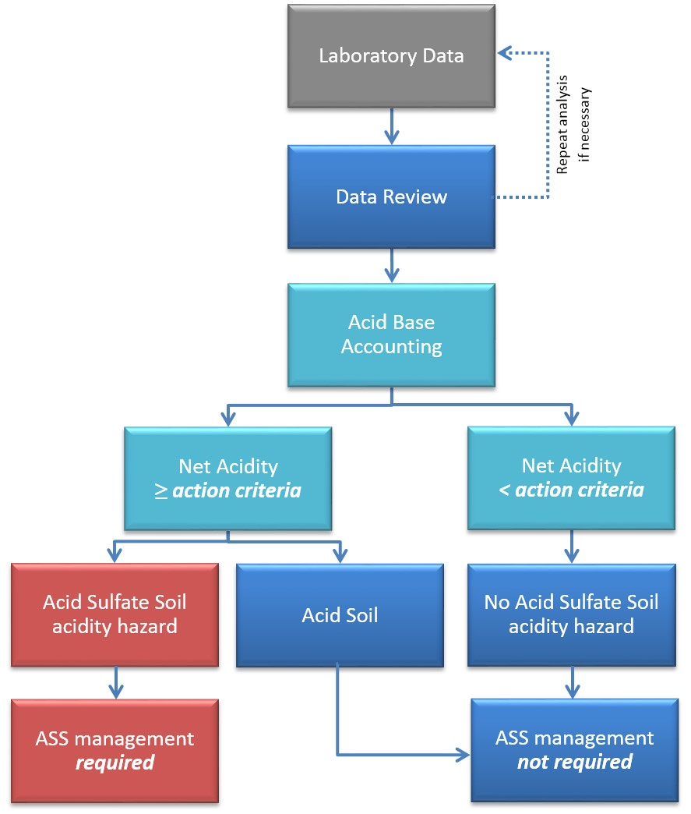

## Data review and presentation

### Review of data quality

The following section on Quality Assurance/Quality Control (QA/QC) has been adapted from (DER 2015).

Acid sulfate soil investigations should include measures to ensure the quality and reproducibility of all field and laboratory analytical results. Where results are produced with inadequate QA/QC procedures, they cannot be accepted as accurate or representative of the site conditions. The QA/QC measures are required regardless of the number of samples collected.

The minimum field QA/QC procedures, which are also discussed in the sampling manual (Sullivan et al. 2018b), include:

* collection of one field duplicate for every 20 investigative samples
* use of standardised field sampling forms, methods and Chains of Custody
* documented calibration of field instruments.

Field duplicates are used to assess small-scale variability at a single sampling point. To measure repeatability, field duplicates must be taken from the same soil sample after mixing. Field duplicates should be submitted to the laboratory as blind samples with no indication to the laboratory that these samples are duplicates.

It is recommended testing be undertaken by National Association of Testing Authorities (NATA) accredited laboratories for the particular parameters and methodologies required. Internal laboratory QA/QC should be completed by laboratories, and if not provided, requested prior to sampling to ensure they meet acceptable standards.

A NATA-endorsed analytical report should include the results of the analyses, sample numbers (or descriptions), laboratory numbers, a statement about the condition of the samples when they were received (for example on ice, cold, ambient, et cetera), date and time of receipt, dates and times of extraction and analysis of samples, QA/QC results, and a report on sampling and extraction holding times.

Data review is a critical part of the assessment process. Laboratory data should initially be compared against field data and observations to identify results inconsistent with field findings. Where inconsistencies are identified, re-sampling or re-analysis may be required.

It is important all required components of the ABA are reported. For example, where a sample has a pHKCl less than 4.5, or jarosite has been identified during field sampling, a result should be recorded for Retained Acidity. Likewise, Retained Acidity is not required for samples with a pHKCl greater than or equal to 4.5 unless the field description reported the samples contained jarosite.

Net Acidity calculations should always be checked for errors. It is not uncommon for analytical reports from laboratories to contain errors (for example transcription errors) and double checking is best practice.

In this guidance, it is important to restate inclusion of ANC in the determination of Net Acidity only occurs where the effectiveness of the ANC has been corroborated (for example slab incubation) or when the effectiveness of a management approach involving the addition of liming materials is being verified post treatment.

The conversions for the units used in the reporting of ASS analyses and calculations (that is liming rates and verification testing) are provided (see Table E1).

### Presentation of results

All data should be reported in a consistent manner to allow easy comparison, interpretation and interrogation of the analytical data. Accordingly, a standard format of presentation provides advantages for laboratories, their clients, consultants and regulators.

An example format for the presentation of laboratory and field data is provided in Figure 8.2.

Figure 8. Example ASS report format.

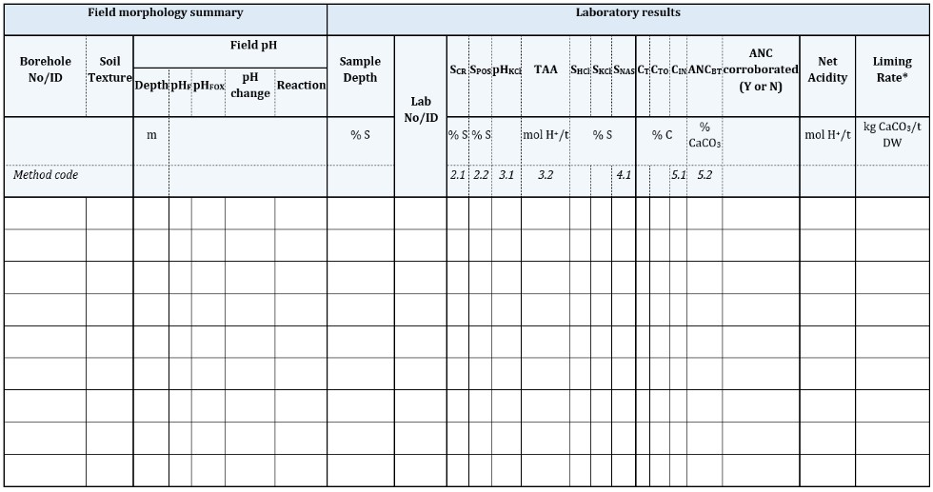

* Liming rate only includes ANC when its effectiveness has been corroborated by simulative oxidation procedures such as incubation.

## Interpretation of laboratory results

### Acidity hazard

The acidity hazard is generally considered to be the main hazard posed by ASS materials and is the hazard for which we have the most assessment and management experience.

If the results of Stage 2 investigation have not already determined whether an ASS management plan is required, then the Net Acidities of all samples should be compared to the appropriate action criterion (see Table 1.1) to determine whether any sample meets or exceed a criterion and hence triggers the need for an ASS management plan (Figure 8.1).

It is important to note again that acidic soils with Net Acidity values greater than or equal to the action criteria need to be assessed to determine whether they are ASS materials that require the development of an ASS management plan, or are naturally occurring acid soils that do not require an ASS management plan.

Where RIS is detected (that is greater than or equal to 0.01% S) but less than the action criterion in the examined profile, and there are no visual indicators of ASS oxidation products, the presence of RIS in the vicinity may indicate the site has been affected by ASS processes. A soluble sulfate: soluble chloride (SO42-:Cl-) ratio greater than 0.5 may also indicate the observed soil acidity is largely a consequence of ASS processes (see Sullivan et al. (2018b) for further details).

A case study explaining how to distinguish between an acid soil and an ASS material when managing these materials is presented in Appendix A (see Case Study 2).

The magnitude of the acidity hazard is determined from Net Acidity values and will assist in determining the available management options. Where liming is determined as the best option, sufficient lime is required to neutralise the Net Acidity. The amount of lime required to treat an ASS material depends on a number of additional factors including the neutralising value (NV) of the liming material, appropriate safety factor, soil bulk density and the amount of soil to be treated.

Once limed, verification testing of the soil may be required to ensure the appropriate amount of lime has been added to neutralise all the acidity identified in the laboratory analysis. In a properly ameliorated soil, the pHKCl will usually be greater than 6.5 and the Verification Net Acidity will be less than zero. In the determination of Verification Net Acidity, the ANC measured in the treated soil is subtracted from that initially measured in the untreated soil.

A case study is presented in Appendix A (see Case Study 3) explaining how to calculated liming requirements and to confirm sufficient lime has been added to satisfactorily address the acidity hazard.

### Other hazards

As previously mentioned information on the assessment and management of the deoxygenation hazard arising from MBOs can be gained from Sullivan et al. (2018a) Overview and management of monosulfidic black ooze (MBO) accumulation in waterways and wetlands.

The assessment and management of the metal and metalloid mobilisation hazard arising from ASS materials is hindered by our relatively limited experience in this area. This guidance document provides tests developed and used for these specific purposes and further guidance will no doubt arise as our practical experience in the application of these methods develops.

### ASS investigation report

The reporting of results is the final stage (Stage 5) of the ASS investigation process (Sullivan et al. 2018b).

The ASS investigation report describes the findings of the desktop assessment and site inspection, soil sampling, field testing and laboratory analysis, and makes recommendations regarding the need for ASS management.

The level of information required varies from site to site, according to variables such as the nature of the proposed development, soil type, groundwater depth, surrounding sensitive receptors and the complexity of the issues.

It is important the ASS investigation report presents sufficient details to provide a good understanding of the nature and characteristics of the site. Regulators and assessors of management plans are generally not able to conduct detailed site visits and investigations of their own, so almost all of their knowledge about a site will be sourced from the reports provided to them by proponents of the development. Supplying inaccurate, insufficient or inappropriate information in the ASS investigation report may lead to delays in gaining development approval or the application of inappropriate management to the site, and the possibility of future liabilities.

The checklist provided in Appendix F (see Table F1) outlines the information which should be considered when reporting on ASS investigations.

## Further information

Further national guidance on acid sulfate soils can be obtained from the following documents:

Shand, P, Applegate, S, Simpson, S & Degens, B 2018, National acid sulfate soils guidance, *Guidance for the dewatering of acid sulfate soils in shallow groundwater environments*, Department of Agriculture and Water Resources, Canberra.

Simpson, SL, Mosley, L, Batley, GE & Shand, P 2018, National acid sulfate soils guidance, *Guidelines for the dredging of acid sulfate soil sediments and associated dredge spoil management*, Department of Agriculture and Water Resources, Canberra.

Sullivan, LA, Ward, NJ, Bush, RT, Toppler, NR & Choppala, G 2018a, National acid sulfate soils guidance, *Overview and management of monosulfidic black ooze (MBO) accumulation in waterways and wetlands*, Department of Agriculture and Water Resources, Canberra.

Sullivan, LA, Ward, NJ, Toppler, NR & Lancaster, G 2018b, *National acid sulfate soils sampling and identification manual*, Department of Agriculture and Water Resources, Canberra.

## Appendix A: Case studies

### Case study 1: Effect of organic matter (SCR vs SPOS)

Organic matter is usually present in ASS materials, ranging from minor amounts in some sands to extremely high levels in peats. The presence of organic sulfur in many ASS materials represents a potential interference to some of the analytical methods. Organic sulfur compounds are generally not considered to pose a significant environmental acidity hazard in contrast to RIS compounds such as pyrite.

It has long been established that concentrated H2O2 can extract organic sulfur. The non-specificity of this reaction in the SPOS method for estimating soil RIS content can lead to overestimation of pyrite concentrations in ASS materials (for example Sullivan et al. 1999). In contrast, the SCR method for the quantification of RIS is not subject to these significant interferences from organic sulfur.

In this case study to illustrate the potential effect of organic matter on the determination of RIS, the RIS fraction was analysed in sandy soils (that is Bassendean Sand, Western Australia) with a range of organic matter contents with both the SCR and SPOS methods.

Figure A1 shows the relationship between the total organic carbon content and the over-estimation of the RIS content by the SPOS method; the values shown represent the mean of duplicate measurements. Figure A1 clearly shows in a strong and close relationship that the interference of the organic matter in these soils has a serious effect on the SPOS estimates of RIS content. Generally, this organic matter caused over estimation of the RIS content by the action criterion (that is 0.03% S) for these soils when the soil organic carbon content was greater than 0.60 % C.

A total organic carbon content of 0.60 % is considered a low soil organic matter content. These results indicate the SPOS method can give false positive identifications of ASS materials, as well as overestimate the acidity hazard of these soil materials. Both of these would result in the likely imposition of over-treatment, and indeed perhaps unnecessary treatment, of these soil materials during development where reliance is placed on SPOS values rather than SCR values.

These results clearly show the importance of using the SCR method to measure the RIS content of soil materials with even relatively low organic matter contents (that is organic carbon contents greater than 0.60 % C) and low levels of sulfide (that is close to the action criteria).

Figure A Effect of organic matter on estimation of Reduced Inorganic Sulfur content by SPOS method.

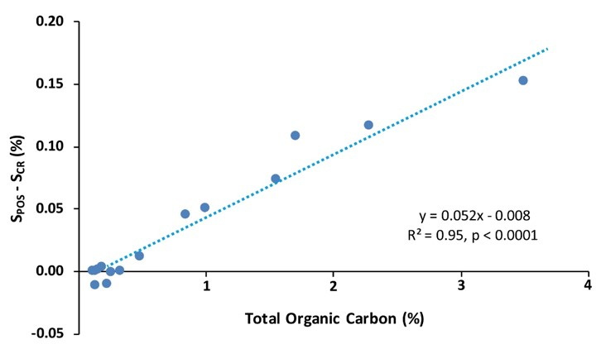

Source: Sullivan et al. 2016.

### Case study 2: ‘Acid’ soil vs ‘acid sulfate’ soil

The role of RIS and sulfur cycling is central to ASS materials. A TAA value above the action criterion does not indicate the presence of an ASS material, as the soluble and exchangeable acidity could be non-sulfidic acidity (for example organic acids). This case study provides an example of how to distinguish between an ‘acid’ soil material and ‘acid sulfate’ soil material.

Soil profiles were collected at 50 m intervals for the construction of a road where more than 1000 t of soil was to be disturbed. The ASS risk map indicated the area had a high probability of containing ASS material within 1 m of the ground surface. The maximum depth of excavation was expected to be 1.5 m below the ground surface, and therefore soil cores were collected to a depth of 2.5 m (that is 1 m beyond the depth of the proposed excavation). As many of the soil samples had high organic matter contents, the Potential Sulfidic Acidity analysis was undertaken using the Chromium Reducible Sulfur (SCR) method.

The ASS results for an example soil profile are shown in Figure A2. The field pH test (pHF) data indicated the presence of acidic soils (pHF less than or equal to 4.95) throughout the profile, and possible Actual ASS materials (that is pHF less than 4) between 0.25 m and 0.75 m. The field peroxide test (pHFOX) data strongly indicated the presence of RIS and potential ASS material (that is a high reaction and pHFOX values less than 3 with all samples), however, the high organic matter contents (CTO greater than or equal to 2.81% C) may have been responsible for these properties.

The laboratory analysis gave Net Acidity values between 52 and 118 mol H+/t. All layers had Net Acidities exceeding the action criterion for disturbance of greater than 1000 t soil material, and therefore would require management if identified as ASS materials.

The samples analysed all had low sulfide contents ranging between less than 0.005 and 0.112% S.

Retained Acidity was not identified by laboratory analysis.

Therefore, for the two soils with a pHF less than 4 to be identified as Actual ASS materials (that is sulfuric soil) it was necessary to show the low pH was caused by sulfide oxidation.

For the soils to be identified as sulfuric materials they need to show evidence of one of the following:

* mottles and coatings with accumulations of jarosite or other iron and aluminium sulfate or hydroxy sulfate minerals such as natrojarosite, schwertmannite, sideronatrite, tamarugite, et cetera
* underlying sulfidic material (Sullivan et al. 2010b).

In this case study the two soils with a pHF less than 4 would be identified as Actual ASS materials as there is underlying sulfidic material (that is 0.112% S); a sulfidic material contains detectable inorganic sulfides (greater than or equal to 0.01% sulfidic S) (Sullivan et al. 2010b).

However, had RIS been absent the soluble sulfate: soluble chloride (SO42-:Cl-) ratios may have provided further indication of whether the acidity in the soil was a likely a consequence of RIS oxidation (see Sullivan et al. (2018b) for further details).

Figure A ASS results for an example soil profile.

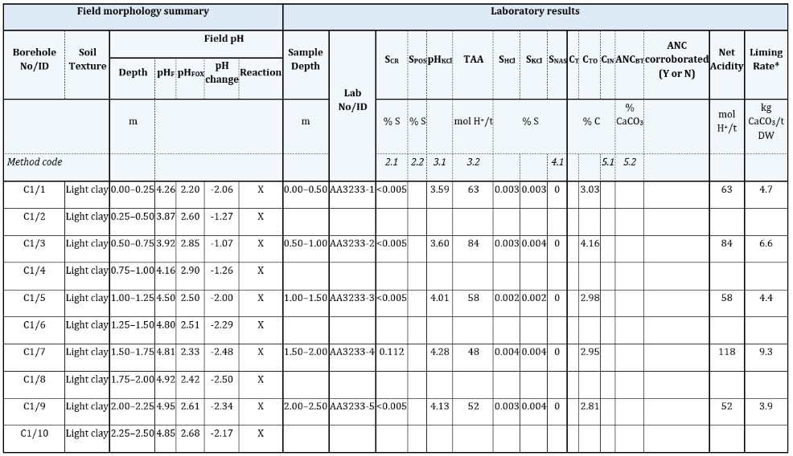

* Liming rate only includes ANC when its effectiveness has been corroborated by simulative oxidation procedures such as incubation.

### Case study 3: ASS material recognition, liming requirement and verification testing

In the third case study we present field and laboratory analytical data to demonstrate how we can use the data to:

1. identify the presence of an ASS material
2. determine the amount of lime required to neutralise all the acidity present, and
3. confirm that sufficient lime has been added to soil to neutralise all the acidity.

The ASS risk map for the area in question indicated there was a high probability of ASS materials between 1 and 3 m below the ground surface. The maximum depth excavation was 2.0 m. The total volume of the excavation was calculated as 2000 m3 (that is 1000 m2 of disturbance to 2 m depth), and the soil was to be used on site following the thorough incorporation of liming materials [in this case aglime (CaCO3)].

Soil sampling, field pH testing and the selection of soils for laboratory analysis were undertaken in accordance with guidelines outlined in the National ASS sampling and identification manual (Sullivan et al. 2018b).

The volume and depth of the excavation required collection of four soil cores (that is less than 1 ha) to a depth of 3.0 m (that is 1 m beyond the depth of the proposed excavation).

Field pH testing was undertaken at every 25 cm depth increment and samples for laboratory analysis were collected every 50 cm. An example soil profile for borehole C1, including the field pH testing results and the samples selected for laboratory analysis, is presented in Figure A2. The laboratory analysis results for this profile are also shown in Figure A4. No jarosite was observed in the sampled soil profiles.

For simplification, in this case study all soils layers have similar Net Acidities and discussion is limited to the results for Core 1. The conversions factors required for the calculations are provided in Appendix E (see Table E1).

#### Recognition of ASS material

While only one of the four cores sampled at this site is discussed here, for a complete interpretation of the site the soil samples from all four cores would need to be analysed and interpreted.

The field pH test (pHF) data shows the presence of acidic soils to a depth of 1.0 m (that is pHF less than or equal to 4.8). The field peroxide test (pHFOX) data indicated a High reaction and pHFOX less than or equal to 3 below a depth of 1.0 m. While the peroxide data provides a strong indication of the presence of RIS below 1.0 m, this must be confirmed by laboratory analysis as other constituents may produce similar behaviour (for example organic matter, manganese oxides).

The laboratory results confirm the presence of sulfidic soils (that is SCR greater than or equal to 0.01% S) below 1.0 m, with concentrations as high as 0.12% S (Figure A4).

The Net Acidities of the soil materials to be excavated (that is 0.0–2.0 m) ranged between 125 and 131 mol H+/t. This site would require an ASS management plan as at least one of the soil materials exceeded the appropriate action criterion of 18 mol H+/t [where it is likely greater than 1000 t of material will be disturbed (see Table 1.1)].

Figure A Soil profile for Core 1 (C1).

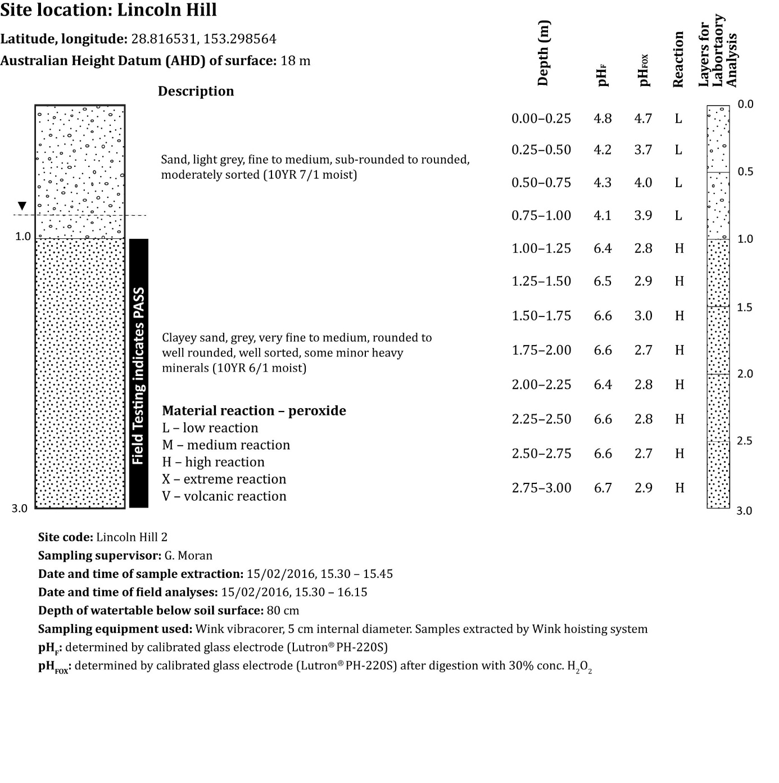

Figure A ASS material assessment results for proposed infrastructure site (Core 1).

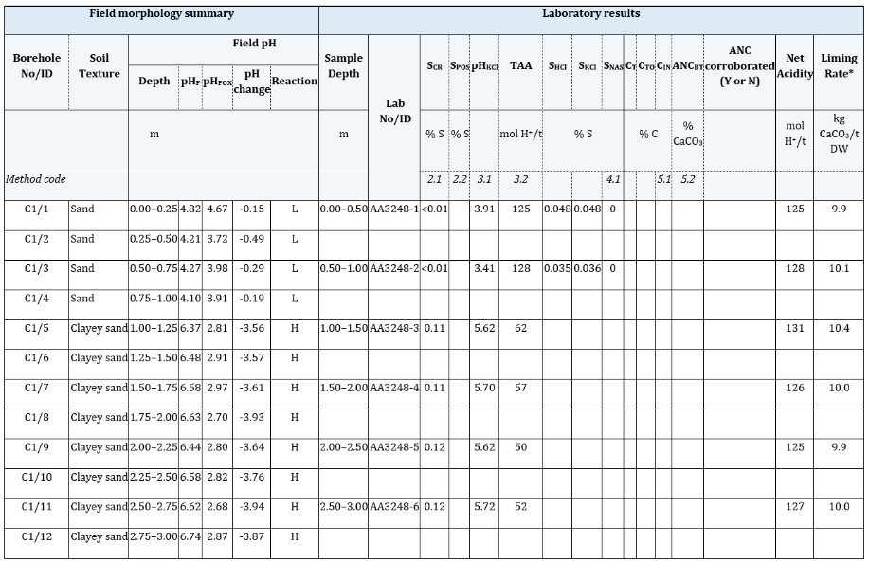

* Liming rate only includes ANC when its effectiveness has been corroborated by simulative oxidation procedures such as incubation.

#### Calculation of lime requirement

The liming rate for the laboratory analysed layers are presented in Figure A4. The rates shown assume a safety factor of 1.5, neutralising value (NV) of 100% and are the rates required to neutralise a dry soil material. For this case study, a super-fine grade agricultural lime with a neutralising value of 95 was used. The bulk density of the soil material was assumed to be 1.3 g/cm3.

The volume of soil disturbed was 2000 m3. Addition of lime to the excavated soil was chosen approach for the management of the Net Acidity. The soil material to be excavated had a mean Net Acidity of 123 mol H+/t with a standard deviation of 8 mol H+/t. For convenience of management, given the volume of soil to be disturbed and the relative uniformity of Net Acidity values down the core, different soil layers were not managed separately for this case study. Under these conditions the maximum observed Net Acidity value, not the mean value, was taken to provide the quantitative acidity hazard requiring to be treatment.

As per DER (2015) guidelines, for linear disturbances and non-linear disturbances less than 1000 m3, the highest Net Acidity detected at the site should be used to calculate the amount of neutralising material needed.

When the volume of soil to be disturbed is more than 1000 m3, the mean Net Acidity plus the standard deviation, in this example 123 mol H+/t, may be used to calculate the amount of neutralising material needed, provided a sufficient number of laboratory analyses have been performed to satisfactorily characterise the soil profile and ASS materials at the site.

The steps required to calculate the lime requirement for this ASS material are outlined as follows.

Step 1: Initially work out the weight of pure CaCO3 needed to neutralise the Net Acidity of 131 mol H+/t. To convert from mol H+/t to kg CaCO3/t divide by 19.98 (see Table E1):

$$131 mol H^{+}/t÷19.98=6.6 kg Ca{CO}_{3}/t$$

Step 2: The neutralising value of the aglime needs to be taken into account and a suitable safety factor determined. The neutralising value of the aglime was 95, to convert from kg CaCO3/t to kg aglime/t multiply the weight of pure CaCO3 by (100/95).

$$6.6 kg Ca{CO}_{3}/t×(100/95)=6.9 kg aglime/t$$

The aglime is super-fine grade, so the minimum safety factor of 1.5 was applicable.

$$Aglime rate×safety factor=6.9 kg aglime/t×1.5=10.4 kg aglime/t$$

Step 3: The previously mentioned value is the required rate for the dry soil. The next step is to calculate the rate for wet soil assuming a bulk density of 1.3 g/cm3 (equivalent to 1.3 t/m3).

So for 2000 m3, 2000 × 13.5 = 27 000 kg (that is 27 t) of aglime would need to be applied and evenly mixed into these excavated soil materials.

#### Verification testing

Verification testing can be used to determine if sufficient neutralising material has been applied to prevent any further acidification.

This testing can prove that ASS materials were treated as stated in the management plan.

In a properly ameliorated soil, the pHKCl will usually be greater than 6.5 and the Net Acidity will be less than zero.

In this study six samples were required from throughout the stockpile for laboratory analysis (Sullivan et al. 2018b).

The verification testing results for the limed soil materials in the previous example, after liming and 12 months of stockpiling, are as follows:

* the pHKCl of the six soils ranged between 8.48 and 8.61
* the mean SCR of the six soils was 0.05% S
* the mean ANC of the six stockpiled soils was 0.00 mol H+/t prior to liming and 195.8 mol H+/t at the time of sampling 12 months after the addition of lime and stockpiling.

An Acid Base Account approach can be used to determine whether sufficient lime has been added to neutralise the acidity (Equation 3.3). The steps required to determine whether sufficient lime has been added to one of these stockpiled soil materials is outlined as follows.

As the pHKCl was approximately 8.5 and jarosite was not observed in the initial investigation: the determination of Actual and Retained Acidity was not required:

$$Verification Net Acidity = Potential Sulfidic Acidity – (post treatment Acid Neutralising Capacity – initial Acid Neutralising Capacity)$$

$$Potential Sulfidic Acidity (as mol H^{+}/t): S_{CR}=S_{CR}×623.7=0.05×623.7=31.2 mol H^{+}/t$$

There was no ANC in the original samples (that is pHKCl less than 6.5), and therefore, the initial ANC was zero.

$$Post treatment ANC (as mol H^{+}/t) after liming and stockpiling={ANC}_{BT}×199.8=0.98×199.8=195.8 mol H^{+}/t$$

$$Verification Net Acidity =Potential Sulfidic Acidity–post treatment Acid Neutralising Capacity$$

$$= {SC}_{R}–{ANC}_{BT}=31.2 –195.8=-164.6 mol H^{+}/t$$

This negative Verification Net Acidity result indicates sufficient lime was added to this soil and it has passed verification testing.

## Appendix B: Recent developments in laboratory method guidelines

Many of the methods in this manual are based on the Queensland Acid Sulfate Soils Investigation Team (QASSIT) Acid sulfate soils laboratory methods guidelines (Ahern et al. 2004). A summary of the methods no longer included, and those added to this manual are presented in Table B1.

Table B Summary of laboratory method changes from the QASSIT Laboratory Methods Guidelines.

|  |  |  |  |
| --- | --- | --- | --- |
| Methods removed | | Methods added | |
| Method | Method code | Method | Method code* |
| Excess acid neutralizing capacity (ANCE) | 23Q | ‘As received’ Moisture Content dried at 105 °C | 2B1 |
| Acid extractable sulfur in soil residue after peroxide oxidation (SRAS) | 23R | ‘As received’ Moisture Content dried at 85 °C | 2B2 |
| Total sulfur (ST) | 20A | Steel Core Ring Bulk Density | - |
| Total oxidisable sulfur (STOS) | 20C | Syringe Bulk Density | - |
| Potassium chloride extractable calcium (CaKCl) and magnesium (MgKCl) | 23V, 23S | Acid Volatile Sulfide, diffusion (SAV) | 22A |
| Peroxide calcium (CaP) and magnesium (MgP) | 23W, 23T | Acid Volatile Sulfide, rapid (SRAV) | - |
| Hydrochloric acid extractable calcium (CaHCl) and magnesium (MgHCl) | 20E, 20F | Sequential Metals and Metalloid Extraction | - |
| Peroxide reacted calcium (CaA) and reacted magnesium (MgA) | 23X, 23T | Elutriate Testing | - |
| Calculation of net acid-soluble calcium (CaNAS) and magnesium (MgNAS) | 19F1, 19G1 | Slab Incubation | - |
| Titratable sulfidic acidity (TSA) | 23H | Chip-tray Incubation | - |

*Procedures for these methods were not outlined in the QASSIT Acid sulfate soils laboratory methods guidelines.

## Appendix C: Laboratory incubation

### Introduction

The incubation of moist soil has commonly been used to simulate the natural oxidation behaviour of ASS materials, to identify the presence of potential ASS, and in the calculation of lime requirements (Dent 1986; Willett et al. 1992; Ward et al. 2002; Ward et al. 2004; Creeper et al. 2012; Isbell & NCST 2016). The moist incubation of soil simulates oxidation under natural conditions, although the leaching of oxidation products is prevented (Dent 1986). The incubation method is a semi-quantitative technique for assessing the acidification potential of ASS materials (Creeper et al. 2012).

The approach used in this method, whereby soil material is exposed to ambient conditions to simulate natural acidification behaviour (for example field weather conditions, air drying or storing in a moist state within laboratories), has been used since the beginning of scientific study into these materials (for example Doyne 1937; Teakle & Southern 1937). This method is considered to be direct (allowing the soil to ‘speak for itself’ (Dent 1986) with respect to whether or not the soil material will acidify upon oxidation), qualitative, inexpensive, but also one that is protracted requiring 2 to 3 months to give a determination (Andriesse 1993).

In this method incubating soil materials are maintained at room temperature and at field capacity by rewetting as required. Critical pH targets and the required duration of the incubation period necessary to identify a soil material as being sulfidic, have been discussed widely (Andriesse 1993). Some researchers have favoured a critical pH target after incubation as 3.5 (van Breemen 1982), others a pH of 4.0 (Dent 1980; Thomas & Varley 1982), and yet others a pH of 3.7 (Sutrisno et al. 1990). The recommended duration of incubation similarly ranged from a few weeks to over a year, depending on the volume of soil incubated (Andriesse 1993).

In the latest soil classifications using the incubation method for the recognition of sulfidic materials both the critical pH target and the duration of incubation have been defined (for example Soil Survey Staff 2014; Isbell & NCST 2016). For example, the Australian Soil Classification (Isbell & NCST 2016) following the approach of Sullivan et al. (2009) states a Hypersulfidic material has: a field pH of 4 or more and is identified by experiencing a substantial drop in pH to 4 or less (1:1 by weight in water, or in a minimum of water to permit measurement) when a 2–10 mm thick layer is incubated aerobically at field capacity. The duration of the incubation is either: a) until the soil pH changes by at least 0.5 pH unit to below 4, or b) until a stable pH is reached after at least 8 weeks of incubation. A stable pH occurs when either the decrease in pH is less than 0.1 pH unit over at least a 14 day period, or the pH begins to increase.

The incubation to a stable pH has been shown to greatly improve the accuracy of the incubation method, and is currently considered best practice (Creeper et al. 2012). However, the continual monitoring of the moisture content and repeated pH measurements until a stable pH is reached has the potential to become both time-consuming and labour intensive (Creeper et al. 2012). In addition, the scope of a study may not permit incubation until a stable pH is reached due to logistical or time constraints (Creeper et al. 2012). For these reasons a simplified incubation method using chip-trays has also recently been developed to identify the presence of sulfidic soils (Fitzpatrick et al. 2010; MDBA 2010; Creeper et al. 2012). This Chip-tray Incubation method has been used widely in the assessment of ASS materials in the Murray-Darling Basin (for example MDBA 2010, 2011).

The two commonly used incubation methods (that is Slab Incubation and Chip-tray Incubation) for identification of sulfidic soils are outlined as follows.

### Slab Incubation – NLM-8.1

The incubation method for 2 mm slabs outlined further on is based on the procedure outlined in Sullivan et al. (2009). The field pH test (pHF; NSM-1.1) must be carried out on each representative soil sample prior to incubation (see Sullivan et al. (2018b) for further details).

#### Reagents

Not applicable.

#### Apparatus

Fine gauze mesh (for example 2.0×1.5 mm); 2 mm high spacers; roller; plastic mesh (for example 10×10 mm); water sprayer; calibrated pH meter.

#### Procedure

* Thoroughly mix at least 0.2 kg of field-moist soil in a plastic bag prior to preparation for incubation.
* To prepare 2 mm slabs, smear the soil material onto a fine gauze mesh (for example 2.0×1.5 mm) strip between 2 mm high spacers. Then spread the soil material with the roller on top of the spacers to ensure a consistent slab thickness. To prevent excessive desiccation during incubation, place a 5 mm thick sponge, wetted (but unsaturated) with deionised water, on the surface of the slab.
* Place the gauze mesh supporting each sample onto suspended coarse plastic mesh (for example 10×10 mm) to allow maximum atmospheric access to both sides of the slab. If incubating sandy materials, place cling film under the fine gauze mesh to prevent loss of soil.
* Incubate the soils in a dark humid environment at a constant temperature (20 °C), and maintain field-moist condition by wetting the slabs with finely sprayed deionised water every few days as required.
* Regularly measure the pH of a subsample of soil (that is at least fortnightly) using a calibrated pH meter. The soil subsample must be initially homogenised prior to measuring the pH by mixing with a glass rod whilst the minimum amount of deionised water is added (soil-to-solution ratio of less than 1:1).
* Incubate the soil materials until the soil pH changes by at least 0.5 pH unit to below 4, or until a stable pH (pHINC) is reached after at least 8 weeks of incubation. A stable pH is assumed to have been reached after at least 8 weeks of incubation when either the decrease in pH is less than 0.1 pH unit over at least a 14 day period, or the pH begins to increase.
* If the pH measured at any point during the incubation is less than 6.5, ANC cannot be included in the determination of Net Acidity.

### Chip-tray Incubation – NLM-8.2

The incubation method outlined further on is based on the procedure outlined in Creeper et al. (2012). Soil samples should be prepared for incubation in the field when using this incubation method. The field pH test (pHF; NSM-1.1) must be carried out on each representative soil sample prior to incubation (see Sullivan et al. (2018b) for further details). Only soil samples with a pHF greater than or equal to 4 need to undergo the Chip-tray Incubation method.

#### Reagents

Not applicable.

#### Apparatus

The apparatus is shown in Figure C1. The polypropylene chip-trays have dimensions of 51×3.5×5 cm (L×H×W); each chip-tray is divided into 20 individual compartments (internal dimensions of approximately 2.5×3×5 cm). Additional apparatus includes a calibrated pH meter; deionised water wash bottle; glass stirring rod.

Figure C Illustration of an empty chip-tray and photograph of chip-trays filled with soil samples.

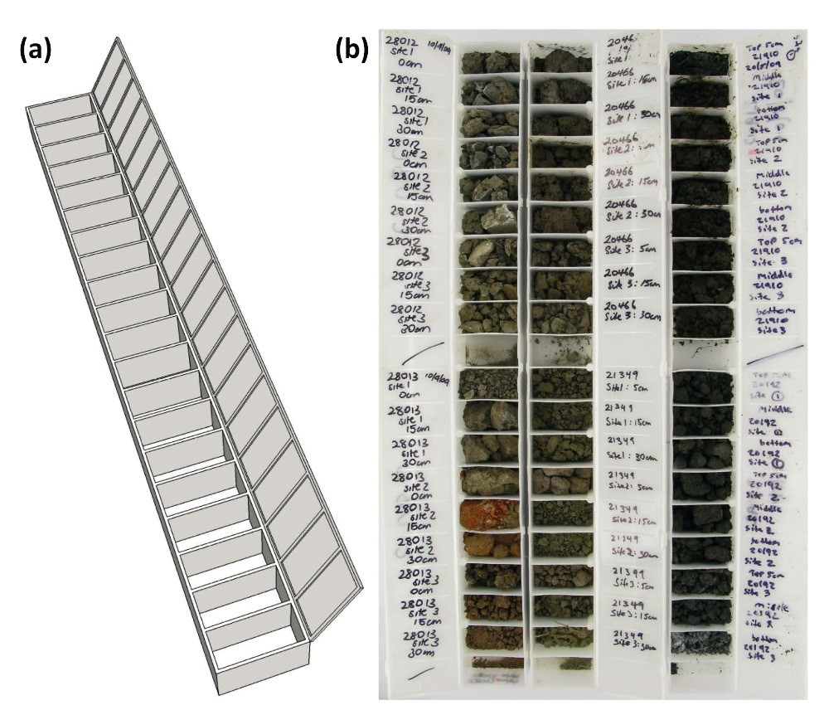

Note: (a) empty chip-tray and (b) filled chip-tray.

Source: Creeper et al. 2012.

#### Procedure

A flow chart summarising the main steps involved with the Chip-tray Incubation method is presented in Figure C2.

* In the field, homogenise at least 0.5 kg of the incubation soil in a plastic bag and then remove approximately 20 g of a representative soil material.
* Place the representative soil sample into a labelled chip-tray compartment, so the compartment is approximately a third full; this will form a soil layer approximately 10 mm thick. Dry soil samples should be moistened (not saturated) with deionised water.
* Once all soil samples have been placed into the chip-trays, the trays should be wrapped in cling film prior to transportation to the laboratory to prevent drying and spillage.
* In the laboratory, the soil water content must be assessed; a soil water content of near field capacity is optimal for incubation. An initially dry sample must be moistened to near field capacity before incubation, and any excess water should be removed from a saturated sample prior to incubation. Excess water can be effectively removed via evaporation by leaving the chip-tray lid open overnight at room temperature. Once the soil water contents have been adjusted to optimal levels, the soil samples are stored and allowed to incubate aerobically.
* During incubation, the water status of the soil samples should be monitored once to twice per month, and adjusted when required. If soil sample is dry or saturated commence/re-establish or continue incubation (see Figure C2).
* After at least 9 weeks of incubation measure the soil pH (pHINC) using a calibrated pH meter. The soil sample must be initially homogenised by mixing with a glass rod whilst the minimum amount of deionised water is added (soil-to-solution ratio of less than 1:1).
* If pHINC is less than 4, the sample is classified as sulfidic. If pHINC is greater than 6.5, the sample is classified as non ASS. If pHINC is greater than or equal to 4 and less than or equal to 6.5, the sample is incubated for at least a further 10 week period (that is a total incubation period of greater than or equal to 19 weeks) before classification (see Figure C2). Before incubation is continued excess water from pH measurement must be removed by overnight evaporation at room temperature.
* After a total incubation period of greater than or equal to 19 weeks, re-measured the pH. If pHINC is less than 4, the sample is classified as sulfidic. If pHINC is greater than or equal to 4, the sample is classified as non ASS materials.
* If the pH measured at any point during the chip-tray incubation is less than 6.5, ANC cannot be included in the determination of Net Acidity.

Figure C Flow chart of the Chip-tray Incubation method.

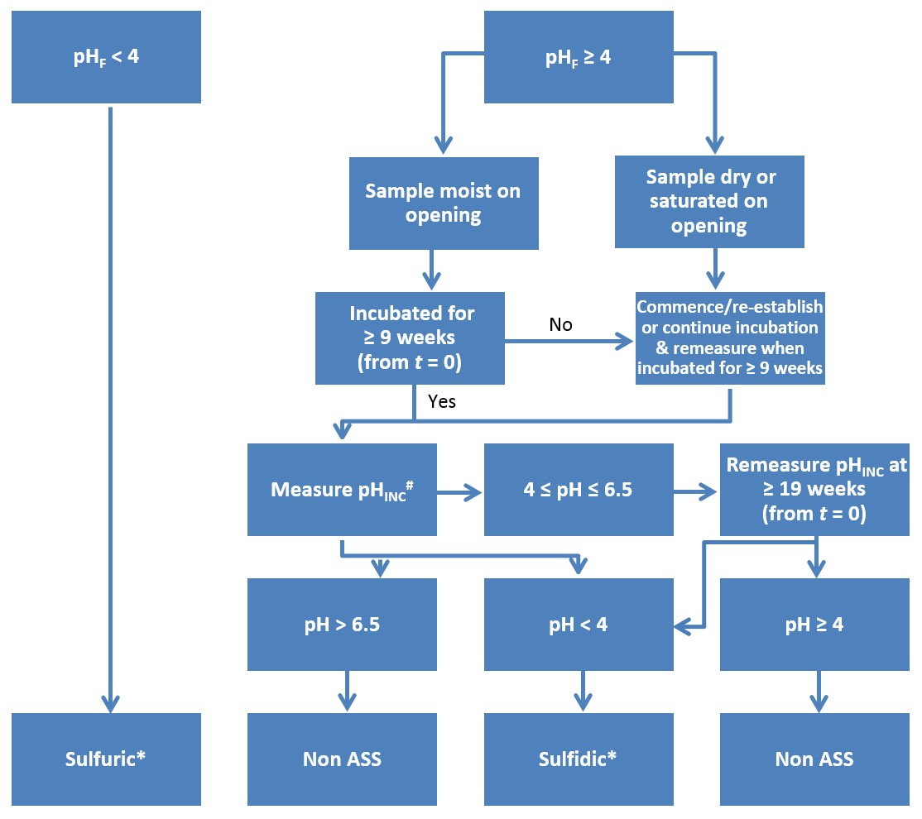

# If pH during incubation is less than 6.5, ANC cannot be included in Net Acidity determination.

* (Isbell 1996) - the low pH must be demonstrated to be due to ASS processes for the soil material to be classified as an ASS material.

Source: Creeper et al. 2012.

## Appendix D: Laboratory method codes and standards

A list of the National Laboratory Method (NLM) codes and corresponding QASSIT Acid Sulfate Soil Laboratory Methods Guidelines (Ahern et al. 2004) method codes and Australian Standards are presented in Table D1.

Table D Summary of National Laboratory Method codes, QASSIT Laboratory Methods Guidelines method codes and Australian Standards.

|  |  |  |  |
| --- | --- | --- | --- |
| National Laboratory Method code | QASSIT Method code | Australian Standard® | Summary of method |
| NLM-1.1 | 2B1 | - | ‘As received’ Moisture Content dried at 105 °C |
| NLM-1.2 | 2B2 | - | ‘As received’ Moisture Content dried at 85 °C |
| NLM-1.3 | - | - | Steel Core Ring Bulk density |
| NLM-1.4 | - | - | Syringe Bulk Density |
| NLM-2.1 | 22B | 4969.7 | Chromium Reducible Sulfur (SCR) |
| NLM-2.2 | 23A, 23B, 23D, 23E, 23G | 4969.2, 4969.3, 4969.5, 4969.10 | Peroxide Oxidisable Sulfur (SPOS) |
| NLM-3.1 | 23A | 4969.2 | KCl Extractable pH (pHKCl) |
| NLM-3.2 | 23F | 4969.2 | Titratable Actual Acidity (TAA) |
| NLM-4.1 | 20B, 20J, 23C | 4969.4, 4969.8, 4969.11 | Net Acid Soluble Sulfur (SNAS) |
| NLM-5.1 | 6B4, 6B5, 19C1 | - | Total Inorganic Carbon (CIN) |
| NLM-5.2 | 19A2 | 4969.13 | Acid Neutralising Capacity back-titration (ANCBT) |
| NLM-6.1 | 22A | - | Acid Volatile Sulfide, diffusion (SAV) |
| NLM-6.2 | - | - | Acid Volatile Sulfide, rapid (SRAV) |
| NLM-7.1 | - | - | Sequential Metals and Metalloid Extraction |
| NLM-7.2 |  |  | Elutriate Testing |
| NLM-8.1 | - | - | Slab Incubation |
| NLM-8.2 | - | - | Chip-tray Incubation |

The Acid Base Accounting procedures for the analysis of ASS materials have also been formalised into International Standard 14388 (ISO 14388). The three current international standards are given in Table D2.

Table D Summary of ISO 14388: Acid Base Accounting procedure for ASS materials.

|  |  |
| --- | --- |
| ISO | Summary of International Standard |
| 14388-1 | Part 1: Introduction and definitions, symbols and acronyms, sampling and sample preparation |
| 14388-2 | Part 2: Chromium Reducible Sulfur (CRS) methodology |
| 14388-3 | Part 3: Suspension Peroxide Oxidation Combined Acidity and Sulfur (SPOCAS) methodology |

Note there are some minor differences between the National Laboratory Methods outlined in this manual, and the Australian and International Standards. Further details of Australian Standard® 4969 are available on the [Standards Australia website](http://www.standards.org.au).

## Appendix E: Conversion of units

Conversion factors are provided in Table E1. These are used to change the units of measurement for ASS analytical results to calculate Net Acidity, liming rates and to confirm liming rates following verification testing.

Table E Conversions of units used in the reporting of ASS analyses and calculations.

|  |  |  |
| --- | --- | --- |
| Initial units | Units required | Conversion factor |
| SCR, SPOS (% S) | mol H+/t | × 623.7 |
| SNAS (% S) | mol H+/t | × 467.8 |
| CIN (% C) | mol H+/t | × 1665 |
| ANCBT (% CaCO3) | mol H+/t | × 199.8 |
| mol H+/t | % S | ÷ 623.7 |
| CIN (% C) | % S | × 2.67 |
| ANCBT (% CaCO3) | % S | ÷ 3.121 |
| mol H+/t | kg CaCO3/t | ÷ 19.98 |
| kg CaCO3/t | mol H+/t | × 19.98 |
| % CaCO3 | kg CaCO3/t | × 10 |

### Converting % S to mol H+/t

In this section an example is provided to explain the calculations required to convert % S in sulfidic materials to mol H+/t. An explanation of the calculation required for soils containing Retained Acidity is also provided.

A soil has a SCR value of 1.23% S, which in other words is 1.23 g sulfur (as pyrite) per 100 g of oven-dry soil.

The calculation of acidity from the oxidation of ASS material is based on the stoichiometry of the pyrite oxidation reaction.

Equation E oxidation of pyrite (FeS2) in the presence of water resulting in the precipitation of ferric hydroxide (Fe(OH)3) and the liberation of acidity (H+) and dissolved sulfate (SO42-).

$$FeS_{2}+{3.750}_{2}+3.5H_{2}O→Fe{(OH)}_{3}+4H^{+}+2{{SO}_{4}}^{2-}$$

$$1 mole pyrite \left(FeS_{2}\right)→4 moles acid (H^{+})$$

$$1 mole sulfur \left(S\right)→2moles acid (H^{+})$$

The first step is to convert grams of sulfur to moles of sulfur. The molar mass of sulfur (that is the weight of 1 mole of sulfur) is 32.066 g/mol.

$$1.23\% S (or g S/100 g soil)÷32.066=3.836×{10}^{-2} mol S/100 g soil$$

­ To convert from moles S to moles H+. From Equation E1, for every mole of pyrite S oxidised, 2 moles of H+ is produced.

$$3.836×{10}^{-2} mol S/100 g soil×2=7.672×{10}^{-2} mol H^{+}/100 g soil$$

All that remains is to convert from per 100 g to per tonne. There are 1000 kg, or 1 000 000 g in a tonne, so multiply the previous result by 1 000 000/100 (that is multiply by 10 000).

$$7.672×{10}^{-2} mol H^{+}/100 g soil×10 000=767 mol H^{+}/t$$

Hence, to convert from % S to mol H+/t: % S ÷ 32.066 x 2 x 10 000, or multiply % S by 623.7.

Conversely, to convert from mol H+/t to % S, divide by 623.7.

For soils containing Retained Acidity or Net Acid Soluble Sulfur (SNAS) acidity, less acidity is produced. It is assumed 1 mol of sulfur produces 1.5 mol of acidity; as is the case for jarosite (Equation E2) or natrojarosite.

Equation E hydrolysis of jarosite (KFe3(SO4)2(OH)6) resulting in the precipitation of ferric hydroxide (Fe(OH)3) and the liberation of dissolved sulfate (SO42-), acidity (H+) and potassium (K+)

$$K{Fe}_{3}{\left({SO}_{4}\right)}_{2}{(OH)}_{6}+3H_{2}O→3Fe{(OH)}_{3}+2{{SO}_{4}}^{2-}+3H^{+}+K^{+}$$

Therefore, to convert soils containing Retained Acidity from % S to mol H+/t it is necessary to multiply % S by 467.8 (that is 623.7 × 0.75).

## Appendix F: ASS investigation reporting checklist

Table F ASS investigation reporting.

| Report sections | Information to be included, where relevant | Comments |
| --- | --- | --- |
| 1 - Executive summary | Background  Objectives of the investigation  Scope of work  Summary of analytical results (where applicable)  Summary of conclusions and recommendations | Mandatory information |
| 2 - Scope of work | Clear statement of the scope of work | Mandatory information |
| 3 - Site identification | Street number, lot number, street name and suburb  Common title/name of site (for example Sparkling Waters Residential Estate)  Certificate of title (copy of document including survey plan)  Coordinates of site boundaries (Northings/Eastings—specify datum set)  Locality map  Current site plan showing any existing infrastructure, scale bar, north arrow, local environmentally significant features, ‘stages’ of development  Local government authority | Mandatory information |
| 4 - Details of development | Full description of proposed development  Full description of proposed ground disturbing activities (including soil and water disturbance, anticipated time-lines)  Details of proponent and Project Manager  Details of planning conditions including full and clear identification of section of the development project for which clearance of conditions is sought—that is site plans clearly showing cadastral boundaries, ‘stage’ boundaries, spatial co-ordinates, gazetted roads, et cetera, (where applicable)  List of all other names under which the development has been known or referred to as (where applicable) | Mandatory information |
| 5 - Site history | Land owner—past and present  Zoning—previous, present and proposed  Land use—previous, present and proposed, focusing on history of ground disturbance on site or in vicinity of site (for example disposal of dredge spoil, mineral sand or peat mining, previous dewatering, drainage or deep excavation)  Local usage of ground/surface waters, and location of groundwater bores  Integrity assessment (assessment of the accuracy of information) | Mandatory information |
| 6 - Site conditions and surrounding environment | Topography  Drainage/hydrology  Soil, water, vegetation and infrastructure characteristic indicators of AASS and/or PASS  Flood potential  Preferential pathways for contaminants, for example drains  Residents in close proximity to site  Details of any relevant local sensitive environment, for example water courses, wetlands, local habitat areas  Photographs of site and surrounds  Photographs of characteristic indicators of AASS and/or PASS (where applicable) | Mandatory information |
| 7 - Geology and hydrogeology | DER ASS risk mapping  Published geological mapping  Soil stratigraphy using recognised geological classification method  Location and extent of imported and locally derived fill  Site borehole logs or test pit logs showing stratigraphy  Detailed description of the location, design and construction of on-site groundwater bores  Description and location of springs and wells within a 1 km radius of the site  Known or expected depth to groundwater table  Presence of multi-layered aquifer (investigations may result in cross- contamination of aquifers if there is no detailed knowledge of site conditions and contaminants)  Direction and rate of groundwater flow  Permeability of strata on the site  Direction of surface water runoff  Groundwater discharge location  Groundwater quality  Groundwater/surface water interaction  Groundwater conditions (for example unconfined, confined, ephemeral or perched)  Beneficial use of groundwater in the vicinity such as public drinking water supply and source areas, domestic irrigation, aquatic ecosystems, and the potential impacts on these uses  Location and use of groundwater bores within a 1 km radius of the site  Location of sensitive receptors/users  Preferential migratory pathways | Mandatory information |
| 8 - Sampling and analysis plan and sampling methodology | The exact location of each borehole shown on an appropriately scaled map  Justification for the density of the sampling program  Justification for the locations of sampling points  Justification for the selection of samples for laboratory analysis  A brief description of the equipment and/or methods used to retrieve the samples  Calibration certificates or calibration results  For further guidance refer to the DER contaminated sites guidelines | Mandatory information, where sampling was undertaken |
| 9 - Field quality assurance quality control (QA/QC) | Decontamination procedures carried out between sampling events  Logs for each sample collected including time, location, initials of sampler, duplicate type, chemical analyses to be performed, site observations  Chain of custody identifying (for each sample), the sampler, nature of the sample, collection date and time, analyses to be performed, sample preservation method, departure time from the site  Statement of duplicate frequency  Field blank results  Rinsate sample results  Field instrument calibrations | Mandatory information, where sampling was undertaken |
| 10 - Laboratory quality assurance quality control (QA/QC) | A copy of signed chain-of-custody forms acknowledging receipt date and time, identity of samples included in shipments, description of condition of samples received (cold, on ice, frozen, et cetera)  Record of holding times and a comparison with methods specification  Analytical methods used  Laboratory accreditation for analytical methods used  Sample splitting techniques  Description of surrogates and spikes used  Percent recoveries of spikes and surrogates  Instrument and method detection limits  Matrix or practical quantification limits  Laboratory duplicate and blanks results | Mandatory information, where sampling was undertaken |
| 11 - QA/QC data evaluation | Evaluation of all QA/QC information listed in section 10 against the stated data quality objectives (DQO), including discussion of: documentation completeness, data completeness, data comparability, data representativeness, precision and accuracy of both sampling and analysis for each analyte in each environmental matrix informing data users of the reliability, unreliability or qualitative value of the data  Data comparability checks, which should include collection and analysis of samples by different personnel, use of different methodologies, collection and analysis by the same personnel using the same methods but at different times, spatial and temporal changes (because of the environmental dynamics) | Mandatory information, where sampling was undertaken |
| 12 - Basis for adoption of assessment criteria | Table listing all selected assessment criteria and references  Rationale for and appropriateness of the selection of criteria  Assumptions and limitations of criteria | Mandatory information, where sampling was undertaken |
| 13 - Results | Summary of all soil results in a table with observations and data, including:  the full grid reference of each borehole using Australian Metric Grid  an exact description of the vertical dimensions of the borehole relative to existing surface height in both metres below ground level (m BGL) and metres above AHD  soil texture, grain size, roundness, sorting and sphericity using the Australian Soil and Land Survey Field Handbook (NCST 2009) as a guide  colour using a Munsell colour chart  mottling, organic matter, moisture content, watertable level and other diagnostic features (for example jarosite, shell)  results from field soil pHF and pHFOX tests, including the pH of water and peroxide used (where conducted)  tabulated summary of results of laboratory analyses in mol H+/t  all results exceeding the adopted assessment criteria highlighted  Summary of all water quality results in a table that shows essential details such as sampling locations and depths, assessment criteria, highlights all results exceeding the adopted assessment criteria (where water quality testing has been undertaken)  Calibration certificates or calibration results  Cross-sections of the soil profile beneath the study area  Copies of original laboratory result certificates including NATA accreditation details  Discussion of any discrepancy between field observations and laboratory analyses results  Site plan showing all sample locations, sample identification numbers and sampling depths  Discussion and interpretation of results to create detailed 3-dimensional maps and cross-sections of ASS occurrence/absence at the site, including soil type and net acidity by depth  Site plan showing extent of groundwater acidity and/or metal contamination beneath site (where applicable)  Photographs of the soil profile, identifying each stratum | Mandatory information, where sampling was undertaken |
| 14 - Risk assessment | Receptor identification  Assessment of receiving environment’s sensitivity  Exposure assessment  Discussion of the potential risk of harm to human health and/or the environment associated with disturbance of the site  Discussion of assumptions  Risk management decisions based on outcome of the assessment | Mandatory information, where disturbance of ASS is proposed |
| 15 - Conclusions and recommendations | Brief summary of all findings  Assumptions used in reaching the conclusions  Extent of uncertainties in the results  A clear statement that the consultant considers the subject site to be suitable for the proposed development (where applicable)  Recommendations of further sampling and/or the need for an ASS Management Plan for the proposed development (where applicable)  A statement detailing all limitations, constraints and cautions on the development of the site (where applicable) | Mandatory information |
| 16 - HSEP | Confirm that a Health, Safety & Environmental Plan (HSEP) has been prepared and adhered to | A copy of the HSEP is not required by DER |

Source: Adapted from DER 2015.

## Glossary

| Term | Definition |
| --- | --- |
| Acid Base Accounting (ABA) | The procedure by which acid-producing components of the soil are compared with the acid neutralising components so that the soil’s Net Acidity can be calculated. |
| Acid Volatile Sulfide | Sulfur released as H2S from RIS by reaction with strong acids. |
| Action criteria | The measured level of potential plus existing acidity beyond which management action is required if an ASS material is to be disturbed. The trigger levels vary for texture categories and the amount of disturbance. The action criteria only apply to ASS materials and do not apply for acidic materials such as naturally occurring, non ASS soils, for example many organic soils (for example peats) and heavily leached soils. |
| Actual Acidity | The soluble and exchangeable acidity already present in the soil, often as a consequence of previous oxidation of RIS. It is this acidity that will be most mobilised and discharged following a rainfall event. It is measured in the laboratory using the Titratable Actual Acidity method. It does not aim to include the less soluble acidity (that is Retained Acidity) held in hydroxy-sulfate minerals such as jarosite. |
| Actual ASS (AASS) | Soils containing highly acidic soil horizons resulting from the oxidation of soil materials are rich in RIS primarily pyrite. When this oxidation of RIS produces acidity in excess of the soil material’s capacity to neutralise this acidity, the soil material will often acidify to a pH 4 or less, forming an Actual ASS. The recognition of Actual ASS materials can be confirmed by the presence of jarosite in these materials, or the location of other Actual ASS or PASS materials within or in the nearby vicinity to the sampling location. |
| Acid Neutralising Capacity (ANC) | A measure of a soil’s inherent ability to buffer acidity and resist the lowering of the soil pH. |
| ANCBT | Acid Neutralising Capacity by back-titration. Acid Neutralising Capacity measured by acid digest followed by back-titration of the acid that has not been consumed. |
| Australian Height Datum (AHD) | The datum used for the determination of elevations in Australia. The measurement uses a national network of benchmarks and tide gauges, and sets mean sea level as zero elevation. |
| Bulk density (BD) | The mass of an oven-dry soil material per unit volume of the soil material as found in the field. In an ASS risk assessment context, planned disturbance volumes can be converted to tonnage using the bulk density (volume x BD = tonnage). Expressed in units of g/cm3 or t/m3, which are numerically equivalent (that is 1.5 g/cm3 is the same as 1.5 t/m3). |
| CIN | Total Inorganic Carbon (CT – CTO). It is used to estimate the carbonate content of the soil. |
| CRS | The acronym often given to the Chromium Reducible Sulfur method. Also referred to as SCR. |
| CT | Total Carbon. A measure of the total carbon content of the soil, encompassing both organic and inorganic forms. |
| CTO | Total Organic Carbon. The carbon in a sample measured following a sulfurous acid digestion procedure used to remove carbonate carbon. |
| Existing Acidity | The acidity already present in ASS, usually as a result of oxidation of RIS, but which can also be from organic material or acidic cations. It can be further sub-divided into Actual and Retained Acidity, that is Existing Acidity = Actual Acidity + Retained Acidity. |
| Jarosite | An acidic, pale yellow (straw- or butter-coloured) iron hydroxy sulfate mineral: KFe3(SO4)2(OH)6. Jarosite is a by-product of the ASS oxidation process, forms at pH less than 3.7, and is commonly found precipitated along root channels and other soil surfaces exposed to air. It is an environmentally important store of acidity as it can slowly hydrolyse to release acidity relatively rapidly. |
| Mackinawite | A monosulfide mineral with the formula Fe1+xS, where x = 0‒0.11. Mackinawite crystals can form in sedimentary reducing environments and their formation is bacterially mediated. |
| Monosulfidic black ooze(MBO) | The term used to describe black, gel-like materials (moisture content greater than 70%), often oily in appearance, greatly enriched in monosulfides (up to 27%), high in organic matter (usually 10% organic carbon) that can form thick (greater than 1.0 m) accumulations in waterways (including drains), in ASS wetlands. |
| NATA | National Association of Testing Authorities, Australia. Provides independent assurance of technical competence through a proven network of best practice industry experts. |
| Natrojarosite | A variant of the mineral jarosite, in which potassium is replaced by sodium. The chemical formula is NaFe3(SO4)2(OH)6 and it forms under similar conditions to jarosite but in areas where potassium is not available. Does not have the same distinctive colour as jarosite, and is more commonly encountered in mining situations. |
| Net Acidity | The measure of the acidity hazard of ASS materials. Determined from laboratory analysis, it is the result obtained when the values for various components of soil acidity and acid neutralising capacity (but only after corroboration of the ANC’s effectiveness) are substituted into the Acid Base Accounting equation. |
| pHF | Field pH. Field determination of pH in a soil:water paste or equivalent. |
| pHFOX | Field peroxide pH. Field determination of pH in a soil: conc. H2O2 mixture after the complete reaction between 30% H2O2 and RIS has taken place. |
| pHKCl | Potassium chloride pH. pH in a 1:40 (W/V) suspension of soil in a solution of 1 M potassium chloride measured prior to TAA titration. |
| Potential ASS (PASS) | Soils that contain appreciable RIS that have not oxidised but will acidify to a pH of less than 4.0 after oxidation. The soils are also known as hypersulfidic soil materials. The field pH of these soils in their undisturbed state is pH 4 or more, and may be neutral or slightly alkaline. Potential ASS pose an environmental hazard if disturbed, as they can generate considerable acidity if mismanaged. |
| Potential Sulfidic Acidity | The latent acidity in ASS materials that will be released if the RIS they contain (for example pyrite) are oxidised. It is quantified from determinations of SCR or SPOS contents. |
| Retained Acidity | The ‘less available’ fraction of the existing acidity (not measured by the TAA) that may be released slowly into the environment by hydrolysis of relatively insoluble sulfate salts (such as jarosite, natrojarosite, schwertmannite and other iron and aluminium hydroxy sulfate minerals). |
| Schwertmannite | An iron oxy-hydroxysulfate mineral with the formula Fe8O8(OH)6SO4 that forms in low-pH, iron-rich waters. Schwertmannite is the major component of iron floc in such waters, and acts as a buffer to keep ASS-affected waters highly acidic. |
| SCR | The symbol given to the result from the Chromium Reducible Sulfur method. The SCR method provides a measure of RIS content using iodometric titration after an acidic chromous chloride reduction. This method is not subject to interferences from organic sulfur. |
| SHCl | Sulfur soluble in 4 M HCl which includes soluble and adsorbed sulfate, sulfate from gypsum, as well as sulfate from hydroxy sulfate minerals such as jarosite and natrojarosite. |
| SKCl | Potassium chloride extractable sulfur measured following the TAA analysis, which includes soluble and adsorbed sulfate as well as sulfate from gypsum. |
| SNAS | Net Acid Soluble Sulfur (SHCl – SKCl). The sulfur soluble in 4 M HCl that is not soluble in 1 M KCl. It provides an estimate of the sulfate contained in jarosite and similar low solubility hydroxy sulfate minerals (and can be used to estimate Retained Acidity). |
| Soil materials | The term soil material refers to both soil materials and sediments in this guideline. |
| SP | Peroxide sulfur. Sulfur measured following hydrogen peroxide digestion and titration. It includes soluble and exchangeable sulfate, sulfate from gypsum, as well as sulfide converted to sulfate and that released from organic matter as a result of peroxide oxidation. |
| SPOS | Peroxide Oxidisable Sulfur. The sulfur soluble after the peroxide digest and TPA titration that was not soluble following KCl-extraction and TAA titration (SP – SKCl). It provides an estimate of the soil sulfide content, but is affected by interferences from organic sulfur. |
| TAA | Titratable Actual Acidity. The acidity measured by titration with dilute sodium hydroxide following extraction with potassium chloride solution. |

## References

Ahern, CR, McElnea, AE & Baker, DE 1996, *To dry or not to dry? - That is the question for sulfidic soils*, Paper presented at the Proceedings of the Australian and New Zealand National Soils Conference, Melbourne, Victoria.

Ahern, CR, Sullivan, LA & McElnea, AE 2004, *Acid sulfate soils laboratory methods guidelines*, Queensland Department of Natural Resources, Mines and Energy, Indooroopilly, Queensland.

Amacher, MC 1996, *Methods of soil analysis: nickel, cadmium and lead. In D. L. Sparks* (Ed), Methods of soil analysis, Part 3: Chemical methods (pp. 739–768), American Society of Agronomy and Soil Science Society of America, Wisconsin, USA.

Andriesse, W 1993, *Acid sulphate soils: diagnosing the illness*, Paper presented at the Selected papers of the Ho Chi Minh City Symposium on Acid Sulphate Soils, Vietnam.

ANZECC/ARMCANZ 2000, *Australian and New Zealand guidelines for fresh and marine water quality*, Australian and New Zealand Environment and Conservation Council, Agricultural and Resource Management Council of Australia and New Zealand, Canberra, Australian Capital Territory.

APHA/AWWA/WEF (Ed) 2012, *Standard methods for the examination of water and wastewater* (22nd ed.), American Public Health Association/American Water Works Association/Water Environment Federation, Baltimore, United States of America.

Åström, M 1998, 'Partitioning of transition metals in oxidised and reduced zones of sulphide-bearing fine-grained sediments', *Applied Geochemistry*, vol. 13, pp. 607–617.

Åström, M 2001, 'Effect of widespread severely acidic soils on spatial features and abundance of trace elements in streams', *Journal of Geochemical Exploration*, vol. 73, pp. 181–191.

Bloomfield, C 1972, 'The oxidation of iron sulphides in soils in relation to the formation of acid sulphate soils, and of ochre deposits in field drains', *Journal of Soil Science*, vol. 23, pp. 1–16.

Burton, ED, Phillips, IR & Hawker, DW 2005, 'Reactive sulfide relationships with trace metal extractability in sediments from southern Moreton Bay, Australia', *Marine Pollution Bulletin*, vol. 50, pp. 583–608.

Burton, ED, Bush, RT & Sullivan, LA 2006, 'Acid-volatile sulfide oxidation in coastal floodplain drains: iron-sulfur cycling and effects on water quality', *Environmental Science & Technology*, vol. 40, pp. 1217–1222.

Burton, ED, Bush, RT, Sullivan, LA & Mitchell, DRG 2007, 'Reductive transformation of iron and sulfur in schwertmannite-rich accumulations associated with acidified coastal lowlands', *Geochimica et Cosmochimica Acta*, vol. 71, pp. 4456–4473.

Burton, ED, Bush, RT, Sullivan, LA, Johnston, SG & Mitchell, DRG 2008, 'Mobility of arsenic and selected metals during re-flooding of iron- and organic-rich acid-sulfate soil', *Chemical Geology*, vol. 253, pp. 64–73.

Bush, RT & Sullivan, LA 1998a, *Acid volatile sulfur (SAV) - Method 22A*, in CR Ahern, B Blunden & Y Stone (Eds), *Acid Sulfate Soils Laboratory Methods Guidelines*, Acid Sulfate Soil Management Advisory Committee, Wollongbar, New South Wales.

Bush, RT & Sullivan, LA 1998b, *Acid volatile sulfur distribution in acid sulfate soil and some implications for management*, Paper presented at the Proceedings of the National Soils Conference, Brisbane, Queensland.

Canfield, DE, Raiswell, R, Westrich, JT, Reaves, CM & Berner, RA 1986, 'The use of chromium reduction in the analysis of reduced inorganic sulfur in sediments and shales', *Chemical Geology*, vol. 54, pp. 149–155.

Claff, SR, Sullivan, LA, Burton, ED & Bush, RT 2010, 'A sequential extraction procedure for acid sulfate soils: Partitioning of iron', *Geoderma*, vol. 155, pp. 224–230.

Claff, SR, Burton, ED, Sullivan, LA & Bush, RT 2011, 'Metal partitioning dynamics during the oxidation and acidification of sulfidic soil', *Chemical Geology*, vol. 286, pp. 146–157.

Cline, ID 1969, 'Spectrophotometric determination of hydrogen sulfide in natural waters', *Limnology and Oceanography*, vol. 14, pp. 454–458.

Commonwealth Government 2009, *National Assessment Guidelines for Dredging*, Canberra, Australian Capital Territory.

Creeper, N, Fitzpatrick, R & Shand, P 2012, 'A simplified incubation method using chip-trays as incubation vessels to identify sulphidic materials in acid sulphate soils', *Soil Use and Management*, vol. 28, pp. 401–408.

Dear, S-E, Ahern, CR, O'Brien, LE, Dobos, SK, McElnea, AE, Moore, NG & Watling, KM 2014, *Queensland Acid Sulfate Soil Technical Manual: Soil Management Guidelines*, Queensland Government, Brisbane, Queensland.

Dent, D 1980, 'Acid sulphate soils: morphology and prediction', *Journal of Soils Science*, vol. 31, pp. 87–99.

Dent, D 1986, *Acid sulphate soils: a baseline for research and development*, International Institute for Land Reclamation and Improvement ILRI, Wageningen, The Netherlands.

DER 2015, *Identification and investigation of acid sulfate soils and acidic landscapes*, Acid Sulfate Soils Guideline Series, Department of Environment Regulation, Perth, Western Australia.

Doyne, HC 1937, 'A note on the acidity of mangrove swamp soils', *Tropical Agriculture (Trinidad)*, vol. 14, pp. 286–287.

Faltmarsch, RM, Åström, ME & Vuori, K 2008, 'Environmental risks of metals mobilised from acid sulphate soils in Finland: a literature review', *Boreal Environment Research*, vol. 13, pp. 444–456.

Fitzpatrick, R, Grealish, G, Shand, P, Merry, R, Creeper, N, Thomas, M, Baker, A, Thomas, B, Hicks, W & Jayalath, N 2010, *Chip-tray incubation: A new field and laboratory method to support acid sulfate soil hazard assessment, classification and communication*, Paper presented at the 19th World Congress of Soil Science, Soil Solutions for a Changing World, Brisbane, Queensland.

Habicht, KS & Canfield, DE 1997, 'Sulphur isotope fractionation during bacterial sulfate reduction in organic-rich sediments', *Geochimica et Cosmochimica Acta*, vol. 61(24), pp. 5351–5361.

Holmer, M, Kristensen, E, Banta, G, Hansen, K, Jensen, M & Bussawarit, N 1994, 'Biogeochemical cycling of sulfur and iron in sediments of a south-east Asian mangrove, Phuket Island, Thailand', *Biogeochemistry*, vol. 26, pp. 145–161.

Hsieh, YP, Chung, SW, Tsau, YJ & Sue, CT 2002, 'Analysis of sulfides in the presence of ferric minerals by diffusion methods', *Chemical Geology*, vol. 182, pp. 195–201.

Huerta-Diaz, MA & Morse, JW 1992, 'Pyritisation of trace metals in anoxic marine sediments', *Geochimica et Cosmochimica Acta*, vol. 56, pp. 2681–2702.

Isbell, RF 1996, The Australian soil classification, CSIRO Publishing, Melbourne, Vic.

Isbell, RF & NCST 2016, *The Australian soil classification* (2nd ed.), CSIRO Publishing, Melbourne, Victoria.

Latham, NP, Grant, IJC, Lyons, D, McElnea, AE & Ahern, CR 2002, *Peroxide oxidation of self-neutralising soils*, Paper presented at the Fifth International Acid Sulfate Soil Conference, Tweed Heads, New South Wales.

Lewis, DW & McConchie, D 1994, *Analytical sedimentology*, Chapman & Hall, New York, United States of America.

Luther III, GW, Kostka, JE, Church, TM, Sulzberger, B & Stumm, W 1992, 'Seasonal iron cycling in salt-marsh sedimentary environment: the importance of ligand complexes with Fe(II) and Fe(III) in dissolution of Fe(III) minerals and pyrite, respectively', *Marine Chemistry*, vol. 40, pp. 81–103.

Macdonald, BCT, Smith, J, Keene, AK, Tunks, M, Kinsela, A & White, I 2004, 'Impacts from runoff from sulphuric soils on sediment chemistry in an estuary lake', *Science of the Total Environment*, vol. 329, pp. 115–130.

Matejovic, I 1997, 'Determination of carbon and nitrogen in samples of various soils by dry combustion', *Communications in Soil Science and Plant Analysis*, vol. 28, pp. 1499–1511.

McElnea, AE, Ahern, CR & Menzies, NW 2002a, 'The measurement of actual acidity in acid sulfate soils and the determination of sulfidic acidity in suspension after peroxide oxidation', *Australian Journal of Soil Research*, vol. 40, pp. 1133–1157.

McElnea, AE, Ahern, CR & Menzies, NW 2002b, 'Improvements to peroxide oxidation for analysing sulfur in acid sulfate soils', *Australian Journal of Soil Research*, vol. 40, pp. 1115–1132.

MDBA 2010, *Detailed assessment of acid sulfate soils in the Murray-Darling Basin: Protocols for sampling, field characterisation, laboratory analysis and data presentation*, Murray-Darling Basin Authority (MDBA), Canberra, Australian Capital Territory.

MDBA 2011, *Acid sulfate soils in the Murray-Darling Basin*, MDBA Publication No. 147/11, Murray-Darling Basin Authority (MDBA), Canberra, Australian Capital Territory.

Melville, MD 1998, *Moisture content, bulk density, specific gravity, pore space relationships*, In CR Ahern, B Blunden & Y Stone (Eds), *Acid Sulfate Soils Laboratory Methods Guidelines*, Acid Sulfate Soil Management Advisory Committee, Wollongbar, New South Wales.

Moeslund, L, Thamdrup, B & Jørgensen, BB 1994, 'Sulfur and iron cycling in a coastal sediment: radiotracer studies and seasonal dynamics', *Biogeochemistry*, vol. 27, pp. 129–152.

Morse, JW & Cornwell, JC 1987, 'Analysis and distribution of iron sulfide minerals in recent anoxic marine sediments', *Marine Chemistry*, vol. 22, pp. 55–69.

NCST 2009, *Australian soil and land survey field handbook* (3rd ed.), CSIRO Publishing, Collingwood, Victoria.

Nelson, DW & Sommers, LE 1982, *Total carbon, organic carbon and organic matter*, In AL Page, RH Miller & R Keeney (Eds), *Methods of Soil Analysis Part 2 Chemical and Microbiological Properties* (2nd ed., pp. 539–579 ), American Society of Agronomy, Soil Science Society of America Inc., Madison, Wisconsin, United States of America.

Raiswell, R, Buckley, F, Berner, RA & Anderson, TF 1988, 'Degree of pyritization of iron as a paleoenvironmental indicator of bottom-water oxygenation', *Journal of Sedimentary Petrology*, vol. 58(5), pp. 812–819.

Rayment, GE & Lyons, DJ 2010, *Soil chemical methods - Australasia*, CSIRO Publishing, Melbourne, Victoria.

Rice, CA, Tuttle, ML & Reynolds, RL 1993, 'The analysis of forms of sulfur in ancient sediments and sedimentary rocks: comments and cautions', *Chemical Geology*, vol. 107, pp. 83–95.

Rickard, D 1997, 'Kinetics of pyrite formation by the H2S oxidation of iron (II) monosulfide in aqueous solutions between 25 and 125 °C: the rate equation', *Geochimica et Cosmochimica Acta*, vol. 61(1), pp. 115–134.

Rickard, D & Morse, JW 2005, 'Acid volatile sulfide (AVS)', *Marine Chemistry*, vol. 97, pp. 14–197.

Rickard, DT 1975, 'Kinetics and mechanism of pyrite formation at low temperatures', *American Journal of Science*, vol. 275(June 1975), pp. 636–652.

Saffigna, PG, Holland, GL, Joyce, AS, Cordwell, GB, Cordwell, BA & Covey, NR 1996, *Distribution of pyrite in silt, sand, gravel and wood in a soil profile near Yandina, Queensland*, Paper presented at the Proceedings 2nd National Conference of Acid Sulfate Soils, Coffs Harbour, New South Wales.

Schoonen, MAA & Barnes, HL 1991, 'Reactions forming pyrite and marcasite from solution: II. Via FeS precursors below 100 °C ', *Geochimica et Cosmochimica Acta*, vol. 55, pp. 1505–1514.

Shand, P, Grocke, S, Kirby, J & Baker, AK 2012, *The characterisation of metal and metalloid contaminants in re-flooded acid sulfate soils of Lake Alexandrina, South Australia*, CSIRO Water for a Healthy Country Flagship, Australia.

Simpson, S & Batley, G (Eds) 2016, *Sediment quality assessment: A practical guide* (2nd ed.), CSIRO Publishing, Clayton South, Victoria.

Simpson, SL 2001, 'A rapid screening method for acid-volatile sulfide in sediments', *Environmental Toxicology and Chemistry*, vol. 20(12), pp. 2657–2661.

Simpson, SL, Batley, GE, Chariton, AA, Stauber, JL, King, CK, Chapman, JC, Hyne, RV, Gale, SA, Roach, AC & Maher, WA 2005, *Handbook for Sediment Quality Assessment*, CSIRO, Bangor, New South Wales.

Simpson, SL, Fitzpatrick, RW, Shand, P, Angel, BM, Spadaro, DA & Mosley, L 2010, 'Climate-driven mobilisation of acid and metals from acid sulfate soils', *Marine and Freshwater Research*, vol. 61, pp. 129–138.

Soil Survey Staff 2014, *Keys to soil taxonomy, United States Department of Agriculture* (12th ed.), Natural Resources Conservation Service, Washington, United States of America.

Standards Australia 2008, AS 4969-2008 - Analysis of Acid Sulfate Soils, SAI Global, Sydney, New South Wales.

Sullivan, L, Masterson, S, Roberson, J, Bush, R & Ward, N 2016, *Characteristics of acid sulfate soil materials in the Bassendean Sand: Identification, behaviour and implications for management*, Graduate School and Southern Cross GeoScience Technical Report, Southern Cross University, Lismore, New South Wales.

Sullivan, LA, Bush, RT, McConchie, D, Lancaster, G, Haskins, PG & Clark, MW 1999, 'Comparison of peroxide-oxidisable sulfur and chromium-reducible sulfur methods for determination of reduced inorganic sulfur in soil', *Australian Journal of Soil Research*, vol. 37(2), pp. 255–265.

Sullivan, LA, Bush, RT & McConchie, DM 2000, 'A modified chromium-reducible sulfur method for reduced inorganic sulfur: optimum reaction time for acid sulfate soil', *Australian Journal of Soil Research*, vol. 38, pp. 729–734.

Sullivan, LA, Ward, NJ, Bush, RT & Burton, ED 2009, 'Improved identification of sulfidic soil materials by a modified incubation method', *Geoderma*, vol. 149, pp. 33–38.

Sullivan, LA, Bush, RT, Ward, NJ, Fyfe, DM, Johnston, M, Burton, ED, Cheeseman, P, Bush, M, Maher, C, Cheetham, M, Watling, KM, Wong, VNL, Maher, R & Weber, E 2010a, *Lower Lakes laboratory study of contaminant mobilisation under seawater and freshwater inundation*, Southern Cross GeoScience Report 1109, Southern Cross University, Lismore, New South Wales.

Sullivan, LA, Fitzpatrick, RW, Bush, RT, Burton, ED, Shand, P & Ward, NJ 2010b, *The classification of acid sulfate soil materials: further modifications*, Southern Cross GeoScience Technical Report No. 310. April 2010, Southern Cross University, Lismore, New South Wales.

Sullivan, LA, Bush, RT, Burton, ED, Ritsema, CJ & van Mensvoort, MEF 2012, *Acid sulfate soils*, In PM Huang, Y Li & ME Sumner (Eds), *Handbook of Soil Science, Volume II: Resource Management and Environmental Impacts* (2nd ed.), pp. 21-21–21-26), Taylor & Francis, Boca Raton, United States of America.

Sullivan, LA, Ward, NJ, Bush, RT, Toppler, NR & Choppala, G 2018a, National acid sulfate soils guidance, *Overview and management of monosulfidic black ooze (MBO) accumulation in waterways and wetlands*, Department of Agriculture and Water Resources, Canberra, Australian Capital Territory.

Sullivan, LA, Ward, NJ, Toppler, NR & Lancaster, G 2018b, *National acid sulfate soils sampling and identification manual*, Department of Agriculture and Water Resources, Canberra, Australian Capital Territory.

Sutrisno, JAM, Janssen, BH & Alkasuma 1990, *Classification of acid sulphate soils: a proposal for the improvement of the soil taxonomy system*, Paper presented at the Workshop on Acid Sulphate Soils in the Humid Tropics, Bogor, Indonesia.

Sweeny, RE & Kaplan, IR 1973, 'Pyrite framboid formation: laboratory synthesis and marine sediments', *Economic Geology*, vol. 68, pp. 618–634.

Teakle, LJH & Southern, BL 1937, 'The peat soils and related soils of Western Australia. 11. Soil Survey of Herdsman Lake.', *Journal of Agriculture Western Australia*, vol. 14, pp. 404–424.

Thomas, A & Varley, JA 1982, *Soil survey of tidal sulphidic soils in the tropics: A case study*, Paper presented at the Proceedings of the Bangkok symposium on acid sulphate soils, Second International Symposium on Acid Sulphate Soils, Bangkok, Thailand.

USDA-NRCS 1999, [Soil quality test kit guide](https://www.nrcs.usda.gov/wps/portal/nrcs/detailfull/soils/health/assessment/?cid=nrcs142p2_053873).

van Breemen, N 1982, *Genesis, morphology, and classification of acid sulfate soils in coastal plains*, In JA Kittrick, DS Fanning & LR Hossner (Eds), *Acid sulfate weathering* (Vol. SSSA Special Publication Number 10, pp. 95–108), Soil Science Society of America, Madison, United States of America.

Vithana, CL, Sullivan, LA, Bush, RT & Burton, ED 2013, 'Acidity fractions in acid sulfate soils and sediments: contributions of schwertmannite and jarosite', *Soil Research*, vol. 51, pp. 203–214.

Wang, Q & Morse, JW 1996, 'Pyrite formation under conditions approximating those in anoxic sediments I. Pathways and morphology', *Marine Chemisty*, vol. 52, pp. 99–121.

Ward, NJ, Sullivan, LA & Bush, RT 2002, 'Sulfide oxidation and acidification of acid sulfate soil materials treated with CaCO3 and seawater-neutralised bauxite refinery residue', *Australian Journal of Soil Research*, vol. 40(6), pp. 1057–1067.

Ward, NJ 2004, *Sulfide oxidation in some acid sulfate soils,* (Ph.D.), Southern Cross University, Lismore, New South Wales.

Ward, NJ, Sullivan, LA, Fyfe, DM, Bush, RT & Ferguson, AJP 2004, 'The process of sulfide oxidation in some acid sulfate soil materials', *Australian Journal of Soil Research*, vol. 42(4), pp. 449–458.

Ward, NJ, Bush, RT, Wang, Z, Sullivan, LA, Fyfe, DM, Choppala, G, Williams, L, Toppler, N & Bush, M 2014, *Investigations into the factors affecting the rates of recovery of acid sulfate soils in the Lower Lakes*, Southern Cross GeoScience Technical Report No. 114, Southern Cross University, Lismore, New South Wales.

Wilkin, RT & Barnes, HL 1996, 'Pyrite formation by reactions of iron monosulfides with dissolved inorganic and organic species', *Geochimica et Cosmochimica Acta*, vol. 60(21), pp. 4167–4179.

Willett, IR, Crockford, RH & Milnes, AR 1992, *Transformations of iron, manganese and aluminium during oxidation of a sulfidic material from an acid sulfate soil*, In HCW. Skinner & RW Fitzpatrick (Eds), *Biomineralization processes of iron and manganese – modern and ancient environments* (pp. 287–302), Catena Supplement No. 21. Catena Verlag, Cremlingen-Destedt, Germany.

Yeomans, JC & Bremmer, JM 1991, 'Carbon and nitrogen analysis of soils by automated combustion techniques', *Communications in Soil Science and Plant Analysis*, vol. 22, pp. 834–850.

Zhabina, NN & Volkov, II 1978, *A method of determination of various sulfur compounds in sea sediments and rocks*, In WE Krumbein (Ed.), *Environmental Biogeochemistry and Geomicrobiology. Volume 3: Methods, metals and assessment* (pp. 735–746), Ann Arbor Science, Michigan, United States of America.