Toxicant default guideline values for aquatic ecosystem protection

Fipronil in marine water
Technical brief
October 2025

© Commonwealth of Australia 2025
Ownership of intellectual property rights
Unless otherwise noted, copyright (and any other intellectual property rights, if any) in this publication is owned by the Commonwealth of Australia (referred to as the Commonwealth).
Creative Commons licence
All material in this publication is licensed under a Creative Commons Attribution 4.0 Australia Licence, save for content supplied by third parties, photographic images, logos and the Commonwealth Coat of Arms.

Creative Commons Attribution 4.0 Australia Licence is a standard form licence agreement that allows you to copy, distribute, transmit and adapt this publication provided you attribute the work. See the summary of the licence terms or the full licence terms.
Inquiries about the licence and any use of this document should be emailed to copyright@dcceew.gov.au.
Cataloguing data
This publication (and any material sourced from it) should be attributed as: ANZG 2025, Toxicant default guideline values for aquatic ecosystem protection: Fipronil in marine water. Australian and New Zealand Guidelines for Fresh and Marine Water Quality. CC BY 4.0. Australian and New Zealand Governments and Australian state and territory governments, Canberra, ACT, Australia.
This publication is available at waterquality.gov.au/anz-guidelines/guideline-values/default/water-quality-toxicants/toxicants.
Contact
Australian Government Department of Climate Change, Energy, the Environment and Water
GPO Box 858 Canberra ACT 2601
Switchboard +61 2 6272 3933 or 1800 900 090
Email waterquality@dcceew.gov.au
Disclaimer
The author(s) of this publication, all other entities associated with funding this publication or preparing and compiling this publication, and the publisher of this publication, and their employees and advisers, disclaim all liability, including liability for negligence and for any loss, damage, injury, expense or cost incurred by any person as a result of accessing, using or relying on any of the information or data in this publication to the maximum extent permitted by law.
Acknowledgements
The default guideline values (DGVs) were derived by Olivia C King, Dr Rachael A Smith and Dr Reinier M Mann (Queensland Department of the Environment, Tourism, Science and Innovation (DETSI)), Hannah Allan and Julius Frangos (Griffith University), and Dr Michael St J Warne (University of Queensland, DESTI, and Coventry University, UK).The DGVs were peer reviewed by two anonymous reviewers and by contracted technical advisors Dr Rick van Dam and Dr Melanie Trenfield.

Contents
Summary iv
1 Introduction 1
2 Aquatic toxicology 2
2.1 Mechanisms of toxicity 2
2.2 Relative toxicity 2
3 Factors affecting toxicity 4
4 Default guideline value derivation 4
4.1 Toxicity data used in derivation 4
4.2 Species sensitivity distribution 7
4.3 Default guideline values 8
4.4 Reliability classification 8
Glossary 9
Appendix A: Toxicity data that passed the screening and quality assessment and were used to derive the default guideline values 11
Appendix B: Modality assessment for fipronil toxicity to aquatic species 16
References 19
Figures
Figure 1 Structure of fipronil 1
Figure 2 Species sensitivity distribution, fipronil in marine water 7
Tables
Table 1 Summary, physico-chemical properties of fipronil 1
Table 2 Summary of single toxicity values, all species used to derive default guideline values for fipronil in marine water 5
Table 3 Default guideline values, fipronil in marine water, moderate reliability 8
Appendix figures
Figure B 1 Box plot, freshwater, marine and estuarine species sensitivity to fipronil 16
Figure B 2 Histogram, freshwater, marine and estuarine species dataset 17
Figure B 3 Box plot, arthropod and non-arthropod sensitivity to fipronil 17
Figure B 4 Species sensitivity distribution, arthropod and non-arthropod sensitivity to fipronil 18
Appendix tables
Table A 1 Summary, toxicity data that passed the screening and quality assessment, for fipronil in marine water 11

Summary
The default guideline values (DGVs) and associated information in this technical brief should be used in accordance with the detailed guidance provided in the Australian and New Zealand Guidelines for Fresh and Marine Water Quality website (www.waterquality.gov.au/anz-guidelines).
Fipronil (5-amino-3-cyano-1-(2,6-dichloro-4-trifluoromethylphenyl)-4-fluoromethylsulfinyl pyrazole) is a broad-spectrum pyrazole insecticide or, more specifically, a phenylpyrazole insecticide. Fipronil is used for the selective control of insects in a variety of crops, and it exhibits its toxicity by interfering with the γ-aminobutyric acid (GABA) receptors and glutamate-gated chloride channels of invertebrates (BCPC 2012; University of Hertfordshire 2013). Fipronil is registered for application to a range of agricultural crops including fibres, fruit, fungi, grains, pasture, grass, herbs, oilseed, and vegetables (APVMA 2020). Non-agricultural uses include application to lawns, sports fields and timber plantations and for the treatment of fleas and ticks on pets (APVMA 2020).
Previously, no Australian and New Zealand DGVs existed for fipronil in freshwater or marine water. Data on fipronil toxicity to marine species are still scarce and are insufficient to derive DGVs without including estuarine and freshwater toxicity data.
Fipronil is more toxic to arthropods (particularly insects) than to non-arthropods; as such, it exhibits bimodal toxicity for aquatic species. Therefore, only the toxicity data for arthropods were used to derive the DGVs. The lowest reported acute and chronic toxicity values for freshwater species are 0.14 µg/L (insect, 96-h NOEL) and 2 µg/L (cladoceran, 8-d LOEC), respectively. The lowest reported acute and chronic toxicity values for estuarine and marine species are 0.031 µg/L (crustacean, 96-h NOEL) and 0.005 µg/L (crustacean, 28-d LOEC), respectively.
Moderate reliability DGVs for fipronil in marine water were derived based on chronic and chronic estimated negligible effect values combined with converted acute values for 24 arthropod species (one marine, two estuarine and 21 freshwater) belonging to one phylum (Arthropoda), with a good fit of the species sensitivity distribution (SSD) to the toxicity data.
The DGVs are expressed in terms of the active ingredient and relate to fipronil only—not its breakdown products or commercial formulations. The fipronil DGVs for 99%, 95%, 90% and 80% species protection are 0.003 µg/L, 0.01 µg/L, 0.02 µg/L and 0.04 µg/L, respectively. The 95% species protection DGV of 0.01 µg/L is recommended for application to slightly-to-moderately disturbed ecosystems.

Introduction
Fipronil (CAS No. 120068-37-3) is a phenylpyrazole insecticide (C₁₂H₄Cl₂F₆N₄OS; Figure 1). It is the active ingredient of a variety of commercial insecticides. Physico-chemical properties of fipronil that may affect its environmental fate and toxicity are in Table 1.
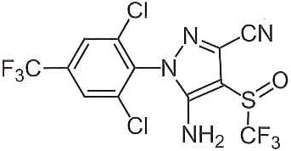
Figure 1 Structure of fipronil
Table 1 Summary, physico-chemical properties of fipronil
Physico-chemical property | Value
Molecular weight | 437.2 amu ª
Aqueous solubility | 1.9 mg/L at pH 5 and 20°C/25°C ^{a, c}  2.4 mg/L at pH 9 and 20°C/25°C ^{a, c}  3.78 mg/L at 20°C ^{b}
Logarithm of the octanol-water partition coefficient (log K_{ow}) | 4.0 (shake flask method) at pH 7 and 20°C ª  3.75 at pH 7 and 20°C ^{b}
Logarithm of the organic carbon water partition coefficient (log K_{oc}) | 2.63 (Speyer 2.2) to 3.09 (sandy loam) ª
Logarithm of the bioconcentration factor (log BCF) | 2.51 ^{b}
Half-life in water (t_{1/2}) | 54 d  Stable at pH 5–7 and 20°C ^{b}  125 h (5.2 d) ^{c}
Half-life in soils (t_{1/2}) | 68 d (65–142 d in field and laboratory (20°C) respectively)) ^{b}  438 h (18.25 d) ^{c}
a BCPC (2012).
b Pesticide Properties Database (University of Hertfordshire 2013).
c Gunasekara et al. 2007.
Fipronil belongs to the phenylpyrazole group within the pyrazole family of insecticides. Fipronil is one of the most-used insecticides worldwide, alongside neonicotinoids such as imidacloprid and clothianidin (Bonmatin et al. 2015). Fipronil is an insecticide that is registered for application to numerous agricultural crops in Australia and New Zealand (APVMA 2020; ACVM 2023). These include fibres, fruit, fungi, grains, pasture, grass, herbs, oilseed and vegetables (APVMA 2020; ACVM 2023). Fipronil is also used in Australia for locust and grasshopper control (APVMA 2012). Non-agricultural uses include application to lawn, turf, sports fields, timber plantations and pets (to treat fleas, ticks and lice) (APVMA 2020; ACVM 2023). Fipronil is also used for direct nest injection treatment for fire ant management (DAF 2024). The Australian Pesticides and Veterinary Medicines Authority is undertaking a chemical review of fipronil; the outcome of this review may influence the registration and use of fipronil described in this technical brief.
Although fipronil is not routinely monitored in Australian and New Zealand marine water, it may end up in aquatic environments due to runoff (APVMA 2012; Bonmatin et al. 2015). Waterways that discharge to the Great Barrier Reef lagoon have reported fipronil concentrations at less than the limit of reporting (0.005 µg/L) (Water Quality and Investigations 2020). Therefore, concentrations in the Great Barrier Reef lagoon are likely to be even lower.
Fipronil is a broad-spectrum insecticide that has low-to-moderate solubility in water and high soil adsorption characteristics as indicated by its log K_{oc} value (Table 1) (BCPC 2012; University of Hertfordshire 2013). It has a low potential for volatilisation, with variable persistence in soils, waterways and non-target plants (Table 1).
Fipronil is manufactured and used as a 1:1 mixture of enantiomers (called a racemate), containing 50% each of (+) and (-) enantiomers (Overmyer et al. 2007; Wilson et al. 2008) identified by the International Union of Pure and Applied Chemistry name (RS)-5-amino-1-[2,6-dichloro-4-(trifluoromethyl)phenyl]-4-(trifluoromethylsulfinyl)-1H-pyrazole-3-carbonitrile. Biological processes within organisms or in the environment can alter the enantiomeric fractions of fipronil, resulting in enrichment in one enantiomer over the other, where one is selectively biotransformed (Baird et al. 2013). Environmental occurrences of fipronil may be from mixtures enriched in either enantiomer, even though ﬁpronil is applied as a racemate (Overmyer et al. 2007). The ecotoxicology of the (+) and (-) enantiomers and racemic mixtures of fipronil indicates some evidence of enantiomer-specific toxicity. Konwick et al. (2005) states that the S enantiomer is generally more toxic than the R enantiomer or a 50:50 racemic mixture; however, this trend is not distinctly recognisable in the present dataset due to the limited ecotoxicity data available for fipronil. Insufficient data were available during preparation of these DGVs to support intra-species comparisons to confirm whether the racemate, or an enantiomer, was consistently more toxic.

Aquatic toxicology

Mechanisms of toxicity
Fipronil is absorbed through plant leaves following foliar application. It is then translocated acropetally (i.e. moved upwards from plant base to apex) in the xylem and accumulates in the plant tissues (Bonmatin et al. 2015). Fipronil exerts toxicity by binding to the γ-aminobutyric acid (GABA) receptors and glutamate-gated chloride channels in nerve cells. It more-strongly binds to receptors in arthropods (e.g. insects, crustaceans) than to receptors in vertebrates (Konwick et al. 2005; Narahashi et al. 2010; Baird et al. 2013; Simon-Delso et al. 2015). Blocking these receptors results in neuronal hyperexcitation, which paralyses and kills the organism (Simon-Delso et al. 2015). Its systemic properties make fipronil effective at controlling insects and arthropods with piercing/sucking mouthparts, such as stem borers, leaf miners, plant hoppers, and weevils (BCPC 2012).

Relative toxicity
Based on a review of the mechanisms of toxicity, and consistent with its mode of action, fipronil is highly toxic to aquatic invertebrates, with lower toxicity to fish, frogs and phototrophs such as macrophytes and algae. The evidence indicates that arthropods are more sensitive than non-arthropods (i.e. toxic effects occurred at lower concentrations), although there is some overlap in their sensitivities (Appendix B: Modality assessment for fipronil toxicity to aquatic species).
There are substantially fewer toxicity data available for fipronil for marine or estuarine species compared to freshwater species. In collating data for the DGV derivation, there were toxicity data for nine marine and estuarine species compared to toxicity data for 36 freshwater species that passed the screening and quality assessment processes.

Marine and estuarine data
The toxicity values for arthropods were diverse, with values ranging from a chronic 45-d LOEC of 0.000143 µg/L for Palaemonetes pugio (Volz et al. 2003) to an acute 96-h LC50 value of 13 µg/L for Amphiascus tenuiremis (Chandler et al. 2004). The value for P. pugio is 35 times lower than the next most sensitive arthropod, the mysid shrimp Americamysis bahia, which had a chronic 28-d LOEC of 0.005 µg/L.
The toxicity values for non-arthropods ranged from 0.24 µg/L to 770 µg/L.
- Fish: toxicity values ranged from a chronic 32-d NOEL of 0.24 µg/L to an acute 96-h LC50 of 130 µg/L, both for the sheepshead minnow Cyprinodon variegatus (USEPA 2015).
- Bivalves: toxicity values ranged from an acute 96-h LC50 of 177 µg/L (Overmyer et al. 2007) for the clam Mercenaria to an acute 96-h EC50 of 770 µg/L for the oyster Crassostrea virginica (USEPA 2015).
- Microalgae: toxicity values ranged from a chronic 5-d NOEL of 140 µg/L for the diatom Skeletonema costatum (USEPA 2015) to a chronic 96-h EC50 of 631 µg/L for the green alga Duneliella tertiolecta (Overmyer et al. 2007).
- Cnidarians: toxicity values ranged from a chronic 48-h NOEC of 12.6 µg/L to a chronic 48-h EC50 of 29.2 µg/L, both for the coral Acropora tenuis (Negri et al. 2020).

Freshwater data
Freshwater data were needed to supplement the small marine toxicity dataset (see Section 4.1). The sensitivity of freshwater arthropods generally ranged over three orders of magnitude, from an acute 96-h NOEL of 0.14 µg/L for the mayfly Hexagenia sp. (Weston and Lydy 2014) to an acute 48-h EC50 of 190 µg/L for Daphnia magna (USEPA 2015). The exception to this was an acute 48-h LC50 of 646.3 µg/L for the midge Chaoborus crystallinus (Chaton et al. 2002), which was approximately 3.5 times higher than the next least sensitive arthropod (D. magna).
The toxicity values for non-arthropods ranged from 6.7 µg/L to 5 000 µg/L.
- Fish: toxicity values ranged from a chronic 90-d NOEL of 6.6 µg/L for Oncorhynchus mykiss (USEPA 2015) to an acute 5-d LOEC of 5 000 µg/L for Danio rerio (Stehr et al. 2006).
- Microalgae: toxicity values ranged from a chronic 5-d NOEL of 120 µg/L for the diatom Navicula pelliculosa (USEPA 2015) to a chronic 72-h EC50 of 1 500 µg/L for the green alga Scenedesmus obliquus (Qu et al. 2014).
- Amphibian: toxicity values for Xenopus laevis ranged from 850 µg/L to 1 140 µg/L (both acute 96-h LC50s) (Overmyer et al. 2007).
- Macrophyte: the toxicity value for Lemna gibba was an acute 5-d NOEL of 100 µg/L (USEPA 2015).

Factors affecting toxicity
No factors that modify the toxicity of fipronil have been reported.

Default guideline value derivation
The DGVs were derived in accordance with the method described in Warne et al. (2018) and using the Burrlioz 2.0 software.

Toxicity data used in derivation
To obtain data for fipronil toxicity to marine organisms, the scientific literature was searched. The following databases were also searched: ECOTOX Knowledgebase (USEPA 2015); Australasian Ecotoxicology Database (Warne et al. 1998); and ANZECC/ARMCANZ (2000) and (Sunderam et al. 2000) toxicant databases. There were insufficient fipronil toxicity data for marine species to derive the DGVs. Therefore, the marine species dataset was supplemented with toxicity data for estuarine and freshwater species. A comparison of the sensitivities of freshwater and marine organisms in Appendix B: Modality assessment for fipronil toxicity to aquatic species shows no apparent differences in sensitivity to fipronil between the two groups.
There were acute and chronic toxicity data for nine marine and estuarine species (six phyla and seven classes) that passed the screening and quality assessment processes. The represented phyla were Arthropoda, Bacillariophyta, Chlorophyta, Chordata, Cnidaria and Mollusca. The seven classes were Actinopterygii (which accounts for approximately 99% of fish), Anthozoa (class of marine invertebrates), Bivalvia (group of molluscs), Chlorophyceae (major group of green algae), Malacostraca (large group of crustaceans), Mediophyceae (class of diatoms) and Maxillopoda (large group of crustaceans). Chronic toxicity data were available for seven of the nine species, comprising three arthropods and four non-arthropods; acute toxicity data were available for six of the nine species, comprising three arthropods and three non-arthropods.
Normally, species classified to genus only (e.g. Hexagenia sp.) are not used in the DGV derivation, as ambiguity at the genus level could result in more than one toxicity value being assigned to a single species. However, visual identification and classification of species within a genus, particularly for microalgae, can be difficult for some genera due to their lack of characteristic morphological features (Kessler and Huss 1992). When there are no other data for species belonging to the same genus (i.e. there is no chance of duplicating a species) and/or when there are limited toxicity data available, genus level toxicity data can be included in the DGV derivation. Therefore, in deriving the DGVs for fipronil in marine water, data for Hexagenia sp. were included as no other toxicity data for this genus were available.
Based on the mode of action of fipronil (Section 2), arthropods are considered more sensitive to fipronil than other organisms. A modality assessment of the fipronil toxicity dataset (including freshwater, marine and estuarine arthropod and non-arthropod data) was undertaken according to the weight of evidence approach described by Warne et al. (2018) (Appendix B: Modality assessment for fipronil toxicity to aquatic species). Most lines of evidence suggest that the distribution of the fipronil toxicity data is bimodal. Therefore, as recommended by Warne et al. (2018), only the toxicity data for the more sensitive group of organisms (in this case, arthropods) were used to derive the DGVs.
The marine dataset of the most sensitive group of organisms (i.e. arthropods) consisted of data for one species; this does not meet the minimum data requirements (i.e. at least five species from at least four phyla) of Warne et al. (2018). Adding the toxicity data for the two estuarine arthropod species still did not meet the minimum data requirements. Therefore, a dataset of marine, estuarine and freshwater arthropod species was assessed. This final dataset consisted of chronic, chronic estimated and converted acute values for 24 arthropods (one marine, two estuarine, 21 freshwater).
For C. dubia, Wilson et al. (2008) determined NOECs and LOECs for a range of endpoints for the S enantiomer, R enantiomer and racemate forms of fipronil. In this study, NOECs could not be determined for the S enantiomer for two endpoints (fecundity and brood size), as the lowest concentration tested was significantly different to the control (i.e. the lowest concentration tested was a LOEC). These LOECs for the S enantiomer were lower than the NOECs for the R enantiomer and racemate forms of fipronil (using the same endpoints). Although NOECs are preferred over LOECs when determining the single value for each species (Warne et al. 2018), the LOECs for the S enantiomer were used (after conversion to negligible effect estimates) in the DGV derivation as they were more protective of this species than the NOECs for the R enantiomer and racemate forms.
In calculating the single toxicity value for each species, different instars of insect larvae were treated as being the same life stage (i.e. provided the endpoint, test duration and test conditions were the same, different instars were combined to calculate geometric means). For example, this was done for the mosquito Aedes aegypti and Aedes albopictus (Appendix A: Toxicity data that passed the screening and quality assessment and were used to derive the default guideline values).
Chandler et al. (2004) reported a 62% reduction in predicted population size for the third generation of copepod Amphiascus tenuiremis at a fipronil concentration of 0.16 µg/L; however, this value was not used in the derivation because it was a modelled prediction of the population size of the third generation based on data for the first generation. Instead, a NOEL of 0.16 µg/L based on measured 21-d reproduction and 12-d development was used as the final toxicity value for A. tenuiremis.
A summary of the toxicity data (one value per species) used to derive the DGVs for fipronil in marine water is in Table 2, with additional details of the data provided in Appendix A: Toxicity data that passed the screening and quality assessment and were used to derive the default guideline values. Details of the data quality assessment and the data that passed the quality assessment are provided as supporting information. Where studies provided toxicity data for enantiomers and the racemate, the form that had the most sensitive response for each organism was used to derive the DGVs and was expressed in terms of the concentration of the active ingredient (i.e. fipronil).
Table 2 Summary of single toxicity values, all species used to derive default guideline values for fipronil in marine water
Taxonomic group | Species | Life stage | Duration (days) | Toxicity measure ª (endpoint) | Reported toxicity value (µg/L) | Final toxicity values (µg/L)
Marine
Crustacean | Americamysis bahia | Early juvenile | 28 | Chronic LOEC  (Mortality) | 0.0084 ^{c, e} | 0.003
Estuarine
Crustacean | Amphiascus tenuiremis | Life cycle / Nauplii stage I | 12, 21 | Chronic NOEL  (Reproduction, development) | 0.16 | 0.16
Crustacean | Palaemonetes pugio | Adult | 45 | Chronic NOEC  (Survival) | 0.098 | 0.098
Freshwater
Crustacean | Acanthocyclops robustus | – | 2 | Acute LC50  (Mortality) | 84.9 ^{b} | 8.49
Crustacean | Diaptomus castor | – | 2 | Acute LC50  (Mortality) | 3.45 ^{b} | 0.345
Crustacean | Ceriodaphnia dubia ^{d} | Neonate | 8 | Chronic LOEC  (Fecundity, brood size) | 2 ^{c} | 0.8
Crustacean | Daphnia magna | Neonate | 21 | Chronic NOEL  (Growth) | 9.6 | 9.6
Crustacean | Procambarus clarkii | Adult | 4 | Acute LC50  (Mortality) | 14.3 ^{b} | 1.43
Crustacean | Procambarus zonangulus | Adult | 4 | Acute LC50  (Mortality) | 19.5 ^{b} | 1.95
Crustacean | Simocephalus elizabethae ^{d} | Neonate | 2 | Acute LC50  (Mortality) | 11.13 ^{b} | 1.113
Insect | Aedes aegypti ^{d} | Fourth instar larva | 2 | Acute LC50  (Mortality) | 3.2 ^{b, e} | 0.32
Insect | Aedes albopictus HAmAal strain ^{d} | First and fourth instar larva | 2 | Acute LC50  (Mortality) | 13.65 ^{b, e} | 1.365
Insect | Aedes taeniorhynchus | Fourth instar larva | 2 | Acute LC50  (Mortality) | 0.43 ^{b} | 0.043
Insect | AnopheIes quadrimaculatus | Fourth instar larva | 2 | Acute LC50  (Mortality) | 0.43 ^{b} | 0.043
Insect | Chaoborus crystallinus | Larva | 2 | Acute LC50  (Mortality) | 646.3 ^{b} | 64.6
Insect | Cheumatopsyche brevilineata | First instar larva | 2 | Acute LC50  (Immobilisation) | 0.153 ^{b} | 0.0153
Insect | Chironomus annularius | Larva | 2 | Acute LC50  (Mortality) | 2.45 ^{b} | 0.245
Insect | Chironomus crassicaudatus | Fourth instar larva | 2 | Acute LC50  (Mortality) | 0.42 ^{b} | 0.042
Insect | Culex nigripalpus | Fourth instar larva | 2 | Acute LC50  (Mortality) | 0.87 ^{b} | 0.087
Insect | Culex quinquefasciatus ^{d} | First and fourth instar larva | 2 | Acute LC50  (Mortality) | 2.3 ^{b, e} | 0.23
Insect | Glyptotendipes paripes | Fourth instar larva | 2 | Acute LC50  (Mortality) | 0.42 ^{b} | 0.042
Insect | Hexagenia sp. | Nymph | 4 | Acute LC50  (Immobilisation) | 0.44 ^{b} | 0.044
Insect | Polypedilum nubiferum ^{d} | Fourth instar larva | 2 | Acute LC50  (Mortality) | 1 ^{b} | 0.1
Insect | Simulium vittatum | Fourth and fifth instar larva | 2 | Acute LC50  (Mortality) | 0.29 ^{b, e} | 0.029
– : Not stated or not applicable.
a The measure of toxicity being determined. LC50: median lethal concentration; LOEC: lowest observed effect concentration; NOEC/NOEL: no observed effect concentration/level.
b Acute EC50 andLC50 values were converted to chronic negligible effect values by dividing by 10 (Warne et al. 2018).
c Chronic LOEC and LC50 values were converted to chronic negligible effect values by dividing by 2.5 and 5, respectively (Warne et al. 2018).
d Species that originate from, or are distributed in, Australia and/or New Zealand.
e Value is a geometric mean of >1 toxicity value (see Appendix A: Toxicity data that passed the screening and quality assessment and were used to derive the default guideline values).
To identify species that were relevant to Australia and New Zealand ecosystems, the following databases were searched: AlgaeBase (Guiry and Guiry 2017); Atlas of Living Australia (ALA 2017); Catalogue of Life (Roskov et al. 2017); Integrated Taxonomic Information System (ITIS 2017); and World Register of Marine Species (WoRMS 2017). The dataset used in the DGV derivation for fipronil in marine water (Table 2) includes toxicity data for six freshwater species that originate from, or are distributed in, Australia and/or New Zealand.

Species sensitivity distribution
The cumulative frequency (species sensitivity) distribution (SSD) of the 24 toxicity values used to derive the DGVs is presented in Figure 2. The SSD was plotted using the Burrlioz 2.0 software, and the model provided a good fit to the data (Figure 2).
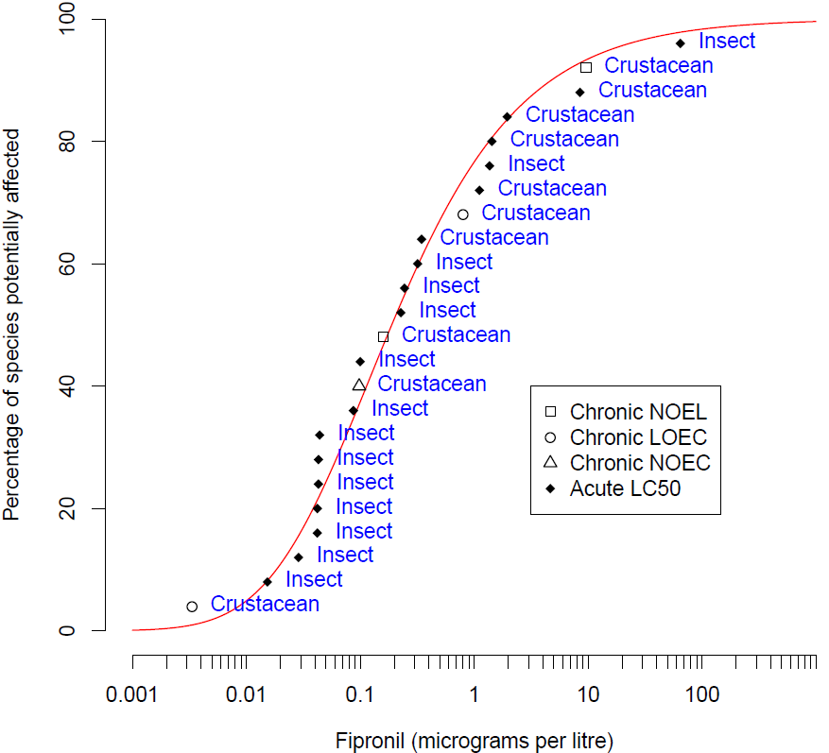
Figure 2 Species sensitivity distribution, fipronil in marine water

Default guideline values
It is important that the DGVs (Table 3) and associated information in this technical brief are used in accordance with the detailed guidance provided in the Australian and New Zealand Guidelines for Fresh and Marine Water Quality website (ANZG 2018).
The DGVs are expressed in terms of the concentration of the active ingredient; they relate to fipronil only—not any of its breakdown products.
Measured log BCF values for fipronil are low (Table 1) and below the threshold at which secondary poisoning must be considered (i.e. threshold log BCF = 4 (Warne et al. 2018)). Therefore, the DGVs for fipronil do not account for secondary poisoning.
The DGVs for fipronil in marine water are provided in Table 3. The 95% species protection DGV of 0.01 µg/L is recommended for application to slightly-to-moderately disturbed ecosystems. To derive higher reliability DGVs, additional chronic toxicity tests of fipronil with marine arthropods should be conducted.
Table 3 Default guideline values, fipronil in marine water, moderate reliability
Level of species protection (%) | DGV for fipronil in marine water (µg/L) ª
99 | 0.003
95 | 0.01
90 | 0.02
80 | 0.04
a DGVs were derived using the Burrlioz 2.0 software and rounded to one significant figure.

Reliability classification
The fipronil marine water DGVs have a moderate reliability classification (Warne et al. 2018) based on the outcomes for the following three criteria:
- sample size—24 (preferred)
- type of toxicity data—chronic and acute estuarine, freshwater and marine data
- SSD model fit—good (Burr type III).

Glossary
Term | Definition
acute toxicity | A lethal or adverse sub-lethal effect that occurs as the result of a short exposure period to a chemical relative to the organism’s life span.
bimodal | When the distribution of the sensitivity of species to a toxicant has two modes. This typically occurs with chemicals with specific modes of action. For example, herbicides are designed to affect plants at low concentrations but most animals are only affected at high concentrations.
CAS no. | Chemical Abstracts Service number. Each chemical has a unique identifying number that is allocated by the American Chemical Society.
chronic toxicity | A lethal or sublethal adverse effect that occurs after exposure to a chemical for a period of time that is a substantial portion of the organism’s life span or an adverse effect on a sensitive early life stage.
DGV (default guideline value) | A guideline value recommended for generic application in the absence of a more specific guideline value (e.g. site-specific) in the Australian and New Zealand Guidelines for Fresh and Marine Water Quality.
EC50 (median effective concentration) | The concentration of a substance in water or sediment that is estimated to produce a 50% change in the response being measured or a certain effect in 50% of the test organisms relative to the control response, under specified conditions.
ECx | The concentration of a substance in water or sediment that is estimated to produce an x% change in the response being measured or a certain effect in x% of the test organisms, under specified conditions.
endpoint | The specific response of an organism that is measured in a toxicity test (e.g. mortality, growth, a particular biomarker).
GABA | γ-aminobutyric acid.
guideline value (GV) | A measurable quantity (e.g. concentration) or condition of an indicator for a specific community value below which (or above which, in the case of stressors such as pH, dissolved oxygen and many biodiversity responses) there is considered to be a low risk of unacceptable effects occurring to that community value. Guideline values for more than one indicator should be used simultaneously in a multiple lines of evidence approach.
LC50 (median lethal concentration) | The concentration of a substance in water or sediment that is estimated to be lethal to 50% of a group of test organisms, relative to the control response, under specified conditions.
LOEC (lowest observed effect concentration) | The lowest concentration of a material used in a toxicity test that has a statistically significant adverse effect on the exposed population of test organisms as compared with the controls.
LOEL (lowest observed effect level) | Synonymous with LOEC.
mode of action | The means by which a chemical exerts its toxic effects. For example, triazine herbicides inhibit the photosystem II component of plants’ photosynthesis biochemical reaction.
NOEC (no observed effect concentration) | The highest concentration of a material used in a toxicity test that has no statistically significant adverse effect on the exposed population of test organisms as compared with the controls.
NOEL (no observed effect level) | Synonymous with NOEC.
phototrophs | An organism that photosynthesises as its main means of obtaining energy (e.g. plants, algae).
PSII | Photosystem II of the photosynthetic biochemical pathway.
site-specific guideline value | A guideline value that is relevant to the specific location or conditions that are the focus of a given assessment or issue.
species (biological) | A group of organisms that resemble each other to a greater degree than members of other groups and that form a reproductively isolated group that will not produce viable offspring if bred with members of another group.
SSD (species sensitivity distribution) | A method that plots the cumulative frequency of species’ sensitivities to a toxicant and fits a statistical distribution to the data. From the distribution, the concentration that should theoretically protect a selected percentage of species can be determined.
toxicity | The inherent potential or capacity of a material to cause adverse effects in a living organism.
toxicity test | The means by which the toxicity of a chemical or other test material is determined. A toxicity test is used to measure the degree of response produced by exposure to a specific level of stimulus (or concentration of chemical) for a specified test period.

Appendix A: Toxicity data that passed the screening and quality assessment and were used to derive the default guideline values
Table A 1 Summary, toxicity data that passed the screening and quality assessment, for fipronil in marine water
Taxonomic group | Species | Life stage | Exposure duration (days) | Test type | Toxicity measure (test endpoint) | Test medium | Temp. (°C) | pH | Concentration (µg/L) | Reference
Freshwater
Crustacean | Ceriodaphnia dubia | <24-h neonate | 8 | Chronic | LOEC ª  (Fecundity) | Moderately hard water | 20–25 | 7.5–8.3 | 2 | Wilson et al. (2008)
Crustacean | Ceriodaphnia dubia | <24-h neonate | 8 | Chronic | LOEC ª  (Brood size) | Moderately hard water | 20–25 | 7.5–8.3 | 2 | Wilson et al. (2008)
– |  |  |  |  |  |  |  |  | 0.8 ^{b} | Value used in SSD
Crustacean | Daphnia magna | Neonate | 21 | Chronic | NOEL  (Growth) | Fresh, flow-through laboratory water | 20 ± 1 | – | 9.6 | USEPA (2015)
– |  |  |  |  |  |  |  |  | 9.6 | Value used in SSD
Crustacean | Diaptomus castor | – | 2 | Acute | LC50  (Mortality) | Dechlorinated tap water | 25 | 7.5 | 3.45 | Chaton et al. (2002)
– |  |  |  |  |  |  |  |  | 0.345 ^{c} | Value used in SSD
Crustacean | Simocephalus elizabethae | Neonate (unfed) | 2 | Acute | LC50  (Mortality) | Martins rearing solution / thiamine hydrochloride | – | – | 11.13 | Stevens et al. (2011)
– |  |  |  |  |  |  |  |  | 1.113 ^{c} | Value used in SSD
Insect | Aedes aegypti | Fourth instar larva | 2 | Acute | LC50  (Mortality) | Tap water | 26 ± 2 | – | 1.54 | Ali et al. (1998)
Insect | Aedes aegypti | Fourth instar larva | 2 | Acute | LC50  (Mortality) | Tap water | 26 ± 1 | – | 6.6 | Chaton et al. (2001)
– |  |  |  |  |  |  |  |  | 3.2 | Geometric mean
 |  |  |  |  |  |  |  |  | 0.32 ^{c} | Value used in SSD
Insect | Aedes albopictus HAmAal strain | Fourth instar larva | 2 | Acute | LC50  (Mortality) | Tap water | 26 ± 2 | – | 23 | Ali et al. (1998)
Insect | Aedes albopictus HAmAal strain | First instar larva | 2 | Acute | LC50  (Mortality) | Tap water | 26 ± 2 | – | 8.1 | Ali et al. (1998)
– |  |  |  |  |  |  |  |  | 13.65 | Geometric mean
 |  |  |  |  |  |  |  |  | 1.365 ^{c} | Value used in SSD
Insect | Aedes taeniorhynchus | Fourth instar larva | 2 | Acute | LC50  (Mortality) | Tap water | 26 ± 2 | – | 0.43 | Ali et al. (1998)
– |  |  |  |  |  |  |  |  | 0.043 ^{c} | Value used in SSD
Insect | AnopheIes quadrimaculatus | Fourth instar larva | 2 | Acute | LC50  (Mortality) | Tap water | 26 ± 2 | – | 0.43 | Ali et al. (1998)
– |  |  |  |  |  |  |  |  | 0.043 ^{c} | Value used in SSD
Insect | Chaoborus crystallinus | Larva | 2 | Acute | LC50  (Mortality) | Dechlorinated tap water | 25 | 7.5 | 646.3 | Chaton et al. (2002)
– |  |  |  |  |  |  |  |  | 64.6 ^{c} | Value used in SSD
Insect | Cheumatopsyche brevilineata | First instar larva | 2 | Acute | LC50  (Immobilisation) | Dechlorinated tap water | 20 | 7.5 | 0.153 | Yokoyama et al. (2009)
– |  |  |  |  |  |  |  |  | 0.0153 ^{c} | Value used in SSD
Insect | Chironomus annularius | Larva | 2 | Acute | LC50  (Mortality) | Dechlorinated tap water | 25 | 7.5 | 2.45 | Chaton et al. (2002)
– |  |  |  |  |  |  |  |  | 0.245 ^{c} | Value used in SSD
Insect | Chironomus crassicaudatus | Fourth instar larva | 2 | Acute | LC50  (Mortality) | Tap water | 26 ± 2 | – | 0.42 | Ali et al. (1998)
– |  |  |  |  |  |  |  |  | 0.042 ^{c} | Value used in SSD
Insect | Culex nigripalpus | Fourth instar larva | 2 | Acute | LC50  (Mortality) | Tap water | 26 ± 2 | – | 0.87 | Ali et al. (1998)
– |  |  |  |  |  |  |  |  | 0.087 ^{c} | Value used in SSD
Insect | Culex quinquefasciatus | Fourth instar larva | 2 | Acute | LC50  (Mortality) | Tap water | 26 ± 2 | – | 7.3 | Ali et al. (1998)
Insect | Culex quinquefasciatus | First instar larva | 2 | Acute | LC50  (Mortality) | Tap water | 26 ± 2 | – | 4.6 | Ali et al. (1998)
Insect | Culex quinquefasciatus | Fourth instar larva | 2 | Acute | LC50  (Mortality) | Tap water | 28 ± 3 | – | 0.35 | Ali et al. (1998)
– |  |  |  |  |  |  |  |  | 2.3 | Geometric mean
 |  |  |  |  |  |  |  |  | 0.23 ^{c} | Value used in SSD
Insect | Glyptotendipes paripes | Fourth instar larva | 2 | Acute | LC50  (Mortality) | Tap water | 26 ± 2 | – | 0.42 | Ali et al. (1998)
– |  |  |  |  |  |  |  |  | 0.042 ^{c} | Value used in SSD
Insect | Hexagenia sp. | Nymph | 4 | Acute | LC50  (Immobilisation) | Moderately hard deionised water | 20 ± 2 | – | 0.44 | Weston and Lydy (2014)
– |  |  |  |  |  |  |  |  | 0.044 ^{c} | Value used in SSD
Insect | Polypedilum nubiferum | Fourth instar larva (unfed) | 2 | Acute | LC50  (Mortality) | Martins rearing solution / thiamine hydrochloride | – | – | 1 | Stevens et al. (2011)
– |  |  |  |  |  |  |  |  | 0.1 ^{c} | Value used in SSD
Insect | Simulium vittatum (IS-7 genetic type) | Fifth instar larva | 2 | Acute | LC50  (Mortality) | Moderately hard reconstituted water | – | – | 0.19 | Overmyer et al. (2005)
Insect | Simulium vittatum (IS-7 genetic type) | Fifth instar larva | 2 | Acute | LC50  (Mortality) | Moderately hard reconstituted water | – | – | 0.19 | Overmyer et al. (2005)
Insect | Simulium vittatum (IS-7 genetic type) | Fifth instar larva | 2 | Acute | LC50  (Mortality) | Moderately hard reconstituted water | – | – | 0.29 | Overmyer et al. (2005)
Insect | Simulium vittatum (IS-7 genetic type) | Fourth–fifth instar larva | 2 | Acute | LC50  (Mortality) | Moderately hard water | – | – | 0.65 | Overmyer et al. (2007)
– |  |  |  |  |  |  |  |  | 0.29 | Geometric mean
 |  |  |  |  |  |  |  |  | 0.029 ^{c} | Value used in SSD
Crustacean | Procambarus clarkii | Adult | 4 | Acute | LC50  (Mortality) | Deionised reconstituted water | 25 | 8.1 | 14.3 | Schlenk et al. (2001)
– |  |  |  |  |  |  |  |  | 1.43 ^{c} | Value used in SSD
Crustacean | Procambarus zonangulus | Adult | 4 | Acute | LC50  (Mortality) | Deionised reconstituted water | 25 | 8.1 | 19.5 | Schlenk et al. (2001)
– |  |  |  |  |  |  |  |  | 1.95 ^{c} | Value used in SSD
Crustacean | Acanthocyclops robustus | – | 2 | Acute | LC50  (Mortality) | Dechlorinated tap water | 25 | 7.5 | 84.9 | Chaton et al. (2002)
– |  |  |  |  |  |  |  |  | 8.49 ^{c} | Value used in SSD
Estuarine
Crustacean | Amphiascus tenuiremis | Life cycle | 21 | Chronic | NOEL  (Reproduction) | Artificial seawater | 25 | 8.3 | 0.16 ^{d} | Chandler et al. (2004)
Crustacean | Amphiascus tenuiremis | Nauplii Stage I | 12 | Chronic | NOEL  (Development) | Artificial seawater | 25 | 8.3 | 0.16 | Chandler et al. (2004)
– |  |  |  |  |  |  |  |  | 0.16 | Value used in SSD
Crustacean | Palaemonetes pugio | Adult | 45 | Chronic | NOEC  (Survival) | Filtered seawater | 23.2 ± 0.4 | 8 ± 0.2 | 0.098 | Volz et al. (2003)
– |  |  |  |  |  |  |  |  | 0.098 | Value used in SSD
Marine
Crustacean | Americamysis bahia | <24 h early juvenile | 28 | Chronic | LOEC  (Mortality) | Natural or artificial seawater | 25 ± 2 | – | 0.014 | USEPA (2015)
Crustacean | Americamysis bahia | <24 h early juvenile | 28 | Chronic | LOEC  (Mortality) | Natural or artificial seawater | 25 ± 2 | – | 0.005 | USEPA (2015)
– |  |  |  |  |  |  |  |  | 0.008 | Geometric mean
 |  |  |  |  |  |  |  |  | 0.003 ^{b} | Value used in SSD
– : Not stated or not applicable.
a LOEC values are for the S enantiomer, which were lower than the NOEC values for the R enantiomer and racemate forms of fipronil (see Section 4.1).
b Chronic LOEC values were converted to chronic negligible effect values by dividing by 2.5 (Warne et al. 2018).
c Acute EC50 and LC50 values were converted to chronic negligible effect values by dividing by 10 (Warne et al. 2018).
d The NOEL value for this species and endpoint was used over a lower LOEL value due to NOELs being a preferred type of toxicity value over LOELs (refer to accompanying datasheets).

Appendix B: Modality assessment for fipronil toxicity to aquatic species
A modality assessment was undertaken for fipronil according to the weight of evidence approach specified in Warne et al. (2018).

Is there a specific mode of action that could result in taxa-specific sensitivity?
Fipronil exerts toxicity by binding to and blocking the γ-aminobutyric acid (GABA) receptors and glutamate-gated chloride channels in nerve cells. Fipronil has a stronger affinity for these receptors in insects and other arthropods than for receptors in vertebrates (Konwick et al. 2005; Narahashi et al. 2010; Baird et al. 2013; Simon-Delso et al. 2015). As such, fipronil is considered more toxic to arthropods than to vertebrates and plants.

Does the dataset suggest bimodality?
Modality was assessed using a dataset that combined all estuarine, freshwater and marine toxicity data that passed the screening and quality assessment (n = 42). This was done to increase the sample size of the dataset being assessed. All data that were not chronic negligible effect values (e.g. NOEC) were converted to this type of data using the methods recommended by Warne et al. (2018). Box and whisker plots for the freshwater, marine and estuarine data indicated the organisms in these media have similar sensitivities (Figure B 1); as such, the pooled dataset was retained for the modality assessment. Calculation of the bimodality coefficient (BC) on log-transformed data yielded a value of 0.510 (which is below the indicative threshold BC for bimodality of 0.55), suggesting the dataset does not exhibit bimodality. However, a frequency histogram of the dataset indicated that the dataset may not be unimodal (Figure B 2). Thus, the evidence is somewhat contradictory.
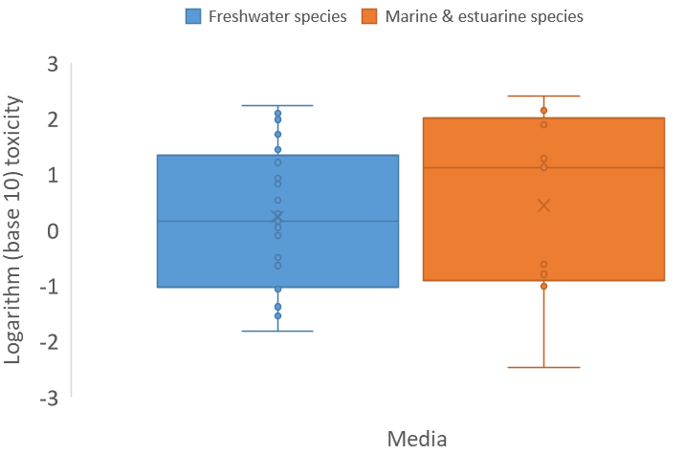
Note: ‘x’ denotes the mean; circles represent the individual toxicity values.
Figure B 1 Box plot, freshwater, marine and estuarine species sensitivity to fipronil
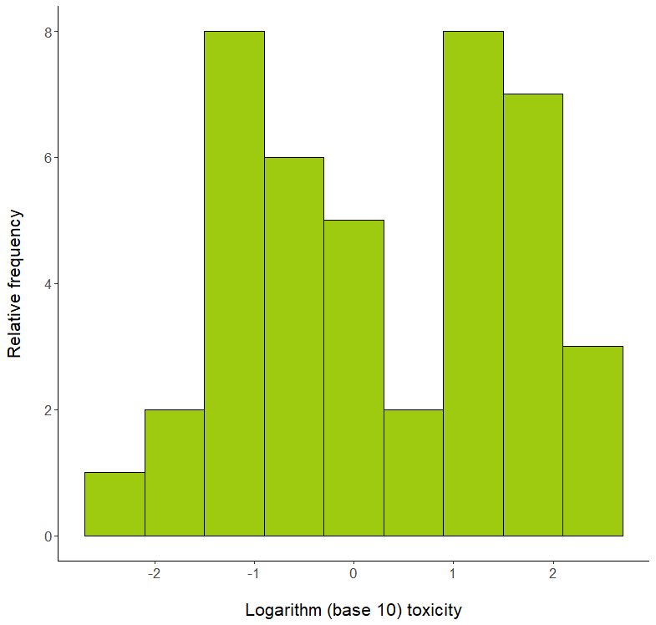
Figure B 2 Histogram, freshwater, marine and estuarine species dataset

Do data show taxa-specific sensitivity (i.e. through distinct groupings of different taxa types)?
The relative sensitivity of arthropods and non-arthropods to fipronil was compared using box and whisker plots (Figure B 3) and a species sensitivity distribution (Figure B 4). These visual analyses indicated that arthropods are more sensitive to fipronil than non-arthropods, although there was not a clear separation between the sensitivities of the two groups.
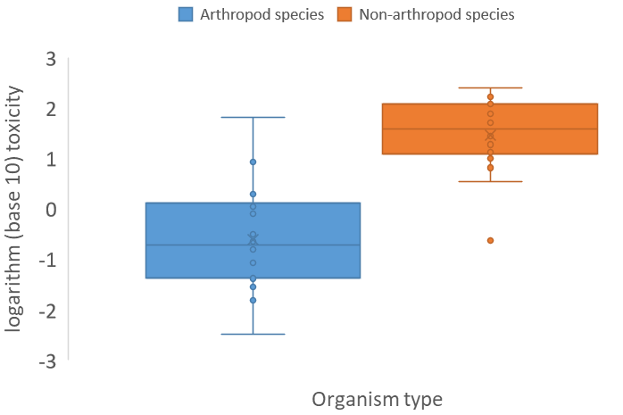
Note: ‘x’ denotes the mean; circles represent the individual toxicity values.
Figure B 3 Box plot, arthropod and non-arthropod sensitivity to fipronil
Figure B 4 Species sensitivity distribution, arthropod and non-arthropod sensitivity to fipronil

Is it likely that indications of bimodality or multimodality or distinct clustering of taxa groups are not due to artefacts of data selection, small sample size, test procedures, or other reasons unrelated to a specific mode of action?
Given that there are data for 24 arthropods and 18 non-arthropods, it is likely that the distributions are representative and are not an artefact of the data, sample size or test procedures. The mode of action indicates that fipronil should have a bimodal distribution of species sensitivity. Although the other lines of evidence provide somewhat equivocal results, there is sufficient taxa-specific sensitivity to indicate bimodality of the toxicity response to fipronil. Consequently, the toxicity data for the most sensitive grouping—arthropods—were used to derive the DGVs for fipronil in marine water, as per Warne et al. (2018).

References
ACVM (2023) Agricultural Compounds and Veterinary Medicines (ACVM) register [website], Minister for Primary Industries New Zealand, accessed March 2023.
ALA (2017) Atlas of Living Australia [website], National Research Infrastructure for Australia and Commonwealth Scientific and Industrial Research Organisation, accessed May 2017.
Ali A, Nayar JK and Gu WD (1998) ‘Toxicity of a phenyl pyrazole insecticide, fipronil, to mosquito and chironomid midge larvae in the laboratory’, Journal of the American Mosquito Control Association, 14:216–218.
ANZECC/ARMCANZ (2000) Australian and New Zealand guidelines for fresh and marine water quality, Australian and New Zealand Environment and Conservation Council and Agriculture and Resource Management Council of Australia and New Zealand.
ANZG (2018) Australian and New Zealand Guidelines for Fresh & Marine Water Quality [website], Australian and New Zealand governments and Australian state and territory governments.
APVMA (2012) Fipronil – review scope document, part 2: environmental considerations summary, Australian Pesticides and Veterinary Medicines Authority, Australian Capital Territory.
APVMA (2020) Public Chemical Registration Information System Search (PubCRIS) [website], Australian Pesticides and Veterinary Medicines Authority, accessed June 2020.
Baird S, Garrison A, Jones J, Avants J, Bringolf R and Black M (2013) ‘Enantioselective toxicity and bioaccumulation of fipronil in fathead minnows (Pimephales promelas) following water and sediment exposures’, Environmental Toxicology and Chemistry, 32:222–227.
BCPC (2012) A world compendium: the pesticide manual, 16th edn, MacBean C (ed), British Crop Production Council, United Kingdom.
Bonmatin JM, Giorio C, Girolami V, Goulson D, Kreutzweiser DP, Krupke C, Liess M, Long E, Marzaro M, Mitchell EAD, Noome DA, Simon-Delso N and Tapparo A (2015) ‘Environmental fate and exposure; neonicotinoids and fipronil’, Environmental Science and Pollution Research International, 22(1):35–67.
Chandler GT, Cary TL, Volz DC, Walse SS, Ferry JL and Klosterhaus SL (2004) ‘Fipronil effects on estuarine copepod (Amphiascus tenuiremis) development, fertility and reproduction: A rapid life-cycle assay in 96-well microplate format’, Environmental Science and Technology, 23:117–124.
Chaton PF, Ravanel P, Meyran JC and Tissut M (2001) ‘The toxicological effects and bioaccumulation of fipronil in larvae of the mosquito Aedes aegypti in aqueous medium’, Pesticide Biochemisty and Physiology, 69:183–188.
Chaton PF, Ravanel P, Tissut M and Meyran JC (2002) ‘Toxicity and bioaccumulation of fipronil in the nontarget arthropodan fauna associated with subalpine mosquito breeding sites’, Ecotoxicology and Environmental Safety, 52:8–12.
DAF (2024) National Fire Ant Eradication Program. Treating fire ant nests [website], Department of Agriculture and Fisheries, accessed April 2024.
Guiry MD and Guiry GM (2017) AlgaeBase [online database], University of Galway, accessed May 2017.
Gunasekara AS, Truong T, Goh KS, Spurlock F and Tjeerdema RS (2007) ‘Environmental fate and toxicology of fipronil’, Journal of Pesticide Science, 32:189–199.
ITIS (2017) Integrated Taxonomic Information System [online database], accessed May 2017.
Kessler E and Huss VAR (1992) ‘Comparative physiology and biochemistry and taxonomic assignment of the Chlorella (Chlorophyceae) strains of the culture collection of the University of Texas at Austin’, Journal of Phycology, 28:550–553.
Konwick BJ, Fisk AT, Garrisson AW, Avants JK and Black MC (2005) ‘Acute enantioselective toxicity of fipronil and its desulfinyl photoproduct to Ceridaphnia dubia’, Environmental Toxicology and Chemistry, 24(9):2350–2355.
Narahashi T, Zhao X, Ikeda T, Salgado VL and Yeh JZ (2010) ‘Glutamate-activated chloride channels: Unique fipronil targets present in insects but not in mammals’, Pesticide Biochemistry and Physiology, 97(2):149–152.
Negri AP, Templeman S, Flores F, van Dam J, Thomas M, McKenzie M, Stapp L, Kaserzon S, Mann RM, Smith R, Warne MStJ and Mueller J (2020) Ecotoxicology of pesticides on the Great Barrier Reef for guideline development and risk assessments, final report to the National Environmental Science Program, Reef and Rainforest Research Centre Limited, Cairns.
Overmyer JP, Mason BN and Armbrust KL (2005) ‘Acute toxicity of imidacloprid and fipronil to a nontarget aquatic insect, Simulium vittatum Zetterstedt Cytospecies IS-7’, Bulletin of Environmental Contamination and Toxicology, 74:872–879.
Overmyer JP, Rouse DR, Avants JK, Garrison AW, DeLorenzo ME, Chung KW, Key PB, Wilson WA and Black MC (2007) ‘Toxicity of fipronil and its enantiomers to marine and freshwater non-targets’, Journal of Environmental Science and Health, Part B: Pesticides, Food Contamination and Agricultural Wastes, 42:471–480.
Qu H, Ma RX, Liu DH, Wang P, Huang LD, Qiu XX and Zhou ZQ (2014) ‘Enantioselective toxicity and degradation of the chiral insecticide fipronil in Scenedesmus obliguus suspension system’, Environmental Toxicology and Chemistry, 33:2516–2521.
Roskov Y, Abucay L, Orrell T, Nicolson D, Bailly N, Kirk PM, Bourgoin T, DeWalt RE, Decock W, De Wever A, Nieukerken E, Zarucchi J and Penev L (eds) (2017) Species 2000 & ITIS catalogue of life [online database], Species 2000, Naturalis, Netherlands, accessed May 2017.
Schlenk D, Huggett DB, Allgood J, Bennett E, Rimoldi J, Beeler AB, Block D, Holder AW, Hovinga R and Bed P (2001) ‘Toxicity of fipronil and its degradation products to Procambarus sp.: Field and laboratory studies’, Archives of Environmental Contamination and Toxicology, 41:325–332.
Simon-Delso N, Amaral-Rogers V, Belzunces LP, Bonmatin JM, Chagnon M, Downs C, Furlan L, Gibbons DW, Giorio C, Girolami V, Goulson D, Kreutzweiser DP, Krupke CH, Liess M, Long E, McField M, Mineau P, Mitchell EAD, Morrissey CA, Noome DA, Pisa L, Settele J, Stark JD, Tapparo A, Van Dyck H, Van Praagh J, Van der Sluijs JP, Whitehorn PR and Wiemers M (2015) ‘Systemic insecticides (neonicotinoids and fipronil): Trends, uses, mode of action and metabolites’, Environmental Science and Pollution Research, 22(1):5–34.
Stehr CM, Linbo TL, Incardona JP and Scholz NL (2006) ‘The developmental neurotoxicity of fipronil: Notochord degeneration and locomotor defects in Zebrafish embryos and larvae’, Toxicology and Science, 92:270–278.
Stevens MM, Burdett AS, Mudford EM, Helliwell S and Doran G (2011) ‘The acute toxicity of fipronil to two non-target invertebrates associated with mosquito breeding sites in Australia, Acta Tropica’, 117:125–130.
Sunderam RIM, Warne MStJ, Chapman JC, Pablo F, Hawkins J, Rose RM and Patra RW (2000) The ANZECC/ARMCANZ water quality guideline database for toxicants, supplied as CD-ROM in ANZECC/ARMCANZ Australian and New Zealand guidelines for fresh and marine water quality.
University of Hertfordshire (2013) PPDB: The Pesticide Properties DataBase [website], University of Hertfordshire, accessed May 2016.
USEPA (2015) ECOTOX Knowledgebase [website], United States Environmental Protection Agency, accessed May 2015 – April 2016.
Volz DC, Wirth EF, Fulton MH, Scott GI, Strozier E, Block DS, Ferry JL, Walse SS and Chandler GT (2003) ‘Effects of fipronil and chlorpyrifos on endocrine-related endpoints in female grass shrimp (Palaemonetes pugio)’, Bulletin of Environmental Contamination and Toxicology, 71:497–503.
Warne MStJ, Batley GE, van Dam RA, Chapman JC, Fox DR, Hickey CW, and Stauber JL (2018) Revised method for deriving Australian and New Zealand water quality guideline values for toxicants – update of 2015 version, Australian and New Zealand governments and Australian state and territory governments.
Warne MStJ, Westbury A-M and Sunderam R (1998) ‘A compilation of toxicity data for chemicals to Australasian aquatic species. Part 1: pesticides’, Australasian Journal of Ecotoxicology, 4:93–144.
Water Quality and Investigations (2020) Pesticide Reporting Portal [website], Queensland Department of Environment and Science, accessed December 2022.
Weston DP and Lydy MJ (2014) ‘Toxicity of the insecticide fipronil and its degradates to benthic macroinvertebrates of urban streams’, Environmental Science and Technology, 48:1290–1297.
Wilson WA, Konwick BJ, Garrison AW, Avants JK, Black MC (2008) ‘Enantioselective chronic toxicity of fipronil to Ceriodaphnia dubia’, Archives of Environmental Contamination and Toxicology, 54:36–43.
WoRMS (2017) World Register of Marine Species [website], WoRMS Editorial Board, accessed May 2017.
Yokoyama A, Ohtsu K, Iwafune T, Nagai T, Ishihara S, Kobara Y, Horio T and Endo S (2009) ‘A useful new insecticide bioassay using first-instar larvae of a net-spinning caddisfly, Cheumatopsyche brevilineata (Trichoptera: Hydropsychidae)’, Journal of Pesticide Science, 34:13–20.

