# National Acid Sulfate Soils Guidance

Guidance for the dewatering of acid sulfate soils in shallow groundwater environments

June 2018

© Commonwealth of Australia 2018

**Ownership of intellectual property rights**

Unless otherwise noted, copyright (and any other intellectual property rights, if any) in this publication is owned by the Commonwealth of Australia (referred to as the Commonwealth).

**Creative Commons licence**

All material in this publication is licensed under a Creative [Commons Attribution 4.0 International Licence](https://creativecommons.org/licenses/by/4.0/legalcode) except content supplied by third parties, logos and the Commonwealth Coat of Arms.

Inquiries about the licence and any use of this document should be emailed to [copyright@agriculture.gov.au](mailto:copyright@agriculture.gov.au).

by

**Cataloguing data**

This publication (and any material sourced from it) should be attributed as: Shand, P, Appleyard, S, Simpson, SL, Degens, B, Mosley, LM 2018, *National Acid Sulfate Soils Guidance: Guidance for the dewatering of acid sulfate soils in shallow groundwater environments,* Department of Agriculture and Water Resources, Canberra, ACT. CC BY 4.0.

This publication is available at waterquality.gov.au.

Australian Government Department of Agriculture and Water Resources

GPO Box 858 Canberra ACT 2601

Switchboard +61 2 6272 3933 or 1800 900 090

Email [waterquality@agriculture.gov.au](mailto:waterquality@agriculture.gov.au)

**Liability**

The Australian Government acting through the Department of Agriculture and Water Resources has exercised due care and skill in preparing and compiling the information in this publication. Notwithstanding, the Australian Government Department of Agriculture and Water Resources, its employees and advisers disclaim all liability, including liability for negligence and for any loss, damage, injury, expense or cost incurred by any person as a result of accessing, using or relying on any of the information or data in this publication to the maximum extent permitted by law.

**Acknowledgements**

The authors are grateful for the Department of Agriculture and Water Resources for overseeing the management of the acid sulfate soils national guidances project, and for providing support throughout. Amandine Schneider and David Sim are kindly thanked for providing excellent case studies and for sharing experience and knowledge of acid sulfate soils and groundwater. Amadine provided the ‘Management of Acid Sulfate Soils for the New Parallel Runway Project at Brisbane Airport, Queensland’ case study, whereas David provided the ‘Dewatering for Construction of a Canal Estate, Western Australia’ case study. The Acid Sulfate Soils Technical Working Group and the National Committee for Acid Sulfate Soils provided continuous support and guidance since the projects inception. In particular, Liz Barnett, Lawrence Fox and Mitch Tulau are thanked for contributing reviews. Funding for this guidance was provided by the Department of Agriculture and Water Resources with in-kind support from the CSIRO (EP174687).



Contents

1 The purpose of this guidance 1

2 Introduction 2

2.1 Acid Sulfate Soils 2

2.2 Groundwater and ASS 3

3 The extent of and risk associated with groundwater dewatering 6

3.1 Type and extent of groundwater dewatering in areas of acid sulfate soils 9

3.2 Hazards and risks of groundwater dewatering in areas of acid sulfate soils 10

3.3 Policy and regulatory environment 21

3.4 Current management practices 21

4 Management strategies 24

4.1 Step 1 Project description 27

4.2 Step 2 Desktop assessment 28

4.3 Step 3 Evaluating alternatives to dewatering or minimise impacted area 30

4.4 Step 4 Characterising soils and groundwater 31

4.5 Step 5 Groundwater investigations – hydrogeology 38

4.6 Step 6 Mitigation and control measures 43

4.7 Step 7 Monitoring strategy 57

4.8 Step 8 Closure reports 62

5 ASS Groundwater management levels and planning 64

5.1 Introduction 64

5.2 Management levels 65

5.3 Management planning 66

5.4 Management of ASS in complex terrains: a case study 72

6 Future work and data gaps 76

Appendix A: Texture based action criteria for acid sulfate soils 77

Appendix B: Calculating the extent and duration of a cone of depression 79

Appendix C: Dewatering effluent monitoring matrix 82

Appendix D: A one-dimensional analytical solution for the transport of contaminants in groundwater 84

Appendix E: Checklist for reporting for initial closure report as required by Department of Water and Environment Regulation (DWER) 86

Appendix F: Checklist for reporting for post-monitoring closure report as required by Department of Water and Environment Regulation (DWER) 90

Appendix G: Management Levels for dewatering scale of acid sulfate soils 93

Glossary 96

References 102

Figures

Figure 2.1 Water movement and potential pathways for better management responses at a range of scales. 4

Figure 3.1 Urban and rural development activities. 8

Figure 3.2 Processes of soil acidification and contaminant discharge in urban drains under varying rainfall-runoff periods. 13

Figure 3.3 High ASS risk areas on Gnangara Mound Western Australia. 14

Figure 3.4 Clogging of pumps (left) and well screens (right) by amorphous Al hydroxide. 18

Figure 3.5 Changes in groundwater level, soil pH and groundwater pH before, during and after the Millennium Drought. 19

Figure 4.1 Typical framework used as an assessment framework. 25

Figure 4.2 The formation of a cone of depression during pumping from a bore. 39

Figure 4.3 The principle of superposition. 40

Figure 4.4 A well point dewatering system for a shallow excavation. 45

Figure 4.5 Stage 5 development area prior to construction. 46

Figure 4.6 ASSDMP concept diagram of dewatering infrastructure. 47

Figure 4.7 Open excavation of canal infrastructure with dewatering sump pump in foreground and recharge trench with settling basin. 48

Figure 4.8 Perimeter recharge trench in operation and spear point dewatering in operation. 49

Figure 4.9 Wall construction underway within central canal. 49

Figure 4.10 Groundwater level and electrical conductance before and after the commencement of dewatering. 50

Figure 4.11 Finished canal infrastructure post-construction. 50

Figure 4.12 Schematic view of a construction dewatering treatment scheme. 51

Figure 4.13 Schematic of a PRB and lime slotting machine for shallow PRBs. 52

Figure 4.14 Formation of hydroxysulfate mineral schwertmannite in acidic drains 55

Figure 5.1 Flowchart for proposed assessment framework for dewatering of ASS. 69

Figure 5.2 Construction of the Kedron Brook Floodway Drain. 73

Tables

Table 4.1 Preliminary estimates of scale of dewatering. 29

Table 4.2 Suggested determinands for assessing hazards in leachate tests. 34

Table 4.3 Suggested pumped groundwater parameters for baseline characterisation and monitoring during dewatering of ASS. 37

Table 4.4 Some groundwater geochemical indicators that pyrite oxidation is occurring. 38

Table 4.5 Different risk classes for groundwaters based on dissolved alkalinity. 38

Table 4.6 Aspects of monitoring that should be covered in any monitoring program. 58

Table 4.7 Indicators of sulfide oxidation in groundwater and potential trigger values for dissolved parameters. 59

Table 4.8 Strategy for developing a contingency plan for groundwater contamination. 60

Table 4.9 Key actions for monitoring potentially impacted water bodies caused by dewatering. 61

Table 4.10 Trigger levels for use when dewatering effluent is to be discharged directly, or indirectly, to a sensitive wetland or waterway. 62

Table 5.1 Management levels suggested for different scales of impact. 66

Table A1 Texture based acid sulfate soil action criteria. 77

Table C1 Dewatering effluent monitoring matrix. 82

Table E1 Checklist for reporting for initial closure report as required by DWER (DER 2015a). 86

Equations

Equation B1 Dimensions of a rectangular excavation. 79

Equation B2 Sichardt's equation. 79

Equation B3 Relationship between water table elevation changes, hydraulic conductivity and radius of influence. 80

Equation B4 Cooper-Jacob empirical relationship. 80

Equation D1 Concentration of a conservative contaminant in groundwater. 84

Boxes

Box 2.1 Management Principles. 3

Box 3.1 Managing regional groundwater with ASS on Gnangara Mound Western Australia. 14

Box 3.2 Drought impacts on groundwater in the Lower River Murray, South Australia. 18

Box 4.1 Net acidity calculation. 36

Box 4.2 Dewatering for Construction of a Canal Estate, Western Australia. 46

Box 5.1 Management of Acid Sulfate Soils for the New Parallel Runaway Project at Brisbane Airport, Queensland. 73

## The purpose of this guidance

The purpose of this guidance material on groundwater dewatering in acid sulfate soils (ASS) landscapes is to provide technical and practical advice on managing ASS to help prevent or minimize harm to the environment. They have been designed to help in the decision making process to increase certainty when groundwater dewatering or removal of overburden to expose ASS present below the water table is required. They can be used for best effect along with the decision support tool (Sullivan et al. 2018a), which provides linkages to other relevant national guidances. These national guidances do not replace existing guidelines, but should be used alongside existing state and territory guidelines for the characterization and management of ASS. The intent is to update this guidance on an on-going basis as more data become available and understanding increases.

This guidance document is divided into five sections:

1. An introduction to ASS and demarcates the scope of the document and coverage of sub-surface ASS;
2. The extent of and risks associated with groundwater dewatering or exposure and current management strategies;
3. Recommended management strategies for dealing with ASS in shallow groundwater environments based on current best practices. It recommends using a tiered system comprising eight consecutive steps as part of a staged approach to managing the dewatering of groundwater ASS from project plan to closure reporting. It details the range of management options and techniques currently used from which a specific management plan can be developed for the site(s) of interest;
4. A framework, including different levels of management, for inclusion within a site ASS management plan (ASSMP) for groundwater ASS, incorporating the staged approach developed in Section 3. This includes a tiered assessment framework with management levels of response based on scale of disturbance; it also emphasises the concept of developing conceptual models to help proponents and authorities to understand the groundwater environment at sites, and ultimately to minimise risk;
5. Data gaps in terms of knowledge or techniques which are needed to underpin future improved management practices.

The guidance does NOT replace the need for a site ASSMP which is generally required by regulatory authorities. It builds upon existing guidelines, particularly those developed in Western Australia (DER 2015a) for dewatering, and aims to be consistent with current ASS guidelines at national, state and territory level.

## Introduction

### Acid Sulfate Soils

Acid sulfate soils (ASS) is the term used to describe soils and sediments which either contain sulfide minerals, principally pyrite (FeS2) and iron monosulfides (FeS), or have been impacted by acidification due to oxidation of sulfide minerals. These soils are a generally present in low-lying areas of both coastal and inland landscapes across Australia, with an estimated area of around 15 million hectares (Fitzpatrick et al. 2011).

A number of terms have been used to describe ASS, including actual/potential ASS (Dear et al. 2014) and ripe/unripe ASS (Dent & Pons 1995), with the former being more common in Australia. Recent suggestions for improving the definition (Sullivan et al. 2009; 2010) have largely been incorporated into the latest classification scheme for Australian soils (Isbell 2015). The definitions for ASS used in these guidances are:

* Sulfidic: soils containing detectable sulfide, with the following sub-division:
  + Hypersulfidic: Sulfidic soil material that is capable of severe acidification (pH less than 4) as a result of oxidation of contained sulfides
  + Hyposulfidic: Sulfidic soil material that is not capable of severe acidification (pH less than 4) as a result of oxidation of contained sulfides
* Sulfuric: Soil material that has a pH less than 4 (1:1 by weight in water, or in a minimum of water to permit measurement) when measured in dry season conditions as a result of the oxidation of sulfidic materials
* Monosulfidic: Soil material containing greater than or equal to 0.01% acid volatile sulfur.

The term ‘acid sulfate soils’ is generally used for sulfidic/sulfuric sediments in wetlands (classed as sub-aqueous soils when water depths are shallow), on or close to floodplains and within regolith (the weathered material above bedrock). ASS form under anoxic conditions, typically in waterlogged or saturated environments along the coast or inland, beneath floodplains and within drains, rivers and wetlands. They do not generally pose a significant risk to human health or the environment if undisturbed, however, sulfide is unstable in the presence of oxygen (and other oxidising agents such as nitrate) reacting to generate sulfuric acid. Severe acidification may result if there is insufficient acid neutralising capacity (for example carbonate minerals) in the soil. A number of other hazards have been recognised in association with ASS including deoxygenation of surface waters, contaminant metal and metalloid release, malodours and nutrient release. Some of these hazards occur due to redox changes in the soil, and some may occur, and even be enhanced, under high pH conditions in systems that are well-buffered in terms of acid neutralisation capacity (ANC). The disturbance of ASS has the potential to cause significant impacts, including fish kills, loss of biodiversity in wetlands, contamination of surface water and groundwater, and corrosion of steel and concrete structures. Some of the problems associated with ASS have been known for several centuries, for example during dewatering of the Dutch polders from the 17th Century onwards (Dent & Pons 1995).

Shallow ASS are generally managed in accordance with the principles outlined in the National Strategy for the management of Coastal Acid Sulfate Soils (NatCASS 2000), along with a range of jurisdictional guidelines. The management of ASS should be guided by the principle of avoidance and/or minimising disturbance. Eight management principles (Box 2.1) are generally accepted as those which should be applied across Australia (Dear et al. 2014).

Box 2.1 Management Principles.

1. The disturbance of ASS should be avoided wherever possible.

2. Where disturbance of ASS is unavoidable, preferred management strategies are:

* minimisation of disturbance;
* neutralisation of acidity;
* hydraulic separation of sulfides either on its own or in conjunction with dredging; and
* strategic reburial (reinternment).

Other management measures may be considered but must not pose unacceptably high risks.

3. Works should be performed in accordance with best practice environmental management when it has been demonstrated that the potential impacts of works involving ASS are manageable to ensure that the potential short and long term environmental impacts are minimised.

4. The material being disturbed (including the in situ ASS) and any potentially contaminated waters associated with ASS disturbance, must be considered in developing a management plan for ASS and/or in complying with the general environmental duty.

5. Receiving marine, estuarine, brackish or fresh waters are not to be used as a primary means of diluting and/or neutralising ASS or associated contaminated waters.

6. Management of disturbed ASS is to occur if the ASS action criteria listed in Dear et al. 2014 guidelines is reached or exceeded (See Appendix A: Texture based action criteria for acid sulfate soils).

7. Stockpiling of untreated ASS above the permanent groundwater table with (or without) containment is not an acceptable long-term management strategy. For example, soils that are to be stockpiled, disposed of, used as fill, placed as temporary or permanent cover on land or in waterways, sold or exported off the treatment site or used in earth bunds, that exceed the ASS action criteria listed in Appendix A: Texture based action criteria for acid sulfate soils should be treated/managed.

8. The following issues should be considered when formulating ASS environmental management strategies:

* the sensitivity and environmental values of the receiving environment. This includes the conservation, protected or other relevant status of the receiving environment (for example Fish Habitat Area, Marine Park, Coastal Management District and protected wildlife);
* whether groundwater and/or surface water are likely to be directly or indirectly affected;
* the heterogeneity, geochemical and textural properties of soils on-site; and
* the management and planning strategies of Local Government and/or State Government, including Regional or Catchment Management Plans/Strategies and State and Regional Coastal Management Plans.

Source: Dear et al. 2014.

### Groundwater and ASS

The natural or artificial lowering of water tables, below those typically experienced under natural conditions with seasonal fluctuations, can lead to acidification of soil and groundwater in areas where these sub-surface environments contain appreciable amounts of sulfide minerals, particularly pyrite. It can also cause the release and mobilisation in the sub-surface of a number of contaminants including metals, metalloids and nutrients that can result in contamination of groundwater and surface waters. This can lead to significant impacts including degradation of surface water and groundwater supplies, loss of aquatic biodiversity where groundwater discharges, and increased rates of corrosion of subsurface infrastructure with economic consequences. Groundwater acidification associated with ASS is an emerging issue which has received little attention in the past, in part due to the initial impacts being out of sight beneath the land surface.

The residence times of shallow groundwater are typically greater than surface waters due to the slower movement of groundwater, typically months to decades in shallow systems. For groundwater in deep aquifers, this can be thousands to millions of years. The impacts of changes in groundwater level on water quality within and beyond an aquifer may thus not be apparent until a considerable time after disturbance, depending on sub-surface flow pathways, natural attenuation processes and the proximity of any receptor (a medium for example soil or organism affected by contaminants) of interest. A knowledge of the sub-surface gained through conceptual models is a useful visual and practical aid to decision making at a range of scales (Figure 2.1).

Figure 2.1 Water movement and potential pathways for better management responses at a range of scales.

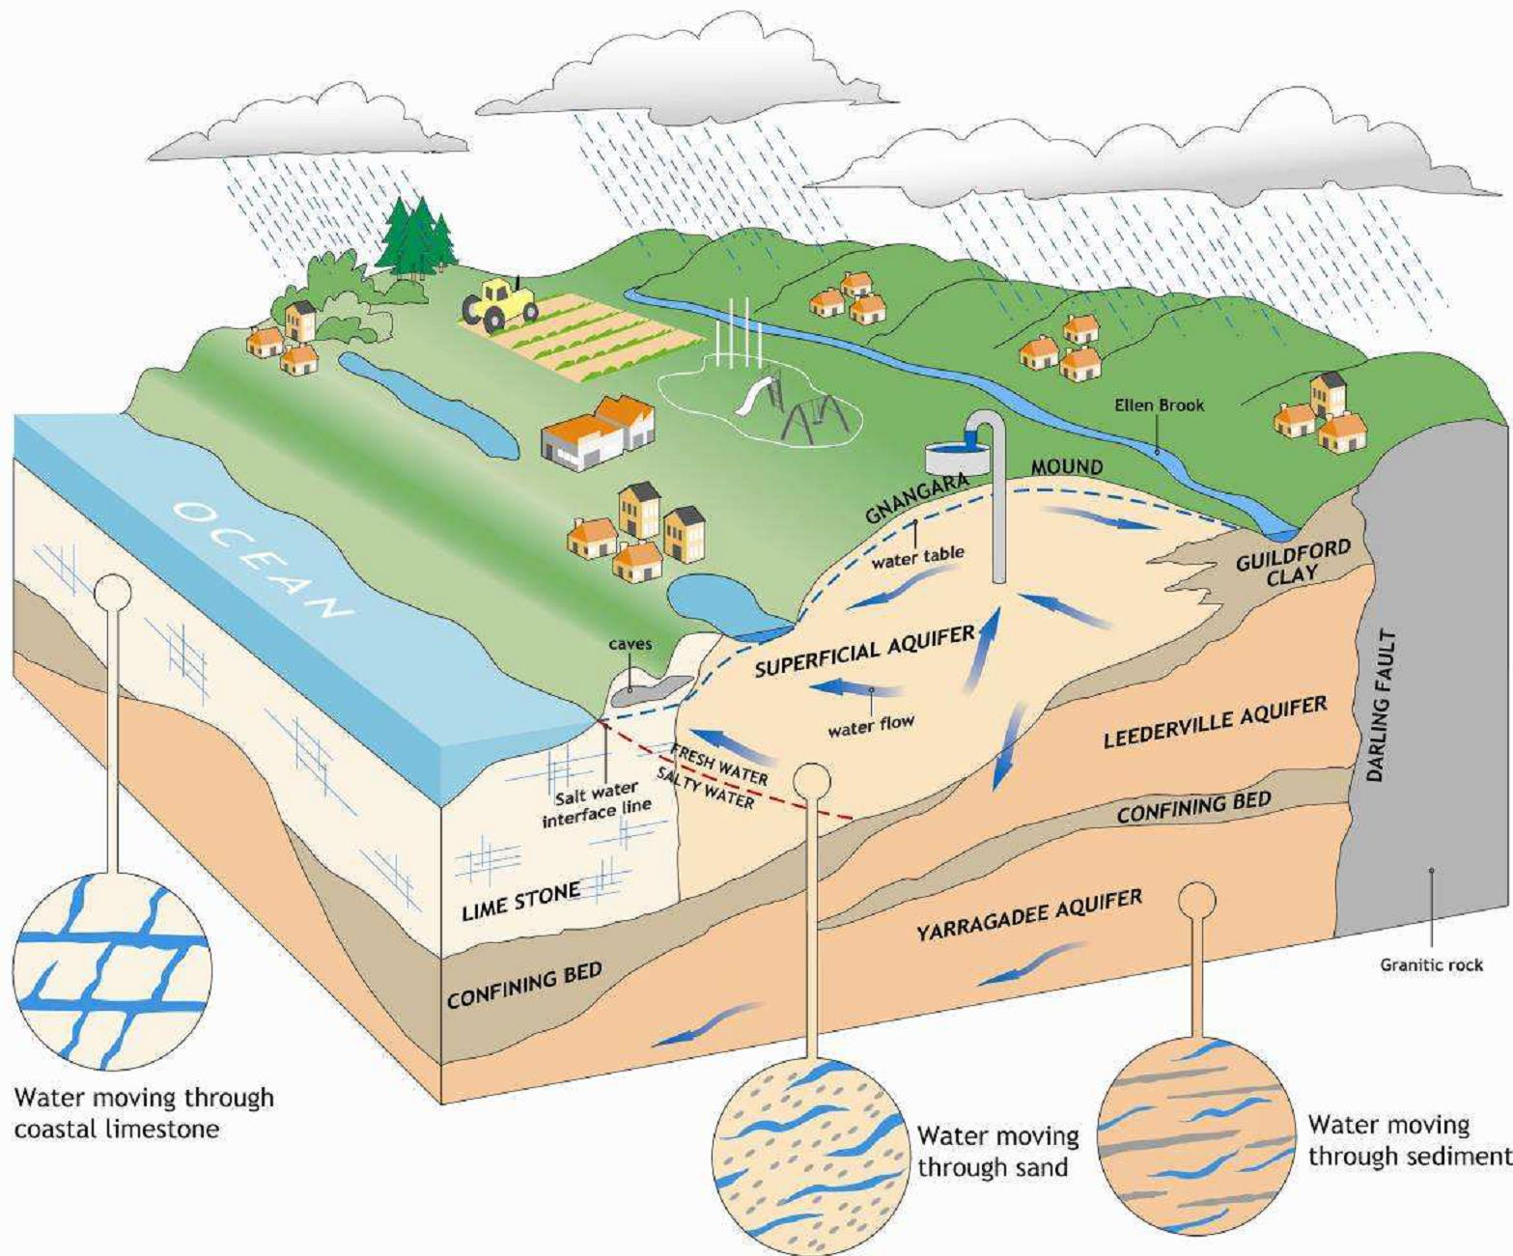

It has recently become well established that the recovery of sub-surface oxidised ASS in wetlands can take years to decades, even once reflooding is established and surface water pH has recovered (Shand et al. 2010, Baker & Shand 2013, Creeper et al. 2015). This is particularly the case in clay-rich soils which contain high amounts of secondary stored acidity (for example in jarosite), due to the quantity of acid and the slow flushing as a consequence of low hydraulic conductivity.

Activities which involve the disturbance of ASS require an assessment both of the hazards and risks associated with these activities, taking into account potential impacts away from the site. Successful management of ASS requires a robust investigation to characterise these soils in order to determine the most appropriate management strategy. The preparation of an acid sulfate soil management plan is deemed prudent and a requirement in most state jurisdictions (Sullivan et al. 2018a). Although a number of guidance documents exist at national, state and territory level (Sullivan et al. 2018a), some key activities which may impact ASS environments are not well understood. One of these areas is the impact of lowering water tables over the short and long term during dewatering activities.

The scope of this document is to provide guidance on managing dewatering activities in shallow groundwater systems where ASS are present below the water table. It is partly based on previous guidelines developed in Western Australia (DER 2015a). The presence of ASS below an unsaturated zone may not be obvious from a study of surface features, yet their impacts can be severe. This limits the use of existing guidelines largely designed for surface (for example wetland and river) and very shallow (for example floodplain) ASS. The intent of this guidance document is to provide best practice methods on characterising shallow groundwater systems comprising mainly unconsolidated soils and sediment containing ASS materials. The chemical processes occurring in these environments are also relevant to deeper aquifer systems, for example sulfide-containing aquifers such as the Loxton Sands of the Murray Darling Basin where pyrite is present below the water table (Shand et al. 2008b), deep coal and coal seam gas systems and basement rocks. However, these aquifer systems are sufficiently different and need different management approaches and are, therefore, beyond the scope of this guidance. This document is not intended to replace existing national, state and territory guidelines. Due to the nature of specific problems related to groundwater dewatering, it is considered complementary, to be used in conjunction with existing guidelines (Sullivan et al. 2018a).

## The extent of and risk associated with groundwater dewatering

Acid sulfate soils (ASS) are a common natural feature in low lying coastal and inland areas and wetland systems of Australia, including regions of high population density and on-going urban development. Floodplain and wetland systems are relatively easy to identify, and guidelines for assessing the presence of ASS, their characterization and management exist at national, state and territory level. For groundwater systems, impacts from disturbance or water table decline are often realised some considerable time after dewatering. This may be due to inter alia a slow decline in the water table, mobilisation of acidity or contaminants only once the profile wets up, or long timescales of groundwater transport of contaminants to receptors. Receptors can range from organisms in within aquifers or hydrologically connected water features such as wetlands, lakes, rivers and estuaries through to humans consuming groundwater and submerged infrastructure. The lowering of groundwater may lead to soil acidification and the release of a range of contaminants (metals, metalloids, nutrients) which are a function of:

* soil type and structure,
* soil mineralogy,
* sulfide content,
* volume of soil exposed to air,
* rate of dewatering, and
* duration of dewatering.

The rate and duration of dewatering control the volume of area dewatered and are key management variables that can be optimally managed to minimise risk. The oxidation of ASS during dewatering, and subsequent reduction following groundwater rebound, are non-linear and poorly understood in detail in the environment. Recent studies in wetland systems have shown that the timescales of remediation (return to reducing conditions) of sub-surface soils can be much longer than the period oxidation of ASS (Shand et al. 2010; Baker & Shand 2015). The management of areas underlain by ASS should adhere to the key principles highlighted in Introduction (Box 2.1).

Urban development continues to expand in Australia’s cities and towns at a range of scales (Figure 3.1) requiring guidelines appropriate to the potential scale of impact. This includes revitalization of industrial and commercial space as well as a trend towards higher density housing to meet the needs of changing demographics. Development often includes dewatering activities which need to be effectively managed to attain successful structures as well as protect the local environment. A lack of effective management may lead to costly, ongoing commitment, and potentially to litigation if damage is caused to neighbouring structures or ecosystems.

Groundwater acidification and associated impacts may also be a natural phenomenon related to natural climate change and variability (for example drought), however, the rates of change are often slow enough that wetland and groundwater systems have learnt to cope with such changes. The rates are often much more rapid during anthropically induced change, particularly in highly modified or managed systems.

A number of regions in southern and central Australia have been affected by declining rainfall and regionally declining water tables. There is a risk that groundwater acidification may become more widespread even in areas where groundwater abstraction is low if pyrite or other reduced phases are present and the aquifers buffering capacity is low.

Figure 3.1 Urban and rural development activities.

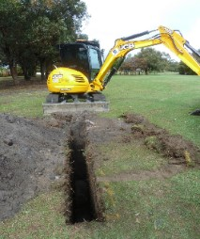 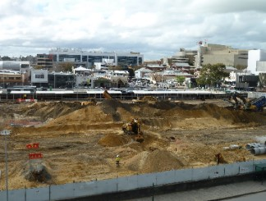

Note: These development activities can lead to dewatering at a range of scales, and management options need to be tailored to the degree of impact as well as a range of local and regional factors.

### Type and extent of groundwater dewatering in areas of acid sulfate soils

A number of processes and actions induce lowering of the water table which could lead to oxidation of sulfide minerals. These may include:

* drought or long-term climate change and variability,
* soil and sediment de-watering during infrastructure and development projects,
* groundwater abstraction for irrigation or public supply,
* groundwater pumping for dust suppression by irrigation of open space during construction,
* installation of drains,
* changes in vegetation for example afforestation,
* rerouting of surface streams or channels,
* decreasing managed irrigation resulting in lower recharge and water tables,
* the removal of soil and other overburden allowing direct ingress of air or overlying oxidizing water (with or without impacts on water table depth), and
* mining of mineral sands, peat and sand and gravel for construction materials.

The amount of dewatering can vary depending on the extent of dewatering and the duration. For example, changes in vegetation or irrigation practices may cause regional scale impacts to the water table, depending on the areal extent of change. Groundwater pumping typically causes a more local cone of depression around the pumped bore or trench which will depend on the hydraulic properties of the soil or sediment as well as duration; multiple bores or high abstraction over time will increase the extent of influence.

For deep uncased bores, there is the potential for water to move from one part of the aquifer to another through the borehole itself that is from areas of high head to lower head. This is particularly the case in complex aquifers where fracture flow is present. It is essential, therefore, to have a good understanding of the hydrogeology of the site prior to dewatering and to design and manage dewatering schemes appropriately. The extracted water may also be highly reducing if sulfidic soils are present, and contain dissolved gases such as H2S and other toxic gases, or dissolved metals such as iron and manganese which may precipitate as (oxy)hydroxide phases upon contact with the atmosphere, as well as very low dissolved oxygen. The National Water Quality Management Strategy (NWQMS 1994), that includes guidelines for surface water and sediments (for example ANZECC/ARMCANZ 2000; Simpson et al. 2013) and for Groundwater protection in Australia (NWQMS 2013), provides guidance for many of these issues.

Sandy soil materials have traditionally been considered to pose a higher risk to soil water and groundwater than clays. This has been largely due to the ability of sands to dewater and oxidise quicker than clays, as well as less buffering capacity if the sands are clean and free of clays and especially carbonate. However, the legacy from drying of sulfidic clays often highlights a greater intensity of acidification, much longer recovery and more difficult remediation. This is due to a number of factors commonly associated with clays:

* typically higher sulfide contents,
* secondary development of sparingly soluble buffering minerals such as jarosite,
* low hydraulic conductivity (dual porosity if cracks have developed), and
* rapid flow to drains and other receptors along preferential flow paths if clays have extensively cracked.

The lowering of the water table in sulfidic peats can also lead to severe problems. They may have high sulfide contents, in some areas they contain high concentrations of arsenic (Appleyard et al. 2006), and are prone to subsidence if dried due to high water contents.

The oxidation processes of ASS are complex and non-linear, hence there is a need to identify trigger points beyond which the impacts are more severe or difficult to manage, and to include these in a management plan and risk assessment. Some of the stages involved in a system undergoing acidification, which are useful in developing conceptual models for management purposes, include:

* initially seasonal or intermittent declines in pH and increased sulfate (SO4) concentrations,
* an increase in base cations (Ca, Mg, Na, K) as well as SO4 due to loss from soil exchange sites such as clays,
* loss of alkalinity as buffering capacity is consumed, and
* dramatic decrease in pH, and increase in Al and other trace metals once alkalinity is completely consumed.

Acid sulfate soils cover large areas of Australia and their actual and potential occurrence has been summarised on ASS maps, available on the Australian Soil Resource Information System (ASRIS) soil map of Australia, a [web-based hazard assessment tool](http://www.asris.csiro.au/mapping/viewer.htm) with a nationally consistent legend; Fitzpatrick et al. 2008). Some state jurisdictions have also produced detailed maps of key areas of interest, which may not yet have been added to ASRIS. These maps do not explicitly cover sub-surface ASS, the distribution of which may well be much greater than currently realised.

### Hazards and risks of groundwater dewatering in areas of acid sulfate soils

The dewatering of sub-surface ASS introduces air into the saturated zone and their subsequent oxidation. This may lead to soil and porewater acidification, depending on the acid neutralisation capacity (ANC) of the soil (mainly the amount of readily soluble carbonate minerals) relative to sulfide oxidised, and the release of metal cations (ions with a positive charge) soluble at low pH (for example aluminium from soil minerals, metals and metalloids from sulfide minerals for example As, Cd, Fe, Ni, Pb). If the soil porewater gets neutralised or if the soils are well buffered, most metals will precipitate from solution or be sorbed onto negatively charged mineral surfaces such as Fe and Mn oxides/oxyhydroxides. These minerals are commonly observed close to impacted ASS and in acid mine drainage areas, the Fe flocs commonly formed as a product of neutralisation of acidic waters (see Step 6 Mitigation and control measures). Radium may also be mobilised due to competition with H+ in acidic sediments, particularly in sandy soils (de Paul & Szabo 2007), but the extent of this in Australia is not well documented due to limited data. In order to predict impacts from acidity or contaminants, it is essential to understand the potential transport pathways of acidic waters towards receptors and the geochemical environment and processes along potential flow pathways.

In general, pyritic sandy soils will oxidise within hours to days of exposure to air (DER 2015a), so it is very likely that oxidation will take place even during a short dewatering program. Groundwater acidification generally starts at the water table and increases with depth as the water table falls, forming an ‘acidification front’. It often forms a shallow stratified layer above otherwise un-impacted deeper groundwater initially (Kjøller et al. 2004; Appleyard & Cook 2009), with subsequent impacts depending very much on groundwater flow characteristics and mineralogy of the soil/aquifer.

It is commonly assumed that ASS which do not undergo acidification due to high ANC can be considered to represent a low hazard. However, there are a number of other hazards associated with ASS (nutrient release, deoxygenation, increased salinity) and some contaminants are mobile at high pH. This latter is often due to the formation of negatively charged oxyanions which sorb less at higher pH. For example, metalloids such as arsenic (As), selenium (Se), antimony (Sb) and the heavy metal uranium (U), which commonly form negatively charged anions, are mobile over a wide range of higher pH values. Salinity increases in groundwater can be large, for example it was found that the electrical conductance (EC) of groundwater more than doubled in irrigation areas at Myalup in Western Australia, largely due to increases in Ca and SO4 from pyrite oxidation (B Degens pers. Comm. 2016). Sulfate is typically very mobile in many hydrological environments and can cause severe environmental problems when discharged to wetlands where sulfate reduction occurs: sulfate reducing bacteria have been shown to be important in methyl-mercury production in the Florida Everglades (USGS 2004); sulfide toxicity to sensitive wetland plants may occur (MPCA 2014); and internal eutrophication due to the release of ammonium and phosphorus during sulfidisation (Smolders et al. 2006). In the US, some jurisdictions have imposed discharge limits on sulfate to water bodies (MPCA 2014). Therefore pH cannot be used alone as a guide to contaminant mobilisation.

Monosulfidic black oozes (MBOs) are typically a surface ASS feature and unlikely to be a hazard in the sub-surface. They may be present in groundwater discharge zones including seepages and wetlands, the latter being important potential receptors during groundwater disturbance. As pumping of highly reducing groundwater poses a risk from reducing toxic gases such as hydrogen sulfide (H2S) and other organo-S gases, safety measures need to considered, particularly in the design of borehole/piezometer installations that will avoid confinement or build-up of these gases (Heckman et al. 2008).

The occurrence of ASS is well known in most low lying coastal areas, but it is only recently that the extent of inland ASS in wetland systems has been realised (Fitzpatrick & Shand 2008). The extent of sulfide minerals in shallow fresh groundwater systems is not well known, in large part due to limited visibility and accessibility to the sub-surface. Nevertheless, the presence of sulfide minerals may be indicated by chemical parameters in the groundwater such as very low redox potential (Eh) and the rotten egg smell of H2S gas. The oxidation of reduced species in solution (for example Fe2+, Mn2+, HS-) generates acidity as H+, so care should be taken when dealing with reducing waters to consider such changes between sampling and analysis.

Groundwater acidification and/or contamination associated with a decline in the water table has been documented in a number of different environments across Australia, some of which are summarised below.

Urban development and dewatering activities on the Quaternary soils and sediment of the Swan Coastal Plain around Perth, Western Australia represent a key management challenge due to the presence of pyrite in thick peaty soils or within underlying Bassendean Sands aquifer of the region (Appleyard et al. 2004). Impacts related to the removal of sulfidic peat (up to 15 wt. % sulfide) for residential development have included groundwater abstraction (including domestic bores) and artificial lake acidification and contamination by metals and metalloids above national drinking and ecosystem protection guideline values (for example As concentrations up to 7300 µg/L). The progressive urbanization of previously undeveloped land may lead to a rise in water-tables and use of drainage to control the impacts of these. This may lead to the need for extensive drainage to lower the risk of flooding, especially in low lying areas. The drains may act as conduits for rapid transport of water to water bodies with the potential to impact receiving environments. Seasonal fluctuations in rainfall and runoff, combined with mobilisation of organic matter to drains can also lead to pulsed releases of acidity and contaminants (Figure 3.2 Processes of soil acidification and contaminant discharge in urban drains under varying rainfall-runoff periods.). The demand for water features, such as artificial lakes, in public open spaces may also lead to acidification of water if the drains are set too deep and intersect ASS in the shallow aquifer. Wetlands with pH values as low as 2.5 have been recorded in the Perth metropolitan area following excavation (Appleyard et al. 2007).

Groundwater acidification has also been documented at a regional scale with decreasing water tables due to abstraction and a long-term reduction in recharge (Appleyard & Cook 2009; Clohessy et al. 2013; see Box 3.1). This has occurred even in high purity sands with extremely low sulfide contents (approximately 0.01 weight %) which were poorly buffered due to low alkalinity (no carbonates or clays to buffer acidity).

A decrease in the water table in irrigation areas on floodplains adjacent to the lower River Murray in South Australia during the Millennium Drought also caused extensive acidification of groundwater and drain water along with mobilisation of metals and metalloids (Fitzpatrick et al. 2012; Mosley at al. 2014). In this case, the problem was only realised post-drought (late 2010) after the water table rose due to increased recharge and a return to normal river pool levels (Box 3.2). The affected soils comprised cracking clay soils which proved extremely difficult to remediate due to high acidity (high contents of jarosite were formed) and low hydraulic soil conductivity of clays. The presence of deep cracked clays allowed for rapid transport of acidic waters to drains and across paddocks, whilst the presence of jarosite in clay peds buffered the pH to low values. In some areas of the basin, groundwater pH still remains acidic (less than pH 4 during 2017), years after groundwater rebound (Baker et al. 2014; Mosley et al. 2015; Shand et al. 2017). The limited success of treatment options (Box 3.2) highlights the preferred options of minimizing water table decline or time of oxidation/duration of dewatering in clay soils. The presence of rapid preferential flow paths in heavily cracked sulfuric soils means that a different approach is needed to manage such sites compared to saturated soils (although preferential flow paths are not uncommon in saturated clays).

Figure 3.2 Processes of soil acidification and contaminant discharge in urban drains under varying rainfall-runoff periods.

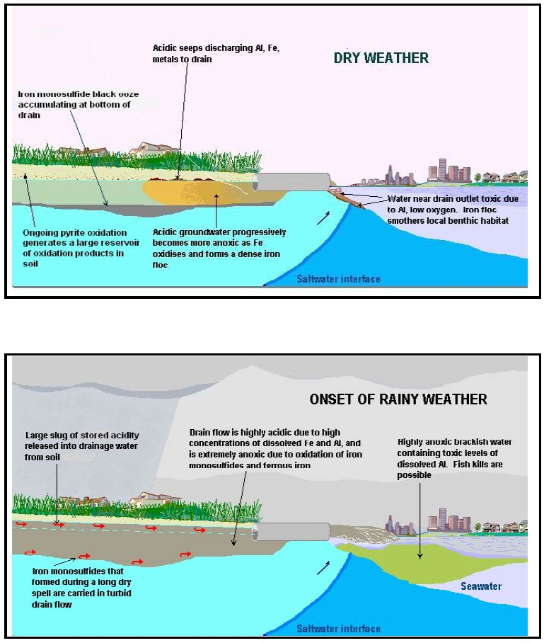

Source: DER 2015a.

The problem of acidification near the water table may not be apparent from pH measurements if a long screened interval is such that the acidic water becomes neutralised in the borehole column. During pumping for salt interception schemes in the Lower Murray-Darling Basin, circumneutral pH groundwater was found to contain high concentrations of Al (as colloids and precipitates of amorphous aluminium hydroxide colloids/gels) which clogged well screens and pumps (Figure 3.4) as the acidic inputs were neutralised (Shand et al. 2008b).

The mining of mineral sands from below the water table directly affects shallow groundwater and may have a local impact on water quality. This may lead to mobilisation of dissolved iron and sulfate if pyrite is present in the sands (Viswanathan 1990; BHP 2003) or to the release of contaminants from mineral phases especially if pH becomes very acidic.

Box 3.1 Managing regional groundwater with ASS on Gnangara Mound Western Australia.

The Gnangara mound is part of a groundwater system beneath the northern part of Perth that provides over 75% of public water supply, irrigated horticulture, ovals, parks and gardens for the city. The system comprises a regional superficial aquifer in Quaternary sediments that recharges deep confined aquifers of Cretaceous and Jurassic age in the Perth Basin. Shallow groundwater beneath the mound supports numerous groundwater-dependent wetlands. In many, groundwater is important for the health of the wetland as it flows through and interacts with sediment and pooled water in the wetlands. Rainfall has decreased by 16% on Gnangara mound since the late 1960’s(Indian Ocean Climate Initiative, 2012) with a drying and warming trend projected to continue over coming decades (Department of Water, 2015a).

Figure 3.3 High ASS risk areas on Gnangara Mound Western Australia.

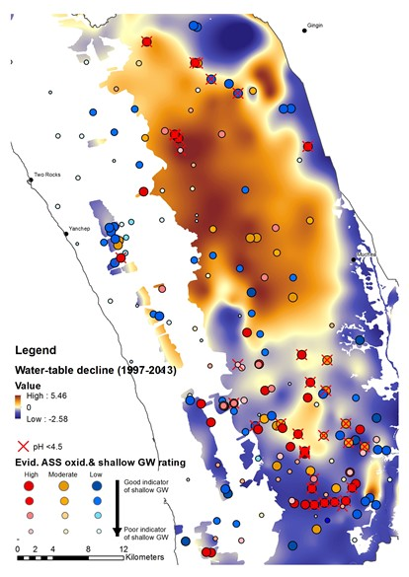

ASS are extensive with sulfidic horizons marginally beneath the water-table at more than 60 m above sea level (Appleyard & Cook, 2008; Prakongkep et al. 2012). Sulfides are concentrated in wetland and palaeo-wetland deposits (typically greater than 0.2%S) (Appleyard & Cook, 2008; Searle et al. 2010) mapped as high ASS risk areas (see Figure 3.3). These are interspersed by more extensive areas where sulfides at low concentrations (0.01 to 0.03%S) occur in low buffer capacity, sands of the Bassendean sand formation (Prakongkep et al. 2012) mapped as medium ASS risk (see Figure 3.3).

**The situation**

ASS have been disturbed by regional water-table decline on Gnangara mound due to a combination of drying climate, pumping and land use such as pine plantations, with the latter two being more significant in the central and southern part of the State.

Regional decline in the water table has led to drying and acidification of some wetlands and regional decline in water quality. There has been acidification of water in several wetlands such as Lake Gnangara and Lake Mariginiup (Searle et al. 2010) coupled with acidification of sediments and shallow groundwater at a much larger number of wetlands, mostly those in the Bassendean sands (Department of Water, 2011a; Degens et al. 2017). Soil and groundwater investigations at 16 wetlands have found oxidation of sulfides at or near the top of the water-table (lower pH, depleted or no alkalinity and/or elevated SO4:Cl)(Searle et al. 2010; Department of Water, 2011a; Degens et al. 2017). The influence on groundwater quality at wetlands, could extend up to 10 m below the water-table (Degens et al. 2017).

Wetland acidification is coupled with patchy but spatially extensive impacts on shallow groundwater quality (Appleyard & Cook, 2008; Clohessy et al. 2013; Degens, 2017). Data combined from multiples sources indicates an influence of ASS oxidation on shallow groundwater quality mostly in the south and on the fringes of the mound at wetlands (Degens, 2017), but is less evident in areas with greatest water-table decline: the Figure shows the extent of water table decline in areas with ASS risk on the mound in relation to indication of ASS oxidation for shallow groundwater. While low pH groundwater was detected in some places, other aspects of the quality indicated oxidation was occurring, such as depleted alkalinity and elevated SO4. Greater evidence of ASS impacts in the south were clear because data was available from a network of shallower bores (Clohessy et al. 2013) and rises in water-levels in the recent decade accelerated flushing of oxidation products to shallow groundwater. Elsewhere, limited recharge and leaching of oxidation products to groundwater was probably responsible for the limited impacts on shallow groundwater quality, despite likely oxidation of sulfidic materials with water-table decline.

**Managing groundwater**

Groundwater is managed on Gnangara mound through water use planning to meet water level and quality targets and licensing and assessment of use, long-term pumping and short-term dewatering. Plans set limits on groundwater pumping and licensing within sub-areas on the mound, and are regularly updated and revised taking into account monitoring information (Department of Water, 2011, 2015a). ASS have been progressively addressed in successive groundwater allocation plans and revisions since 2004 with a transition from risk assessment based on broad mapping to risk assessment based on tools integrating ASS management criteria with outputs from regional groundwater modelling.

Groundwater management in areas with ASS risk is guided by defining minimum water levels that maintain submergence of surface ASS or saturation of sub-surface ASS. These are determined from soil investigations to benchmark the depth of sulfidic horizons. The minimum levels are often incorporated with eco-hydrological information to define environmental water requirements (EWR’s) at many wetlands and are often adopted as surrogate EWR’s when no other information is available. The impacts of various rates and location of groundwater pumping on groundwater levels are determined in relation to the impacts of climate change and land use change using the Perth Regional Aquifer Modelling System (PRAMS). This information is used to determine appropriate levels of allocation so that water-level changes due to pumping impacts are minimised.

**Risk profiling**

A recently developed tool has enabled the effects of ASS on water quality to be fed into the decision making process around allocation limits, to complement management of ASS risks incorporated with EWR’s. This tool provides tailored information on the spatial impacts of ASS from changes in modelled groundwater levels modelled by PRAMS10. ASS risk mapping is combined with water-level changes to generate a broad indication of the relative risks to groundwater quality and impacts on groundwater users. The approach is based on estimating the depth of acidification in the unconfined aquifer from future changes in water levels in areas with ASS risk and using this to quantify groundwater use likely to be affected. Depth of acidification is determined by a simple numeric function representing an average equilibrium state of low pH, metal enriched water below the future water table arising from water table decline exposing extensive, low % sulfides in Bassendean sands. The function provides an interim mechanism to rank spatial impacts of ASS on water quality, and is within an order of magnitude of actual equilibrium leaching (Degens, 2010), despite being a gross over-simplification of complex processes of unsaturated and saturated zone reactive transport. However, there is evidence at a number of sites that the depth of acidification below the water-table broadly corresponds with previous water-table decline (Degens, 2010) and is consistent with local scale reactive transport modelling (Salmon et al. 2014). Volume of use is modelled from distributions of inlet depths for pumping bores for sub-areas with ASS risk(Degens, 2010).

**Managing the problem and a way ahead?**

The Western Australia Department of Water is reducing groundwater pumping, advocating land use change (urbanisation and removing plantations), increasing efficiency and facilitating managed aquifer recharge to minimise water level decline where current impacts on groundwater acidification and wetlands are greatest (Department of Water, 2015b). Pumping is being progressively reduced to bring use into balance with reduced recharge caused by the change to a drier climate.

Management responses to the drying climate consist of progressively moving from maintaining water levels to slowing water-level decline, where possible. The drying climate is a significant contributor to water level decline in many areas of Gnangara mound that has led to drying and acidification of wetlands and shallow groundwater in northern areas (Figure 3.3). Drying and water-level decline is expected to continue in the coming decades (Indian Ocean Climate Initiative, 2012; Department of Water, 2015a; CSIRO, 2009) which raises the prospect of continued regional scale oxidation of ASS. In Bassendean sands with extensive ASS, but with low sulfide concentrations, climate change may result in slow rates of acid generation over large areas, as ASS are progressively oxidised in the mid-term by falling water tables. For more concentrated sulfidic materials in wetlands and palaeo-wetland deposits (with %S greater than 0.2%), acid generation is likely to be significant and extend over many decades if these dry out.

Options for mitigating and remediating acidification on Gnangara mound can be adapted from measures used at local scales. Future acidification on Gnangara is likely to comprise the same combination of existing acidification; being more concentrated in wetlands and more diffuse and regional between wetland systems.

The nature of the acidity sources and concentrations point to management measures that work at the different scales. For regional acidification, the rate of acid generation might in some parts of the aquifer be matched by in-situ remediation processes (for example rate of neutralisation from sulfide reduction) depending on the concentrations and quality of dissolved organic C in recharge. Strategic management of the alkalinity of recharge waters in particular land uses is an option for enhancing these processes. This can be achieved by liming of soakwells and stormwater infiltration pits in new and existing urban developments and liming of soils following removal of pine plantations (when recharge rapidly increases).

Mitigation options for more concentrated sulfidic materials in wetlands might include re-submergence or isolation and control of impacts. Re-submergence requires raising water-levels to prevent further oxidation and encourage re-sulfidisation to reverse ASS oxidation, but would need to consider whether this is practical in the long-term with the effects of a continued drying climate. In the short-term, this could involve supplementation from the confined aquifers until water levels rise through management measures to reduce pumping and increase recharge (for example by removing pine plantations or increased urbanisation). Several wetlands are currently supplemented on Gnangara mound, but this is expensive and in some cases increasingly difficult to achieve with continued decline in water levels, for example at Nowergup (Global Groundwater, 2015). Isolation of acidity sources to minimise recharge and reduce impacts on down-gradient groundwater may be an impact mitigation option for ASS where drying is unavoidable.

**References**

Appleyard, S & Cook, T 2008, ‘Reassessing the management of groundwater use from sandy aquifers with climate change and population increase: acidification and calcium depletion exacerbated by drought, groundwater withdrawal and land use practices on the Gnangara Mound, Western Australia’, *Hydrogeology Journal*, vol. 17, pp. 579–588.

Clohessy, S, Appleyard, S & Vogwill, R 2013, ‘Groundwater acidification near the water table of the Superficial aquifer, Gnangara Mound, Swan Coastal Plain, Western Australia’, *Applied Geochemistry*, vol. 36, pp. 140-152.

CSIRO 2009, *Groundwater yields in south-west Western Australia*, a report to the Australian Government from the CSIRO South-West Western Australia Sustainable Yields Project, CSIRO Water for a Healthy Country Flagship, Australia.

Degens, BP 2017, *Estimating acid sulfate soil impacts from water-table decline on Gnangara mound groundwater users*, Department of Water Hydrogeological Report Series, Report No HR348.

Degens, BP, Hammond, MJ & Bathols, GR 2017, *Perth shallow groundwater systems investigation: North Yeal Wetlands*, Department of Water Hydrogeological Record Series, Report No HG63.

Department of Water 2011a, *Perth shallow groundwater systems investigation: Tangletoe Swamp*, Department of Water Hydrogeological Record Series, Report No HG49.

Department of Water 2011b, *Water allocation planning in Western Australia – a guide to our process*, Water Resource Allocation Planning Series, Department of Water, Government of Western Australia, Perth.

Department of Water 2015a, *Selection of future climate projections for Western Australia*, Water Science Technical Series, report no. 72, Department of Water, Western Australia.

Department of Water 2015b, *Gnangara groundwater areas allocation plan – evaluation statement 2011-2014*, Department of Water, Government of Western Australia, Perth.

Global Groundwater 2015, *Lake Nowergup – factors in declining lake and groundwater levels*, Report to Department of Water, Government of Western Australia.

Indian Ocean Climate Initiative 2012, *Western Australia's weather and climate: a synthesis of Indian Ocean Climate Initiative Stage 3 Research*, CSIRO and BoM, Australia.

Prakongkep, N, Gilkes, RJ, Singh, B & Wong, S 2012, ‘Pyrite and other sulphur minerals in giant aquic spodosols, Western Australia’, *Geoderma*, vol. 181-182 pp. 78–79.

Salmon, SU, Rate, AW, Rengel, Z, Appleyard, S, Prommer, H & Hinz, C 2014, ‘Reactive transport controls on sandy acid sulfate soils and impacts on shallow groundwater quality’, *Water Resources Research*, vol. 50, pp. 4924–4952.

Searle, JA, McHugh, SL, Paton, AC & Bathols, G 2010, *Perth Shallow Groundwater Systems Investigation: Lake Mariginiup*, Western Australia Department of Water, Hydrogeological record series, Report no. HG 36.

A change in water pressure in confined aquifers may also impact on associated groundwater dependent ecosystems, for example a decrease in deeply sourced groundwater discharge to springs in the Great Artesian Basin in South Australia has caused severe acidification of soils (pH less than 1) and impacts on unique endemic groundwater dependent ecosystems in an otherwise arid environment (Shand et al. 2016).

Figure 3.4 Clogging of pumps (left) and well screens (right) by amorphous Al hydroxide.

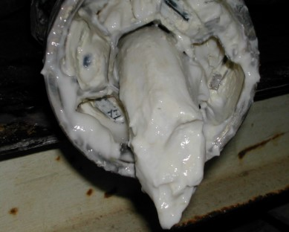 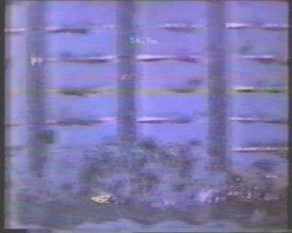

Note: Al hydroxide was caused by the ingress of Al-rich acidic groundwater into a borehole column of circumneutral pH.

Source: Shand et al. 2008b.

Box 3.2 Drought impacts on groundwater in the Lower River Murray, South Australia.

The “millennium” drought from 2000 to 2010 in the Murray-Darling Basin resulted in extreme low river flows and water levels in the lower reaches of the river in South Australia. The groundwater on adjacent agricultural floodplains is hydraulically connected to the river and, coupled with the lack of irrigation application, groundwater levels declined by greater than 1 m from pre-drought levels (see Figure 3.5). The magnitude of the surface water and groundwater decline was unprecedented over the last few decades as river levels had been maintained via regulation. The drainage from the agricultural irrigation areas is returned to the River Murray using large pumps, a process required to prevent land salinization. This region of the Lower Murray is just upstream from the Lower Lakes (Ramsar listed system of international ecological importance) and also contains major drinking water offtakes for the city of Adelaide.

Figure 3.5 Changes in groundwater level, soil pH and groundwater pH before, during and after the Millennium Drought.

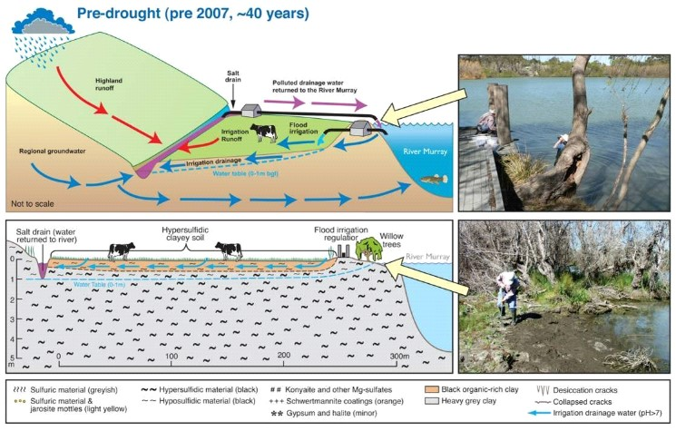 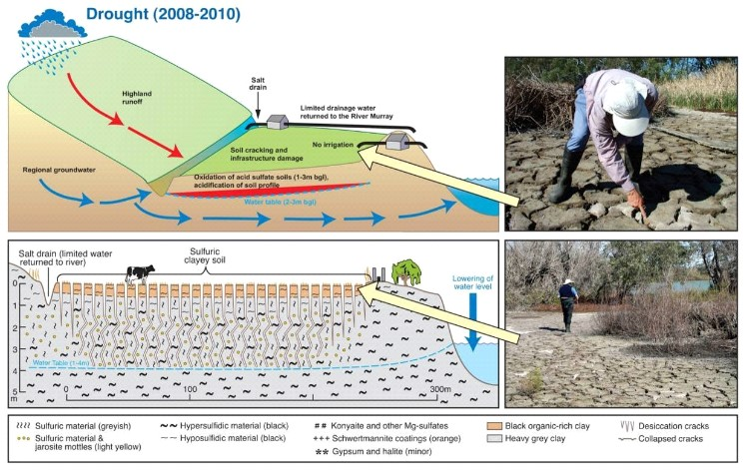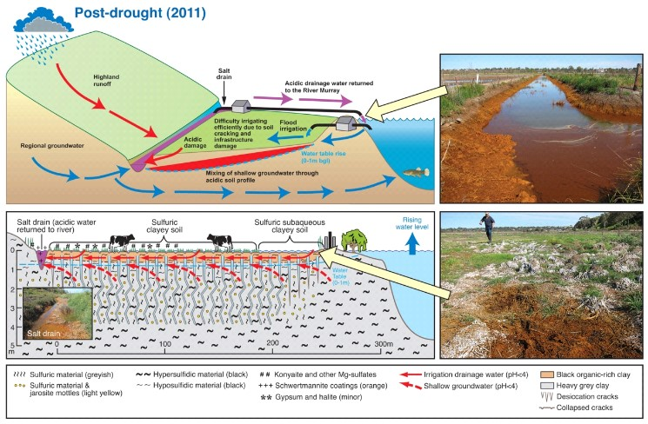

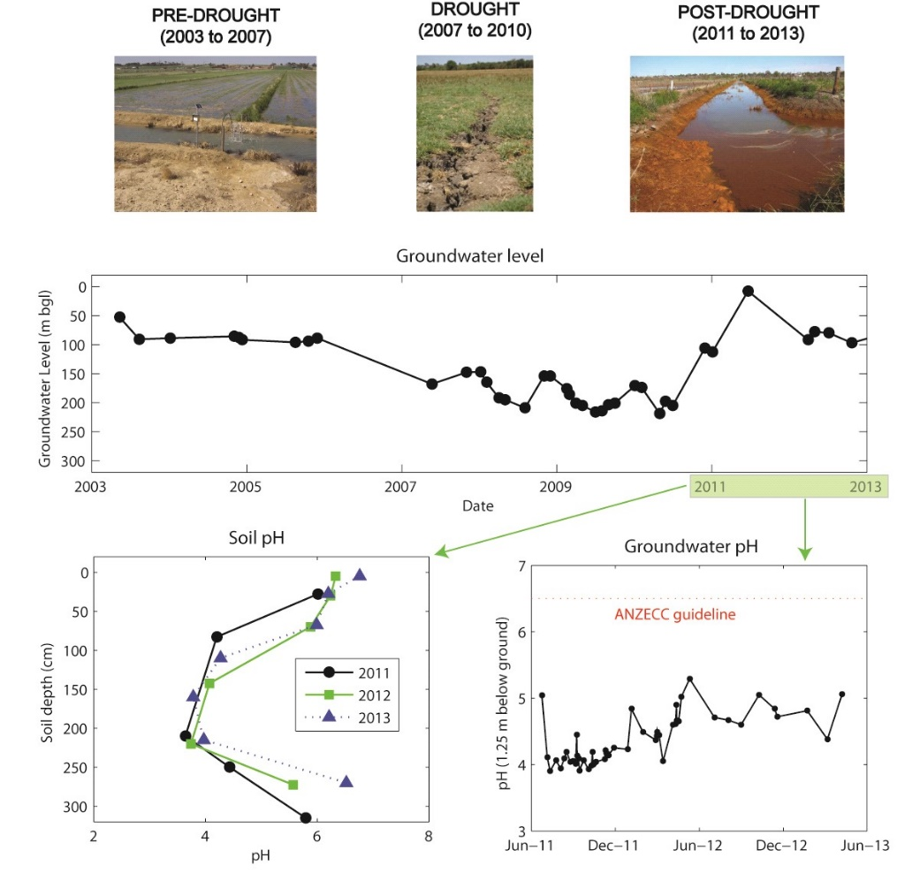

During the latter 3 years of the drought period, the heavy-clay soils cracked and sulfidic material oxidised to form sulfuric material in a zone approximately 1 to 2 m below ground level over an estimated 3300 ha of floodplains (Mosely et al. 2014b). After re-flooding and irrigation during 2011, acidification of surface water (pH 2–5) and groundwater (pH 4), release of metals, and precipitation of orange-brown iron sulfate minerals (Schwertmannite) in drains was observed (Mosely et al. 2014a, b). This acidic drainage water is returned to the River Murray with the saline plume sinking and travelling downstream on the bottom of the river. The pH is neutralised in the immediate mixing zone (Mosely et al. 2014a). Despite over six years of re-submergence after groundwater levels returned to normal after the millennium drought, the oxidised subsoil and groundwater on floodplains along the River Murray has remained very acidic (pH 3–5).

The persistent and severe landscape acidification that developed in the area during the drought has proven very difficult to manage. Various management techniques were trialled (Palmer et al. 2013). Lime (CaOH2) dosing of drains proved successful but would be costly to implement over a large area and to maintain long term. Flood irrigation, spreading of limestone on paddocks and deep lime injection showed only temporary benefits. The deep location of the acidity made treatment at the soil source very difficult. The lack of natural remediation after several years is linked to the lack of sulfate reduction (generates alkalinity) due to unavailability of organic carbon (Yuan et al. 2015) and low pH. Monitoring and assessment by South Australian government agencies is continuing.

**References**

Mosley, LM, Fitzpatrick, RW, Palmer, D, Leyden, E & Shand, P 2014a, ‘Changes in acidity and metal geochemistry in soils, groundwater, drain and river water in the Lower Murray River after a severe drought’, *Sci. Total Environ.*, vol. 485–486, pp. 281-291.

Mosley, LM, Palmer, D, Leyden, E, Cook, F, Zammit, B, Shand, P, Baker, A & Fitzpatrick, RW 2014b, ‘Acidification of floodplains due to river level decline during drought’, *J. Contam. Hydrol.*, vol. 161, pp. 10-23.

Palmer D, Leyden E, Fogg M, Mettam P, Fradley K & Mosley LM 2013, *Lower Murray Reclaimed Irrigation Area (LMRIA) acidification risk project: scoping and trialling of remediation options*, EPA, Adelaide.

Yuan, C, Fitzpatrick, R, Mosley, LM & Marschner, P 2015, ‘Sulfate reduction in sulfuric material after re-flooding: Effectiveness of organic carbon addition and pH increase depends on soil properties’, *J. Hazard. Materials* vol. 298, pp. 138-145.

Acidic, saline drains in the Western Australia Wheatbelt are thought to be caused by land use change as well as dewatering activities (Shand et al. 2008a; Degens et al. 2012), however, the acidification is not directly related to the oxidation of ASS (although ASS form within drains). Nevertheless, recent guidelines which have been developed for the treatment and management of such acidic drains (Degens 2009) are relevant to dewatering in acid sulfate soil terranes.

Sandy ASS on Bribie Island Area of Queensland together with podzolic soil profiles, coffee rock and low-pH suggests that similar processes to the Swan Coastal Plain are taking place there and other sand islands in the region (Malcolm et al. 2007).

Groundwaters within an aquifer are typically variable in terms of chemical parameters, related to spatial variability of the host soils/rocks, residence time and geochemical environment (in terms of pH and Eh). This generally leads to spatial variations in water quality and impacts, both horizontally and vertically. The acidity associated with regional scale dewatering can be restricted to the region near the water table surface (Kjoller et al. 2005; Appleyard & Cook 2009), but is dependent on a number of factors including rate of change and buffering capacity of the aquifer. Characterization of the soils and groundwater, and the development of groundwater conceptual models need to take into account these aspects in any management plan.

### Policy and regulatory environment

The NWQMS (2013) Guidelines for Groundwater Protection in Australia provide a framework for protecting groundwater from contamination in Australia. Each of the states and territories have a range of legislation (Acts) that require consideration when assessing and providing approvals and/or consents for activities which involve disturbance of the landscape. They also have their own regulations with regard to installation of boreholes, the amount of dewatering, and licensing which will need to be considered and adhered to in project planning and implementation. Project proposals (and their consent) will also need to consider any local management plans and systems, such as Catchment Management Plans/Strategies and Coastal Management Plans, Resource Management and Planning System (RMPS), and guidance specific to ASS management, and water, sediment and soils quality guidelines (ANZECC/ARMCANZ, 2000; NEPM, 2013; Simpson et al. 2013).

### Current management practices

Current management practice documents on groundwater dewatering are limited, and largely based on, and incorporated in, guidelines for ASS in general, for example quantifying the amount of soil within the area of dewatering as a contribution to soil removed. The challenges for site assessment, monitoring, treatment, remediation and assessing risk are however significantly different for the sub-surface compared to surface and near-surface ASS.

The key management principles associated with ASS (Box 2.1 and National Working Party on Acid Sulfate Soils 2000) remain broadly relevant to managing the dewatering of groundwater in sulfidic environments. These management principles outlined in the National Strategy are:

• Identify and define the distribution of ASS,

• avoid disturbance of ASS,

• mitigate impacts when disturbance in unavoidable, and

• Rehabilitate disturbed soils and associated drainage.

In some cases for example regional dewatering due to a decrease in recharge, avoidance may not be possible and mitigation may have to be focused on the protection of key assets whilst managing regional groundwater resources. Management and risk assessment of ASS should also include monitoring to understand the progression of acidification risks. This provides information to enable development of approaches and opportunities for regional scale remediation including strategic liming, aquifer treatment walls et cetera. Many of these have been used for specific contamination issues and might be adapted for regional acidification issues.

The sampling and characterization of ASS, which forms a requirement of any ASS management plan (ASSMP) are summarized in a number of state guidelines, and these are summarised in the guidance document by Sullivan et al. (2018b,c). Most states follow similar protocols in their jurisdictional guidelines, albeit with a slightly different emphasis depending on local issues (for example Ahern et al. 2004; DER 2015b; Dear et al. 2014). For inland ASS, national guidelines (EPHC & MRMMC 2010), largely based on coastal ASS guidelines, play a similar role. The characterization and trigger values for further action (Appendix A: Texture based action criteria for acid sulfate soils) are accepted across Australia, but in detail, management protocols and legislation do vary (Sullivan et al. 2018a).

The most comprehensive guidelines specifically for groundwater were developed by the Western Australia Department of Water and Environment Regulation (DWER; formerly DER) as part of a Guideline Series for ASS (DER 2015a). These deal largely with the type of soil and sediment in the Swan Coastal Plain around Perth comprising mainly sands with low contents of sulfide, but limited acid buffering capacity. For urban development activities in Perth, developers are required to submit a dewatering management plan to meet the requirements of DWER (DER 2015a). This needs to demonstrate that the extent of dewatering will not cause excessive drawdown of the water table beyond the construction site. An on-line tool is available on the DWER website which allows calculation of a simple cone of depression and timescales involved with some basic input parameters (extent of excavation, required drawdown, saturated aquifer thickness and hydraulic conductivity). Depending on the extent of dewatering, a groundwater flow model may be required to determine the extent of dewatering. The DWER guidelines also cover techniques to constrain the lateral extent of dewatering including sheet piling or recharge barriers (DER 2015a), and also recommends that ASS disturbance be staged so that the area disturbed at any one time is limited. The level of management response was also linked to the extent and duration of dewatering, with greater degrees of dewatering linked to a more comprehensive response. DWER (DER 2015a) also provided a range of mitigation and monitoring techniques and advice on completion of required closure plans.

Dewatering and drainage is also discussed in Queensland guidelines (Dear et al. 2014), where they emphasise that large-scale dewatering activities are high-risk, will need management measures sufficient to reduce risk to levels acceptable to administering authorities, and no permanent dewatering may be undertaken in such areas. The risks are considered lower if limited or localised drawdown takes place of short duration, and are also considered to decrease in clay soils where hydraulic conductivity is low.

These studies form a good basis for the following guidelines developed in Management strategies and ASS Groundwater management levels and planning.

## Management strategies

With the purpose of avoiding environmental harm from acid sulfate soils (ASS) encountered during dewatering projects, it is recommended that a tiered assessment framework be adopted through which technical and procedural guidances can be implemented. The assessment of environmental risks is commonly undertaken in an iterative manner between project managers and regulatory agencies where the suitability of site-specific data is assessed and consensus reached. The acceptance of any management plan for implementation of dewatering is likely to be based on the following conditions:

* development of a sound conceptual model relevant to the site, including hydrogeology, distribution of potential ASS hazard and sensitive receptors, and paths to impact,
* implementation or a firm commitment to implementation of risk mitigation measures appropriate to the scale of dewatering, and
* long-term contingency plan incorporating a commitment to appropriate monitoring.

This chapter details steps within the assessment framework, provides information and guidance on methodologies used and requirements for final closure of intended works. A generic framework is shown in Figure 4.1 which illustrates the principles involved and role of the conceptual model throughout the process. This is developed further Management strategies and in ASS Groundwater management levels and planning.

Figure 4.1 Typical framework used as an assessment framework.

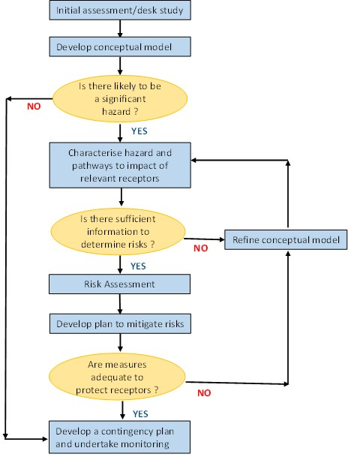

Source: Modified from Younger and Sapsford 2004.

The proposed assessment framework is intended to provide a step-wise decision process through which proponents that are considering dewatering activities can work through to provide adequate information when applying for approvals/consents. The proposed eight steps comprise:

1. Providing a project description that includes details of the proposed dewatering activity (the need, location, scale, environment).
2. Desktop assessment determining the likelihood that ASS may be encountered and if it represents an environmental risk; and if not then ASS assessment may not be necessary and the proponent should consider the relevant state, territory and national guidelines for assessing dewatering activities. The assessment of hazardous ASS requires careful consideration of scale and ASS properties. Initial semi-empirical groundwater hydraulic calculations should be performed and an initial conceptual model developed.
3. Where ASS hazards exist or are likely to exist at a scale requiring management of risks from dewatering (relating to quantity and properties), then an evaluation of alternatives be made to avoid and/or minimise disturbance or impacts of the ASS. Then re-assess as per step 2 to determine whether potential ASS impacts remain (that is once the likelihood of disturbance of hazard has lowered).
4. Where ASS hazard is or is likely to be present, following measures to avoid and minimise disturbance, then a full characterization of the ASS properties and an assessment of risks posed by ASS at site of dewatering will be required. The groundwater chemistry (and adjacent receptors) prior to disturbance should also be characterised to determine an initial baseline. This step will underpin the needs for management during dewatering operations, and monitoring.
5. Groundwater investigations should be undertaken to determine a more detailed conceptual groundwater model of the area including all potential receptors, calculations of the area of impact, the extent and duration of dewatering required and the impacts related to ASS using data from Steps 1-4. This should also include a plan for disposal of groundwater. A risk assessment should be completed at this stage, as well as any update of the conceptual model.
6. Development of mitigation and control measures to minimise the risks of acidification and other impacts which may affect the site, adjacent area or potentially connected receptors.
7. A monitoring strategy should be planned and implemented. This should be designed so as to determine changes in the area of dewatering, leakage through constructed barriers and potentially impacted receptors.
8. Closure reports should be completed and include details of the work carried out, any treatment work undertaken, the results of the monitoring program, off-site removal and disposal, discussion of the effectiveness of the management strategy and any further remedial measures that might be needed in the future.

These steps will provide strategies, processes, protocols and actions to identify and define the management problem, to avoid and minimise disturbance, to mitigate and limit impacts when disturbance is unavoidable or has occurred, and to rehabilitate sites and affected areas to ‘fit for purpose’ use where there has been impacts from disturbance. This approach is consistent with existing guidance documents, for example decision trees with ANZECC/ARMCANZ (2000), NAGD (2009) and Simpson et al. (2013), and will provide a risk-based approach to minimising the impacts on water quality from dewatering of ASS. Where impacts cannot be avoided, then the framework directs the proponent to minimise impacts, and develop clear management and monitoring plans, with justification specific to the project needs and any constraints.

A risk assessment process should identify and characterise the environmental hazards associated with dewatering ASS below the water table, identify environmental receptors, and determine the principal pathways through which contaminants may be transported to the receptors. The general process for undertaking such a risk assessment can be found in the National Environmental Protection Measure (NEPM 1999, amended 2013) for the [Assessment of Contaminated Sites](http://www.scew.gov.au/nepms/assessment-site-contamination).

The risk assessment approach adopted should be based around a source-pathway-receptor framework. The risks posed are likely to vary in space and time as well as in intensity during and following dewatering operations.

A number of management options are discussed in the following sections for mitigation and control measures that are commonly applied in remediation of impacted sites, for example the use of permeable reactive barriers, lime injection or limestone drains. However, remediation and management strategies are beyond the scope of this document and the reader is referred to existing national and regional guidelines (for example DER 2015a) for guidance on remediation (Sullivan et al. 2018a).

### Step 1 Project description

The project description should be the first and ‘minimum requirement’ for proposed dewatering activities that may disturb ASS. It should describe the need for the proposed dewatering activity and the intended management of the water table (artesian pressure if confined), and disposal of the extracted groundwater (including longer-term monitoring). The application of ‘best practice’ should form the basis for all aspects of project description, including proposed design, selection of methods and environmental management and monitoring. It should clearly describe and demonstrate consideration of options to avoid impacts to the environment, including any terrestrial, aquatic and benthic receptors. The project description could include, depending on the nature and scale of the proposed dewatering operation:

* purpose of the dewatering operation, including a clear rationale for the location, scale (for example potential volume of groundwater extraction) and pumping rate,
* a site map with proposed extraction and disposal areas, and location of any other relevant points of interest/potential impact (for example Aboriginal heritage areas, sensitive/important aquatic ecosystems, water offtakes, native vegetation),
* detect all storm water drains, channels and other potential pathways to waterways,
* utilisation of ASS maps using ASRIS and local hazard or risk ASS maps if available,
* alternatives to undertaking dewatering (including environmental, social and economic impacts of each alternative),
* significant natural and cultural features of the sites (where extraction occurs, where disposal occurs),
* the physical constraints of the site (such as groundwater depth, sediment type, height – Australian Height Datum),
* area of cone of depression or change in depth of water table and areal extent,
* environmental impacts of the project on air, soil and water quality (groundwater and surface water),
* proposed extraction technique, source of equipment and temporary storage or transport strategies,
* a description of opportunities for beneficial use of extracted groundwater, including treatment to create beneficial re-use,
* options to prevent oxidation of ASS (for example minimise time of dewatering activity, installation of barriers to minimise dewatering area) and spreading drawdown across several bores,
* waste management and disposal, particularly saline/contaminated groundwater,
* waste prevention strategies to reduce or remove the hazardous constituents (contaminants, salinisation), preventing acidification, leachates (mitigation or remediation measures, and methods for monitoring the effectiveness of those measures),
* a cost and benefit analysis of alternative management options,
* outline the uncertainties, particularly around heterogeneity of ASS materials (for example ASS properties, geochemical and textural) and soil/aquifer characterisation, and
* a monitoring program for extraction operations and disposed materials.

Some of the detail in these dot points may not be available at such an early stage, and require further assessment, but will demonstrate that the proponent is aware of some of the important considerations and impacts to be addressed.

The strategies for management of environmental impacts of dewatering ASS should include a consideration of the environmental values of the receiving environment, and the sensitivity of these values to the activities being proposed. Environmental considerations could also include on-land and downstream aquatic disposal activities that may potentially be affected directly or indirectly through overland flow or infiltration. The management strategy must consider how the proposed activities and management strategies meet the requirements of other policies or legislation at the local and/or State Government level.

### Step 2 Desktop assessment

A desk-top review is a prerequisite for determining the likelihood for ASS existing in the proposed dewatering area utilising, for example local ASS risk maps and the [National ASRIS soil database](http://www.asris.csiro.au/). If no background information exists, or poor quality predictions are suspected for the inclusion or exclusion of ASS, then analyses should be completed in the initial site characterisation as necessary to adequately inform the project description. Management of dewatering and groundwater investigations are often just one part of a larger management program.

This review or site characterization should determine if sulfidic soils or sediments exist in the proposed dewatering area. The sulfidic sediments may pose a risk to the groundwater environment and connected receptors such as rivers and wetlands due to oxidation which can result in acid production and release of heavy metals or metalloids. Where sulfidic soils and sediment are determined to be present, the review or characterisation should also provide information on the Net Acid Generating Potential (NAGP) and the Acid Neutralising Capacity (ANC), the difference being the Net Acidity (NA), to enable degree of hazard and initial estimation of risk, and these calculations should be undertaken as described below (hazardous ASS). It should be emphasised that even soils and sediment with very low sulfide and metal concentrations can generate contaminant problems because many water quality guidelines values (WQGVs) are in the low µg/L range for water. This is particularly the case where the sediments are sandy with negligible ANC (Prakonkep et al. 2012). The desktop study should also include an assessment of the vulnerability of the groundwater to acidification, ground water levels and flow patterns and the determination of ground water quality.

A key aspect of the desktop study will be to assess available information on the type and character of soils likely to be encountered, for example hydraulic conductivity, soil texture (clay, silt, sand, loam), likely flow type (matrix flow, fracture flow, dual porosity), depth to water, flow direction (lateral and vertical), the degree of cracking and potential connectivity within and between layers at depth.

A preliminary hydrogeological and hydrological conceptual model should be developed for the site and region at a relevant scale (that is encompassing regions of groundwater flow to and from the site and connectivity of channels and drains which may impact offsite areas). This should include, as a minimum (modified from DER 2015a):

* groundwater levels,
* aquifer characteristics: lithology, hydraulic conductivity, specific yield,
* groundwater flow patterns,
* environmental receptors in the vicinity of the dewatering operation,
* foundation infrastructure, drains and other installations in the vicinity,
* identification of groundwater users in the vicinity of the dewatering operation,
* assessment of the hydrogeological regime of the local area, and
* groundwater discharge areas in the vicinity of the dewatering operation.

Much of this information can often be obtained from the relevant water resource management agencies in each state and territory. The existing information on groundwater quality should be compiled to determine potential hazards, for example salinity/acidity/contamination, including spatial variations along potential flow paths. Preliminary estimates for the area of dewatering, using the methods outlined in Appendix B: Calculating the extent and duration of a cone of depression and section 4.5 (it is likely at this stage that estimates of soil/sediment will be used), can be determined to provide an idea of the scale of impact and to assess if any sensitive receptors are likely to be impacted. The scale of impact typically increases with the rate of abstraction. Table 4.1 Preliminary estimates of scale of dewatering, shows the default search areas for water features used by the UK Environment Agency. It should also be emphasised that the impacts may cross groundwater divides (UK Environment Agency 2007).

Table 4.1 Preliminary estimates of scale of dewatering.

|  |  |
| --- | --- |
| Abstraction rate (m3/d) | Radius of survey area (km) |
| Up to 20 | 0.100 |
| 2-100 | 0.250 |
| 100-500 | 0.5 |
| 500-1000 | 1 |
| 1000-3000 | 1.5 |
| 3000-5000 | 2 |
| Over 5000 | 2 to 4 |

Source: UK Environment Agency 2007.

Potential environmental (as well as anthropic receptors) should be identified including the presence of key environmental assets such as groundwater dependent ecosystems and the presence of sensitive species.

If ASS are known to be present, or likely to be encountered beneath the water table, it will be necessary to evaluate alternatives to dewatering (Step 3), determine the ASS characteristics (Step 4), calculate likely zone of influence and specific area to be dewatered (Step 5), and develop a monitoring strategy (Step 6). A map of ASS will be useful for considering strategies for avoidance or minimization of disturbance. The scales may vary depending on the project purpose or dredging disposal strategy, and variability in ASS distributions may require more detailed maps to determine risks.

Where ASS is determined to be absent in the proposed dewatering materials, or present at levels that are below action criteria, then the ASS assessment will be determined to be complete and additional steps in the framework may not apply. The proponent will continue to apply other relevant guidelines, for example those applicable to assessing general dewatering activities, water quality (for example ANZECC/ARMCANZ, 2000) and lands (for example NEPM, 2013). Where ASS are determined to exist, then the assessment proceeds to Step 3. Note that the lack of ASS at the surface is not an indicator that ASS will be absent at depth, therefore, evidence must be strong that ASS are not present before undertaking any dewatering activities via this route.

An initial conceptual model should be developed at this stage based on existing data and proponents’ knowledge of ASS. A conceptual model in this sense can be defined as a simplified representation of the system of interest, often portrayed schematically, incorporating justified assumptions of the extent of hazard and the flow of components (water, contaminants et cetera) to and from the system. Conceptual models typically evolve over time as information is collected at the site, and a greater understanding of processes affecting the system is gained (from desk top study or site investigations). The conceptual model will be strengthened by incorporating information about sources, pathways and receptors, adding confidence to risk assessment aspects of the plan. For systems containing ASS, this should include information on the amount and distribution of pyrite, the likelihood and extent of oxidation, specific contaminants, whether surrounding ecosystems and other receptors are likely to be exposed to contamination, the likely degree of retardation or neutralization along pathways, and modifications to the environment that may cause irreversible change or a decrease in the resilience of the system (for example loss of ANC along groundwater pathways may cause the system to be more susceptible in future operations). The evolving conceptual model will form a key component of the ASS management plan (ASSMP) to help assess any potential impacts on groundwater quality and sensitive receptors.

To summarise, the aim of this important initial stage is to:

* enable options to be assessed in relation to dewatering methodologies and the management and treatment and dewatering effluent,
* assess the potential for impacts to occur to surrounding environmental receptors,
* assess the potential for impacts to occur to surrounding groundwater users, and
* provide an initial conceptual model of the site and surroundings to guide further characterization, assess data gaps, and a platform to build a more detailed conceptualisation during the work period.

### Step 3 Evaluating alternatives to dewatering or minimise impacted area

All projects should be subject to a risk assessment to determine the degree to which risks can be managed without environmental harm. The avoidance and minimisation of disturbance of ASS are the most preferred management strategies to avoid environmental harm. This is largely due to the large expenses involved in remediation, but it is also now well established that the recovery of many ASS from acidification will typically take a much longer time than the initial period of oxidation (Shand et al. 2010; Baker & Shand 2014; Mosley et al. 2014), and that the longer the oxidation periods, the less likely natural remediation and rehabilitation will occur.

In some instances, for example reduction in irrigation, ways should be sought to minimise the rate of falling water tables. Consideration can also be given to relocation of specific structures to avoid potential ASS hot spots. In many development activities, however, there may be limited scope for alternatives. Some alternatives to construction dewatering in urban areas include the use of trenchless (no-dig) technologies and ground freezing to enable excavations to be dug without dewatering. The cone of depression of the water table caused by construction dewatering can also be reduced by slurry walls/sheet piling/recharge barriers around the excavation area (for example see Box 4.2). The effects of pumping for water supply can be reduced by spreading the drawdown by pumping from a number of small bores instead of one large bore, or pumping from underlying aquifers so that leakage from the shallow aquifer is spread over a larger area.

### Step 4 Characterising soils and groundwater

If the desktop study does not conclusively show that ASS are absent, the potentially impacted area should be characterised. This will involve an analysis of key parameters of the soil to determine the degree of hazard, and data to support and underpin monitoring and management options during any dewatering activities.

#### Characterising acid sulfate soils

ASS should be characterised in terms of standard descriptions including texture (for example sand/silt/clay), structure and profile using existing relevant guidelines (for example Ahern et al. 2004; Dear et al. 2014; DER 2015b) summarized and updated in Sullivan et al. (2018b).

Sampling should be carried out to characterise all areas which can be potentially impacted by dewatering, particularly close to bore sites where the cone of depression is likely to be at a maximum. Consideration should also be given to the potential of ASS hazards in the surrounding area, especially along pathways to potential receptors and where groundwater flow is poorly constrained or difficult to predict, for example if fractures, rapid-flow pathways or other discontinuities are likely to be present.

It is recommended that simple field assessments be carried out initially to determine the presence of ASS (Sullivan et al 2018b). Soil pH should be measured in a soil paste (1:1 soil:water), preferably in the field (to avoid oxidation). If this is not feasible, samples should be suitably preserved (frozen or chilled) and measured in the laboratory as soon as possible after sampling. This data will provide a baseline, as well as determine if any sulfuric materials (pH less than 4) are present as a consequence of previous oxidation. The disturbance of sulfuric materials will have to be managed appropriately in accordance with existing legislation as a hazardous soil material. For sulfidic materials, field or laboratory peroxide (pHFOX, pHOX) tests are a useful “screening tool” in determining the likely presence of pyrite and for selecting samples for more detailed laboratory analysis. The field tests are guides only and cannot be used as a substitute for laboratory analysis. The peroxide pH is generally lower than what will occur naturally because peroxide is an extremely strong oxidizing agent, and the screening value is usually taken to be pHFOX/OX less than 2.5 (Isbell 2015). If peroxide testing indicates that ASS are present, then quantification is recommended.

Key steps in undertaking this work are also to:

* assess the spatial distribution of ASS,
* quantification of actual and potential acidity (see below),
* assess contaminants likely to be mobilised under oxidised conditions (Assessing contaminant hazard: leachate quality), and
* relate leachate quality to likely changes in groundwater quality.

Two laboratory methodologies commonly used for characterization are acid-base accounting (Ahern et al. 2004) and soil incubation (Creeper et al. 2012), and both are useful to employ. The behaviour of ASS in situ under field conditions may be different from laboratory tests on sub-samples due to a range of factors, for example moisture content, spatial variability, influence of adjacent soil layers et cetera. Therefore, these techniques are not definitive, but should be used as guides in any risk assessment, and monitoring activities used to provide a safety net to protect potential receptors.

A quantitative assessment of soil acidity and acid neutralizing capacity (Sullivan et al. 2018b) is recommended following an initial screening or desk top study. The acidity within a soil may exist in a number of forms and each should be measured. The following operational descriptions are used for the different forms of acidity in soils:

**Titratable actual acidity** (TAA): soluble and exchangeable acidity readily available for reaction, including pore waters containing metal species capable of hydrolysis (for example Fe2+, Fe3+, Al3+). The analysis of TAA may also include highly soluble metal salts in very acidic systems (Shand et al. 2016).

**Potential sulfidic acidity** (SCR or CRS both meaning Cr-reducible S): acidity stored within sulfide minerals that is the acidity which may be released by the oxidation of existing sulfide minerals, principally pyrite.

**Retained acidity:** acidity stored in sparingly soluble and insoluble sulfur compounds (other than sulfide). This phase is commonly assumed to represent minerals such as jarosite and natrojarosite which dissolves slowly and may release acidity for long periods of time.

Of particular importance to the assessment of hazard and risk in ASS is the acid neutralizing capacity of a soil.

**Acid neutralizing capacity** (ANC): the ability of a soil to neutralise or buffer against the addition of acidity. This is usually in the form of carbonate minerals, but may also include ion exchange, organic reactions or clay dissolution.

Acid base accounting compares the amount of acidity (acid generating potential, Table A1) with the acid neutralising capacity by defining a term Net Acidity which is the difference between the 2 components:

Net Acidity = (TAA + SCr + RA) – ANC/Safety Factor

The safety factor is introduced when assessing the amount of lime to be added for treatment of ASS and typically varies depending on particle size of the added limestone, the reactivity of the carbonate (for example shelly material dissolves slowly), and armouring of limestone by metal (Fe, Mn) precipitates. A commonly used value for the safety factor is 1.5.

A useful addition to net acidity that avoids the potential for limited reaction of sulfides or carbonate is soil incubation. This can be completed easily using chip trays (Fitzpatrick et al. 2010; Creeper et al. 2012). The technique involves incubating small amounts of soil under moist (unsaturated) conditions for a specified time period (usually greater than 8 weeks) and measuring the change in pH, effectively letting the soil ‘speak for itself’. This provides an indicator of behaviour of how reactive the acid generating and acid consuming reactions are.

It is important to have sufficient samples to represent the zone of dewatering and adjacent areas at risk of dewatering. Sampling should be completed to at least 1 meter beneath the depth of planned dewatering if disturbances are small, and to greater depths if it is possible that localised deeper dewatering will be greater (for example where fracture/preferential flow paths dominate flow) or acid generation is very high. Samples should be collected from each visually-distinct unit within the profile. Note that the cone of depression in a porous media will be deeper closer to the bore. This should be reflected in the characterization phase as acidity and contaminants can be mobilised from these areas during or after pumping. For fractured and dual porosity systems, sampling may need to be undertaken further away from the point of groundwater extraction.

#### Assessing contaminant hazard: leachate quality

The prediction of leachates from sulfidic soils which are yet to oxidise, and their mobilisation to receptors associated with surface waters and groundwater, is one of the most difficult tasks in the assessment process. For sulfidic soils, many potential contaminants are stable, locked up in sulfide minerals, and released only during oxidation, along with contaminants mobilised from soil minerals (for example Al from clays) once acidification occurs.

The leachate may include:

* acidity (pH, reduced metal species),
* nutrients (for example NH4, NO3, NO2, P, K, organic C),
* metals (for example Al, Fe, Co, Ni, Pb, U),
* metalloids (for example As, Se, Sb),
* base cations,
* sulfate, and
* radionuclides (Ra).

Most metals are soluble and mobile under low pH conditions, hence the risk from these is often strongly linked to pH (Simpson et al. 2008, 2010; Shand et al. 2010). Although the metalloids are also released under acidic conditions, they are also typically mobile at high pH after a return to reducing conditions following water table rebound. The presence of high concentrations of nutrients is largely controlled by redox processes, and their mobility is often related to iron and sulfur cycling in ASS environments. Sulfate is commonly considered a relatively benign element in natural waters, however, it does pose some risk to ecosystems since it has been shown to affect natural biogeochemical cycles and lead to eutrophication and degradation of wetlands (Lammers et al. 1998; Smolders et al. 2006).

If the net acidity exceeds trigger values (Appendix A: Texture based action criteria for acid sulfate soils), then it is recommended that further detailed analyses be completed to determine contaminant hazard. This may include static tests (Ahern et al. 2004) or batch experiments (MDBA 2000). Larger scale rainfall-leaching simulators have been developed by the US Army Corps (USACE 2003) which are used in assessing the risks from oxidised dredge spoil. Column studies have also been trialled using wetting-drying cycles and proved successful (DER, unpublished), but these require approximately 20-50 weeks for complete oxidation. These tests cannot represent an accurate prediction of how soils will alter in the natural environment, but provide an indicator of their likely behaviour. A balance needs to be struck between conducting highly detailed and exact analyses on a limited number of samples and the need for the analysis of a sufficient number of samples to adequately characterise a site. Short (24 hour.) leach tests (Simpson et al. 2008; MDBA 2010) on oxidised soils are considered useful to determine potential leachate characteristics. The oxidation can be completed, where needed, alongside the pH incubation tests. As an initial approximation, the leachate can be used to estimate concentrations in groundwater using the equation:

Groundwater concentration = column leachate concentration / DAF

where DAF is the Dilution Attenuation Factor (typically varying between 1 -50) which can be calculated using methodologies outlined in US EPA (1996).

A broad suite of contaminants is suggested for analysis and compared to appropriate guidelines to provide initial screening and identification of the likelihood of unacceptable impacts to the environment. The determinands considered essential and useful are tabulated in Table 4.2 Suggested determinands for assessing hazards in leachate tests.

The data can then be incorporated into the risk assessment to determine potential impacts on receptors. If contamination appears to be a major risk, more advanced techniques, as discussed above, should be considered and the results incorporated into the conceptual model and risk assessment.

Table 4.2 Suggested determinands for assessing hazards in leachate tests.

|  |  |
| --- | --- |
| Requirement | Determinands |
| Essential | pH, titratable acidity/alkalinity, *SEC, major elements (Na, K, Ca, Mg, HCO3, SO4, Cl), trace elements (Al, Cd, Co, Cr, Cu, Fe, Mn, Ni, Pb, Zn), metalloids (As, Se) |
| Recommended | Nutrients: Dissolved organic C, N-species, P-species |
| others | Be, Tl, U, gross-alpha, gross-beta radionuclide assessment, Ra |

* Specific electrical conductance (commonly referred to as EC).

#### Characterising groundwater

Groundwater quality should also be characterised to determine its suitability for potential reinjection, irrigation or required treatment if moved from site. The data gathered here are also important to determine local baselines, in assessing the vulnerability of the groundwater to acidification, and to be combined with the hydrogeology to develop a conceptual model to underpin risk assessment. Note that if the groundwater is itself a resource, it should also be considered as a significant receptor. Long-term monitoring data can provide a good basis for assessing any temporal (for example seasonal) variations in water quality and previous problems in water quality. In the absence of such data, the onus is likely to be on the developer for deviations in water quality between the initial baseline and post-dewatering. The results of these investigations will enable options to be assessed in relation to dewatering.

It is highly recommended that an initial baseline groundwater survey be completed prior to disturbance. Natural groundwater quality varies enormously (Edmunds & Shand 2008) and elevated concentrations of natural (as well as anthropogenic) contaminants may be present in groundwater. This will allow a better estimate of the direct impact of the works being undertaken, as well as data relevant to disposal or treatment options. Groundwater composition varies both spatially and with time, for example seasonally, with the largest variations being in the shallow environment due to short groundwater residence times. Ideally, therefore, it is recommended to undertake more than one baseline sampling (in different seasons or under different hydrological conditions) to ensure that the data are representative. The number of determinands recommended in ASS investigations varies, but in general the suite shown in Table 4.3 is considered the minimum necessary to determine and/or monitor hazard, and useful to understand the groundwater hydrochemical system. Although the list of metals is not comprehensive, further characterization can be undertaken if the environment is such that metals are present at high concentration, for example due to very acidic conditions.

It is essential in ASS systems that in addition to pH, the acidity of groundwater be measured or calculated, as pH can sometimes be a poor indicator of acidity if the water contains hydrolysable metals (see Box 4.1). The presence of alkalinity in groundwater provides some protection against acidification due to its ability to buffer pH, but this can be easily consumed if sufficient protons are added to the water during the oxidation of sulfides. The degree to which buffering capacity can neutralise acidic inputs can be gained from a quantitative knowledge of the alkalinity of the groundwater as well as the amount of ANC present in the soils. Where groundwater alkalinity is low, this suggests that there is limited buffering capacity in the system, or it has been consumed in neutralising acidity. Where alkalinity is low in groundwater, it is considered that there is a significant risk that water quality will deteriorate if acids are added to the system, that is the system is vulnerable (Table 4.4 and Table 4.5).

Whilst alkalinity is present in groundwater, it will act as a buffer and pH decrease may not be very clear, however, the pH will decrease dramatically once alkalinity is consumed (that is pH is a poor trigger alone). Alkalinity monitoring is a much better guide to assess if the system is losing its ability to buffer. A trigger value of about 20-30 mg/L as CaCO3 is therefore recommended, but should be considered along with total acidity by calculation of net acidity (Box 4.1) and taking into account trends of decreasing alkalinity. Acidification risks of groundwater can also be assessed by calculation of net acidity. Net acidity, calculated as acidity - alkalinity (see Box 4.1) can indicate the balance between acidity from protons and dissolved metals and alkalinity in groundwater.

International guidelines recommend net acidity trigger limits of less than 0 mg CaCO3/L (PIRAMID Consortium, 2003), that is that waters contain more alkalinity than potential acidity. The pH and alkalinity of the water should be measured in the field due to the potential for change between sampling and analysis. Field test kits are also available for acidity, but are at best an approximation, and may be under- or over-estimated if soluble metals are present (See Box 4.1). Furthermore, in highly acidic systems the end-point during titration can be difficult to determine due to the precipitation of colloidal Fe and Al sulfates. In such cases, it is recommended that either pH is used to determine the end-point measurement or the analyses are completed as soon as possible in the laboratory (Box 4.1). Acidity can also be calculated from analysis of dissolved metals (See Box 4.1).

Box 4.1 Net acidity calculation.

The pH of a water is a measure of its actual acidity in terms of protons (H+). Due to the low numbers of protons present in water, it is expressed in logarithmic form as an activity (square brackets), a measure of the effective concentration:

pH = -log[H+]

The scale normally varies between 0 and 14 with a lower scale denoting higher acidity, for example a pH of 7 represents an activity of 10-7 moles [H+], whilst a pH of 4 is 10-4 moles [H+]. Due to the log scale, a difference of 1 pH unit represents a 10-fold difference in H+ that is a water of pH 4 contains 10 × [H+] of a water of pH 5 water and 100 × [H+] of pH 6 water.

The total acidity of a water sample, as well as alkalinity, should be measured or calculated. Acidity takes into account both the [H+] in the water sample and the “stored” acidity that can be generated by the hydrolysis of dissolved metals for example:

2Fe2+ + ½O2 + 5H2O ↔ 2Fe(OH)3(S) + 4H+

It is possible for a groundwater with a neutral-alkaline pH to become acidic on exposure to the atmosphere, if it contains high dissolved Fe which precipitates when the water comes into contact with the atmosphere.

Acidity can be measured in the field or laboratory by titration with sodium hydroxide to an endpoint at pH 9.3 using phenolphthalein as an indicator. Field titration kits without hot peroxide treatment may underestimate total acidity if Fe2+ is present (Degens 2013) and should be used as a guide only. In contrast, titration of highly acidic, Al rich waters can result in over-estimation of acidity due to precipitates clouding the end point (Degens, 2013; Mosely et al. 2014b). Total acidity in water is expressed in units of the equivalent mass of calcium carbonate that would be required to neutralise the acidity, that is as mg/L as CaCO3.

Total acidity can also calculated from a water analysis using:

Acidity = 50{1000(10-pH) + [2(Fe2+) + 3 (Fe3+)]/56 + 2(Mn)/55 + 3(Al)/27}

where concentrations are in mg/L (Kirby & Cravotta 2005).

Net acidity can be calculated as:

Net acidity = acidity - alkalinity (PIRAMID Consortium, 2003; Kirby and Cravotta, 2005).

The cycles of the nutrients nitrogen (N) and phosphorus (P) are closely linked to redox processes occurring in ASS and can be mobilised during ASS disturbance and rehabilitation, hence their inclusion. Most metals are mobilised only at the low pH range of natural waters, forming positively charged ions which are easily adsorbed to negatively charged mineral surfaces at high pH. Some metals may, however, form complexes (for example U with CO3) at higher pH and remain mobile. The metalloids typically form oxyanions (with a negative charge) and are therefore typically mobile also at high pH due to limited adsorption. The redox potential (Eh), as well as pH, has an effect on the solubility of metals and metalloids and, in addition, may determine the toxicity of some species, for example As3+ is more toxic than As5+. Total concentrations for Al, Fe and Mn are included as these may form significant suspended flocs which may impact waterways or wetlands if discharged at the surface (Simpson et al. 2014).

A number of chemical parameters can be used to indicate if sulfide oxidation is occurring (Table 4.3), although some may be more clear than others depending on the composition of groundwater and geochemical environment (for example redox status, buffering capacity). Any trends towards these values may indicate a need to reconsider the monitoring strategy, for example increase timing or extent of monitoring. Trigger values during monitoring are discussed in Step 7 Monitoring strategy.

Table 4.3 Suggested pumped groundwater parameters for baseline characterisation and monitoring during dewatering of ASS.

|  |  |  |
| --- | --- | --- |
| Suite | Key determinands | Comments |
| Physical parameters | Water level, discharge rate | Monitored daily or continuously in highly sensitive sites. Discharge rate if removing water by pumping to quantify how much water removed |
| Field parameters | pH, SEC, Eh, alkalinity/acidity, smell of noxious gases | Monitored daily during discharge, reducing over time. Care should be taken in enclosed spaces where gases may accumulate |
| Major and minor elements | Na, K, Ca, Mg, HCO3, Cl, SO4, NO3, NH4, SRP, total P | Monitored monthly initially and if field parameters indicate a risk, for example decreasing pH |
| Metal and metalloid (soluble form) | Al, Cd, Co, Cr, Cu, Mn, Ni, U, Zn Total (unfiltered) Al, Fe, Mn | Monitored monthly initially and if field parameters indicate a risk for example decreasing pH. Some, for example U may be mobile at high pH. Note that soluble metals and pH are needed to calculate acidity (see Box 4.1) |
| Metalloids | As, Se, Sb | Often mobile at low and high pH, the latter due to the formation of oxyanions; these may also be mobilised as pH increases if sorbed to/ incorporated in Fe minerals |
| Soil materials | ABA or peroxide pH | This may be useful if acidic conditions are formed to assess the loss and continued existing hazard in the area of dewatering, which may improve the conceptual model and understanding of the site. May or may not be necessary depending on degree of risk |
| Soil materials | Visual observations | The formation of easily identifiable minerals such as straw-yellow jarosite occurs at an advanced stage of acidification. Once formed, these sparingly soluble minerals are difficult to remove and may prolong remediation efforts |

Table 4.4 Some groundwater geochemical indicators that pyrite oxidation is occurring.

|  |  |
| --- | --- |
| Parameter | comments |
| pH | Although low pH may be caused by other chemical processes in nature, a pH < 4 is unlikely to be caused by processes other than sulfide oxidation (a correlation with SO4/Cl is useful to discount Fe oxidation) |
| SO4/Cl | Typical rainfall inputs are likely to be close to seawater (ratio of 0.142 by weight). High values suggest an additional source (for example pyrite, gypsum, contamination) |
| Alkalinity | Once alkalinity (buffering capacity) is consumed, pH falls dramatically. A decreasing trend provides an early warning system of the ability of the system to continue buffering pH |
| SO4/alkalinity | High values may indicate sulfide oxidation and/or loss of alkalinity, useful to monitor trends |
| Al/Ca | Al becomes more mobile as pH decreases. Low pH (high H+) and high Al may displace Ca and other cations from soil particle surfaces, useful to monitor trends |

Note: trends are useful to ascertain if oxidation is currently taking place and how the groundwater system can cope through buffering processes.

Table 4.5 Different risk classes for groundwaters based on dissolved alkalinity.

|  |  |  |  |  |  |
| --- | --- | --- | --- | --- | --- |
| Class | Designation | Alkalinity mg/L | Alkalinity meq/L | Typical pH | Description |
| 1 | Very high alkalinity | >180 | >3 | >6.5 | Adequate to maintain acceptable pH level in the future |
| 2 | High alkalinity | 60-180 | 1-3 | >6.0 | Adequate to maintain acceptable pH level in the future |
| 3 | Moderate alkalinity | 30-60 | 0.5-1.0 | 5.5-7.5 | Inadequate to maintain stable, acceptable pH level in areas vulnerable to acidification |
| 4 | Low alkalinity | 10-30 | 0.2-0.5 | 5.0-6.0 | Inadequate to maintain stable, acceptable pH level |
| 5 | Very low alkalinity | <10 | <0.2 | <6.0 | Unacceptable pH level under all circumstances |

Note: pH is provided as a guide only.

Source: Modified from DER 2015a.

### Step 5 Groundwater investigations – hydrogeology

Artificial dewatering is often required during engineering operations, involving the lowering of the water table to the required depth, and then maintaining it at that depth for a specific time period. The main aim of the hydrogeology aspects is to determine the saturated areas affected by dewatering that is those likely to become oxidised, the groundwater flow regime, and the potential flow pathways and directions to sensitive receptors. The variations of the water table should be considered, both seasonal and longer term for example due to drought in characterising the baseline condition.

The area of dewatering or cone of depression should be calculated before any actual dewatering takes place. This step should be completed by a professional hydrogeologist with relevant skills in hydrogeology and/or modelling the effects of dewatering. Heterogeneity is a ubiquitous feature of the environment and it is therefore highly recommended that this aspect be considered, and where possible, characterised. If significant oxidation occurs during dewatering, the main risk may be during the rebound phase when acidity and contaminants become mobilised.

Of critical importance where ASS are present is calculation of the area which is to be dewatered and potentially oxidised. In simple porous media, for example homogeneous sand, this area can represented by a cone of depression (Figure 4.2).

Figure 4.2 The formation of a cone of depression during pumping from a bore.

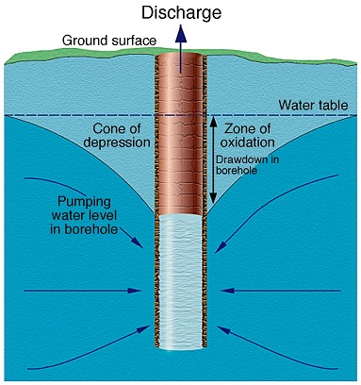

Note: The degree and shape of the cone will depend on the duration of pumping and the hydraulic properties of the soil or aquifer.

Source: Modified from UK Groundwater Forum, Groundwater: our hidden asset.

As a first approximation for screening purposes, the radius of the cone of depression can be calculated using several formulae, the simplest of which is the Sichardt equation (DER 2015a; Appendix B: Calculating the extent and duration of a cone of depression). This is useful to get an idea of the scale of impact, helping to assess if there are sensitive receptors likely to be affected by dewatering. Other basic hydrogeological relationships can then be used to calculate pumping rates and duration of pumping to achieve the intended area of dewatering. Details and an example of this process are given in Appendix B: Calculating the extent and duration of a cone of depression. Linear disturbances should be assumed to consist of a number of rectangular dewatering areas that abut each other and that are pumped sequentially (DER 2015a).

During dewatering, the necessary drawdown is first achieved by lowering the water table to a specified depth, and then this level needs to be maintained until completion. Initially, the cone of depression expands rapidly but then slows logarithmically as the volume of contributing aquifer increases over time. Note that the ‘principle of superposition’ shows that the drawdown at a given point due to the pumping of more than one borehole nearby is simply the sum of the individual drawdowns which each of the boreholes would produce if pumped alone (Figure 4.3 The principle of superposition.), which is often applied in areas of construction dewatering (section 4.6.3).

Figure 4.3 The principle of superposition.

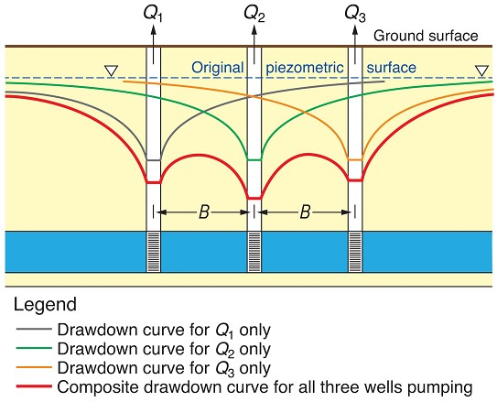

Note: This shows how the drawdown from a number of wells/boreholes is simply the sum of the drawdown caused by each operating alone.

The following analytical solutions can also be used to predict drawdown and the radius of the cone of depression when pumping from confined and unconfined aquifers:

* Thiem and Dupuit-Thiem equations for steady state flow to a bore in a confined and an unconfined aquifer respectively,
* Thiess equation for time-variant flow to a bore in a confined aquifer,
* Cooper-Jacob approximations to the Thiess equation for time variant flow confined and unconfined aquifers, and
* De Glee equation for steady-state flow to a well in a leaky aquifer.

These are what the UK Environment Agency guideline calls Tier 1 drawdown assessment tools – the equations apply to a single bore in a uniform, isotropic aquifer (UK Environment Agency 2007), mostly under steady-state conditions. When pumping will be from multiple bores in an otherwise uniform aquifer, the Agency suggests using a Tier 2 groundwater drawdown assessment using simple (and publically available) analytical element models such as Winflow. When a lot of site specific hydrogeological data are present and/or there are significant environmental receptors likely to be affected by drawdown, a full numerical finite-element or finite-difference flow model such as MODFLOW is suggested to predict the cone of depression of a dewatering operation (a so-called Tier 3 assessment). Depending on the sensitivity of the location, regulators may require a Tier 2 or Tier 3 drawdown assessment to be carried out after an initial Tier 1 assessment, and subsequent field investigations may be required to obtain data for more refined modelling.

In highly permeable soils, a transient phase of heavier pumping may be required, which effectively removes water from groundwater storage. This is often much greater than the rate required to maintain steady drawdown (Younger et al. 2002). The change in water table elevation is a function of pumping rate, hydraulic conductivity and the radius of influence of the borehole that is the distance from the borehole to the point on water table at which drawdown is zero. As a first approximation, the drawdown and rate of pumping can be simply estimated from the Theim-Dupuit equation and the Cooper-Jacob empirical relationship respectively. Details and an example of this approach developed for ASS dewatering by DWER (DER 2015a) are given in Appendix B: Calculating the extent and duration of a cone of depression, and an [online tool](http://www.der.wa.gov.au/your-environment/acid-sulfate-soils/66-cone-of-depression) recommended as an initial screening.

The cone of depression is influenced by a number of factors including hydraulic conductivity, soil type, heterogeneity and duration of pumping, and in reality the area of dewatering is seldom as simple as this. The zone of influence may also vary if the soil or sediment is stratified in terms of grain size, being greater in coarser more permeable layers. The shape of the cone is also affected by flow direction, being wider on the downstream side of the pumping borehole. Soils are typically heterogeneous and the presence of even a thin clay-rich layer in sand is sufficient to affect the rate and scale of dewatering.

For small scale operations where dewatering is limited in area or of short duration, authorities may not require further groundwater modelling. For large scale operations, a more detailed modelling approach is likely to be required, with a need for site specific aquifer properties. One of the most common techniques to determine aquifer properties is the use of pump tests: this involves injecting or removing water from a bore and measuring the response. A model is then used to estimate aquifer properties such as hydraulic conductivity and specific storage. For larger scale dewatering activities, where a more detailed understanding of the soils is required, pump tests can be used to assess boundary conditions, for example recharge boundaries (such as lakes or streams) or barrier boundaries (for example presence of less permeable boundaries such as hard rock or faults) and better define the zones of influence in detail. The application and interpretation of pump test data are covered in most basic hydrogeology texts (Kruseman & Ridder 1991; Domenico & Schwartz 1997; Fetter 2014; Younger 2007). However, in areas where the ASS hazard is considered high, and it is likely that pump testing will lead to extensive oxidation of ASS, and consequent risk, other methodologies can be used to determine aquifer properties such as slug tests (where water is quickly added or removed from a groundwater well, and the change in hydraulic head is monitored through time to determine the near-well aquifer characteristics), sediment grain-size analysis techniques or core testing. A range of standard hydrogeological models are used in the groundwater industry by consultants and contractors to set up site-specific groundwater models.

The presence of cracked clay soils may lead to complex distributions in hydraulic properties more akin to those found in fractured aquifers. In these situations, connectivity may be difficult to predict and the soils may behave as a dual- or multi-porosity system. Pumping tests in fractured media are fraught with difficulties including (Cook 2003):

* Highly sensitive to the model used,
* Simple models are inappropriate (may not be obvious from test results), and
* Hydraulic conductivity may change during tests due to heterogeneity as the area of influence increases.

Multiple borehole tests are more useful in these systems, but where there is considerable heterogeneity, the response can be variable, for example there may be limited drawdown in bores close the pumped borehole whilst others further away may display significant drawdown. An analysis of fractured systems usually requires more advanced techniques (for example numerical modelling, flow gauging, tracers, geophysics) and their application should be determined by the scale of dewatering. In such cases mitigation techniques may have to be more extensive and monitoring increased to deal with the degree of complexity. This should be focused particularly on protecting any nearby sensitive receptors.

Predictions of water quality change should be made using a reactive transport model with the capability of dealing with variably saturated media such as MIN3P (Mayer et al. 2012; Salmon et al. 2012). However, in some situations, for example lack of detailed chemical parameters, simpler models may be useful for predicting water quality changes caused by pyrite oxidation (for example Blunden and Indraratna, 2001; Mosley et al. 2015). At the end of step 5, conceptual model refinement should be undertaken. This may include the following activities, depending on the level of risk to receptors:

* identify key areas of uncertainty,
* identify any additional data requirements, for example more detailed hazard assessment, hydraulic properties of the soil/aquifer, groundwater flow and residence time to receptors, behaviour of contaminants at the site, and
* reactive transport modelling based on site specific activities to improve the level of confidence in the model and groundwater near any sensitive receptors.

In larger dewatering activities, containment may be necessary as the preferred option for the protection of specific receptors or to minimise pumping costs, oxidation area and other identified risks.

### Step 6 Mitigation and control measures

It is unlikely that a complete understanding of the groundwater environment will be possible, especially where large areas of dewatering are required. It is, therefore, essential to plan mitigation and control measures. If management measures do not control acidification of the dewatered or surrounding areas (for example due to leakage or unidentified bypass flow), management of the acidity will be required. A cost-benefit analysis will be useful, because remediation measures are often very expensive.

Contingency planning involves outlining mitigation measures to prevent predicted impacts. Contingency planning is linked to setting trigger levels based on risk and it should be practical and effective. If there is significant delay between a trigger level being reached and the mitigation measures being implemented, this could result in unacceptable damage to sensitive receptors. The proposed mitigation measures should be established and agreed at an early stage before site work commences so that they can be implemented without delay.

Management options that minimise the extent and duration of exposure to oxygen, or other oxidizing agents (for example nitrate) are likely to reduce the potential risk of acidification and metal mobilisation. There are a number of other options that can be effective, described below, and which are not mutually exclusive.

#### Staged approach to dewatering

A staged approach to dewatering large areas should be considered, such that a smaller area is exposed to air at any one time and/or with shorter time period. This may not always be possible, or alternative cheaper strategies might be preferred.

#### Recharge trenches

Where the cone of depression is likely to impact soil significantly beyond the required area, or where large trenches need to be dug, recharge trenches could be established to use the pumped water to maintain saturation around the site. This would effectively limit the extent of the cone of depression. Care should, however, be taken to ensure that the recharge water does not induce negative effects on the groundwater, for example pumping oxygenated water into deeper reducing soil/sediment may induce oxidation of sulfide minerals present. Any acidified recharge water can also be improved by the addition of a neutralizing agent. The DWER (DER 2015a) guidelines suggest, for example lime-treatment in order to maintain recharge water alkalinity above 100 mg/L CaCO3.

#### Construction dewatering

A number of techniques, used as standard practice in the construction industry, help to minimise disturbance of ASS, one of these being the use of driven piles, timber piles and screw piles that displace soil rather than disturb or bring soil to the surface. Driven piles are commonly used when the surface soils have low load-bearing capacity and the weight of the building must be carried by deeper soils and weathered bedrock. The major benefit of these is that they negate the need for the removal of geotechnically unsuitable material and the disturbance of ASS. Therefore, treatment and management of ASS becomes unnecessary. Driven piles are long, load-bearing rods that are driven through soft soils into more consolidated material at depth, and provide support for surface structures to prevent subsidence problems. They have been used for building on ASS in the Netherlands since the 18th century. Most modern piles consist of steel and concrete as reinforced concrete and pre-tensioned concrete, or a variety of acid-resistant composite materials.

Many construction projects, however, include excavations, even where only shallow foundations are required. It is, therefore, not possible to minimise changes to groundwater levels completely. Sumps with submersible pumps at their base are sometimes used as they are relatively cheap to install and operate, but may be of limited use with large storage aquifers and where it is essential to maintain dryness at the entire surface (they may also need an array of hoses around the site to transport the water which may not be wanted for logistical reasons). Care needs to be taken during excavations as a steep hydraulic gradient in the surrounding soil can lead to quicksand conditions, localised subsidence or floor heave (for example if low permeability beds at the base are confining groundwater). In addition, excavated slopes are generally much less stable when wet than in a dry state, and sheet piles are often used to provide support, which may also block groundwater flow to the excavation. Sheet piling comprises interlocking steel sheets used to support soil in deep excavations to avoid the large excavated areas needed to obtain sufficiently gentle slopes in the water table to maintain stable slopes. They typically impede, but don’t stop, water but can be improved using cement or bentonite-based grouts. In order to minimise the impacts mentioned above, the complementary addition of groundwater pumping is commonly used to mitigate such hazards, by decreasing the hydraulic gradient close to the excavation edge (Younger 2007).

The lowering of the water table can be achieved by installing temporary wellfields. The principle of superposition as discussed in section 4.5, can be used to optimise the number and locations of boreholes and/or wellpoints for small or large areas of dewatering. This should be designed taking into account the known hydrogeology and conceptual model developed within the plan. For example, where a thick and extensive aquifer is present beneath the proposed site, large boreholes may be needed to depressurise the underlying aquifer locally to prevent floor heave.

Wellpoints and ejectors are both used to dewater soils. At sites where there is a substantial amount of sand interbedded with silty, peaty or clayey materials, dewatering is typically carried out with an array of dewatering ‘well-points’ or ‘spears’ connected to a common suction pump or vacuum extraction system (Figure 4.4). The well-point systems are normally sunk into a permeable sand unit below the base of the proposed excavation.

The array of well points will typically be up to about 12 shallow (less than 10 m), small diameter (50 mm) wells connected to a common surface collector pipe (Younger 2007) placed under suction using a large pump (Figure 4.4). The dewatering array is normally constructed to encircle the proposed excavation site, and two or more stages of dewatering may be needed to lower the water table to the required depth. Alternatively, when dewatering is needed for linear projects, such as sewer excavations, dewatering spears are typically installed only on one side of the excavation. They are relatively cheap to install, but practically limited in their application depth (approximately 6 m). For deeper dewatering, especially where well yields are too low for electric submersible pumps, it may be possible to use ejectors, which are capable of pumping air/water mixtures at greater depths (30 – 50 m), hence are much more effective than spears or sumps where hydraulic conductivities are low and there is a risk of standard submersible pumps having to pump air which they are not designed for. Both of these techniques can be used effectively with sheet piling to minimise leakage and pressure effects in the construction area. In detail, a range of techniques to effectively manage ASS are selected depending on a range of management pressures as well as site-specific characteristics. A case study demonstrating such challenges is shown on Box 4.2.

Figure 4.4 A well point dewatering system for a shallow excavation.

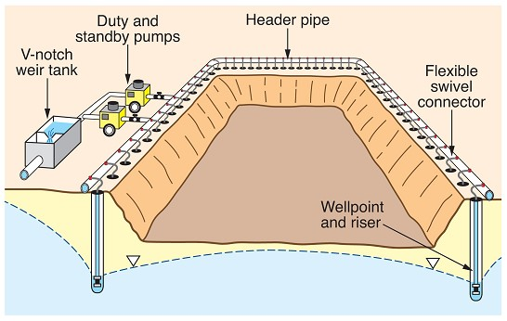

Source: Modified from Younger et al. 2007.

The management of dewatering effluent is a critical component of dewatering programs in areas underlain by ASS. When water containing high concentrations of soluble iron is discharged into waterways or wetlands, iron oxyhydroxides precipitate out where the waters mix. This can have serious impacts on benthic organisms due to smothering of the sediment/water interface. These chemical reactions may also release large quantities of acid into the aquatic ecosystem and consume oxygen causing de-oxygenation of the water column. The combination of acid, iron floc and de-oxygenation can cause fish kills, reduced fish spawning and the destruction of benthic habitats for macro-invertebrates (DER 2015a). The precipitation of aluminium hydroxide around fish gills may also lead to suffocation of fish (Lyderson et al. 2002).

Any acidified groundwater due to oxidation should be treated with an acid neutralising agent before discharging to the environment, providing that this form of disposal is acceptable to regulatory authorities. The generally preferred option for disposal of dewatering effluent is to re-infiltrate on-site via earthen basins or trenches. These infiltration structures may be placed strategically to mound groundwater and limit off-site impacts, particularly near protected or sensitive wetlands (DER 2015a). An example is shown on Figure 4.12. It is recommended that dewatering effluent be aerated in tanks or suitably sized treatment ponds to oxidise and precipitate dissolved iron (and other metals) then lime-treated and passed through a retention basin to settle out further precipitates before re-infiltration. The first stage is neutralisation by lime dosing to neutralise acidity and increase pH. Aglime (CaCO3) is commonly used as it is relatively cheap, but its solubility is relatively low in water hence neutralization might be slow. Care should be taken with the more soluble Na bicarbonate to avoid local sodicity/salinity problems, hence offsite disposal of any residues might be required. Hydrated lime (Ca(OH2)) and quicklime (CaO) and are more effective, but care should be taken to ensure that the pH does not become too alkaline – the optimum conditions are usually considered to be pH 6.5 – 8.5 with low total acidity (less than 40 mg/L). The amount of neutralising agent should be based on the total acidity (Box 4.1) as it is common for most of the acidity in a water to be present as dissolved metals rather than as H+. Large-scale dosing of waters to alter the chemical characteristics, such as may be the case in the mining industry, is a specialised and highly technical task that requires considerable expertise and experience. Professional guidance should be obtained in these situations.

A number of methods are in use for the addition of a neutralizing agent, for example lime dosing units, spraying a slurry over the water, and a range of mobile water treatment techniques (Degens, 2009, Younger et al. 2002). The water should be monitored before and after treatment. A monitoring scheme should be established to assess the quality of the water being pumped, and define action criteria for treatment of acidity. A dewatering matrix as used in Western Australia showing trigger levels, actions and further monitoring requirements is provided as an example in Appendix C: Dewatering effluent monitoring matrix. This is followed by aeration to maximise oxidation (iron) and hydrolysis (iron, aluminium and other metals present) to a settlement pond to allow flocculation and removal of any produced mineral flocs, possibly with the addition of a flocculating agent.

Box 4.2 Dewatering for Construction of a Canal Estate, Western Australia.

In Western Australia, the State’s ASS Investigation and Management Guidelines (DER 2015 a,b) have increased our understanding of ASS, while introducing new practices and techniques to both treat ASS and control dewatering. This has required changes to construction practices on all ASS sites, and notably for marina and canal developments that had historically represented a legacy of undiagnosed and untreated acid-sulfate soil impacts. The construction of Eastport Canal Estate, Mandurah between 2008 and 2009 demonstrates how industry adapted its practices to mitigate the potential for ASS oxidation and environmental harm.

The 5.5 hectare Stage 5 development was the final stage in the canal estate, with construction approval only being granted after a comprehensive ASS Dewatering Management Plan (ASSDMP) had been developed. This plan established the management framework, and set defendable environmental triggers that would be monitored during and post-construction to assess performance.

**Figure 4.5 Stage 5 development area prior to construction.**

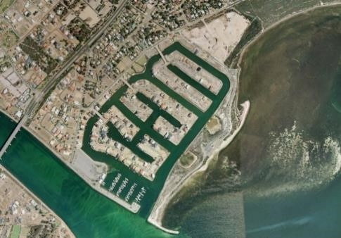

Challenges posed by the site included being space-constrained, having long-term dewatering at rates of up to approximately 90 L/sec, and in abutting environmentally sensitive waterways. Soils onsite were typically sandy, with maximum chromium reducible sulfur contents of up to 0.2% S. The site was initially covered by approximately 200,000 m3 of previously excavated Acid Sulfate Soil sediments and dredge spoil from earlier construction activities.

The ASS management practices applied on the project included:

* detailed upfront environmental planning including development of a site-specific groundwater model and groundwater drawdown triggers, and water quality triggers developed from baseline monitoring
* early contractor engagement in formulating the site working methodology
* staged dewatering practices, thereby limiting the area of drawn-down at any time
* a move away from “dry excavation” to “wet excavation” methods where practicable
* use of extensive groundwater-recharge systems and settling ponds that acted to reduce the drawdown zone of influence, maintain ASS soils wetted-up, and reduce effluent release to waterways
* regular onsite monitoring during construction for groundwater quality, groundwater levels and dewatering effluent quality
* use of lime dosing, erosion control structures, and silt curtains in managing dewatering effluent
* post-construction groundwater monitoring to assess the final condition.

ASSDMP concept diagram showing dewatering infrastructure, including “ring” recharge trench and settling basin.

**Figure 4.6 ASSDMP concept diagram of dewatering infrastructure.**

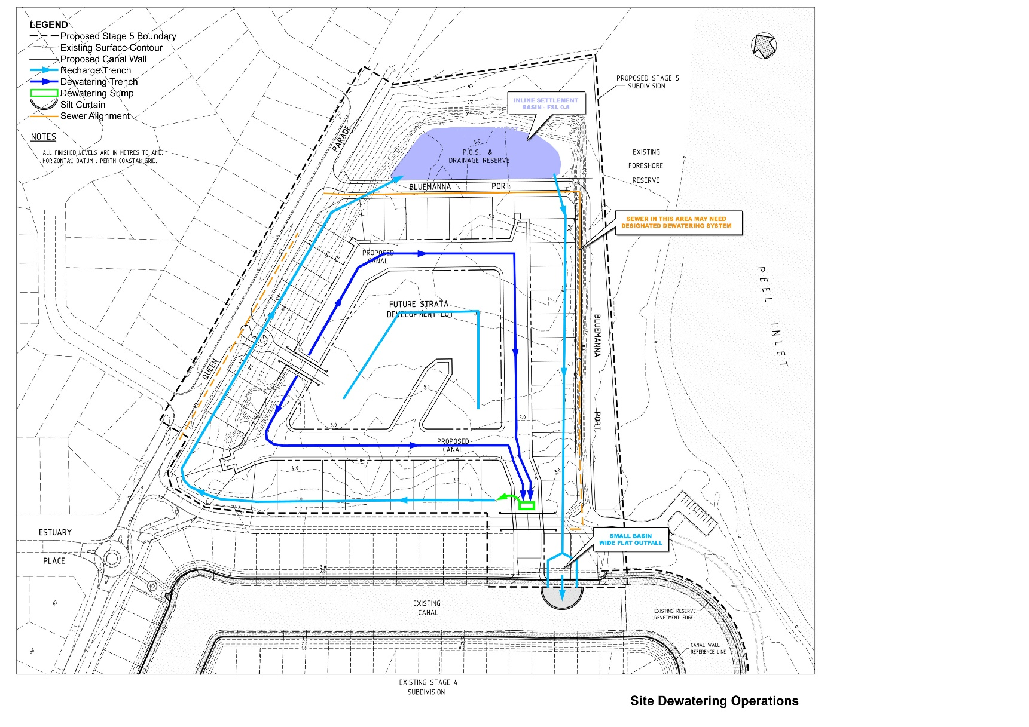

Note: Diagram includes “ring” recharge trench and settling basin.

**Figure 4.7 Open excavation of canal infrastructure with dewatering sump pump in foreground and recharge trench with settling basin.**

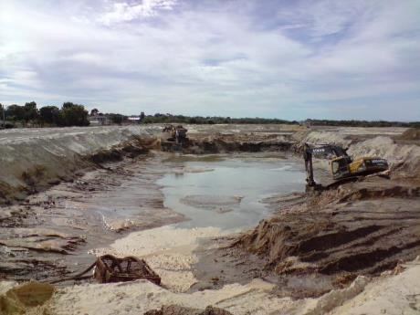 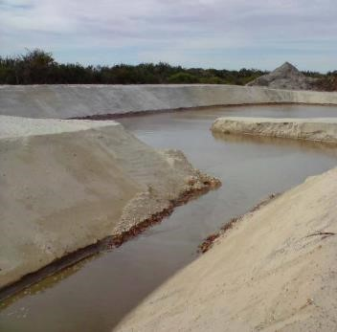

Surplus ASS soils were treated with aglime, being removed in a series of lifts using graders that incorporated the lime as the soils were stripped. Treated stockpiled soils were subject to validation testing to confirm effective rates of treatment had been achieved, and any stockpiles that failed these tests were retreated. The surplus soils were re-used sustainably as fill on another site. Central to managing dewatering impacts on and offsite was the use of an extensive recharge trench and settling basin. The earthworks concept included a “ring” dewatering recharge trench that extended around the perimeter of the site. Water pumped from the canal excavation areas in the centre of the site during construction was discharged into this recharge trench where it gravity flowed around the perimeter of the working area. This allowed for recharge into soils below the trench, and acted to limit the extent of dewatering drawdown offsite. The setup also enabled settlement of fines via the settling basin and through a series of silt curtains established in the trench, and also the opportunity to dose the effluent water with aglime to adjust water acidity and promote metal precipitation. The surplus treated effluent was finally discharged into the existing canal areas, which were also subject to water quality monitoring.

The construction dewatering campaign ran for nine months continuously, at times dewatering extended to 3.5 m depth. During construction, water levels were maintained within targets agreed with the regulatory agencies, and the adopted dewatering methodology and controls were proven to reduce offsite groundwater drawdown. The Contractor was responsible for collection of groundwater and dewatering effluent information every second day, including from a series of nearby offsite bores. Through this data capture, the project team was at all times knowledgeable of the extent of dewatering influence, so that adjustments could be made to the dewatering infrastructure and pumping rates.

**Figure 4.8 Perimeter recharge trench in operation and spear point dewatering in operation.**

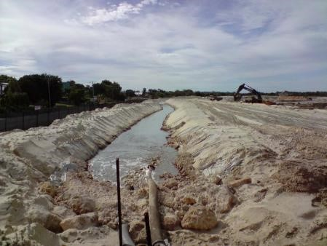 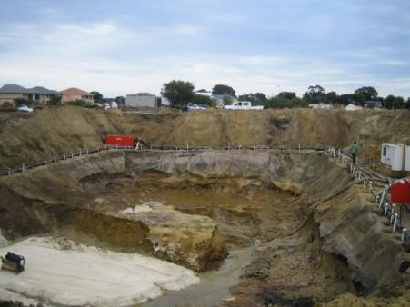

**Figure 4.9 Wall construction underway within central canal.**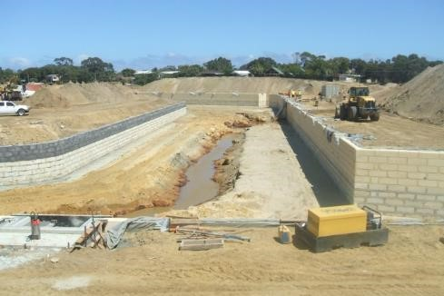

During construction, areas of the canals were allowed to re-flood to reduce the overall area under dewatering drawdown. The study identified that an estimated 30-50% of extracted groundwater was recharged into the sandy soils. Water quality data collated by the project’s environmental consultants showed that dissolved metals were largely removed from dewatering effluent, through the use of lime dosing and extended settling. Results from this study suggested that total metal concentrations (iron and aluminium) attached to sediment load were reduced by approximately 50% using the adopted treatment system.

Example of contractor collected groundwater monitoring data during 9-month dewatering campaign. Short-term dewatering drawdown below established groundwater level trigger was required in this area to install bridge footings in October/November.

**Figure 4.10 Groundwater level and electrical conductance before and after the commencement of dewatering.**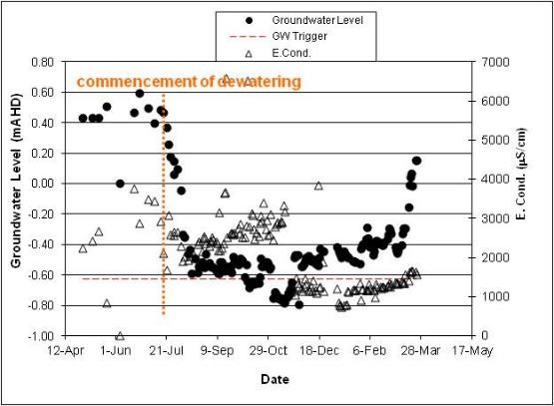

At the cessation of construction activities, the site was monitored monthly for a period of 12-months to identify whether any acidification influences were observed with the re-bounding of the water-table into previously dewatered ASS profiles. The monitoring identified that any acidity that may have been released from partially oxidised ASS was fully buffered by the naturally carbonate rich estuarine waters, and from lime-treated ASS that was backfilled in development areas. No water quality impacts were observed.

Left: Canals in late stage of construction. Partial flooding of northern canal to reduce dewatering drawdown pressure. Settling basin and recharge trench are part deconstructed during final earthworks. Trapped iron floc/sediments clearly visible, hence the treatment system is doing its job.

**Figure 4.11 Finished canal infrastructure post-construction.**

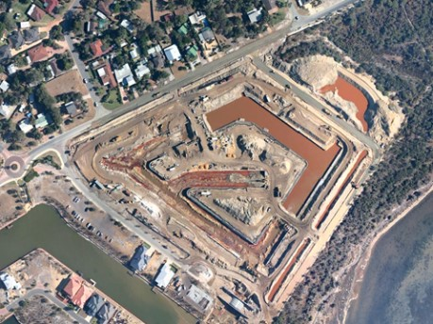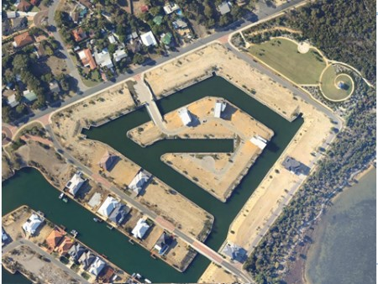

DER June 2015a. Department of Environment Regulation. Acid Sulfate Soils Guideline Series. Identification and investigation of acid sulfate soils and acidic landscapes. Department of Environment Regulation, Perth.

DER June 2015b. Department of Environment Regulation. Acid Sulfate Soils Guideline Series. Treatment and management of soils and water in acid sulfate soil landscapes. Department of Environment Regulation, Perth.

Figure 4.12 Schematic view of a construction dewatering treatment scheme.

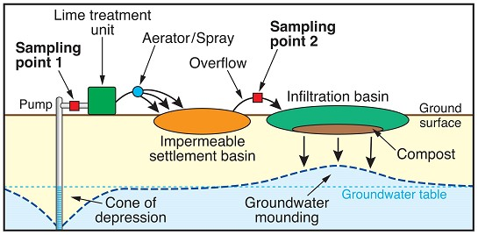

Source: DER 2015a.

Depending on state or territory regulations, the water, of a suitable quality, may need to be returned to the sub-surface through infiltration basins or injection bores. The development of groundwater mounds can form part of the management plan and be incorporated into any groundwater models, the risks to potential receptors assessed and, as such, be monitored at a scale relevant to the identified receptors and timescales for the model. Management of clogging in infiltration basins or re-injection bores will be critical where the recharge forms part of a plan to manage the extent of groundwater drawdown. Poor removal of colloids and precipitates prior to infiltration (particularly with treated waters) will require additional regular intervention to minimise clogging with extended operation/ drawdown.

The direct discharge to waterways that flow into environmentally-sensitive wetlands is often not permitted unless there are no other disposal options and the quality of the water meets water quality guidelines (DER 2015a). Western Australia authorities also recommend that, wherever possible, dewatering discharge should first be disposed of, or reused on-site, before off-site disposal options are considered. The decision process in other states and territories should be guided by relevant local guidelines in discussion with relevant authorities. Possible on-site uses for the water include disposal to ground via infiltration basins, irrigation (if sufficient land area is available), or used for dust control on construction sites. Off-site disposal options include irrigation on adjacent land (provided an agreement has been reached with the land owner), use in industrial or commercial processes, disposal to sewer (provided this has been approved), and removal by liquid waste contractors.

At the completion of works, accumulated sediments at the bottom of treatment and infiltration basins/trenches, along with the top 30 cm of the underlying soil profile, should be sampled to determine appropriate decommissioning requirements, and then remediated and validated as required. Any material requiring remediation should be disposed of in accordance with the relevant regulations.

Dewatering and excavation on some ASS sites may release a large amount of hydrogen sulfide (or other gases, Hicks et al. 2008) from groundwater. This may reach toxic levels within excavations and in confined spaces. Therefore, it is strongly recommended that on-site gas monitoring and occupational health and safety measures are implemented to deal with this contingency during dewatering on such sites.

A number of mitigation measures can be used to minimise the impacts off-site and to sensitive receptors, including single or multiple barrier approaches.

The use of permeable reactive barriers (PRBs) can be used to reduce or mitigate the migration of acidity and contaminants towards sensitive receptors, forming a passive alternative to pump-and-treat systems. These comprise buried structures that extend below the water table and are filled with permeable reactive materials that react with/remove contaminants flowing through the structure. Simple PRBs comprising trenches filled with crushed limestone have been used to treat ASS (Cook et al. 2002; Figure 4.13). Larger scale structures are also possible and a range of fill materials have been used, including recycled concrete (Golab et al. 2006) and alkaline steel-making wastes (Smyth et al. 2004). The material within PRB structures has a finite lifespan which depends on groundwater flow rates and the total acidity of the groundwater. It is important that sufficient field and laboratory work is undertaken before the installation of a PRB to ensure that it has adequate capacity to treat acidity for a number of years. Monitoring bores should be installed up and down hydraulic gradient of the PRB to monitor its effectiveness during the lifespan of the structure.

Figure 4.13 Schematic of a PRB and lime slotting machine for shallow PRBs.

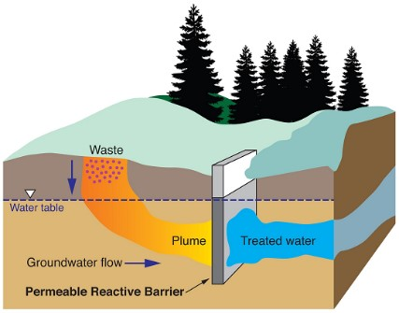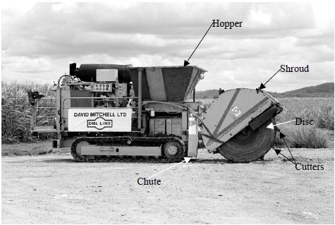

Source: Modified from US EPA 1998 and Cook et al. 2002.

The use of alkaline PRBs may also suffer from the problem of armouring – where the precipitation of Fe oxides/oxyhydroxides precipitate around the neutralizing agent forming a barrier and decreasing neutralisation efficiency. They are also limited, in general, in their ability to decrease concentrations of dissolved sulfate which is typically mobile under circumneutral oxidizing to mildly reducing groundwater conditions. The problems of armouring and high sulfate can be ameliorated by using Reducing and Alkalinity Producing Systems (RAPS). These are basically anoxic limestone drains overlain by a compost bed (or a mixed limestone-compost), often used in acid mine drainage areas where waters contain high concentrations of dissolved iron, aluminium and dissolved oxygen (Younger 2000; 2002; PIMRAMID Consortium 2003). The compost helps maintain reducing conditions necessary to stop iron oxides/oxyhydroxides forming, whilst the limestone component maintains high pH that reduces metal concentrations. Depending on the design, it may be necessary to follow the RAPS with a settlement lagoon. Under sufficiently reducing conditions, iron, sulfur and a range of metals and metalloids are formed which decrease in the outflow water from the RAPS.

#### Regional groundwater abstraction

A common cause of larger scale lowering of water tables, both locally and regionally (Box 3.1), is the abstraction of groundwater for a range of uses including drinking water, irrigation and industrial purposes; and land-use change such as afforestation. Water management practices may be optimized such that the sustainable use of groundwater maintains a steady state, with seasonal effects being the main changes in water table depth. Changes to a managed water regime, for example decrease in irrigation during drought, may have a significant effect on recharge and induce oxidation if the water table falls. The latter effect, combined with a decrease in river level, was responsible for large changes in water table depth and unforeseen acidification in irrigation areas along the River Murray (Box 3.2).

The management of saline groundwater tables through, for example pumping and removal of shallow saline groundwater, may have an impact on acidification in dewatered parts of the aquifer and groundwater extraction efficiency if sulfidic sediments/soils are present below the water table (Shand et al. 2008b). The degree and timing of impact may also be affected by borehole construction; and if the screened interval is present at depth, the impact of dewatering may not be realised in the pumped water for some time after abstraction commences.

Predicting the impacts of acidification at a regional scale due to over-abstraction is often difficult to assess during routine monitoring as the onset of acidification may only occur rapidly once alkalinity is consumed. It is, therefore, recommended that alkalinity be considered a key analyte in any monitoring or assessment strategies for groundwater quality. Field titrations using a standard alkalinity kit is useful to determine changes on-site. Other useful indicators (Table 4.4) are an increase in SO4/Cl ratio (due to an increase in sulfate from sulfide oxidation) or changes in calcium and magnesium. Increases in Ca and Mg have been noted in groundwaters undergoing acidification due to leaching (Appleyard & Cook 2009). It should be noted, however, that rapid decreases in Ca and Mg may occur once these are exhausted from the aquifer matrix if acidification is intense.

The regulations governing the drilling of boreholes varies between the state and territory jurisdictions (for example there is no licensing requirement for garden bores in Western Australia). Nevertheless, knowledge of the impacts and risks of dewatering in ASS areas is poorly known in the community in general as well as the groundwater abstraction industry. For small domestic boreholes, DWER (DER 2015a) suggested the following measures that can be used to minimise drawdown, and hence the degree of oxidation:

* Reduce water use in gardens: gardens irrigated with domestic bores often use twice as much water as those irrigated with scheme water and much of this extra water is wasted by evapotranspiration. Increasing the efficiency of water use in gardens through ’WaterWise’ gardening techniques will reduce the amount of groundwater pumped.
* Increase urban density: increasing the density of urban development reduces the total area of gardens that are watered and can increase recharge of water from roof and paved area runoff. This is occurring already in many suburbs but could be encouraged as a management measure in areas where there is a high risk that iron sulfide minerals will oxidise if the water table falls.
* Use alternative water sources: alternatives to shallow groundwater for irrigating gardens, parks and open space include stored rainwater, grey water from bathrooms and laundries in houses, treated sewage and scheme water (not preferred). Treated sewage may be beneficial in areas where soil and shallow groundwater has been affected by acidification as this effluent has a high acid neutralisation capacity and may help reverse acidification at the water table. However, excessive use of sewage can also increase nitrate concentrations in groundwater. The advice of Health Departments should be sought in relation to the use of grey water and treated sewage.

The management of large and/or deep aquifers requires modelling of pumping over long (years-decades) time periods. Such timescales should be modelled alongside predictions of land use change and predicted rainfall and recharge estimates.

Consideration of a range of options to manage regional problems may include:

* The rate of acid generation to be matched by in-situ remediation processes (for example rate of neutralisation from sulfide reduction) depending on the concentrations and quality of dissolved organic C in recharge. This will require improved regional understanding of the distribution of sulfides and rates of formation, rate of acid generation and transport, and reactions in the aquifer (that is substantial monitoring and investigation).
* Strategic management of the alkalinity in recharge waters for enhancing alkalinity in shallow groundwater at regional scales. This can be achieved by liming of all soakwells and stormwater infiltration pits in new and existing urban developments and liming of soils following removal of non-native high water using vegetation (such as plantations) (when recharge rapidly increases).
* Mitigation options for more concentrated sulfidic materials in wetlands might include re-submergence or isolation and control of impacts. Re-submergence requires raising water-levels to prevent further oxidation and encourage re-sulfidisation, but would need to consider whether this is practicable in the long-term with the effects of a continued drying climate. In the short-term, this could involve supplementation from confined aquifers until water-levels rise through management to reduce pumping and increase recharge (for example by removing pine plantations or increased urbanisation).
* Physical isolation of acidity sources to minimise transport of acidity in recharge and reduce impacts on down-gradient groundwater where drying is unavoidable. This more extreme option minimises the regional impact on groundwater quality by reducing recharge, for example by capping or sealing.

#### Drain waters impacted by dewatering

Acidic drain waters are often a consequence of discharging acidic groundwater or higher pH groundwater that contains high net acidity (that is dissolved hydrolysable metal cations). During the latter part of the Millennium Drought in South Australia, low river levels and cessation of irrigation adjacent to the River Murray led to a decrease in the water table. The first indicator of severe groundwater acidification beneath irrigation bays was the formation of bright orange-brown precipitates (the Fe-rich hydroxysulfate mineral schwertmannite which forms under acidic conditions) due to discharge of strongly acidic groundwater as the water table rose (Figure 4.14). Although the soils beneath the water table were impermeable clays, the formation of large cracks allowed rapid transport of acidic groundwater to the drains. The cracks did not reseal effectively and acidic drain water and groundwater remained years after the water table recovered.

Figure 4.14 Formation of hydroxysulfate mineral schwertmannite in acidic drains

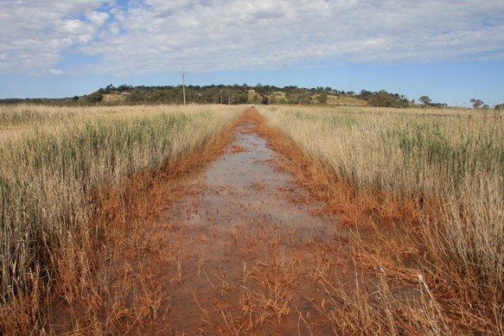

Note: This formation occurred following groundwater rebound at the end of the Millennium Drought in South Australia.

Although treatment options were undertaken in the drains, the source of acidity in the soils remained, and continuous treatment proved prohibitively expensive. Attempts at remediation of the source (sub-surface clays), for example injection of lime (finely powdered calcium carbonate), proved difficult due to the scale of the problem and the difficulty of injecting lime to required depths (Palmer et al. 2013). Testing is still being completed at these sites.

Passive treatment options have been applied to acidic saline drain waters in the Western Australia Wheatbelt where deep drains were established to control shallow saline groundwater. These are outlined in Degens (2009) along with guidelines on a range of treatments outlining advantages and disadvantages of each.

The digging of drains in urban areas affected by ASS may also pose risks to the environment, especially if these form direct connections to sensitive receiving environments. Drains may continue to discharge acidity to the environment for many decades after construction and, although discharge water can be treated or managed, it may not be possible to entirely eliminate the discharge of acidity to drains when sulfide oxidation is well established in soils. A number of measures can help minimise the impacts caused by drains (DER 2015a):

* avoid construction in critical areas: the most effective way of preventing acidification problems in drains and excavated lakes is to avoid constructing these features in areas underlain by ASS at shallow depth. Inappropriate construction of drains and lakes can create expensive and long-term management problems.
* construct shallow instead of deep drains: in situations where ASS materials are located at some depth below the water table, it may be possible to construct drains that do not disturb these materials. In general, broad shallow-drains are less likely to have acidification problems than narrow deep-drains. Wherever possible, the base of a drain should be constructed to be at least 0.5 m above any sulfidic material (Dear et al. 2014). In situations where sulfides cannot be avoided, sufficient neutralising materials should be used during drain construction.
* adopt water sensitive urban design management principles: adopting design features in urban areas that minimise surface runoff and maximise the infiltration of rainfall throughout an urban catchment can be an effective strategy for minimising the disturbance of sulfidic materials caused by the construction of stormwater drains.

In cases where drains and lakes are undergoing acidification, there are a number of possible remediation options that can be implemented to manage the acidity problem:

* redesign existing drains: in areas where existing drains have been constructed into sulfide layers and are exporting acid, it may be possible to redesign the drainage network to reduce acid discharge. This may include reassessing the network with a hydrological study to decide whether all the drains are necessary, filling in superfluous drains (reducing the drainage density will often reduce the net export of acid from a catchment) and neutralising acidic spoil. Existing drains can be modified by neutralising existing acidity in drain walls, raising the base of the drains and broadening drains to allow them to carry the same volume of water without disturbing sulfidic material.
* passive treatment systems: a variety of techniques have been developed by the mining industry for treating acidity and high metal concentrations in acid mine drainage (AMD) using naturally occurring chemical processes (for example PIRAMID Consortium, 2003), and many of these techniques could be used to manage drainage from disturbed ASS.
* lime treatment: often the simplest way to neutralise an acidic drain or lake is to add an appropriate amount of Aglime (CaCO3). This method, however, may only provide a temporary neutralising effect. Continual, periodic monitoring, following the addition of lime, will be necessary to ensure the drain or lake does not revert to acidic conditions with time. If more caustic neutralizing agents are permitted, then automatic dosing systems are recommended to ensure pH changes are carefully managed.

Degens (2009) discusses acid-saline groundwater options which are also relevant to drainage systems acidified by ASS.

#### Groundwater rebound impacts

The impacts of contaminant mobilisation may not be seen during the pumping phase as the cone of depressions remains unsaturated. The oxidation products, including a range of contaminants such as metals, metalloids and nutrients, within the cone of depression can subsequently dissolve in water as the water table rises, leading to contamination of groundwater (particularly by iron and sulfate). Information is provided in section 4.4.2 on ways to determine this. This can cause ongoing problems at sites where poor-quality water is discharged to rivers via surface flow, interflow and groundwater flow (this is a common occurrence in mine sites where impacts may last decades to centuries). The problems are likely to be much more short-term in nature for construction dewatering operations in sandy aquifers, but should still be considered and managed. Management measures would probably include:

* a risk assessment to determine whether there are likely to be impacts on nearby environmental receptors or groundwater users, and
* implementation of a measure such as monitored natural attenuation (DWER has draft guidelines that deal with metal contaminated groundwater) or the installation of a permeable reactive barrier to protect the receptor(s).

### Step 7 Monitoring strategy

Monitoring is a key requirement to assess the impact of dewatering on groundwater and to maximise the ability to respond to impacts on the surrounding groundwater and other receptors. Ideally, from an economic perspective, monitoring can be carried out using piezometers or boreholes installed during the groundwater characterization phase. This has the added benefit of comparing changes to the initial sites used to establish a baseline. However, the optimum number and positioning should also be based on the evolving conceptual model, and sufficient to provide data to help protect the identified sensitive receptors. There is no generally accepted minimum number of boreholes to monitor, but any plan should be able to provide relevant information on the following aspects:

* determine water quality and changes at different depths at each monitoring location, with a focus close to the water table,
* determine water quality and changes beneath the cone of depression or area of dewatering, and if not possible as close to this as possible,
* determine water quality and changes downgradient of the groundwater flow path and at least 1 control point up flow of any potential impact, and
* determine water quality and changes between the area of dewatering and any sensitive receptors.

A suggested minimum groundwater monitoring program is outlined in Table 4.6. The monitoring should be completed on boreholes screened to different depths to ensure that vertical variations in groundwater and the extent of contaminated soil or aquifer are determined. Otherwise, the extent of contamination may be overestimated (for example it may be restricted to close to the water table) or potentially completely missed (for example if the contamination is diluted by inflows from other sections of the screened intervals). The guidelines in Western Australia require the definition and vertical extent of contamination to be known through sufficient monitoring before monitored natural attenuation is considered as a remediation option.

The range of parameters to be measured will depend on the scale and nature of the dewatering operation considering the risk to any sensitive receptors. An indicative suite for monitoring relevant to ASS is suggested in Table 4.4 for both a baseline survey and monitoring. The monitoring should be continued post-dewatering (although at longer time intervals) to ensure that there are no effects following water table rebound that may impact sensitive receptors. Contingency plans should be in place to deal with such impacts. This monitoring scheme is likely to be site specific and the timing to be agreed with relevant state and territory jurisdictions. It is considered that a good conceptual model will provide a much better basis for agreement than use of the precautionary principle for both developers and managing authorities. It is likely that regulators will take a much more precautionary approach in the absence of enough site-specific information.

Table 4.6 Aspects of monitoring that should be covered in any monitoring program.

|  |  |
| --- | --- |
|  | Monitoring component |
| 1 | Baseline groundwater data to be collected prior to commencement of any dewatering activity, or any activity which may impact the baseline. More than one monitoring event should be completed to ensure that the data are representative and to cover the range of seasonal variations |
| 2 | Water table monitoring – ensure that water table decline is minimal away from the cone of depression |
| 3 | Water level, pH, SEC, acidity/alkalinity monitored at short intervals (to be agreed with relevant local authority) and continued, at longer intervals, until groundwater rebound is complete and water quality not impacted – the latter will typically be for a period of at least six months |
| 4 | Samples to be collected at agreed intervals during the dewatering operation |
| 5 | Analysis to include relevant parameters – see Table 4.4 |
| 6 | Water quality and other measurements to assessed for trends during and after operation for duration of monitoring |
| 7 | All results to be collated and reported within an initial closure report at the end of any works period (Step 8 Closure reports) |
| 8 | Results from the post works period to be collated and reported within a post-works monitoring closure report along with a discussion of any environmental impacts observed (potential requirements for continued monitoring and/or remediation may be required by responsible authority) |

Note that monitoring is not simply a dewatering and post-dewatering activity. Sufficient monitoring data should be collected prior to any operations information to assess natural or background variations in the soils and groundwater. A baseline will help quantify changes and to select criteria beyond which such changes require action. This will include water levels, where the data help determine that the required area of dewatering is being met, and minimising excess dewatering. Trigger values for groundwater should be selected that are indicative of pyrite oxidation and acidification. In detail, they are generally developed on a site specific basis and will depend on the groundwater characteristics at the site, to be agreed with relevant authorities. Plotting trends is a good way to visualise change and rate of change (for example decreasing alkalinity) which may help avoid more expensive mitigation requirements. The indicators in Table 4.7 are commonly used to monitor ASS processes, but note that they may not all be present depending on the geochemical environment.

Groundwater trigger levels may not be the same throughout the project due to changes in groundwater quality caused by seasonal variations. If statistical techniques are adopted to determine acceptable trigger levels (for example using mean and/or standard deviations), sufficient background monitoring data should be collected to develop a good understanding of the groundwater system. If the measured values of a certain parameter shows an increasing trend (that is decline in groundwater quality) over the monitoring period, the trigger level should be based on the ‘best case’ results or should not be established using this data until the trend is normalised (DER 2015a).

Table 4.7 Indicators of sulfide oxidation in groundwater and potential trigger values for dissolved parameters.

|  |  |  |
| --- | --- | --- |
| Monitoring parameter | Trigger value | Comments |
| SO4/Cl mass ratio | >0.5 | Indicator of sulfide oxidation compared with seawater ratio of 0.14 |
| SO4/alkalinity | >0.2 | May indicate sulfide oxidation and/or consumption of alkalinity |
| Al/Ca mole ratio | >1 | May indicate Ca depletion and potential for Al toxicity to plants |
| pH | <5.5 | Al and other metal species become soluble at low pH |
| Alkalinity | 20-30 mg/L | pH can reduce rapidly if alkalinity decreases to 0. Noting the trend here is important prior to extreme acidification |
| Al | >1 mg/L | Indicative of Al mobilisation; should correlate with pH - note that Al may be present as colloids at higher pH, and small filter sizes (for example 0.1-0.2 µm) |
| Other trace metals and metalloids | variable | Useful to monitor and compare with ANZECC guideline values for ecosystem protection |
| Net acidity (calculated with acidity) | <10 mg/L | Calculated from field measured acidity - field alkalinity. |

The trigger values should be integrated into a contingency plan as a key component of the overall ASSMP. The aim of the plan is to ensure that effective measures will be implemented to protect sensitive receptors. Within the contingency plan, the management actions to be undertaken if the trigger values are exceeded should be listed. The plan would typically be phased, the scale of action related to the magnitude and duration of exceedance. This can also take into account the susceptibility of the local environment, for example poorly buffered (susceptible) or carbonate-cemented (less susceptible) sands. Such an approach is listed in Table 4.8 for the potential of groundwater contamination.

Where dewatering has the potential to impact on sensitive receptors, or such receptors are close (less than 500 m) to the area of dewatering, it is considered prudent to include this as part of the monitoring plan. For example, if the receptor is a water body, baseline water quality data (including seasonal variations) should be collected and the water body monitored in the same manner as groundwater. If groundwater monitoring shows deterioration in groundwater quality, additional monitoring should be undertaken to determine the extent of the impact and determine whether the water quality within any surface water body has also deteriorated or is at risk of deterioration. If a deterioration in the water body is observed, then additional management measures should be employed. Monitoring and key actions for consideration are provided in Table 4.9.

Table 4.8 Strategy for developing a contingency plan for groundwater contamination.

|  |
| --- |
| Exceedance detected |
| Inform relevant authority |
| Carry out additional testing to confirm |
| If they still exceed trigger values |
| Install additional piezometers to assess the extent and severity of contamination |
| Undertake additional studies to determine the fate and transport of contaminants in groundwater |
| Remediation measures considered |
| Groundwater recharge barriers to divert flow |
| Permeable reactive barriers |
| Monitored natural attenuation |

Discharge of dewatering effluent to wetlands or waterways should only ever be considered as a last resort when planning dewatering operations. It is likely that this will only be considered if permission is granted from waterway authorities, the discharge is of reasonably high quality that will not impact on environmental values, and there is a robust contingency plan place to alternatively manage the discharge if quality deteriorates. Monitoring should be carried out on groundwater discharge and receptors (wetland or waterway) as suggested in Table 4.3 and Table 4.9. A range of trigger values have been suggested by DWER (DER 2015a) in Western Australia and shown on Table 4.10. Any variation from the discharge quality guidance will normally only be considered if an appropriate Risk Assessment is conducted, trigger values are derived, and reporting demonstrates that the discharge quality will not cause any harm to human health or the environment. A calculated net acidity of no more than 10 mg/L CaCO3 has been suggested for saline waters in the Western Australia Wheatbelt (Degens 2013) and is recommended in addition to those suggested by DWER (DER 2015a).

Table 4.9 Key actions for monitoring potentially impacted water bodies caused by dewatering.

|  |
| --- |
| Key actions |
| Monitor pH, SEC, DO, acidity/alkalinity every second day during dewatering |
| Laboratory data to be collected at s longer timescale, for example 2 weeks |
| Laboratory analytical suite as in Table 4.3 |
| Measurement of water levels to ensure that levels are not reduced as a result of groundwater dewatering |
| Measurement and monitoring of groundwater levels adjacent to the water body |
| Dewatering to cease upon any deterioration in water quality of significant decrease in groundwater water levels adjacent to the water body related to dewatering |
| Results of water quality and water level monitoring program for the surface water body must be |
| reported within an Initial Closure Report (section 4.8) for the project along with a discussion of |
| any environmental impacts observed |
| Laboratory water quality data to be collected from the surface water body at intervals for a period of 6 to 12 months (depending upon the magnitude of the dewatering operation) following completion of the dewatering operation |
| Laboratory water quality data to be collected from the surface water body for a period of 6 to 12 months (depending upon the magnitude of the dewatering operation) following completion of the dewatering operation |
| Remedial actions to be undertaken to restore the water quality of the surface water body if needed |

Source: Modified from DER, 2015a.

It is stressed that the purpose of monitoring is to provide ongoing management information. The reporting of the monitoring programs should therefore not be seen as purely an administrative task. There needs to be ongoing review and interpretation (by suitably qualified personnel appointed by the project’s proponent) of data collected during site works to ensure early detection of trends so that management can be adapted and/or contingency measures implemented. If trend analysis of monitoring data indicates deterioration in soil, surface water or groundwater quality further disturbance/dewatering should cease immediately and relevant authorities be informed.

Table 4.10 Trigger levels for use when dewatering effluent is to be discharged directly, or indirectly, to a sensitive wetland or waterway.

|  |  |
| --- | --- |
|  | Trigger level and comments |
| 1 | pH should remain within the range of 6.5 to 8.5 and should aim to remain within 1 pH unit of that of the receiving environment in order to minimise stresses on the aquatic ecology of the receiving environment |
| 2 | Solution net acidity (calculated from acidity and alkalinity measurements)should be < 10 mg/L as CaCO3* |
| 3 | In the absence of comprehensive data for background water quality of the receiving environment, contaminant concentrations in effluent must meet relevant criteria specific to the receiving environment as outlined in ANZECC & ARMCANZ (2000) |
| 4 | Where background water quality of the receiving environment has been conclusively established, concentrations of metals and organics in discharge should not exceed background concentrations of the receiving environment |
| 5 | Total iron concentrations in the effluent should not exceed 1000 µg/L; and iron should not be allowed to cause floc formation in the receiving environment |
| 6 | Total aluminium concentrations in the effluent should not exceed 150 μg/L and the concentration of aluminium in the receiving environment should not be allowed to exceed 150 μg/L |
| 7 | Nutrient concentrations in discharges should comply with relevant jurisdictional guidelines. Discharges to any other surface water bodies should aim to meet default guideline values for nutrients as outlined in ANZECC & ARMCANZ 2000 |
| 8 | Salinity should not be more that 10 per cent of the receiving environment (a salinity concentration of less than that of the receiving environment is generally acceptable if this is not likely to cause detrimental impacts) |
| 9 | Discharge should not cause an objectionable odour |
| 10 | Discharge should not contain any floating matter |
| 11 | Temperature should not vary by more than two degrees Celsius from that of the receiving environment |

Source: DER 2015a.

Note: the values presented in Table 4.10 are suggested as a minimum requirement. Local conditions and appropriate local, state or territory regulations should be considered as a priority when dewatering activities are undertaken.

### Step 8 Closure reports

After completion of site works, a closure report should be prepared and submitted to relevant authorities. The aim of a closure report is to provide relevant authorities with the necessary information to determine that:

* mandatory data have been collected in an appropriate manner,
* protocols have been followed as agreed in an overall ASSMP for the site,
* lessons learned can be made available to future users,
* the site is left in a condition that is unlikely to leave a legacy of contamination, and
* sufficient data is available, modifications to the site made explicit, and a conceptual model available to help deal with any unforeseen legacy issues.

The initial report should detail, but not necessarily be limited to (DER 2015a):

* the soil and water management measures undertaken at the site,
* the volume of soil and groundwater treated at the site,
* the amount of neutralising agent used during works,
* the results of soil validation and monitoring programs,
* the results of dewatering effluent monitoring programs,
* the results of the groundwater monitoring program (plus surface water body monitoring program here applicable), with particular emphasis on trends in water quality (graphs of water quality data should be presented to aid the identification of trends),
* a discussion of the effectiveness of management strategies employed at the site,
* a discussion of any potential risks to human health or the environment, and
* a discussion of any remedial measures needed.

A comprehensive checklist is provided in Appendix E: Checklist for reporting for initial closure report as required by the WA Department of Water and Environment R which outlines the information which should be considered when preparing an Initial Closure Report. Some of the information may be deemed mandatory, regardless of the site, and where a practitioner chooses to deviate from the mandatory information requirements of the checklist, the deviations should be highlighted and clear reasons should be given for the deviation from the standard format. The potential requirement for further investigative or remedial works should then be assessed by the relevant state or territory department should the results of the Initial Closure Report indicate any residual risks.

Where groundwater monitoring is to continue after completion of the dewatering operation, a further Post-Dewatering Monitoring Closure Report should be completed, to be submitted after completion of the monitoring period. This Post-Dewatering Monitoring Closure Report should detail, but not necessarily be limited to:

* the results of the groundwater monitoring program (plus surface water body monitoring program where applicable), with particular emphasis on trends in water quality (graphs of water quality data should be presented to aid the identification of trends), and
* a further discussion of the effectiveness of management strategies employed at the site.

A comprehensive checklist was developed by DWER (DER 2015a) and is provided in Appendix F: Checklist for reporting for post-monitoring closure report as required by the WA Department of Water and Environment R.

## ASS Groundwater management levels and planning

### Introduction

In managing risk and selecting preferred management strategies, it is the responsibility of the proponent to ensure that the work can be conducted in a way that will not result in environmental harm. The management of acid sulfate soil environments during dewatering should be incorporated within an overall site/regional management plan. The focus of an acid sulfate soils management plan (ASSMP) should, therefore, be focused on the potential impacts and risks associated with identified receptors and infrastructure, and include the necessary mitigation and monitoring strategies to minimise any harm.

Once acid sulfate soils (ASS) have been identified, an ASSMP should be developed for the planned works. For many sites, the works may involve the removal of ASS as well as dewatering and other measures. The plan for dewatering aspects expounded here should, therefore, may form part of a larger overall ASSMP, with guidance provided in the relevant state and territory guidelines (Sullivan et al. 2018). An ASSMP should outline the strategies to manage potential impacts of development works that are likely to disturb ASS. The ASSMP should be structured to address the key elements of environmental management on-site and in proximity to the site for the life of the development, and should be accompanied by the results of the ASS investigations and include contingency measures.

Management will include monitoring and measures to prevent potential impacts of stressors in the surrounding soils, and also the water column for surface waters (pH, dissolved oxygen and sediment/water contaminants). Failure to incorporate these two principles into dewatering plans may result in unacceptable risks to waterways, ecosystems or land resources and infrastructure. There should not be reliance on the natural capacity of systems to buffer effects of ASS or dilute contaminants released from project sites. Effective management strategies need to be developed based on appropriate measures and considerations during the project planning stages. Note that when undertaking groundwater monitoring standard quality assurance/quality control (QA/QC) procedures should be followed and stipulated in any work plan.

The management response should be linked to the scale of dewatering since this determines the scale of impact and the ability to provide reasonable and practical outcomes. A minor amount of dewatering generally carries a localised risk and mitigation measures, for example, whilst a major construction project may carry a much greater risk and a requirement for more protective measures. At a regional scale, external factors (including climate variability and change) and multiple stakeholders (water supply companies, farming and forestry, government agencies) may be involved and this goes beyond the responsibility of an individual proponent.

Although management considerations will have to take into account local and site-specific factors as well as jurisdictional regulations, the following high level considerations are relevant:

* undertake an initial desktop assessment which can be highly informative,
* undertake groundwater investigations in conjunction with an ASS assessment,
* minimise the volumes excavated and areas of soil dewatered,
* minimise the duration of dewatering,
* physically confine the cone of depression to the excavation area if possible,
* develop a standard risk assessment matrix including the consequences of a hazard and the likelihood of occurrence, and
* install piezometers and monitor groundwater levels and water quality, prior to, during, and following dewatering.

For de-watering activities, where there is potential for soil and groundwater acidification, this should include the following factors:

* characterise the soil hazard for acidification potential (acid-base accounting),
* characterise the soil hazard for contaminant leaching potential,
* assess the zone of influence of dewatering,
* assess the timing and extent of recovery of the water table,
* determine monitoring strategy for groundwater considering identified receptors at risk,
* assess numbers and positioning of piezometers to protect receptors,
* monitor key physical and chemical groundwater parameters during dewatering including gas releases (for example H2S),
* determine risks and potential impacts to identified receptors,
* specify risk triggers appropriate to the local environment,
* assess monitoring requirements needed for residual risks after applying risk response strategies, and
* containment, treatment and remediation options.

The disposal or storage of the extracted groundwater should be governed by the overall management plan for disposal of groundwater relevant to the jurisdiction, for example ANZECC/ARMCANZ (2000), NEPM (2013).

Where the management options undertaken have been unsuccessful in preventing in-situ oxidation, further management of the acidification will be necessary. This can be an ongoing and costly process, especially where damage to adjacent structures or environmental assets is involved and may involve litigation.

### Management levels

The scale of management required, and the potential risks are likely to increase with the magnitude of dewatering. For small-scale works where the amount of dewatering and impacts are likely to be low, it might be considered that a detailed risk assessment is over onerous and unlikely to improve confidence in management actions or outcomes. For these activities, although management is considered prudent, a less rigorous plan is suggested. Three different management levels/approaches are suggested, as shown on Table 5.1, and detailed in Source: DER 2015a.

Appendix G: Management Levels for dewatering scale of acid sulfate soils. These are modified from the approach adopted by DWER (DER 2015a).

Table 5.1 Management levels suggested for different scales of impact.

|  |  |
| --- | --- |
| Management level | Scope of works or scale of impact |
| 1 | Dewatering confined to < 50 m radius cone of depression and/or duration of dewatering less than 7 days |
| 2 | Dewatering duration > 7 days with a radial extent of the cone of groundwater depression > 50 m |
| 3 | Regional scale dewatering where multi-stakeholders are involved and/or external processes are responsible. Responsibility typically comes under the auspices of state and territory jurisdictions, but may require multilateral or multi-jurisdictional agreement |

The first, Management level 1 is considered appropriate to very small scale operations, where the volume of dewatering is small and the pumping of short duration. The assessment framework (Figure 5.1) remains relevant and should be followed if any problems are met, or should the amount of dewatering be larger than planned, or impacts occur outside of the planned dewatering area. For most development activities, Management level 2 is deemed most appropriate. Although this appears onerous, careful planning and a good understanding of the site will help minimise the risks of failure and avoid costly clean-up and remediation activities. Specific recommendations are provided in Source: DER 2015a.

Appendix G: Management Levels for dewatering scale of acid sulfate soils.

Management level 3 is the most complex. Regional scale dewatering is often a multi-faceted issue involving not only a range of stakeholders, but the effects of climate change and variability. This is an area that many state, territory and federal agencies are dealing with, and one which remains poorly understood. The recommendations provided for level 2 remain relevant for level 3 management, but need to be put into the context of a multi-scale framework including consideration of trade-offs in asset management.

### Management planning

A core objective of developing an ASSMP is to provide details of approval conditions and management actions for the proposed activities. It should allow adaptive management and monitoring strategies to be implemented at appropriate spatial and temporal scales that enable effective environmental management outcomes. It should establish an agreed outline for the management of disturbed materials which is transparent to stakeholders, including environmental management triggers and response requirements.

In managing risk and selecting preferred management strategies it is the responsibility of the proponent to ensure that the work can be conducted in a way that will not result in environmental harm. There exist a wide range of mitigation and abatement measures that may be used to protect the terrestrial and aquatic environment during groundwater dewatering operations (for example controlled water table change, sheet piling) and measures may include neutralisation and containment of hazards, and monitoring, prevention and treatment of offsite transport leachates.

A flow chart for the proposed assessment framework shown on Figure 5.1 is based on the steps outlined in section 4 (which provides a more detailed discussion on each of the steps). Some additional information is provided below for context.

***Step 1 Project description***

The project description represents the initiation of a conceptual model of the site as it is likely that some preliminary work has been completed, for example to determine the appropriateness of the site for development or change. Some of the information considered of benefit to progressing to future steps are outlined in Step 1 Project description, however the detail generally must await the following Step.

***Step 2 Desktop assessment***

The desktop study determines the likelihood of ASS being present. It is difficult to predict if sulfidic soils are present beneath the water table based on surface soil characteristics alone. Therefore, only if it has been shown conclusively that ASS are absent or limited in abundance at the site should the ASS management plan proceed from step 2 to commencement of works.

Proponents should only do this if one or more of the following criteria are met:

* It can be shown that no decrease in the water table will take place
* Preliminary testing of all representative samples indicate that greater than 90 % of samples from below the water table to the depth of predicted drawdown are above criteria indicating the presence of ASS with the potential to acidify (that is samples should have pHFOX/OX greater than 2.5; pHINC greater than 5.5; Net acidity less than action criteria).

Otherwise the subsequent steps are recommended.

Step 2 is the first formal step in conceptual model development, setting the scene for the detailed information required to underpin a risk assessment. The information available is likely to vary from region to region, depending on previous mapping, development, remoteness et cetera. A key component of the desktop study is thus to identify key data gaps.

Of particular significance to relevant authorities will be the location and significance of local receptors in relation to the area of dewatering. These may include adjacent infrastructure such as buildings, buried supports et cetera in urban areas, or wetlands and other waterways in urban and more remote locations.

***Step 3 Evaluate alternatives***

This step is recommended for a number of reasons, and one that should be considered throughout the process. The desktop study may highlight more appropriate areas for dewatering avoiding ‘hot spots’, for example based on existing ASS risk maps, or the risks to receptors might outweigh the costs of control measures. Having a list of possible alternatives, may also save time if hazards are not fully appreciated until after works commence.

***Step 4 Characterise soils and groundwater***

This step is important to determine the baseline characteristics of the soil and groundwater, and that of any nearby receptors which will need to be monitored. The aim of soil characterization is focused on assessing the acidification hazard from knowledge of the actual acidity and potential acidity (mainly in the form of sulfides), and acid neutralizing capacity of the soils which will form a basis for a risk assessment (section 4.4.1). A number of standard techniques exist (Ahern et al. 2004; Sullivan et al. 2018b, c) and several laboratories provide routine services for these analyses.

Figure 5.1 Flowchart for proposed assessment framework for dewatering of ASS.

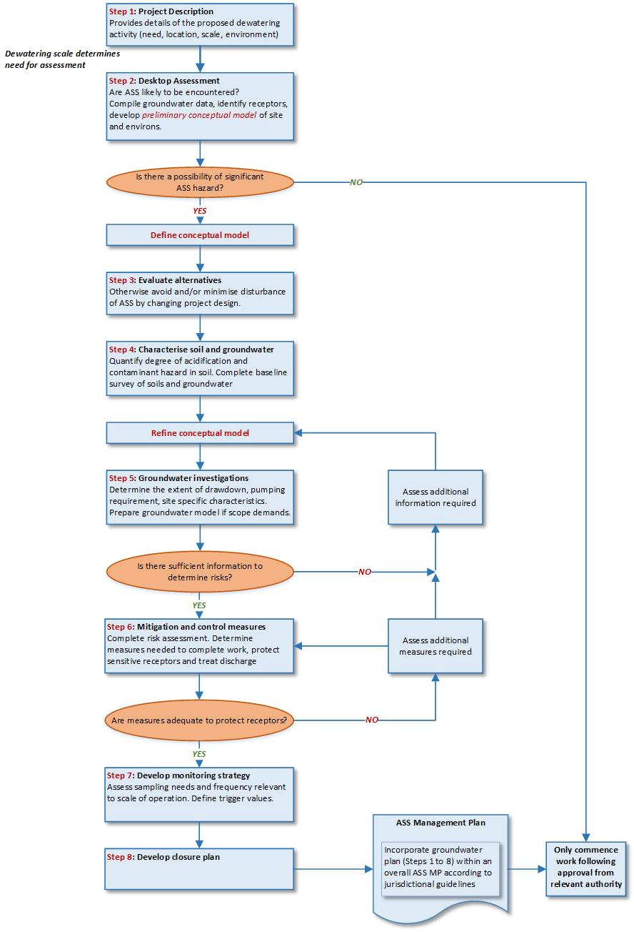

There is no current standard leaching protocol for assessing leachate properties of ASS. A simple porewater extraction is limited because many of the contaminants are only released during oxidation of the soils. It is recommended that any work is completed both on unoxidised samples and following a laboratory-based oxidation stage (section 4.4.2). Due to the number of variables in determining impacts on receptors (for example transport pathways/residence times/retardation) a relatively simple approach is considered appropriate to determine the range of contaminants potentially available, and an appreciation of quantities. A number of techniques are commonly used (for example sequential extractions) to assess how strongly bound different contaminant species to soils, but these are only likely to be essential where a risk assessment indicates a serious risk to receptors, or leachate tests indicate a high risk of impact from a specific type of contaminant.

Groundwater is not a homogeneous medium; it commonly varies aerially and with depth in soil/sediment profiles. It is important to be able to have a good understanding of such spatial variability of water quality, which can be related to expected areas of dewatering. This will also provide critical data in understanding the geochemical environment (for example pH and Eh) which will be useful in predicting chemical changes during imposed changes to flow regimes as a consequence of dewatering.

***Step 5 Groundwater Investigations***

The extent of groundwater investigations should be dependent on the extent of dewatering and the duration of pumping. The extent of dewatering controls the potential area of exposure of ASS and the duration of dewatering controls the time that soil and sediment actively remain under oxidizing conditions (where pumping is undertaken simply to maintain the required water level). Three different management levels based on these criteria were suggested by DWER (DER 2015a) and this is the approach recommended here. The management levels are shown on Table 5.1.

Where the radius of influence (section 4.5; Appendix B: Calculating the extent and duration of a cone of depression), Ro, of dewatering extends less than 50 m from each dewatered excavation and/or pumping of each excavation is less than 7 days in duration (whichever is the smaller), it is considered that no further assessment is required of dewatering other than requiring a monitoring program to be undertaken prior to, during, and after the dewatering program. This is conditional on there being no sensitive receptors (wetlands, waterways, conservation reserves, abstraction bores and contaminated sites) within 50 m of each dewatered excavation.

Otherwise, site-specific investigations and groundwater flow modelling may be required to better quantify the potential impacts of dewatering on the local groundwater flow regime. Under these conditions, proponents will be required to implement measures to reduce the extent of the cone of depression of the water table and reduce the duration of dewatering in any given excavation. Measures to achieve these objectives include (see section 4 for more details):

* reducing the depth and/or size of the excavation or dewatering system so that the dewatering footprint does not affect sensitive receptors,
* reducing the size of each excavation to reduce the groundwater pumping rate required to keep each excavation dry,
* use of sheet piling or soil grouting to constrain the lateral extent of the cone of depression of the water table to the immediate vicinity of the excavation, and
* use of barriers or other techniques to constrain the lateral extent of the cone of depression of the water table to the immediate vicinity of the excavation.

Where it is not possible to reduce the size of the cone of depression sufficiently to prevent drawdown impacts on nearby environmental receptors, a risk assessment should be undertaken to demonstrate that any environmental impacts are manageable. This will require a higher level of management level (level 2, Table 5.1).

It should be highlighted that the risks associated with dewatering are likely to vary with time, and risk mitigations plans should be adaptive. The risks can be thought about as evolving during the operational plan:

1. Groundwater pumping – during this phase a cone of depression or area of dewatering is established. Oxidation of the unsaturated zone will be initiated with potential for acidification. It is possible that some dissolved components will contaminate the groundwater beneath the cone of depression. The main risk is likely to be in relation to disposal of pumped groundwater, if of poor quality. The wider the cone of depression and/or duration of timing, the higher the likelihood of oxidation occurring.
2. Groundwater rebound – during this phase, the water table recovers, with recovery being controlled by groundwater head distribution and hydraulic conductivity of the soil. The impact on water quality will be controlled by the amount of acidity generated and mobility of contaminants formed during the pumping phase. Note that there is often a rapid release of contaminants during a “first flush” of oxidised soils (Shand et al. 2010).
3. Transport and attenuation – once the water table recovers from pumping, the natural groundwater flow will become re-established around the dewatered area. The impact of any contamination will be dependent on the transport, dilution, chemical reactions (for example neutralization), buffering by acid containing/generating phases (e.g. jarosite) and attenuation (for example dispersion, adsorption). Rates of recovery may be a considerable time (years) if oxidation has occurred over long time periods (Thom & Jones 1999), hence they may impact receptors some distance away from the site.

If ANC, organic matter or flow are limited, the dewatered area may remain acidic for some time after groundwater rebound. The risk assessment and conceptual model should, therefore, take into account both spatial and temporal considerations when assessing the risk to specific receptors. The approach of assessing hazard and risk using updated conceptual models and modelling programs should be linked closely with monitoring to provide optimum mitigation planning. A large number of proprietary 2-D and 3-D computer models exist to assess potential impacts and timescales, however, if site specific information is limited in the early stages of assessment, a 1-D approach may be as meaningful. If impacts are considered likely, this can be followed up during the subsequent steps of the framework. A 1-D example is given in Appendix B: Calculating the extent and duration of a cone of depression from DWER (DER 2015a).

***Step 6 Mitigation and control measures***

A number of control measures are well established in the urban development industry and used to a standard practice to deal with controlling groundwater, particularly to stabilise soil slopes and minimise pumping. Many of these also help to limit the amount of oxidation in areas surrounding sites.

These guidelines (see also section 4.6) suggest changes to practices in areas where ASS are present, with a focus on minimizing the area of dewatering and duration of pumping. The character of ASS change during the oxidation process (for example the formation of actual acidity is first formed, prior to sparingly soluble secondary minerals such as jarosite under lower pH conditions), therefore, it is recommended to allow groundwater rebound as soon as practically feasible. A staged approach should thus be considered as a way to reduce risk.

***Step 7 Develop monitoring strategy***

The precise number of groundwater bores and other monitoring is likely to be site specific. Use of the conceptual model and any groundwater model should highlight key receptors that may be impacted based on groundwater flow and knowledge (or estimates) of pathways and residence times. Monitoring should also take into account depth variations in groundwater flow and quality, as well as preferential flow pathways and soils with varying hydraulic properties.

In addition to monitoring groundwater in-situ and pumped groundwater, it is recommended that routine monitoring of soil is undertaken if the duration of dewatering is long. The distribution of acidity and contaminants is not static, but may change over time, particularly in the near surface in highly permeable soils. Significant recharge through the area of dewatering may wash acidity through the unsaturated zone to be neutralised at the water table if sufficient ANC is present, thus decreasing the hazard and minimizing the risks during rebound. Conversely, if acidification potential is high, oxidation may lead to the formation of secondary hydroxysulfate minerals such as jarosite over longer timescales. Once formed, the sparingly soluble jarosite may buffer the soil pH for considerable amounts of time. It is recommended that any monitoring protocols make visual observations of changes in colour and to undergo checks if this occurs: this could be a simple check of the pH at these sites or mineral identification (for example by x-ray diffraction) if pH is low.

***Step 8 Develop closure plan***

An initial closure plan should include all works completed on the site including volumes of water and soil displaced and their fate. A second closure plan is also recommended following the agreed period of monitoring. For details see section 4.8, Appendix E: Checklist for reporting for initial closure report as required by the WA Department of Water and Environment R and Appendix F: Checklist for reporting for post-monitoring closure report as required by the WA Department of Water and Environment R.

### Management of ASS in complex terrains: a case study

The management of groundwater in ASS terrains is often completed in parallel with other ASS activities, for example the removal and treatment of ASS. It should thus be incorporated into an overall ASSMP. The guidelines presented above will hopefully provide the necessary information to make this task easier and to minimise risks during the management process. The following case study (Box 5.1) highlights the complexities of an ASS site and some of the mitigation techniques used to successfully manage works through the construction process.

Box 5.1 Management of Acid Sulfate Soils for the New Parallel Runway Project at Brisbane Airport, Queensland.

Brisbane Airport Corporation (BAC) commenced construction of its New Parallel Runway (NPR) in September 2012. The project had received Australian and State Government approval in late 2007 following an intensive 2½ year environmental assessment process. The New Parallel Runway will be 3.3 km long, 60 m wide and 2 km west of and parallel to the existing main runway. The Brisbane Airport is situated on the low lying floodplain of the greater Brisbane River system, in an area of Holocene estuarine sediments. The 360 ha runway site contains alluvial Quaternary deposits and includes areas of “undifferentiated flood plain” and “tidal flats”. To raise the ground level and strengthen the soft underlying soils to allow construction of the new airfield and taxiways system, the geotechnical design involved the placement of 11M m³ of clean sand dredged from Middle Banks, Moreton Bay and the installation of 330,000 vertical wick drains to depths of 35 m below ground, designed to accelerate the consolidation process.

Two major new drainage systems, the Kedron Brook Floodway Drain to the south of the site and the Serpentine Inlet Drain to the north, were constructed to manage storm water drainage for the new airfield. ASS investigations of the site indicated the presence of several “hot spots” of potential ASS and low levels of actual ASS in near surface soils over most of the runway site. Over a two year period, more than 600,000 m³ of material predominantly from the excavation of the new drains, was successfully treated with liming rates up to 220 kg/m³, and verified for re-use in the project. The treated material was then used to form the “reclamation bund” which was constructed to enclose the entire site footprint as a giant containment area which allowed the dredge water to be captured, treated and tested prior to being discharged back into Kedron Brook Floodway.

**Figure 5.2 Construction of the Kedron Brook Floodway Drain.**

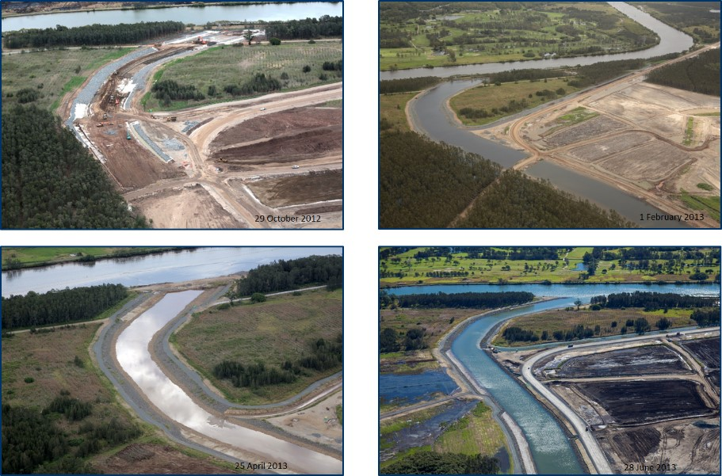

**(1) Treatment of ASS In-situ** – In-situ treatment was only allowed to be undertaken on soils that were above the water table or that were sufficiently dry to mix the lime through. Any water-logged materials had to be removed and treated at a treatment pad. 90% purity agricultural lime was spread on the surface, at the designated liming rates for that area, and mixed through within 48 h, using an agricultural tine or similar. Treatment had to be undertaken in maximum 300 mm layers. Verification testing and results had to be undertaken prior to the materials being allowed to be removed.

**(2) Treatment of ASS at a treatment pad** - Two major areas were allocated for the treatment of ASS, with up to 29 treatment cells being used within the treatment pads. Purpose built lime treatment pads, contained within a minimum 1m high low permeability compacted earth bund, comprised a layer of compacted non-ASS clayey material. A ‘guard layer’ of fine crushed limestone was placed on the base of the pad and up the side of the bunds at a rate of 10 kg of lime/m². The treatments pads were separated into cells, which were graded to facilitate collection of water in a purpose-built sump. Material requiring different liming rates was not allowed to be mixed within the same cell. Excavated material had to be spread within the treatment cell at a maximum thickness of 300 mm, with lime to be added only if soil was dry enough to be adequately worked. Once lime was spread, mixing had to occur within a 48 hour period, with excavated material to be treated within 5 days of disturbance. If the excavated materials were too wet to work, lime had to be applied to the exposed surface of the stockpiled materials within the cell, at a rate of 5 kg lime/m² and the material treated as soon as practical. Once the material was treated, verification testing was completed and reviewed against performance criteria. If the material passed the verification testing, this material was then compacted to form the new base of the cell and fresh excavated materials brought up for treatment. This allowed for the stockpiling of the large amount of excavated materials to be successfully treated, verified and stockpiled prior to be used for the construction of the reclamation bunds during the dredging activities, the next construction phase of the project.

**(3) Verification Testing** – A total of 1,132 composite samples were collected and verified using the SPOCAS or SCr laboratory analysis at the following frequencies:

a. One test per 250m3 of spoil for liming rates greater than 50 kg/m3;

b. One test per 1000m3 of spoil for liming rates of 30 to 50 kg/m3;

c. One test per 1500m3 of spoil for liming rates of 10 to 30 kg/m3; and

d. One test per 2,000m3 of spoil for liming rates of less than 10 kg/m3.

Verification testing had to be undertaken by a qualified person and once verification samples had been collected from within a treatment cell, additional material could not be added to the cell until the verification results had returned and results demonstrated that soil had passed verification. In addition, material could not be removed from a cell unless the verification results had returned confirmation that the treatment had been successful. Treatment was considered successful if all the three performance limits were met.

**(4) Lime guard layer and lime cut-off trenches** – A lime guard layer of up to 15 kg/m², within two weeks of the final surface shaping of any new constructed drains for the NPR project had to be installed. A lime guard layer of 10 kg/m² was also placed beneath the perimeter bund of the fill platform, for the width of the bund, prior to the construction of the bund. Two lime cut-off trenches up to 2 m below ground level were also installed between the edge of the fill platform and the adjacent Kedron Brook Floodway, running parallel for a distance of 3 km. To supplement the lime cut-off trenches, lime chip rock check dams were also installed within the shallow drains, which transported the groundwater being brought to the surface by the sand surcharge and the wick drains.

**(5) Surface water and Groundwater Monitoring** – Prior to construction starting, BAC established a range of baseline conditions for surface water and groundwater quality surrounding the site. These baseline levels in combination with the water quality objectives for the receiving environment were considered in the establishment of the discharge water quality criteria that the contractors were compelled to achieve during the construction activities. Groundwater wells and piezometers were installed along the Kedron Brook Floodway Drain as well as surrounding the filling platform. Monthly monitoring of both surface water and groundwater quality for ASS impacts was undertaken throughout the construction activities, with contingency measures in place should the performance criteria be exceeded. A 25 m wide section of both major drains had to remain in place at the mouth to act as a natural in-situ bund during construction, with this bund being the last part to be excavated. Water quality testing, for ASS impacts of the water held behind the bund, had to meet water quality performance criteria prior to the bund being removed to connect the drains to the existing waterway.

**(6) Management of Contractors** – The NPR Project is located on Commonwealth land and due to the nature and location of some parts of the project was compelled to respond to three levels of government (Commonwealth, State and Local) conditions. The successful management of ASS within such a large scale project can be attributed to the decision by BAC to prepare a construction environmental management plan (CEMP) in response to the environmental conditions set out for the project and have it approved by the regulators prior to seeking tender submissions. This allowed for mature documents to be produced without the rush of having to start construction as soon as the contract was awarded with the engaged contractor knowing the expected environmental performance since bidding on the Project. The CEMP, which included numerous “Hold Point” and ‘Witness Point” for ASS management, formed part of the contract for the project with the contractors being very clear as to what environmental outcomes were expected and still having to prepare their own CEMP.

## Future work and data gaps

The guidance presented in this report represent a first step in supporting the effective management of dewatering and groundwater-related acid sulfate soils (ASS). They have largely built upon existing guidelines developed in Western Australia (DER 2015a), which focused on sand and peat deposits of the Perth coastal plain. The guidance is largely adequate for porous media such as sands, but may not be directly applicable to soils and aquifers which display preferential flow pathways including fracture flow. Groundwater flow in such media is poorly understood in general, which presents difficulties when making recommendations for dewatering and impacts on sensitive receptors. Impacts may be felt at great distances from the area of dewatering in such cases even where there are no impacts closer to the discharging zone. The precautionary principle needs to be applied in such cases to maximise detection of impacts before reaching sensitive receptors. This is considered a key area for consideration in future work.

One of the key tenets of ASS management, that of not disturbing soils, followed by minimizing disturbance is not always possible in areas where urban or other developments take precedent. Although a range of mitigation measures are currently being used, there is no clear guidance as to which are most effective in specific terrains where ASS are present. For both mitigation and remediation in acidic environments, knowledge gaps are not confined to ASS environments as authorities have been dealing with acid mine drainage issues for decades. However, it is universally agreed that good practice in mitigation techniques are much more economic than dealing with remediation of legacy issues.

A significant gap is also in the area of contaminant mobilisation following groundwater rebound. The oxidised environment is not only complex in terms of solid phase speciation of contaminants, but also continually changing as the cone of depression equilibrates to changing redox and pH conditions. Research and modelling improvements would benefit management options in this area. Field scale research studies are not common, but would help support management decisions; there may be options for researchers and industry to work together in real situations for mutual benefit.

There are a range of existing technologies for dealing with acidification that have been used elsewhere (and occasionally in ASS but which are not yet fully tested in groundwater systems) which may have relevance to mitigation and remediation. These include techniques such as bioremediation, passive wetland systems and sub-surface injection technologies. Further work would be warranted to look at the range of industry by-products which may offer a cheap method to neutralise sub-surface acidity, for example in permeable reactive barriers.

The problems involved in regional scale dewatering are well known and the difficulties are not so much in understanding the causes of acidification, but in ways to manage problems with multi-stakeholders with complex often conflicting interests. One of the key limitations is knowledge of the extent of sulfide minerals in the sub-surface, and they are likely to be much more common than currently realised. The risks are linked to water table depths hence to groundwater management and future climate change impacts on groundwater recharge.

## Appendix A: Texture based action criteria for acid sulfate soils

The amount of sulfide present in a soil has traditionally been used to define action criteria in many state and territory jurisdictions, taking into account soil texture (Table A1). Action criteria define the acidity levels beyond which management is required, and used in conjunction with amount of soil to be disturbed.

Table A1 Texture based acid sulfate soil action criteria.

|  |  |  |  |  |  |
| --- | --- | --- | --- | --- | --- |
| Type of material | | Sum of existing and potential acidity: acid generating potential (AGP) | | | |
| Texture range (NCST, 2009) | Approximate clay content % | 1−1000 tonne (t) material disturbed | | > 1000 t material disturbed | |
| % S-equiv. | mol H+/t | % S-equiv. | mol H+/t |
| Fine: medium to heavy clays and silty clays | >40 | 0.1 | 62 | 0.03 | 18 |
| Medium: sandy loams to light clays | 5-40 | 0.06 | 36 | 0.03 | 18 |
| Coarse: sands to loamy sands and peats | <5 | 0.03 | 18 | 0.03 | 18 |
| Draft action criteria for poorly buffered sands -Coarse: sands, poorly buffered | <5 | 0.01 | 6 | 0.01 | 6 |

Source: Modified from Dear et al. 2014.

The criteria are based on acid generating potential, taking into account soil texture as clays may have a degree of acid neutralization where acid generating potential (AGP) is low. Recent updates of these criteria (Dear et al. 2014) have also included draft action criteria for poorly buffered sands such as the Bassendean Sands of Western Australia.

A comprehensive framework exists for assessing the extent and severity of acid sulfate soils (ASS) for coastal ASS using the above criteria (Ahern et al. 2004; 2008), which has also been adapted to inland systems (EPHC & NRMMC 2010; MDBA 2010). The action criteria shown in Table A1 are based on actual and potential acidity, but not including the acid neutralizing capacity (ANC) of the soils. If a soil has some self-neutralising capacity, this can be used to offset the acidity of the soil. For this purpose the term net acidity can be defined and used for acid-base accounting purposes.

The risk of acidification of ASS can be determined indirectly using an acid-base accounting approach (Ahern et al. 2004), whereby the Net Acidity, a measure of the acid-producing capacity of the soil is defined as:

Net acidity = TAA + SCr + RA – ANC/FF

where,

TAA = titratable actual acidity (a measure of the actual acidity of the soil, may also include soluble sulfate salts)

SCr = Cr-reducible S (the acidity that could be released with complete oxidation of sulfide minerals)

RA = retained acidity (acidity released from relatively insoluble minerals such as jarosite)

ANC = acid neutralizing capacity, mainly the carbonate content of a soil. A fineness factor (FF), usually greater than or equal to 1.5, is applied to compensate for potential limited reactivity of carbonate, for example a large grain size may limit the rates of dissolution or armouring of carbonate by Fe oxyhydroxides may occur.

Soils with a net acidity of more than 18 moles H+/tonne trigger the requirement for detailed acid sulfate soil assessment, if that acidity is sulfide related (Ahern et al. 2004). The trigger value is to some degree based on susceptibility, as clays have more buffering capacity than pure sands. However, clays often contain more sulfide than pure sands and prolonged oxidation may cause the formation of secondary sulfate minerals such as jarosite. The combination of low hydraulic conductivity in clays and the slow dissolution rates of sparingly soluble jarosite may mean that remediation is often a very slow process.

## Appendix B: Calculating the extent and duration of a cone of depression

The calculations are based on the following methodology. Dewatering of a rectangular excavation with dimensions a metres wide and b metres long can be approximated as pumping from a large-diameter bore with an equivalent radius of re metres, where:

Equation B1 Dimensions of a rectangular excavation.

$$r_{e}=\sqrt{\frac{ab}{π}}$$

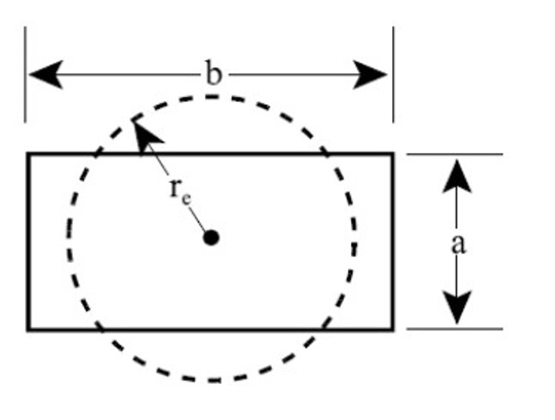

The radius of influence of this large-diameter bore (that is the radius of the cone of depression of the water table) can be approximated using Sichardt’s equation:

Equation B2 Sichardt's equation.

$$R_{o}=3000\left(H-h\right)\sqrt{K}$$

Where:

H = saturated thickness of the aquifer undisturbed by pumping (m)

h = saturated thickness of the aquifer at maximum drawdown (m)

K = hydraulic conductivity of aquifer matrix (units of m/s)

In the absence of site-specific hydraulic data, assume a value of K of 3.5 x 10-4 m/s for sandy aquifer materials and 1 x 10-5 m/s for silty or clayey aquifer materials.

As a first approximation, changes in water table elevation caused by dewatering are related to the pumping rate, hydraulic conductivity of the aquifer matrix and radius of influence of pumping by the equation:

Equation B3 Relationship between water table elevation changes, hydraulic conductivity and radius of influence.

$$H^{2}-h^{2}=\frac{nq}{πk}\left(\ln{R_{o}-\ln{r_{e}}}\right)$$

Where:

H = saturated thickness of the aquifer undisturbed by pumping (m)

h = saturated thickness of the aquifer at maximum drawdown (m)

k = hydraulic conductivity of aquifer matrix (units of m/s) Ro = radius of influence of an equivalent pumping bore (m)

Ro = radius of influence of an equivalent pumping bore (m)

re = effective radius of an equivalent pumping bore (m)

q = pumping rate of individual dewatering well points (m3/s)

n = number of well points used to dewater the excavation

The pumping time required for the cone of depression of the water table to extend out to Ro is given by the Cooper-Jacob empirical relationship:

Equation B4 Cooper-Jacob empirical relationship.

$$R_{o}={\left(\left(2.25kht\right)/S\right)}^{0.5}$$

Where:

t = pumping time (seconds)

S = specific yield of aquifer sediments

Other parameters as previously defined

In the absence of site-specific hydraulic information, assume a specific yield of 0.1. The following example demonstrates how these equations can be used to estimate the radius of influence of a dewatering program and the pumping rate and time required to lower the water table by a specified amount in the area of excavation:

**Example 1**

A dewatering program is planned at a site underlain by sandy sediments where the saturated thickness of the superficial aquifer is 45 m. It is planned to lower the water table by 5 m in a rectangular area of dimensions 30 m by 15 m. It is proposed to use 26 well points around the rectangular area to lower the water table to the base of the excavation.

Solution:

Firstly, use Sichardt’s equation (Equation No 2) to determine the radius of influence (that is the radius of ultimate cone of depression) if one large pumping bore is used to dewater the excavation:

Ro = 3000 x (45 – 40) x (3.5 x 10-4)0.5

= 281 m

The equivalent radius of this pumping bore is determined using Equation 1.

re = (30 x 15/p)0.5

= 12 m

The pumping rate to dewater the excavation can be determined using Equation 3:

(45)2 –(40)2 = nq x ((ln(281) – ln(12))

p x (3.5 x 10-4)

That is nq = 0.15 m3/s

Given that there are 26 well points in use to dewater the excavation, the pumping rate of each well point must be 0.15/26 m3/s, or about 5.8 L/s.

The pumping time needed is given by the Cooper-Jacob equation (Equation No 4)

281 = ((2.25 x 3.5 x 10-4 x 40)/0.1)0.5 x (t)0.5

That is 281/0.56 = (t)0.5

That is t = 251789 seconds or about 70 hours or 3 days

## Appendix C: Dewatering effluent monitoring matrix

Table C1 Dewatering effluent monitoring matrix.

|  |  |  |
| --- | --- | --- |
| Trigger | Action | Monitoring |
| Total titratable acidity <40mg/L, pH>6 | Continue daily field measurements of pH and total titratable acidity | **Daily** - field measurement: pH, electrical conductivity (EC) & Total Titratable Acidity (TTA)  **Fortnightly** - laboratory analysis: total acidity, total alkalinity, pH |
| Total titratable acidity <40mg/L, pH in range 4 to 6 | Undertake neutralization treatment (liming) | **Daily** - field measurement: pH, EC & TTA  **Weekly** - laboratory analysis: total acidity, total alkalinity, pH |
| Total titratable acidity in range 40mg/L to 100mg/L, pH>6 | Effluent should be aerated to precipitate dissolved iron and directed to a series of settlement basins/ trenches or other treatment system to allow removal of iron and other metals. Undertake neutralization treatment (liming) | **Daily** - field measurement: pH, EC & TTA  **Weekly** - laboratory analysis: total acidity, total alkalinity, pH  **Fortnightly** - laboratory analysis: total acidity, total alkalinity, pH, sulfate, chloride, total iron, dissolved iron (filtered), total aluminium, dissolved aluminium (filtered), total arsenic, total chromium, total cadmium, total manganese, total nickel, total zinc, total selenium, ammoniacal nitrogen, hydrogen sulfide*, EC, total suspended solids (TSS), total dissolved solids (TDS), total nitrogen (TN), total phosphorus (TP), filterable reactive phosphorus (FRP)  **Fortnightly** - field measurement: dissolved oxygen (DO), redox potential (Eh) |
| Total titratable acidity in range 40mg/L to 100mg/L, pH in range 4 to 6 | Effluent should be aerated to precipitate dissolved iron and directed to a series of settlement basins/ trenches or other treatment system to allow removal of iron and other metals Undertake neutralization treatment (liming) | **Daily** - field measurement: pH, EC, TTA  **Weekly** - laboratory analysis: total acidity, total alkalinity, pH  **Fortnightly** - laboratory analysis: total acidity, total alkalinity, pH, sulfate, chloride, total iron, dissolved iron (filtered), total aluminium, dissolved aluminium (filtered), total arsenic, total chromium, total cadmium, total manganese, total nickel, total zinc, total selenium, ammoniacal nitrogen, hydrogen sulfide*, EC, TSS, TDS, TN, TP, FRP  **Fortnightly** - field measurement: DO, Eh |
| Total titratable acidity > 100mg/L | Effluent should be aerated to precipitate dissolved iron and directed to a series of settlement basins/ trenches or other treatment system to allow removal of iron and other metals Increase neutralization treatment (liming) rate Advise appropriate authorities immediately who will advise appropriate action which may include ceasing dewatering | **Twice daily** – field measurement: pH, EC, TTA **Weekly** - laboratory analysis: total acidity, total alkalinity, pH, sulfate, chloride, total iron, dissolved iron (filtered), total aluminium, dissolved aluminium (filtered), total arsenic, total chromium, total cadmium, total manganese, total nickel, total zinc, total selenium, ammoniacal nitrogen, hydrogen sulfide*, EC, TSS, TDS, TN, TP, FRP  **Fortnightly** - field measurement: DO, Eh May be required to undertake investigations to determine the size of the “acidic footprint” created and manage this impact appropriately |
| pH<4 | Increase neutralization treatment (liming) rate. Advise appropriate authorities immediately who will advise appropriate action which may include ceasing dewatering | **Twice daily** - field measurement: pH, EC, TTA  **Weekly** - laboratory analysis: total acidity, total alkalinity, pH, sulfate, chloride, total iron, dissolved iron (filtered), total aluminium, dissolved aluminium (filtered), total arsenic, total chromium, total cadmium, total manganese, total nickel, total zinc, total selenium, ammoniacal nitrogen, hydrogen sulfide*, EC, TSS, TDS, TN, TP, FRP  **Fortnightly** - field measurement: DO, Eh May be required to undertake investigations to determine the size of the “acidic footprint” created and manage this impact appropriately |

Note:

1. Measurement of metal concentrations in dewatering effluent should be as total concentrations from an unfiltered water sample. These concentrations should then be used to determine appropriate treatment options for the effluent, except where otherwise specified, and to identify any emerging trends in groundwater quality. It is not the intention that these values for total metals be directly compared against environmental or health-based criteria for dissolved metals. However, when determining treatment options, consider that: a) any metals contained within suspended solids have the potential to be mobilised if pH and/or redox conditions change (which is common in ASS environments); and b) if dewatering effluent is to be discharged into a receiving environment then these suspended solids will be discharged along with the water.

2. If dewatering effluent is to be discharged via irrigation or used for dust suppression purposes the proponent needs to demonstrate that it is of suitable quality for this purpose. Similarly, if dewatering effluent is to be discharged via infiltration the proponent needs to demonstrate that it is of suitable quality for this purpose. The Australian and New Zealand Guidelines for Fresh and Marine Water Quality (Australian and New Zealand Environment and Conservation Council & Agriculture and Resource Management Council of Australia and New Zealand (ANZECC & ARMCANZ, 2000) may provide more guidance in this regard.

3. If there are naturally acidic wetlands in the vicinity of the project area it may be more appropriate to adopt a trigger value for pH of 5.5 rather than 6.0.

4. *The measurement of hydrogen sulfide is only required when discharging effluent to the natural environment.

Source: Modified from DER 2015a.

## Appendix D: A one-dimensional analytical solution for the transport of contaminants in groundwater

The concentration, C, of a conservative contaminant in groundwater at various distances and travel times from a source can be estimated using the following expression (Fetter, 1988):

Equation D1 Concentration of a conservative contaminant in groundwater.

$$C=\frac{C_{o}}{2}\left[erfc\left(\frac{x-{\overline{ν}}_{x}t}{2\sqrt{D_{x}t}}\right)+exp\left(\frac{{\overline{ν}}_{x}x}{D_{x}}\right)erfc\left(\frac{x+{\overline{ν}}_{x}t}{2\sqrt{D_{x}t}}\right)\right]$$

Where

$\overline{ν}$ = average groundwater flow rate (m/day)

Co = initial concentration at a point source (mg/L =g/m3)

x = distance down-gradient from the source (m)

t = travel time (days)

Dx = Dispersion coefficient (m2/day)

erfc = complementary error function

The average groundwater flow rate can be estimated by the expression:

$\overline{ν}$ = Ki/n

Where

K = hydraulic conductivity of the aquifer sediments (m/day)

i = hydraulic gradient in the direction of groundwater flow

n = porosity (assume a value of 0.3 in the absence of site-specific information)

As a first approximation, the dispersion coefficient can be estimated using the expression:

Dx = (Kix)/3

These equations can be solved by fixing the travel distance to a sensitive receptor as constant value, and determining concentrations at that point with varying travel times. This will enable the breakthrough curve and peak concentration-values for groundwater contaminants at that point to be determined. The breakthrough curve will indicate whether contaminant concentrations in groundwater at that distance from a sand mine site are likely to reach levels of environmental concern, and the period of time over which environmental impacts on a receptor at that location are possible.

## Appendix E: Checklist for reporting for initial closure report as required by the WA Department of Water and Environment Regulation (DWER)

Table E1 Checklist for reporting for initial closure report as required by DWER (DER 2015a).

| Report sections | Information to be included, where relevant | Comments |
| --- | --- | --- |
| 1 - Executive summary | * Background * Objectives of the Acid Sulfate Soil Management Plan * (ASSMP) * Scope of work * Summary of ASS investigations * Summary of site works * Summary of ASSMP * Acid Sulfate Soils Summary Form B - Closure Report, available from the [Department of Environment Regulation (DWER) website](http://www.der.wa.gov.au/ass). | Mandatory information |
| 2 - Scope of work | * Clear statement of the scope of work | Mandatory information |
| 3 - Site identification | * Street number, lot number, street name and suburb * Common title/name of site (for example Sparkling Waters Residential * Estate) * Certificates of title (copy of document including survey plan) * Co-ordinates of site boundaries (Northings/Eastings – specify datum set) * Locality map * Current site plan showing any existing infrastructure, scale bar, north arrow, local environmentally significant features, * ‘stages’ of development | Mandatory information |
| 4 - Details of land development | * Full description of proposed development * Site lay-out plans and cross-sectional diagrams for proposed development * Details of proponent and Project Manager * Details of planning conditions including full and clear identification of section of the development project for which clearance of conditions is sought – that is site plans clearly showing cadastral boundaries, “stage” boundaries, spatial co-ordinates, gazetted roads et cetera, (where applicable) * List of all other names under which the development has been known (where applicable). | Mandatory information |
| 5 - Geology and hydrogeology | * Description of geology and hydrogeology encountered during ground disturbing activities * Discussion of any discrepancies between the geology and hydrogeology expected to be encountered and that which was encountered (where applicable) * Depth to groundwater table * Direction and rate of groundwater flow * Direction of surface water runoff * Groundwater discharge location * Groundwater quality * Groundwater/surface water interaction * Groundwater conditions (for example unconfined, confined, ephemeral or perched) * Beneficial use of groundwater in the vicinity such as public drinking water supply and source areas, domestic irrigation, aquatic ecosystems, and the potential impacts on these uses * Location and use of groundwater bores within a 1km radius of the site * Location of sensitive receptors/users * Preferential migratory pathways encountered during ground disturbing activities. | Mandatory information |
| 6 - Details of site works | * Full description of ground disturbing activities which were undertaken, including both soil and water disturbance (including volumes, depths, duration, locations et cetera) * Volume of soil and groundwater treated at the site * Amount of neutralising agent used during works * Details and verification of off-site treatment of soils (where applicable). | Mandatory information |
| 7 - Adherence to ASS Management Plan | * Details of whether environmental performance objectives were met. * Details of ASS management strategy implemented at the site including confirmation that the site works were carried out in accordance with the DWER-approved ASSMP. * Identification of and justification for any deviations from the Department of Water and Environmental Regulation (DWER) approved ASSMP (where applicable) * Details of the implementation of any contingency plans (where applicable) * Verification of compliance with regulatory requirements such as licenses and approvals (local and state level) * Photographs of site works confirming adherence with ASS Management Plan (for example photos of excavation, soils being stockpiled and treated, water treatment systems, effluent disposal, et cetera). | Mandatory information |
| 8 - Basis for adoption of assessment criteria | * Table listing all selected assessment criteria and references * Rationale for and appropriateness of the selection of criteria * Assumptions and limitations of criteria. | Mandatory information |
| 9 - Monitoring results | * Results of all soil, groundwater and surface water monitoring programs. * Summary of all monitoring results - in a table that shows essential details, such as sampling locations and depths, assessment criteria and highlights all results exceeding the adopted assessment criteria. * Site plans showing the location of all monitoring points, showing their relation to ground disturbing activities and soil and water treatment and disposal areas. * Full discussion of the results of the groundwater monitoring program (plus surface water body monitoring program where applicable) with particular emphasis on trends in water quality (graphs of water quality data should be presented to aid the identification of trends). * Results of soil treatment validation program (where applicable) * Results of validation of soil and water treatment areas after decommissioning (where applicable) * Calibration certificates or calibration results * Copies of original laboratory result certificates including National Association of Testing Authorities (NATA) accreditation details * Discussion of any discrepancy between field observations and laboratory analyses results * Site plan showing all sample locations, sample identification numbers and sampling depths * Site plan showing extent of groundwater acidity and/or metal contamination beneath site (where applicable). | Mandatory information |
| 10 - Risk assessment | * Receptor identification * Assessment of receiving environment’s sensitivity * Exposure assessment * Discussion of the potential risk of harm to human health and/or the environment associated with the ground disturbing works undertaken with reference to the results of the monitoring programs. * Discussion of assumptions used in reaching the conclusions * Extent of uncertainties in the results. * Discussion, justification and remedial measures proposed if environmental performance objectives were not met * Risk management decisions based on outcome of the assessment. | Mandatory information |
| 11 - Community consultation | * Details of stakeholders (individuals and groups) consulted * Summary of information provided to stakeholders (for example minutes of meetings, informative flyers) * Input and comments received from stakeholders * Details of how stakeholder input was considered in decision- making * Brief description of community consultation undertaken during previous stages of site investigation, if details have already been submitted to Department of Water and Environment Regulation (DWER) in previous report(s) * Refer to Community Consultation (DER, 2006) guideline. | Include information where community consultation was undertaken |
| 12 - Ongoing monitoring | * Ongoing soil, groundwater, and/or surface water monitoring requirements. * Details of party(s) responsible for ongoing monitoring program. * Commitment to and timing of submission of results of monitoring programs. | Mandatory information where applicable |
| 13 - Conclusions and recommendations | * Brief summary of all findings * Full discussion of the effectiveness of management strategies employed at the site * Discussion of any potential risks to human health or the environment (where applicable) * Assumptions used in reaching the conclusions * Extent of uncertainties in the results * Discussion of any remedial measures required (where applicable) * Recommendations for further sampling (where applicable) * Long term site management plan (where applicable) * A statement detailing all limitations and constraints on the use of the site (where applicable) * Clear statement from the consultant as to whether the site should be reported as a known or suspected contaminated site under the *Contaminated Sites Act 2003.* | Mandatory information |

Source: DER 2015a.

## Appendix F: Checklist for reporting for post-monitoring closure report as required by the WA Department of Water and Environment Regulation (DWER)

Table F1 Checklist for reporting for post-monitoring closure report as required by DWER (DER 2015a).

| Report sections | Information to be included, where relevant | Comments |
| --- | --- | --- |
| 1 - Executive summary | * Background * Objectives of the monitoring program * Scope of work * Summary of acid sulfate soils (ASS) investigations * Summary of site works * Acid Sulfate Soils Summary Form C – Post-dewatering Monitoring Report, available from the [Department of Environment Regulation (DWER) website](http://www.dec.wa.gov.au/ass). | Mandatory information |
| 2 - Scope of work | * Clear statement of the scope of work | Mandatory information |
| 3 - Site identification | * Street number, lot number, street name and suburb * Common title/name of site (for example Sparkling Waters Residential * Estate) * Certificates of title (copy of document including survey plan) * Co-ordinates of site boundaries (Northings/Eastings – specify datum set) * Locality map * Current site plan showing any existing infrastructure, scale bar, north arrow, local environmentally significant features, “stages” of development * Local government authority. | Mandatory information |
| 4 - Details of land development | * Full description of proposed development * Details of proponent and project manager * Details of planning conditions including full and clear identification of section of the development project for which clearance of conditions is sought – that is site plans clearly showing cadastral boundaries, ‘stage’ boundaries, spatial co- ordinates, gazetted roads et cetera, (where applicable) * List of all other names under which the development has been known or referred to as (where applicable). | Mandatory information |
| 5 - Geology and hydrogeology | * Description of geology and hydrogeology * Depth to groundwater table * Direction and rate of groundwater flow * Groundwater discharge location * Groundwater quality * Groundwater/surface water interaction * Groundwater conditions (for example unconfined, confined, ephemeral or perched) * Beneficial use of groundwater in the vicinity such as public drinking water supply and source areas, domestic irrigation, aquatic ecosystems and the potential impacts on these uses * Location and use of groundwater bores within a 1km radius of the site * Location of sensitive receptors/users * Preferential migratory pathways encountered during ground disturbing activities. | Mandatory information |
| 6 - Details of site works | * Description of ground disturbing activities which were undertaken, including both soil and water disturbance. | A brief summary of the Site Works is adequate if detailed information was provided to DWER in a referenced previous report |
| 7 - Basis for adoption of assessment criteria | * Table listing all selected assessment criteria and references * Rationale for and appropriateness of the selection of criteria * Assumptions and limitations of criteria. | Mandatory information |
| 8 - Monitoring results | * Results of all groundwater and surface water monitoring programs * Summary of all monitoring results - in a table that shows essential details such as sampling locations and depths, * assessment criteria, highlights all results exceeding the adopted assessment criteria. * Site plans detailing the location of all monitoring points and showing their relation to ground disturbing activities, soil and water treatment and disposal areas. * Full discussion of the results of the groundwater monitoring program (plus surface water body monitoring program where applicable), with particular emphasis on trends in water quality (graphs of water quality data should be presented to aid the identification of trends). * Calibration certificates or calibration results * Copies of original laboratory result certificates including National Association of Testing Authorities (NATA) accreditation details * Discussion of any discrepancy between field observations and laboratory analyses results * Site plan showing extent of groundwater acidity and/or metal contamination beneath site (where applicable). | Mandatory information |
| 9 - Risk assessment | * Receptor identification * Assessment of receiving environment’s sensitivity * Exposure assessment * Discussion of the potential risk of harm to human health and/or the environment associated with the ground disturbing works undertaken with reference to the results of the water monitoring program * Discussion of assumptions used in reaching the conclusions * Extent of uncertainties in the results * Risk management decisions based on outcome of the assessment. | Mandatory information |
| 10 - Community consultation | * Details of stakeholders (individuals and groups) consulted * Summary of information provided to stakeholders (for example minutes of meetings, informative flyers) * Input and comments received from stakeholders * Details of how stakeholder input was considered in decision- making * Brief description of community consultation undertaken during previous stages of site investigation, if details have already been submitted to DWER in previous report(s) * Refer to *Community Consultation* (DEC, 2006) guideline. | Include information where community consultation was undertaken |
| 11 - Conclusions and recommendations | * Brief summary of all findings * Full discussion of the effectiveness of management strategies employed at the site * Discussion of any potential risks to human health or the environment (where applicable) * Assumptions used in reaching the conclusions * Extent of uncertainties in the results * Discussion of any remedial measures required (where applicable) * Recommendations for further sampling (where applicable) * Long term site management plan (where applicable) * A statement detailing all limitations and constraints on the use of the site (where applicable) * Clear statement from the consultant as to whether the site should be reported as a known or suspected contaminated site under the *Contaminated Sites Ac*t 2003. | Mandatory information |
| 12 - Ongoing monitoring | * Ongoing soil, groundwater and/or surface water monitoring requirements * Details of party(s) responsible for ongoing monitoring program * Commitment to and timing of submission of results of monitoring programs. | Mandatory information where applicable |

Source: DER 2015a.

## Appendix G: Management Levels for dewatering scale of acid sulfate soils

**Dewatering Management Level 1**

Where dewatering will be undertaken in an area underlain by acid sulfate soils (ASS) for a total duration of less than seven days, the management should include (but not necessarily be limited to):

* staging of earthworks and dewatering program to minimise the duration and magnitude of dewatering (to limit the amount of time that ASS are exposed to the atmosphere),
* management of the dewatering program to minimise the lateral and vertical extent of groundwater drawdown (to limit the volume of ASS exposed to the atmosphere),
* calculation of the radius of the groundwater cone of depression,
* if the actual radial extent of the groundwater cone of depression exceeds 50 m and the duration of the dewatering operation exceeds seven days, Dewatering Management Level 2, as outlined in Section 8.2.3 will need to be implemented and Department of Water and Environment Regulation (DWER) should be advised,
* management of dewatering effluent,
* water table level monitoring to ensure that the actual radial extent of the groundwater cone of depression is not more than that predicted from calculations,
* if the actual duration of dewatering exceeds seven days and the radial extent of the groundwater cone of depression is greater than 50 m, Dewatering Management Level 2 will need to be implemented,
* development of an Acid Sulfate Soil Management Plan (ASSMP) for approval before commencement of site works(site works cannot commence until the ASSMP has been approved),
* submission of an Initial Closure Report, and
* remedial actions to restore groundwater quality, if needed.

**Dewatering Management Level 2**

Where dewatering will be undertaken in an area underlain by ASS for a total duration of greater than seven days with a radial extent of the cone of groundwater depression greater than 50 m, the management should include (but not necessarily be limited to):

* staging of disturbance such that the potential effects on any area disturbed at any one time are limited and easily managed,
* staging of earthworks and dewatering program to minimise the duration and magnitude of dewatering (to limit the amount of time that ASS are exposed to the atmosphere),
* management of the dewatering program to minimise the lateral and vertical extent of groundwater drawdown (to limit the volume of ASS exposed to the atmosphere, see Section 5.2),
* calculation and modelling of the radius of the groundwater cone of depression (see Section 5.3.4),
* limiting the lateral radius of the groundwater cone of depression to less than 100 m,
* baseline laboratory groundwater quality data to be collected before the commencement of dewatering operations (this may involve more than one monitoring event to ensure the data are representative and to capture seasonal variations),
* installation of groundwater monitoring bores up-gradient and down-gradient of dewatering location (bores must be appropriately positioned to enable them to be used to assess any impacts of dewatering on groundwater level and quality),
* management of dewatering effluent,
* water table level monitoring to ensure that water table drawdown does not exceed 10 cm at a distance of 100 m from the dewatering location,
* groundwater pH, standing water levels, EC, redox, DO, total titratable acidity and total alkalinity to be monitored in the field every second day during the dewatering operation and continued until it can be shown that groundwater levels have returned to normal elevations,
* groundwater samples to be collected for laboratory analysis at fortnightly intervals during the dewatering operation,
* laboratory groundwater quality analytical suite to include: total acidity, total alkalinity, sulfate, chloride, dissolved aluminium (filtered), dissolved arsenic (filtered), dissolved chromium (filtered), dissolved cadmium (filtered), dissolved iron (filtered), dissolved manganese (filtered), dissolved nickel (filtered), dissolved zinc (filtered), dissolved selenium (filtered), ammoniacal nitrogen, TDS, total nitrogen, total phosphorus, filterable reactive phosphorus (FRP),
* development of an Acid Sulfate Soil Management Plan (ASSMP) in accordance with relevant authority for approval before commencement of site works. Site works cannot commence until the ASSMP has been approved,
* dewatering operations to cease immediately if the results of groundwater and/or dewatering effluent monitoring indicate any deterioration in groundwater quality,
* remediation of groundwater to be undertaken should the results of the groundwater quality monitoring program indicate that any environmental impact has occurred as a result of project works,
* laboratory groundwater quality data to be collected after finalisation of dewatering operations,
* results of the groundwater and effluent water quality and water level monitoring program to be reported within an Initial Closure Report (Section 10.2.1) for the project along with a discussion of any environmental impacts observed,
* groundwater samples to be collected from all groundwater monitoring bores for laboratory analysis at intervals of one month to two months for a period of at least six months, including at least one groundwater monitoring event taken at the time of highest seasonal groundwater levels following completion of the dewatering operation (the period of monitoring needed will increase with increasing magnitude and duration of the dewatering operation),
* results of the post-dewatering groundwater quality monitoring program to be reported within a Post- Dewatering Monitoring Closure Report (see Section 10.2.2) for the project along with a discussion of any environmental impacts observed. Potential requirements for continued monitoring and/or remediation will be assessed after reviews this Post-Dewatering Monitoring Closure Report, and
* remedial actions to restore groundwater quality, if needed.

Source: Modified from DER 2015a.

## Glossary

| Term | Definition |
| --- | --- |
| Acid base account (ABA) | A simple equation used to combine the results of several laboratory soil tests to produce a consistent and comparable measure of net soil acidity. The accounting system includes measures of freely available (actual) acidity, acidity released from low solubility chemical compounds (retained acidity) and sulfides vulnerable to oxidation (potential acidity), balanced against any acid-neutralising capacity (ANC) if present in the soil. Except where the neutralising material in the soil is very fine, ANC on fine-ground laboratory samples is usually an overestimate of effective ANC compared to its field reactions and kinetics. Hence a compensating ‘fineness factor’ is employed in the equation. |
| Acid-neutralising capacity (ANC) | The ability of a soil to counteract acidity and resist the lowering of the soil pH. In an ASS context, acid-neutralising capacity is considered negligible if the soil’s pHKCl after processing (according to the latest Laboratory Methods Guidelines) is less than 6.5. Above pH 6.5, ANC is defined and measured according to the latest Laboratory Methods Guidelines (or AS 4969). |
| Acid sulfate soils (ASS) | Soils, sediments or other materials containing iron sulfides and/or acidity generated by their breakdown. These materials are environmentally benign when left undisturbed in an aqueous, anoxic environment but when exposed to oxygen the iron sulfides break down, releasing large quantities of sulfuric acid and soluble iron. |
| Action criteria | For ASS, the measured level of potential plus existing acidity beyond which management action is required if a soil or sediment is to be disturbed. The trigger levels vary for texture categories and the amount of disturbance. The extent of management required will vary with the level of acidity and the volume of the disturbance, among other factors. |
| Aglime | A neutralising agent used to treat acidic soils; by composition high quality aglime may be 98% calcium carbonate (CaCO3) and hence has a neutralising value of 98%; it is mildly soluble in pure water, with a pH of approximately 8.3; application rates will depend on the purity and fineness of the product. Some commercially available lime(s) have much lower neutralising values. |
| Alkaline | Description of a substance with a pH greater than 7 when dissolved in or mixed with water. |
| Amorphous | Lacking a clear shape; when referring to ionic solids, it describes a lack of long- range ordered crystalline structure. |
| Anoxic | An environment where oxygen is intrinsically rare or absent. |
| ANZECC | Australian and New Zealand Environment and Conservation Council. |
| Aquatic ecosystem | Any water environment, from an ephemeral pond to the ocean, in which plants and animals interact with the chemical and physical features of the environment. |
| Aqueous | Composed of or pertaining to water. |
| Aquifer | Layers of rock, sand or gravel that can contain free water and allow it to flow. An aquifer acts as a groundwater reservoir when the underlying rock is impermeable. |
| ARMCANZ | Agriculture and Resource Management Council of Australia and New Zealand. |
| Aquatic environment | The geochemical environment in which dredged material is submerged under water and remains water saturated after disposal is completed. |
| ASSMP | The approved Acid Sulfate Soil Management Plan, including any amendments or addendums that may be approved from time to time. |
| Attenuation | A reduction in concentration of a contaminant with increasing distance from the source. Attenuation is specifically used in this document to describe reductions in leachate concentrations as a result of mixing with groundwater, adsorption of contaminants in foundation soils, degradation, volatilisation, and precipitation. |
| Available lime | The amount of reactive lime. |
| Background | Environmental conditions that commonly occur, or concentration of a substance (ASS or contaminant) that is commonly found, in the local concentration environment at the site being considered. |
| Best practice environmental management (BPEM) | The management of an activity to achieve a continuing minimisation of the activity’s environmental harm, through cost-effective measures, assessed against the measures now used nationally and internationally for the activity. See Section 21 of the Federal Environmental Protection Act 1994. |
| Biodiversity | The variety and variability of living organisms and the ecological complexes in which they occur. |
| Buffering capacity | The ability of a mixture or solution to resist pH change ‒ in an ASS context, this may refer to surface or groundwaters, or to the soil solution, or to the soil itself. |
| Bund | A wall constructed to retain spoil, generally as an elongated earth mound used to direct and/or contain the flow of water. |
| Capping | The controlled, accurate placement of contaminated material at an open-water site, followed by a covering or cap of clean isolating material. |
| Conceptual model | A simplified representation of how a real system is believed to behave based on a qualitative analysis of data. A quantitative conceptual model includes preliminary calculations for key processes. |
| Contaminants | Biological or chemical substances or entities, not normally present in a system, capable of producing an adverse effect in a biological system, seriously injuring structure or function. |
| Control | Part of an experimental procedure that is ideally exactly like the treated part except that it is not subject to the test conditions. It is used as a standard of comparison, to check that the outcome of the experiment is a reflection of the test conditions and not of some unknown general factor. |
| CRS | The acronym often given to the Chromium Reducible Sulfur method. Also referred to as SCR. |
| Dewatering | The process of extracting water from a saturated soil or sediment. |
| Dissolution | In chemistry, the process by which a solid material forms a homogenous mixture with a solvent. |
| Dispersion | The transport and dilution of contaminants and/or suspended particles in air or water by the combined effects of shear and diffusion. |
| Disposal site or area | A precise geographical area within which disposal of dredged material occurs. |
| DO | Dissolved oxygen. |
| Dredged material | Material which has been dredged from a water body, while the term sediment refers to material in a water body prior to the dredging process. |
| Dredging | An excavation activity or operation usually carried out at least partly underwater (generally in shallow water areas) with the purpose of removing bottom sediments and relocating them. |
| Effluent | Water that is discharged from a confined disposal facility during and as a result of the filling or placement of dredged material. |
| Eh | Redox potential. |
| Environmental harm | Any adverse effect or potential adverse effect (whether temporary or permanent and of whatever magnitude, frequency or duration) on an environmental value, and includes environmental nuisance. |
| Environmental management plan | A document detailing the management procedures for a development with the goal of meeting the general environmental duty under an Environmental Protection Act. While non-statutory, these may be requested by an assessment manager as a condition of development approval. |
| Existing Acidity | In acid base accounting, a collective term that includes actual acidity and retained acidity. |
| Groundwater | Subsurface water in the zone of saturation, including water below the watertable and water occupying cavities, pores and openings in underlying soil and rock. |
| Guideline | Numerical concentration limit or narrative statement to support and maintain a designated water use. |
| Habitat | The specific area or environment in which a particular type of plant or animal lives. An organism's habitat provides all of the basic requirements for the maintenance of life. Typical coastal habitats include beaches, marshes, rocky shores, bottom sediments, mudflats, and the water itself. |
| Hydrated lime | The results of the controlled slaking of quicklime to produce a dried powder. They may also be referred to as calcium hydroxides or slaked limes. |
| Hydrogen sulfide | A gas with the formula H2S, released from anaerobic systems as a metabolic by-product. Commonly known as 'rotten egg gas' due to its smell. |
| Hypersulfidic | In relation to ASS, refers to sulfidic soil material that is capable of severe acidification (pH < 4) as a result of oxidation of contained sulfides. |
| Hyposulfidic | In relation to ASS, refers to sulfidic soil material that is not capable of severe acidification (pH < 4) as a result of oxidation of contained sulfides. Materials were previously referred to as potential acid sulfate soils (PASS) previously. |
| Impact | Environmental change (usually biological) that has occurred as a result of dredging activity. The extent of the change may be considered unacceptable and may require some intervention by regulatory authorities. |
| Indicator | Measurement parameter or combination of parameters that can be used to assess the quality of water. |
| Infrastructure | The basic facilities and support systems underpinning urban areas, for instance water, power, sewerage and transport networks. Infrastructure can include services and institutional arrangements, but in the context of this document only refers to physical structures like roads and pipelines. |
| Jarosite | An acidic, pale yellow (straw- or butter-coloured) iron hydroxysulfate mineral: KFe3(SO4)2(OH)6. Jarosite is a by-product of the ASS oxidation process, forms at pH < 3.7, and is commonly found precipitated along root channels and other soil surfaces exposed to air. It is an environmentally important store of acidity as it can hydrolyse to release acidity relatively rapidly. |
| Leachate | Water or any other liquid that may contain dissolved (leached) soluble materials, such as organic salts and mineral salts, derived from a solid material. For example, rainwater that percolates through a confined disposal facility and picks up dissolved contaminants is considered leachate. |
| Lime | A general term for the various forms of calcium oxide and/or hydroxide. |
| Measurement parameter | Any parameter or variable that is measured to find something out about an environment or ecosystem. |
| Mobilise (of metals) | Where the naturally occurring metals in soil or sediment are changed from an insoluble to a soluble state. |
| mol H+/tonne | A measure of acidity, expressed as the number of moles of hydrogen cations per tonne of oven-dry soil material. A mole is 6.022x1023 atoms of a given substance. The term can also be used as an 'equivalent acidity unit' when comparing the results of tests expressed in other units, such as when doing acid base accounting. |
| Monosulfides | The term given to highly reactive RIS compounds with the approximate cation:sulfur ratio of one. In ASS materials RIS includes iron monosulfide minerals, such as greigite and mackinawite, as well as aqueous FeS ad HS-. Monosulfides are operationally measured as Acid Volatile Sulfide (AVS). |
| Monosulfidic | In relation to ASS, refers to soil material containing ≥ 0.01% acid volatile sulfide (AVS). |
| Monosulfidic black ooze (MBO) | Amorphous gels that contain high concentrations of iron monosulfide minerals (general formula FeS). These minerals form in the base of low-flow surface water bodies in acid sulfate soil‒influenced environments. MBOs are highly reactive in the presence of oxygen, breaking down in a matter of minutes to produce free iron and acidity. The reactions are controlled by the presence of oxygen in the water, and their disturbance can cause significant deoxygenation events in natural waters, killing aquatic life. MBOs may sometimes be referred to as iron monosulfides, monosulfides or acid volatile sulfides. MBO formation is considered a precursor to biogenic pyrite formation, and thus formation of ASS. |
| NATA | National Association of Testing Authorities, Australia. Provides independent assurance of technical competence through a proven network of best practice industry experts. |
| Natrojarosite | A variant of the mineral jarosite, in which potassium is replaced by sodium. The chemical formula is NaFe3(SO4)2(OH)6 and it forms under similar conditions to jarosite but in areas where potassium is not available. Does not have the same distinctive colour as jarosite, and is more commonly encountered in mining situations. |
| NEPM | National environmental protection measure. |
| Net Acidity | The measure of the acidity hazard of ASS materials. Determined from laboratory analysis, it is the result obtained when the values for various components of soil acidity and Acid Neutralising Capacity (but only after corroboration of the ANC’s effectiveness) are substituted into the Acid Base Accounting equation. |
| Neutralising | The process whereby acid produced (by the oxidation of iron sulfides) is counteracted by the addition of an ameliorant such as lime (CaCO3); there are formulae for calculating the amount of ameliorant needed. |
| NWQMS | National Water Quality Management Strategy. |
| Organism | Any living animal or plant; anything capable of carrying on life processes. |
| Oxidation | The combination of oxygen with a substance, or the removal of hydrogen from it; or, more generally, any reaction in which an atom loses electrons. |
| Oxidised | A process of chemical change involving the addition of oxygen following exposure to air. |
| pH | The intensity of the acidic or basic character of a solution, defined as the negative logarithm of the hydrogen ion concentration of a solution. Used as a measure of the acidity of alkalinity of a soil of water body on a logarithmic scale of 0 to 14; a pH <7 is acid, pH 7 is neutral, and pH >7 is alkaline. Note that one unit change in pH is a ten-fold change in acidity. |
| Phase | Distinct state of matter (solid, liquid or gas) which in aquatic systems comprises sediment, water and air. |
| pHF | Field pH. Field determination of pH in a soil:water paste or equivalent. |
| pHFOX | Field peroxide pH. Field determination of pH in a soil: conc. H2O2 mixture after the complete reaction between 30% H2O2 and RIS has taken place. |
| Potential acidity | Acidity associated with the complete oxidation of sulfides (mainly pyrite) – that is, the maximum theoretical amount of acidity that could be produced if all the pyrite in the soil oxidised. In an acid sulfate soils context, potential acidity is operationally defined by either the chromium-reducible sulfur method or the peroxide-oxidisable sulfur method. |
| Potential Sulfidic Acidity | The latent acidity in ASS materials that will be released if the RIS they contain (for example pyrite) are oxidised. It is quantified from determinations of SCR or SPOS contents. |
| Pyrite | pale-bronze or brass-yellow, isometric mineral: FeS2; the most widespread and abundant of the sulfide minerals. |
| QA/QC | Quality assurance/quality control. |
| Quality assurance (QA) | The implementation of checks on the success of quality control (for example replicate samples, analysis of samples of known concentration). |
| Quality control (QC) | The implementation of procedures to maximise the integrity of monitoring data (for example cleaning procedures, contamination avoidance, sample preservation methods). |
| Receptor | A plant or animal that may be exposed to a stressor. |
| Redox | Simultaneous (chemical) reduction and oxidation; reduction is the transfer of electrons to an atom or molecule, whereas oxidation is the removal of electrons from an atom or molecule. |
| Redox potential | A measure of the oxidation–reduction potential (ORP) of sediments. The redox potential is often reported as Eh (versus the normal hydrogen electrode). |
| Risk | A statistical concept defined as the expected frequency or probability of undesirable effects resulting from a specified exposure to known or potential environmental concentrations of a material, organism or condition. A material is considered safe if the risks associated with its exposure are judged to be acceptable. Estimates of risk may be expressed in absolute or relative terms. Absolute risk is the excess risk due to exposure. Relative risk is the ratio of the risk in the exposed population to the risk in the unexposed population. |
| Runoff | The liquid fraction of dredged material or the surface flow caused by precipitation on upland or nearshore dredged material disposal sites. |
| % S | A measure of reduced inorganic sulfur (using the SCR or SPOS methods) expressed as a percentage of the weight of dry soil analysed. Can also be used as an 'equivalent sulfur unit' when comparing the results of tests expressed in other units, or when doing acid base accounting. |
| Salinity | The presence of soluble salts in water or soils. |
| Schwertmannite | An iron oxy-hydroxysulfate mineral with the formula Fe8O8(OH)6SO4 that forms in low-pH, iron-rich waters. Schwertmannite is the major component of iron floc in such waters, and acts as a buffer to keep ASS-affected waters highly acidic. |
| SCR | The symbol given to the result from the Chromium Reducible Sulfur method. The SCR method provides a measure of RIS content using iodometric titration after an acidic chromous chloride reduction. This method is not subject to interferences from organic sulfur. |
| Sediment | Unconsolidated mineral and organic particulate material that has settled to the bottom of aquatic environments. The term dredged material refers to material which has been dredged from a water body, while the term sediment refers to material in a water body prior to the dredging process. |
| Soil materials | The term soil material refers to both soil materials and sediments in this guideline. |
| Solubility | In chemistry, how easily a substance will dissolve into a homogeneous solution, and also how much of a substance can dissolve into a solvent before saturation is reached. Solubility in water is the most common measurement, and the most relevant to ASS management. |
| Speciation | Measurement of different chemical forms or species of an element in a solution or solid. |
| Species | Generally regarded as a group of organisms that resemble each other to a greater degree than members of other groups and that form a reproductively isolated group that will not normally breed with members of another group. (Chemical species are differing compounds of an element.). |
| SPOCAS | The ‘suspension peroxide oxidation combined acidity and sulfur’ method, a peroxide- based method of measuring the acid-generating potential of an acid sulfate soil. The SPOCAS suite is a set of analytical results and derived calculations from the method that allow calculation of net acidity. An alternative to the chromium suite. See the Laboratory Methods Guidelines or AS 4969 for more information. |
| Spoil | Material obtained by dredging. |
| Stressors | The physical, chemical or biological factors that can cause an adverse effect on an aquatic ecosystem as measured by the condition indicators. |
| Sulfide | A compound containing the –S functional group, or the S2- anion itself. The terms ‘sulfides’ and ‘sulfidic’ are used more generally throughout this document to refer to all the inorganic sulfur-containing minerals and precipitates involved in acid sulfate soils chemistry. |
| Sulfidic | In relation to ASS, refers to soils containing detectable sulfide, with the following sub-division. |
| Sulfuric | In relation to ASS, refers to soil material that has a pH less than 4 (1:1 by weight in water, or in a minimum of water to permit measurement) when measured in dry season conditions as a result of the oxidation of sulfidic materials. Materials were previously referred to as actual acid sulfate soils (AASS). |
| Sulfuric acid | A compound with the formula H2SO4. A strong mineral acid that is highly soluble in water, it is a principal breakdown product of the oxidation of pyrite. |
| Suspended solids | Organic or inorganic particles that are suspended in water. The term includes sand, silt, and clay particles as well as other solids, such as biological material, suspended in the water column. |
| TAA | Titratable Actual Acidity. The acidity measured by titration with dilute sodium hydroxide following extraction with potassium chloride solution. |
| Toxicity | The inherent potential or capacity of a material to cause adverse effects in a living organism. |
| Treatment pad | Area where soils are treated during neutralisation on which a guard layer is spread before the placement of the soils or sediment. |
| Wetlands | Areas that are inundated or saturated by surface or groundwater at a frequency and duration sufficient to support and that, under normal circumstances, do support a prevalence of vegetation typically adapted for life in saturated-soil conditions. Wetlands generally include swamps, marshes, bogs, and similar areas. |
| WQGV | Water quality guideline value. |

## References

Ahern, CR, McElnea, AE & Sullivan, LA 2004, *Acid Sulfate Soils Laboratory Methods Guidelines*, Queensland Department of Natural Resources, Mines and Energy, Indooroopilly, Queensland, Australia.

ANZECC/ARMCANZ 2000, *Australian and New Zealand Guidelines for Fresh and Marine Water Quality*, Australian and New Zealand Environment and Conservation Council/Agriculture and Resource Management Council of Australia and New Zealand, October 2000.

Appleyard, SJ & Cook, T 2009, ‘Reassessing the management of groundwater use from sandy aquifers: acidification and base cation depletion exacerbated by drought and groundwater withdrawal on the Gnangara Mound, Western Australia’, *Hydrogeology Journal*, vol. 17, pp. 579-588.

Appleyard, SJ, Angeloni, J & Watkins, R 2006, ‘Arsenic-rich groundwater in an urban area experiencing drought and increasing population density, Perth, Australia’, *Applied Geochemistry*, vol. 21, pp. 83-97.

Appleyard, S, Wong, S, Willis-Jones, B, Angeloni, J & Watkins, R 2004, ‘Groundwater acidification caused by urban development in Perth, Western Australia: source, distribution, and implications for management’, *Australian Journal of Soil Research*, vol. 42, pp. 579-585.

Baker, AK & Shand, P 2014, *An overview of changes in soil acidity in reflooded acid sulfate soil environments around Lakes Alexandrina and Albert, South Australia*, CSIRO Land and Water Report.

BHP 2003, *BHP Billiton 2003 – Health Safety Environment and Community Case Study report,* <www.bhpbilliton.com/investors/reports/casestudies/>.

Cook, FJ, Lush, A, Carlin, GD & Bott, K 2002, [*Novel Method of Controlling Acid Discharge in Drainage Water Using Lime Slots*](http://www.clw.csiro.au/publications/technical2003/tr45-03.pdf), CSIRO Land and Water Technical Report 45/03.

Cook, PG 2003, *A guide to regional groundwater flow in fractured rock aquifers*, CSIRO/Land & Water Australia.

Clohessy, S, Appleyard, S & Vogwill, R 2013, ‘Groundwater acidification near the water table of the Superficial aquifer, Gnangara Mound, Swan Coastal Plain, Western Australia’, *Applied Geochemistry*, vol. 36, pp. 140-152.

Creeper, NL, Fitzpatrick, RW & Shand, P 2012, ‘A simplified incubation method incorporating the use of chip-trays as incubation vessels to identify sulfidic materials in Acid Sulfate Soils’, *Soil Use and Management*, vol. 28, pp. 401-408.

Creeper, N, Hicks, WS, Shand, P & Fitzpatrick, RW 2015, ‘Geochemical processes following freshwater reflooding of acidified inland acid sulfate soils: An in situ mesocosm experiment’, *Chemical Geology*, vol. 411, pp. 200-214.

De Paul, V & Szabo, Z 2007, [*Occurrence of Radium-224, Radium-226 and Radium-228 in Water from the Vincentown and Wenonah-Mount Laurel Aquifers, the Englishtown Aquifer System, and the Hornerstown and Red Bank Sands, Southwestern and South-Central New Jersey*](http://pubs.usgs.gov/fs/1998/0062/report.pdf)*,* US Department of the Interior and US Geological Survey, Scientific Investigations Report 2007-5064.

Dear, S-E, Ahern, CR, O'Brien, LE, Dobos, SK, McElnea, AE, Moore, NG & Watling, KM 2014, *Queensland Acid Sulfate Soil Technical Manual: Soil Management Guidelines*, Department of Science, Information Technology, Innovation and the Arts, Queensland Government, Brisbane.

DER 2015a, *Treatment and Management of Soils and Water in Acid Sulfate Soil Landscapes*, Department of Environment Regulation management guideline, <www.der.wa.gov.au/>.

DER 2015b, *Identification and investigation of acid sulfate soils and acidic landscapes*, Department of Environment Regulation guideline, <www.der.wa.gov.au/>.

Degens, BP 2013, *Acidic water discharge criteria for saline aquatic ecosystems in the WA Wheatbelt – a technical discussion paper*, Salinity and land use impacts series, Report no. SLUI 65, Department of Water.

Degens, BP 2009, *Proposed Guidelines for Treating Acidic Drain Water in the Avon Catchment, Western Australia: Adapting Acid Mine Drainage Treatment Systems for Saline Acidic Drains*, Salinity and Land Use Impacts Series, SLUI54, Department of Water, Perth.

Degens, B, Muirden, PD, Kelly, B & Allen, M 2012, ‘Acidification of salinised waterways by saline groundwater discharge in south-western Australia’, *Journal of Hydrology*, vol. 470-471, pp. 111-123.

Dent, DL & Pons, LJ 1995, ‘A world perspective on acid sulphate soils’, *Geoderma*, vol. 67, pp. 263-276.

Domenico, DL & Schwartz, FW 1997, *Physical and chemical hydrogeology*, Wiley.

Edmunds, WM & Shand, P 2008, *Natural Groundwater Quality*, Blackwell, Oxford, ISBN 978-14051-5675-2.

EPHC & MRMMC 2010, *National guidance for the management of acid sulfate soils in inland aquatic ecosystems*, Environment Protection and Heritage Council and National Resource Management Ministerial Council, Canberra, Australian Capital Territory.

Fetter, CW 2014, *Applied Hydrogeology* (2nd edn), Merrill Publishing Company.

Fitzpatrick, R, Powell, B, & Marvanek, S 2008, *Atlas of Australian Acid Sulfate Soils*, in: R Fitzpatrick and P Shand (eds) *Inland Acid Sulfate Soil Systems across Australia*, CRC LEME Open File Report No. 249, (Thematic Volume) CRC LEME, Perth, Australia, pp. 75-89.

Fitzpatrick, RW & Shand, P (eds) 2008, *Inland Acid Sulfate Soil Systems across Australia: Covering: distribution, properties, significance and biogeochemical processes of inland Acid Sulfate Soils (ASS) across Australia and overseas*, CRC LEME Open File Report No. 249 (Thematic Volume) CRC LEME, Perth, Australia, ISBN 1329-4768.

Fitzpatrick, R, Grealish, G, Shand, P, Merry, R, Creeper, N, Thomas, M, Baker, A, Thomas, B, Hicks, W & Jayalath, N 2010, *Chip-tray incubation: A new field and laboratory method to support Acid Sulfate Soil Hazard Assessment, Classification and Communication*, in: RJ Gilkes & N Prakongkep (eds) *Soil Solutions for a Changing World*, Proceedings of the 19th World Congress of Soil Science, ISBN 987-0-646-53783-2, Symposium WG 3.1 Processes in acid sulfate soil materials, Aug 1–6 2010, Brisbane, Australia, IUSS; 2010, pp. 28-31, <http//www.iuss.org>.

Fitzpatrick, RW, Shand, P & Merry, RH 2011, *Technical guidelines for the assessment and management of inland freshwater areas impacted by acid sulfate soils*, CSIRO Land and Water Science Report 5/11.

Fitzpatrick, RW, Shand, P, Simpson, S, Grocke, S, Baker, AKM, Mosley, L & Self, P 2012, *Assessment of re-flooded Acid Sulfate Soil environments at Long Flat, Jervois, Toora and Pompoota in the Lower Murray Reclaimed Irrigation Area (LMRIA)*, CSIRO Land and Water Science Report 03/12.

Golab, AN, Peterson, MA & Indraratna, B 2006, ‘Selection of potential reactive materials for a permeable reactive barrier for remediating acidic groundwater in acid sulphate soil terrains’, *Quarterly Journal of Engineering Geology and Hydrogeology*, vol. 39, pp. 209-223.

Isbell, RF 2015, *The Australian Soil Classification*, CSIRO Publishing.

Heckman, EL, Schafer, PL & Wolstenholme, P 2008, *Chapter 23 Heating, Ventilating and Cooling*, in: GM Jones (ed) *Pumping Station Design*, Elsevier.

Hicks, WS, Lamontagne, S, Toumi, S & Ren, YL 2008, *Loveday Disposal Basin Odour Control Program - Laboratory Trial and Ambient Air Monitoring*, CSIRO Report.

Kirby, CS & Cravotta, CA 2005, ‘Net alkalinity and net acidity 1: Theoretical considerations’, *Applied Geochemistry*, vol. 20, pp. 1920-1940.

Kjoller, C, Postma, D & Larsen, F 2005, ‘Groundwater acidification and the mobilization of trace metals in a sandy aquifer’, *Environmental Science and Technology*, vol. 38, pp. 2829-2835.

Kruseman, GP & de Ridder, NA 1991, *Analysis and evaluation of pumping test data: International Institute for Land Reclamation and Improvement*, Wageningen, The Netherlands, pub. 47, pp.377.

Lamers, L, Tomassen, H & Roelofs, J 1998, ‘Sulfate-induced eutrophication and phytotoxicity in freshwater wetlands’, *Environmental Science and Technology*, vol. 32, pp. 199-205.

Lydersen, E, Oxnevad, S, Ostbyte, K, Andersen, RA, Bjerkely, F, Vollestad, LA & Poleo, AB 2002, ‘The effect of ionic strength on the toxicity of aluminium to Atlantic salmon (Salmo salar) under non-steady state conditions’, *Journal of Limnology*, vol. 61, pp. 69-72.

Malcolm, DT, Pointon, SM, Manders, JA & Hall, IR 2007, *Moreton Bay Regional Council Acid Sulfate Soils – Bribie Island Area*, Department of Natural Resources and Water, Indooroopilly, Queensland, Australia.

Mayer, KU, Frind, EO & Blowes, DW 2002, ‘Multicomponent reactive transport modeling in variably saturated porous media using a generalized formulation for kinetically controlled reactions’, *Water Resources Research*, vol. 38, issue 9, pp. 13-1 – 13-21.

MDBA 2010, *Detailed Assessment of Acid Sulfate Soils in the Murray–Darling Basin: Protocols for sampling, field characterisation, laboratory analysis and data presentation*, Murray–Darling Basin Authority MDBA Publication No. 57/10.

MPCA (Minnesota Pollution Control Agency) 2014, [Analysis of the Wild Rice Sulfate Standard Study: Draft for Scientific Peer Review](http://www.pca.state.mn.us/index.php/view-document.html?gid=21244).

Mosley, LM, Daly, R, Palmer, D, Yeates, P, Dallimore, C, Biswas, T, Simpson, SL 2015, ‘Predictive modelling of pH and dissolved metal concentrations and speciation following mixing of acid drainage with river water’, *Applied Geochemistry,* vol. 59, pp. 1-10.

Mosley, LM, Fitzpatrick, RW, Palmer, D, Leyden, D & Shand, P 2014a, ‘Changes in acidity and metal geochemistry in soils, groundwater, drain and river water in the Lower Murray River after a severe drought’, *Science of the Total Environment*, vol. 485–486, pp. 281-291.

Mosely, LM, Zammit, B, Jolley, AM, Barnett, L & Fitzpatrick, R 2014b, ‘Monitoring and assessment of surface water acidification following rewetting of oxidised acid sulfate soils’, *Environ. Monit. Assess.*, vol. 186, pp. 1-18.

NatCASS (National Committee for Acid Sulfate Soils) 2000, [National Strategy for the management of Coastal Acid Sulfate Soils](http://www.mincos.gov.au/__data/assets/pdf_file/0003/316065/natass.pdf).

NWQMS 1994, *National Water Quality Management Strategy, Water Quality Management – An Outline of the Policies*, Agriculture and Resource Management Council of Australia and New Zealand, Australian and New Zealand Environment and Conservation Council.

NWQMS 2013, *National Water Quality Management Strategy, Guidelines for Groundwater Protection in Australia*, Agriculture and Resource Management Council of Australia and New Zealand, Australian and New Zealand Environment and Conservation Council.

Palmer, D, Leyden, E, Fogg, M, Mettam, P, Fradley, K & Mosley, LM 2013, *Lower Murray Reclaimed Irrigation Area (LMRIA) acidification risk project: scoping and trialling of remediation options,* Environment Protection Authority, South Australia.

Prakongkep, N, Gilkes, RJ, Singh, B & Wong, S 2012, ‘Pyrite and other sulphur minerals in giant aquic spodosols, Western Australia’, *Geoderma*, vol. 181-182, pp. 78-90.

IRAMID Consortium 2003, [Engineering guidelines for the passive remediation of acidic and/or metalliferous mine drainage and similar wastewaters](http://www.ncl.ac.uk/environment/research/PIRAMID.htm), Hydrogeochemical Engineering Research and Outreach, Newcastle upon Tyne, United Kingdom.

Salmon, SU, Rate, AW, Rengel, Z, Appleyard, S, Prommer, H & Hinz, C 2014, ‘Reactive transport controls on sandy acid sulfate soils and impacts on shallow groundwater quality’, *Water Resources Research*, vol. 50(6), pp. 4924-4952.

Shand, P, Degens, B & Rogers, S 2008a, ‘The geochemistry of acid-saline waters and drainage sediments in the Avon Catchment, Western Australian Wheatbelt’, *Explore*, vol. 140, pp. 1-11.

Shand, P, James-Smith, J, Hodgkin, T, Fitzpatrick, RW, McClure, S, Raven, M, Love, A, Stadter, M & Hill, T 2008b, *Ancient Acid Sulfate Soils in Murray Basin Sediments: Impacts on Borehole Clogging by Al(OH)3 and Salt Interception Scheme Efficiency*, in: R Fitzpatrick & P Shand (eds) *Inland Acid Sulfate Soil Systems across Australia*, CRC LEME Open File Report No. 249, (Thematic Volume) CRC LEME, Perth, Australia, pp. 129-136.

Shand, P, Gotch, T, Love, A, Raven, M, Priestley, S & Grocke, S 2016, ‘Extreme environments in the critical zone: linking acidification hazard of acid sulfate soils in mound spring discharge zones to groundwater evolution and mantle degassing’, *Science of the Total Environment*, vol. 568, pp. 1238-1252.

Shand, P, Grocke, S, Creeper, NL, Baker, AKM, Fitzpatrick, RW & Love, AJ 2017, ‘Impacts of climate change, climate variability and management on soil and water quality in wetlands of South Australia’, *Procedia Earth and Planetary Science*, vol. 17, pp. 456-459.

Shand, P, Merry, R, Grocke, S, Thomas, M, Fitzpatrick, RW, Thomas, B, Baker, A & Creeper, N 2010, *Water and soil quality impacts during reflooding of Nelwart Lagoon, South Australia*, CSIRO: Water for a Healthy Country National Research Flagship.

Shand, P, Love, A, Priestley, S, Gotch, T & Raven, M 2012, *Chapter 4: Formation of Acid sulfate soils*, in: AJ Love, P Shand, L Crossey, G Harrington G & P Rousseau-Gueutin (eds) *2012 Groundwater discharge of the western margin of the Great Artesian Basin*, Australia, pp. 72-76.

Simpson, SL, Angel, BA, Spadaro, DA, Fitzpatrick, RW, Shand, P, Merry, RH & Thomas, M 2008, *Acid, metal and nutrient mobilisation following rewetting of acid sulfate soils in the Lower Murray*, CSIRO Land and Water Science Report CLW27/08.

Simpson, SL, Fitzpatrick, RW, Shand, P, Angel, BM, Spadaro, DA & Mosely, LM 2010, ‘Climate-driven mobilisation of acid and metals from acid sulfate soil’, *Marine and Freshwater Research*, vol. 61, pp. 129-138.

Simpson, SL, Batley, GE & Chariton, AA 2013, *Revision of the ANZECC/ARMCANZ sediment quality guidelines*, CSIRO Land and Water Report 8/07.

Simpson, SL, Vardanega, CR, Jarolimek, C, Jolley, DF, Angel, BA & Mosley, LM 2014, ‘Metal speciation and potential bioavailability changes during discharge and neutralisation of acidic drainage water’, *Chemosphere*, vol. 103, pp. 172–180.

Smolders, A, Lamers, L, Lacassen, E, van der Velde, G & Roelofs, J 2006, ‘Internal eutrophication: How it works and what to do about it – a review’, *Chemistry and Ecology*, vol. 22, pp. 93-111.

Smyth, DA, Blowes, D, Ptacek, C & Bain, J 2004, ‘[Application of permeable reactive barriers for treating mine drainage and dissolved metals in groundwater](http://www.infomine.com/publications/docs/Smyth2004.pdf)’, *Waste Geotechnics*, March 2004, pp. 39-44.

Sullivan, LA, Clay, C, Ward, NJ, Baker, AKM & Shand, P 2018a, *National Acid Sulfate Soils Guidance: A synthesis*, Department of Agriculture and Water Resources, Canberra.

Sullivan, LA, Fitzpatrick, RW, Bush, RT, Burton, ED, Shand, P and Ward, NJ 2009, *Modifications to the classification of acid sulfate soil materials*, Southern Cross GeoScience Technical Report No. 309.

Sullivan, LA, Fitzpatrick, RW, Bush, RT, Burton, ED, Shand, P and Ward, NJ 2010, *The classification of acid sulfate soil materials: further modifications*, Southern Cross GeoScience Technical Report No. 310, Southern Cross University, Lismore, New South Wales, Australia.

Sullivan, LA, Ward, NJ, Toppler, N and Lancaster, G 2018b, *National acid sulfate soils guidance: national acid sulfate soils sampling and identification methods manual*, Department of Agriculture and Water Resources, Canberra.

Sullivan, LA, Ward, NJ, Toppler, N and Lancaster, G 2018c, *National acid sulfate soils guidance: national acid sulfate soils identification and laboratory methods manual*, Department of Agriculture and Water Resources, Canberra.

Thom, MJ & Jones, SR 1999, *Twenty five years of groundwater monitoring at the Tomago Sand beds, Newcastle*, Proceedings of the 8th Australia New Zealand Conference and Geomechanics; Consolidating Knowledge, Barton, Australian Capital Territory 1999, pp. 709-717.

UK Environment Agency, 2007, [Hydrogeological impact appraisal for groundwater abstractions](https://www.gov.uk/government/publications/hydrogeological-impact-appraisal-for-dewatering-abstractions), United Kingdom Environment Agency Science Report SC040020/SR2.

UK Groundwater Forum, Groundwater: Our Hidden Asset, published by United Kingdom Groundwater Forum, United Kingdom.

USACE 2003, *Evaluation of Dredged Material Proposed for Disposal at Island, Nearshore, or Upland Confined Disposal Facilities — Testing Manual*, ERDC/EL TR-03-1, Washington, DC.

US EPA 1998, [Permeable Reactive Barrier Technologies for Contaminants Remediation](http://www.clu-in.org/download/rtdf/prb/reactbar.pdf), US EPA Report EPA/600/R-98/125.

USGS 2004, [Impacts of Sulfate Contamination on the Florida Everglades Ecosystem](https://pubs.usgs.gov/fs/fs109-03/fs109-03.pdf). USGS Factsheet.

Viswanathan, MN 1990, ‘Mineral sand mining and its effect of groundwater quality’, *Water Science and Technology*, vol. 22(6), pp. 95-100.

Younger, PL 2000, ‘The adoption and adaption of passive treatment technologies for mine waters in the United Kingdom’, *Mine Water and the Environment*, vol. 19, pp. 84-97.

Younger, PL, Banwart, SA, Hedin, RS 2002, *Mine water: hydrology, pollution, remediation*, Kluwer Academic Publishers, London, United Kingdom.

Younger, PL 2007, *Groundwater in the Environment Blackwell*, Oxford.

Younger, PL and Sapsford, D 2004, *Evaluating the potential impact of opencast coal mining on water quality (Groundwater Regulations 1998)*, report prepared for the Scottish EPA (SEPA), <www.researchgate.net/>.