# Toxicant default guideline values for aquatic ecosystem protection

Copper in marine water

Technical brief

September 2025

© Commonwealth of Australia 2025

**Ownership of intellectual property rights**

Unless otherwise noted, copyright (and any other intellectual property rights, if any) in this publication is owned by the Commonwealth of Australia (referred to as the Commonwealth).

**Creative Commons licence**

All material in this publication is licensed under a Creative Commons Attribution 4.0 Australia Licence, save for content supplied by third parties, photographic images, logos and the Commonwealth Coat of Arms.



Creative Commons Attribution 4.0 Australia Licence is a standard form licence agreement that allows you to copy, distribute, transmit and adapt this publication provided you attribute the work. See the [summary of the licence terms](https://creativecommons.org/licenses/by/4.0/) or the [full licence terms](https://creativecommons.org/licenses/by/4.0/legalcode).

Inquiries about the licence and any use of this document should be emailed to [copyright@dcceew.gov.au](mailto:copyright@dcceew.gov.au).

**Cataloguing data**

This publication (and any material sourced from it) should be attributed as: ANZG 2025, *Toxicant default guideline values for aquatic ecosystem protection: Copper in marine water.* Australian and New Zealand Guidelines for Fresh and Marine Water Quality.CC BY 4.0. Australian and New Zealand Governments and Australian state and territory governments, Canberra, ACT, Australia.

This publication is available at the [Toxicant default guideline values technical briefs](http://www.waterquality.gov.au/anz-guidelines/guideline-values/default/water-quality-toxicants/toxicants) website.

**Contact**

Australian Government Department of Climate Change, Energy, the Environment and Water

GPO Box 858 Canberra ACT 2601

Switchboard +61 2 6272 3933 or 1800 900 090

Email [waterquality@dcceew.gov.au](mailto:waterquality@dcceew.gov.au)

**Disclaimer**

The author(s) of this publication, all other entities associated with funding this publication or preparing and compiling this publication, and the publisher of this publication, and their employees and advisers, disclaim all liability, including liability for negligence and for any loss, damage, injury, expense or cost incurred by any person as a result of accessing, using or relying on any of the information or data in this publication to the maximum extent permitted by law.

**Acknowledgements**

These default guideline values (DGVs) were derived by Dr Jennifer Gadd and Dr Chris Hickey, National Institute of Water and Atmospheric Research (NIWA), Auckland/Hamilton, New Zealand. This document was reviewed by Dr Graeme Batley and Dr Jenny Stauber from CSIRO Land and Water, Lucas Heights, NSW, Australia. The DGVs were reviewed by 2 anonymous reviewers and by three contracted technical advisors. The DGVs were also reviewed and approved by jurisdictional technical and policy oversight groups and a National Water Reform Committee prior to being published. The DGVs also underwent a public consultation process, the comments from which were addressed and used to improve the final DGVs.



Contents

Summary vi

1 Introduction 1

2 Aquatic toxicology 3

2.1 Mechanisms of toxicity 3

2.2 Toxicity 3

3 Factors affecting toxicity 5

3.1 Copper speciation 5

3.2 Toxicity modifying factors 5

3.3 Accounting for toxicity modifying factors 6

4 Default guideline value derivation 8

4.1 Collation of toxicity data 8

4.2 Toxicity data used in derivation 9

4.3 Species sensitivity distribution 14

4.4 Default guideline values 15

4.5 Reliability classification 16

Glossary and acronyms 17

Appendix A: actions to assess the bioavailable fraction of a metal 19

Appendix B: toxicity data that passed the screening and quality assessment and were used to derive the default guideline values 21

Appendix C: dissolved organic carbon correction for dissolved copper default guideline values 27

Appendix D: rationale for dissolved organic carbon correction 28

Appendix E: chronic toxicity data for Australasian species not used to derive the default guideline values 33

Appendix F: guideline value derivation with preferred toxicity estimates only 38

Appendix G: sensitivity analysis of default guideline values 41

Appendix H: modality assessment for copper 43

References 47

Figures

Figure 1 Species sensitivity distribution for dissolved copper in marine water 14

Tables

Table 1 Summary of chronic toxicity values for each species used to derive the default guideline values for dissolved copper in marine water 11

Table 2 Toxicant default guideline values for dissolved copper in marine water with very high reliability 15

Table 3 Bioavailability-adjusted guideline values (BAGVs) for 95% species protection for dissolved copper in marine water at different concentrations of dissolved organic carbon 16

Appendix figures

Figure A1 Actions to assess the bioavailable fraction of copper in marine water 20

Figure D1 Relationship between copper and dissolved organic carbon concentrations with bioavailability corrections of the European Union, United Kingdom and United States 30

Figure D2 Relationship between US EPA criterion continuous concentration for copper and dissolved organic carbon concentration, as predicted by the US EPA biotic ligand model 31

Figure F1 Species sensitivity distribution for dissolved copper in marine water using preferred chronic data only 40

Figure H1 Histograms of final toxicity dataset using (a) species geometric means and (b) all acceptable data 43

Figure H2 Boxplot comparing dissolved copper toxicity between microinvertebrates, microalgae, macroinvertebrates, macroalgae and fish 44

Figure H3 Boxplot comparing dissolved copper toxicity between the taxa diatom, crustacean, brown microalga, annelid, mollusc, echinoderm, green microalga, cnidaria, coral, brown macroalga, fish and blue-green alga 45

Figure H4 Species sensitivity distribution of the final dataset for dissolved copper 46

Appendix tables

Table B1 Summary of the toxicity data that passed the screening and quality assurance processes for dissolved copper in marine water 21

Table C1 Equations for the default guideline values at different concentrations of dissolved organic carbon 27

Table C2 Default guideline values for dissolved copper in marine water (µg/L) at different concentrations of dissolved organic carbon 27

Table E1 Toxicity data excluded from the default guideline value derivation for dissolved copper in marine water, in order of sensitivity 33

Table F1 Summary of preferred chronic toxicity values for dissolved copper in marine water 38

Table G1 Comparison of the treatment of different datasets to derive copper guideline values 42

Table G2 Comparison of copper guideline values (µg/L) derived from different datasets 42

Appendix equations

Equation D1 European predicted no-effect concentration adjustment based on dissolved organic carbon 28

Equation D2 Calculating European predicted no-effect concentration when natural dissolved organic carbon > 1 mg/L 29

## Summary

The default guideline values (DGVs) and associated information in this technical brief should be used in accordance with the detailed guidance provided in the [*Australian and New Zealand Guidelines for Fresh and Marine Water Quality*](http://www.waterquality.gov.au/anz-guidelines) website (ANZG 2018).

Copper is widely distributed in the Earth’s crust and is an essential trace element for micro-organisms, plants and animals. It is commonly used in roofing, plumbing, electrical wiring and electronics. Copper is also used as a biocide in antifouling paints, wood preservatives, fungicides and herbicides. Major anthropogenic sources of copper in marine environments include antifouling paints, stormwater, municipal wastewater discharges, mining and mineral processing, and metal and electrical manufacturing.

Since the last revision of the marine copper DGVs in 2000, new data have become available, including high-quality local species data. There is also increased understanding of the effect of dissolved organic carbon (DOC) on the toxicity of copper. Increases in DOC reduce the aquatic toxicity of copper because copper binds to DOC, decreasing the concentration of available free copper ions. Consequently, the current DGVs incorporate a correction for DOC.

Very high reliability DGVs for dissolved copper in marine water were derived from chronic (long-term) toxicity data for 45 species from 12 taxonomic groups, comprising 4 diatoms, 4 golden microalgae, one blue-green alga, 3 green microalgae, 2 green macroalgae, 2 brown macroalgae, 6 cnidarians, 2 echinoderms, one annelid, 3 crustaceans, 15 molluscs and 2 fish. The DGVs (at salinities of 25‰ to 36‰ and DOC ≤ 0.5 mg/L) for 99%, 95%, 90% and 80% species protection are 0.2 µg/L, 0.6 µg/L, 0.9 µg/L and 1.6 µg/L, respectively. Adjustments to the DGVs can be made when DOC is > 0.5 mg/L, although no further adjustments should be made when DOC is > 6 mg/L. The 95%species-protection values for copper in marine water are recommended for adoption when assessing ecosystems that are slightly to moderately disturbed. The DGVs for dissolved copper in marine water reported here supersede the ANZECC and ARMCANZ (2000) DGVs.

ANZG (2018) provides guidance for evaluating monitoring data against DGVs, and recommends a decision scheme that includes consideration of the bioavailable fraction. Such guidance for metals, presented as a decision tree, is provided in Appendix A.

Appendix B lists all chronic toxicity data used in the derivation. Equations for the adjustment of the DGVs based on DOC are provided in Appendix C.

## Introduction

Copper is a naturally occurring metallic element. It is an abundant trace element, present in the Earth’s crust at approximately 50 ppm (Landner and Reuther 2004). It is found as the native metal but predominantly in the form of sulfide minerals chalcopyrite (CuFeS2), chalcocite (Cu2S) and bornite (Cu5FeS4), copper carbonates azurite (Cu3(CO3)2(OH)2) and malachite (Cu2CO3(OH)2), and the Cu+ oxide mineral cuprite (Cu2O) (Stumm and Morgan 1996; European Copper Institute 2008). The major copper mines are in the Americas (particularly Chile), Australia and Eurasia (particularly Russia, Poland and Sweden) (Landner and Reuther 2004; European Copper Institute 2008).

Copper has been used for centuries in jewellery, vessels, currency and tools (Landner and Reuther 2004). Current uses include architectural structures, roofing, plumbing, electrical wiring and electronics (European Copper Institute 2008). Copper is also used as a biocide in antifouling paints, wood preservatives, fungicides and herbicides (European Copper Institute 2008). One of the major anthropogenic sources of copper (as cuprous ions) in marine environments is antifouling paints, as Cu(I) oxide is the most commonly used biocide in these paints internationally (Turner 2010; Ytreberg et al. 2010) and in Australia and New Zealand (Gadd et al. 2011). Measurements in water in marinas indicate dissolved copper concentrations of up to 20 µg/L (Gadd and Cameron 2012). Other sources of copper include municipal wastewater discharges, mining and mineral processing, metal and electrical manufacturing, and stormwater (from copper in architectural structures and vehicle brake linings; Timperley et al. 2005; Kennedy and Sutherland 2008).

Copper is a transition metal. As such, it has more than one oxidation state (Stumm and Morgan 1996; European Copper Institute 2008). The principal states are cuprous (Cu+) and cupric (Cu2+) (Stumm and Morgan 1996). These are found as salts such as Cu2+ sulfate pentahydrate (CuSO4.5H2O) and Cu(I) oxide (Cu2O) (Stumm and Morgan 1996). Cu+ is unstable in aqueous media and will oxidise to Cu2+, which typically binds to inorganic and organic ligands, such as iron oxides or humic acids. In water, sediment and soil, the binding affinities of Cu2+ with inorganic and organic matter depend on pH, the oxidation–reduction potential in the local environment, and the presence of competing metal ions and inorganic anions. The solubility limit of copper (as the cupric ion) is approximately 500 µg/L in saline water (Krauskopf 1956; Angel et al. 2021).

Background concentrations of copper in marine waters are low and can be difficult to measure accurately, and ultra-trace techniques and special precautions are required to avoid sample contamination. In the North Pacific Ocean, total copper has been measured at 0.03–0.1 µg/L (Bruland 1980). In the Tasman Sea, dissolved copper concentrations were 0.030–0.036 µg/L in surface water, increasing to ~0.2 µg/L at depths of 3,000 m or more (Thompson et al. 2014). In most of these samples, the dissolved copper was more than 99% complexed by organic ligands (Thompson et al. 2014). Closer to shore, in measurements off the coast of New South Wales, Australia, dissolved copper was 0.025–0.036 µg/L (Apte et al. 1998). In Western Australia’s north-west shelf, dissolved copper concentrations have been reported to be higher (e.g. mean values 0.10 µg/L; Wenziker et al. 2006).

In New Zealand coastal waters, total copper concentrations were 0.15–0.5 µg/L in the outer Otago Harbour (Hunter and Tyler 1987), away from sources of pollution. At sites in the Hauraki Gulf, New Zealand, dissolved copper concentrations ranged from 0.02 µg/L to 0.07 µg/L, reaching 0.2 µg/L at a depth of 2,000 m (Zitoun 2019). At a location offshore of Bay of Plenty, New Zealand, total copper concentrations measured 0.07–0.17 µg/L (Hartland et al. 2019). Measured dissolved copper was 0.38 µg/L in Milford Sound (NIWA unpublished data) at locations influenced by marinas and vessel moorings. Total copper measured 1.5–1.8 µg/L in Waitemata Harbour (Gadd and Cameron 2012), an area influenced by urban land use and vessels.

The ANZECC and ARMCANZ (2000) default guideline values (DGVs) for dissolved copper in marine water for 99%, 95%, 90% and 80% species protection were 0.3 μg/L, 1.3 μg/L, 3 μg/L and 8 μg/L, respectively. The DGVs were derived using the species sensitivity distribution (SSD) method from 70 chronic toxicity values for 26 species from 5 taxonomic groups (fish, crustaceans, molluscs, annelids and algae) and were considered high reliability values. The lowest toxicity value at the time was for the mollusc Mytilus edulis (0.4 μg/L, converted from a 30-day EC50 [see ‘Glossary and acronyms’ for definitions] for reproduction of 2 μg/L).

This technical brief provides updated DGVs for dissolved copper in marine water, which supersede the ANZECC and ARMCANZ (2000) DGVs. The current derivation has added new data published since 2000, including chronic data for Australasian species, and has added an adjustment based on dissolved organic carbon (DOC). The derivation has also drawn upon relevant aspects of copper risk assessments for the European Union (European Copper Institute 2008) and copper guidelines for the United Kingdom (Maycock et al. 2011) and the United States (US EPA 2016a). The DGV derivation process and the data included are described in section 4.

## Aquatic toxicology

Copper is an essential trace element for micro-organisms, plants and animals because it is a cofactor for numerous enzymes (IPCS 1998) and insufficient concentrations can lead to impaired metabolic functions and reduced growth. Copper deficiency has been observed in marine diatoms due to the naturally low concentrations in open oceans (Peers and Price 2006), although these deficiencies occur at concentrations < 0.1 µg/L (Peers et al. 2005). Although marine organisms can regulate copper to some extent via excretion or storage in a detoxified form, copper is both acutely and chronically toxic when intake exceeds the capacity for regulation (European Copper Institute 2008).

### Mechanisms of toxicity

The mechanisms of copper toxicity in marine systems are reviewed in detail in the European Union risk assessment report for copper (European Copper Institute 2008). In marine fish and invertebrates, copper toxicity is thought to be due to disruption of the osmoregulatory and ionoregulatory systems and plasma ammonia metabolism (Grosell et al. 2003; Lewis et al. 2016). Chronic exposure to excess copper can result in alterations of brain function, enzyme activity, blood chemistry and metabolism, which lead to adverse effects on growth, reproduction and survival. In microalgae, copper toxicity is thought to be due to reactive oxygen species, disruption of antioxidant defence mechanisms, and consequent disruption of cell division (Stauber and Florence 1987; Adams et al. 2016; Jiang et al. 2016). As there are different mechanisms of copper toxicity between fish, invertebrates and plants (including algae), copper toxicity datasets have potential to exhibit bimodality or multimodality.

### Toxicity

The acute toxicity of copper to marine species ranges over more than an order of magnitude based on North American data, from an EC50 of 17 μg/L for a mysid shrimp (Holmesimysis costata) to EC50 values of ~500 μg/L for several fish and some invertebrate species (US EPA 2003). However, EC50 values similar to or above the copper solubility limit for marine water (500 μg/L) are not reliable, as the tests would have included concentrations at which copper is not completely soluble. Toxicity values are typically lower for longer test durations, although there is usually less than 10-fold difference between EC50s (chronic toxicity) and LC50s (acute toxicity) for copper (European Copper Institute 2008; JRC-IHCP 2010). For example, for the saltwater cladoceran Moina mongolica, the 24-hour LC50 value was 154 μg/L (acute), compared to a 21-day EC50 of 20 μg/L for total reproduction (chronic) (Wang et al. 2007a).

NOEC values for chronic toxicity tests reviewed in the European Union copper risk assessment ranged from 3 μg/L to > 3,000 μg/L (European Copper Institute 2008). Microalgal species (diatoms and green microalgae) were amongst the most sensitive species – NOEC/EC10 values of < 10 μg/L were reported for 48–72-hour tests (European Copper Institute 2008). These data are also included in the current derivation. Macroalgal growth and germination are also affected by copper – NOEC values of < 10–50 μg/L were reported for 14–19-day tests (Anderson et al. 1990; Brooks et al. 2008).

The early life stages of molluscs, echinoderms and corals are generally much more sensitive than the adult stages of the corresponding taxa and are also more sensitive than the early life stages of annelids and crustaceans (Markich et al. 2002; Langdon et al. 2009). Development tests using mollusc embryos resulted in NOEC values of 6–10 μg/L for the Pacific oyster (Crassostrea gigas) and Mediterranean mussel (Mytilus galloprovincialis) in standard test waters (European Copper Institute 2008). However, there are some exceptions to this difference between early life stages and adults. For example, mussel larvae were less sensitive than adults when tested at DOC concentrations > 2.5 mg/L (Deruytter et al. 2017). Several early life-stage tests are included in the current derivation (see section 4.2).

There are comparatively few chronic toxicity data for marine fish. Some studies report effects on juvenile fish growth (length or weight) at copper concentrations of ~100 μg/L (Wang et al. 2014, 2015). Studies of topsmelt (Atherinops affinis) suggest that larval development is a more sensitive endpoint than larval mortality or embryo development (Anderson et al. 1991; McNulty et al. 1994).

## Factors affecting toxicity

### Copper speciation

In saline water, dissolved copper is complexed by organic ligands (Stumm and Morgan 1996; Thompson et al. 2014; Sander et al. 2015). Inorganic species are dominated by CuCO3 and Cu(CO3)22−, and only a small fraction of copper is present in the free ionic form Cu2+ or as copper hydroxides (CuOH− and Cu(OH)2) or chlorides (e.g. CuCl42−) (Grosell 2011). The ionic Cu2+ form is generally acknowledged as the primary toxic form. Hydroxide forms may also be toxic, while carbonate complexes are typically not toxic (Hunt 1987). Note that studies examining this have only been undertaken on freshwater species.

Organic matter has a greater influence on copper speciation than the pH and salinity of marine water. The pH is important for determining the complexation capacity of dissolved organic matter (DOM; typically and hereafter referred to as ‘DOC’, as it contains ~50% carbon by mass; Duarte et al. 2016) and for determining the speciation of carbonate complexes, all of which influence metal speciation (Stumm and Morgan 1996; US EPA 2016a). In estuarine water, which has lower salinity and pH, the concentrations of Cu2+ may be higher than in ocean water (Millero et al. 2009). The partitioning of copper to suspended particles is also a major removal route for copper (Stumm and Morgan 1996), and conditions need to become acidic (e.g. pH < 6) before significant proportions of copper will desorb from particles and dissociate inorganic and organic complexes.

### Toxicity modifying factors

The aquatic toxicity of copper is negatively correlated with the concentration of DOC (Arnold et al. 2006; Nadella et al. 2009; DePlama et al. 2011; Deruytter et al. 2015). For example, in the mussel Mytilus sp., the EC50 based on 48-hour embryo-larval development increased (i.e. toxicity was reduced) approximately 5-fold as DOC concentration increased from 1 mg/L to 9 mg/L (i.e. EC50 ~12 μg/L at DOC 1–1.2 mg/L to EC50 60 μg/L at DOC 9 mg/L) (Arnold et al. 2006). The effect was similar for the estuarine copepod Eurytemora affinis, where the LC50 concentrations increased from 76 μg/L to 170 μg/L as DOC increased from 2 mg/L to 8 mg/L (Hall et al. 2008). The influence of DOC on copper toxicity has been reported for multiple taxonomic groups, including:

* molluscs, such as the mussels Mytilus galloprovincialis (Arnold et al. 2010a, Rosen et al. 2008, Zitoun et al. 2019) and Mytilus trossulus (Nadella et al. 2009) and the oysters Crassostrea virginica (Arnold et al. 2010a) and C. gigas (Brooks et al. 2007)
* echinoderms, such as the sand dollar Dendraster excentricus and the Pacific purple sea urchin Strongylocentrotus purpuratus (Arnold et al. 2010a; Rosen et al. 2008)
* the rotifer Brachionus plicatilis (Arnold et al. 2010b)
* macroalgae, such as the brown alga Fucus vesiculosus (Brooks et al. 2008).

For the current DGVs, the effect of DOC on toxicity is considered through adjustment of the DGVs at differing DOC concentrations (see section 4.4, Appendix C and Appendix D).

The concentration of DOC is not the only factor that affects metal binding (and hence toxicity) – the composition of DOC is also important (Baken et al. 2011; Mueller et al. 2012; Pearson et al. 2017). The complexation (binding) capacity of DOC depends on the prevalence of metal-binding functional groups, including hydroxyl, aromatic, phenolic, amino and thiol groups (Smith et al. 2002). The prevalence of such groups depends on the DOC source (i.e. terrestrial or aquatic) and whether it comes from natural sources (e.g. leaf litter breakdown) or anthropogenic sources (e.g. wastewater treatment plant discharges). Generally, copper binding is highest in DOC from terrestrial sources that have a prevalence of humic-like components with high aromaticity (Chen et al. 2018). However, non-humic substances can also complex copper. In fact, both Baken et al. (2011) and Constantino et al. (2017) found higher complexation with DOC from anthropogenic sources (compared to natural sources), particularly where the chelating agent ethylenediaminetetraacetic acid (EDTA) was present in the samples. That work was undertaken in freshwater, but testing with wastewater effluents in marine waters (e.g. Sánchez-Marín et al. 2010) also demonstrated Cu complexation with the effluent-associated DOC. This is an area of ongoing research, and future models of DOC and toxicity may incorporate DOC quality as well as quantity.

The effects of salinity on copper toxicity are less clear. In the estuarine copepod E. affinis, salinity influenced toxicity within the range of 2.5‰ to 25‰, and toxicity was higher at the higher salinity (Millero et al. 2009). Conversely, the estuarine fish Fundulus heteroclitus was most sensitive to copper in freshwater (96-hour LC50 value of 18 µg/L), followed by copper in high-salinity water (35‰, LC50 value of 294 µg/L), and was least sensitive to copper in intermediate salinity water (10‰, LC50 value of > 963 µg/L) (Grosell et al. 2007). A slightly different pattern was shown for larval topsmelt (A. affinis), where copper toxicity decreased as salinity increased (LC50s: 44 µg/L at 10‰, 72 µg/L at 17‰, 134 µg/L at 25‰ and 205 µg/L at 34‰) (Anderson et al. 1995). However, in other studies, including those on the estuarine rotifer B. plicatilis, salinity (and pH) had no effect on copper toxicity (Arnold et al. 2010b). Overall, the studies suggest that salinity affects copper speciation and, therefore, toxicity, but these effects are non-linear and are species dependent. Consequently, it is difficult to incorporate corrections for salinity into DGVs.

As water temperature affects metabolism and speciation, it could be expected to influence metal toxicity and lead to higher toxicity at higher temperatures. However, there are few studies that show this conclusively. For the protist Euplotes crassus, copper toxicity increased as water temperature increased (Gomiero and Viarengo 2014). However, for the tropical brittle star Amphipholis squamata (Delle Chiaje 1828), toxicity was higher at a lower temperature (15°C) than at a higher temperature (25°C) (Black et al. 2015). The effects of temperature on copper toxicity are likely dependent on the thermal tolerance range of each species.

### Accounting for toxicity modifying factors

In response to these potential influences on copper toxicity, the biotic ligand model (BLM), initially developed for freshwater (Di Toro et al. 2001; Santore et al. 2002), has been extended to predicting copper toxicity in marine water. The BLM is a metal bioavailability model that simulates speciation as an equilibrium system that includes the complexation of inorganic ions and DOC (Chadwick et al. 2008; US EPA 2016a). The BLM also includes reactions that describe the chemical interactions of copper and other cations with physiologically active sites, termed ‘biotic ligands’, which correspond to the proximate site of action of toxicity in aquatic organisms, such as fish gills. US EPA (2016a) uses a BLM to calculate a water-quality criterion (WQC) at site-specific concentrations of DOC, pH, salinity and temperature. Of these 4 factors, DOC has the most influence in determining the WQC. There is an approximately 1:1 relationship, whereby the WQC approximately doubles as DOC doubles. By comparison, salinity and pH have minor effects (11% difference in the WQC between salinity of 10‰ and 30‰, at pH 8.1; and 4% difference in the WQC between pH 7.5 and 8.5, at salinity of 30‰) and temperature has a negligible effect (0.1% difference in the WQC between 5°C and 30°C, based on pH 8.1 and salinity 30‰).

For the current copper in marine water DGVs, a simple approach was sought to incorporate bioavailability, based on DOC as the key toxicity modifying factor. The calculation of the DOC adjustment for the copper marine DGVs was based on the BLM used for the US EPA (2016a) copper marine WQC, as described in Appendix D. The toxicity values in the toxicity database were not adjusted for DOC but were restricted to tests with low DOC concentrations (≤ 2 mg/L). The DOC adjustment is used to calculate bioavailability-adjusted guideline values (BAGVs) at differing concentrations of DOC to match site-specific water chemistry (see section **Error! Reference source not found.**).

## Default guideline value derivation

The DGVs were derived in accordance with the method described in Warne et al. (2018) and using Burrlioz 2.0 software.

### Collation of toxicity data

Toxicity data were collated from the ECOTOX database (US EPA 2016b), the ANZECC and ARMCANZ (2000) water quality guidelines, compilations of Australasian toxicity data (Markich et al. 2002; Langdon et al. 2009), and from the European Union risk assessment (European Copper Institute 2008) and the United Kingdom marine copper guideline derivation (Maycock et al. 2011). These were supplemented by searches using the journal abstracting service Web of Science for studies published during 2015–16 and not included in the ECOTOX database, and internet searches for Australian and New Zealand toxicity data contained within grey literature, theses or unpublished reports. Additional data were also provided during the public-submission process from papers published up to 2021 (inclusive).

The toxicity dataset was restricted to chronic studies (following details in Warne et al. 2018). Data were only included for studies that had measured the copper concentrations either in the test solutions, or in the stock solutions used to produce the test solutions, provided that a clear concentration–response relationship was observed or stated. Although some studies reported concentrations as total copper, all copper was assumed to be in dissolved form in the test solutions, given that laboratory toxicity-test solutions typically have low particulate concentrations. Therefore, the DGVs are representative of dissolved copper concentrations. Dissolved copper is operationally defined to be the < 0.45-µm filtered fraction. Data were restricted to tests with salinities between 25‰ and 36‰, following the guidance from Warne et al. (2018), although studies where the salinity at times exceeded 36‰ were included where the midpoint of the range was approximately 35‰. Antarctic species and any other testing conducted at < 1°C were not included in the derivation, thus the current DGVs are not appropriate for Antarctic waters. Because DOC influences copper toxicity, the data were restricted to studies with DOC < 2 mg/L. If a study did not report DOC, it was assumed to have low DOC, as would be the case for standard laboratory test control/diluent waters, and the study was included in the derivation.

These data-exclusion rules resulted in several Australasian species not being included in the current derivation despite the existence of chronic data (see Appendix E). This was predominantly due to not measuring the copper in the test medium or stock solutions. Of these species, the most sensitive were:

* the diatom Thalassiosira weissflogii (NOEC 0.08 µg/L for a population test; Karner et al. 2006)
* the blue mussel Mytilus edulis (NOEC 0.4 µg/L, converted from an EC50 of 2 µg/L, for a reproduction test; Stromgren and Nielsen 1991)
* the annelid Galeolaria caespitose (NOEC 0.9 µg/L, converted from an EC50 of 4.6 µg/L, for a development test; Ross and Bidwell 2001)
* the oyster *Magallana gigas* for a development test (EC10 of 1.0 µg/L; Worboys et al. 2002)

The mussel, annelid and oyster species are expected to be protected by the DGVs for 95% species protection, and only the annelid and oyster are expected to be protected at the 90% species-protection level. The toxicity data suggest that the annelid and oyster would not be protected at the 80% species-protection level. The toxicity data suggest the diatom T. weissflogii would not be protected at any species-protection level. The sensitivity of this species should be confirmed by further toxicity testing that incorporates the measurement of copper in the test solutions.

### Toxicity data used in derivation

Data sourced from the ANZECC and ARMCANZ (2000) guidelines, the compiled Australasian toxicity datasets (Markich et al. 2002; Langdon et al. 2009), the European Union risk assessment (European Copper Institute 2008) and the United Kingdom guidelines (Maycock et al. 2011) were considered to have already been assessed for quality and considered to be acceptable, as recommended by Warne et al. (2018). The quality of all other data was assessed as per Warne et al. (2018) to ensure their suitability for inclusion. The review of papers included assessing whether effects of copper could be due to copper limitation.

Warne et al. (2018) advise that NOEC or LOEC data should not be used where there are preferred data (e.g. chronic NEC, EC10, IC10) for ≥ 8 species that belong to ≥ 4 taxonomic groups, but that the exclusion of NOEC/LOEC data should not compromise the reliability and protectiveness of the DGVs. Because of the large pool of data for copper toxicity to marine organisms, only preferred data were included in an initial derivation. This resulted in data for 26 species, which is sufficient to derive DGVs using the species sensitivity distribution (Warne et al. 2018). Based on the use of chronic data, the number of species included (27 species; classified as ‘preferred’), and the good fit of the model to the data (see SSD in Appendix F), DGVs based on these data alone would have very high reliability. However, inclusion of only preferred data excludes several sensitive unicellular algae for which only NOEC data were available. The omission of NOEC data from the toxicity dataset resulted in higher DGVs. Therefore, additional data were included in the DGV derivation to ensure the protection of sensitive species.

Specifically, the preferred data (NEC and EC10–20 data) were supplemented with NOEC data for species found in Australia or New Zealand. For 4 species, the NOEC data were reported as less-than (<) values. These can be used in DGV derivation (Warne et al. 2018) and were treated and included as described below. The resulting effect on the DGVs of using or excluding these data was assessed, as described in Appendix G.

* For the diatom Minutocellus polymorphus, a value of 0.2 μg/L was used, based on a reported LOEC of 0.2 μg/L and a NOEC of < 0.2 μg/L (Levy et al. 2007). A more conservative approach of dividing the LOEC value of 0.2 μg/L by the default conversion factor of 2.5 for a LOEC to a negligible-effect equivalent was not justified on the basis that:
  + it would have resulted in a concentration close to background concentrations of copper
  + the effect size at the LOEC was only 16%, which is within the 20% effect size accepted for DGV derivation (i.e. up to EC20; Warne et al. 2018).

Notably, the Minutocellus polymorphus toxicity value of 0.2 μg/L was the lowest toxicity value in the dataset, and the apparent high sensitivity of this species was supported by a subsequent study that reported an IC50 of 1.0 μg/L (Golding et al. 2015), similar to the IC50 of 0.6 μg/L reported by Levy et al. (2007).

* For the annelid Hydroides elegans, where the NOEC was reported as < 6.2 μg/L (based on the measured copper concentrations), the LC50 value was 52 μg/L (Xie et al. 2005). When converted to a negligible-effect equivalent by dividing by 5, this would have resulted in 10 μg/L, the nominal concentration at the reported NOEC. The LOEC (6.2 µg/L, nominal 10 µg/L) had an effect of around 15%, which could be considered a low-effect equivalent like an EC10. For this species, the value of the NOEC was used (6.2 μg/L).
* For the brown microalga Proteomonas sulcata, where the NOEC was reported as < 5 μg/L (Levy et al. 2007), the IC50 value was 4.2 μg/L. No LOEC was reported as it was greater than the IC50 (Levy et al. 2007). Therefore, it was more conservative to use the IC50 divided by 5 to estimate a negligible-effect equivalent of 0.84 μg/L.
* For the brown macroalga *Macrocystis pyrifera,* a 20-day NOECof < 10.2 µg/L was reported for sporophyte production (Anderson et al. 1990). The effect size at this concentration was close to 50%, above the effect size accepted for DGV derivation without conversion (i.e. up to EC20; Warne et al. 2018). Therefore, this value was considered a LOEC and converted to a negligible-effect equivalent of 4.1 µg/L by dividing by 2.5. This value is supported by a 48-hour test that reported 100% effect on sporophyte production at the lowest test concentration of 18 µg/L (Anderson et al. 1990).

As there were no preferred data for any fish species, NOEC data were accepted for fish to ensure that this taxonomic group was included in the DGV derivation.

There were 95 chronic toxicity values assessed as being of suitable quality for use in the DGV derivation (Appendix B). Of these, 14 were of the highest preference (NEC) from 11 species, 38 were of the next highest preference (EC/LC10–20) from 18 species, and 41 were NOEC values from 16 species. There was one converted IC50 for one species and one converted LOEC for one species. The salinity range for the acceptable toxicity tests was 25‰ to 37‰, and the maximum was slightly higher than Warne et al. (2018) advise. Two studies reported a range that exceeded 36‰ – tests on the giant kelp Macrocystis pyrifera (Anderson et al. 1990) and on the snail *Nassarius dorsatus,* both with salinity range reported as 35‰ to 37‰ (Gissi et al. 2018). Based on the midpoint of the salinity ranges being ≤ 36‰, the toxicity values from these tests were included in the derivation. The temperature range for the acceptable toxicity tests was 13°C to 31°C; thus, the dataset included both temperate and (sub)tropical species. Dissolved organic carbon was reported for 37 toxicity values representing 23 species and ranged from < 0.001 mg/L to 2 mg/L. For tests that did not report DOC, it was assumed to be < 0.5 mg/L.

The 95 acceptable toxicity values were selectively filtered to obtain 45 single species values (Table 1) for use in the SSD, by either calculating geometric means or selecting the value for the most sensitive endpoint, life stage and toxicity test duration for each species, based on Warne et al. (2018). The DGV derivation used data from 45 species from 12 taxonomic groups, comprising 4 diatoms, 4 golden microalgae, one blue-green alga, 3 green microalgae, 2 green macroalgae, 2 brown macroalgae, 6 cnidarians, 2 echinoderms, one annelid, 3 crustaceans, 15 molluscs and 2 fish. The toxicity values in the SSD range over 3 orders of magnitude. The lowest values were 0.2 μg/L for the diatom Minutocellus polymorphus and 0.3 μg/L for the green microalga Micromonas pusilla (Levy et al. 2007). The most sensitive fauna species were the New Zealand paua (mollusc) Haliotis iris, at 0.7 μg/L (Rouchon 2015), and the copepod Acartia sinjiensis, at 1.0 μg/L (Gissi et al. 2018; Stone et al. 2021). The least sensitive species was a blue-green alga (Cyanobium sp.), at 300 μg/L (Alquezar and Anastasi 2013). Details of the data-quality assessment and all the data that were deemed to have passed the quality assessment are provided as supporting information.

Table 1 Summary of chronic toxicity values for each species used to derive the default guideline values for dissolved copper in marine water

| Taxonomic group | Species | Life stage | Exposure duration (d) | Toxicity measure (test endpoint) | Reported toxicity value (µg/L) | Final toxicity value (µg/L) |
| --- | --- | --- | --- | --- | --- | --- |
| Diatom | Entomoneis punctulata | Exponential growth | 3 | IC10 (population growth rate) | 1.4 | 1.4 |
| Diatom | Minutocellus polymorphus | Exponential growth | 3 | NOEC (population growth rate) | < 0.2 | 0.2**a** |
| Diatom | Ceratoneis closterium | Exponential growth | 3 | EC10 (population growth rate) | 3.3 | 3.3 |
| Diatom | Phaeodactylum tricornutum | Exponential growth | 3 | IC10-20 (population biomass/cell yield) | 1.0 | 1.0 |
| Golden microalga | Coccolithus huxleyi | Exponential growth | 3 | NOEC (population growth rate) | 8.5 | 8.5 |
| Golden microalga | Gephyrocapsa oceanica | Exponential growth | 3 | NOEC (population growth rate) | 1.3 | 1.3 |
| Golden microalga | Proteomonas sulcata | Exponential growth | 3 | EC50 (population growth rate) | 4.2 | 0.84**b** |
| Golden microalga | Tisochrysis luteac | Exponential growth | 3 | EC10 (population growth rate) | 2.7 | 2.7 |
| Blue-green alga | Cyanobium sp. | Exponential growth | 3 | EC10 (population abundance) | 300 | 300 |
| Green microalga | Dunaliella tertiolecta | Exponential growth | 3 | NOEC (population growth rate) | 8 | 8 |
| Green microalga | Micromonas pusilla | Exponential growth | 3 | NOEC (population growth rate) | 0.3 | 0.3 |
| Green microalga | Tetraselmis sp. | Exponential growth | 3 | NOEC (population growth rate) | 7 | 7 |
| Green macroalga | Ulva fasciata | Zoospore | 4 | NOEC (reproduction) | 27 | 27 |
| Green macroalga | Ulva lactuca | Zoospore | 3 | EC10 (settlement and growth inhibition) | 56 | 56 |
| Brown macroalga | Macrocystis pyrifera | Zoospore | 20 | LOEC (sporophyte production) | 10.2 | 4.1**d** |
| Brown macroalga | Fucus vesiculosus | Germling | 14 | NEC (growth) | 17 | 17 |
| Cnidarian | Acropora aspera | Gamete | 0.2 | EC10 (fertilisation) | 5.8 | 5.8 |
| Cnidarian | Acropora longicyathus | Gamete | 0.2 | NOEC (fertilisation) | 15.3 | 15.3 |
| Cnidarian | Acropora tenuis | Gamete | 0.2 | NOEC (fertilisation) | 34 | 34 |
| Cnidarian | Coelastrea aspera | Gamete | 0.2 | NOEC (fertilisation) | 13 | 13 |
| Cnidarian | Platygyra daedalea | Gamete | 0.2 | EC10 (fertilisation) | 16 | 16 |
| Cnidarian | Exaiptasia diaphana**e** | Adult | 28 | EC10 (reproduction) | 9.8 | 9.8 |
| Echinoderm | Diadema savignyi | Embryo | 2 | NOEC (development) | 9.6 | 9.6 |
| Echinoderm | Evechinus chloroticus | Larva | 3 | EC10 (development) | 2.1 | 2.1 |
| Annelid | Hydroides elegans | Gamete | 8 | NOEC (metamorphosis) | < 6.2 | 6.2**a** |
| Mollusc (bivalve) | Anadara trapezia | Embryo | 2 | NEC (development) | 2.5 | 2.5 |
| Mollusc (bivalve) | Barnea australasiae | Embryo | 2 | NEC (development) | 4.5 | 4.5 |
| Mollusc (bivalve) | Fulvia tenuicostata | Embryo | 2 | NEC (development) | 3.6 | 3.6 |
| Mollusc (bivalve) | Hiatula alba | Embryo | 2 | NEC (development) | 3.8 | 3.8 |
| Mollusc (bivalve) | Irus crenatus | Embryo | 2 | NEC (development) | 6 | 6 |
| Mollusc (bivalve) | Magallana gigas | Embryo | 2 | NEC (development) | 1.4 | 1.4 |
| Mollusc (bivalve) | Mimachlamys asperrima | Larva | 2 | NOEC (development) | 2 | 2 |
| Mollusc (bivalve) | Mytilus galloprovincialis | Embryo | 2 | EC10 (development) | 4.8 | 4.8 |
| Mollusc (bivalve) | Mytilus trossulus | Embryo | 2 | EC20 (development) | 4.2 | 4.2 |
| Mollusc (bivalve) | Saccostrea glomerata | Larva | 14 | NEC (mortality) | 1.5 | 1.5 |
| Mollusc (bivalve) | Scaeochlamys livida | Embryo | 2 | NEC (development) | 2.2 | 2.2 |
| Mollusc (bivalve) | Spisula trigonella | Embryo | 2 | NEC (development) | 5 | 5 |
| Mollusc (bivalve) | Xenostrobus securis | Embryo | 2 | NEC (development) | 1.9 | 1.9 |
| Mollusc (gastropod) | Haliotis iris | Larva | 3 | EC10 (development) | 0.7 | 0.7 |
| Mollusc (gastropod) | Nassarius dorsatus | Larvae | 4 | EC10 (larval growth) | 3.7 | 3.7 |
| Crustacean | *Acartia sinjiensis* | Eggs | 3.3 | EC10 (larval development) | 1.0 | 1.0 |
| Crustacean | Amphibalanus amphitrite | Larva | 4 | EC10 (metamorphosis) | 10 | 10 |
| Crustacean | Tisbe furcata | Life cycle | 100 | NOEC (survival and reproduction) | 19 | 19 |
| Fish | Atherinops affinis | Larva | 12 | NOEC (development) | 62 | 62 |
| Fish | Epinephelus coioides | Juvenile | 25 | NOEC (growth) | 21 | 21 |

**a** Less than (<) value; actual value used in SSD (Warne et al. 2018).

**b** Chronic IC50 converted to chronic NOEC/EC10 value by dividing by 5 (Warne et al. 2018).

**c** Formerly *Isochrysis galbana*.

**d** Chronic LOEC value converted to chronic NOEC/EC10 value by dividing by 2.5 (Warne et al. 2018).

**e** Formerly Aiptasia pulchella and Exaiptasia pallida.

For the species that indicated very high sensitivity to copper, the methods used for toxicity testing and the results reported were further examined. It has been suggested that culturing organisms in low metal concentrations in the laboratory can result in higher sensitivity in toxicity tests. The most sensitive microalgal species were *Minutocellus polymorphus* (0.2 µg/L), *Micromonas pusilla* (0.3 µg/L), *Proteomonas sulcata* (0.84 µg/L), all from a paper by Levy et al. (2007), and *Phaeodactylum tricornutum* (0.7 µg/L) from a paper by Angel et al. (2015). The algal cultures used in these toxicity tests all include approximately 2–3.5 µg/L copper within the culture medium in addition to the natural background copper of the seawater used to prepare the medium (note that the culture medium also includes chelating agents, so not all of this copper would be bioavailable). The inclusion of copper at that concentration would prevent the cultured organisms from becoming overly sensitive to copper.

The SSD dataset is based on 16 algae (including macroalgae) (36% of total species), 27 invertebrates and 2 fish. There is a clear paucity of data for fish. Algae dominate the toxicity dataset when compared to some estimates of diversity of organisms in the marine environment. For example, an estimate of diversity in New Zealand’s Exclusive Economic Zone suggests 2,900 described cyanobacteria, plant, protozoa and chromista species, compared with 9,863 described animal species (Gordon et al. 2010). However, algae, as primary producers, are at the base of the food chain, including in rocky reefs (see Truong et al. 2017), and are responsible for the transfer of energy to all higher trophic levels. Ecological theory and food-web studies show that species diversity is highest at low trophic levels (i.e. primary producers such as algae) and lowest at high trophic levels (Turney and Buddle 2016), demonstrating a ‘pyramid of species richness’. This suggests that there should be more algae in the SSD than invertebrates and fish, if the SSD is to represent marine ecosystems.

As the different mechanisms of copper toxicity to plants and animals suggest the potential to exhibit bimodality or multimodality, the toxicity dataset was assessed for this following the advice in Warne et al. (2018). There was some visual evidence of bimodality but little evidence from statistical tests and limited evidence of taxa-specific sensitivity, with the possible exception of diatoms (Appendix H). It is considered that the apparent visual bimodality is simply an artefact of the data included and the use of NOEC data in the distribution. Consequently, all the acceptable data were used in the DGV derivation.

The ANZECC and ARMCANZ (2000) DGVs for copper in marine water were based on 25 species, 20 fewer than the current derivation. This is the result of substantial new data becoming available in the past 20 years. Data for 40 of the 45 included species are from studies published since 2003.

Several species that were in the ANZECC and ARMCANZ (2000) derivation are not included in the current derivation, primarily due to the:

* new classifications for chronic toxicity tests, which require longer test durations than in the ANZECC and ARMCANZ (2000) derivation (e.g. adult fish tests now require ≥ 21 days [Warne et al. 2018] compared to ≥ 7 days [ANZECC and ARMCANZ 2000])
* preference for EC10/NOEC data over converted EC50 data
* the avoidance of data reported before 1980.

### Species sensitivity distribution

The cumulative frequency SSD of the 45 marine copper chronic toxicity values reported in Table 1 is shown in Figure 1. The SSD was plotted using the Burrlioz 2.0 software. The model provided a good fit to the data, including the most sensitive species (Figure 1).

Figure 1 Species sensitivity distribution for dissolved copper in marine water

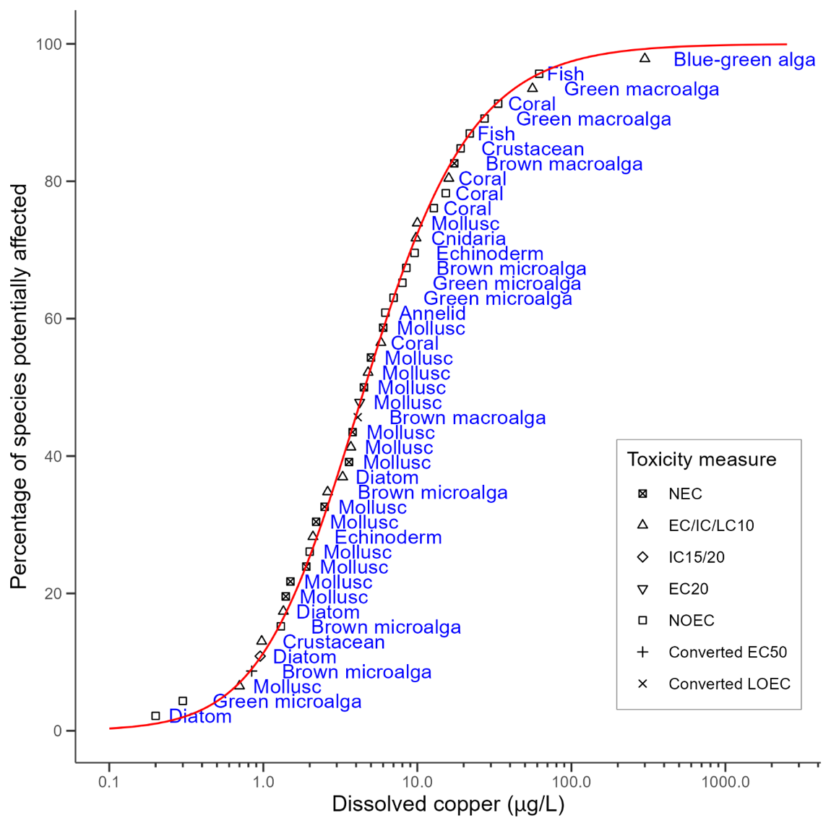

### Default guideline values

It is important that the DGVs (Table 2) and associated information in this technical brief are used in accordance with the detailed guidance provided in the [*Australian and New Zealand Guidelines for Fresh and Marine Water Quality*](http://www.waterquality.gov.au/anz-guidelines) (ANZG 2018).

The DGVs for copper in marine water for 99%, 95%, 90% and 80% species protection are shown in Table 2. The DGVs apply to dissolved copper concentrations and are applicable to water with:

* DOC ≤ 0.5 mg/L
* salinity 25‰ to 36‰
* pH 6.5–8.0.

For marine water outside this range of salinity, pH and DOC, site-specific factors affecting toxicity should be considered, including modelling of metal speciation (see Appendix A). As the data were from studies up to 31°C, these DGVs are appropriate for temperate, semi-tropical and tropical waters. However, as the toxicity dataset excluded studies at < 1°C, the DGVs are not appropriate for Antarctic waters.

Table 2 Toxicant default guideline values for dissolved copper in marine water with very high reliability

| Level of species protection (%) | DGV for copper in marine water (μg/L)****a,b**** |
| --- | --- |
| 99 | 0.2 |
| 95 | 0.6 |
| 90 | 0.9 |
| 80 | 1.6 |

**a The default guideline values (DGVs) apply when dissolved organic carbon (DOC) is ≤ 0.5 mg/L. When DOC is > 0.5 mg/L, the DGVs should be adjusted based on the values in** Table 3 **or the equations in** Appendix C**; however, no further adjustments should be made when DOC is > 6 mg/L.**

**b The DGVs were derived using the Burr Type III model fitted in the ssdtools package in R (Thorley et al. 2024), rounded to one significant figure for values < 1 µg/L and 2 significant figures for values > 1 µg/L.**

The DGVs can be adjusted for different DOC concentrations to produce bioavailability-adjusted guideline values (BAGVs) (Table 3). Equations and tables for deriving BAGVs at other DOC concentrations are provided in Appendix C, and the rationale for this is provided in Appendix G. The adjustment is based on a linear slope of 1.24, obtained from a linear regression of the copper marine WQC US EPA (2016a) with varying DOC as modelled by its BLM, based on DOC from 0.5 mg/L to 6 mg/L. These DOC concentrations are expected to be representative of most Australian and New Zealand coastal marine waters. There is no adjustment when DOC is ≥ 6 mg/L. For DOC concentrations well above 6 mg/L, either the adjustment to 6 mg/L should be used or site-specific studies undertaken.

Table 3 Bioavailability-adjusted guideline values (BAGVs) for 95% species protection for dissolved copper in marine water at different concentrations of dissolved organic carbon

|  |  |
| --- | --- |
| DOC (mg/L) | Dissolved copper BAGV at 95% species protection (µg/L) |
| 0.5 | 0.6 |
| 1.0 | 1.2 |
| 2.0 | 2.4 |
| 4.0 | 4.9 |
| ≥ 6.0 | 7.4 |

DOC = dissolved organic carbon. Shading indicates the default guideline value for 95% species protection in the absence of information on DOC concentration.

The US EPA (2016a) BLM and the chemical-speciation modelling within it were based on copper complexometric titrations. Although this should in theory be applicable to all species, it appears that the protective effect of DOC does not apply to settled mussels, potentially due to DOC–Cu complexes being bioavailable to these mussels, or becoming bioavailable within the gill microenvironment (Deruytter et al. 2017). The reported 5% effect concentration (EC5) for Mytilus edulis is 8.8 µg/L for clearance rate (Deruytter et al. 2017). Therefore, this species should be protected by all of the DGVs for 95% species protection up to the maximum DGV of 7.4 µg/L for ≥ 6 mg/L DOC (Table 3).

Although most of the DGVs (at 0.5 mg/L DOC) are below analytical detection limits routinely used by commercial laboratories (e.g. 1 µg/L), when DOC is 1 mg/L or more, the corresponding BAGVs are likely to be above the typical limits of detection. [ANZG (2018)](https://www.waterquality.gov.au/anz-guidelines/guideline-values/default/water-quality-toxicants/local-conditions#default-guideline-values-and-analytical-detection-limits) provides advice on data analysis where the DGV is less than the limit of detection.

The DGVs at higher levels of protection may be close to background levels in some locations. However, they are not below reported copper requirements for marine organisms (Peers et al. 2005). [ANZG (2018)](https://www.waterquality.gov.au/anz-guidelines/guideline-values/default/water-quality-toxicants/local-conditions#default-guideline-values-and-background-concentrations) provides guidance for situations where a DGV is below natural background concentrations.

### Reliability classification

The DGVs for dissolved copper in marine water have a very high reliability classification (Warne et al. 2018) based on the outcomes for the following 3 criteria:

* sample size – 45 (preferred)
* type of toxicity data – chronic
* SSD model fit – good (Burr type III model).

## Glossary and acronyms

| Term | Definition |
| --- | --- |
| Acute toxicity | A lethal or adverse sub-lethal effect that occurs due to a short (relative to the organism’s life span) exposure to a chemical. Refer to Warne et al. (2018) for examples of acute exposures. |
| Acute-to-chronic ratio | The species’ mean acute value (LC/EC50) divided by the chronic value (e.g. NOEC or EC10) for the same species. |
| BLM | Biotic ligand model. |
| Chronic toxicity | A lethal or sub-lethal adverse effect that occurs as the result of exposure to a chemical for a period that is a substantial portion of the organism’s life span or an adverse sub-lethal effect on a sensitive early life stage. Refer to Warne et al. (2018) for examples of chronic exposures. |
| Default guideline value (DGV) | A guideline value recommended for generic application in the absence of a more specific guideline value (e.g. a site-specific value) in the *Australian and New Zealand Guidelines for Fresh and Marine Water Quality*. Formerly known as ‘trigger values’. |
| DOC | Dissolved organic carbon. |
| DOM | Dissolved organic matter. |
| ECx | The concentration of a substance in water or sediment that is estimated to produce an x% change in the response being measured or a certain effect in x% of the test organisms, under specified conditions. |
| EDTA | Ethylenediaminetetraacetic acid. |
| Endpoint | The specific response of an organism that is measured in a toxicity test (e.g. mortality, growth, a particular biomarker). |
| Guideline value (GV) | A measurable quantity (e.g. concentration) or condition of an indicator for a specific community value below which (or above which, in the case of stressors such as pH, dissolved oxygen and many biodiversity responses) there is considered a low risk of unacceptable effects occurring to that community value. Guideline values for more than one indicator should be used simultaneously in a multiple lines of evidence approach. (Also refer to default guideline value and site-specific guideline value.) |
| HC5 (5% hazardous concentration) | The concentration that may result in effects to 5% of species. It is equivalent to the concentration that will protect 95% of species. |
| Humic substances | Organic substances only partially broken down that occur in water mainly in a colloidal state. Humic acids are large-molecule organic acids that dissolve in water. |
| ICx | The concentration of a substance in water or sediment that is estimated to produce an x% inhibition of the response being measured in test organisms relative to the control response, under specified conditions. |
| LCx | The concentration of a substance in water or sediment that is estimated to be lethal to x% of a group of test organisms under specified conditions. |
| Lowest-observed-effect concentration) (LOEC) | The lowest concentration of a material used in a toxicity test that has a statistically significant (p ≤ 0.05) adverse effect on the exposed population of test organisms as compared with the controls. All higher concentrations should also cause statistically significant effects. |
| No-effect concentration) (NEC) | The maximum concentration of a toxicant that causes no adverse effect in a target organism, based on a threshold parameter in a concentration–response model. |
| No-observed-effect concentration (NOEC) | The highest concentration of a toxicant used in a toxicity test that does not have a statistically significant (p ≤ 0.05) adverse effect on the exposed population of test organisms as compared with the controls. |
| Predicted no-effect concentration (PNEC) | The concentration of a chemical that marks the limit at which below no adverse effects of exposure in an ecosystem are measured. |
| Site-specific guideline value | A guideline value that is relevant to the specific location or conditions that are the focus of a given assessment or issue. |
| Speciation | The intimate chemical environment of the indicator, that is the compound or ion of which it forms a part. |
| Species (biological) | A group of organisms that resemble each other to a greater degree than members of other groups and that form a reproductively isolated group that will not produce viable offspring if bred with members of another group. |
| Species (chemical) | Most commonly used for metals, chemical species are different forms of a particular chemical that may include different oxidation states, isotopes, complexes with organic ligands (in the case of metals) or with particulate matter. |
| Species sensitivity distribution (SSD) | A method that plots the cumulative frequency of species’ sensitivities to a toxicant and fits a statistical distribution to the data. From the distribution, the concentration that should theoretically protect a selected percentage of species can be determined. |
| Toxicity | The inherent potential or capacity of a material to cause adverse effects in a living organism. |
| Toxicity test | The means by which the toxicity of a chemical or other test material is determined. A toxicity test is used to measure the degree of response produced by exposure to a specific level of stimulus (or concentration of chemical) for a specified test period. |
| WQC | Water-quality criterion. |

## Appendix A: actions to assess the bioavailable fraction of a metal

A decision tree for evaluating monitoring data against DGVs or site-specific guideline values for dissolved copper in marine water is shown in Figure A1. This decision tree involves comparing copper concentrations to the guideline value and, where there is exceedance, accounting for DOC to predict copper speciation and the bioavailable fraction of copper. The outcomes of this process for water-chemistry assessment should be used with other lines of evidence (e.g. biodiversity assessment, direct toxicity assessment) in a weight-of-evidence approach to assess overall water quality.

With respect to the modelling of bioavailable copper, it is necessary to consider simple ionic complexes. However, it is also known that there are colloidal forms and weak ionic complexes that can dissociate and cross biological membranes. Approaches such as the BLM for copper in marine water (US EPA 2016a) are appropriate modelling options. Alternatively, speciation modelling is also an option – for example, the Windermere Humic Aqueous Model (WHAM7), which includes a solution speciation model as well as sub-models for ion binding to humic and fulvic acids, clay, and oxides of iron, aluminium, manganese and silica (UKCEH 2021). Bioavailable copper can be measured using a range of techniques designed to measure the labile fraction of metals that has been shown to correlate with the fraction that is biologically available (see Batley et al. 2004). Currently, the use of Chelex columns and diffusive gradients in thin films are the most widely used approaches.

Figure A1 Actions to assess the bioavailable fraction of copper in marine water

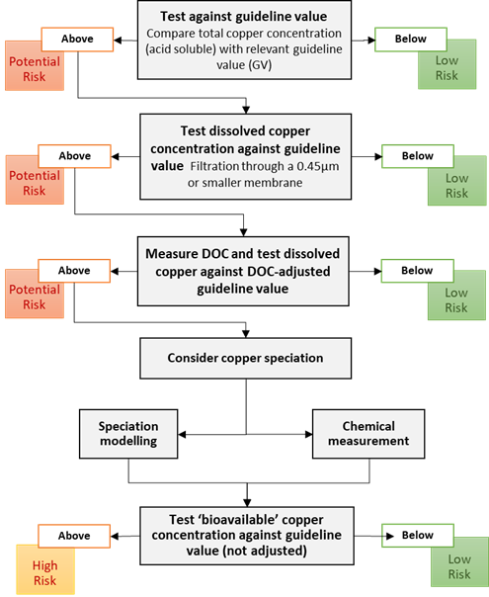

## Appendix B: toxicity data that passed the screening and quality assessment and were used to derive the default guideline values

Table B1 Summary of the toxicity data that passed the screening and quality assurance processes for dissolved copper in marine water

| **Taxonomic group** | **Species** | **Life stage** | **Exposure duration (d)** | Toxicity measure (test endpoint) | **Salinity (‰)** | **Dissolved organic carbon (mg/L)** | **Temperature (°C)** | **Concentration (µg/L)** | **Reference** |
| --- | --- | --- | --- | --- | --- | --- | --- | --- | --- |
| Diatom | Entomoneis punctulata | Exponential growth | 3 | IC10 (population growth rate) | 34 | 1 | 21 | 1.4 | Stauber et al. (2008) |
| Diatom | Minutocellus polymorphus | Exponential growth | 3 | NOEC (population growth rate) | — | — | 21 | < 0.2 | Levy et al. (2007) |
| Diatom | Ceratoneis closterium**a** | Exponential growth | 3 | IC10 (population growth rate) | 34 | — | 27 | 11 | Johnson et al. (2007) |
| Diatom | Ceratoneis closterium**a** | Exponential growth | 3 | EC10 (population growth rate) | 36 | 1.4 | 27 | 1.0 | McKnight et al. (2023) |
| Diatom | Phaeodactylum tricornutum | Exponential growth | 3 | IC15 (biomass/cell yield) | 34–36 | — | 21 | 1.3 | Simpson et al. (2003) |
| Diatom | Phaeodactylum tricornutum | Exponential growth | 3 | IC15 (growth rate) | 34–36 | — | 21 | 2.3 | Simpson et al. (2003) |
| Diatom | Phaeodactylum tricornutum | Exponential growth | 3 | IC10 (growth rate) | 35 | — | 21 | 1.5 | Osborne and Hook (2013) |
| Diatom | Phaeodactylum tricornutum | Exponential growth | 3 | IC20 (biomass yield) | — | — | 21 | 0.7 | Angel et al. (2015) |
| Golden microalga | Coccolithus huxleyi | Exponential growth | 3 | NOEC (population growth rate) | — | — | 21 | 8 | Levy et al. (2007) |
| Golden microalga | Coccolithus huxleyi | Exponential growth | 3 | NOEC (population growth rate) | — | — | 21 | 9 | Levy et al. (2007) |
| Golden microalga | Gephyrocapsa oceanica | Exponential growth | 3 | NOEC (population growth rate) | — | — | 21 | 1.3 | Levy et al. (2007) |
| Golden microalga | Proteomonas sulcata | Exponential growth | 3 | IC50 (population growth rate) | — | — | 27 | 4.2 | Levy et al. (2007) |
| Golden microalga | Tisochrysis luteab | Exponential growth | 3 | EC10 (population growth rate) | 35 | 1.1 | 24 | 2.0 | Trenfield et al. (2015) |
| Golden microalga | Tisochrysis luteab | Exponential growth | 3 | EC10 (population growth rate) | 35 | 1.1 | 28 | 2.5 | Trenfield et al. (2015) |
| Golden microalga | Tisochrysis luteab | Exponential growth | 3 | EC10 (population growth rate) | 35 | 1.1 | 31 | 6.0 | Trenfield et al. (2015) |
| Golden microalga | Tisochrysis luteab | Exponential growth | 3 | EC10 (population growth rate) | 36 | — | 27 | 2.3 | McKnight et al. (2023) |
| Blue-green alga | Cyanobium sp. | Exponential growth | 3 | EC10 (population abundance) | — | — | 25 | 300 | Alquezar and Anastasi (2013) |
| Green microalga | Dunaliella tertiolecta | Exponential growth | 3 | NOEC (population growth rate) | — | — | 21 | 8 | Levy et al. (2008) |
| Green microalga | Dunaliella tertiolecta | Exponential growth | 3 | NOEC (population growth rate) | — | — | 21 | 8 | Levy et al. (2007) |
| Green microalga | Micromonas pusilla | Exponential growth | 3 | NOEC (population growth rate) | — | — | 21 | 0.3 | Levy et al. (2007) |
| Green microalga | Tetraselmis sp. | Exponential growth | 3 | NOEC (population growth rate) | — | — | 21 | 7 | Levy et al. (2008) |
| Green microalga | Tetraselmis sp. | Exponential growth | 3 | NOEC (population growth rate) | — | — | 21 | 7 | Levy et al. (2007) |
| Green macroalga | Ulva fasciata | Zoospore | 4 | NOEC (reproduction) | — | — | 20 | 27 | Hooten and Carr (1998) |
| Green macroalga | Ulva lactuca | Zoospore | 3 | EC10 (settlement and growth inhibition) | — | — | 15 | 56 | Wendt et al. (2013) |
| Brown macroalga | Macrocystis pyrifera | Zoospore | 20 | LOEC (sporophyte production) | 35–37 | — | 13–15 | 10.2 | Anderson et al. (1990) |
| Brown macroalga | Fucus vesiculosus | Germling | 14 | NEC (growth) | 31 | < 0.001 | 22 | 11 | Brooks et al. (2008) |
| Brown macroalga | Fucus vesiculosus | Germling | 14 | NEC (growth) | 31 | 0.009 | 22 | 14 | Brooks et al. (2008) |
| Brown macroalga | Fucus vesiculosus | Germling | 14 | NEC (growth) | 31 | 0.55 | 22 | 19 | Brooks et al. (2008) |
| Brown macroalga | Fucus vesiculosus | Germling | 14 | NEC (growth) | 31 | 1.65 | 22 | 32 | Brooks et al. (2008) |
| Cnidarian | Acropora tenuis | Gamete | 0.2 | NOEC (fertilisation) | — | — | 28 | 34 | Reichelt-Brushett and Harrison (2005) |
| Cnidarian | Acropora longicyathus | Gamete | 0.2 | NOEC (fertilisation) | — | — | 28 | 15.3 | Reichelt-Brushett and Harrison (2005) |
| Cnidarian | Acropora aspera | Gamete | 0.2 | EC10 (fertilisation) | 34 | 0.8 | 25 | 5.8 | Gissi et al. (2017) |
| Cnidarian | Coelastrea aspera | Gamete | 0.2 | NOEC (fertilisation) | — | — | 28 | 13 | Reichelt-Brushett and Harrison (2005) |
| Cnidarian | Platygyra daedalea | Gamete | 0.2 | EC10 (fertilisation) | 34 | 0.8 | 25 | 16 | Gissi et al. (2017) |
| Cnidarian | Exaiptasia diaphana**c** | Adult | 28 | EC10 (progeny: offspring) | — | — | 25 | 12 | Howe et al. (2014) |
| Cnidarian | Exaiptasia diaphana**c** | Adult | 28 | EC10 (progeny: juveniles) | — | — | 25 | 8 | Howe et al. (2014) |
| Cnidarian | Exaiptasia diaphana**c** | Adult | 14 | EC10 (reproduction rate) | 36 | 1.1 | 24 | 12 | Trenfield et al. (2017) |
| Cnidarian | Exaiptasia diaphana**c** | Adult | 14 | EC10 (reproduction rate) | 36 | 1.1 | 28 | 8.8 | Trenfield et al. (2017) |
| Cnidarian | Exaiptasia diaphana**c** | Adult | 14 | EC10 (reproduction rate) | 36 | 1.1 | 31 | 11 | Trenfield et al. (2017) |
| Echinoderm | Diadema savignyi | Embryo | 2 | NOEC (development) | 34 | — | 25 | 9.6 | Rosen et al. (2015) |
| Echinoderm | Evechinus chloroticus | Larva | 3 | EC10 (development) | 34 | — | 16 | 2.1 | Rouchon (2015) |
| Annelid | Hydroides elegans | Gamete | 8 | NOEC (metamorphosis) | 34 | — | 24 | < 6.2 | Xie et al. (2005) |
| Mollusc (bivalve) | Anadara trapezia |  | 2 | NEC (development) | 30 | 1.2 | 21 | 2.5 | Markich (2021) |
| Mollusc (bivalve) | Barnea australasiae |  | 2 | NEC (development) | 30 | 1.2 | 21 | 4.5 | Markich (2021) |
| Mollusc (bivalve) | Fulvia tenuicostata |  | 2 | NEC (development) | 30 | 1.2 | 21 | 3.6 | Markich (2021) |
| Mollusc (bivalve) | Hiatula alba | Embryo | 2 | NEC (development) | 30 | 1.2 | 21 | 3.8 | Markich (2021) |
| Mollusc (bivalve) | Irus crenatus | Embryo | 2 | NEC (development) | 30 | 1.2 | 21 | 6.0 | Markich (2021) |
| Mollusc (bivalve) | Magallana gigas | Embryo | 2 | NEC (development) | 30 | 1.2 | 21 | 1.4 | Markich (2021) |
| Mollusc (bivalve) | Mimachlamys asperrima | Larva | 2 | NOEC (development) | 33 | — | 18 | 2 | Krassoi et al. (1997) |
| Mollusc (bivalve) | Mytilus galloprovincialis | Embryo | 2 | EC10 (development) | 30 | 1.0 | 22 | 7.2 | Zitoun et al. (2019) |
| Mollusc (bivalve) | Mytilus galloprovincialis | Embryo | 2 | EC10 (development) | 30 | 1.9 | 22 | 8.8 | Zitoun et al. (2019) |
| Mollusc (bivalve) | Mytilus galloprovincialis | Embryo | 2 | EC10 (development) | 36 | 0.7 | 22 | 4.1 | Zitoun et al. (2019) |
| Mollusc (bivalve) | Mytilus galloprovincialis | Embryo | 2 | EC10 (development) | 36 | 1.1 | 22 | 3.2 | Zitoun et al. (2019) |
| Mollusc (bivalve) | Mytilus galloprovincialis | Embryo | 2 | EC10 (development) | 25 | 1.2 | 16 | 8.5 | Deruytter et al. (2015) |
| Mollusc (bivalve) | Mytilus galloprovincialis | Embryo | 2 | EC10 (development) | 30 | 0.6 | 16 | 2.8 | Deruytter et al. (2015) |
| Mollusc (bivalve) | Mytilus galloprovincialis | Embryo | 2 | EC10 (development) | 35 | 1.5 | 16 | 2.9 | Deruytter et al. (2015) |
| Mollusc (bivalve) | Mytilus trossulus | Embryo | 2 | EC20 (development) | 35 | — | 20 | 6.6 | Nadella et al. (2009) |
| Mollusc (bivalve) | Mytilus trossulus | Embryo | 2 | EC20 (development) | 35 | — | 20 | 2.7 | Nadella et al. (2009) |
| Mollusc (bivalve) | Saccostrea glomerata | Larva | 14 | LC10 (mortality) | 34 | — | 20 | 70 | Markich et al. (2002) |
| Mollusc (bivalve) | Saccostrea glomerata | Embryo | 2 | NEC (development) | 30 | 1.2 | 21 | 1.5 | Markich (2021) |
| Mollusc (bivalve) | Scaeochlamys livida | Embryo | 2 | NEC (development) | 30 | 1.2 | 21 | 2.2 | Markich (2021) |
| Mollusc (bivalve) | Spisula trigonella | Embryo | 2 | NEC (development) | 30 | 1.2 | 21 | 5 | Markich (2021) |
| Mollusc (bivalve) | Xenostrobus securis | Embryo | 2 | NEC (development) | 30 | 1.2 | 21 | 1.9 | Markich (2021) |
| Mollusc (gastropod) | Haliotis iris | Larva | 3 | EC10 (development) | 34 | — | 14 | 0.7 | Rouchon (2015) |
| Mollusc (gastropod) | Nassarius dorsatus | Larvae | 4 | EC10 (larval growth) | 35–37 | 0.7 | 28 | 3.7 | Gissi et al. (2018) |
| Crustacean | Acartia sinjiensis | Eggs | 3.3 | EC10 (larval development) | 34–36 | 0.8 | 30 | 1.4 | Gissi et al. (2018) |
| Crustacean | Acartia sinjiensis | Eggs | 3.3 | EC10 (larval development) | 34–36 | — | 2–31 | 0.68 | Stone et al. (2021) |
| Crustacean | Acartia sinjiensis | Eggs | 3.3 | EC10 (hatching success) | 34–36 | — | 28–31 | 2.6 | Stone et al. (2021) |
| Crustacean | Amphibalanus amphitrite | Larva | 4 | EC10 (metamorphosis) | 32 | — | 30 | 10 | van Dam et al. (2016) |
| Crustacean | Tisbe furcata | Life cycle | 100 | NOEC (survival and reproduction) | 34 | 2 | 15 | 19 | Diz et al. (2009) |
| Fish | Atherinops affinis | Embryo | 12 | NOEC (development) | 33 | — | 21 | 92 | Anderson et al. (1991) |
| Fish | Atherinops affinis | Larva | 12 | NOEC (development) | 33 | — | 21 | 62 | Anderson et al. (1991) |
| Fish | Atherinops affinis | Larva | 7 | NOEC (mortality) | — | — | — | 134 | McNulty et al. (1994) |
| Fish | Epinephelus coioides | Juvenile | 25 | NOEC (growth) | 28 | — | 24 | 21 | Wang et al. (2014) |

**a** Formerly Nitzschia closterium.

b Formerly Isochrysis galbana.

**c** Formerly Aiptasia pulchella and Exaiptasia pallida.

## Appendix C: dissolved organic carbon correction for dissolved copper default guideline values

The equations for calculating bioavailability-adjusted guideline values (BAGVs) at different DOC concentrations are provided in Table C1. The rationale for determining the DOC correction is provided in Appendix G.

Table C1 Equations to calculate bioavailability-adjusted guideline values at different concentrations of dissolved organic carbon

|  |  |
| --- | --- |
| Equation 1 | $$Guideline value at 99\% protection level=1.24 ×\left({DOC}_{site specific}- 0.5\right)+0.20$$ |
| Equation 2 | $$Guideline value at 95\% protection level=1.24 ×\left({DOC}_{site specific}- 0.5\right)+0.55$$ |
| Equation 3 | $$Guideline value at 90\% protection level=1.24 ×\left({DOC}_{site specific}- 0.5\right)+0.90$$ |
| Equation 4 | $$Guideline value at 80\% protection level=1.24 ×\left({DOC}_{site specific}- 0.5\right)+1.6$$ |

DOCsite specific means the DOC (in mg/L) at the site of interest. These equations apply up to a maximum DOC of 6 mg/L.

The BAGVs at representative DOC concentrations were calculated from these equations. These are presented in Table C2.

Table C2 bioavailability-adjusted guideline values for dissolved copper in marine water (µg/L) at different concentrations of dissolved organic carbon

|  |  |  |  |  |
| --- | --- | --- | --- | --- |
| DOC (mg/L) | 99% species protection | 95% species protection | 90% species protection | 80% species protection |
| 0.5 | 0.19 | 0.55 | 0.91 | 1.6 |
| 1 | 0.8 | 1.2 | 1.5 | 2.2 |
| 2 | 2.1 | 2.4 | 2.8 | 3.5 |
| 3 | 3.3 | 3.7 | 4.0 | 4.7 |
| 4 | 4.5 | 4.9 | 5.2 | 5.9 |
| 5 | 5.8 | 6.1 | 6.5 | 7.2 |
| 6 | 7.0 | 7.4 | 7.7 | 8.4 |

## Appendix D: rationale for dissolved organic carbon correction

Bioavailability corrections for dissolved copper DGVs in marine water are being used (or have been proposed) in several jurisdictions. These are discussed as follows.

The European Union risk assessment (European Copper Institute 2008) investigated relationships between DOC and toxicity data based on 6 species:

* Mytilus galloprovincialis
* Mytilus edulis
* Crassostrea gigas
* Dendraster excentricus
* Strongylocentrotus purpuratus
* Fucus vesiculosis.

Copper toxicity was investigated at multiple DOC concentrations for each of these species in chronic tests (48-hour embryo-larval development tests for the invertebrates and zoospore growth for the alga). Although NOEC data were used in the risk assessment SSD, EC50 data were used to develop statistical relationships between DOC and toxicity, as EC50 data are stronger descriptors of toxicity than NOEC data. There was no significant difference between the slopes for each species; therefore, a single power relationship was developed for all 6 species after normalising EC50 data to the most sensitive species (*Mytilus* edulis). All NOEC data included in the SSD were then normalised based on this relationship, with the assumption that added DOC was 100% active and natural DOC was 50% active. An HC5 of 5.2 µg/L of copper was calculated based on 2 mg/L of DOC (equivalent to 1 mg/L active DOC). A predicted no-effect concentration (PNEC) of 2.6 µg/L of copper was recommended based on the HC5 and an assessment factor of 2, due to the absence of high-quality mesocosm data. An adjustment based on DOC is provided from the power equation in Equation D1.

Equation D1 European predicted no-effect concentration adjustment based on dissolved organic carbon

$${PNEC}_{site specific}=2.64 × {\left(\frac{DOC}{2}\right)}^{0.6139}$$

For the United Kingdom guidelines (Maycock et al. 2011), a linear model was derived to describe the relationship between DOC and toxicity, based on EC10 data for Mytilus galloprovincialis from 48-hour embryo-larval development tests (Arnold et al. 2005, 2006, 2009, 2010a). The dataset used in the European Union risk assessment (European Copper Institute 2008) was updated with additional data, and all data were adjusted to a DOC of 1 mg/L (natural DOC, equivalent to 0.5 mg/L active DOC). The HC5 calculated from this was 2.64 µg/L and an assessment factor of 1 was applied, resulting in a PNEC of 2.64 µg/L. Where natural DOC exceeds 1 mg/L, a site-specific PNEC can be calculated with Equation D2.

Equation D2 Calculating European predicted no-effect concentration when natural dissolved organic carbon > 1 mg/L

$${PNEC}_{site specific}=2.64 +2.677 × {\left(\frac{DOC}{2}-0.5\right)}^{}$$

The United States implemented a DOC correction within its draft marine BLM (US EPA 2016a). A BLM includes models for copper speciation, based on the chemical equilibrium model WHAM, which describes metal interactions with natural organic matter. The chemical speciation part of the marine water BLM was developed from copper complexometric titrations of water samples collected in San Diego and Pearl Harbour (Chadwick et al. 2008). Three DOC binding sites were included in the model (Chadwick et al. 2008).

The BLM also included models of the interaction of copper and competing cations with physiologically active sites (biotic ligands), using binding constants. The copper and cation binding constants for those biotic ligands were based on data from Mytilus galloprovincialis and S. purpuratus 48-hour embryo-larval development tests. The BLM was implemented with the United States draft WQC for copper in marine water, thus enabling adjustment of the criterion based on the temperature, pH, salinity and DOC of water.

The United States draft chronic criterion for copper in marine/estuarine water, known as a criterion continuous concentration, is based on acute data that have been adjusted based on a geometric mean of acute-to-chronic ratios for 5 sensitive freshwater species and 2 estuarine/marine species. This method was used because there were only 2 species for which there was acceptable chronic values according to the guideline development principles (which use EC20 for chronic criteria derivation). The criterion continuous concentration was obtained from the draft water-quality criteria document (US EPA 2016a) for a salinity of 30‰, temperature of 20°C and pH of 8.2.

The relationships between copper guideline values and DOC concentrations from these 3 jurisdictions are shown in Figure D1 with linear regression lines. These show very similar slopes, especially for the United States and United Kingdom guidelines. The European Union data are derived from a power relationship and, therefore, the linear model does not fit as well.

Figure D1 Relationship between copper and dissolved organic carbon concentrations with bioavailability corrections of the European Union, United Kingdom and United States

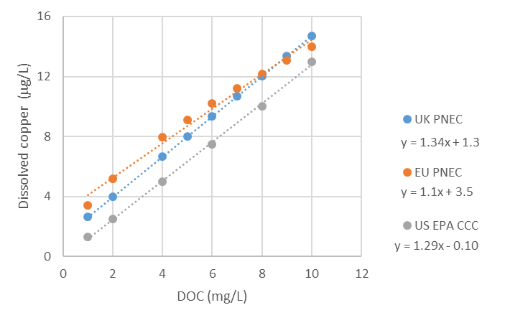

For the ANZG (2018) DGVs for dissolved copper in marine water, the BLM was selected as a suitable model to correct the DGVs for varying levels of DOC because it is based on chemical speciation modelling rather than toxicity data, and therefore should be applicable to all species. However, a recent study suggests that copper toxicity to settled mussels is not affected by DOC, and that DOC corrections should not be used for this life stage (Deruytter et al. 2017). The BLM showed a generally linear relationship between DOC and dissolved copper; however, the fit at low DOC concentrations was improved when the regression was based on DOC from 1 mg/L to 6 mg/L. This linear regression provided a slope of 1.24 (Figure D2). This slope results in the most accurate predictions of values at the lower DOC concentrations, which are representative of most Australian and New Zealand marine waters and where bioavailability and toxicity would be highest.

Figure D2 Relationship between US EPA criterion continuous concentration for copper and dissolved organic carbon concentration, as predicted by the US EPA biotic ligand model

Grey dotted line shows fitted linear regression for data with a dissolved organic carbon concentration between 1 mg/L and 6 mg/L.



The lack of a protective effect of DOC on settled mussels is potentially due to DOC–Cu complexes either being bioavailable to these mussels or becoming bioavailable within the gill microenvironment (Deruytter et al. 2017). Therefore, the DOC adjustment should not result in DGVs that exceed toxicity estimates reported for settled mussels, to ensure that these species are protected. The 5% effect concentration (EC5) for Mytilus edulis is 8.8 µg/L for clearance rate (Deruytter et al. 2017). Adjustments of the DGVs up to 6 mg/L DOC should be protective of this species, and the BAGV is 8.3 µg/L for 80% level of protection. Therefore, there is no adjustment recommended above 6 mg/L DOC.

It is recognised that there is considerable variation in the complexation capacity of DOC, depending on the source of that DOC (Baken et al. 2011; Mueller et al. 2012; Pearson et al. 2017). The US EPA marine BLM was derived using data from water samples collected at multiple sites in San Diego Bay and Pearl Harbour, where the DOC is derived from both natural and anthropogenic sources. The copper binding factors used in that model are therefore expected to be appropriate for coastal marine environments around ports and harbours where anthropogenic DOC dominates.

There is a lack of available data for Australasian species that could be used to assess the DOC correction. However, there are data related to the estimation of bioavailable copper (e.g. as measured with diffusive gradients in thin films or voltammetry) that can be used to assess the suitability of the DOC correction, given that the correction is based on abiotic processes. For example, samples collected off the Hauraki Gulf of New Zealand and in the Tasman Sea indicate less than 1% of the copper is bioavailable (Thompson et al. 2014; Zitoun 2019). At sites affected by shipwreck-related copper contamination, where total and dissolved copper concentrations were in the range 0.3–80 µg/L, bioavailable copper remained a low proportion of dissolved copper (1% to 9%; Hartland et al. 2019). The DOC correction used in these DGVs assumes that the dissolved copper is 15% to 73% bioavailable at DOC 1 mg/L and 2% to 20% bioavailable at DOC of 6 mg/L – lower than the proportions generally recorded in marine waters. Therefore, the BAGVs are based on a conservative estimate of the bioavailable copper in a marine water sample.

## Appendix E: chronic toxicity data for Australasian species not used to derive the default guideline values

Table E1 Toxicity data excluded from the default guideline value derivation for dissolved copper in marine water, in order of sensitivity

| Taxonomic group | Species | Life stage | Exposure duration (d) | Endpoint | Toxicity measure**a** | Salinity (‰) | Temperature (°C) | Toxicity value (µg/L) | Converted concentration (µg/L) | Reason for exclusion | Reference |
| --- | --- | --- | --- | --- | --- | --- | --- | --- | --- | --- | --- |
| Diatom | Thalassiosira weissflogii | Exponential growth | 1.25 | Population growth rate | NOEC | — | 21 | 0.075 | 0.075 | No copper measurement | Karner et al. (2006) |
| Mollusc | Mytilus edulis | Gamete | 30 | Reproduction | EC50 | 32 | — | 2 | 0.4 | No copper measurement | Stromgren and Nielsen (1991) |
| Annelid | Galeolaria caespitosa | Gamete | 2 | Development | EC50 | 32–35 | 16–18 | 4.6 | 0.92 | No EC10/NOEC data | Ross and Bidwell (2001) |
| Mollusc | Magallana gigasb | Egg/larva | 2 | Development | EC10 | 35 | 20 | 1 | 1 | No copper measurement | Worboys et al. (2002) |
| Mollusc | Magallana gigasb | Egg/larva | 2 | Development | EC50 | 34 | 20 | 5.3 | 1.1 | No EC10/NOEC data | Martin et al. (1981) |
| Mollusc | Mytilus edulis | Gamete | 2 | Development | EC50 | 34 | 20 | 5.8 | 1.2 | EC50 data only | Martin et al. (1981) |
| Cnidarian | Pocillopora damicornis | — | 35 | Growth | LOEC | 36 | 26 | 4 | 1.6 | No EC10/NOEC data | Bielmyer et al. (2010) |
| Echinoderm | Heliocidaris tuberculata | Zygote | 3 | Development | NOEC | 34 | 18 | 2 | 2 | No copper measurement | Doyle et al. (2003) |
| Green macroalga | Ulva intestinalis | Germling | 5 | Mortality | LC50 | — | 20 | 9.9 | 2 | No copper measurement | Girling et al. (2015) |
| Mollusc | Mytilus edulis | Embryo | 2 | Development | EC50 | 30 | 15 | 11 | 2.1 | EC50 data only | Arnold et al. (2009) |
| Diatom | Ceratoneis closterium | Exponential growth | 3 | Population growth rate | EC10 | 35 | 21 | 2.2 | 2.2 | No copper measurement | Hook et al. (2014) |
| Echinoderm | Diadema setosum | Embryo | 0.042 | Fertilisation | EC50 | 30 | — | 12 | 2.4 | No copper measurement | Ramachandran et al. (1997) |
| Mollusc | Mytilus edulis | Embryo | 2 | Development | EC50 | 26–34 | 14–18 | 12 | 2.4 | EC50 data only | Tucker (1998) |
| Crustacean | Allorchestes compressa | Juvenile | 27 | Population | NOEC | 22 | — | 3 | 3 | Salinity < 25‰ | Stauber et al. (1996) |
| Mollusc | Nassarius dorsatus | Larvae | 4 | Growth | EC10 | 34 | 24–31 | 3.1 | 3.1 | DOC > 2 (2.4 mg/L) | Trenfield et al. (2016) |
| Mollusc | Haliotis rubra | Embryo | 2 | Development | EC10 | — | 20 | 3.7 | 3.7 | No copper measurement | Gorski and Nugegoda (2006) |
| Crustacean | Moina mongolica | Neonate | 21 | Reproduction | EC20 | 10 | 20 | 3.8 | 3.8 | Salinity < 25‰ | Wang et al. (2007a) |
| Echinoderm | Centrostephanus rodgersii | Sperm | 0.055 | Fertilisation | NOEC | 35.5 | 20 | 4 | 4 | No copper measurement | King (1999) |
| Red macroalga | Ceramium tenuicorne | — | 7 | Growth | EC20 | 7 | 22 | 4 | 4 | Salinity < 25‰ | Ytreberg et al. (2010) |
| Diatom | Nitzschia paleacea | Exponential growth | 2 | Population growth rate | EC50 | — | 21 | 23 | 4.6 | No EC10/NOEC data | Franklin et al. (2001) |
| Annelid | Galeolaria caespitosa | Gamete | 2 | Development | EC50 | 32–35 | 16–18 | 23 | 4.6 | No EC10/NOEC data | Ross and Bidwell (2001) |
| Red macroalga | Champia parvula | — | 14 | Reproduction | MATC | 30 | 20–22 | 5.1 | 5.1 | No EC10/NOEC data | Steele and Thursby (1983) |
| Amphipod | Allorchestes compressa | Juvenile | 28 | Growth | MEC | 31 | 19 | 5.2 | 5.2 | No EC10/NOEC data | Ahsanullah and Williams (1991) |
| Mollusc | Mytilus edulis | Embryo | 2 | Development | IC10 | 20 | — | 16 | 6.6 | Salinity < 25‰ | CH2M HILL (1999) |
| Green macroalga | Ulva reticulata | — | 7 | Population | NOEC | 20–40 | 20 | 8.7 | 8.7 | No copper measurement | Mamboya et al. (2009) |
| Diatom | Skeletonema costatum | Exponential growth | 4 | Population growth rate | EC10 | 33 | 25 | 9.1 | 9.1 | No copper measurement | Fisher and Frood (1980) |
| Platyhelminth | Stylochus pygmaeus | Adult | 10 | Reproduction | LOEC | 34 | 23–24 | 10 | 9.5 | No EC10/NOEC data | Lee and Johnston (2007) |
| Brown microalga | Rhodomonas salina | Exponential growth | 3 | Population | EC50 | — | 20 | 48 | 9.6 | No EC10/NOEC data | Debelius et al. (2009) |
| Sponge | Halichondria panacea | — | 80 | Population | NOEC | — | — | 9.9 | 9.9 | DOC 2.4–6.8 mg/L | Foekema et al. (2015) |
| Diatom | Entomoneis punctulata | Exponential growth | 3 | Population | NOEC | 34 | 21 | 10 | 10 | No copper measurement | Stauber (1995) |
| Diatom | Nitzschia bilobata | Exponential growth | 3 | Population | NOEC | 34 | 21 | 10 | 10 | No copper measurement | Stauber (1995) |
| Cnidarian | Goniastrea retiformis | Gamete | 0.23 | Fertilisation | NOEC | — | — | 10 | 10 | No copper measurement | Reichelt-Brushett and Harrison (2005) |
| Crustacean | Moina mongolica | Neonate | 21 | Population | EC20 | 10 | 20 | 12 | 12 | Salinity < 25‰ | Wang et al. (2007a) |
| Echinoderm | Heliocidaris erythrogramma | Larva | 6 | Development | NOEC | 35.5 | 20 | 13 | 13 | No copper measurement | King (1999) |
| Crustacean | Moina mongolica | Neonate | 21 | Mortality | EC20 | 10 | 20 | 15 | 15 | Salinity < 25‰ | Wang et al. (2007a) |
| Ascidian | Ciona intestinalis | Gamete | 0.833 | Development | NOEC | 33 | 20 | 16 | 16 | No copper measurement | Bellas et al. (2004) |
| Mollusc | Mytilus edulis | Gamete | 2 | Development | EC50 | 32–35 | 16–18 | 84 | 17 | EC50 data only | Ross and Bidwell (2001) |
| Crustacean | Amphibalanus amphitrite | Larva | 2 | Development | NOEC | 34 | 24 | 17 | 17 | No copper measurement | Qiu et al. (2005) |
| Diatom | Chaetoceros sp. | Exponential growth | 3 | Population | EC50 | — | 20 | 88 | 18 | No EC10/NOEC data | Debelius et al. (2009) |
| Arthropod | Allorchestes compressa | Juvenile | 28 | Mortality | MEC | 31 | 19 | 24 | 24 | No EC10/NOEC data | Ahsanullah and Williams (1991) |
| Arthropod | Artemia franciscana | Adult | > 40–< 60 | Mortality | NOEL | 90 | 23 | 25 | 25 | No copper measurement | Browne et al. (2002) |
| Echinoderm | Tripneustes gratilla | Gamete | 0.25 | Fertilisation | LOEC | 31 | 28 | 25 | 10 | No copper measurement | Edullantes and Galapate (2014) |
| Ochrophyta | Nannochloropsis gaditana | Exponential growth | 3 | Population | EC50 | — | 20 | 137 | 27 | No EC10/NOEC data | Debelius et al. (2009) |
| Fish | Morone sp. | Juvenile | 42 | Growth | NOEC | 13–14 | 19–25 | 33 | 33 | Salinity < 25‰ | Bielmyer et al. (2005) |
| Arthropod | Callianassa australiensis | Adult | 14 | Immobilisation | EC50 | 34–38 | 18–20 | 190 | 38 | No EC10/NOEC data | Ahsanullah et al. (1981) |
| Annelid | Capitella capitata | Adult | 28 | Mortality | LC50 | — | — | 200 | 40 | No copper measurement; data from before 1980 | Reish et al. (1976) |
| Fish | Morone sp. | Juvenile | 21 | Growth | NOEC | 15 | 19 | 53 | 53 | Salinity < 25‰ | Bielmyer et al. (2006) |
| Fish | Synechogobius hasta | — | 30 | Growth | NOEC | 19–20 | 19–21 | 57 | 57 | Salinity < 25‰ | Chen et al. (2013) |
| Crustacean | Tigriopus angulatus | Larva | 28 | Population | NOEC | 34 | 20 | 60 | 60 | No measurement of copper | Medina et al. (2008) |
| Green microalga | Chlorella vulgaris | Exponential growth | 9 | Population | EC10 | 7.6 | 24 | 94 | 94 | No copper measurement | Latala and Surosz (1999) |
| Diatom | Nitzschia palea | Exponential growth | 5 | Population | NOEC | — | 23 | 95 | 95 | No copper measurement | Nguyen-Deroche et al. (2009) |
| Green microalga | Stichococcus bacillaris | — | 9 | Population | EC10 | 7.6 | 24 | 95 | 95 | No copper measurement | Latala and Surosz (1999) |
| Green microalga | Chlorella pyrenoidosa | Exponential growth | 4 | Population | EC50 | 10 | 20 | 510 | 101 | No copper measurement | Wang et al. (2007b) |
| Green microalga | Oocystis submarina | — | 9 | Population | EC10 | 7.6 | 24 | 123 | 123 | No copper measurement | Latala and Surosz (1999) |
| Mollusc | Scutus breviculus | Adult | 2 | Growth | NOEC | 41 | 13 | 221 | 221 | Salinity > 36‰ | Lee et al. (2010) |
| Brown macroalga | Hormosira banksia | Gamete | 3 | Growth | NOEC | 34 | 15 | 500 | 500 | No copper measurement | Kevekordes (2001) |
| Diatom | Thalassiosira pseudonana | — | 4 | Population | EC10 | 33 | 25 | 550 | 550 | No copper measurement | Nguyen-Deroche et al. (2009) |
| Diatom | Cylindrotheca sp. | Exponential growth | 3 | Population | IC50 | — | 22 | 7,700 | 1,540 | No copper measurement | Satoh et al. (2005) |

**a** Toxicity measures:

* EC10: 10% effect concentration
* EC20: 20% effect concentration
* EC50: median effect concentration
* IC10: 10% inhibition concentration
* IC50: median inhibition concentration
* LC50: median lethal concentration
* LOEC: lowest-observed-effect concentration
* LOEL: lowest-observed-effect level
* MATC: maximum acceptable toxicant concentration
* MEC: minimum effect concentration
* NOEC: no-observed-effect concentration
* NOEL: no-observed-effect level.

b Described as Crassostrea gigas in this paper (species renamed in 2012).

## Appendix F: guideline value derivation with preferred toxicity estimates only

Chronic data using the preferred toxicity estimates of EC/IC/LCx (where x is ≤ 10), NEC and EC/IC/LC15–20 are summarised in Table F1. The SSD based on these data is shown in Figure F1. The fit of the Burr III distribution to these data was good.

Based on the use of chronic data, the number of species included (27 species; classified as ‘preferred’) and the good fit of the distribution, protective concentration (PC) values based on these data alone would have very high reliability. These PC values were 0.6 µg/L, 0.9 µg/L, 1.2 µg/L and 1.6 µg/L for 99%, 95%, 90% and 80% species protection, respectively.

However, the use of only preferred toxicity estimates excludes 3 sensitive unicellular algae for which only NOEC data were available. The PC values derived from only the preferred data would protect one of these species based on 95% level of protection or above (Proteomonas sulcata, converted NOEC 0.8 µg/L) but would provide no protection for the other 2 species (Minutocellus polymorphus, NOEC 0.2 µg/L; Micromonas pusilla, NOEC 0.3 µg/L). Therefore, it was deemed necessary to include non-preferred data in the DGV derivation to ensure that sensitive species would be sufficiently protected.

Table F1 Summary of preferred chronic toxicity values for dissolved copper in marine water

| Taxonomic group | Species | Life stage | Exposure duration (d) | Toxicity measure (test endpoint) | Toxicity value (µg/L) |
| --- | --- | --- | --- | --- | --- |
| Diatom | Ceratoneis closterium | Exponential growth | 3 | EC10 (population growth rate) | 1.7 |
| Diatom | Entomoneis punctulata | Exponential growth | 3 | IC10 (population growth rate) | 1.4 |
| Diatom | Phaeodactylum tricornutum | Exponential growth | 2–3 | IC20 (population growth rate) | 0.7 |
| Blue-green alga | Cyanobium sp. | Exponential growth | 3 | EC10 (population growth rate) | 300 |
| Golden microalga | Tisochrysis luteaa | Exponential growth | 3 | EC10 (population growth rate) | 2.6 |
| Green macroalga | Ulva lactuca | Zoospore | 3 | EC10 (settlement and growth) | 56 |
| Brown macroalga | Fucus vesiculosus | Germling | 14 | NEC (growth) | 17 |
| Cnidarian | Exaiptasia diaphana**b** | Adult | 28 | EC10 (reproduction) | 9.8 |
| Cnidarian | Platygyra daedalea | Gamete | 0.2 | EC10 (fertilisation) | 1.4 |
| Echinoderm | Evechinus chloroticus | Larva | 3 | EC10 (development) | 2.1 |
| Mollusc (bivalve) | Anadara trapezia | Embryo | 2 | NEC (development) | 2.5 |
| Mollusc (bivalve) | Barnea australasiae | Embryo | 2 | NEC (development) | 4.5 |
| Mollusc (bivalve) | Fulvia tenuicostata | Embryo | 2 | NEC (development) | 3.6 |
| Mollusc (bivalve) | Hiatula alba | Embryo | 2 | NEC (development) | 3.8 |
| Mollusc (bivalve) | Irus crenatus | Embryo | 2 | NEC (development) | 6 |
| Mollusc (bivalve) | Magallana gigas | Embryo | 2 | NEC (development) | 1.4 |
| Mollusc (bivalve) | Mytilus galloprovincialis | Embryo | 2 | EC10 (development) | 4.8 |
| Mollusc (bivalve) | Mytilus trossulus | Embryo | 2 | EC20 (development) | 5.6 |
| Mollusc (bivalve) | Saccostrea glomerata | Larva | 2 | NEC (development) | 1.5 |
| Mollusc (bivalve) | Scaeochlamys livida | Embryo | 2 | NEC (development) | 2.2 |
| Mollusc (bivalve) | Spisula trigonella | Embryo | 2 | NEC (development) | 5 |
| Mollusc (bivalve) | Xenostrobus securis | Embryo | 2 | NEC (development) | 1.9 |
| Mollusc (gastropod) | Haliotis iris | Larva | 3 | EC10 (development) | 0.7 |
| Mollusc (gastropod) | Nassarius dorsatus | Larvae | 4 | EC10 (larval growth) | 3.7 |
| Crustacean | Acartia sinjiensis | Eggs | 3.3 | EC10 (larval development) | 0.98 |
| Crustacean | Amphiblanus amphitrite | Larva | 4 | EC10 (metamorphosis) | 28 |

**a** Formerly *Isochrysis galbana*.

**b** Formerly Aiptasia pulchella and Exaiptasia pallida.

Figure F1 Species sensitivity distribution for dissolved copper in marine water using preferred chronic data only

‘Brown microalga’ refers to golden microalga.

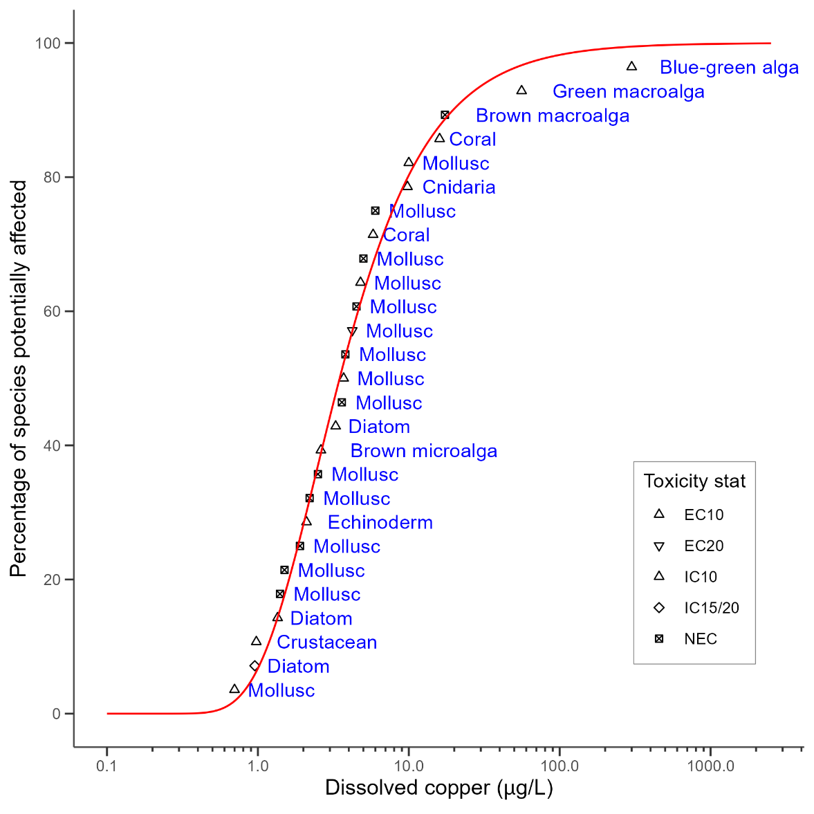

## Appendix G: sensitivity analysis of default guideline values

This section presents the effect on the DGVs of using slightly different copper toxicity datasets, through the inclusion or exclusion of non-preferred ecotoxicological data or adjustments related to DOC.

There were 4 values where NOEC data for species found in Australia or New Zealand were available but not in a form suitable for inclusion, as they were reported as < values. These data were each carefully considered to determine a suitable value for each for inclusion in the SSD and, in 2 cases, converted NOEC data were accepted for the derivation. An alternative is to use all the values directly from data reported as < values.

In addition, 2 alternative methods to deal with the influence of DOC on copper bioavailability were assessed:

* Ignore the influence of DOC on bioavailability, and use all available data regardless of the DOC in the test waters (e.g. include tests undertaken at ≥ 2 mg/L of DOC).
* Use a bioavailability model to normalise all toxicity data used in the SSD to a standard DOC concentration (e.g. 0.5 mg/L).

Therefore, 3 alternative scenarios were assessed and compared to the DGV as follows.

**Sensitivity test 1:** Instead of using 2 converted NOEC values, the censored values were used as if they were not censored. For *Proteomonas sulcata*, where the NOEC was reported as < 5 μg/L, a value of 5 μg/L was used (compared to an IC50 divided by 5 to estimate a negligible-effect equivalent of 0.84 μg/L, as used in DGV). For *Macrocystis pyrifera*, where the NOEC was reported as < 10.2 µg/L, a value of 10.2 µg/L was used (compared to the value of 4.1 µg/L in DGV, by dividing by 2.5).

**Sensitivity test 2:** Use all available data with no DOC adjustment. There was no increase in the number of species included (45) when data were included regardless of DOC; however, there was an increase in the total number of acceptable data – an increase to 130 data points where DOC measured 0.009–21.6 mg/L. These values included data from additional tests on 2 species (*Mytilus galloprovincialis* and *Mytilus trossolus*) where DOC was varied to assess the effect on copper toxicity.

**Sensitivity test 3:** Use bioavailability model and normalise to DOC 0.5 mg/L. This also resulted in a total of 45 species, and data from tests had measured DOC of 0.009–21.6 mg/L. In 68 of the 130 tests, DOC was not reported. It was assumed to be 0.5 mg/L for the purposes of adjusting the toxicity data to the standard DOC (thus resulting in no adjustment for those values). The linear model recommended for the DGV adjustment was not appropriate for this adjustment. The linear model implies there is a consistent absolute increase in EC10 value for a given increase in DOC. This was not appropriate when applying to species where the sensitivity ranged from an EC10 of 0.2 µg/L to 30 µg/L, as it resulted in large adjustments for the very sensitive species, at times resulting in negative values. A power model was instead used to adjust the toxicity data. The power model assumed that there is a consistent proportional increase in the EC10 for each increase in DOC (i.e. the slopes are the same between species). The power model was based on the same data as the linear adjustment model and had a slope of 0.6136.

The GVs calculated for the 3 different options above and compared to the DGVs are shown in Table G1 and Table G2. There is minimal difference between the values, particularly for the 95% level of protection. For the DOC sensitivity testing, this is largely because the DOC concentrations in the test solutions were rarely reported (reported in 48% tests) and, if unreported, it was assumed to be 0.5 mg/L (therefore included in both the DGV and test 2 and not adjusted in test 3). Due to this, the original approach of excluding data with DOC > 2mg/L was retained for DGV derivation.

When the values lower than detection (< values) were used in the derivation, the resulting guideline values were slightly higher (except at 99% level of protection). Through this reassessment, the approach for *Hydroides elegans* used in the draft DGV released for public comment (value of 2.5 µg/L calculated by dividing the LOEC of 6.2 µg/L by 2.5), was considered too conservative and was replaced with the value 6.2 µg/L (based on the reported NOEC of < 6.2 µg/L).

Table G1 Comparison of the treatment of different datasets to derive copper guideline values

|  | DGV | Sensitivity test 1 | Sensitivity test 2 | Sensitivity test 3 |
| --- | --- | --- | --- | --- |
| Data treatment | Convert < NOEC values | Use NOEC values as < value | Use converted values, as per DGV | Use converted values, as per DGV |
| DOC treatment | Exclude tests with DOC > 2 mg/L | Exclude tests with DOC > 2 mg/L | Include all data, regardless DOC | Normalise data to DOC 0.5 mg/L |
| No. species | 45 | 45 | 45 | 45 |

Table G2 Comparison of copper guideline values (µg/L) derived from different datasets

| Level of species protection (%) | DGV | Sensitivity test 1 | Sensitivity test 2 | Sensitivity test 3 |
| --- | --- | --- | --- | --- |
| 99 | 0.19 | 0.20 | 0.20 | 0.22 |
| 95 | 0.55 | 0.59 | 0.66 | 0.53 |
| 90 | 0.91 | 0.97 | 0.92 | 0.83 |
| 80 | 1.60 | 1.70 | 1.63 | 1.42 |

## Appendix H: modality assessment for copper

A modality assessment was undertaken for copper according to the 4 questions stipulated in Warne et al (2018). These questions and their answers are listed as follows.

##### Is there a specific mode of action that could result in taxa-specific sensitivity?

Yes, there are differences in the mode of action for copper between fish/invertebrates and plants/algae. Copper is a well-known fungicide and herbicide.

##### Does the dataset suggest bimodality?

A visual assessment of the SSD for the final toxicity dataset (45 species; section 4) did not indicate any bimodality, and none was visible in a histogram (Figure H1).

Figure H1 Histograms of final toxicity dataset using (a) species geometric means and (b) all acceptable data

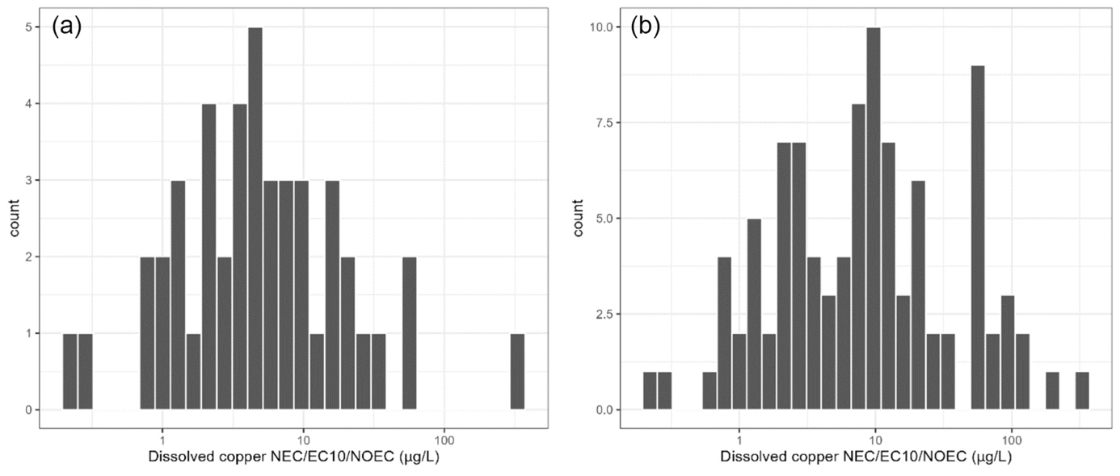

A bimodality coefficient of 0.28 was calculated for the log-transformed dataset used in the SSD. The bimodality coefficient based on all the individual data points was 0.38. Values between 0.555 and 1 represent bimodal distributions, so neither value indicated bimodality in this dataset.

##### Do the data show taxa-specific sensitivity (i.e. through distinct grouping of different taxa types)?

There was some indication of taxa-specific sensitivity when broad taxonomic groupings were compared. Microalgae, microinvertebrates and macroinvertebrates were typically more sensitive than macroalgae or fish (Figure H2). This is primarily due to the highly sensitive diatom species, as shown in Figure H3 where toxicity is compared across the 12 taxonomic groups. There are also some crustacean, mollusc and green microalgal species that are highly sensitive.

Figure H2 Boxplot comparing dissolved copper toxicity between microinvertebrates, microalgae, macroinvertebrates, macroalgae and fish

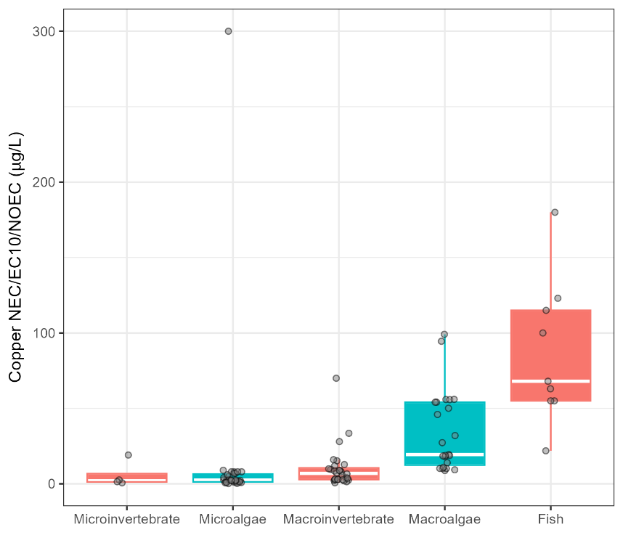

Figure H3 Boxplot comparing dissolved copper toxicity between the taxa diatom, crustacean, brown microalga, annelid, mollusc, echinoderm, green microalga, cnidaria, coral, brown macroalga, fish and blue-green alga

Primary producers shown in green. ‘Brown microalga’ refers to golden microalga.

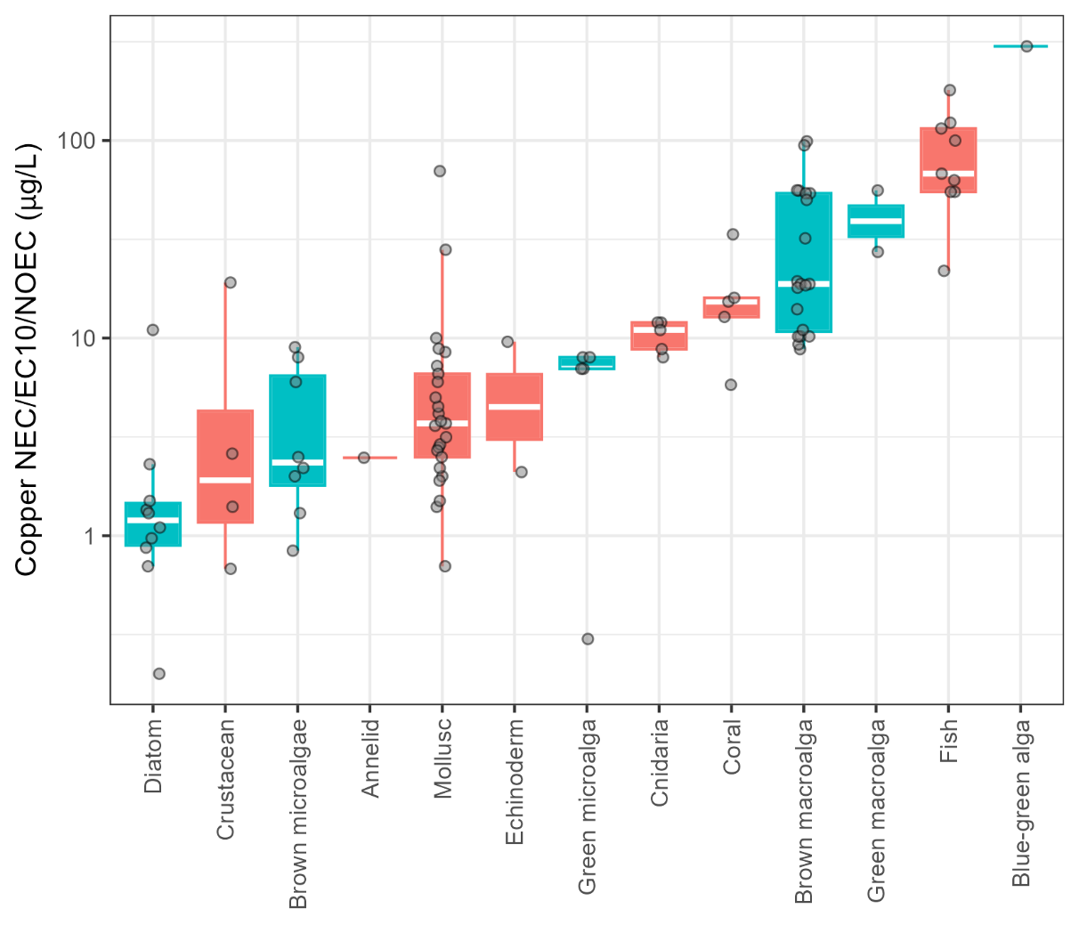

The data are also shown in the SSD in Figure H4 and indicate that microalgae are in the bottom two-thirds of the final dataset (though there is one data point for a blue-green alga at the top of the curve). However, the distribution of the microalgae data does not result in any bimodality.

Figure H4 Species sensitivity distribution of the final dataset for dissolved copper

‘Brown microalga’ refers to golden microalga.

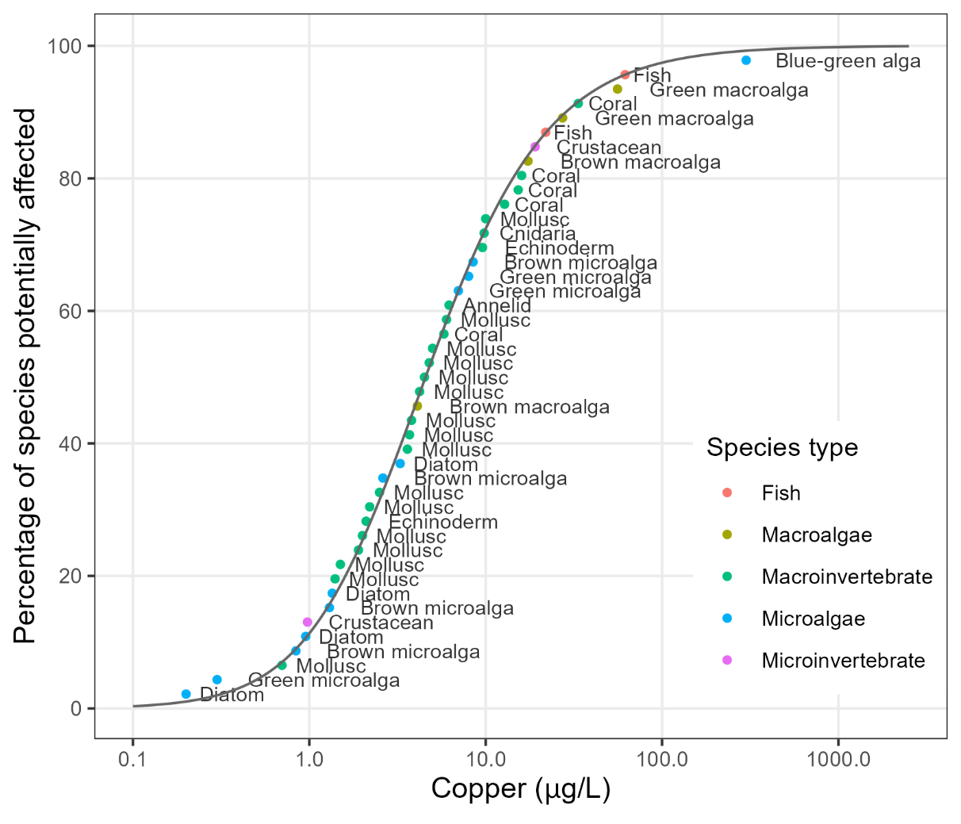

##### Is it likely that indications of bimodality or multimodality or distinct clustering of taxa groups are not due to artefacts of data selection, small sample size, test procedures or other reasons unrelated to a specific mode of action?

While there are some apparent differences in the sensitivity between taxonomic groups – for example, diatoms tend to be more sensitive and fish less sensitive – there is considerable overlap between groups. The lack of strong evidence for bimodality and the high degree of overlap in taxa-specific sensitivity, with the possible exception of diatoms, supports the use of all the acceptable data to derive the DGVs.

## References

Adams MS, Dillon CT, Vogt S, Lai B, Stauber J and Jolley DF (2016) ‘[Copper uptake, intracellular localization, and speciation in marine microalgae measured by synchrotron radiation X-ray fluorescence and absorption microspectroscopy](https://doi.org/10.1021/acs.est.6b00861)’, Environmental Science and Technology, 50:8827–8839, doi:10.1021/acs.est.6b00861.

Ahsanullah M and Williams AR (1991) ‘[Sublethal effects and bioaccumulation of cadmium, chromium, copper and zinc in the marine amphipod *Allorchestes compressa*](https://doi.org/10.1007/BF01313471)’, Marine Biology, 108:1, 59–65, doi:10.1007/BF01313471.

Ahsanullah M, Negilski DS and Mobley MC (1981) ‘Toxicity of zinc, cadmium and copper to the shrimp Callianassa australiensis. I. Effects of individual metals’, Marine Biology, 64(3):299–304.

Alquezar R and Anastasi A (2013) ‘[The use of the cyanobacteria, *Cyanobium* sp., as a suitable organism for toxicity testing by flow cytometry](https://doi.org/10.1007/s00128-013-0977-8)’, Bulletin of Environmental Contamination and Toxicology, 90:684–690, doi:10.1007/s00128-013-0977-8.

Anderson BS, Hunt JW, Turpen SL, Coulon AR and Martin M (1990) ‘[Copper toxicity to microscopic stages of giant kelp *Macrocystis pyrifera* – interpopulation comparisons and temporal variability](https://doi.org/10.3354/meps068147)’, Marine Ecology Progress Series, 68:147–156, doi:10.3354/meps068147.

Anderson BS, Middaugh DP, Hunt JW and Turpen SL (1991) ‘[Copper toxicity to sperm, embryos and larvae of topsmelt *Atherinops affinis*, with notes on induced spawning](https://doi.org/10.1016/0141-1136(91)90003-Q)’, Marine Environmental Research, 31:17–35.

Anderson BS, Hunt JW, Piekarski WJ, Phillips BM, Englund MA, Tjeerdema RS and Goetzl JD (1995) ‘[Influence of salinity on copper and azide toxicity to larval topsmelt *Atherinops affinis* (Ayres)](https://doi.org/10.1007/bf00212502)’, Archives of Environmental Contamination and Toxicology, 29:366–372, doi:10.1007/bf00212502.

Angel BM, Simpson SL, Chariton AA, Stauber JL and Jolley DF (2015) ‘[Time-averaged copper concentrations from continuous exposures predicts pulsed exposure toxicity to the marine diatom, *Phaeodactylum tricornutum*: importance of uptake and elimination](https://doi.org/10.1016/j.aquatox.2015.04.008)’, Aquatic Toxicology, 164:1–9, doi:10.1016/j.aquatox.2015.04.008.

Angel BM, Apte SC, Batley GE, and Raven M (2021) ‘[Geochemical factors affecting the solubility of copper in seawater](https://doi.org/10.1071/EN20133)’, *Environmental Chemistry,* 18(1):1–11, doi:10.1071/EN20133.

ANZECC and ARMCANZ (Australian and New Zealand Environment and Conservation Council and Agriculture and Resource Management Council of Australia and New Zealand) (2000) [*Australian and New Zealand Guidelines for Fresh and Marine Water Quality, volume 1, the guidelines*](https://www.waterquality.gov.au/sites/default/files/documents/anzecc-armcanz-2000-guidelines-vol1.pdf), ANZECC and ARMCANZ.

ANZG (Australian and New Zealand Guidelines) (2018) [*Australian and New Zealand Guidelines for Fresh and Marine Water Quality*](https://www.waterquality.gov.au/anz-guidelines), Australian and New Zealand governments and Australian state and territory governments.

Apte SC, Batley GE, Szymczak R, Rendell PS, Lee R and Waite TD (1998) ‘[Baseline trace metal concentrations in New South Wales coastal waters](http://dx.doi.org/10.1071/MF96121)’, Marine and Freshwater Research, 49:203–214, doi:10.1071/MF96121.

Arnold WR, Santore RC and Cotsifas JS (2005) ‘[Predicting copper toxicity in estuarine and marine waters using the biotic ligand model](https://doi.org/10.1016/j.marpolbul.2005.06.035)’, Marine Pollution Bulletin, 50:1634–1640, doi:10.1016/j.marpolbul.2005.06.035.

Arnold WR, Cotsifas JS and Corneillie KM (2006) ‘[Validation and update of a model used to predict copper toxicity to the marine bivalve *Mytilus* sp.](https://doi.org/10.1002/tox.20156)’, Environmental Toxicology, 21:65–70, doi:10.1002/tox.20156.

Arnold WR, Cotsifas JS, Smith DS, Page SL and Gruenthal KM (2009) ‘[A comparison of the copper sensitivity of two economically important saltwater mussel species and a review of previously reported copper toxicity data for mussels: important implications for determining future ambient copper saltwater criteria in the USA](https://doi.org/10.1002/tox.20452)’, Environmental Toxicology, 24:618–628, doi:10.1002/tox.20452.

Arnold WR, Cotsifas JS, Ogle RS, DePalma SGS and Smith DS (2010a) ‘[A comparison of the copper sensitivity of six invertebrate species in ambient salt water of varying dissolved organic matter concentrations](https://doi.org/10.1002/etc.45)’, Environmental Toxicology and Chemistry, 29:311–319, doi:10.1002/etc.45.

Arnold WR, Diamond RL and Smith DS (2010b) ‘[The effects of salinity, pH, and dissolved organic matter on acute copper toxicity to the rotifer, *Brachionus plicatilis* (‘L’ strain)](https://doi.org/10.1007/s00244-010-9467-8)’, Archives of Environmental Contamination and Toxicology, 59:225–234, doi:10.1007/s00244-010-9467-8.

Baken S, Degryse F, Verheyen L, Merckx R and Smolders E (2011) ‘[Metal complexation properties of freshwater dissolved organic matter are explained by its aromaticity and by anthropogenic ligands](https://doi.org/10.1021/es103532a)’, Environmental Science and Technology, 45:2584–2590, doi:10.1021/es103532a.

Batley GE, Apte SC and Stauber JL (2004) ‘[Speciation and bioavailability of trace metals in water: progress since 1982](http://dx.doi.org/10.1071/CH04095)’, Australian Journal of Chemistry, 57:903–919, doi:10.1071/CH04095.

Bellas J, Beiras R and Vázquez E (2004) ‘[Sublethal effects of trace metals (Cd, Cr, Cu, Hg) on embryogenesis and larval settlement of the ascidian *Ciona intestinalis*](https://doi.org/10.1007/s00244-003-0238-7)’, Archives of Environmental Contamination and Toxicology, 46:61–66, doi:10.1007/s00244-003-0238-7.

Bielmyer GK, Gatlin D, Isely JJ, Tomasso J and Klaine SJ (2005) ‘[Responses of hybrid striped bass to waterborne and dietary copper in freshwater and saltwater](https://doi.org/10.1016/j.cca.2005.01.014)’, Comparative Biochemistry and Physiology Part C: Pharmacology and Toxicology, 140(1):131–137, doi:10.1016/j.cca.2005.01.014.

Bielmyer GK, Tomasso J and Klaine SJ (2006) ‘[Physiological responses of hybrid striped bass to aqueous copper in freshwater and saltwater](https://doi.org/10.1007/s00244-005-0131-7)’, Archives of Environmental Contamination and Toxicology, 50(4):531–538, doi:10.1007/s00244-005-0131-7.

Bielmyer GK, Grosell M, Bhagooli R, Baker AC, Langdon C, Gillette P and Capo TR (2010) ‘[Differential effects of copper on three species of Scleractinian corals and their algal symbionts (*Symbiodinium* spp.)](https://doi.org/10.1016/j.aquatox.2009.12.021)’, Aquatic Toxicology, 97(2):125–133, doi:10.1016/j.aquatox.2009.12.021.

Black JG, Reichelt-Brushett AJ and Clark MW (2015) ‘[The effect of copper and temperature on juveniles of the eurybathic brittle star *Amphipholis squamata* – exploring responses related to motility and the water vascular system](https://doi.org/10.1016/j.chemosphere.2014.10.063)’, Chemosphere, 124:32–39, doi:10.1016/j.chemosphere.2014.10.063.

Brooks SJ, Bolam T, Tolhurst L, Bassett J, Roche JL, Waldock M, Barry J and Thomas KV (2007) ‘[Effects of dissolved organic carbon on the toxicity of copper to the developing embryos of the Pacific oyster (*Crassostrea gigas*)](https://doi.org/10.1897/06-460r1.1)’, Environmental Toxicology and Chemistry, 26:1756–1763, doi:10.1897/06-460r1.1.

Brooks SJ, Bolam T, Tolhurst L, Bassett J, La Roche J, Waldock M, Barry J and Thomas KV (2008) ‘[Dissolved organic carbon reduces the toxicity of copper to germlings of the macroalgae, *Fucus vesiculosus*](https://doi.org/10.1016/j.ecoenv.2007.04.007)’, Ecotoxicology and Environmental Safety, 70:88–98, doi:10.1016/j.ecoenv.2007.04.007.

Browne RA, Moller V, Forbes VE and Depledge MH (2002) ‘[Estimating genetic and environmental components of variance using sexual and clonal *Artemia*](https://doi.org/10.1016/S0022-0981(01)00363-X)’, Journal of Experimental Marine Biology and Ecology, 267(1):107–119, doi:10.1016/S0022-0981(01)00363-X.

Bruland KW (1980) ‘[Oceanographic distributions of cadmium, zinc, nickel, and copper in the North Pacific](https://doi.org/10.1016/0012-821X(80)90035-7)’, Earth and Planetary Science Letters, 47:176–198, doi:10.1016/0012-821X(80)90035-7.

CH2M HILL (1999) *Bioassay report: acute toxicity of copper to blue mussel (*Mytilus edulis*)*, final report prepared for US Navy, CH 2(NA).

Chadwick D, Rivera-Duarte I, Rosen G, Wang P, Santore RC, Ryan A, Paquin P, Hafner S and Choi W (2008) [*Demonstration of an integrated compliance model for predicting copper fate and effects in DoD harbors*](https://apps.dtic.mil/sti/citations/ADA503101), Project ER-0523, Technical Report 1973, SSC Pacific, San Diego, CA.

Chen QL, Luo Z, Liu X, Song YF, Liu CX, Zheng JL and Zhao YH (2013) ‘[Effects of waterborne chronic copper exposure on hepatic lipid metabolism and metal-element composition in *Synechogobius hasta*](https://doi.org/10.1007/s00244-012-9835-7)’, Archives of Environmental Contamination and Toxicology, 64(2):301–315, doi:10.1007/s00244-012-9835-7.

Chen W, Gueguen C, Smith SD, Galceran J, Puy J and Companys E (2018) ‘[Metal (Pb, Cd, Zn) binding to diverse organic matter samples and implications for speciation modelling](https://doi.org/10.1021/acs.est.7b05302)’, Environmental Science and Technology, 52:4163–4172, doi:10.1021/acs.est.7b05302.

Constantino C, Comber S and Scrimshaw M (2017) ‘[The effect of wastewater effluent derived ligands on copper and zinc complexation](https://doi.org/10.1007/s11356-016-8332-3)’, *Environmental Science and Pollution Research* 24:8363–8374, doi:10.1007/s11356-016-8332-3.

Debelius B, Forja JM, DelValls A and Lubian LM (2009) ‘[Toxicity and bioaccumulation of copper and lead in five marine microalgae](https://doi.org/10.1016/j.ecoenv.2009.04.006)’, Ecotoxicology and Environmental Safety, 72(5):1503–1513, doi:10.1016/j.ecoenv.2009.04.006.

DePalma SGS, Arnold WR, McGeer JC, Dixon DG and Smith DS (2011) ‘[Effects of dissolved organic matter and reduced sulphur on copper bioavailability in coastal marine environments](https://doi.org/10.1016/j.ecoenv.2010.12.003)’, Ecotoxicology and Environmental Safety, 74:230–237, doi:10.1016/j.ecoenv.2010.12.003.

Deruytter D, Vandegehuchte MB, Garrevoet J, de Laender F, Vergucht E, Delbeke K, Blust R, de Schamphelaere KAC, Vincze L and Janssen CR (2015) ‘[Salinity and dissolved organic carbon both affect copper toxicity in mussel larvae: copper speciation or competition cannot explain everything](https://doi.org/10.1002/etc.2924)’, Environmental Toxicology and Chemistry, 34:1330–1336, doi:10.1002/etc.2924.

Deruytter D, Vandegehuchte MB, Garrevoet J, Blust R, Vincze L, de Schamphelaere KAC and Janssen CR (2017) ‘[Salinity, dissolved organic carbon, and interpopulation variability hardly influence the accumulation and effect of copper in *Mytilus edulis*](https://doi.org/10.1002/etc.3736)’, Environmental Toxicology and Chemistry, 3:2074–2082, doi:10.1002/etc.3736.

Di Toro DM, Allen HE, Bergman HL, Meyer JS, Paquin PR and Santore RC (2001) ‘[Biotic ligand model of the acute toxicity of metals. 1. Technical basis](https://doi.org/10.1002/etc.5620201034)’, Environmental Toxicology and Chemistry, 20:2383–2396, doi:10.1002/etc.5620201034.

Diz FR, Araújo CVM, Moreno-Garrido IM, Hampel M and Blasco J (2009) ‘[Short-term toxicity tests on the harpacticoid copepod *Tisbe battagliai*: lethal and reproductive endpoints](https://doi.org/10.1016/j.ecoenv.2009.03.004)’, Ecotoxicology and Environmental Safety, 72:1881–1886, doi:10.1016/j.ecoenv.2009.03.004.

Doyle CJ, Pablo F, Lim RP and Hyne RV (2003) ‘[Assessment of metal toxicity in sediment pore water from Lake Macquarie, Australia](https://doi.org/10.1007/s00244-002-2003-8)’, Archives of Environmental Contamination and Toxicology, 44(3):343–350, doi:10.1007/s00244-002-2003-8.

Duarte RM, Smith DS, Val AL and Wood CM (2016) ‘[Dissolved organic carbon from the upper Rio Negro protects zebrafish (*Danio rerio*) against ionoregulatory disturbances caused by low pH exposure](https://doi.org/10.1038/srep20377)’, Scientific Reports, 6:20377, doi:10.1038/srep20377.

Edullantes B and Galapate RP (2014) ‘Embryotoxicity of copper and zinc in tropical sea urchin Tripneustes gratilla’, Science Diliman, 26(1):25–40.

European Copper Institute (2008) [*Voluntary risk assessment reports – copper and copper compounds*](https://echa.europa.eu/copper-voluntary-risk-assessment-reports), submitted to European Chemicals Agency. Brussels, Belgium.

Fisher NS and Frood D (1980) ‘Heavy metals and marine diatoms – influence of dissolved organic compounds on toxicity and selection for metal tolerance among four species’, Marine Biology, 59(2):85–93.

Foekema EM, Kaag NHBM, Kramer KJM and Long K (2015) ‘[Mesocosm validation of the marine no effect concentration of dissolved copper derived from a species sensitivity distribution](https://doi.org/10.1016/j.scitotenv.2015.03.086)’, Science of the Total Environment, 521:173–182, doi:10.1016/j.scitotenv.2015.03.086.

Franklin NM, Adams MS, Stauber JL and Lim RP (2001) ‘[Development of an improved rapid enzyme inhibition bioassay with marine and freshwater microalgae using flow cytometry](https://doi.org/10.1007/s002440010199)’, Archives of Environmental Contamination and Toxicology, 40(4):469–480, doi:10.1007/s002440010199.

Gadd J and Cameron M (2012) [*Antifouling biocides in marinas: measurement of copper concentrations and comparison to model predictions for eight Auckland sites*](https://knowledgeauckland.org.nz/publications/antifouling-biocides-in-marinas-measurement-of-copper-concentrations-and-comparison-to-model-predictions-for-eight-auckland-sites/), Technical Report TR2012/033, October 2012, Auckland Council, Auckland.

Gadd J, Depree C and Hickey CW (2011) *Relevance to New Zealand of the OECD emission scenario document for antifouling products: Phase 2 report*, Client Report HAM2011-005, August 2011, National Institute of Water and Atmospheric Research, Hamilton.

Girling JA, Thomas KV, Brooks SJ, Smith D, Shahsavari E and Ball AS (2015) ‘[A macroalgal germling bioassay to assess biocide concentrations in marine waters](https://doi.org/10.1016/j.marpolbul.2014.12.025)’, Marine Pollution Bulletin, 91(1):82–86, doi:10.1016/j.marpolbul.2014.12.025.

Gissi F, Stauber JL, Binet MT, Trenfield MA, Van Dam JW and Jolley D (2018) ‘[Assessing the chronic toxicity of nickel to a tropical marine gastropod and two crustaceans](https://doi.org/10.1016/j.ecoenv.2018.05.010)’, *Ecotoxicology and Environmental Safety*, 159:284–292, doi:10.1016/j.ecoenv.2018.05.010.

Gissi F, Stauber J, Reichelt-Brushett A, Harrison PL, Jolley DF (2017) ‘[Inhibition in fertilisation of coral gametes following exposure to nickel and copper](http://dx.doi.org/10.1016/j.ecoenv.2017.07.009)’, *Ecotoxicology and Environmental Safety*, 145:32–41, doi:10.1016/j.ecoenv.2017.07.009.

Golding LA, Angel BM, Batley GE, Apte SC, Krassoi R and Doyle CJ (2015) ‘[Derivation of a water quality guideline for aluminium in marine waters](https://doi.org/10.1002/etc.2771)’, *Environmental Toxicology and Chemistry*, 34:141–151 doi:10.1002/etc.2771.

Gomiero A and Viarengo A (2014) ‘[Effects of elevated temperature on the toxicity of copper and oxytetracycline in the marine model, *Euplotes crassus*: a climate change perspective](https://doi.org/10.1016/j.envpol.2014.07.035)’, Environmental Pollution, 194:262–271, doi:10.1016/j.envpol.2014.07.035.

Gordon DP, Beaumont J, MacDiarmid A, Robertson DA and Ahyong ST (2010) ‘[Marine biodiversity of *Aotearoa* New Zealand](https://doi.org/10.1371/journal.pone.0010905)’, *PLoS ONE*, 5(8):e10905, doi:10.1371/journal.pone.0010905.

Gorski J and Nugegoda D (2006) ‘[Toxicity of trace metals to juvenile abalone, *Haliotis rubra* following short-term exposure](https://doi.org/10.1007/s00128-006-1125-5)’, Bulletin of Environmental Contamination and Toxicology, 77(5):732–740, doi:10.1007/s00128-006-1125-5.

Grosell M, Wood CM and Walsh PJ (2003) ‘[Copper homeostasis and toxicity in the elasmobranch *Raja erinacea* and the teleost *Myoxocephalus octodecemspinosus* during exposure to elevated water-borne copper](https://doi.org/10.1016/S1532-0456(03)00089-9)’, Comparative Biochemistry and Physiology Part C: Toxicology and Pharmacology, 135:179–190, doi:10.1016/S1532-0456(03)00089-9.

Grosell M (2011) ‘2 – Copper’, in Wood CM (ed) Homeostasis and toxicology of essential metals. Vol 31: fish physiology, Academic Press.

Grosell M, Blanchard J, Brix KV and Gerdes R (2007) ‘[Physiology is pivotal for interactions between salinity and acute copper toxicity to fish and invertebrates](https://doi.org/10.1016/j.aquatox.2007.03.026)’, Aquatic Toxicology, 84:162–172, doi:10.1016/j.aquatox.2007.03.026.

Hall LWJ, Anderson RD, Lewis BL and Arnold WR (2008) ‘[The influence of salinity and dissolved organic carbon on the toxicity of copper to the estuarine copepod, *Eurytemora affinis*](https://doi.org/10.1007/s00244-007-9010-8)’, Archives of Environmental Contamination and Toxicology, 54:44–56, doi:10.1007/s00244-007-9010-8.

Hartland A, Zitoun R, Middag R, Sander S, Laferriere A, Saeed H, De Luca S and Ross PM (2019) ‘[Aqueous copper bioavailability linked to shipwreck-contaminated reef sediments](https://doi.org/10.1038/s41598-019-45911-8)’, *Scientific Reports* 9:9573, doi:10.1038/s41598-019-45911-8.

Hook SE, Osborn HL, Gissi F, Moncuquet P, Twine NA, Wilkins MR and Adams MS (2014) ‘[RNA-Seq analysis of the toxicant-induced transcriptome of the marine diatom, *Ceratoneis closterium*](https://doi.org/10.1016/j.margen.2013.12.004)’, Marine Genomics, 16:45–53, doi:10.1016/j.margen.2013.12.004.

Hooten RL and Carr RS (1998) ‘[Development and application of a marine sediment pore-water toxicity test using *Ulva fasciata* zoospores](https://doi.org/10.1002/etc.5620170524)’, Environmental Toxicology and Chemistry, 17(5):932–940, doi:10.1002/etc.5620170524.

Howe PL, Reichelt-Brushett AJ and Clark MW (2014) ‘[Effects of Cd, Co, Cu, Ni and Zn on asexual reproduction and early development of the tropical sea anemone *Aiptasia pulchella*](https://doi.org/10.1007/s10646-014-1299-2)’, Ecotoxicology, 23(9):1593–1606, doi:10.1007/s10646-014-1299-2.

Hunt DTE (1987) *Trace metal speciation and toxicity to aquatic organisms – a review*, Water Research Centre, Marlow, Bucks, United Kingdom.

Hunter KA and Tyler SR (1987) ‘[The distribution of zinc and reactive silicate in the Otago Harbour, New Zealand](https://doi.org/10.1016/0304-4203(87)90069-7)’, Marine Chemistry, 20:377–387, doi:10.1016/0304-4203(87)90069-7.

IPCS (International Programme on Chemical Safety) (1998) [*Environmental Health Criteria 200 – copper*](https://www.inchem.org/documents/ehc/ehc/ehc200.htm), International Programme on Chemical Safety, Inter-Organization Programme for the Sound Management of Chemicals, World Health Organisation, Geneva.

Jiang Y, Zhu Y, Hu Z, Lei A and Wang J (2016) ‘[Towards elucidation of the toxic mechanism of copper on the model green alga *Chlamydomonas reinhardtii*](https://doi.org/10.1007/s10646-016-1692-0)’, Ecotoxicology, 25:1417–1425, doi:10.1007/s10646-016-1692-0.

Johnson HL, Stauber JL, Adams MS and Jolley DF (2007) ‘[Copper and zinc tolerance of two tropical microalgae after copper acclimation](https://doi.org/10.1002/tox.20265)’, Environmental Toxicology, 22(3):234–244, doi:10.1002/tox.20265.

JRC-IHCP (Joint Research Centre, Institute for Health and Consumer Protection) (2010) [*European Union risk assessment report: zinc metal*](https://publications.jrc.ec.europa.eu/repository/handle/JRC61245), European Commission, JRC-IHCP, Luxembourg.

Karner DA, Shafer MM, Overdier JT, Hemming JDC and Sonzogni WC (2006) ‘[An algal probe for copper speciation in marine waters: laboratory method development](https://doi.org/10.1897/05-214r.1)’, Environmental Toxicology and Chemistry, 25:1106–1113, doi:10.1897/05-214r.1.

Kennedy P and Sutherland S (2008) [*Urban sources of copper, lead and zinc* [PDF 3.2 MB]](http://www.aucklandcity.govt.nz/council/documents/technicalpublications/TR2008_023%20-%20Urban%20sources%20of%20copper,%20lead%20and%20zinc.pdf), Technical Report TR 2008/023, Auckland Regional Council, Auckland.

Kevekordes K (2001) ‘[Toxicity tests using developmental stages of *Hormosira banksii* (Phaeophyta) identify ammonium as a damaging component of secondary treated sewage effluent discharged into Bass Strait, Victoria, Australia [PDF 188 KB]](https://www.int-res.com/articles/meps/219/m219p139.pdf)’, Marine Ecology Progress Series, 219:139–148.

King CK (1999) *The impact of metals and organic pollutants on the development of marine invertebrates from class Echinoidea and class Bivalvia* [PhD thesis], The University of Sydney.

Krassoi R, Anderson I and Everett D (1997) ‘Larval abnormalities in doughboy scallops Chlamys (Mimachlamys) asperrima L. in response to test conditions and six reference toxicants’, Australasian Journal of Ecotoxicology, 3(1):65–74.

Krauskopf KB (1956) ‘[Factors controlling the concentrations of thirteen rare metals in sea-water](https://doi.org/10.1016/0016-7037(56)90055-2)’, Geochimica et Cosmochimica Acta, 9:1–B32, doi:10.1016/0016-7037(56)90055-2.

Landner L and Reuther R (2004) *Metals in society and in the environment: a critical review of current knowledge on fluxes, speciation, bioavailability and risk for adverse effects of copper, chromium, nickel and zinc*, Springer, Netherlands.

Langdon K, Warne M and Sunderam R (2009) ‘A compilation of data on the toxicity of chemicals to species in Australasia. Part 4: metals (2000–2009)’, Australasian Journal of Ecotoxicology, 15:51–186.

Latala A and Surosz W (1999) ‘Growth of four planktonic algae from brackish water in the presence of heavy metals’, Polskie Archiwum Hydrobiologii, 46(2):131–154.

Lee KM and Johnston EL (2007) ‘[Low levels of copper reduce the reproductive success of a mobile invertebrate predator](https://doi.org/10.1016/j.marenvres.2007.02.004)’, Marine Environmental Research, 64(3):336–346, doi:10.1016/j.marenvres.2007.02.004.

Lee JA, Marsden ID and Glover CN (2010) ‘[The influence of salinity on copper accumulation and its toxic effects in estuarine animals with differing osmoregulatory strategies](https://doi.org/10.1016/j.aquatox.2010.04.006)’, Aquatic Toxicology, 99(1):65–72, doi:10.1016/j.aquatox.2010.04.006.

Levy JL, Stauber JL and Jolley DF (2007) ‘[Sensitivity of marine microalgae to copper: the effect of biotic factors on copper adsorption and toxicity](https://doi.org/10.1016/j.scitotenv.2007.07.016)’, Science of the Total Environment, 387:141–154, doi:10.1016/j.scitotenv.2007.07.016.

Levy JL, Angel BM, Stauber JL, Poon WL, Simpson SL, Cheng SH and Jolley DF (2008) ‘[Uptake and internalisation of copper by three marine microalgae: comparison of copper-sensitive and copper-tolerant species](https://doi.org/10.1016/j.aquatox.2008.06.003)’, Aquatic Toxicology, 89(2):82–93, doi:10.1016/j.aquatox.2008.06.003.

Lewis C, Ellis RP, Vernon E, Elliot K, Newbatt S and Wilson RW (2016) ‘[Ocean acidification increases copper toxicity differentially in two key marine invertebrates with distinct acid-base responses](https://doi.org/10.1038/srep21554)’, Scientific Reports, 6:21554, doi:10.1038/srep21554.

Mamboya F, Lyimo TJ, Landberg T and Bjork M (2009) ‘[Influence of combined changes in salinity and copper modulation on growth and copper uptake in the tropical green macroalga *Ulva reticulata*](http://dx.doi.org/10.1016/j.ecss.2009.03.034)’, Estuarine, Coastal and Shelf Science, 84(3):326–330, doi:10.1016/j.ecss.2009.03.034.

Markich SJ (2021) ‘[Comparative embryo/larval sensitivity of Australian marine bivalves to ten metals: a disjunct between physiology and phylogeny](https://doi.org/10.1016/j.scitotenv.2021.147988)’, *Science of the Total Environment*, 789:1479858, doi:10.1016/j.scitotenv.2021.147988.

Markich SJ, Warne M, Westbury AM and Roberts C (2002) ‘A compilation of data on the toxicity of chemicals to species in Australasia. Part 3: metals’, Australasian Journal of Ecotoxicology, 8:1–72.

Martin M, Osborn KE, Billig P and Glickstein N (1981) ‘[Toxicities of ten metals to *Crassostrea gigas* and *Mytilus edulis* embryos and *Cancer magister* larvae](https://doi.org/10.1016/0025-326X(81)90081-3)’, Marine Pollution Bulletin, 12:305–308, doi:10.1016/0025-326X(81)90081-3.

Maycock D, Merrington G and Peters A (2011) *Proposed EQS for Water Framework Directive Annex VIII substances: copper (saltwater)*, SC080021/8n, Water Framework Directive – United Kingdom Technical Advisory Group.

McKnight KS, Gissi F, Adams MS, Stone S, Jolley D and Stauber J (2023) ‘[The effects of nickel and copper on tropical marine and freshwater microalgae using single and multispecies tests](https://doi.org/10.1002/etc.5565)’, *Environmental Toxicology and Chemistry* 42(4):901–913, doi:10.1002/etc.5565.

McNulty HR, Anderson BS, Hunt JW, Turpen SL and Singer MM (1994) ‘[Age-specific toxicity of copper to larval topsmelt *Atherinops affinis*](https://doi.org/10.1002/etc.5620130318)’, Environmental Toxicology and Chemistry, 13:487–492, doi:10.1002/etc.5620130318.

Medina MH, Morandi B and Correa JA (2008) ‘[Copper effects in the copepod *Tigriopus angulatus* Lang, 1933: natural broad tolerance allows maintenance of food webs in copper-enriched coastal areas](http://dx.doi.org/10.1071/MF08122)’, Marine and Freshwater Research, 59(12):1061–1066, doi:10.1071/MF08122.

Millero FJ, Woosley R, Ditrolio B and Waters J (2009) ‘[Effect of ocean acidification on the speciation of metals in seawater](https://doi.org/10.5670/oceanog.2009.98)’, Oceanography, 22:72–85, doi:10.5670/oceanog.2009.98.

Mueller KK, Lofts S, Fortin C and Campbell PGC (2012) ‘[Trace metal speciation predictions in natural aquatic systems: incorporation of dissolved organic matter (DOM) spectroscopic quality](https://doi.org/10.1071/EN11156)’, Environmental Chemistry, 9:356–368, doi:10.1071/EN11156.

Nadella SR, Fitzpatrick JL, Franklin N, Bucking C, Smith S and Wood CM (2009) ‘[Toxicity of dissolved Cu, Zn, Ni and Cd to developing embryos of the blue mussel (*Mytilus trossolus*) and the protective effect of dissolved organic carbon](https://doi.org/10.1016/j.cbpc.2008.09.001)’, Comparative Biochemistry and Physiology Part C: Pharmacology and Toxicology, 149:340–348, doi:10.1016/j.cbpc.2008.09.001.

Nguyen-Deroche TLN, Le TT, Bui TV, Rince Y, Tremblin G and Morant-Manceau A (2009) ‘[Effects of copper on growth and photosynthesis in marine diatoms: a comparison between species from two different geographical areas](https://sciencepress.mnhn.fr/en/periodiques/algologie/30/2/effets-du-cuivre-sur-la-croissance-et-la-photosynthese-de-diatomees-marines-etude-comparative-entre-les-especes-d-origines-geographiques-differentes)’, Cryptogamie Algologie, 30(2):97–109.

Osborn HL and Hook SE (2013) ‘[Using transcriptomic profiles in the diatom *Phaeodactylum tricornutum* to identify and prioritize stressors](https://doi.org/10.1016/j.aquatox.2013.04.002)’, Aquatic Toxicology, 138:12–25, doi:10.1016/j.aquatox.2013.04.002.

Pearson HBC, Comber SDW, Braungardt C and Worsfold PJ (2017) ‘[Predicting copper speciation in estuarine waters—is dissolved organic carbon a good proxy for the presence of organic ligands?](https://doi.org/10.1021/acs.est.6b05510)’, Environmental Science and Technology, 51:2206–2216, doi:10.1021/acs.est.6b05510.

Peers G and Price NM (2006) ‘[Copper-containing plastocyanin used for electron transport by an oceanic diatom](https://doi.org/10.1038/nature04630)’, Nature, 441:341–344, doi:10.1038/nature04630.

Peers G, Quesnel SA and Price NM (2005) ‘[Copper requirements for iron acquisition and growth of coastal and oceanic diatoms](http://dx.doi.org/10.4319/lo.2005.50.4.1149)’, *Limnology and Oceanography*, 50(4):1149–1158, doi:10.4319/lo.2005.50.4.1149.

Qiu JW, Thiyagarajan V, Cheung S and Qian PY (2005) ‘[Toxic effects of copper on larval development of the barnacle *Balanus amphitrite*](https://doi.org/10.1016/j.marpolbul.2004.11.039)’, Marine Pollution Bulletin, 51(8–12):688–693, doi:10.1016/j.marpolbul.2004.11.039.

Ramachandran S, Patel TR and Colbo MH (1997) ‘[Effect of copper and cadmium on three Malaysian tropical estuarine invertebrate larvae](https://doi.org/10.1006/eesa.1996.1508)’, Ecotoxicology and Environmental Safety, 36:183–188, doi:10.1006/eesa.1996.1508.

Reichelt-Brushett AJ and Harrison PL (2005) ‘[The effect of selected trace metals on the fertilization success of several scleractinian coral species](https://doi.org/10.1007/s00338-005-0013-5)’, Coral Reefs, 24(4):524–534, doi:10.1007/s00338-005-0013-5.

Reish DJ, Martin JM, Piltz FM and Word JQ (1976) ‘[The effect of heavy metals on laboratory populations of two polychaetes with comparisons to the water quality conditions and standards in Southern California marine waters](https://doi.org/10.1016/0043-1354(76)90170-6)’, Water Research, 10:299–302, doi:10.1016/0043-1354(76)90170-6.

Rosen G, Rivera-Duarte I, Chadwick DB, Ryan A, Santore RC and Paquin PR (2008) ‘[Critical tissue copper residues for marine bivalve (*Mytilus galloprovincialis*) and echinoderm (*Strongylocentrotus purpuratus*) embryonic development: conceptual, regulatory and environmental implications](https://doi.org/10.1016/j.marenvres.2008.05.006)’, Marine Environmental Research, 66:327–336, doi:10.1016/j.marenvres.2008.05.006.

Rosen G, Rivera-Duarte I, Colvin MA, Dolecal RE, Raymundo LJ and Earley PJ (2015) ‘[Nickel and copper toxicity to embryos of the long-spined sea urchin, *Diadema savignyi*](https://doi.org/10.1007/s00128-015-1457-0)’, Bulletin of Environmental Contamination and Toxicology, 95(1):6–11, doi:10.1007/s00128-015-1457-0.

Ross KE and Bidwell JR (2001) ‘[A 48-h larval development toxicity test using the marine polychaete *Galeolaria caespitosa* Lamarck (Fam. Serpulidae)](https://doi.org/10.1007/s002440010201)’, Archives of Environmental Contamination and Toxicology, 40:489–496, doi:10.1007/s002440010201.

Rouchon A (2015) [*Effects of metal toxicity on the early life stages of the sea urchin* Evechinus chloroticus [PhD thesis]](https://openaccess.wgtn.ac.nz/articles/thesis/Effects_of_metal_toxicity_on_the_early_life_stages_of_the_sea_urchin_Evechinus_chloroticus/17013266), Victoria University of Wellington, New Zealand.

Sánchez-Marín P, Santos-Echeandía J, Nieto-Cid M, Álvarez-Salgado XA, and Beiras R (2010) ‘[Effect of dissolved organic matter (DOM) of contrasting origins on Cu and Pb speciation and toxicity to *Paracentrotus lividus* larvae](https://doi.org/10.1016/j.aquatox.2009.10.005)’, *Aquatic Toxicology*, 96(2):90–102, doi:10.1016/j.aquatox.2009.10.005.

Sander SG, Buck KN and Wells M (2015) ‘[The effect of natural organic ligands on trace metal speciation in San Francisco Bay: implications for water quality criteria](https://doi.org/10.1016/j.marchem.2014.09.015)’, Marine Chemistry, 173:269–281, doi:10.1016/j.marchem.2014.09.015.

Santore RC, Mathew R, Paquin PR and Di Toro D (2002) ‘[Application of the biotic ligand model to predicting zinc toxicity to rainbow trout, fathead minnow, and *Daphnia magna*](https://doi.org/10.1016/s1532-0456(02)00106-0)’, Comparative Biochemistry and Physiology Part C: Toxicology and Pharmacology, 133:271–285, doi:10.1016/s1532-0456(02)00106-0.

Satoh A, Vudikaria LQ, Kurano N and Miyachi S (2005) ‘[Evaluation of the sensitivity of marine microalgal strains to the heavy metals, Cu, As, Sb, Pb and Cd](https://doi.org/10.1016/j.envint.2005.01.001)’, Environment International, 31(5):713–722, doi:10.1016/j.envint.2005.01.001.

Simpson SL, Roland MGE, Stauber JL and Batley GE (2003) ‘[Effect of declining toxicant concentrations on algal bioassay endpoints](https://doi.org/10.1897/02-418)’, Environmental Toxicology and Chemistry, 22(9):2073–2079, doi:10.1897/02-418.

Smith DS, Bell RA and Kramer JR (2002) ‘[Metal speciation in natural waters with emphasis on reduced sulfur groups as strong metal binding sites](https://doi.org/10.1016/s1532-0456(02)00108-4)’, Comparative Biochemistry and Physiology Part C: Toxicology and Pharmacology, 133:65–74, doi:10.1016/s1532-0456(02)00108-4.

Stauber JL (1995) ‘Toxicity testing using marine and freshwater unicellular algae’, Australasian Journal of Ecotoxicology, 1(1):15–24.

Stauber JL and Florence TM (1987) ‘Mechanism of toxicity of ionic copper and copper complexes to algae’, Marine Biology, 94:511–519.

Stauber JL, Ahsanullah M, Nowak B, Eriksen R and Florence TM (1996) *Mount Lyell remediation: toxicity assessment of waters from Macquarie Harbour, western Tasmania, using algae, invertebrates and fish*, Supervising Scientist Report 112, Supervising Scientist, Canberra.

Stauber JL, Binet MT, Bao VWW, Boge J, Zhang AQ, Leung KMY and Adams MS (2008) ‘[Comparison of the Qwiklite algal bioluminescence test with marine algal growth rate inhibition bioassays](https://doi.org/10.1002/tox.20400)’, Environmental Toxicology, 23(5):617–625, doi:10.1002/tox.20400.

Steele RL and Thursby GB (1983) ‘[A toxicity test using life stages of *Champia parvula* (Rhodophyta)](https://doi.org/10.1520/STP33498S)’, in Bishop WE, Cardwell RD and Heidolph BB (eds) Aquatic toxicology and hazard assessment, 6th Symposium, ASTM STP 802, Philadelphia, doi:10.1520/STP33498S.

Stone S, McKnight K, Legendre L, Koppel DJ, Binet MT, Simpson SL and Jolley DF (2021) ‘[The effects of pulse exposures of metal toxicants on different life stages of the tropical copepod *Acartia sinjiensis*](https://doi.org/10.1016/j.envpol.2021.117212)’, *Environmental Pollution*, 285:117–212, doi:10.1016/j.envpol.2021.117212.

Stromgren T and Nielsen MV (1991) ‘Spawning frequency, growth and mortality of Mytilus edulis larvae, exposed to copper and diesel oil’, Aquatic Toxicology, 21:171–180.

Stumm W and Morgan JJ (1996) *Aquatic chemistry: chemical equilibria and rates in natural waters*, Wiley, New York.

Thompson CM, Ellwood MJ and Sander SG (2014) ‘[Dissolved copper speciation in the Tasman Sea, SW Pacific Ocean](https://doi.org/10.1016/j.marchem.2014.06.003)’, Marine Chemistry, 164:84–94, doi:10.1016/j.marchem.2014.06.003.

Thorley J, Fisher R, Fox D and Schwarz C (2024) [*An R package to fit and plot species sensitivity distributions (SSDs)*](https://github.com/bcgov/ssdtools), version 1.0.6.9025, accessed May 2025.

Timperley M, Williamson B, Mills G, Horne B and Hasan MQ (2005) [*Sources and loads of metals in urban stormwater* [PDF 2.1 MB]](https://citeseerx.ist.psu.edu/document?repid=rep1&type=pdf&doi=ece2dd7b44fe5f1edc48e5269f7aab3bd5939d6f), Technical Publication No ARC04104, June 2005, Auckland Regional Council, Auckland.

Trenfield MA, van Dam JW, Harford AJ, Parry D, Streten C, Gibb K and van Dam RA (2015) ‘[Aluminium, gallium, and molybdenum toxicity to the tropical marine microalga *Isochrysis galbana*](https://doi.org/10.1002/etc.2996)’, *Environmental Toxicology and Chemistry*, 34:1833–1840, doi:10.1002/etc.2996.

Trenfield MA, van Dam JW, Harford AJ, Parry D, Streten C, Gibb K and van Dam RA (2016) ‘[A chronic toxicity test for the tropical marine snail *Nassarius dorsatus* to assess the toxicity of copper, aluminium, gallium, and molybdenum](https://doi.org/10.1002/etc.3331)’, *Environmental Toxicology and Chemistry*, 35:1788–1795, doi:10.1002/etc.3331.

Trenfield MA, van Dam JW, Harford AJ, Parry D, Streten C, Gibb K and van Dam RA (2017) ‘[Assessing the chronic toxicity of copper and aluminium to the tropical sea anemone *Exaiptasia pallida*](https://doi.org/10.1016/j.ecoenv.2017.02.007)’, *Ecotoxicology and Environmental Safety*, 13:408–415, doi:10.1016/j.ecoenv.2017.02.007.

Truong L, Suthers IM, Cruz DO and Smith JA (2017) ‘[Plankton supports the majority of fish biomass on temperate rocky reefs](https://link.springer.com/article/10.1007/s00227-017-3101-5)’, *Marine Biology*, 164(4):73, doi:10.1007/s00227-017-3101-5.

Tucker DW (1998) *Development of a site-specific water quality criterion for copper in south San Francisco Bay*, Copper site-specific WQC report, San Jose/Santa Clara Water Pollution Control Plant, Environmental Services Department, San Jose.

Turner A (2010) ‘[Marine pollution from antifouling paint particles](https://doi.org/10.1016/j.marpolbul.2009.12.004)’, Marine Pollution Bulletin, 60:159–171, doi:10.1016/j.marpolbul.2009.12.004.

Turney S and Buddle CM (2016) ‘[Pyramids of species richness: the determinants and distribution of species diversity across trophic levels](https://doi.org/10.1111/oik.03404)’, *Oikos*, 125(9):1224–1232, doi:10.1111/oik.03404.

UKCEH (United Kingdom Centre for Ecology and Hydrology) (2021) [*Windermere Humic Aqueous Model (WHAM) | UK Centre for Ecology & Hydrology*](https://www.ceh.ac.uk/data/software-models/windermere-humic-aqueous-model-wham), UKCEH, United Kingdom, accessed May 2025.

US EPA (United States Environmental Protection Agency) (2003) [*2003 draft update of ambient water quality criteria for copper*](https://archive.epa.gov/epa/wqc/2003-draft-update-ambient-water-quality-criteria-copper.html), EPA-822-R-03-026, US EPA, United States Government.

US EPA (2016a) [*2016 draft estuarine/marine copper aquatic life ambient water quality criteria*](https://archive.epa.gov/epa/wqc/2016-draft-estuarinemarine-copper-aquatic-life-ambient-water-quality-criteria.html), EPA-822-P-16-001, July 2016, US EPA, United States Government.

US EPA (2016b) [*ECOTOX knowledgebase. Version 4.0*](http://cfpub.epa.gov/ecotox), US EPA website, accessed May 2025.

van Dam JW, Trenfield MA, Harries SJ, Streten C, Harford AJ, Parry D and van Dam RA (2016) ‘[A novel bioassay using the barnacle *Amphibalanus amphitrite* to evaluate chronic effects of aluminium, gallium and molybdenum in tropical marine receiving environments](https://doi.org/10.1016/j.marpolbul.2016.07.015)’, *Marine Pollution Bulletin*, 112:427–435, doi:10.1016/j.marpolbul.2016.07.015.

Wang Z, Kong H and Wu D (2007a) ‘[Acute and chronic copper toxicity to a saltwater cladoceran *Moina monogolica* Daday](https://doi.org/10.1007/s00244-006-0206-0)’, Archives of Environmental Contamination and Toxicology, 53(1):50–56.

Wang Z, Kong H and Wu D (2007b) ‘[Reproductive toxicity of dietary copper to a saltwater cladoceran, *Moina monogolica* Daday](https://doi.org/10.1897/06-216R1.1)’, Environmental Toxicology and Chemistry, 26(1):126–131, doi:10.1897/06-216R1.1.

Wang T, Long X, Cheng Y, Liu Z and Yan S (2014) ‘[The potential toxicity of copper nanoparticles and copper sulphate on juvenile *Epinephelus coioides*](https://doi.org/10.1016/j.aquatox.2014.03.023)’, Aquatic Toxicology, 152:96–104, doi:10.1016/j.aquatox.2014.03.023.

Wang T, Long X, Cheng Y, Liu Z and Yan S (2015) ‘[A comparison effect of copper nanoparticles versus copper sulphate on juvenile *Epinephelus coioides*: Growth parameters, digestive enzymes, body composition, and histology as biomarkers](http://dx.doi.org/10.1155/2015/783021)’, International Journal of Genomics, 783021, doi:10.1155/2015/783021.

Warne MStJ, Batley GE, van Dam RA, Chapman JC, Fox DR, Hickey CW and Stauber JL (2018) [*Revised method for deriving Australian and New Zealand water quality guideline values for toxicants*](https://www.waterquality.gov.au/anz-guidelines/guideline-values/derive/warne-method-derive), report prepared for the Australian and New Zealand Guidelines for Fresh and Marine Water Quality, Australian and New Zealand governments and Australian state and territory governments.

Wendt I, Arrhenius A, Backhaus T, Hilvarsson A, Holm K, Langford K, Tunovic T and Blanck H (2013) ‘[Effects of five antifouling biocides on settlement and growth of zoospores from the marine macroalga *Ulva lactuca* L](https://doi.org/10.1007/s00128-013-1057-9)’, Bulletin of Environmental Contamination and Toxicology, 91(4):426–432, doi:10.1007/s00128-013-1057-9.

Wenziker K, McAlpine K, Apte S and Masini R (2006) [*Background quality for coastal marine waters of the North West Shelf, Western Australia*](https://www.epa.wa.gov.au/policies-guidance/background-quality-coastal-marine-waters-north-west-shelf-western-australia), North West Shelf Joint Environmental Management Study Technical Report.

Worboys MA, Leung KMY, Grist EPM and Crane M (2002) ‘[Time should be considered in developmental ecotoxicity test](https://doi.org/10.1016/s0025-326x(02)00116-9)’, Marine Pollution Bulletin, 45:92–99, doi:10.1016/s0025-326x(02)00116-9.

Xie ZC, Wong NC, Qian PY and Qiu JW (2005) ‘[Responses of polychaete *Hydroides elegans* life stages to copper stress](http://dx.doi.org/10.3354/meps285089)’, Marine Ecology Progress Series, 285:89–96, doi:10.3354/meps285089.

Ytreberg E, Karlsson J and Eklund B (2010) ‘[Comparison of toxicity and release rates of Cu and Zn from anti-fouling paints leached in natural and artificial brackish seawater](https://doi.org/10.1016/j.scitotenv.2010.02.036)’, Science of the Total Environment, 408:2459–2466, doi:10.1016/j.scitotenv.2010.02.036.

Zitoun R (2019) [*Copper speciation in different marine ecosystems around New Zealand* [PhD thesis]](https://ourarchive.otago.ac.nz/esploro/outputs/doctoral/Copper-speciation-in-different-marine-ecosystems/9926480101001891), University of Otago, Dunedin, New Zealand.

Zitoun R, Clearwater SJ, Hassler C, Thompson KJ, Albert A and Sander SG (2019) ‘[Copper toxicity to blue mussel embryos (*Mytilus galloprovincialis*): the effect of natural dissolved organic matter on copper toxicity in estuarine waters](https://doi.org/10.1016/j.scitotenv.2018.10.263)’, Science of the Total Environment, 653:300–314, doi:10.1016/j.scitotenv.2018.10.263.