Optimisation of the US EPA (1991) 200.1 pH 1.75 ± 0.1 extraction method for measuring potentially bioavailable chromium (III)
October 2025

© Commonwealth of Australia 2025
Ownership of intellectual property rights
Unless otherwise noted, copyright (and any other intellectual property rights, if any) in this publication is owned by the Commonwealth of Australia (referred to as the Commonwealth).
Creative Commons licence
All material in this publication is licensed under a Creative Commons Attribution 4.0 Australia Licence, except for photographic images, logos and the Commonwealth Coat of Arms.

Creative Commons Attribution 4.0 Australia Licence is a standard form licence agreement that allows you to copy, distribute, transmit and adapt this publication provided you attribute the work. See the summary of the licence terms or the full licence terms.
Inquiries about the licence and any use of this document should be emailed to copyright@dcceew.gov.au.
Cataloguing data
This publication (and any material sourced from it) should be attributed as: ANZG (2025) Optimisation of the US EPA (1991) 200.1 pH 1.75 ± 0.1 extraction method for measuring potentially bioavailable chromium (III), Australian and New Zealand guidelines for fresh and marine water quality. CC BY 4.0. Australian and New Zealand Governments and Australian state and territory governments, Canberra, ACT, Australia.
Contact
Australian Government Department of Climate Change, Energy, the Environment and Water
GPO Box 858 Canberra ACT 2601
General enquiries: 1800 920 528
Email waterquality@dcceew.gov.au
Liability
The authors of this publication, all other entities associated with funding this publication or preparing and compiling this publication, and the publisher of this publication, and their employees and advisers, disclaim all liability, including liability for negligence and for any loss, damage, injury, expense or cost incurred by any person as a result of accessing, using or relying on any of the information or data in this publication to the maximum extent permitted by law.
Acknowledgements
This guidance document was prepared by Dr Tatiana Komarova (Supervising Scientist of the Inorganic Chemistry Laboratory, Public and Environmental Health Reference Laboratories, Queensland Health) and reviewed by Dr Graeme Batley (CSIRO), Giovanni Agosti (Group Technical Manager, Envirolab), Dr Rick van Dam (WQadvice) and Dr Melanie Trenfield (Office of the Supervising Scientist, Department of Climate Change, Energy, the Environment, and Water). The document was also reviewed and approved by jurisdictional technical and policy oversight groups prior to being published.


Contents
Executive summary ix
1 Introduction 1
1.1 Chemistry of chromium – overview 2
2 Methods 6
2.1 Analysis of freshly prepared solutions A, B, C and D for chemical and physical parameters 7
2.2 Outliers 10
3 Results 11
3.1 Recovery of potentially bioavailable chromium from synthetic freshwater solution 1 15
3.2 Recovery of potentially bioavailable chromium from synthetic freshwater solution 2 16
3.3 Recovery of potentially bioavailable chromium from raw freshwater solution 17
3.4 Recovery of potentially bioavailable chromium from raw turbid freshwater solution 18
3.5 Recovery of potentially bioavailable chromium from sea water solution 19
4 Summary 21
Glossary and acronyms 22
Appendix A. Results for synthetic freshwater solution 1 23
Appendix B. Results for synthetic freshwater solution 2 39
Appendix C. Results for raw freshwater solution 58
Appendix D. Results for raw turbid freshwater solution 77
Appendix E. Results for sea water solution 88
Appendix F. Evaluation of different acid-digestion methods for determination of chromium in aqueous solutions 104
Appendix G. Method for the determination of potentially bioavailable chromium (III) in environmental freshwater and sea water through acid extraction at pH 1.75 ± 0.1 108
References 113

Figures
Figure 1 Speciation diagram for aqueous chromium 2

Tables
Table 1 Preparation of synthetic solutions A, B, C and D from 10 litres of stock solution 6
Table 2 Physical and chemical parameters of solutions A, B, C and D measured before acidification 7
Table 3 Identification names of replicate and duplicate solution A samples. Starting volume is 2 litres 8
Table 4 Identification names of replicate and duplicate solution B samples. Starting volume is 2.6 litres 8
Table 5 Identification names of replicate and duplicate solution C samples. Starting volume is 2.6 litres 9
Table 6 Identification names of replicate and duplicate solution D samples. Starting volume is 2.6 litres 9
Table 7 Summary of issues identified for the pH 1.75 ± 0.1 extraction method (US EPA 1991) for chromium and conclusions drawn from the validation study that should be further addressed via additional research and development or validation studies 11
Table 8 Summary of issues identified for the pH 1.75 ± 0.1 extraction method (US EPA 1991) for chromium and conclusions drawn from the validation study that require minor procedural adjustments 13
Table 9 Summary of issues identified for the pH 1.75 ± 0.1 extraction method (US EPA 1991) for chromium and conclusions drawn from the validation study that do not require further consideration 14

Appendix Figures
Figure A.1 Dissolution of chromium in synthetic freshwater solution B for different holding times (3, 7 and 14 days) and pH 1.75 ± 0.1 extraction periods 36
Figure A.2 Percent recovery of chromium in synthetic freshwater solution B for different holding times (3, 7 and 14 days) and pH 1.75 ± 0.1 extraction periods 36
Figure A.3 Dissolution of chromium in synthetic freshwater solution C for different holding times (3, 7 and 14 days) and pH 1.75 ± 0.1 extraction periods 37
Figure A.4 Percent recovery of chromium in synthetic freshwater solution C for different holding times (3, 7 and 14 days) and pH 1.75 ± 0.1 extraction periods 37
Figure A.5 Dissolution of chromium in synthetic freshwater solution D for different holding times (3, 7 and 14 days) and pH 1.75 ± 0.1 extraction periods 38
Figure A.6 Percent recovery of chromium in synthetic freshwater solution D for different holding times (3, 7 and 14 days) and pH 1.75 ± 0.1 extraction periods 38
Figure B.1 Dissolution of chromium in shaken synthetic freshwater solution B (Syn 2) for different holding times (3, 7 and 14 days) and pH 1.75 ± 0.1 extraction periods 55
Figure B.2 Percent recovery of chromium in shaken synthetic freshwater solution B (Syn 2) for different holding times (3, 7 and 14 days) and pH 1.75 ± 0.1 extraction periods 55
Figure B.3 Dissolution of chromium in shaken synthetic freshwater solution D (Syn 2) for different holding times (3, 7 and 14 days) and pH 1.75 ± 0.1 extraction periods 56
Figure B.4 Percent recovery of chromium in shaken synthetic freshwater solution D (Syn 2) for different holding times (3, 7 and 14 days) and pH 1.75 ± 0.1 extraction periods 56
Figure B.5 Percent recovery of chromium in synthetic freshwater solution B for different holding times (3, 7 and 14 days) and pH 1.75 ± 0.1 extraction periods estimated with the use of total recoverable chromium concentrations for synthetic freshwater solution B (Syn 1) 57
Figure C.1 Dissolution of chromium in raw water solution B for different holding times (3, 7 and 14 days) and pH 1.75 ± 0.1 extraction periods 74
Figure C.2 Percent recovery of chromium in raw water solution B for different holding times (3, 7 and 14 days) and pH 1.75 ± 0.1 extraction periods 74
Figure C.3 Dissolution of chromium in raw water solution D for different holding times (3, 7 and 14 days) and pH 1.75 ± 0.1 extraction periods 75
Figure C.4 Percent recovery of chromium in raw water solution D for different holding times (3, 7 and 14 days) and pH 1.75 ± 0.1 extraction periods 75
Figure C.5 Percent recovery of chromium in raw water solution B for different holding times (3, 7 and 14 days) and pH 1.75 ± 0.1 extraction periods 76
Figure D.1 Dissolution and percent recovery of chromium in raw turbid water solution D for different holding times (3, 7 and 14 days) and pH 1.75 ± 0.1 extraction periods 87
Figure D.2 Percent recovery of chromium in raw turbid water solution D for different holding times (3, 7 and 14 days) and pH 1.75 ± 0.1 extraction periods 87
Figure E.1 Dissolution of chromium in sea water solution B for different holding times (3, 7 and 14 days) and pH 1.75 ± 0.1 extraction periods 102
Figure E.2 Percent recovery of chromium in sea water solution B for different holding times (3, 7 and 14 days) and pH 1.75 ± 0.1 extraction periods 102
Figure E.3 Dissolution of chromium in sea water solution D for different holding times (3, 7 and 14 days) and pH 1.75 ± 0.1 extraction periods 103
Figure E.4 Percent recovery of chromium in sea water solution D for different holding times (3, 7 and 14 days) and pH 1.75 ± 0.1 extraction periods 103

Appendix Tables
Table A.1 Physical and chemical parameters for freshly prepared synthetic solutions A, B, C and D 23
Table A.2 Concentration of dissolved chromium in pre-extracted samples (time 0) and acid-extracted samples 4 hours, 8 hours and 16 hours after acidification 23
Table A.3 Concentration of dissolved chromium in pre-extracted samples (time 0) and acid-extracted samples 4 hours, 8 hours and 16 hours after acidification 27
Table A.4 Concentration of dissolved chromium in pre-extracted samples (time 0) and acid-extracted samples 4 hours, 8 hours and 16 hours after acidification 30
Table A.5 Change of dissolved chromium concentration in some synthetic freshwater solutions after additional (exceeding 16 hours) acid extraction at different conditions (stable and shaking on horizontal platform at 100 rotations per minute) 34
Table A.6 pH control before (pre-extraction) and 0 hours, 4 hours, 8 hours and 16 hours after acidification of synthetic freshwater solutions A, B, C and D 35
Table B.1 Physical and chemical parameters for freshly prepared synthetic solutions A, B, C and D 39
Table B.2 Concentration of dissolved chromium in pre-extracted samples (time 0) and acid-extracted samples 4 hours, 8 hours and 16 hours after acidification 39
Table B.3 Concentration of dissolved chromium in pre-extracted samples (time 0) and acid-extracted samples 4 hours, 8 hours and 16 hours after acidification 43
Table B.4 Concentration of dissolved chromium in pre-extracted samples (time 0) and acid-extracted samples 4 hours, 8 hours and 16 hours after acidification 46
Table B.5 Recovery of chromium from pre-extracted samples (time 0) and acid-extracted samples 4 hours, 8 hours and 16 hours after acidification evaluated against total recoverable chromium for stable solution B (synthetic solution 1 experiment) 50
Table B.6 Recovery of chromium in pre-extracted samples (time 0) and acid-extracted samples 4 hours, 8 hours and 16 hours after acidification evaluated against total recoverable chromium for stable solution B (synthetic solution 1 experiment) 51
Table B.7 Recovery of chromium in pre-extracted samples (time 0) and acid-extracted samples 4 hours, 8 hours and 16 hours after acidification evaluated against total recoverable chromium for stable solution B (synthetic solution 1 experiment) 52
Table B.8 Comparison of chromium concentrations in the final solution B with and without additional extraction steps for turbid samples 53
Table B.9 pH control before (pre-extraction) and 0 hours, 4 hours, 8 hours and 16 hours after acidification of synthetic freshwater solutions A, B, C and D 54
Table C.1 Physical and chemical parameters for freshly prepared synthetic solutions A, B, C and D 58
Table C.2 Concentration of dissolved chromium in pre-extracted samples (time 0) and acid-extracted samples 4 hours, 8 hours and 16 hours after acidification 58
Table C.3 Concentration of dissolved chromium in pre-extracted samples (time 0) and acid-extracted samples 4 hours, 8 hours and 16 hours after acidification 62
Table C.4 Concentration of dissolved chromium in pre-extracted samples (time 0) and acid-extracted samples 4 hours, 8 hours and 16 hours after acidification 65
Table C.5 Recovery of dissolved chromium in pre-extracted solution B samples (time 0) and acid-extracted solution B samples 4 hours, 8 hours and 16 hours after acidification with additional extraction steps for turbid samples for evaluation of total recoverable chromium 69
Table C.6 Recovery of dissolved chromium in pre-extracted solution B samples (time 0) and acid-extracted solution B samples 4 hours, 8 hours and 16 hours after acidification with additional extraction steps for turbid samples for evaluation of total recoverable chromium 70
Table C.7 Recovery of dissolved chromium in pre-extracted solution B samples (time 0) and acid-extracted solution B samples 4 hours, 8 hours and 16 hours after acidification with additional extraction steps for turbid samples for evaluation of total recoverable chromium 71
Table C.8 Change of dissolved chromium concentration in raw water solutions after additional (exceeding 16 hours) acid extraction 72
Table C.9 pH control before (pre-extraction) and 0 hours, 4 hours, 8 hours and 16 hours after acidification of raw water solutions A, B, C and D 73
Table D.1 Physical and chemical parameters for freshly prepared turbid water solutions C and D 77
Table D.2 Concentration of dissolved chromium in pre-extracted samples (time 0) and acid-extracted samples 4 hours, 8 hours and 16 hours after acidification 77
Table D.3 Concentration of dissolved chromium in pre-extracted samples (time 0) and acid-extracted samples 4 hours, 8 hours and 16 hours after acidification 79
Table D.4 Concentration of dissolved chromium in pre-extracted samples (time 0) and acid-extracted samples 4 hours, 8 hours and 16 hours after acidification 82
Table D.5 Change of dissolved chromium concentration in raw turbid water solutions after additional (exceeding 16 hours) acid extraction 85
Table D.6 pH control before (pre-extraction) and 0 hours, 4 hours, 8 hours and 16 hours after acidification of raw turbid water solutions C and D 86
Table E.1 Physical and chemical parameters for sea water solutions A, B, C and D 88
Table E.2 Concentration of dissolved chromium in pre-extracted samples (time 0) and acid-extracted samples 4 hours, 8 hours and 16 hours after acidification 88
Table E.3 Concentration of dissolved chromium in pre-extracted samples (time 0) and acid-extracted samples 4 hours, 8 hours and 16 hours after acidification 92
Table E.4 Concentration of dissolved chromium in pre-extracted samples (time 0) and acid-extracted samples 4 hours, 8 hours and 16 hours after acidification 95
Table E.5 Change of dissolved chromium concentration in sea water solutions after additional (exceeding 16 hours) acid extraction 99
Table E.6 Concentration of chromium in the final solutions A and B of sea water before and after additional extraction steps for turbid samples 100
Table E.7 pH control before (pre-extraction) and 0 hours, 4 hours, 8 hours and 16 hours after acidification of sea water solutions A, B, C and D 101
Table F.1 Characteristics of the chromium extraction methods specific to a sample volume of 250 mL 105
Table F.2 Evaluation of the dissolved chromium concentration in different solutions after acid digestion by the Public and Environmental Health Reference Laboratories method over time 106
Table F.3 Total and dissolved chromium concentrations (C µg/L) estimated in different solutions using the Public and Environmental Health Reference Laboratories method 106
Table F.4 Concentration of chromium (C µg/L) in fresh and sea water solutions estimated by different methods 107

Executive summary
The scope of the proposed study was to undertake additional validation and optimisation of the US EPA (1991) pH-2 extraction method for the evaluation of potentially bioavailable chromium in fresh and marine waters.
In 2020, draft toxicant default guideline values for chromium (III) in freshwater were released for public comment prior to being finalised in the Australian and New Zealand Guidelines for Fresh and Marine Water. A number of submissions queried the analytical method that was proposed for estimating the bioavailable concentrations of chromium in water. The major concerns were that the analytical method (i) is not in routine commercial use and (ii) has not been validated for analysis of bioavailable chromium (III). A clear, standardised method was necessary to ensure consistent interpretation by analytical laboratories and to enable accreditation by the National Association of Testing Authorities.
This document describes the validation study performed to optimise the US EPA (1991) method for the measurement of potentially bioavailable chromium using extractions at pH 1.75 ± 0.1 from freshwater and seawater samples. The recommended method provides reasonable recovery of chromium from all types of water tested. The method is applicable for measuring dissolved and precipitated/lightly adsorbed fractions of chromium in fresh and marine water. It should be noted that in an aquatic environment, some of this chromium may ultimately not be readily accessible for aquatic organisms.

Introduction
Historically, default guideline values (DGVs) have related to the dissolved fraction of a toxicant, usually being based on a 0.45-µm filtered sample. However, chromium (III) (Cr(III)) is sparingly soluble in water and it can be toxic to aquatic biota at concentrations above its solubility limit. Because some particulate/precipitated forms of this metal are known to contribute to toxicity, it is not appropriate for the DGVs to be expressed as dissolved metal concentration, as this would likely result in under-protective DGVs. On the other hand, the total recoverable metal concentration in a water sample may overestimate the bioavailable and toxic fraction. Ideally, a method is needed that most closely estimates the bioavailable fraction (i.e. that will solubilise precipitated chromium oxyhydroxides, including those that become adsorbed to other substrates such as mineralised forms or particulate/colloidal organic matter, but will not solubilise non-bioavailable mineralised forms of chromium). Prior to the current study, no such methods for chromium had been developed, validated or accredited. Although an interim approach had been recommended based on a pH-2 extraction method such as that described by US EPA (1991), some issues with this method were identified and required further consideration.
Major issues were:
- optimisation of the acidification period
- rationalisation of the pH-adjustment process
- justification of sample holding time prior to extraction.
Issues that required only minor procedural adjustments were:
- optimisation of the sample volume required (reduction from the current 800 mL)
- acceptability of sample acidification in the laboratory (instead of in the field).
Other concerns have also been addressed during method validation. These concerns were:
- the type of acids to be used for chromium extraction
- problems with sample cooling, which is often challenging in remote areas
- possibility of sample contamination during filtering.
The US EPA (1991) method uses only nitric acid (HNO₃), but both HCl and HNO₃ are used in multi-element analyses to completely digest and solubilise different metals and metalloids. Filtration is also required in order to separate the pH 1.75 ± 0.1 solubilised fraction from the insoluble fraction and is a methodological requirement.
The pH < 2 extract is an operationally defined measure of acid-extractable chromium representing the sum of Cr(III) and Cr(VI). Cr(VI) is a potent oxidant at highly acidic conditions and reduces to Cr(III), especially in organic matter-rich environments. In natural waters, the range of chromium concentrations is quite large (Richard and Bourg 1991). The median value in unpolluted fresh or seawater is usually low (< 2.6 µg/L), but natural concentrations as high as 208 µg/L have been recorded (Richard and Bourg 1991). These high concentrations of dissolved chromium are usually associated with the very soluble chromate species with oxidation state of chromium +6. For most natural waters, the chromium concentration is below the 50-µg/L value recommended for drinking water by the World Health Organisation (WHO 2003).

Chemistry of chromium – overview
In natural environments, the most stable oxidation states of chromium are chromium Cr(III) and chromium (VI). Figure 1 is a representation of the effect of pH and redox conditions on the speciation of aqueous chromium (McNeill et al. 2012).
Figure 1 Speciation diagram for aqueous chromium
From McNeill et al. (2012).
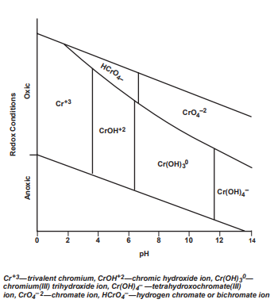
As shown in Figure 1, in a given water sample, Cr(III) may be present in at least 5 forms:
- as soluble Cr(III) species
- as a precipitated Cr(OH)₃ solid
- sorbed to the surface of iron oxide hydroxide (Fe(OH)₃) and other oxides
- ‘fixed’ inside oxides in a form that is relatively inaccessible to solution
- complexed with naturally occurring organic matter, such as humic and fulvic acids.
Depending on circumstances – including the level of organic matter, Fe(OH)₃ and other oxides, pH and other factors – the soluble fraction of Cr(III) can range from 0% to 100%.
In contrast, Cr(VI) will be virtually 100% soluble above pH 8.0, whereas < 10% of Cr(VI) is soluble between pH 2 and 6. Sorption of Cr(VI) to iron oxides or hydroxides starts to become highly significant (> 50%) below about pH 7. Cr(VI) also forms no significant precipitates at levels encountered in potable water and does not strongly bind to natural organic matter. As a result, Cr(VI) is generally present in drinking water as a soluble anion and its potential human toxicity is a much greater concern than Cr(III) (McNeill et al. 2012).
Reduction of Cr(VI) to Cr(III) occurs when dissolved oxygen levels fall below 0.5 mg/L (McNeill et al. 2012). Oxidation of Cr(III) to Cr(VI) in an environment with dissolved oxygen is improved in the presence of solid manganese dioxide (MnO₂). Environments rich in Fe(II) and organic matter favour the reduction of Cr(VI) to Cr(III). Interaction with solid phases can also regulate the chromium content in water. Cr(III) exhibits a typical cationic sorption behaviour – its adsorption increases with pH but decreases when competing cations are present. Cr(VI) exhibits a typical anionic sorption behaviour – its adsorption decreases with increasing pH and when competing dissolved anions are present. Precipitation and adsorption can be inhibited by complexation with dissolved ligands such as natural organic matter (Richard and Bourg 1991).
Hexavalent chromium can also be reduced by organic matter, such as simple amino acids or humic or fulvic acids. Intermediate Cr(V) species are produced and rapidly decay into Cr(III). This reduction is favoured by acidic conditions (Richard and Bourg 1991).
Hexaaquachromium (III) [Cr(H₂O)₆ ]³⁺ is the main Cr species in solutions of inorganic Cr(III) salts under strongly acidic conditions. At pH 4 and higher, Cr(III)-bound water molecules undergo hydrolysis, which leads to the formation of soluble and insoluble oligomeric and polymeric products. The reaction of hydrolysis and polymerisation are accelerated by increasing pH above 5, and the adjustment of solutions to neutral pH results in a rapid precipitation of multinuclear Cr(III) hydroxides. In addition to pH, the generation of polymeric products is influenced by the chromium concentrations, composition and ‘age’ of the solution. Surface waters commonly have a mixture of soluble monomeric and oligomeric Cr(III) products. Mild acidity and the absence of significant amounts of organics in drinking water supplies limit the presence of dissolved Cr(III) due to its poor solubility. In contrast to its aqua complexes, Cr(III) compounds with small organic molecules, such as organic acids, biological buffers, amino acids and others, are soluble and remain monomeric for a long time. Thus, the description of Cr(III) insolubility at neutral pH is only correct for solutions lacking ligands that compete with water. Formation of stable Cr(III) complexes with small organic molecules at the primary source of emission or contamination sites can increase their environmental mobility and maintain the solubility of Cr(III) even at neutral pH. Interaction of Cr(III) with components of environmental media involve continuous cycles of adsorption–desorption and precipitation–dissolution, which control the extent of its environmental mobility (Zhitkovich 2011).
The absence of toxic effects for Cr(III) complexes results from their poor ability to enter cells, their lack of intracellular accumulation, and the high stability of coordinated multidentate ligands, which prevent binding to cellular macromolecules. Systematic absorption of Cr(III) taken by human volunteers in the form of dissolved inorganic salts is measurable but usually less than 0.5%. No elevation in urinary excretion of Cr(III) was detected from the ingestion of insoluble chromium oxide (Cr₂O₃). Highly acidic conditions of the human gastric environment (pH 1–3) promote dissociation of Cr(III) oligomers. Low pH also strongly enhances the exchange of water for organic ligands in the Cr(III) coordination sphere, allowing the formation of new Cr(III) complexes that could remain soluble upon reaching neutral pH of the small intestine, where the absorption of metal ions takes place. A short stomach residency time for pure water and other simple liquids, however, is expected to limit the extent of ligand-exchange reactions (Zhitkovich 2011).
Dissolved organic matter may assemble into colloidal and particulate material that can sink as well as scavenge other material (Alldredge et al. 1993; Kepkay 1994; Chin et al. 1998). Colloids and colloidal organic carbon (COC) have not been adequately accounted for, because the current operational definition uses 0.45 µm as the cutoff size for colloids. Yan et al. (2018) quantified and characterised loadings of colloids and COC in aqueous samples collected from agricultural, forestry, freshwater wetland and estuary ecosystems. Results reveal that, in all samples and regardless of sampling sources, the total colloidal loads were underestimated by ≥ 50% and considered as ‘dissolved’ solutes when the cutoff size of 0.45 µm was used. Together with a large amount of data from the literature, their results further demonstrate that colloids are quantitatively substantial and carbon-dense and that as much as 8% to 19% of operationally defined dissolved organic carbon (DOC) is, in fact, COC. Freshwater wetlands were found to be hotspots that released more colloids and COC compared to the other sampled ecosystems. Yan et al. (2018) defined dissolved, colloidal and total mobile organic carbon (OC) as DOC 0.1 (< 10 kDa or 0.1 µm), COC (0.1–0.7/1.0 µm) and total organic carbon (TOC) (> 0.7/1.0 µm), respectively. The quantitative contribution of COC to the TOC pool was found to be significant in all samples. Across all sampling sites, COC generally accounted for ∼10% to 20% of the TOC pool, whereas DOC 0.1 consistently dominated, contributing 82% to 87% to the TOC pool (with 95% certainty). Despite the relatively small percentage of COC compared to DOC 0.1, the absolute concentrations of COC can be substantial (e.g. ∼15 mg/L C in samples collected from the wetland and agricultural field).
Yan et al. (2018) indicated that over 80% of OC in DOC 0.45 (< 0.2–0.45 µm) is dissolved, whereas 12% to 15% of DOC 0.45 is COC. The ratios of DOC 0.1 to DOC 0.45 are relatively constant as reflected by their variance coefficient, 0.11 and 1.81 respectively, and are largely independent of variations in OC concentrations in the many samples analysed. The seemingly constant (~10%) contribution of COC in DOC fraction of < 0.2 µm or 0.45 µm suggests that some of the organic colloids in the water samples may be formed from a reversible assembly/dispersion equilibrium between COC and smaller-sized DOC. This mechanism is supported by Chin et al. (1998) and Verdugo et. al. (2004), who reported approximately 10% of DOC in surface sea water spontaneously assembled into colloidal gels.
Colloid dispersion is possible with increasing pH due to the increase in the negative surface charge of colloids, which promotes repulsion between colloid–colloid or colloid–soil grains. Surface-charge repulsion can also explain COC dispersion with increase in pH. Colloids are more carbon-dense than particulates because they have larger specific surface areas and thus greater sorption capacity, and they form from detachment/transformation of particulate organic matter or from sorption of, or coagulation with, branched high molecular weight organic matter (Yan et al. 2018).
Carbonates are the most widely distributed chemical sedimentary rocks over geological history and have been considered as important archive of paleo-seawater chromium isotope compositions. However, the incorporation behaviour of Cr(III) into carbonates remains undefined. Fang et al. (1922) conducted co-precipitation experiments for Cr(III) with calcium carbonate (CaCO₃) to constrain the behaviour of Cr(III) in carbonate-deposition environments. They found that most chromium is adsorbed on the CaCO₃ surface or exists as amorphous chromium hydroxide (Cr(OH)₃). A small fraction of chromium can reside in the calcite crystal, but Cr³⁺ cannot directly substitute for Ca²⁺, as the ionic radius of Cr³⁺ is much smaller than that of Ca²⁺. It may occupy the position of Ca²⁺ in the form of the divalent chromium hydroxide cation (Cr(OH)²⁺). They suggested that most chromium in natural carbonates is adsorbed on the crystal surface and may be acquired at the water–sediment interface after carbonate precipitation. Direct measurements of chromium valence states in carbonates showed that Cr(III) is the predominant species in all samples from different geological periods, suggesting that reduction of Cr(VI) or preferential direct uptake of Cr(III) by carbonates likely occurred during or after carbonate deposition. Cr(III) is a ubiquitous species of chromium in modern river water and seawater. Thus, it is conceivable that Cr(III) can be captured by carbonates (Fang et al. 1922).
In the present study, we investigated adsorption of chromium in synthetic solutions (Syn 1 and Syn 2) containing OC and CaCO₃ after 3 days, 7 days and 14 days of storage at room temperature. These solutions were then acidified according to US EPA (1991) method, and chromium extraction was monitored 4 hours, 8 hours and 16 hours after acidification.

Methods
The design of our validation study was based on the US EPA (1991) 200.1 method, taking into consideration the issues listed in Section 1 Introduction. Samples were analysed for dissolved and total recoverable (TR) chromium using Agilent Triple Quadrupole ICP-MS (inductively coupled plasma mass spectrometry) and Agilent ICP-OES (inductively coupled plasma optical emission spectrometry). Preliminary investigation was conducted in synthetic freshwater under 2 experimental conditions:
- Synthetic 1: all sample bottles were kept on the bench throughout the experiment (Syn 1)
- Synthetic 2: all sample bottles were shaken on a horizontal shaker at 100 rotations per minute throughout the experiment (Syn 2).
Synthetic freshwater was prepared in a 10-L plastic bottle using deionised water, CaCO₃ (nominal concentration is 80 ± 1 mg/L, solubility in water at 25°C is 15 mg/L) and potassium hydrogen phthalate (KHP; nominal concentration was 8.6 ± 0.1 mg/L and DOC concentration ~4 mg/L). Amounts of these chemicals used to prepare 10 L of Syn 1 and Syn 2 solutions were:
- Synthetic 1: 0.8013 g CaCO₃ (not fully dissolved) + 0.0854 g KHP
- Synthetic 2: 0.8090 g CaCO₃ (not fully dissolved) + 0.0862 g KHP.
Note: minor differences in the masses of these chemicals between Syn 1 and Syn 2 solutions are not critical. Actual concentrations of DOC in these solutions were measured before the experiments.
One 2 L and 3 × 2.6 L of freshly prepared solution were transferred into 4 separate acid-washed 5-L bottles, and solutions A (2 L), B (2.6 L), C (2.6 L) and D (2.6 L) were prepared according to the procedure presented in Table 1.
Table 1 Preparation of synthetic solutions A, B, C and D from 10 litres of stock solution
Solution A (2 L): control/blank | Solution B (2.6 L): freshly spiked chromium (500 µg/L) | Solution C (2.6 L): suspended particulate chromium oxide (57.7 mg/L total suspended solids) | Solution D (2.6 L): combination of B and C
No chromium added | 1.3 mL of 1,000 mg/L chromium stock solution (see Step 1) in 2.6 L of synthetic stock solution | 50 mL of 3 g/L particulate chromium oxide solution (see Step 2) in 2.6 L of synthetic stock solution | 1.3 mL of chromium stock solution and 50 mL of particulate chromium oxide solution in 2.6 L of synthetic stock solution
- Preparation of chromium stock solution (1,000 mg/L):
- Clean metal chromium (99.99% purity) in 1:1 HCl for 1–3 minutes (do not dissolve).
- Wash with deionised water and dry at 105°C for 1 hour.
- Weigh 1 g (actual weight was 1.0140 g) chromium into a 100-mL beaker.
- Add 20 mL 1:1 concentrated HCl to dissolve.
- After complete dissolution, add 10 mL concentrated HCl, transfer into 1-L acid-washed high-density polyethylene (HDPE) bottle, and increase volume to 1.0140 L with deionised water.
- Preparation of suspended particulate Cr₂O₃ solution (3 g/L Cr₂O₃):
- Weigh 600 mg of Cr₂O₃ into 200 mL of ultra-pure water in a volumetric flask.
- Vigorously mix the chromium suspension.
- Store in 250-mL acid-washed HDPE bottle, and use on the same day as preparation.

Analysis of freshly prepared solutions A, B, C and D for chemical and physical parameters
Before commencing the experiment, freshly prepared solutions A, B, C and D were analysed for the physical and chemical parameters presented in Table 2.
Table 2 Physical and chemical parameters of solutions A, B, C and D measured before acidification
Y = yes; N = no; TOC = total organic carbon; DOC = dissolved organic carbon; DO = dissolved oxygen; TSS = total suspended solids.
 | Alkalinity, conductivity, pH (40 mL)* | Filtered chromium, (µg/L) (10–15 mL) | Total chromium, (µg/L) (10–15 mL) | TOC (25 mL) | DOC (25 mL) | DO (300 mL) | TSS (150 mL)
Solution A | Y | Y | Y | Y | Y | Y | N
Solution B | Y | Y | Y | Y | Y | N | N
Solution C | Y | Y | N | Y | Y | N | Y
Solution D | Y | Y | N | Y | Y | N | Y
*volume of sample required.
A volume of 250 mL of solution A was transferred into each of 6 250-mL acid-washed HDPE bottles labelled A1-3, A2-3, A1-7, A2-7, A1-14 and A2-14. These were stored on the bench (or, in the case of Syn 2 solution, on the shaker) for 3 days, 7 days or 14 days; that is, 2 replicates each for the 3-day, 7-day and 14-day holding times. Before acidification on day 3, 7 or 14, each replicate solution was analysed for pH (pre-extraction pH value) and, after mixing, filtered with 0.45-µm polyethersulfone (PES) syringe filters into 2 acid-washed 10-mL tubes (duplicates a and b and extraction time 0). Duplicates were acidified with 100 µL concentrated HNO₃ before ICP-MS analysis.
Acidification of all 6 replicate solutions A was carried out with the addition of 50% v/v HNO₃ to pH 1.75 ± 0.1 at the ratio of acid to solution of 1:400 (i.e. 0.625 mL of acid into 250 mL of solution) on day 3 (replicates A1-3 and A2-3), day 7 (replicates A1-7 and A2-7) and day 14 (replicates A1-14 and A2-14) after preparation. Immediately after acidification, all replicates were analysed for pH to ensure a pH extraction value of 1.75 ± 0.1.
At 4 hours, 8 hours and 16 hours after acidification, replicate solutions were checked for pH (1.75 ± 0.1), mixed well and filtered into 2 acid-washed 10-mL tubes (duplicates a and b and extraction times 4 hours, 8 hours and 16 hours). All duplicates were spiked with 100 µL of HNO₃ before ICP-MS analysis.
To avoid sample contamination during direct measurement of pH from the sample bottles, the pH probe was thoroughly rinsed between measurements of different samples. There were no instances of sample or blank contamination using this method, and pH was within 1.75 ± 0.1 after sample acidification for all experimental conditions. This approach is adopted by the Inorganic Chemistry Laboratory Public and Environmental Health Reference Laboratories, Queensland Health in routine pH analysis using a method accredited by the National Association of Testing Authorities (NATA).
Identification names for all experimental replicate and duplicate solution A samples are presented in Table 3.
Table 3 Identification names of replicate and duplicate solution A samples. Starting volume is 2 litres
Extraction time (hours) | 3 days | 3 days | 7 days | 7 days | 14 days | 14 days
Extraction time (hours) | A1-3 (250 mL) | A2-3 (250 mL) | A1-7 (250 mL) | A2-7 (250 mL) | A1-14 (250 mL) | A2-14 (250 mL)
0 | A1-3a-0,  A1-3b-0 | A2-3a-0,  A2-3b-0 | A1-7a-0,  A1-7b-0 | A2-7a-0,  A2-7b-0 | A1-14a-0,  A1-14b-0 | A2-14a-0,  A2-14b-0
4 | A1-3a-4,  A1-3b-4 | A2-3a-4,  A2-3b-4 | A1-7a-4,  A1-7b-4 | A2-7a-4,  A2-7b-4 | A1-14a-4,  A1-14b-4 | A2-14a-4,  A2-14b-4
8 | A1-3a-8,  A1-3b-8 | A2-3a-8,  A2-3b-8 | A1-7a-8,  A1-7b-8 | A2-7a-8,  A2-7b-8 | A1-14a-8,  A1-14b-8 | A2-14a-8,  A2-14b-8
16 | A1-3a-16,  A1-3b-16 | A2-3a-16,  A2-3b-16 | A1-7a-16,  A1-7b-16 | A2-7a-16,  A2-7b-16 | A1-14a-16,  A1-14b-16 | A2-14a-16,  A2-14b-16
Unlike solution A, solutions B, C and D had 3 replicates and, therefore, each freshly prepared solution was sub-sampled into 9 250-mL acid-washed HDPE bottles (3 × day 3, 3 × day 7 and 3 × day 14 holding time). The pH of replicates before acidification (pre-extraction pH value), immediately after acidification at time 0, and at 4 hours, 8 hours and 16 hours after acidification were measured to ensure their values of 1.75 ± 0.1. After mixing, each replicate was filtered through 0.45-µm PES syringe filters into 2 × 10-mL acid-washed tubes (duplicates a and b) for the subsequent ICP-MS analysis at extraction time 0, 4, 8 and 16 hours.
Identification names for all experimental replicate and duplicate solutions B, C, and D are presented in Table 4, Table 5 and Table 6, respectively.
Table 4 Identification names of replicate and duplicate solution B samples. Starting volume is 2.6 litres
Extraction time (hours) | 3 days | 3 days | 3 days | 7 days | 7 days | 7 days | 14 days | 14 days | 14 days
Extraction time (hours) | B1-3 (250 mL) | B2-3 (250 mL) | B3-3 (250 mL) | B1-7 (250 mL) | B2-7 (250 mL) | B3-7 (250 mL) | B1-14 (250 mL) | B2-14 (250 mL) | B3-14 (250 mL)
0 | B1-3a-0  B1-3b-0 | B2-3a-0  B2-3b-0 | B3-3a-0  B3-3b-0 | B1-7a-0  B1-7b-0 | B2-7a-0  B2-7b-0 | B3-7a-0  B3-7b-0 | B1-14a-0  B1-14b-0 | B2-14a-0  B2-14b-0 | B3-14a  B3-14b
4 | B1-3a-4  B1-3b-4 | B2-3a-4  B2-3b-4 | B3-3a-4  B3-3b-4 | B1-7a-4  B1-7b-4 | B2-7a-4  B2-7b-4 | B3-7a-4  B3-7b-4 | B1-14a-4  B1-14b-4 | B2-14a-4  B2-14b-4 | B3-14a-4  B3-14b-4
8 | B1-3a-8  B1-3b-8 | B2-3a-8  B2-3b-8 | B3-3a-8  B3-3b-8 | B1-7a-8  B1-7b-8 | B2-7a-8  B2-7b-8 | B3-7a-8  B3-7b-8 | B1-14a-8  B1-14b-8 | B2-14a-8  B2-14b-8 | B3-14a-8  B3-14b-8
16 | B1-3a-16  B1-3b-16 | B2-3a-16  B2-3b-16 | B3-3a-16  B3-3b-16 | B1-7a-16  B1-7b-16 | B2-7a-16  B2-7b-16 | B3-7a-16  B3-7b-16 | B1-14a-16  B1-14b-16 | B2-14a-16  B2-14b-16 | B3-14a-16  B3-14b-16

Table 5 Identification names of replicate and duplicate solution C samples. Starting volume is 2.6 litres
Extraction time (hours) | 3 days | 3 days | 3 days | 7 days | 7 days | 7 days | 14 days | 14 days | 14 days
Extraction time (hours) | C1-3 (250 mL) | C2-3 (250 mL) | C3-3 (250 mL) | C1-7 (250 mL) | C2-7 (250 mL) | C3-7 (250 mL) | C1-14 (250 mL) | C2-14 (250 mL) | C3-14 (250 mL)
0 | C1-3a-0  C1-3b-0 | C2-3a-0  C2-3b-0 | C3-3a-0  C3-3b-0 | C1-7a-0  C1-7b-0 | C2-7a-0  C2-7b-0 | C3-7a-0  C3-7b-0 | C1-14a-0  C1-14b-0 | C2-14a-0  C2-14b-0 | C3-14a  C3-14b
4 | C1-3a-4  C1-3b-4 | C2-3a-4  C2-3b-4 | C3-3a-4  C3-3b-4 | C1-7a-4  C1-7b-4 | C2-7a-4  C2-7b-4 | C3-7a-4  C3-7b-4 | C1-14a-4  C1-14b-4 | C2-14a-4  C2-14b-4 | C3-14a-4 C3-14b-4
8 | C1-3a-8  C1-3b-8 | C2-3a-8  C2-3b-8 | C3-3a-8  C3-3b-8 | C1-7a-8  C1-7b-8 | C2-7a-8  C2-7b-8 | C3-7a-8  C3-7b-8 | C1-14a-8  C1-14b-8 | C2-14a-8  C2-14b-8 | C3-14a-8 C3-14b-8
16 | C1-3a-16  C1-3b-16 | C2-3a-16  C2-3b-16 | C3-3a-16  C3-3b-16 | C1-7a-16  C1-7b-16 | C2-7a-16  C2-7b-16 | C3-7a-16  C3-7b-16 | C1-14a-16  C1-14b-16 | C2-14a-16  C2-14b-16 | C3-14a-16 C3-14b-16
Table 6 Identification names of replicate and duplicate solution D samples. Starting volume is 2.6 litres
Extraction time (hours) | 3 days | 3 days | 3 days | 7 days | 7 days | 7 days | 14 days | 14 days | 14 days
Extraction time (hours) | D1-3 (250 mL) | D2-3 (250 mL) | D3-3 (250 mL) | D1-7 (250 mL) | D2-7 (250 mL) | D3-7 (250 mL) | D1-14 (250 mL) | D2-14 (250 mL) | D3-14 (250 mL)
0 | D1-3a-0  D1-3b-0 | D2-3a-0  D2-3b-0 | D3-3a-0  D3-3b-0 | D1-7a-0  D1-7b-0 | D2-7a-0  D2-7b-0 | D3-7a-0  D3-7b-0 | D1-14a-0  D1-14b-0 | D2-14a-0  D2-14b-0 | D3-14a  D3-14b
4 | D1-3a-4  D1-3b-4 | D2-3a-4  D2-3b-4 | D3-3a-4  D3-3b-4 | D1-7a-4  D1-7b-4 | D2-7a-4  D2-7b-4 | D3-7a-4  D3-7b-4 | D1-14a-4  D1-14b-4 | D2-14a-4  D2-14b-4 | D3-14a-4 D3-14b-4
8 | D1-3a-8  D1-3b-8 | D2-3a-8  D2-3b-8 | D3-3a-8  D3-3b-8 | D1-7a-8  D1-7b-8 | D2-7a-8  D2-7b-8 | D3-7a-8  D3-7b-8 | D1-14a-8  D1-14b-8 | D2-14a-8  D2-14b-8 | D3-14a-8 D3-14b-8
16 | D1-3a-16  D1-3b-16 | D2-3a-16  D2-3b-16 | D3-3a-16  D3-3b-16 | D1-7a-16  D1-7b-16 | D2-7a-16  D2-7b-16 | D3-7a-16  D3-7b-16 | D1-14a-16  D1-14b-16 | D2-14a-16  D2-14b-16 | D3-14a-16 D3-14b-16
On completion of the 16-hour extraction period, the remaining replicate solutions (for the 3-day, 7-day and 14-day holding times) were transferred to 2 × 50-mL sample tubes for the TR fraction (corresponding TR duplicates a and b) and acidified with 500 µL concentrated HNO₃.
Total recoverable fractions for solutions C and D (with suspended particulate chromium added) were subjected to additional extraction steps according to the US EPA (1994) 200.8 method, section 11.3 for turbid samples (see ANZG 2025, p. 16) summarised below:
- Evaporate the 50-mL sample down to 5 mL.
- Digest sample for 30 minutes with the addition of 2 mL diluted HNO₃ (1:2) and 5 mL of diluted HCl (1:5).
- Increase volume to 50 mL by adding 5 mL of 20% HCl and the rest ultrapure water.
- Transfer sample to a clean 10-mL polypropylene tube, and filter through 0.45-µm syringe filter if required.
The physical and chemical characteristics of original synthetic solutions, the concentrations of chromium in different synthetic solutions stored for 3 days, 7 days and 14 days before acidification, and the results of acid extraction of chromium at pH 1.75 ± 0.1 for 4 hours, 8 hours, 16 hours and 16+ hours are summarised in Appendix A and Appendix B.
A similar experimental design was applied for the investigation of chromium acid extraction in different environmental solutions – raw water (natural freshwater), raw turbid freshwater and sea water. The results for these other matrices are summarised in Appendix C, Appendix D and Appendix E, respectively.

Outliers
- Duplicates: when the difference between 2 duplicates (a and b) was > 50%, the lower result was used in calculations.
- Replicates (Grubb’s test): the test was performed by calculating a value ‘Z’ for the suspected outlying replicate as follows: Z = |mean – value| / SD, where mean is the mean and SD is the standard deviation of 3 replicate values. The calculated value Z was then compared with 1.15, the critical value for Z (n = 3, 2 decimal places in compliance with experimental results). If Z was higher than 1.15, the replicate was disregarded in calculations, as there is less than 5% chance that it is not an outlier.

Results
The issues that were identified and a summary of the corresponding results from the validation study are discussed in detail in Table 7, Table 8 and Table 9.
Table 7 Summary of issues identified for the pH 1.75 ± 0.1 extraction method (US EPA 1991) for chromium and conclusions drawn from the validation study that should be further addressed via additional research and development or validation studies
Aspect of method | Description of issue | Study results
Acidification period | According to the current US EPA (1991) 200.1 method, ‘the aqueous sample is acidified … and held for a period of at least 16 hours before being filtered …’. | 1. A 16-hour acid-extraction period is optimal, especially when combined with a 3-day sample-holding time. This combination provides highest recovery of potentially bioavailable chromium from both freshwater and sea water.  2. An 8-hour acid-extraction period provided slightly lower recoveries for all solutions: 4% to 6% lower for synthetic solutions, 12% to 17% lower for freshwater solutions and 4% to 5% lower for sea water solutions.  3. An extraction period of 8–16 hours is considered acceptable for both freshwater and sea water solutions. However, as an 8-hour extraction period is likely to be less convenient for chemical laboratories, a 16-hour period is recommended for acid extraction of chromium from freshwater and sea water solutions.
pH adjustment | According to the current US EPA (1991) 200.1 method, the pH of the sample must be 1.75 ± 0.1. Approximately 800 mL of sample is acidified with 2 mL of (1:1) nitric acid. If the sample pH is above 1.85 (1:1), nitric acid should be added in a dropwise manner until the sample is within the desired pH range. If the sample pH is below 1.65 (1:9), ammonium hydroxide should be added slowly until pH is 1.75 ± 0.1. The concern is that this procedure of multiple pH checking and adjustment carries a risk of sample contamination with the dipping of electrodes, washing electrodes, adding nitric acid or ammonium hydroxide, etc. | The same ratio of water sample and (1:1) nitric acid (i.e. 800:2) was used in the current study – 0.625 mL of (1:1) nitric acid was added to 250 mL of water for chromium acid extraction. The pH of all water samples was measured before and after their acidification and during chromium extraction. It was found that for all investigated ambient waters, the addition of 0.625 mL of (1:1) nitric acid to 250 mL of water sample lowers the water pH to 1.75 ± 0.1. After acidification, the pH of water stays within 1.75 ± 0.1 throughout all extraction periods (4, 8 and 16 hours). The same probe was used for blanks and water samples. It was thoroughly rinsed and dried between measurement of different samples. This process allowed for the direct measurement of pH from the sample bottle and did not require pH adjustment. There were no instances of sample or blank contamination using this method.  Thus, 800:2 ratio of water sample to (1:1) nitric acid adjusted according to the sample volume is recommended for the method.
Method suitability | The current US EPA (1991) 200.1 method can be used to determine acid-soluble metals in ambient waters and aqueous wastes. It is applicable to the analysis of a number of metals, including chromium. Based on the total recoverable value, percent recovery of acid-soluble chromium in river water spiked with sludge material is 49% for relatively low-turbidity water (0.25 g of sludge per litre of water) and 37% to 43% for turbid water (1–2.5 g of sludge per litre of water). The method does not provide any data for sea water. | The validation study has demonstrated that the method is suitable for both freshwater and sea water. Based on the total recoverable value, percent recovery for raw low-turbidity water (total suspended solids 0.063 g/L, mostly added chromium oxide) is ~55% and turbid water (total suspended solids 0.045 g/L, natural particulate matter, no chromium oxide added) is about 31%.  In the case of sea water with total suspended solids of 0.049 g/L (mostly added chromium oxide), recovery of chromium is 100% after 16-hour acid extraction from 3-day holding-time solution (not total recoverable value).
Potential issues with Cr(III) analysis | US EPA (1991) 200.1 method is designed to measure acid-extractable chromium (III plus VI). Cr(III) is then determined by subtracting the determined chromium (VI) concentration measured by a different method from the total chromium concentration. | The purpose of this study is to validate a method that most closely estimates the bioavailable fraction of chromium (III). The method is meant to solubilise precipitated chromium oxyhydroxides, including those that become adsorbed to other substrates, such as mineralised forms or particulate/colloidal organic matter, but not solubilise non-bioavailable mineralised forms of chromium.  Two major pathways or uptake vectors for aquatic organisms are available for metals: ingestion of metal-enriched sediment and suspended particles during feeding, and uptake from solution. Aquatic organisms uptake free metal ions from solution quite efficiently. Metal assimilation from ingested particulate matter is also important.  Depending on circumstances, including the level of organic matter, iron(III) hydroxide and other oxides, pH and other factors, the soluble fraction of Cr(III) can range from 0% to 100%.  In contrast, Cr(VI) will be virtually 100% soluble above pH 8.0, whereas between pH 2 and 6, < 10% of Cr(VI) is soluble. Sorption of Cr(VI) to iron oxides or hydroxides starts to become highly significant (> 50%) below about pH 7.  Hexavalent chromium can be reduced by organic matter, such as simple amino-acids or humic or fulvic acids. This reduction is favoured by acidic conditions (Richard and Bourg 1991).  According to the speciation diagram for aqueous chromium in Figure 1 in oxic conditions and pH < 2 (conditions of the human gastric environment), chromium presents in a solution as Cr³⁺. Based on the information above, < 10% of Cr(VI) present in the original solution (before acidification) remains soluble after its acidification, and all soluble Cr(VI) is reduced to Cr(III) under the conditions investigated in our study.  Commonly, laboratories calculate Cr(III) by measuring total dissolved chromium (pH < 2) then subtracting dissolved Cr(VI) (field preserved sample at pH 9.3–9.7). We believe that such an approach results in underestimation of the bioavailable fraction of Cr(III) in water, as only about 10% of Cr(VI) soluble at pH 9.3–9.7 is input into total chromium evaluation at pH < 2.  Trivalent chromium occurs naturally. Hexavalent chromium is most often released into the environment by chemical, leather and textile manufacturing and electropainting, and is an indicator of environmental contamination.  Evaluation of chromium concentration under the conditions investigated in this study provides relatively accurate determination of dissolved chromium (III) in natural waters given that they are not contaminated with Cr(VI). Otherwise, preliminary evaluation of Cr(VI) in water by different methods is required to adjust dissolved chromium (III) concentration estimate by the current method.
Table 8 Summary of issues identified for the pH 1.75 ± 0.1 extraction method (US EPA 1991) for chromium and conclusions drawn from the validation study that require minor procedural adjustments
Aspect of method | Description of issue | Study results
Sample volume | US EPA (1991) 200.1 method requires approximately 800 mL of water sample for the acid extraction of chromium. | The validation study demonstrated that this volume can be significantly reduced. A volume of 250 mL of water was used in our experiments. However, this volume was required to evaluate percentage of chromium recovery after 4 hours, 8 hours and 16 hours of acid extraction, taking duplicate samples at each time point.  Once a 16-hour period is decided for the final method, sample volume can be further reduced to 100 mL.  Thus, 100 mL is a sufficient volume, as a laboratory using this method will require a set of filtered samples for a single time point. A volume of 100 mL is the final recommended sample volume.
Field addition of acid | According to US EPA (1991) 200.1 method, acidification of sample is required at the time of its collection.  This is not practical, especially for remote sites, and needs amending. It is difficult (illegal) to transport acids without Dangerous Goods permits, and they cannot be sent via air. Also, environmental consultants often have occupational health and safety rules that they cannot touch acids. It would be best for the client to send an unpreserved sample to the laboratory, which then takes over the acid addition in a controlled environment. | Addition of acid in the laboratory has been incorporated in the method and is recommended over acidification in the field.
3-day holding time | The sample should not be held more than 3 days at 4°C from the day of collection before processing is started (US EPA 1991, 200.1 method). | The validation study has found that if samples cannot be processed within 3 days of collection, that processing within 7 days and even within 14 days is also acceptable provided a 16-hour extraction at 1.75 ± 0.1 is used. Processing within 7 days and 14 days results in the decrease of recovery of bioavailable chromium by 8% to 12% for raw freshwater, no recovery changes for raw turbid freshwater, and decrease of recovery by 2.5% to 6% for sea water.

Table 9 Summary of issues identified for the pH 1.75 ± 0.1 extraction method (US EPA 1991) for chromium and conclusions drawn from the validation study that do not require further consideration
Aspect of method | Description of issue | Study results
Type of acids to use | US EPA (1991) 200.1 method uses only nitric acid for acid extraction. | A more aggressive acid mixture may lead to extraction of mineralised forms of chromium, which is not desirable. In our study, total recoverable values for solution B samples (raw freshwater) were estimated by acid extraction with nitric acid only, and with a mixture of nitric and hydrochloric acids using US EPA (1994) 200.8 method for turbid samples. They are (average for 16 hours): 454 µg/L compared to 525 µg/L for day 3, 443 µg/L compared to 522 µg/L for day 7, and 455 µg/L compared to 535 µg/L for day 14 (see Table C.2, Table C.3, Table C.4 and Table C.5 in Appendix C). Such increase of total recoverable values (16% to 18%) resulted in insignificant decrease of chromium recoveries (2% for day 14 and 9% for day 3 and day 7). Thus, for chromium, the use of both hydrochloric and nitric acids for acid extraction is not necessary. Nitric acid only is recommended for chromium acid extraction.
Sample filtration | According to the US EPA (1991) 200.1 method, the pH-adjusted sample is filtered through a 0.45-µm membrane filter. To prevent clogging of the filter, the sample is first passed through a 0.8-µm prefilter. | 0.8-µm prefilters were not used in the validation study, as an additional step in the filtering process may result in sample contamination. In case of turbid water analysis, samples can be centrifuged before filtering through 0.45-µm filters. In the current study, only 0.45-µm polyethersulfone syringe filters were used to filter acidified water samples.
Sample cooling | According to the US EPA (1991) 200.1 method, water samples should be placed in an ice chest at 4°C after collection and returned to the laboratory. In the laboratory, they should not be held more than 3 days at 4°C from the day of collection before processing is started.  Keeping samples at 4°C would be difficult in remote areas. | For the validation study, all samples were kept at room temperature (22°C to 23.5°C) over the holding (from 3 days to 14 days) and extraction (from 0 hours to 16 hours) periods. According to the method accredited by the National Association of Testing Authorities (based on APHA, AWWA, WEF 2023 method 3030E Standard methods for the examination of water and wastewater) used in the inorganic chemistry laboratory of the Public and Environmental Health Reference Laboratories for metal analysis, all water samples are kept at room temperature before and after acidification. Based on this, keeping samples at 4°C in the field prior to acidification does not seem necessary.

Recovery of potentially bioavailable chromium from synthetic freshwater solution 1
Appendix A details the findings that are summarised below.

General
- 95% to 100% of chromium spiked into solution B and D samples was adsorbed on CaCO₃ and/or Cr₂O₃ during the 3-day, 7-day and 14-day holding times on the bench at room temperature before acidification.
- A 16-hour acid-extraction period with a 3-day holding time resulted in the highest chromium concentration and recovery in the synthetic solution B and D samples.
- For 3-day holding time and 16-hour extraction, the concentration of chromium (304 µg/L) and its recovery (60%) for solution D was about twice the concentration (140 µg/L) and recovery (29%) than that for solution B.
- Shaking the solution on a horizontal platform at 100 rotations/minute during acid extraction did not result in additional release of chromium into solution.
- After acidification, pH of all solutions remained within 1.75 ± 0.1 throughout all acid-extraction periods.

Solution B
- For all extraction periods, concentrations and recoveries of chromium in solution B almost halved with a change of holding time from 3 days to 7 days. These values were similar for solutions with 7-day and 14-day holding times.
- Concentration of chromium in solution B significantly increased (by a factor of 6–58) after the first 4 hours of acid extraction for all holding times, then slowly increased by 10–15 µg/L as extraction time increased to 8 hours and 16 hours.
- Concentration of chromium in solution B with a 14-day holding time increased to 255 µg/L (from 83 µg/L) 114 days after its acidification, reaching the final recovery of 53% – a 36% increase from the 16-hour extraction recovery.

Solution C
- Chromium was not released into solution C even after its acidification. Concentration of chromium in solution C did not exceed 2 µg/L throughout the experiment.

Solution D
- Concentration of chromium in solution D rapidly increased from non-detectable levels to > 200 µg/L after the first 4 hours of acid extraction for all holding periods, then slowly increased by 40–45 µg/L as extraction time increases to 8 hours and 16 hours.
- Concentrations and recoveries of chromium in solution D were similar for the 3-day and 7-day holding times. These values decreased by < 10% as holding time increased to 14 days.
- Average concentration of chromium in solution D with a 14-day holding time increased up to 510 µg/L (from 262 µg/L) 114 days after its acidification, reaching a final recovery of 102% – a 50% increase from the 16-hour extraction recovery.

Recovery of potentially bioavailable chromium from synthetic freshwater solution 2
Appendix B details the findings that are summarised below.

General
- 90% to 100% of chromium spiked into solution B and D samples was adsorbed on CaCO₃ and/or Cr₂O₃ during the 3-day, 7-day and 14-day holding times on the bench at room temperature before acidification.
- For 3-day holding time and 16-hour extraction, the concentration of chromium (261 µg/L) in solution D was twice the concentration (131 µg/L) than that in solution B. However, recoveries only differed by 12%; that is, 54% for solution D and 42% for solution B. Such minor recovery variation with the 2-fold difference in concentrations is related to TR values.
- After acidification, pH of all solutions remained within 1.75 ± 0.1 throughout all acid-extraction periods.

Solution B
- A 16-hour acid-extraction period with a 3-day holding time resulted in the highest chromium concentration and recovery in the synthetic solution B samples.
- Concentration of chromium in solution B increased by a factor of 2–3 after the first 4 hours of acid extraction for all holding times, then slowly increased by 11–23 µg/L as extraction time increased to 8 hours and 16 hours.
- Concentrations and recoveries of chromium in solution B decreased by a factor of ~2.5 as holding time increased from 3 days to 7 days and by a factor of 2 as holding time increased from 7 days to 14 days.
- For shaken solution B, the values of TR chromium for the 3-day, 7-day and 14-day holding times were less than those for still solution B (from synthetic solution 1 experiment); that is, 280 µg/L compared to 492 µg/L (on average). The use of additional extraction steps for turbid samples (US EPA 1994, 200.8 method) did not result in increase of TR chromium of the final solution B samples.
- Evaluation of chromium recoveries for different acid-extraction and holding times against TRs for still solution B (from synthetic solution 1 experiment) reduced recovery values by a factor of 1.6.
- In general, recoveries for shaken solution B with 3-day, 7-day and 14-day holding times were lower by a factor of 1.2, 1.5 and 2.6, respectively, than those for still solution B when they were evaluated against TRs for stable solution. Thus, shaking did not improve extraction efficiency.

Solution C
- Chromium was not released into solution C even after acidification. Concentration of chromium in solution C was below the limit of reporting throughout the experiment. Trace amount of TR chromium was found in the final solution C samples.

Solution D
- A 16-hour acid-extraction period with 3-day and 14-day holding times resulted in the highest chromium concentration and recovery for synthetic solution D. Note that the slightly lower chromium concentration and recovery for the 16-hour acid-extraction period with a 7-day holding time may be related to some experimental inconsistencies.
- Concentration of chromium in solution D increased from detectable levels to about 200 µg/L after 4 hours of acid extraction for all holding periods, then slowly increased by 41–53 µg/L as extraction time increases to 8 hours and 16 hours.
- Concentrations and recoveries of chromium in solution D were similar for the 3-day and 14-day holding times. Values were slightly lower for the 7-day holding time, which may be related to some experimental inconsistencies.

Recovery of potentially bioavailable chromium from raw freshwater solution
Surface water from 10–15 sampling locations was delivered to the laboratory in 1-L detergent-washed HDPE bottles and pooled into a 10-L bottle within 1–2 days.
One 2 L and 3 × 2.6 L of freshly prepared solution were transferred into 4 separate acid-washed 5-L bottles, and solutions A (2 L), B (2.6 L), C (2.6 L) and D (2.6 L) were prepared according to the procedure presented in Table 1.
Acid extraction of chromium in raw water solutions A, B, C and D was performed according to the procedure used for synthetic solutions. Results are presented in Appendix C and support the following conclusions.

General
- Concentration of chromium in the original solution (solution A) was < 0.5 µg/L. Between 94% and 98% of chromium spiked into solution B and D samples was adsorbed on particulate/organic matter present in the raw water during the 3-day, 7-day and 14-day holding times of these solutions on the bench at room temperature before acidification.
- A 16-hour acid-extraction period with a 3-day holding time resulted in the highest chromium concentration and recovery in solution B and D samples.
- Dissolved concentrations of chromium in solution B and D samples were very similar for all extraction and holding times. Concentrations increased by a factor of 8, 16 and 24 after the first 4 hours of acid extraction for the 3-day, 7-day and 14-day holding-time solutions, respectively. Concentrations increased by 70–80 µg/L as extraction time increased to 8 hours and 16 hours.
- For 3-day holding time and 16-hour extraction, the average concentrations of chromium in solution B and D samples were the same – 293 µg/L. However, the recoveries were different – 65% for solution B and 55% for solution D. This difference is related to some variation in TR values.
- After acidification, concentrations and recoveries of chromium in solution B and D samples did not significantly change with increase of holding time from 3 days to 14 days.
- Concentrations of chromium in solution B and D samples increased as acid-extraction times exceeded 16 hours. Recovery for 3-day holding solutions reached about 80% after a 16-hour extraction. The highest achieved recoveries for 7-day and 14-day holding solution B and D samples were slightly lower – about 76% and 66%, respectively.
- After acidification, pH of all solutions remained within 1.75 ± 0.1 throughout all acid-extraction periods.

Solution B
- Recovery of chromium in solution B increased by about 17% as extraction time increased from 4 hours to 16 hours for all solution holding times.
- Additional extraction for turbid samples (US EPA 1994, 200.8 method) for the final solution B samples resulted in increase of their TR values and reduction of chromium recoveries, making them similar to the values obtained for solution D samples.

Solution C
- Concentration of chromium was detectable in raw solution C and at time 0 (before acidification). Following acidification, it dropped below the detection limit. Trace amounts of TR chromium were found in the final solution C samples.

Solution D
- Recovery of chromium in solution D increased by about 14% as extraction time increased from 4 hours to 16 hours for all solution holding times.

Recovery of potentially bioavailable chromium from raw turbid freshwater solution
Water collected from 15 sampling locations was delivered to the laboratory in 1-L detergent-washed HDPE bottles and pooled into a 10-L bottle within 1–2 days. It was then transferred into 2 separate acid-washed 5-L bottles – solution C (2.6 L) and solution D (2.6 L).
Solution C samples were treated as controls/blanks – no suspended particulate Cr₂O₃ was spiked into the solution, as the water contains natural suspended solids/sediments. Solution D was spiked with 1.3 mL of chromium stock solution (500 µg/L Cr).
Acid extraction of chromium in raw turbid water solutions C and D was performed according to the procedure used for synthetic solutions. Results are presented in Appendix D and support the following conclusions.
- Concentration of chromium in the original solution C was below the reporting limit (< 0.5 µg/L).
- 95% to 98% of chromium spiked into solution D was adsorbed on particulate/organic matter present in the water during the 3-day, 7-day and 14-day holding times of this solution on the bench at room temperature before acidification.
- The highest chromium concentration (168 µg/L) in solution D was detected in the 3-day holding-time solution after 16-hour acid extraction. However, chromium concentrations in the 7-day and 16-day holding-time solutions after 16-hour acid extraction were very similar – 164 µg/L and 155 µg/L, respectively. Recoveries of chromium for these solutions were 31% to 32%.
- Dissolved concentrations and recovery of chromium in solution D after 4 hours and 8 hours of acid extraction did not significantly change as holding time increased from 3 days to 7 days to 14 days.
- Concentrations of chromium in solution D increased by a factor of about 5, 7 and 10 after 4 hours of acid extraction of the 3-day, 7-day and 14-day holding-time solutions, respectively. Eight-hour and 16-hour extractions resulted in further increases of chromium concentrations by 44–47 µg/L; that is, by a factor of 1.4.
- Recovery of chromium increased by a factor of about 5, 9 and 10 after the first 4 hours of acid extraction of the 3-day, 7-day and 14-day holding-time solution D samples, respectively. Eight-hour and 16-hour extractions resulted in further increases of recoveries by 8.8% on average for all holding times.
- Concentration of chromium in solution D increased as acid-extraction times exceeded 16 hours and reached about 260 µg/L after additional 13 days of extraction for the 3-day holding-time solution. This value corresponds to recovery of about 48% of chromium. The highest achieved recoveries for the 7-day and 14-day holding-time solution D samples were 48% and 45%, respectively, after 9 days and 2 days of additional acid extraction.
After acidification, pH of all solutions remained within 1.75 ± 0.1 throughout all acid-extraction periods.

Recovery of potentially bioavailable chromium from sea water solution
One 2 L and 3 × 2.6 L of fresh sea water were transferred into 4 separate acid-washed 5-L bottles, and solutions A (2 L), B (2.6 L), C (2.6 L) and D (2.6 L) were prepared according to the procedure presented in Table 1.
Acid extraction of chromium in sea water solutions A, B, C and D was performed according to the procedure used for synthetic solutions. Results are presented in Appendix E and support the following conclusions.

General
- Concentration of chromium in the original solution (solution A) was < 1 µg/L. Between 98% and 99% of chromium spiked into solution B and D samples was adsorbed on particulate/organic matter present in sea water during the 3-day, 7-day and 14-day holding times of these solutions on the bench at room temperature before acidification.
- A 16-hour acid-extraction period with a 3-day holding time resulted in the highest chromium concentrations of 519 µg/L and 535 µg/L and recoveries of 101% and 100% in solution B and D samples, respectively.
- Dissolved concentrations of chromium in solution B and D samples did not significantly change as extraction time increased from 4 hours to 16 hours and as holding time increased from 3 days to 14 days.
- Concentrations and recoveries of chromium in solution B and D samples did not significantly change as acid-extraction times exceeded 16 hours.
- After acidification, the pH of all solutions remained 1.75 ± 0.1 throughout all acid-extraction periods.

Solution B
- Concentration chromium in solution B increased by a factor of 60, 106 and 127 after the first 4 hours of acid extraction for the 3-day, 7-day and 14-day holding-time solutions, respectively. Eight-hour and 16-hour extractions resulted in insignificant (< 10%) change of concentrations for all holding times.
- Recovery of chromium in solution B changed by < 10% as extraction times increased from 4 hours to 16 hours for all solution-holding times.
- Additional extraction steps for turbid samples (US EPA 1994, 200.8 method) for the final solution B samples did not change their TR values.

Solution C
- Chromium was not released in solution C even after acidification. Concentration of chromium in solution C was below the limit of reporting throughout the experiment. Trace amounts of TR chromium was found in the final solution C.

Solution D
- Chromium concentration in solution D increased by a factor of 36, 71 and 102 after the first 4 hours of acid extraction for the 3-day, 7-day and 14-day holding-time solutions, respectively. Eight-hour and 16-hour extractions resulted in insignificant (< 10%) change of concentrations for all holding times.
- Recovery of chromium in solution D changed by < 10% as extraction time increased from 4 hours to 16 hours for all holding times.

Summary
This validation study was performed using synthetic freshwater, raw (natural fresh) water, raw (natural fresh) turbid water and sea water solutions. Extraction was performed in solutions with dissolved oxygen of 88% to 98% and pH 1.75 ± 0.1. Therefore, it is expected (McNeill et al. 2012) that dissolved chromium is present in the solutions in the form of Cr³⁺. Acid extraction of chromium in these solutions depends on a number of factors (see Section 1.1 Chemistry of chromium – overview). Consequently, distinctive results were obtained for different solutions. However, the validation study has demonstrated the following:
- The method is suitable for both freshwater and sea water samples.
- The sampling requirements in US EPA (1991) 200.1 are to take an 800-mL sample. This volume can be reduced to 250 mL or even less (100 mL) if no repeats are required.
- The first 4 hours of extraction provide the highest release of chromium into the solutions. This is followed by a slower increase of its concentration during 8-hour and 16-hour extractions.
- A 16-hour extraction period is optimal for all investigated solutions, especially when combined with samples being filtered within a 3-day holding time. This combination provides the highest recoveries of potentially bioavailable chromium from all solutions. Given that an 8-hour extraction period is likely to be less convenient for analytical laboratories to apply than a 16-hour period, 16 hours is recommended for extraction. However, a range of 8–16 hours can be acceptable for both raw water and sea water solutions, as chromium recoveries and its dissolved concentrations in solutions do not significantly change during this timeframe.
- Extended extraction of chromium from all solutions (> 16 hours) results in insignificant increases of its concentrations in all investigated solutions.
- Addition of acid in the laboratory is acceptable and recommended over acidification in the field. If samples cannot be processed within 3 days of collection, processing within 7 days is acceptable provided a 16-hour extraction period and pH 1.75 ± 0.1 is used.
- Acidification of 250 mL of solutions with different initial pH values with 50% v/v HNO₃ at a ratio of acid to solution of 1:400 (i.e. 0.625 mL of acid into 250 mL of solution) provides a consistent pH range of 1.75 ± 0.1 throughout the extraction periods.
- Samples were kept at room temperature (~22°C) over the holding and extraction periods, as keeping samples at 4°C (as recommended by the method) would be difficult in remote areas and in analytical laboratories providing routine analyses.
Results of this validation study for the different investigated solutions are presented in Appendix A, Appendix B, Appendix C, Appendix D, Appendix E and Appendix F. The final method for the determination of potentially bioavailable chromium (III) in environmental freshwater and sea water through acid extraction at pH 1.75 ± 0.1 is presented in Appendix G.

Glossary and acronyms
Term | Definition
CaCO₃ | Calcium carbonate, a measure of alkalinity
COC | Colloidal organic carbon
Cr | Chromium
Cr₂O₃ | Chromium oxide
Default guideline value (DGV) | A guideline value recommended for generic application in the absence of a more specific guideline value (e.g. a site-specific value) in the Australian and New Zealand Guidelines for Fresh and Marine Water Quality. Formerly known as ‘trigger value’
Diluent | A diluting agent
DO | Dissolved oxygen
DOC | Dissolved organic carbon
EC | Electrical conductivity
Fe | Iron
HCl | Hydrochloric acid
HDPE | High-density polyethylene
HNO₃ | Nitric acid
ICP-MS | Inductively coupled plasma mass spectrometry
ICP-OES | Inductively coupled plasma optical emission spectrometry
IQ | Instrument quality (refers to a grade of chemical)
KHP | Potassium hydrogen phthalate
NaOH | Sodium hydroxide
NATA | National Association of Testing Authorities
OC | Organic carbon
PES | Polyethersulfone
POVA | Piston-operated volumetric apparatus
RO | Reverse osmosis
TOC | Total organic carbon
Toxicity | The inherent potential or capacity of a material to cause adverse effects in a living organism
TR | Total recoverable (fraction)
TSS | Total suspended solids

Results for synthetic freshwater solution 1
Table A.1 Physical and chemical parameters for freshly prepared synthetic solutions A, B, C and D
Parameters | Solution A | Solution B | Solution C | Solution D
pH | 8.05 | 6.40 | 8.27 | 6.49
Conductivity (µS/cm) | 32.68 | 36.82 | 34.56 | 39.16
Alkalinity (mg/L) | 17.92 | 10.38 | 19.65 | 16.28
Dissolved oxygen (at 21°C) | 8.0 mg/L or 95% | n/a | n/a | n/a
Dissolved chromium (µg/L) | < 0.5 | 455 | < 0.5 | 357
Total chromium (µg/L) | < 0.5 | 443 | n/a | n/a
Total organic carbon (mg/L) | 3.83 | 3.85 | 3.85 | 4.17
Dissolved organic carbon (mg/L) | 3.66 | 3.66 | 3.64 | 3.56
Total suspended solids (mg/L) | n/a | n/a | 115 | 157
Table A.2 Concentration of dissolved chromium in pre-extracted samples (time 0) and acid-extracted samples 4 hours, 8 hours and 16 hours after acidification
Samples were acidified 3 days after preparation. Outliers are highlighted. RSD = relative standard deviation.
Solution | Chromium (µg/L) | Duplicate average (µg/L) | Total recoverable chromium (µg/L) | Recovery (%) | Average chromium in solution (µg/L) | Chromium RSD (µg/L) | Average recovery (%) | Recovery RSD (µg/L)
Blk1-3-0 | < 0.50
Blk2-3-0 | < 0.50
A1-3a-0 | < 0.50
A1-3b-0 | < 0.50
A2-3a-0 | < 0.50
A2-3b-0 | < 0.50
B1-3a-0 | 10.82 | 10.84 | 493.33 | 2.20 | 18.31 | 6.51 | 3.72 | 1.33
B1-3b-0 | 10.86
B2-3a-0 | 21.30 | 21.31 | 495.11 | 4.30
B2-3b-0 | 21.32
B3-3a-0 | 22.84 | 22.79 | 488.33 | 4.67
B3-3b-0 | 22.73
C1-3a-0 | 1.51 | 1.51 | 2.18 | 69.18 | 1.90 | 0.54 | 89.61 | 27.41
C1-3b-0 | 2.30
C2-3a-0 | 2.93 | 2.51 | 2.08 | 120.77
C2-3b-0 | 2.10
C3-3a-0 | 1.39 | 1.67 | 2.11 | 78.89
C3-3b-0 | 1.94
D1-3a-0 | 0.74 | 0.74 | 507.91 | 0.15 | 0.61 | 0.12 | 0.12 | 0.02
D1-3b-0 | 2.68
D2-3a-0 | 0.53 | 0.54 | 512.15 | 0.11
D2-3b-0 | 0.54
D3-3a-0 | 0.54 | 0.54 | 503.64 | 0.11
D3-3b-0 | 0.54
Blk1-3-4 | < 0.50
Blk2-3-4 | < 0.50
A1-3a-4 | < 0.50
A1-3b-4 | < 0.50
A2-3a-4 | < 0.50
A2-3b-4 | < 0.50
B1-3a-4 | 134.71 | 137.04 | 493.33 | 27.78 | 129.35 | 6.84 | 26.28 | 1.39
B1-3b-4 | 139.38
B2-3a-4 | 121.52 | 123.95 | 495.11 | 25.04
B2-3b-4 | 126.39
B3-3a-4 | 125.98 | 127.07 | 488.33 | 26.02
B3-3b-4 | 128.16
C1-3a-4 | < 0.50
C1-3b-4 | < 0.50
C2-3a-4 | < 0.50
C2-3b-4 | < 0.50
C3-3a-4 | < 0.50
C3-3b-4 | < 0.50
D1-3a-4 | 256.19 | 255.22 | 507.91 | 50.25 | 260.08 | 4.93 | 51.21 | 1.26
D1-3b-4 | 254.26
D2-3a-4 | 259.48 | 259.94 | 512.15 | 50.75
D2-3b-4 | 260.39
D3-3a-4 | 263.85 | 265.09 | 503.64 | 52.63
D3-3b-4 | 266.33
Blk1-3-8 | < 0.50
Blk2-3-8 | < 0.50
A1-3a-8 | < 0.50
A1-3b-8 | < 0.50
A2-3a-8 | < 0.50
A2-3b-8 | < 0.50
B1-3a-8 | 144.63 | 142.98 | 493.33 | 28.98 | 135.26 | 6.71 | 27.48 | 1.34
B1-3b-8 | 141.32
B2-3a-8 | 128.72 | 130.81 | 495.11 | 26.42
B2-3b-8 | 132.90
B3-3a-8 | 131.38 | 132.01 | 488.33 | 27.03
B3-3b-8 | 132.63
C1-3a-8 | < 0.50
C1-3b-8 | < 0.50
C2-3a-8 | < 0.50
C2-3b-8 | < 0.50
C3-3a-8 | < 0.50
C3-3b-8 | < 0.50
D1-3a-8 | 278.20 | 278.55 | 507.91 | 54.84 | 285.87 | 7.54 | 56.29 | 1.80
D1-3b-8 | 278.91
D2-3a-8 | 281.17 | 285.43 | 512.15 | 55.73
D2-3b-8 | 289.69
D3-3a-8 | 294.09 | 293.62 | 503.64 | 58.30
D3-3b-8 | 293.15
Blk1-3-16 | < 0.50
Blk2-3-16 | < 0.50
A1-3a-16 | < 0.50
A1-3b-16 | < 0.50
A2-3a-16 | < 0.50
A2-3b-16 | < 0.50
B1-3a-16 | 146.64 | 149.65 | 493.33 | 30.33 | 140.45 | 8.05 | 28.53 | 1.62
B1-3b-16 | 152.66
B2-3a-16 | 133.56 | 134.75 | 495.11 | 27.22
B2-3b-16 | 135.95
B3-3a-16 | 137.47 | 136.94 | 488.33 | 28.04
B3-3b-16 | 136.41
C1-3a-16 | < 0.50
C1-3b-16 | < 0.50
C2-3a-16 | < 0.50
C2-3b-16 | < 0.50
C3-3a-16 | < 0.50
C3-3b-16 | < 0.50
D1-3a-16 | 300.57 | 304.31 | 507.91 | 59.91 | 303.89 | 8.38 | 59.84 | 2.15
D1-3b-16 | 308.04
D2-3a-16 | 297.69 | 295.31 | 512.15 | 57.66
D2-3b-16 | 292.92
D3-3a-16 | 307.16 | 312.04 | 503.64 | 61.96
D3-3b-16 | 316.92
Blk1-3-TR | < 0.50
Blk2-3-TR | < 0.50
A1-3a-TR | < 0.50
A1-3b-TR | < 0.50
A2-3a-TR | < 0.50
A2-3b-TR | < 0.50
B1-3a-TR | 493.25 | 493.33
B1-3b-TR | 493.41
B2-3a-TR | 494.59 | 495.11
B2-3b-TR | 495.62
B3-3a-TR | 487.31 | 488.33
B3-3b-TR | 489.35
C1-3a-TR | 2.19 | 2.18
C1-3b-TR | 2.17
C2-3a-TR | 2.03 | 2.08
C2-3b-TR | 2.13
C3-3a-TR | 2.11 | 2.11
C3-3b-TR | 2.12
D1-3a-TR | 514.25 | 507.91
D1-3b-TR | 501.56
D2-3a-TR | 505.62 | 512.15
D2-3b-TR | 518.67
D3-3a-TR | 506.30 | 503.64
D3-3b-TR | 500.97
Table A.3 Concentration of dissolved chromium in pre-extracted samples (time 0) and acid-extracted samples 4 hours, 8 hours and 16 hours after acidification
Samples were acidified 7 days after preparation. Outliers are highlighted. RSD = relative standard deviation.
Solution | Chromium (µg/L) | Duplicate average (µg/L) | Total recoverable chromium (µg/L) | Recovery (%) | Average chromium in solution (µg/L) | Chromium RSD (µg/L) | Average recovery (%) | Recovery RSD (µg/L)
Blk1-7-0 | < 0.50
Blk2-7-0 | < 0.50
A1-7a-0 | < 0.50
A1-7b-0 | < 0.50
A2-7a-0 | < 0.50
A2-7b-0 | < 0.50
B1-7a-0 | 10.12 | 10.18 | 467.83 | 2.18 | 9.07 | 0.98 | 1.93 | 0.22
B1-7b-0 | 10.24
B2-7a-0 | 8.65 | 8.66 | 473.57 | 1.83
B2-7b-0 | 8.67
B3-7a-0 | 8.37 | 8.35 | 469.05 | 1.78
B3-7b-0 | 8.33
C1-7a-0 | 0.85 | 0.85 | 2.31 | 36.76 | 0.76 | 0.11 | 33.25 | 5.30
C1-7b-0 | < 0.50
C2-7a-0 | 0.62 | 0.79 | 2.22 | 35.84
C2-7b-0 | 0.97
C3-7a-0 | 0.54 | 0.64 | 2.35 | 27.16
C3-7b-0 | 0.74
D1-7a-0 | < 0.50
D1-7b-0 | < 0.50
D2-7a-0 | < 0.50
D2-7b-0 | < 0.50
D3-7a-0 | < 0.50
D3-7b-0 | < 0.50
Blk1-7-4 | < 0.50
Blk2-7-4 | < 0.50
A1-7a-4 | < 0.50
A1-7b-4 | < 0.50
A2-7a-4 | < 0.50
A2-7b-4 | < 0.50
B1-7a-4 | 61.73 | 62.57 | 467.83 | 13.37 | 63.60 | 1.24 | 13.53 | 0.18
B1-7b-4 | 63.41
B2-7a-4 | 63.60 | 64.98 | 473.57 | 13.72
B2-7b-4 | 66.36
B3-7a-4 | 61.48 | 63.25 | 469.05 | 13.48
B3-7b-4 | 65.02
C1-7a-4 | < 0.50
C1-7b-4 | < 0.50
C2-7a-4 | < 0.50
C2-7b-4 | < 0.50
C3-7a-4 | < 0.50
C3-7b-4 | < 0.50
D1-7a-4 | 240.26 | 244.04 | 489.93 | 49.81 | 247.28 | 11.13 | 50.04 | 2.14
D1-7b-4 | 247.82
D2-7a-4 | 233.94 | 238.13 | 495.87 | 48.02
D2-7b-4 | 242.32
D3-7a-4 | 253.40 | 259.67 | 496.61 | 52.29
D3-7b-4 | 265.94
Blk1-7-8 | < 0.50
Blk2-7-8 | < 0.50
A1-7a-8 | < 0.50
A1-7b-8 | < 0.50
A2-7a-8 | < 0.50
A2-7b-8 | < 0.50
B1-7a-8 | 68.49 | 70.02 | 467.83 | 14.97 | 71.76 | 1.53 | 15.26 | 0.29
B1-7b-8 | 71.55
B2-7a-8 | 70.79 | 72.39 | 473.57 | 15.28
B2-7b-8 | 73.98
B3-7a-8 | 71.42 | 72.88 | 469.05 | 15.54
B3-7b-8 | 74.34
C1-7a-8 | < 0.50
C1-7b-8 | < 0.50
C2-7a-8 | < 0.50
C2-7b-8 | < 0.50
C3-7a-8 | < 0.50
C3-7b-8 | < 0.50
D1-7a-8 | 259.90 | 251.39 | 489.93 | 51.31 | 260.60 | 13.45 | 52.73 | 2.47
D1-7b-8 | 242.88
D2-7a-8 | 246.59 | 254.38 | 495.87 | 51.30
D2-7b-8 | 262.18
D3-7a-8 | 271.57 | 276.04 | 496.61 | 55.59
D3-7b-8 | 280.51
Blk1-7-16 | < 0.50
Blk2-7-16 | < 0.50
A1-7a-16 | < 0.50
A1-7b-16 | < 0.50
A2-7a-16 | < 0.50
A2-7b-16 | < 0.50
B1-7a-16 | 76.07 | 77.55 | 467.83 | 16.58 | 78.59 | 0.95 | 16.72 | 0.12
B1-7b-16 | 79.02
B2-7a-16 | 78.70 | 79.41 | 473.57 | 16.77
B2-7b-16 | 80.12
B3-7a-16 | 78.28 | 78.82 | 469.05 | 16.80
B3-7b-16 | 79.36
C1-7a-16 | < 0.50
C1-7b-16 | < 0.50
C2-7a-16 | < 0.50
C2-7b-16 | < 0.50
C3-7a-16 | < 0.50
C3-7b-16 | < 0.50
D1-7a-16 | 291.04 | 288.76 | 489.93 | 58.94 | 292.53 | 10.90 | 59.20 | 2.06
D1-7b-16 | 286.49
D2-7a-16 | 281.28 | 284.02 | 495.87 | 57.28
D2-7b-16 | 286.76
D3-7a-16 | 301.80 | 304.82 | 496.61 | 61.38
D3-7b-16 | 307.84
Blk1-7-TR | < 0.50
Blk2-7-TR | < 0.50
A1-7a-TR | 1.68
A1-7b-TR | < 0.50
A2-7a-TR | < 0.50
A2-7b-TR | < 0.50
B1-7a-TR | 465.54 | 467.83
B1-7b-TR | 470.13
B2-7a-TR | 471.30 | 473.57
B2-7b-TR | 475.84
B3-7a-TR | 472.83 | 469.05
B3-7b-TR | 465.27
C1-7a-TR | 2.35 | 2.31
C1-7b-TR | 2.28
C2-7a-TR | 2.18 | 2.22
C2-7b-TR | 2.26
C3-7a-TR | 2.35 | 2.35
C3-7b-TR | 2.34
D1-7a-TR | 488.33 | 489.93
D1-7b-TR | 491.53
D2-7a-TR | 497.68 | 495.87
D2-7b-TR | 494.06
D3-7a-TR | 500.39 | 496.61
D3-7b-TR | 492.83
Table A.4 Concentration of dissolved chromium in pre-extracted samples (time 0) and acid-extracted samples 4 hours, 8 hours and 16 hours after acidification
Samples were acidified 14 days after preparation (outliers are highlighted). RSD = relative standard deviation.
Solution | Chromium (µg/L) | Duplicate average (µg/L) | Total recoverable chromium (µg/L) | Recovery (%) | Average chromium in solution (µg/L) | Chromium RSD (µg/L) | Average recovery (%) | Recovery RSD (µg/L)
Blk1-14-0 | < 0.50
Blk2-14-0 | < 0.50
A1-14a-0 | < 0.50
A1-14b-0 | < 0.50
A2-14a-0 | < 0.50
A2-14b-0 | < 0.50
B1-14a-0 | 4.27 | 4.27 | 471.87 | 0.90
B1-14b-0 | 4.26
B2-14a-0 | < 0.50
B2-14b-0 | < 0.50
B3-14a-0 | 0.52 | 0.52 | 478.55 | 0.11
B3-14b-0 | 0.52
C1-14a-0 | 0.56 | 0.56 | 2.49 | 22.48
C1-14b-0 | < 0.50
C2-14a-0 | 0.81 | 0.75 | 2.49 | 30.29
C2-14b-0 | 0.69
C3-14a-0 | < 0.50
C3-14b-0 | < 0.50
D1-14a-0 | < 0.50
D1-14b-0 | < 0.50
D2-14a-0 | < 0.50
D2-14b-0 | < 0.50
D3-14a-0 | < 0.50
D3-14b-0 | < 0.50
Blk1-14-4 | < 0.50
Blk2-14-4 | < 0.50
A1-14a-4 | < 0.50
A1-14b-4 | < 0.50
A2-14a-4 | < 0.50
A2-14b-4 | < 0.50
B1-14a-4 | 37.15 | 38.68 | 471.87 | 8.20 | 58.11 | 16.83 | 12.28 | 3.54
B1-14b-4 | 40.21
B2-14a-4 | 66.16 | 68.21 | 469.21 | 14.54
B2-14b-4 | 70.27
B3-14a-4 | 65.48 | 67.44 | 478.55 | 14.09
B3-14b-4 | 69.40
C1-14a-4 | < 0.50
C1-14b-4 | < 0.50
C2-14a-4 | < 0.50
C2-14b-4 | < 0.50
C3-14a-4 | < 0.50
C3-14b-4 | < 0.50
D1-14a-4 | 214.15 | 217.23 | 500.14 | 43.44 | 222.08 | 13.02 | 44.57 | 2.23
D1-14b-4 | 220.32
D2-14a-4 | 208.77 | 212.18 | 491.95 | 43.13
D2-14b-4 | 215.59
D3-14a-4 | 231.73 | 236.84 | 502.48 | 47.13
D3-14b-4 | 241.94
Blk1-14-8 | < 0.50
Blk2-14-8 | < 0.50
A1-14a-8 | < 0.50
A1-14b-8 | < 0.50
A2-14a-8 | < 0.50
A2-14b-8 | < 0.50
B1-14a-8 | 40.99 | 42.24 | 471.87 | 8.95 | 64.53 | 19.31 | 13.63 | 4.06
B1-14b-8 | 43.50
B2-14a-8 | 74.56 | 76.21 | 469.21 | 16.24
B2-14b-8 | 77.87
B3-14a-8 | 74.04 | 75.14 | 478.55 | 15.70
B3-14b-8 | 76.25
C1-14a-8 | < 0.50
C1-14b-8 | < 0.50
C2-14a-8 | < 0.50
C2-14b-8 | < 0.50
C3-14a-8 | < 0.50
C3-14b-8 | < 0.50
D1-14a-8 | 229.94 | 234.95 | 500.14 | 46.98 | 240.88 | 15.86 | 48.34 | 2.76
D1-14b-8 | 239.95
D2-14a-8 | 228.05 | 228.84 | 491.95 | 46.52
D2-14b-8 | 229.63
D3-14a-8 | 254.02 | 258.85 | 502.48 | 51.51
D3-14b-8 | 263.68
Blk1-14-16 | < 0.50
Blk2-14-16 | < 0.50
A1-14a-16 | < 0.50
A1-14b-16 | < 0.50
A2-14a-16 | < 0.50
A2-14b-16 | < 0.50
B1-14a-16 | 48.14 | 48.63 | 471.87 | 10.31 | 72.35 | 20.56 | 15.29 | 4.33
B1-14b-16 | 49.12
B2-14a-16 | 82.99 | 85.16 | 469.21 | 18.15
B2-14b-16 | 87.32
B3-14a-16 | 81.25 | 83.27 | 478.55 | 17.40
B3-14b-16 | 85.29
C1-14a-16 | < 0.50
C1-14b-16 | < 0.50
C2-14a-16 | < 0.50
C2-14b-16 | < 0.50
C3-14a-16 | < 0.50
C3-14b-16 | < 0.50
D1-14a-16 | 252.78 | 257.27 | 500.14 | 51.44 | 261.85 | 15.67 | 52.54 | 2.66
D1-14b-16 | 261.76
D2-14a-16 | 247.49 | 248.98 | 491.95 | 50.61
D2-14b-16 | 250.46
D3-14a-16 | 277.32 | 279.30 | 502.48 | 55.58
D3-14b-16 | 281.27
Blk1-14-TR | < 0.50
Blk2-14-TR | < 0.50
A1-14a-TR | < 0.50
A1-14b-TR | < 0.50
A2-14a-TR | < 0.50
A2-14b-TR | < 0.50
B1-14a-TR | 468.92 | 471.87
B1-14b-TR | 474.82
B2-14a-TR | 464.13 | 469.21
B2-14b-TR | 474.30
B3-14a-TR | 478.63 | 478.55
B3-14b-TR | 478.47
C1-14a-TR | 2.49 | 2.49
C1-14b-TR | 2.50
C2-14a-TR | 2.46 | 2.49
C2-14b-TR | 2.52
C3-14a-TR | 2.49 | 2.53
C3-14b-TR | 2.56
D1-14a-TR | 504.23 | 500.14
D1-14b-TR | 496.05
D2-14a-TR | 494.41 | 491.95
D2-14b-TR | 489.50
D3-14a-TR | 500.63 | 502.48
D3-14b-TR | 504.33
Table A.5 Change of dissolved chromium concentration in some synthetic freshwater solutions after additional (exceeding 16 hours) acid extraction at different conditions (stable and shaking on horizontal platform at 100 rotations per minute)
Solution | Chromium (µg/L) over 16-hr storage | Chromium (µg/L) 16 hours | Storage time (days) | Recovery (%) (16 hours) | Recovery (%) over 16-h storage | Total chromium recovered (µg/L) | Recovery difference (%)
Blk1-3-16 | < 0.5 | < 0.5 | 125 | 0.0 | 0.0 | 0.0 | 0.0
A1-3-16 | < 0.5 | < 0.5 | 125 | 0.0 | 0.0 | 0.0 | 0.0
A2-7-16 | < 0.5 | < 0.5 | 121 | 0.0 | 0.0 | 0.0 | 0.0
B3-14-16 | 255.4 | 83.3 | 114 | 17.4 | 53.4 | 478.6 | 36.0
C2-3-16 | 1.8 | < 0.5 | 125 | 0.0 | 86.5 | 2.1 | 86.5
C2-7-16 | 1.6 | < 0.5 | 121 | 0.0 | 72.7 | 2.2 | 72.7
C2-14-16 | 1.3 | < 0.5 | 114 | 0.0 | 52.0 | 2.5 | 52.0
D1-14-16 | 497.1 | 257.3 | 114 | 51.4 | 99.4 | 500.1 | 48.0
D2-14-16 | 513.4 | 249.0 | 114 | 50.6 | 104.3 | 492.0 | 53.7
D3-14-16 | 518.7 | 279.3 | 114 | 55.6 | 103.2 | 502.5 | 47.6
B-3-pool | 160.0 | 140.5 | 15 | 28.5 | 32.5 | 492.3 | 4.0
B-3-pool shaking | 163.0 | 140.5 | 15 | 28.5 | 33.1 | 492.3 | 4.6
B-7-pool | 90.0 | 78.6 | 11 | 16.7 | 19.1 | 470.2 | 2.4
B-7-pool shaking | 92.0 | 78.6 | 11 | 16.7 | 19.6 | 470.2 | 2.9
D-3-pool | 433.0 | 303.9 | 15 | 59.8 | 85.3 | 507.9 | 25.5
D-3-pool shaking | 431.0 | 303.9 | 15 | 59.8 | 84.9 | 507.9 | 25.1
D-7-pool | 408.0 | 292.5 | 11 | 59.2 | 82.6 | 494.1 | 23.4
D-7-pool shaking | 408.0 | 292.5 | 11 | 59.2 | 82.6 | 494.1 | 23.4

Table A.6 pH control before (pre-extraction) and 0 hours, 4 hours, 8 hours and 16 hours after acidification of synthetic freshwater solutions A, B, C and D
Solution | Pre-extraction | 0 hours | 4 hours | 8 hours | 16 hours
A1-3 | 7.934 | 1.750 | 1.770 | 1.774 | 1.761
A2-3 | 9.030 | 1.779 | 1.784 | 1.782 | 1.765
A1-7 | 8.989 | 1.797 | 1.758 | 1.764 | 1.764
A2-7 | 9.049 | 1.777 | 1.751 | 1.709 | 1.756
A1-14 | 8.308 | 1.774 | 1.771 | 1.771 | 1.793
A2-14 | 8.656 | 1.808 | 1.808 | 1.800 | 1.826
B1-3 | 8.328 | 1.755 | 1.745 | 1.746 | 1.737
B2-3 | 7.845 | 1.745 | 1.750 | 1.743 | 1.732
B3-3 | 7.742 | 1.738 | 1.753 | 1.698 | 1.741
B1-7 | 7.868 | 1.735 | 1.670 | 1.713 | 1.721
B2-7 | 7.670 | 1.746 | 1.708 | 1.681 | 1.723
B3-7 | 7.652 | 1.746 | 1.702 | 1.714 | 1.726
B1-14 | 7.567 | 1.724 | 1.711 | 1.669 | 1.714
B2-14 | 8.003 | 1.733 | 1.719 | 1.723 | 1.726
B3-14 | 7.685 | 1.743 | 1.731 | 1.733 | 1.717
C1-3 | 9.436 | 1.705 | 1.753 | 1.726 | 1.718
C2-3 | 9.586 | 1.743 | 1.767 | 1.744 | 1.710
C3-3 | 9.308 | 1.733 | 1.751 | 1.696 | 1.696
C1-7 | 9.355 | 1.744 | 1.723 | 1.719 | 1.723
C2-7 | 9.191 | 1.697 | 1.744 | 1.707 | 1.747
C3-7 | 9.463 | 1.740 | 1.730 | 1.709 | 1.728
C1-14 | 9.010 | 1.740 | 1.743 | 1.733 | 1.738
C2-14 | 9.315 | 1.741 | 1.752 | 1.726 | 1.685
C3-14 | 9.408 | 1.752 | 1.743 | 1.733 | 1.726
D1-3 | 9.320 | 1.748 | 1.774 | 1.748 | 1.720
D2-3 | 8.863 | 1.746 | 1.772 | 1.751 | 1.705
D3-3 | 9.276 | 1.748 | 1.770 | 1.756 | 1.727
D1-7 | 9.334 | 1.709 | 1.733 | 1.742 | 1.728
D2-7 | 9.406 | 1.745 | 1.702 | 1.725 | 1.739
D3-7 | 9.412 | 1.737 | 1.721 | 1.723 | 1.745
D1-14 | 9.218 | 1.757 | 1.748 | 1.767 | 1.736
D2-14 | 8.965 | 1.743 | 1.755 | 1.742 | 1.729
D3-14 | 8.973 | 1.750 | 1.745 | 1.747 | 1.731
Figure A.1 Dissolution of chromium in synthetic freshwater solution B for different holding times (3, 7 and 14 days) and pH 1.75 ± 0.1 extraction periods
Bars = standard deviation, n = 3.
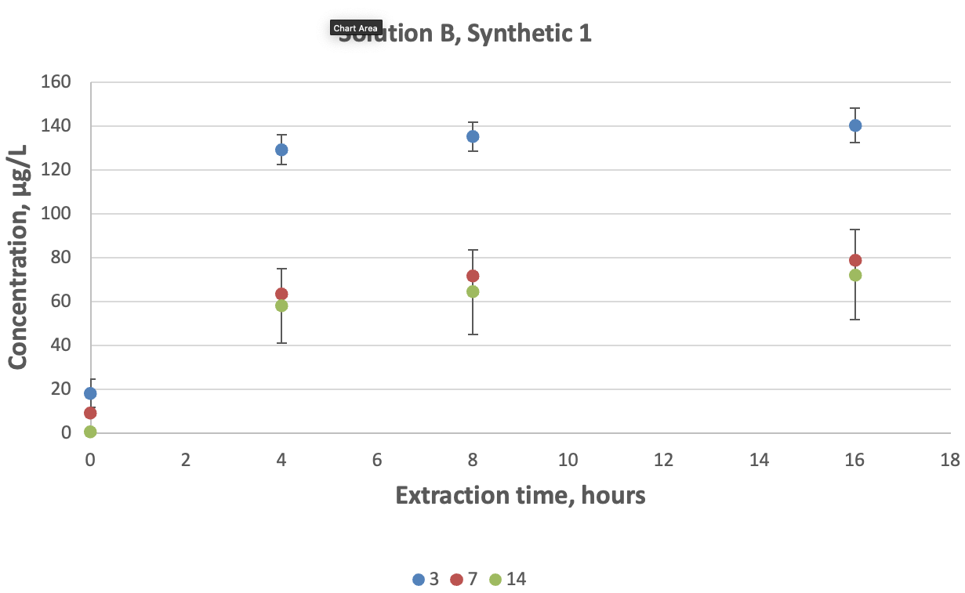
Figure A.2 Percent recovery of chromium in synthetic freshwater solution B for different holding times (3, 7 and 14 days) and pH 1.75 ± 0.1 extraction periods
Bars = standard deviation, n = 3.
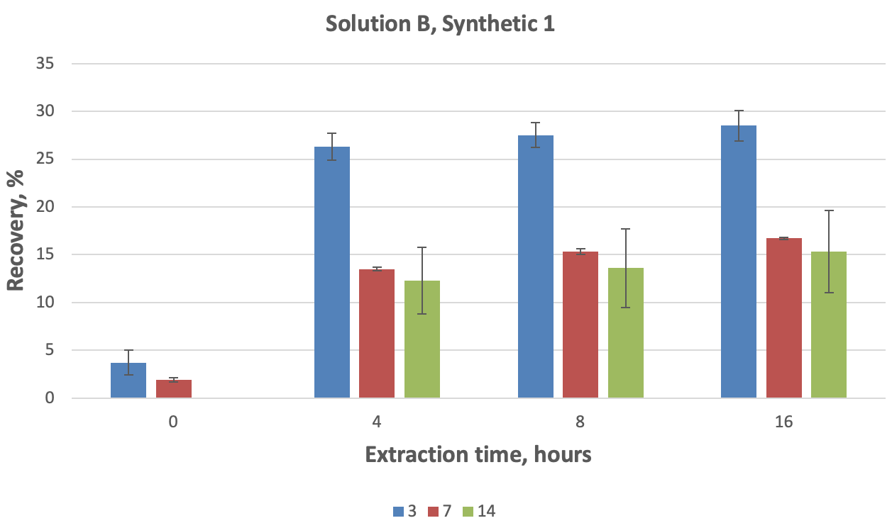
Figure A.3 Dissolution of chromium in synthetic freshwater solution C for different holding times (3, 7 and 14 days) and pH 1.75 ± 0.1 extraction periods
Bars = standard deviation, n = 3.
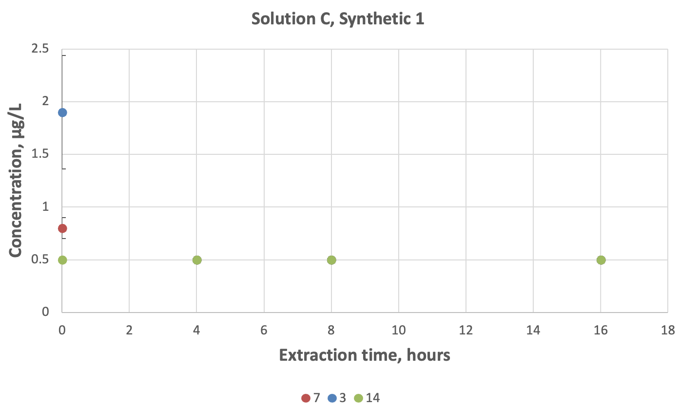
Figure A.4 Percent recovery of chromium in synthetic freshwater solution C for different holding times (3, 7 and 14 days) and pH 1.75 ± 0.1 extraction periods
Bars = standard deviation, n = 3.
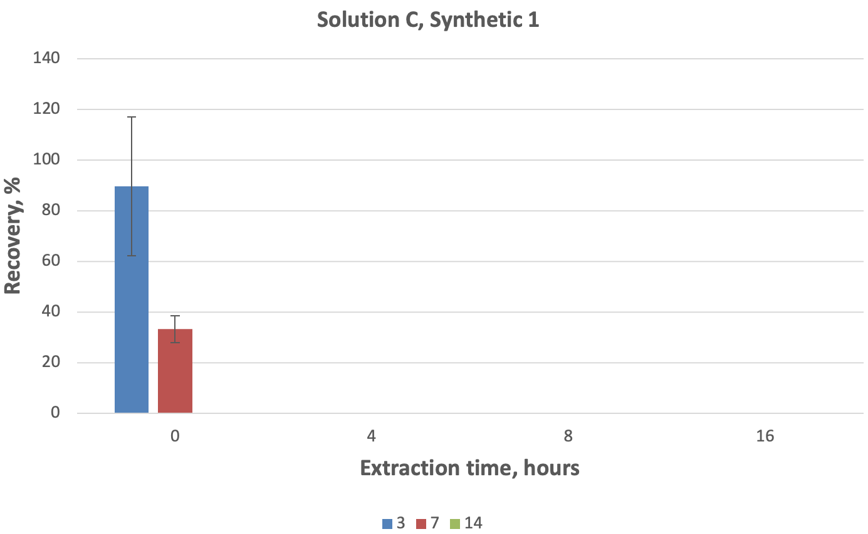
Figure A.5 Dissolution of chromium in synthetic freshwater solution D for different holding times (3, 7 and 14 days) and pH 1.75 ± 0.1 extraction periods
Bars = standard deviation, n = 3.
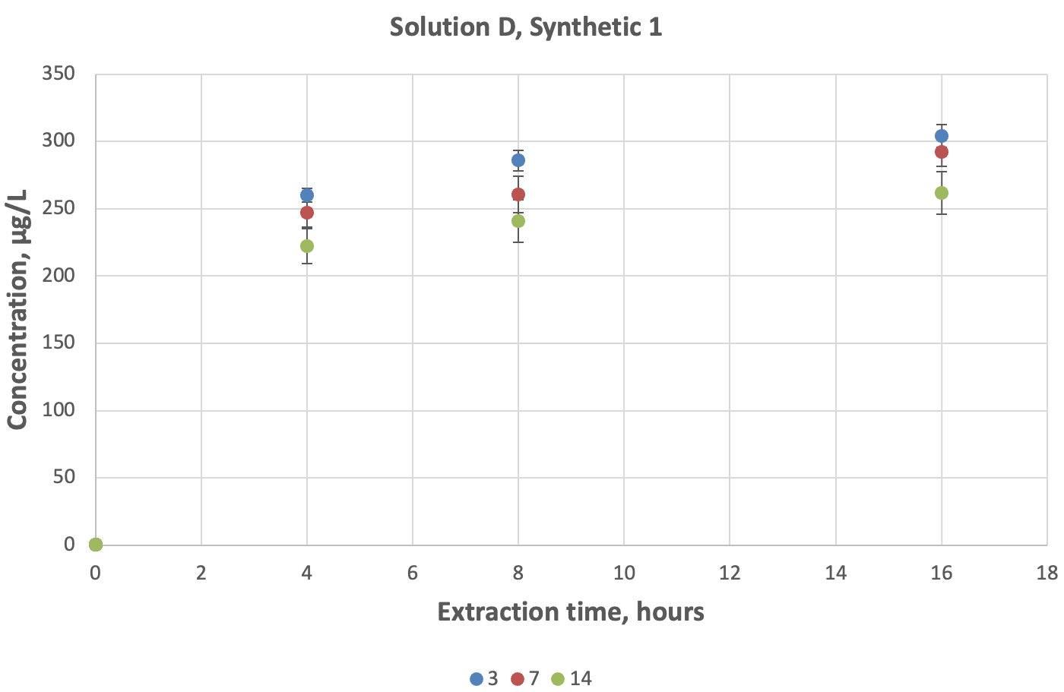
Figure A.6 Percent recovery of chromium in synthetic freshwater solution D for different holding times (3, 7 and 14 days) and pH 1.75 ± 0.1 extraction periods
Bars = standard deviation, n = 3.
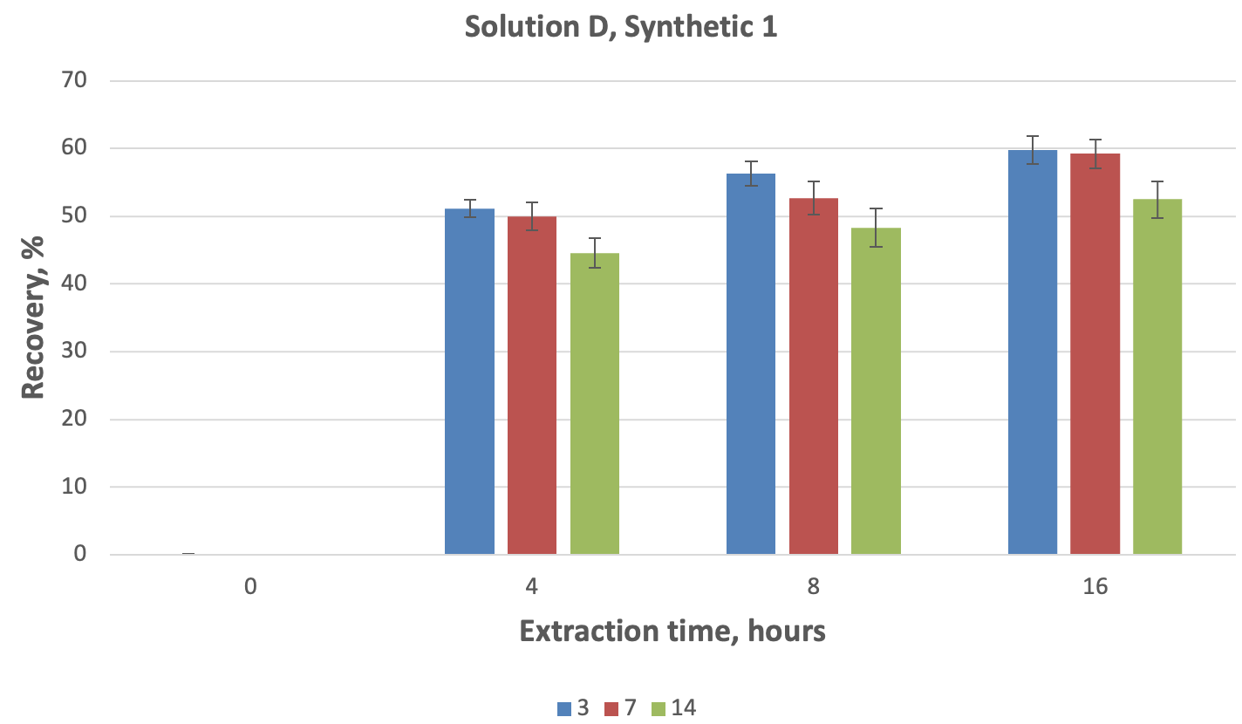

Results for synthetic freshwater solution 2
All solutions were kept on a horizontal platform at 100 rotations per minute immediately after preparation.
Table B.1 Physical and chemical parameters for freshly prepared synthetic solutions A, B, C and D
Parameters | Solution A | Solution B | Solution C | Solution D
pH | 8.92 | 6.58 | 9.07 | 6.81
Conductivity (µS/cm) | 34.29 | 33.11 | 35.57 | 38.80
Alkalinity (mg/L) | 15.55 | 8.02 | 17.85 | 15.06
Dissolved oxygen (at 24°C) | 8.0 mg/L or 98% | n/a | n/a | n/a
Dissolved chromium (µg/L) | < 0.5 | 492 | < 0.5 | 361
Total chromium (µg/L) | < 0.5 | 494 | n/a | n.a
Total organic carbon (mg/L) | 4.54 | n/a | n/a | n/a
Dissolved organic carbon (mg/L) | 4.02 | n/a | n/a | n/a
Total suspended solids (mg/L) | n/a | n/a | 74 | 96
Table B.2 Concentration of dissolved chromium in pre-extracted samples (time 0) and acid-extracted samples 4 hours, 8 hours and 16 hours after acidification
Samples were acidified 3 days after preparation. RSD = relative standard deviation.
Solution | Chromium (µg/L) | Duplicate average (µg/L) | Total recoverable chromium (µg/L) | Recovery (%) | Average chromium in solution (µg/L) | Chromium RSD (µg/L) | Average recovery (%) | Recovery RSD (µg/L)
Blk1-3-0 | < 0.50
Blk2-3-0 | < 0.50
A1-3a-0 | < 0.50
A1-3b-0 | < 0.50
A2-3a-0 | < 0.50
A2-3b-0 | < 0.50
B1-3a-0 | 30.62 | 31.31 | 333.23 | 9.40 | 51.72 | 19.08 | 16.83 | 6.77
B1-3b-0 | 32.00
B2-3a-0 | 68.82 | 69.10 | 305.01 | 22.65
B2-3b-0 | 69.38
B3-3a-0 | 54.28 | 54.74 | 296.88 | 18.44
B3-3b-0 | 55.21
C1-3a-0 | < 0.50
C1-3b-0 | < 0.50
C2-3a-0 | < 0.50
C2-3b-0 | < 0.50
C3-3a-0 | < 0.50
C3-3b-0 | < 0.50
D1-3a-0 | 5.26 | 5.50 | 476.12 | 1.16 | 2.61 | 2.56 | 0.54 | 0.54
D1-3b-0 | 5.74
D2-3a-0 | 0.63 | 0.63 | 490.31 | 0.13
D2-3b-0 | 0.63
D3-3a-0 | 1.64 | 1.71 | 492.99 | 0.35
D3-3b-0 | 1.78
Blk1-3-4 | < 0.50
Blk2-3-4 | < 0.50
A1-3a-4 | < 0.50
A1-3b-4 | < 0.50
A2-3a-4 | < 0.50
A2-3b-4 | < 0.50
B1-3a-4 | 105.46 | 111.81 | 333.23 | 33.55 | 108.01 | 5.08 | 34.68 | 1.27
B1-3b-4 | 118.17
B2-3a-4 | 120.97 | 109.98 | 305.01 | 36.06
B2-3b-4 | 98.99
B3-3a-4 | 100.49 | 102.25 | 296.88 | 34.44
B3-3b-4 | 104.00
C1-3a-4 | < 0.50
C1-3b-4 | < 0.50
C2-3a-4 | < 0.50
C2-3b-4 | < 0.50
C3-3a-4 | < 0.50
C3-3b-4 | < 0.50
D1-3a-4 | 184.46 | 185.12 | 476.12 | 38.88 | 218.88 | 32.65 | 44.93 | 6.08
D1-3b-4 | 185.77
D2-3a-4 | 248.00 | 250.30 | 490.31 | 51.05
D2-3b-4 | 252.60
D3-3a-4 | 221.15 | 221.21 | 492.99 | 44.87
D3-3b-4 | 221.28
Blk1-3-8 | < 0.50
Blk2-3-8 | < 0.50
A1-3a-8 | < 0.50
A1-3b-8 | < 0.50
A2-3a-8 | < 0.50
A2-3b-8 | < 0.50
B1-3a-8 | 113.63 | 114.32 | 333.23 | 34.31 | 116.76 | 10.29 | 37.55 | 3.98
B1-3b-8 | 115.02
B2-3a-8 | 126.81 | 128.05 | 305.01 | 41.98
B2-3b-8 | 129.29
B3-3a-8 | 106.39 | 107.91 | 296.88 | 36.35
B3-3b-8 | 109.43
C1-3a-8 | < 0.50
C1-3b-8 | < 0.50
C2-3a-8 | < 0.50
C2-3b-8 | < 0.50
C3-3a-8 | < 0.50
C3-3b-8 | < 0.50
D1-3a-8 | 202.03 | 203.64 | 476.12 | 42.77 | 238.72 | 34.67 | 49.01 | 6.46
D1-3b-8 | 205.26
D2-3a-8 | 279.31 | 272.97 | 490.31 | 55.67
D2-3b-8 | 266.63
D3-3a-8 | 237.25 | 239.54 | 492.99 | 48.59
D3-3b-8 | 241.83
Blk1-3-16 | < 0.50
Blk2-3-16 | < 0.50
A1-3a-16 | < 0.50
A1-3b-16 | < 0.50
A2-3a-16 | < 0.50
A2-3b-16 | < 0.50
B1-3a-16 | 129.44 | 131.24 | 333.23 | 39.38 | 131.25 | 10.87 | 42.18 | 3.87
B1-3b-16 | 133.03
B2-3a-16 | 140.89 | 142.13 | 305.01 | 46.60
B2-3b-16 | 143.38
B3-3a-16 | 120.27 | 120.39 | 296.88 | 40.55
B3-3b-16 | 120.51
C1-3a-16 | < 0.50
C1-3b-16 | < 0.50
C2-3a-16 | < 0.50
C2-3b-16 | < 0.50
C3-3a-16 | < 0.50
C3-3b-16 | < 0.50
D1-3a-16 | 225.77 | 227.76 | 476.12 | 47.84 | 260.75 | 32.44 | 53.55 | 5.93
D1-3b-16 | 229.74
D2-3a-16 | 290.55 | 292.61 | 490.31 | 59.68
D2-3b-16 | 294.67
D3-3a-16 | 260.56 | 261.89 | 492.99 | 53.12
D3-3b-16 | 263.23
A1-3a-TR | < 0.50
A1-3b-TR | < 0.50
A2-3a-TR | < 0.50
A2-3b-TR | < 0.50
B1-3a-TR | 335.63 | 333.23
B1-3b-TR | 330.83
B2-3a-TR | 304.20 | 305.01
B2-3b-TR | 305.81
B3-3a-TR | 300.48 | 296.88
B3-3b-TR | 293.27
C1-3a-TR | 2.64 | 2.63
C1-3b-TR | 2.62
C2-3a-TR | 2.66 | 2.63
C2-3b-TR | 2.60
C3-3a-TR | 2.61 | 2.59
C3-3b-TR | 2.57
D1-3a-TR | 473.44 | 476.12
D1-3b-TR | 478.79
D2-3a-TR | 492.52 | 490.31
D2-3b-TR | 488.11
D3-3a-TR | 496.16 | 492.99
D3-3b-TR | 489.81

Table B.3 Concentration of dissolved chromium in pre-extracted samples (time 0) and acid-extracted samples 4 hours, 8 hours and 16 hours after acidification
Samples were acidified 7 days after preparation. RSD = relative standard deviation.
Solution | Chromium (µg/L) | Duplicate average (µg/L) | Total recoverable chromium (µg/L) | Recovery (%) | Average chromium in solution (µg/L) | Chromium RSD (µg/L) | Average recovery (%) | Recovery RSD (µg/L)
Blk1-7-0 | < 0.50
Blk2-7-0 | < 0.50
A1-7a-0 | < 0.50
A1-7b-0 | < 0.50
A2-7a-0 | < 0.50
A2-7b-0 | < 0.50
B1-7a-0 | 19.01 | 19.27 | 288.07 | 6.69 | 19.89 | 1.90 | 7.65 | 1.17
B1-7b-0 | 19.52
B2-7a-0 | 22.02 | 22.03 | 245.98 | 8.95
B2-7b-0 | 22.03
B3-7a-0 | 18.30 | 18.37 | 251.87 | 7.29
B3-7b-0 | 18.45
C1-7a-0 | < 0.50
C1-7b-0 | < 0.50
C2-7a-0 | < 0.50
C2-7b-0 | < 0.50
C3-7a-0 | < 0.50
C3-7b-0 | < 0.50
D1-7a-0 | < 0.50
D1-7b-0 | < 0.50
D2-7a-0 | 0.59 | 0.69 | 491.18 | 0.14 | 0.69 | 0.00 | 0.14 | 0.00
D2-7b-0 | 0.79
D3-7a-0 | < 0.50
D3-7b-0 | < 0.50
Blk1-7-4 | < 0.50
Blk2-7-4 | < 0.50
A1-7a-4 | < 0.50
A1-7b-4 | < 0.50
A2-7a-4 | < 0.50
A2-7b-4 | < 0.50
B1-7a-4 | 43.24 | 43.45 | 288.07 | 15.08 | 39.37 | 3.71 | 15.03 | 0.63
B1-7b-4 | 43.66
B2-7a-4 | 38.03 | 38.45 | 245.98 | 15.63
B2-7b-4 | 38.87
B3-7a-4 | 36.02 | 36.21 | 251.87 | 14.38
B3-7b-4 | 36.41
C1-7a-4 | < 0.50
C1-7b-4 | < 0.50
C2-7a-4 | < 0.50
C2-7b-4 | < 0.50
C3-7a-4 | < 0.50
C3-7b-4 | < 0.50
D1-7a-4 | 210.84 | 213.97 | 502.08 | 42.62 | 190.42 | 20.47 | 38.12 | 3.90
D1-7b-4 | 217.10
D2-7a-4 | 175.29 | 176.92 | 491.18 | 36.02
D2-7b-4 | 178.55
D3-7a-4 | 184.58 | 180.37 | 504.88 | 35.72
D3-7b-4 | 176.15
Blk1-7-8 | < 0.50
Blk2-7-8 | < 0.50
A1-7a-8 | < 0.50
A1-7b-8 | < 0.50
A2-7a-8 | < 0.50
A2-7b-8 | < 0.50
B1-7a-8 | 47.76 | 48.61 | 288.07 | 16.87 | 43.86 | 4.45 | 16.74 | 0.88
B1-7b-8 | 49.45
B2-7a-8 | 42.32 | 43.17 | 245.98 | 17.55
B2-7b-8 | 44.02
B3-7a-8 | 39.34 | 39.79 | 251.87 | 15.80
B3-7b-8 | 40.25
C1-7a-8 | < 0.50
C1-7b-8 | < 0.50
C2-7a-8 | < 0.50
C2-7b-8 | < 0.50
C3-7a-8 | < 0.50
C3-7b-8 | < 0.50
D1-7a-8 | 220.72 | 225.82 | 502.08 | 44.98 | 164.47 | 65.36 | 32.98 | 13.12
D1-7b-8 | 230.92
D2-7a-8 | 156.12 | 171.87 | 491.18 | 34.99
D2-7b-8 | 187.62
D3-7a-8 | 84.50 | 95.73 | 504.88 | 18.96
D3-7b-8 | 106.96
Blk1-7-16 | < 0.50
Blk2-7-16 | < 0.50
A1-7a-16 | < 0.50
A1-7b-16 | < 0.50
A2-7a-16 | < 0.50
A2-7b-16 | < 0.50
B1-7a-16 | 59.89 | 59.93 | 288.07 | 20.80 | 54.48 | 5.33 | 20.81 | 1.24
B1-7b-16 | 59.97
B2-7a-16 | 53.74 | 54.22 | 245.98 | 22.04
B2-7b-16 | 54.71
B3-7a-16 | 48.72 | 49.29 | 251.87 | 19.57
B3-7b-16 | 49.85
C1-7a-16 | < 0.50
C1-7b-16 | < 0.50
C2-7a-16 | < 0.50
C2-7b-16 | < 0.50
C3-7a-16 | < 0.50
C3-7b-16 | < 0.50
D1-7a-16 | 260.26 | 259.47 | 502.08 | 51.68 | 242.91 | 17.24 | 48.62 | 2.94
D1-7b-16 | 258.68
D2-7a-16 | 222.96 | 225.06 | 491.18 | 45.82
D2-7b-16 | 227.16
D3-7a-16 | 243.19 | 244.21 | 504.88 | 48.37
D3-7b-16 | 245.23
Blk1-7-TR | < 0.50
Blk2-7-TR | < 0.50
A1-7a-TR | < 0.50
A1-7b-TR | < 0.50
A2-7a-TR | < 0.50
A2-7b-TR | < 0.50
B1-7a-TR | 291.84 | 288.07
B1-7b-TR | 284.31
B2-7a-TR | 246.75 | 245.98
B2-7b-TR | 245.20
B3-7a-TR | 251.41 | 251.87
B3-7b-TR | 252.33
C1-7a-TR | 2.75 | 2.84
C1-7b-TR | 2.93
C2-7a-TR | 2.92 | 2.97
C2-7b-TR | 3.03
C3-7a-TR | 2.83 | 2.84
C3-7b-TR | 2.85
D1-7a-TR | 506.86 | 502.08
D1-7b-TR | 497.31
D2-7a-TR | 487.78 | 491.18
D2-7b-TR | 494.58
D3-7a-TR | 497.93 | 504.88
D3-7b-TR | 511.84
Table B.4 Concentration of dissolved chromium in pre-extracted samples (time 0) and acid-extracted samples 4 hours, 8 hours and 16 hours after acidification
Samples were acidified 14 days after preparation. RSD = relative standard deviation.
Solution | Chromium (µg/L) | Duplicate average (µg/L) | Total recoverable chromium (µg/L) | Recovery (%) | Average chromium in solution (µg/L) | Chromium RSD (µg/L) | Average recovery (%) | Recovery RSD (µg/L)
Blk1-14-0 | < 0.50
Blk2-14-0 | < 0.50
A1-14a-0 | < 0.50
A1-14b-0 | < 0.50
A2-14a-0 | < 0.50
A2-14b-0 | < 0.50
B1-14a-0 | 9.08 | 9.05 | 233.41 | 3.88 | 7.01 | 1.77 | 2.70 | 1.02
B1-14b-0 | 9.03
B2-14a-0 | 6.12 | 6.06 | 289.59 | 2.09
B2-14b-0 | 6.00
B3-14a-0 | 5.93 | 5.92 | 277.28 | 2.14
B3-14b-0 | 5.91
C1-14a-0 | < 0.50
C1-14b-0 | < 0.50
C2-14a-0 | < 0.50
C2-14b-0 | < 0.50
C3-14a-0 | < 0.50
C3-14b-0 | < 0.50
D1-14a-0 | 0.52 | 0.59 | 508.47 | 0.12 | 0.56 | 0.04 | 0.11 | 0.01
D1-14b-0 | 0.67
D2-14a-0 | 0.51 | 0.56 | 512.70 | 0.11
D2-14b-0 | 0.60
D3-14a-0 | 0.51 | 0.52 | 513.80 | 0.10
D3-14b-0 | 0.53
Blk1-14-4 | < 0.50
Blk2-14-4 | < 0.50
A1-14a-4 | < 0.50
A1-14b-4 | < 0.50
A2-14a-4 | < 0.50
A2-14b-4 | < 0.50
B1-14a-4 | 18.52 | 18.84 | 233.41 | 8.07 | 20.92 | 2.04 | 7.86 | 0.54
B1-14b-4 | 19.17
B2-14a-4 | 20.23 | 21.00 | 289.59 | 7.25
B2-14b-4 | 21.77
B3-14a-4 | 22.56 | 22.92 | 277.28 | 8.27
B3-14b-4 | 23.29
C1-14a-4 | < 0.50
C1-14b-4 | < 0.50
C2-14a-4 | < 0.50
C2-14b-4 | < 0.50
C3-14a-4 | < 0.50
C3-14b-4 | < 0.50
D1-14a-4 | 209.22 | 209.84 | 508.47 | 41.27 | 232.03 | 24.69 | 45.33 | 4.60
D1-14b-4 | 210.46
D2-14a-4 | 224.44 | 227.64 | 512.70 | 44.40
D2-14b-4 | 230.83
D3-14a-4 | 256.32 | 258.62 | 513.80 | 50.33
D3-14b-4 | 260.92
Blk1-14-8 | < 0.50
Blk2-14-8 | < 0.50
A1-14a-8 | < 0.50
A1-14b-8 | < 0.50
A2-14a-8 | < 0.50
A2-14b-8 | < 0.50
B1-14a-8 | 21.01 | 21.40 | 233.41 | 9.17 | 24.42 | 2.74 | 9.16 | 0.49
B1-14b-8 | 21.79
B2-14a-8 | 25.00 | 25.10 | 289.59 | 8.67
B2-14b-8 | 25.20
B3-14a-8 | 25.98 | 26.76 | 277.28 | 9.65
B3-14b-8 | 27.54
C1-14a-8 | < 0.50
C1-14b-8 | < 0.50
C2-14a-8 | < 0.50
C2-14b-8 | < 0.50
C3-14a-8 | < 0.50
C3-14b-8 | < 0.50
D1-14a-8 | 225.35 | 225.16 | 508.47 | 44.28 | 250.68 | 25.28 | 48.98 | 4.69
D1-14b-8 | 224.97
D2-14a-8 | 249.07 | 251.15 | 512.70 | 48.98
D2-14b-8 | 253.22
D3-14a-8 | 271.48 | 275.72 | 513.80 | 53.66
D3-14b-8 | 279.96
Blk1-14-16 | < 0.50
Blk2-14-16 | < 0.50
A1-14a-16 | < 0.50
A1-14b-16 | < 0.50
A2-14a-16 | < 0.50
A2-14b-16 | < 0.50
B1-14a-16 | 27.31 | 27.66 | 233.41 | 11.85 | 32.24 | 4.78 | 12.06 | 0.70
B1-14b-16 | 28.01
B2-14a-16 | 36.42 | 37.19 | 289.59 | 12.84
B2-14b-16 | 37.96
B3-14a-16 | 31.66 | 31.86 | 277.28 | 11.49
B3-14b-16 | 32.07
C1-14a-16 | < 0.50
C1-14b-16 | < 0.50
C2-14a-16 | < 0.50
C2-14b-16 | < 0.50
C3-14a-16 | < 0.50
C3-14b-16 | < 0.50
D1-14a-16 | 251.31 | 250.66 | 508.47 | 49.30 | 273.20 | 23.30 | 53.38 | 4.29
D1-14b-16 | 250.02
D2-14a-16 | 270.63 | 271.73 | 512.70 | 53.00
D2-14b-16 | 272.83
D3-14a-16 | 296.76 | 297.19 | 513.80 | 57.84
D3-14b-16 | 297.63
Blk1-14-TR | < 0.50
Blk2-14-TR | < 0.50
A1-14a-TR | < 0.50
A1-14b-TR | < 0.50
A2-14a-TR | < 0.50
A2-14b-TR | < 0.50
B1-14a-TR | 237.12 | 233.41
B1-14b-TR | 229.71
B2-14a-TR | 289.52 | 289.59
B2-14b-TR | 289.66
B3-14a-TR | 274.89 | 277.28
B3-14b-TR | 279.68
C1-14a-TR | 2.60 | 2.61
C1-14b-TR | 2.62
C2-14a-TR | 2.80 | 2.77
C2-14b-TR | 2.74
C3-14a-TR | 2.75 | 2.78
C3-14b-TR | 2.81
D1-14a-TR | 509.88 | 508.47
D1-14b-TR | 507.06
D2-14a-TR | 513.19 | 512.70
D2-14b-TR | 512.21
D3-14a-TR | 513.67 | 513.80
D3-14b-TR | 513.93
Table B.5 Recovery of chromium from pre-extracted samples (time 0) and acid-extracted samples 4 hours, 8 hours and 16 hours after acidification evaluated against total recoverable chromium for stable solution B (synthetic solution 1 experiment)
Samples were acidified 3 days after preparation. RSD = relative standard deviation.
Solution | Chromium (µg/L) | Duplicates average (µg/L) | Total recoverable (µg/L) | Recovery (%) | Solution average (µg/L) | RSD (µg/L) | Average recovery (%) | Recovery RSD (µg/L)
B1-3a-0 | 30.62 | 31.31 | 493.33 | 6.35 | 51.72 | 19.08 | 10.50 | 3.85
B1-3b-0 | 32.00
B2-3a-0 | 68.82 | 69.10 | 495.11 | 13.96
B2-3b-0 | 69.38
B3-3a-0 | 54.28 | 54.74 | 488.33 | 11.21
B3-3b-0 | 55.21
B1-3a-4 | 105.46 | 111.81 | 493.33 | 22.67 | 108.01 | 5.08 | 21.94 | 0.90
B1-3b-4 | 118.17
B2-3a-4 | 120.97 | 109.98 | 495.11 | 22.21
B2-3b-4 | 98.99
B3-3a-4 | 100.49 | 102.25 | 488.33 | 20.94
B3-3b-4 | 104.00
B1-3a-8 | 113.63 | 114.32 | 493.33 | 23.17 | 116.76 | 10.29 | 23.71 | 1.94
B1-3b-8 | 115.02
B2-3a-8 | 126.81 | 128.05 | 495.11 | 25.86
B2-3b-8 | 129.29
B3-3a-8 | 106.39 | 107.91 | 488.33 | 22.10
B3-3b-8 | 109.43
B1-3a-16 | 129.44 | 131.24 | 493.33 | 26.60 | 131.25 | 10.87 | 26.65 | 2.03
B1-3b-16 | 133.03
B2-3a-16 | 140.89 | 142.13 | 495.11 | 28.71
B2-3b-16 | 143.38
B3-3a-16 | 120.27 | 120.39 | 488.33 | 24.65
B3-3b-16 | 120.51

Table B.6 Recovery of chromium in pre-extracted samples (time 0) and acid-extracted samples 4 hours, 8 hours and 16 hours after acidification evaluated against total recoverable chromium for stable solution B (synthetic solution 1 experiment)
Samples were acidified 7 days after preparation. RSD = relative standard deviation.
Solution | Chromium (µg/L) | Duplicates average (µg/L) | Total recoverable (µg/L) | Recovery (%) | Solution average (µg/L) | RSD (µg/L) | Average recovery (%) | Recovery RSD (µg/L)
B1-7a-0 | 19.01 | 19.27 | 467.83 | 4.12 | 19.89 | 1.90 | 4.23 | 0.38
B1-7b-0 | 19.52
B2-7a-0 | 22.02 | 22.03 | 473.57 | 4.65
B2-7b-0 | 22.03
B3-7a-0 | 18.30 | 18.37 | 469.05 | 3.92
B3-7b-0 | 18.45
B1-7a-4 | 43.24 | 43.45 | 467.83 | 9.29 | 39.37 | 3.71 | 8.38 | 0.81
B1-7b-4 | 43.66
B2-7a-4 | 38.03 | 38.45 | 473.57 | 8.12
B2-7b-4 | 38.87
B3-7a-4 | 36.02 | 36.21 | 469.05 | 7.72
B3-7b-4 | 36.41
B1-7a-8 | 47.76 | 48.61 | 467.83 | 10.39 | 43.86 | 4.45 | 9.33 | 0.97
B1-7b-8 | 49.45
B2-7a-8 | 42.32 | 43.17 | 473.57 | 9.12
B2-7b-8 | 44.02
B3-7a-8 | 39.34 | 39.79 | 469.05 | 8.48
B3-7b-8 | 40.25
B1-7a-16 | 59.89 | 59.93 | 467.83 | 12.81 | 54.48 | 5.33 | 11.59 | 1.16
B1-7b-16 | 59.97
B2-7a-16 | 53.74 | 54.22 | 473.57 | 11.45
B2-7b-16 | 54.71
B3-7a-16 | 48.72 | 49.29 | 469.05 | 10.51
B3-7b-16 | 49.85

Table B.7 Recovery of chromium in pre-extracted samples (time 0) and acid-extracted samples 4 hours, 8 hours and 16 hours after acidification evaluated against total recoverable chromium for stable solution B (synthetic solution 1 experiment)
Samples were acidified 14 days after preparation. RSD = relative standard deviation.
Solution | Chromium (µg/L) | Duplicates average (µg/L) | Total recoverable (µg/L) | Recovery (%) | Solution average (µg/L) | RSD (µg/L) | Average recovery (%) | Recovery RSD (µg/L)
B1-14a-0 | 9.08 | 9.05 | 471.87 | 1.92 | 7.01 | 1.77 | 1.48 | 0.38
B1-14b-0 | 9.03
B2-14a-0 | 6.12 | 6.06 | 469.21 | 1.29
B2-14b-0 | 6.00
B3-14a-0 | 5.93 | 5.92 | 478.55 | 1.24
B3-14b-0 | 5.91
B1-14a-4 | 18.52 | 18.84 | 471.87 | 3.99 | 20.92 | 2.04 | 4.42 | 0.40
B1-14b-4 | 19.17
B2-14a-4 | 20.23 | 21.00 | 469.21 | 4.48
B2-14b-4 | 21.77
B3-14a-4 | 22.56 | 22.92 | 478.55 | 4.79
B3-14b-4 | 23.29
B1-14a-8 | 21.01 | 21.40 | 471.87 | 4.54 | 24.42 | 2.74 | 5.16 | 0.55
B1-14b-8 | 21.79
B2-14a-8 | 25.00 | 25.10 | 469.21 | 5.35
B2-14b-8 | 25.20
B3-14a-8 | 25.98 | 26.76 | 478.55 | 5.59
B3-14b-8 | 27.54
B1-14a-16 | 27.31 | 27.66 | 471.87 | 5.86 | 32.24 | 4.78 | 6.82 | 1.04
B1-14b-16 | 28.01
B2-14a-16 | 36.42 | 37.19 | 469.21 | 7.93
B2-14b-16 | 37.96
B3-14a-16 | 31.66 | 31.86 | 478.55 | 6.66
B3-14b-16 | 32.07

Table B.8 Comparison of chromium concentrations in the final solution B with and without additional extraction steps for turbid samples
US EPA (1994) 200.8 method, section 11.3. TR = total recoverable chromium. ICP-MS = inductively coupled plasma mass spectrometry. ICP-OES = inductively coupled plasma optical emission spectrometry.
Solution | TR (µg/L) without additional extraction and filtering, ICP-MS | TR (µg/L) without additional extraction and filtering, ICP-OES | TR (µg/L) with additional extraction, no filtering, ICP-OES | TR (µg/L) with additional extraction and filtering, ICP-OES
B1-3a | 336 | 342 | 333 | 326
B1-3b | 331 | 338 | 318 | 324
B2-3a | 304 | 311 | 315 | 302
B2-3b | 306 | 309 | 309 | 307
B3-3a | 300 | 306 | 310 | 305
B3-3b | 293 | 306 | 304 | 299
B1-7a | 292 | 294 | 292 | n/a
B1-7b | 284 | 290 | 287 | n/a
B2-7a | 247 | 254 | 249 | n/a
B2-7b | 245 | 249 | 242 | n/a
B3-7a | 251 | 263 | 261 | n/a
B3-7b | 251 | 265 | 251 | n/a
B1-14a | 237 | 234 | 235 | n/a
B1-14b | 230 | 227 | 230 | n/a
B2-14a | 290 | 287 | 292 | n/a
B2-14b | 290 | 293 | 294 | n/a
B3-14a | 275 | 283 | 280 | n/a
B3-14b | 280 | 276 | 277 | n/a

Table B.9 pH control before (pre-extraction) and 0 hours, 4 hours, 8 hours and 16 hours after acidification of synthetic freshwater solutions A, B, C and D
Solution | Pre-extraction | 0 hours | 4 hours | 8 hours | 16 hours
A1-3 | 8.826 | 1.770 | 1.729 | 1.730 | 1.723
A2-3 | 8.759 | 1.753 | 1.746 | 1.742 | 1.736
A1-7 | 8.203 | 1.776 | 1.748 | 1.748 | 1.738
A2-7 | 8.941 | 1.776 | 1.766 | 1.779 | 1.753
A1-14 | 8.119 | 1.788 | 1.796 | 1.782 | 1.782
A2-14 | 8.295 | 1.829 | 1.822 | 1.806 | 1.820
B1-3 | 7.768 | 1.770 | 1.729 | 1.737 | 1.774
B2-3 | 7.377 | 1.736 | 1.713 | 1.720 | 1.728
B3-3 | 7.335 | 1.754 | 1.732 | 1.734 | 1.728
B1-7 | 7.512 | 1.733 | 1.721 | 1.724 | 1.717
B2-7 | 7.381 | 1.746 | 1.728 | 1.717 | 1.715
B3-7 | 7.305 | 1.748 | 1.753 | 1.733 | 1.720
B1-14 | 7.535 | 1.719 | 1.722 | 1.702 | 1.663
B2-14 | 7.386 | 1.719 | 1.716 | 1.691 | 1.652
B3-14 | 7.301 | 1.711 | 1.717 | 1.691 | 1.684
C1-3 | 9.546 | 1.749 | 1.742 | 1.735 | 1.728
C2-3 | 8.755 | 1.746 | 1.734 | 1.727 | 1.721
C3-3 | 9.122 | 1.746 | 1.737 | 1.733 | 1.726
C1-7 | 8.625 | 1.743 | 1.752 | 1.731 | 1.726
C2-7 | 8.338 | 1.764 | 1.759 | 1.733 | 1.790
C3-7 | 8.325 | 1.757 | 1.734 | 1.677 | 1.724
C1-14 | 7.735 | 1.697 | 1.736 | 1.712 | 1.701
C2-14 | 8.431 | 1.728 | 1.738 | 1.696 | 1.685
C3-14 | 8.895 | 1.728 | 1.745 | 1.701 | 1.672
D1-3 | 8.323 | 1.763 | 1.744 | 1.713 | 1.780
D2-3 | 8.453 | 1.754 | 1.749 | 1.733 | 1.736
D3-3 | 8.496 | 1.684 | 1.765 | 1.749 | 1.740
D1-7 | 8.325 | 1.746 | 1.750 | 1.736 | 1.727
D2-7 | 8.160 | 1.764 | 1.755 | 1.729 | 1.727
D3-7 | 8.232 | 1.758 | 1.757 | 1.738 | 1.707
D1-14 | 8.192 | 1.740 | 1.733 | 1.710 | 1.706
D2-14 | 8.325 | 1.742 | 1.736 | 1.724 | 1.691
D3-14 | 9.005 | 1.738 | 1.741 | 1.736 | 1.716

Figure B.1 Dissolution of chromium in shaken synthetic freshwater solution B (Syn 2) for different holding times (3, 7 and 14 days) and pH 1.75 ± 0.1 extraction periods
Bars = standard deviation, n = 3.
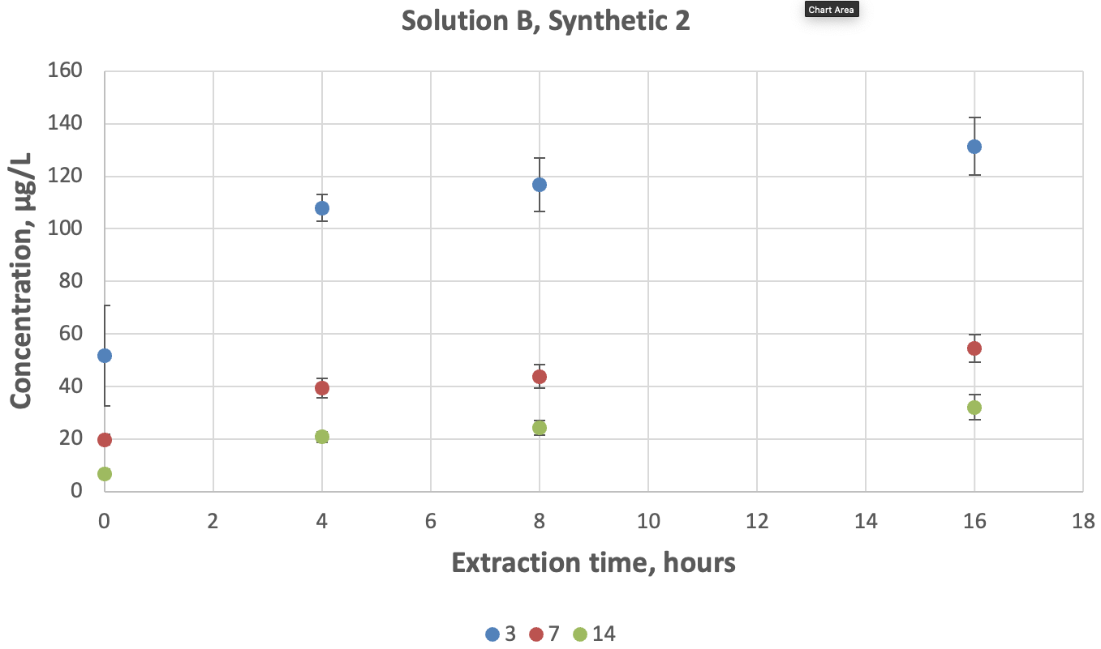
Figure B.2 Percent recovery of chromium in shaken synthetic freshwater solution B (Syn 2) for different holding times (3, 7 and 14 days) and pH 1.75 ± 0.1 extraction periods
Bars = standard deviation, n = 3.
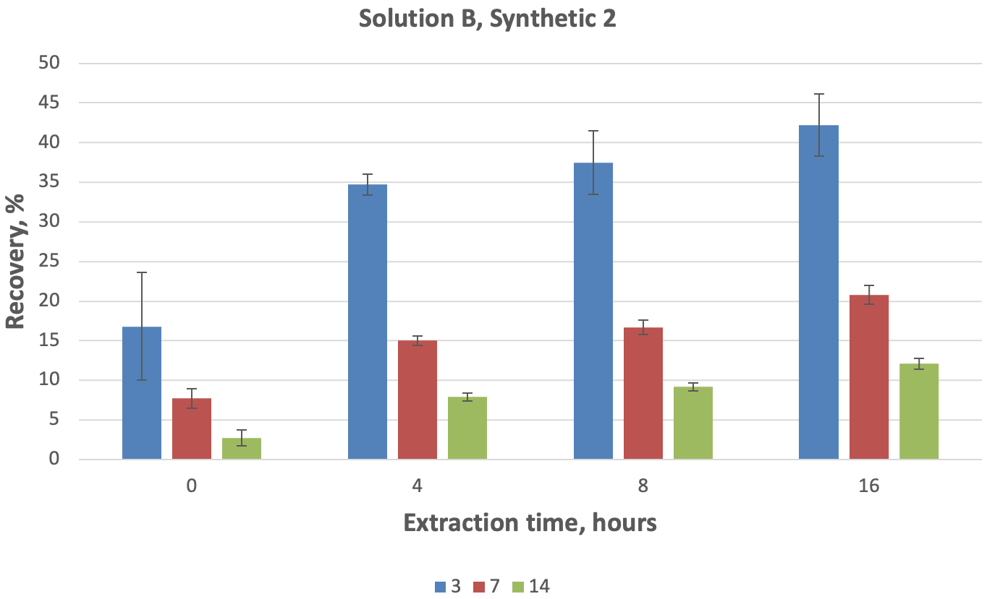
Figure B.3 Dissolution of chromium in shaken synthetic freshwater solution D (Syn 2) for different holding times (3, 7 and 14 days) and pH 1.75 ± 0.1 extraction periods
Bars = standard deviation, n = 3.
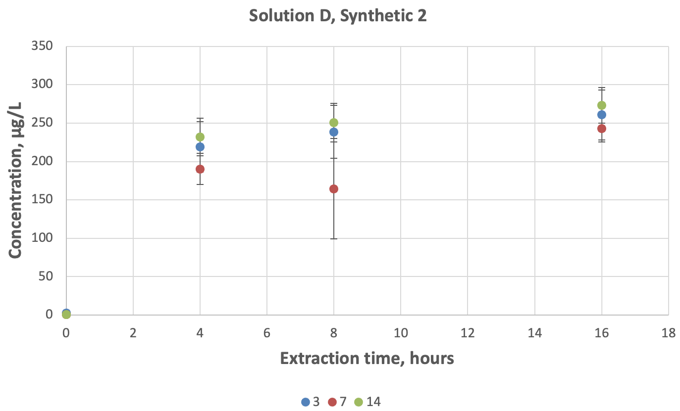
Figure B.4 Percent recovery of chromium in shaken synthetic freshwater solution D (Syn 2) for different holding times (3, 7 and 14 days) and pH 1.75 ± 0.1 extraction periods
Bars = standard deviation, n = 3.
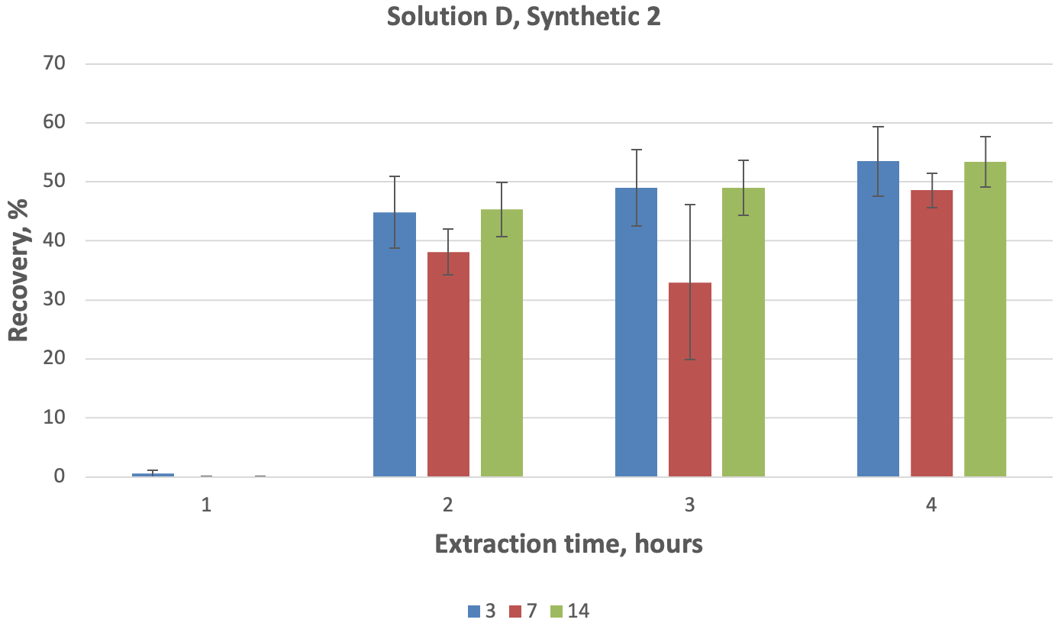
Figure B.5 Percent recovery of chromium in synthetic freshwater solution B for different holding times (3, 7 and 14 days) and pH 1.75 ± 0.1 extraction periods estimated with the use of total recoverable chromium concentrations for synthetic freshwater solution B (Syn 1)
Bars = standard deviation, n = 3. TR = total recoverable chromium.
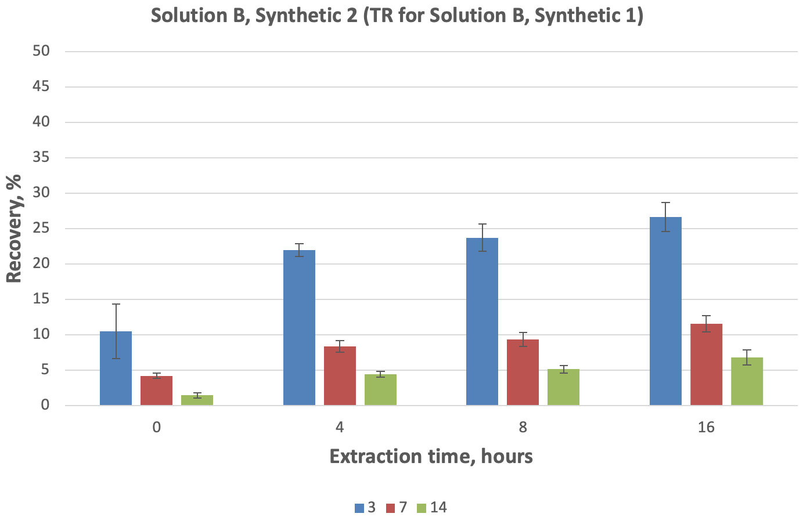

Results for raw freshwater solution
Table C.1 Physical and chemical parameters for freshly prepared synthetic solutions A, B, C and D
Parameters | Solution A | Solution B | Solution C | Solution D
pH | 8.25 | 8.13 | 8.32 | 8.18
Conductivity (µS/cm) | 688.82 | 692.79 | 676.23 | 680.03
Alkalinity (mg/L) | 192.44 | 187.03 | 188.82 | 183.09
Dissolved oxygen (at 22°C) | 8.2 mg/L or 98% | n/a | n/a | n/a
Dissolved chromium (µg/L) | < 0.5 | 125.5 | 20 | 88.8
Total chromium (µg/L) | 1.06 | n/a | n/a | n/a
Total organic carbon (mg/L) | 3.50 | 3.53 | 3.31 | 3.31
Dissolved organic carbon (mg/L) | 2.73 | 2.71 | 2.71 | 2.69
Total suspended solids (mg/L) | n/a | n/a | 57 | 63
Table C.2 Concentration of dissolved chromium in pre-extracted samples (time 0) and acid-extracted samples 4 hours, 8 hours and 16 hours after acidification
Samples were acidified 3 days after preparation. RSD = relative standard deviation.
Solution | Chromium (µg/L) | Duplicate average (µg/L) | Total recoverable chromium (µg/L) | Recovery (%) | Average chromium in solution (µg/L) | Chromium RSD (µg/L) | Average recovery (%) | Recovery RSD (µg/L)
Blk1-3-0 | < 0.50
Blk2-3-0 | < 0.50
A1-3a-0 | < 0.50
A1-3b-0 | < 0.50
A2-3a-0 | < 0.50
A2-3b-0 | < 0.50
B1-3a-0 | 27.55 | 27.83 | 452.80 | 6.15 | 28.29 | 1.01 | 6.22 | 0.17
B1-3b-0 | 28.11
B2-3a-0 | 29.19 | 29.44 | 458.45 | 6.42
B2-3b-0 | 29.70
B3-3a-0 | 27.53 | 27.60 | 452.19 | 6.10
B3-3b-0 | 27.67
C1-3a-0 | 7.59 | 7.39 | 1.42 | 519.63 | 8.21 | 0.76 | 624.59 | 90.96
C1-3b-0 | 7.19
C2-3a-0 | 6.35 | 8.36 | 1.23 | 680.43
C2-3b-0 | 10.36
C3-3a-0 | 6.70 | 8.89 | 1.32 | 673.71
C3-3b-0 | 11.08
D1-3a-0 | 25.93 | 26.33 | 530.24 | 4.97 | 26.77 | 0.65 | 5.04 | 0.08
D1-3b-0 | 26.73
D2-3a-0 | 26.39 | 27.52 | 536.85 | 5.13
D2-3b-0 | 28.65
D3-3a-0 | 25.76 | 26.47 | 526.08 | 5.03
D3-3b-0 | 27.18
Blk1-3-4 | < 0.50
Blk2-3-4 | < 0.50
A1-3a-4 | < 0.50
A1-3b-4 | < 0.50
A2-3a-4 | < 0.50
A2-3b-4 | < 0.50
B1-3a-4 | 215.13 | 216.36 | 452.80 | 47.78 | 217.63 | 1.56 | 47.88 | 0.12
B1-3b-4 | 217.59
B2-3a-4 | 217.57 | 219.37 | 458.45 | 47.85
B2-3b-4 | 221.18
B3-3a-4 | 217.25 | 217.14 | 452.19 | 48.02
B3-3b-4 | 217.04
C1-3a-4 | < 0.50
C1-3b-4 | < 0.50
C2-3a-4 | < 0.50
C2-3b-4 | < 0.50
C3-3a-4 | < 0.50
C3-3b-4 | < 0.50
D1-3a-4 | 220.10 | 218.78 | 530.24 | 41.26 | 220.76 | 1.90 | 41.57 | 0.64
D1-3b-4 | 217.47
D2-3a-4 | 218.40 | 220.91 | 536.85 | 41.15
D2-3b-4 | 223.41
D3-3a-4 | 222.02 | 222.58 | 526.08 | 42.31
D3-3b-4 | 223.14
Blk1-3-8 | < 0.50
Blk2-3-8 | < 0.50
A1-3a-8 | < 0.50
A1-3b-8 | < 0.50
A2-3a-8 | < 0.50
A2-3b-8 | < 0.50
B1-3a-8 | 254.86 | 254.11 | 452.80 | 56.12 | 253.55 | 1.97 | 55.79 | 0.29
B1-3b-8 | 253.36
B2-3a-8 | 255.37 | 255.18 | 458.45 | 55.66
B2-3b-8 | 254.98
B3-3a-8 | 250.29 | 251.36 | 452.19 | 55.59
B3-3b-8 | 252.44
C1-3a-8 | < 0.50
C1-3b-8 | < 0.50
C2-3a-8 | < 0.50
C2-3b-8 | < 0.50
C3-3a-8 | < 0.50
C3-3b-8 | < 0.50
D1-3a-8 | 257.39 | 256.54 | 530.24 | 48.38 | 257.50 | 1.26 | 48.49 | 0.33
D1-3b-8 | 255.70
D2-3a-8 | 255.37 | 258.93 | 536.85 | 48.23
D2-3b-8 | 262.49
D3-3a-8 | 254.12 | 257.01 | 526.08 | 48.86
D3-3b-8 | 259.90
Blk1-3-16 | < 0.50
Blk2-3-16 | < 0.50
A1-3a-16 | < 0.50
A1-3b-16 | < 0.50
A2-3a-16 | < 0.50
A2-3b-16 | < 0.50
B1-3a-16 | 293.75 | 294.18 | 452.80 | 64.97 | 293.15 | 0.95 | 64.51 | 0.65
B1-3b-16 | 294.62
B2-3a-16 | 286.14 | 292.30 | 458.45 | 63.76
B2-3b-16 | 298.47
B3-3a-16 | 293.20 | 292.96 | 452.19 | 64.79
B3-3b-16 | 292.72
C1-3a-16 | 0.56 | 0.54
C1-3b-16 | 0.52
C2-3a-16 | < 0.50 | <0.5
C2-3b-16 | < 0.50
C3-3a-16 | 0.50 | 0.50
C3-3b-16 | < 0.50
D1-3a-16 | 295.37 | 295.51 | 530.24 | 55.73 | 293.09 | 3.27 | 55.19 | 0.48
D1-3b-16 | 295.66
D2-3a-16 | 295.05 | 294.38 | 536.85 | 54.83
D2-3b-16 | 293.71
D3-3a-16 | 289.47 | 289.37 | 526.08 | 55.00
D3-3b-16 | 289.26
Blk1-3-TR | < 0.50
Blk2-3-TR | < 0.50
A1-3a-TR* | 2.35 | 2.36
A2-3a-TR* | 2.37
A1-3b-TR | 0.99 | 0.96
A2-3b-TR | 0.94
B1-3a-TR | 450.28 | 449.32 | 452.80
B1-3b-TR | 457.24 | 456.28
B2-3a-TR | 462.51 | 461.55 | 458.45
B2-3b-TR | 456.31 | 455.35
B3-3a-TR | 449.14 | 448.18 | 452.19
B3-3b-TR | 457.16 | 456.20
C1-3a-TR | 3.81 | 1.45 | 1.42
C1-3b-TR | 3.76 | 1.40
C2-3a-TR | 3.62 | 1.26 | 1.23
C2-3b-TR | 3.56 | 1.20
C3-3a-TR | 3.68 | 1.32 | 1.32
C3-3b-TR | lost | lost
D1-3a-TR | 541.00 | 538.64 | 530.24
D1-3b-TR | 524.20 | 521.84
D2-3a-TR | 536.02 | 533.66 | 536.85
D2-3b-TR | 542.39 | 540.03
D3-3a-TR | 525.19 | 522.83 | 526.08
D3-3b-TR | 531.68 | 529.32
*Subjected to additional extraction steps for turbid samples as per US EPA (1994) 200.8 method.
Table C.3 Concentration of dissolved chromium in pre-extracted samples (time 0) and acid-extracted samples 4 hours, 8 hours and 16 hours after acidification
Samples were acidified 7 days after preparation. RSD = relative standard deviation.
Solution | Chromium (µg/L) | Duplicate average (µg/L) | Total recoverable chromium (µg/L) | Recovery (%) | Average chromium in solution (µg/L) | Chromium RSD (µg/L) | Average recovery (%) | Recovery RSD (µg/L)
Blk1-7-0 | < 0.50
Blk2-7-0 | < 0.50
A1-7a-0 | < 0.50
A1-7b-0 | < 0.50
A2-7a-0 | < 0.50
A2-7b-0 | < 0.50
B1-7a-0 | 12.35 | 12.50 | 444.31 | 2.81 | 12.88 | 0.50 | 2.91 | 0.12
B1-7b-0 | 12.65
B2-7a-0 | 13.05 | 13.45 | 441.57 | 3.05
B2-7b-0 | 13.85
B3-7a-0 | 12.53 | 12.68 | 443.58 | 2.86
B3-7b-0 | 12.82
C1-7a-0 | 5.04 | 5.87 | 1.98 | 296.21 | 5.37 | 0.43 | 284.17 | 15.17
C1-7b-0 | 6.70
C2-7a-0 | 4.35 | 5.19 | 1.79 | 289.16
C2-7b-0 | 6.03
C3-7a-0 | 4.10 | 5.06 | 1.90 | 267.13
C3-7b-0 | 6.02
D1-7a-0 | 11.61 | 12.04 | 544.75 | 2.21 | 11.74 | 0.42 | 2.16 | 0.07
D1-7b-0 | 12.48
D2-7a-0 | 11.56 | 11.90 | 544.26 | 2.19
D2-7b-0 | 12.24
D3-7a-0 | 11.51 | 11.26 | 540.95 | 2.08
D3-7b-0 | 11.00
Blk1-7-4 | < 0.50
Blk2-7-4 | < 0.50
A1-7a-4 | < 0.50
A1-7b-4 | < 0.50
A2-7a-4 | < 0.50
A2-7b-4 | < 0.50
B1-7a-4 | 192.76 | 191.47 | 444.31 | 43.09 | 191.97 | 2.51 | 43.32 | 0.69
B1-7b-4 | 190.19
B2-7a-4 | 192.70 | 194.69 | 441.57 | 44.09
B2-7b-4 | 196.69
B3-7a-4 | 189.40 | 189.75 | 443.58 | 42.78
B3-7b-4 | 190.10
C1-7a-4 | < 0.50
C1-7b-4 | < 0.50
C2-7a-4 | < 0.50
C2-7b-4 | < 0.50
C3-7a-4 | < 0.50
C3-7b-4 | < 0.50
D1-7a-4 | 193.67 | 193.41 | 544.75 | 35.51 | 195.25 | 1.98 | 35.94 | 0.50
D1-7b-4 | 193.15
D2-7a-4 | 193.66 | 194.99 | 544.26 | 35.83
D2-7b-4 | 196.31
D3-7a-4 | 195.74 | 197.35 | 540.95 | 36.48
D3-7b-4 | 198.96
Blk1-7-8 | < 0.50
Blk2-7-8 | < 0.50
A1-7a-8 | < 0.50
A1-7b-8 | < 0.50
A2-7a-8 | < 0.50
A2-7b-8 | < 0.50
B1-7a-8 | 223.85 | 226.37 | 444.31 | 50.95 | 227.17 | 1.27 | 51.26 | 0.45
B1-7b-8 | 228.89
B2-7a-8 | 225.17 | 228.63 | 441.57 | 51.78
B2-7b-8 | 232.08
B3-7a-8 | 226.23 | 226.50 | 443.58 | 51.06
B3-7b-8 | 226.76
C1-7a-8 | < 0.50
C1-7b-8 | < 0.50
C2-7a-8 | < 0.50
C2-7b-8 | < 0.50
C3-7a-8 | < 0.50
C3-7b-8 | < 0.50
D1-7a-8 | 229.40 | 228.62 | 544.75 | 41.97 | 231.05 | 2.11 | 42.53 | 0.49
D1-7b-8 | 227.85
D2-7a-8 | 231.10 | 232.41 | 544.26 | 42.70
D2-7b-8 | 233.71
D3-7a-8 | 228.97 | 232.11 | 540.95 | 42.91
D3-7b-8 | 235.25
Blk1-7-16 | < 0.50
Blk2-7-16 | < 0.50
A1-7a-16 | < 0.50
A1-7b-16 | < 0.50
A2-7a-16 | < 0.50
A2-7b-16 | < 0.50
B1-7a-16 | 261.50 | 262.43 | 444.31 | 59.06 | 262.98 | 1.75 | 59.34 | 0.57
B1-7b-16 | 263.36
B2-7a-16 | 261.82 | 264.94 | 441.57 | 60.00
B2-7b-16 | 268.05
B3-7a-16 | 259.69 | 261.56 | 443.58 | 58.97
B3-7b-16 | 263.44
C1-7a-16 | < 0.50
C1-7b-16 | < 0.50
C2-7a-16 | < 0.50
C2-7b-16 | < 0.50
C3-7a-16 | < 0.50
C3-7b-16 | < 0.50
D1-7a-16 | 261.57 | 263.33 | 544.75 | 48.34 | 264.76 | 1.25 | 48.73 | 0.36
D1-7b-16 | 265.10
D2-7a-16 | 263.58 | 265.60 | 544.26 | 48.80
D2-7b-16 | 267.63
D3-7a-16 | 269.72 | 265.35 | 540.95 | 49.05
D3-7b-16 | 260.99
Blk1-7-TR | < 0.50
Blk2-7-TR | < 0.50
A1-7a-TR* | 2.14 | 2.06
A2-7a-TR* | 1.99
A1-7b-TR | 0.65 | 0.64
A2-7b-TR | 0.62
B1-7a-TR | 444.47 | 443.83 | 444.31
B1-7b-TR | 445.43 | 444.79
B2-7a-TR | 444.39 | 443.75 | 441.57
B2-7b-TR | 440.04 | 439.40
B3-7a-TR | 447.42 | 446.78 | 443.58
B3-7b-TR | 441.02 | 440.38
C1-7a-TR | 4.12 | 2.06 | 1.98
C1-7b-TR | 3.96 | 1.90
C2-7a-TR | 3.83 | 1.77 | 1.79
C2-7b-TR | 3.88 | 1.82
C3-7a-TR | 3.89 | 1.83 | 1.90
C3-7b-TR | 4.03 | 1.97
D1-7a-TR | 534.67 | 532.61 | 544.75
D1-7b-TR | 558.95 | 556.89
D2-7a-TR | 550.73 | 548.67 | 544.26
D2-7b-TR | 541.90 | 539.84
D3-7a-TR | 538.65 | 536.59 | 540.95
D3-7b-TR | 547.37 | 545.31
*Subjected to additional extraction steps for turbid samples as per US EPA (1994) 200.8 method.
Table C.4 Concentration of dissolved chromium in pre-extracted samples (time 0) and acid-extracted samples 4 hours, 8 hours and 16 hours after acidification
Samples were acidified 14 days after preparation. RSD = relative standard deviation.
Solution | Chromium (µg/L) | Duplicate average (µg/L) | Total recoverable chromium (µg/L) | Recovery (%) | Average chromium in solution (µg/L) | Chromium RSD (µg/L) | Average recovery (%) | Recovery RSD (µg/L)
Blk1-14-0 | < 0.50
Blk2-14-0 | < 0.50
A1-14a-0 | < 0.50
A1-14b-0 | < 0.50
A2-14a-0 | < 0.50
A2-14b-0 | < 0.50
B1-14a-0 | 7.26 | 7.65 | 470.62 | 1.63 | 8.15 | 0.57 | 1.79 | 0.16
B1-14b-0 | 8.04
B2-14a-0 | 7.79 | 8.02 | 444.70 | 1.80
B2-14b-0 | 8.25
B3-14a-0 | 8.51 | 8.78 | 449.87 | 1.95
B3-14b-0 | 9.05
C1-14a-0 | 3.88 | 4.66 | 1.85 | 251.29 | 5.89 | 1.07 | 328.98 | 67.28
C1-14b-0 | 5.44
C2-14a-0 | 6.73 | 6.36 | 1.73 | 367.74
C2-14b-0 | 5.99
C3-14a-0 | 6.49 | 6.64 | 1.81 | 367.91
C3-14b-0 | 6.79
D1-14a-0 | 7.40 | 7.91 | 544.51 | 1.45 | 7.87 | 0.29 | 1.44 | 0.05
D1-14b-0 | 8.42
D2-14a-0 | 7.84 | 8.14 | 550.05 | 1.48
D2-14b-0 | 8.45
D3-14a-0 | 7.44 | 7.56 | 545.39 | 1.39
D3-14b-0 | 7.69
Blk1-14-4 | < 0.50
Blk2-14-4 | < 0.50
A1-14a-4 | < 0.50
A1-14b-4 | < 0.50
A2-14a-4 | < 0.50
A2-14b-4 | < 0.50
B1-14a-4 | 186.97 | 190.18 | 470.62 | 40.41 | 191.21 | 0.91 | 42.05 | 1.45
B1-14b-4 | 193.38
B2-14a-4 | 191.73 | 191.86 | 444.70 | 43.14
B2-14b-4 | 191.99
B3-14a-4 | 191.67 | 191.60 | 449.87 | 42.59
B3-14b-4 | 191.53
C1-14a-4 | < 0.50
C1-14b-4 | < 0.50
C2-14a-4 | < 0.50
C2-14b-4 | < 0.50
C3-14a-4 | < 0.50
C3-14b-4 | < 0.50
D1-14a-4 | 191.89 | 190.67 | 544.51 | 35.02 | 190.75 | 0.68 | 34.90 | 0.29
D1-14b-4 | 189.45
D2-14a-4 | 188.94 | 190.11 | 550.05 | 34.56
D2-14b-4 | 191.28
D3-14a-4 | 191.16 | 191.47 | 545.39 | 35.11
D3-14b-4 | 191.77
Blk1-14-8 | < 0.50
Blk2-14-8 | < 0.50
A1-14a-8 | < 0.50
A1-14b-8 | < 0.50
A2-14a-8 | < 0.50
A2-14b-8 | < 0.50
B1-14a-8 | 225.84 | 228.37 | 470.62 | 48.52 | 229.75 | 1.88 | 50.52 | 1.73
B1-14b-8 | 230.89
B2-14a-8 | 224.15 | 228.97 | 444.70 | 51.49
B2-14b-8 | 233.79
B3-14a-8 | 228.83 | 231.89 | 449.87 | 51.55
B3-14b-8 | 234.95
C1-14a-8 | < 0.50
C1-14b-8 | < 0.50
C2-14a-8 | < 0.50
C2-14b-8 | < 0.50
C3-14a-8 | < 0.50
C3-14b-8 | < 0.50
D1-14a-8 | 226.13 | 228.87 | 544.51 | 42.03 | 228.35 | 0.87 | 41.77 | 0.23
D1-14b-8 | 231.61
D2-14a-8 | 230.38 | 228.84 | 550.05 | 41.60
D2-14b-8 | 227.30
D3-14a-8 | 224.18 | 227.34 | 545.39 | 41.68
D3-14b-8 | 230.51
Blk1-14-16 | < 0.50
Blk2-14-16 | < 0.50
A1-14a-16 | < 0.50
A1-14b-16 | < 0.50
A2-14a-16 | < 0.50
A2-14b-16 | < 0.50
B1-14a-16 | 273.15 | 272.50 | 470.62 | 57.90 | 270.19 | 2.78 | 59.40 | 1.30
B1-14b-16 | 271.85
B2-14a-16 | 268.12 | 267.11 | 444.70 | 60.06
B2-14b-16 | 266.09
B3-14a-16 | 272.71 | 270.97 | 449.87 | 60.23
B3-14b-16 | 269.23
C1-14a-16 | < 0.50
C1-14b-16 | < 0.50
C2-14a-16 | < 0.50
C2-14b-16 | < 0.50
C3-14a-16 | < 0.50
C3-14b-16 | < 0.50
D1-14a-16 | 266.46 | 265.16 | 544.51 | 48.70 | 266.81 | 1.53 | 48.81 | 0.32
D1-14b-16 | 263.86
D2-14a-16 | 266.32 | 267.11 | 550.05 | 48.56
D2-14b-16 | 267.90
D3-14a-16 | 270.27 | 268.17 | 545.39 | 49.17
D3-14b-16 | 266.07
Blk1-14-TR | < 0.50
Blk2-14-TR | < 0.50
A1-14a-TR* | 2.20 | 2.17
A2-14a-TR* | 2.15
A1-14b-TR | 0.77 | 0.70
A2-14b-TR | 0.63
B1-14a-TR | 460.59 | 459.89 | 470.62
B1-14b-TR | 482.06 | 481.35
B2-14a-TR | 443.25 | 442.55 | 444.70
B2-14b-TR | 447.55 | 446.85
B3-14a-TR | 454.27 | 453.56 | 449.87
B3-14b-TR | 446.88 | 446.17
C1-14a-TR | 4.07 | 1.90 | 1.85
C1-14b-TR | 3.98 | 1.81
C2-14a-TR | 3.83 | 1.66 | 1.73
C2-14b-TR | 3.97 | 1.80
C3-14a-TR | 4.01 | 1.84 | 1.81
C3-14b-TR | 3.94 | 1.77
D1-14a-TR | 548.25 | 546.08 | 544.51
D1-14b-TR | 545.11 | 542.93
D2-14a-TR | 547.17 | 545.00 | 550.05
D2-14b-TR | 557.27 | 555.10
D3-14a-TR | 546.15 | 543.98 | 545.39
D3-14b-TR | 548.97 | 546.80
*Subjected to additional extraction steps for turbid samples as per US EPA (1994) 200.8 method.
Table C.5 Recovery of dissolved chromium in pre-extracted solution B samples (time 0) and acid-extracted solution B samples 4 hours, 8 hours and 16 hours after acidification with additional extraction steps for turbid samples for evaluation of total recoverable chromium
Samples were acidified 3 days after preparation. RSD = relative standard deviation.
Solution | Chromium (µg/L) | Duplicate average (µg/L) | Total recoverable chromium (µg/L) | Recovery (%) | Average chromium in solution (µg/L) | Chromium RSD (µg/L) | Average recovery (%) | Recovery RSD (µg/L)
B1-3a-0 | 27.55 | 27.83 | 518.04 | 5.37 | 28.29 | 1.01 | 5.39 | 0.19
B1-3b-0 | 28.11
B2-3a-0 | 29.19 | 29.44 | 526.31 | 5.59
B2-3b-0 | 29.70
B3-3a-0 | 27.53 | 27.60 | 529.92 | 5.21
B3-3b-0 | 27.67
B1-3a-4 | 215.13 | 216.36 | 518.04 | 41.77 | 217.63 | 1.56 | 41.47 | 0.43
B1-3b-4 | 217.59
B2-3a-4 | 217.57 | 219.37 | 526.31 | 41.68
B2-3b-4 | 221.18
B3-3a-4 | 217.25 | 217.14 | 529.92 | 40.98
B3-3b-4 | 217.04
B1-3a-8 | 254.86 | 254.11 | 518.04 | 49.05 | 253.55 | 1.97 | 48.32 | 0.82
B1-3b-8 | 253.36
B2-3a-8 | 255.37 | 255.18 | 526.31 | 48.48
B2-3b-8 | 254.98
B3-3a-8 | 250.29 | 251.36 | 529.92 | 47.43
B3-3b-8 | 252.44
B1-3a-16 | 293.75 | 294.18 | 518.04 | 56.79 | 293.15 | 0.95 | 55.87 | 0.80
B1-3b-16 | 294.62
B2-3a-16 | 286.14 | 292.30 | 526.31 | 55.54
B2-3b-16 | 298.47
B3-3a-16 | 293.20 | 292.96 | 529.92 | 55.28
B3-3b-16 | 292.72
A1-3a-TR* | 2.35 | 2.36
A2-3a-TR* | 2.37
B1-3a-TR | 520.35 | 517.99 | 518.04
B1-3b-TR | 520.45 | 518.09
B2-3a-TR | 536.97 | 534.60 | 526.31
B2-3b-TR | 520.38 | 518.02
B3-3a-TR | 527.68 | 525.32 | 529.92
B3-3b-TR | 536.87 | 534.51
*Subjected to additional extraction steps for turbid samples as per US EPA (1994) 200.8 method.
Table C.6 Recovery of dissolved chromium in pre-extracted solution B samples (time 0) and acid-extracted solution B samples 4 hours, 8 hours and 16 hours after acidification with additional extraction steps for turbid samples for evaluation of total recoverable chromium
Samples were acidified 7 days after preparation. RSD = relative standard deviation.
Solution | Chromium (µg/L) | Duplicate average (µg/L) | Total recoverable chromium (µg/L) | Recovery (%) | Average chromium in solution (µg/L) | Chromium RSD (µg/L) | Average recovery (%) | Recovery RSD (µg/L)
B1-7a-0 | 12.35 | 12.50 | 518.42 | 2.41 | 12.88 | 0.50 | 2.47 | 0.11
B1-7b-0 | 12.65
B2-7a-0 | 13.05 | 13.45 | 519.61 | 2.59
B2-7b-0 | 13.85
B3-7a-0 | 12.53 | 12.68 | 528.16 | 2.40
B3-7b-0 | 12.82
B1-7a-4 | 192.76 | 191.47 | 518.42 | 36.93 | 191.97 | 2.51 | 36.78 | 0.78
B1-7b-4 | 190.19
B2-7a-4 | 192.70 | 194.69 | 519.61 | 37.47
B2-7b-4 | 196.69
B3-7a-4 | 189.40 | 189.75 | 528.16 | 35.93
B3-7b-4 | 190.10
B1-7a-8 | 223.85 | 226.37 | 518.42 | 43.67 | 227.17 | 1.27 | 43.52 | 0.57
B1-7b-8 | 228.89
B2-7a-8 | 225.17 | 228.63 | 519.61 | 44.00
B2-7b-8 | 232.08
B3-7a-8 | 226.23 | 226.50 | 528.16 | 42.88
B3-7b-8 | 226.76
B1-7a-16 | 261.50 | 262.43 | 518.42 | 50.62 | 262.98 | 1.75 | 50.38 | 0.76
B1-7b-16 | 263.36
B2-7a-16 | 261.82 | 264.94 | 519.61 | 50.99
B2-7b-16 | 268.05
B3-7a-16 | 259.69 | 261.56 | 528.16 | 49.52
B3-7b-16 | 263.44
A1-7a-TR* | 2.14 | 2.06
A2-7a-TR* | 1.99
B1-7a-TR | 526.22 | 524.16 | 518.42
B1-7b-TR | 514.75 | 512.68
B2-7a-TR | 523.23 | 521.17 | 519.61
B2-7b-TR | 520.12 | 518.05
B3-7a-TR | 522.14 | 520.08 | 528.16
B3-7b-TR | 538.32 | 536.25
*Subjected to additional extraction steps for turbid samples as per US EPA (1994) 200.8 method.
Table C.7 Recovery of dissolved chromium in pre-extracted solution B samples (time 0) and acid-extracted solution B samples 4 hours, 8 hours and 16 hours after acidification with additional extraction steps for turbid samples for evaluation of total recoverable chromium
Samples were acidified 14 days after preparation. RSD = relative standard deviation.
Solution | Chromium (µg/L) | Duplicates average (µg/L) | Total recoverable (µg/L) | Recovery (%) | Solution average (µg/L) | RSD (µg/L) | Average recovery (%) | Recovery RSD (µg/L)
B1-14a-0 | 7.26 | 7.65 | 543.40 | 1.41 | 8.15 | 0.57 | 1.53 | 0.14
B1-14b-0 | 8.04
B2-14a-0 | 7.79 | 8.02 | 541.26 | 1.48
B2-14b-0 | 8.25
B3-14a-0 | 8.51 | 8.78 | 520.15 | 1.69
B3-14b-0 | 9.05
B1-14a-4 | 186.97 | 190.18 | 543.40 | 35.00 | 191.21 | 0.91 | 35.76 | 0.96
B1-14b-4 | 193.38
B2-14a-4 | 191.73 | 191.86 | 541.26 | 35.45
B2-14b-4 | 191.99
B3-14a-4 | 191.67 | 191.60 | 520.15 | 36.84
B3-14b-4 | 191.53
B1-14a-8 | 225.84 | 228.37 | 543.40 | 42.03 | 229.75 | 1.88 | 42.97 | 1.40
B1-14b-8 | 230.89
B2-14a-8 | 224.15 | 228.97 | 541.26 | 42.30
B2-14b-8 | 233.79
B3-14a-8 | 228.83 | 231.89 | 520.15 | 44.58
B3-14b-8 | 234.95
B1-14a-16 | 273.15 | 272.50 | 543.40 | 50.15 | 270.19 | 2.78 | 50.53 | 1.41
B1-14b-16 | 271.85
B2-14a-16 | 268.12 | 267.11 | 541.26 | 49.35
B2-14b-16 | 266.09
B3-14a-16 | 272.71 | 270.97 | 520.15 | 52.09
B3-14b-16 | 269.23
A1-14a-TR* | 2.20 | 2.17
A2-14a-TR* | 2.15
B1-14a-TR | 524.89 | 522.72 | 543.40
B1-14b-TR | 566.26 | 564.09
B2-14a-TR | 563.91 | 561.73 | 541.26
B2-14b-TR | 522.95 | 520.78
B3-14a-TR | 496.81 | 494.63 | 520.15
B3-14b-TR | 547.83 | 545.66
*Subjected to additional extraction steps for turbid samples as per US EPA (1994) 200.8 method.
Table C.8 Change of dissolved chromium concentration in raw water solutions after additional (exceeding 16 hours) acid extraction
TR = total recoverable chromium.
Solution | 16 hr | +2 d | +5 d | +9 d | +12 d | +16 d | +18 d | +19 d | +25 d | +29 d | TR (µg/L) | Final recovery (%)
B1-3 | 294.2 | 351.8 |  | 396.0 |  | 407.5 |  |  |  |  | 518.0 | 78.7
B2-3 | 292.3 | 354.9 |  | 398.3 |  | 413.5 |  |  |  |  | 526.3 | 78.6
B3-3 | 293.0 | 346.6 |  | 389.3 |  | 408.2 |  |  |  |  | 529.9 | 77.0
C1-3 | 0.5 |  |  |  |  |  |  |  |  | 1.2 | 1.4 | 82.3
C2-3 | < 0.5 |  |  |  |  |  |  |  |  | 1.1 | 1.2 | 89.3
C3-3 | 0.5 |  |  |  |  |  |  |  |  | 1.2 | 1.3 | 90.3
D1-3 | 295.5 | 359.4 |  | 393.3 |  | 413.2 |  |  |  |  | 530.2 | 77.9
D2-3 | 294.4 | 359.8 |  | 396.8 |  | 413.1 |  |  |  |  | 536.8 | 77.0
D3-3 | 289.4 | 355.1 |  | 391.0 |  | 409.8 |  |  |  |  | 526.1 | 77.9
B1-7 | 262.4 |  | 356.5 |  | 372.5 |  |  | 382.3 |  |  | 518.4 | 73.7
B2-7 | 264.9 |  | 366.3 |  | 384.6 |  |  | 392.1 |  |  | 519.6 | 75.5
B3-7 | 261.6 |  | 356.2 |  | 381.5 |  |  | 384.7 |  |  | 528.2 | 72.8
C1-7 | < 0.5 |  |  |  |  |  |  |  | 1.0 |  | 2.0 | 52.8
C2-7 | < 0.5 |  |  |  |  |  |  |  | 1.0 |  | 1.8 | 58.2
C3-7 | < 0.5 |  |  |  |  |  |  |  | 1.0 |  | 1.9 | 53.3
D1-7 | 263.3 |  | 348.0 |  | 386.3 |  |  | 400.2 |  |  | 544.7 | 73.5
D2-7 | 265.6 |  | 351.6 |  | 379.3 |  |  | 402.4 |  |  | 544.3 | 73.9
D3-7 | 265.4 |  | 347.6 |  | 384.4 |  |  | 397.9 |  |  | 540.9 | 73.6
B1-14 | 272.5 |  | 351.6 |  | 351.5 |  | 346.0 |  |  |  | 543.4 | 63.7
B2-14 | 267.1 |  | 356.5 |  | 373.3 |  | 363.4 |  |  |  | 541.3 | 67.1
B3-14 | 271.0 |  | 357.0 |  | 359.7 |  | 361.4 |  |  |  | 520.1 | 69.5
C1-14 | < 0.5 |  |  |  |  |  | 1.0 |  |  |  | 1.9 | 54.3
C2-14 | < 0.5 |  |  |  |  |  | 0.9 |  |  |  | 1.7 | 54.1
C3-14 | < 0.5 |  |  |  |  |  | 0.9 |  |  |  | 1.8 | 50.6
D1-14 | 265.2 |  | 351.7 |  | 388.7 |  | 359.5 |  |  |  | 544.5 | 66.0
D2-14 | 267.1 |  | 356.3 |  | 381.3 |  | 357.8 |  |  |  | 550.0 | 65.0
D3-14 | 268.2 |  | 353.2 |  | 378.7 |  | 359.8 |  |  |  | 545.4 | 66.0

Table C.9 pH control before (pre-extraction) and 0 hours, 4 hours, 8 hours and 16 hours after acidification of raw water solutions A, B, C and D
Solution | Pre-extraction | 0 hours | 4 hours | 8 hours | 16 hours
A1-3 | 7.689 | 1.820 | 1.798 | 1.785 | 1.790
A2-3 | 8.460 | 1.803 | 1.791 | 1.785 | 1.782
A1-7 | 8.587 | 1.783 | 1.779 | 1.772 | 1.780
A2-7 | 8.560 | 1.790 | 1.791 | 1.786 | 1.789
A1-14 | 8.599 | 1.798 | 1.783 | 1.785 | 1.786
A2-14 | 8.617 | 1.763 | 1.762 | 1.783 | 1.788
B1-3 | 8.440 | 1.803 | 1.780 | 1.785 | 1.792
B2-3 | 8.410 | 1.787 | 1.796 | 1.791 | 1.794
B3-3 | 8.417 | 1.796 | 1.794 | 1.782 | 1.794
B1-7 | 8.589 | 1.788 | 1.783 | 1.774 | 1.774
B2-7 | 8.496 | 1.776 | 1.776 | 1.762 | 1.729
B3-7 | 8.583 | 1.795 | 1.793 | 1.801 | 1.796
B1-14 | 8.665 | 1.762 | 1.785 | 1.779 | 1.779
B2-14 | 8.641 | 1.785 | 1.785 | 1.788 | 1.791
B3-14 | 8.620 | 1.795 | 1.785 | 1.749 | 1.766
C1-3 | 8.527 | 1.794 | 1.741 | 1.782 | 1.804
C2-3 | 8.524 | 1.787 | 1.780 | 1.790 | 1.799
C3-3 | 8.534 | 1.791 | 1.770 | 1.782 | 1.794
C1-7 | 8.584 | 1.776 | 1.778 | 1.779 | 1.781
C2-7 | 8.618 | 1.786 | 1.786 | 1.786 | 1.786
C3-7 | 8.621 | 1.781 | 1.786 | 1.779 | 1.784
C1-14 | 8.629 | 1.772 | 1.733 | 1.761 | 1.774
C2-14 | 8.659 | 1.771 | 1.750 | 1.788 | 1.791
C3-14 | 8.601 | 1.761 | 1.773 | 1.781 | 1.781
D1-3 | 8.432 | 1.803 | 1.789 | 1.799 | 1.802
D2-3 | 8.439 | 1.798 | 1.784 | 1.790 | 1.802
D3-3 | 8.466 | 1.813 | 1.798 | 1.797 | 1.804
D1-7 | 8.549 | 1.771 | 1.790 | 1.793 | 1.794
D2-7 | 8.620 | 1.779 | 1.776 | 1.800 | 1.791
D3-7 | 8.626 | 1.774 | 1.723 | 1.783 | 1.786
D1-14 | 8.644 | 1.776 | 1.778 | 1.771 | 1.785
D2-14 | 8.626 | 1.776 | 1.778 | 1.780 | 1.790
D3-14 | 8.653 | 1.783 | 1.783 | 1.773 | 1.781

Figure C.1 Dissolution of chromium in raw water solution B for different holding times (3, 7 and 14 days) and pH 1.75 ± 0.1 extraction periods
Bars = standard deviation, n = 3.
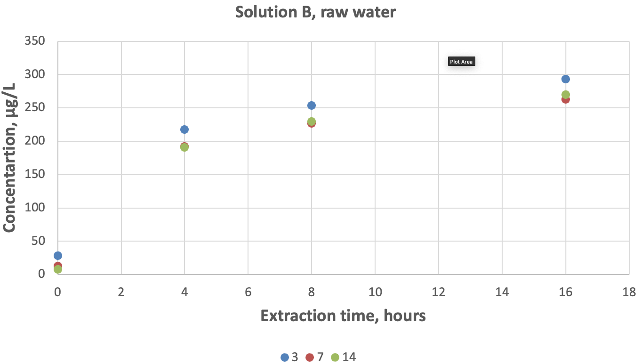
Figure C.2 Percent recovery of chromium in raw water solution B for different holding times (3, 7 and 14 days) and pH 1.75 ± 0.1 extraction periods
Bars = standard deviation, n = 3.
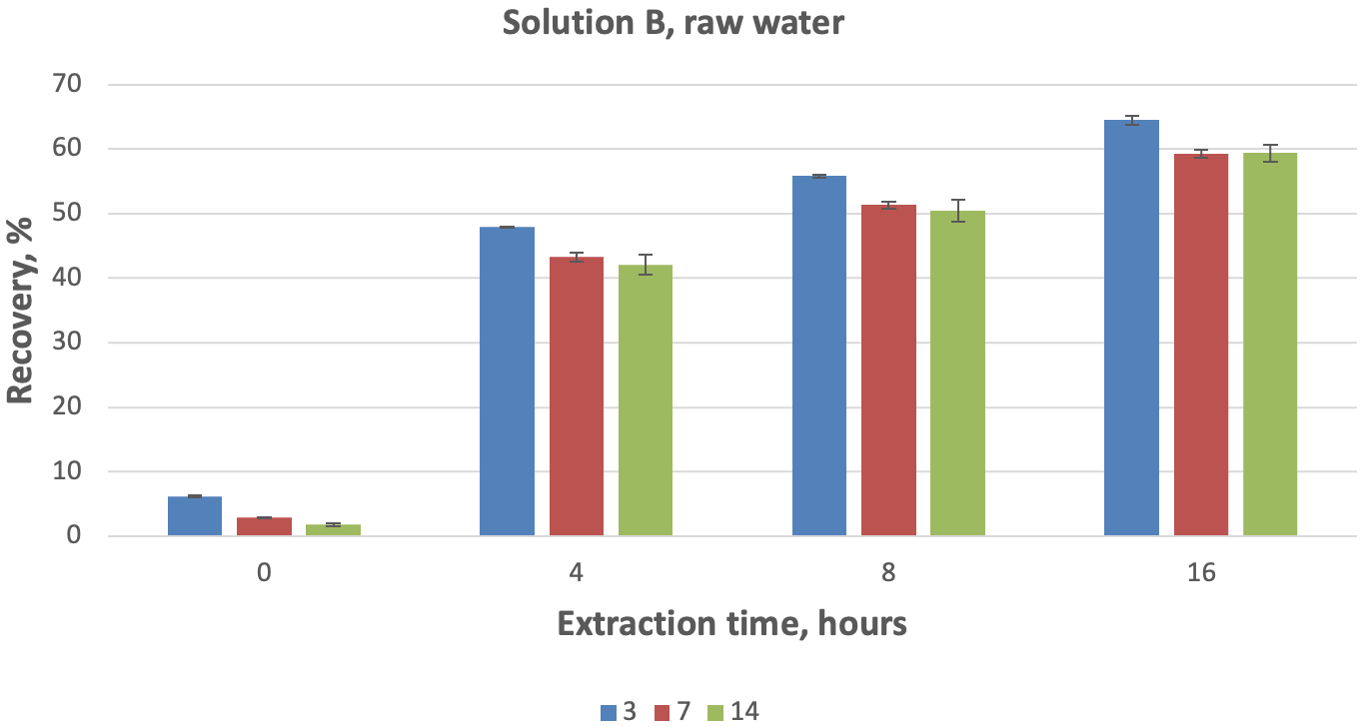
Figure C.3 Dissolution of chromium in raw water solution D for different holding times (3, 7 and 14 days) and pH 1.75 ± 0.1 extraction periods
Bars = standard deviation, n = 3.
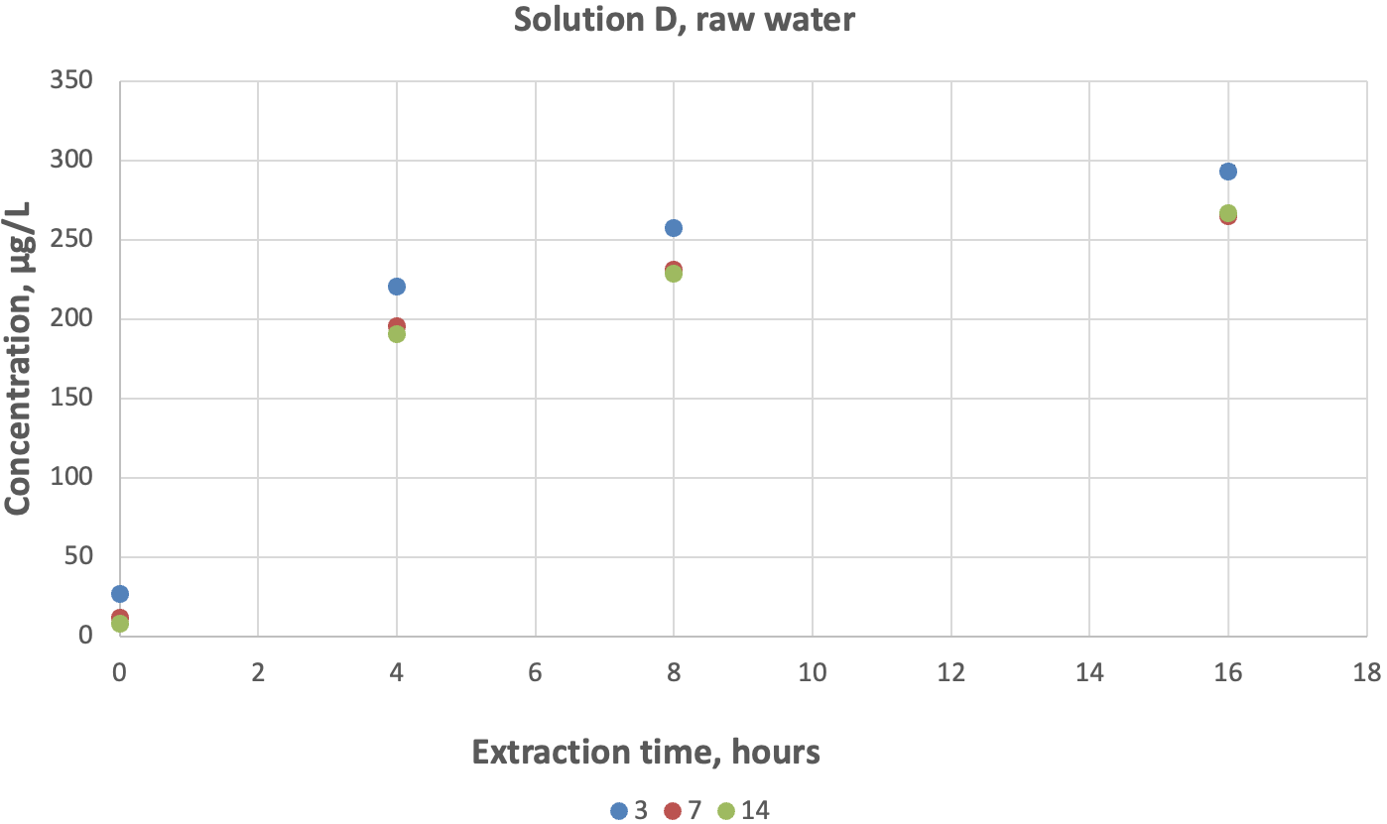
Figure C.4 Percent recovery of chromium in raw water solution D for different holding times (3, 7 and 14 days) and pH 1.75 ± 0.1 extraction periods
Bars = standard deviation, n = 3.
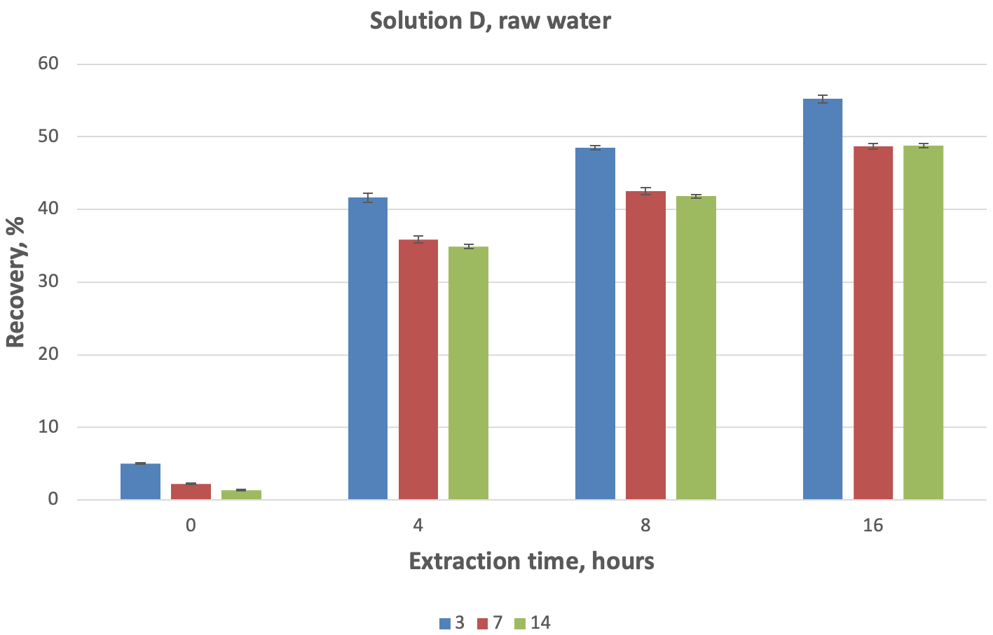
Figure C.5 Percent recovery of chromium in raw water solution B for different holding times (3, 7 and 14 days) and pH 1.75 ± 0.1 extraction periods
Additional extraction steps for turbid samples (US EPA 1994, 200.8 method) are used for total recoverable chromium. Bars = standard deviation, n = 3.
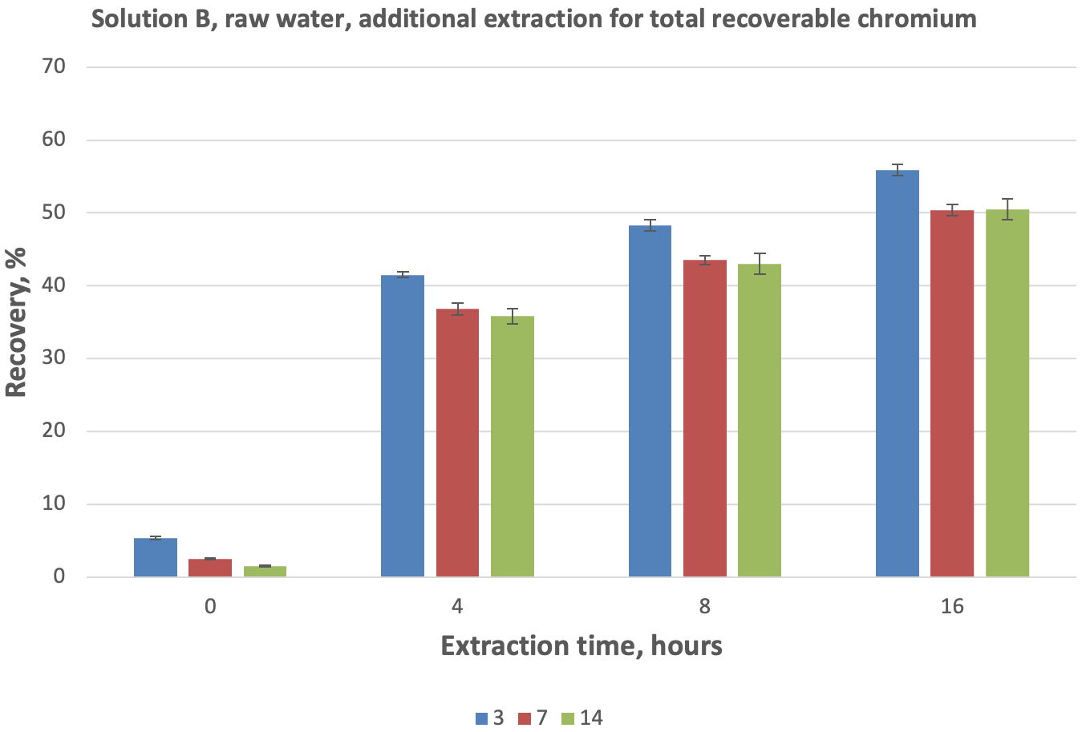

Results for raw turbid freshwater solution
Table D.1 Physical and chemical parameters for freshly prepared turbid water solutions C and D
Parameters | Solution C | Solution D
pH | 8.04 | 7.55
Conductivity (µS/cm) | 822.63 | 829.73
Alkalinity (mg/L) | 145.22 | 138.51
Dissolved oxygen (at 22°C) | 7.9 mg/L or 95% | n/a
Dissolved chromium (µg/L) | < 0.5 | 119.37
Total chromium (µg/L) | n/a | n/a
Total organic carbon (mg/L) | 5.65 | 5.64
Dissolved organic carbon (mg/L) | 4.15 | 4.17
Total suspended solids (mg/L) | 41 | 45
Table D.2 Concentration of dissolved chromium in pre-extracted samples (time 0) and acid-extracted samples 4 hours, 8 hours and 16 hours after acidification
Samples were acidified 3 days after preparation. RSD = relative standard deviation.
Solution | Chromium (µg/L) | Duplicate average (µg/L) | Total recoverable chromium (µg/L) | Recovery (%) | Average chromium in solution (µg/L) | Chromium RSD (µg/L) | Average recovery (%) | Recovery RSD (µg/L)
Blk1-3-0 | < 0.50
Blk2-3-0 | < 0.50
C1-3a-0 | < 0.50
C1-3b-0 | < 0.50
C2-3a-0 | < 0.50
C2-3b-0 | < 0.50
C3-3a-0 | < 0.50
C3-3b-0 | < 0.50
D1-3a-0 | 27.23 | 26.72 | 553.03 | 4.83 | 26.91 | 1.10 | 4.96 | 0.26
D1-3b-0 | 26.21
D2-3a-0 | 26.52 | 28.10 | 535.23 | 5.25
D2-3b-0 | 29.67
D3-3a-0 | 27.57 | 25.92 | 541.48 | 4.79
D3-3b-0 | 24.26
Blk1-3-4 | < 0.50
Blk2-3-4 | < 0.50
C1-3a-4 | < 0.50
C1-3b-4 | < 0.50
C2-3a-4 | < 0.50
C2-3b-4 | < 0.50
C3-3a-4 | < 0.50
C3-3b-4 | < 0.50
D1-3a-4 | 120.19 | 121.09 | 553.03 | 21.90 | 122.70 | 3.88 | 22.60 | 1.01
D1-3b-4 | 121.99
D2-3a-4 | 125.79 | 127.13 | 535.23 | 23.75
D2-3b-4 | 128.47
D3-3a-4 | 117.26 | 119.88 | 541.48 | 22.14
D3-3b-4 | 122.49
Blk1-3-8 | < 0.50
Blk2-3-8 | < 0.50
C1-3a-8 | < 0.50
C1-3b-8 | < 0.50
C2-3a-8 | < 0.50
C2-3b-8 | < 0.50
C3-3a-8 | < 0.50
C3-3b-8 | < 0.50
D1-3a-8 | 139.45 | 165.07 | 553.03 | 29.85 | 147.47 | 15.37 | 27.12 | 2.37
D1-3b-8 | 190.69
D2-3a-8 | 133.35 | 136.75 | 535.23 | 25.55
D2-3b-8 | 140.16
D3-3a-8 | 140.48 | 140.57 | 541.48 | 25.96
D3-3b-8 | 140.66
Blk1-3-16 | < 0.50
Blk2-3-16 | < 0.50
C1-3a-16 | < 0.50
C1-3b-16 | < 0.50
C2-3a-16 | < 0.50
C2-3b-16 | < 0.50
C3-3a-16 | < 0.50
C3-3b-16 | < 0.50
D1-3a-16 | 161.12 | 165.58 | 553.03 | 29.94 | 167.63 | 4.02 | 30.86 | 0.94
D1-3b-16 | 170.04
D2-3a-16 | 162.25 | 165.06 | 535.23 | 30.84
D2-3b-16 | 167.86
D3-3a-16 | 171.65 | 172.26 | 541.48 | 31.81
D3-3b-16 | 172.88
Blk1-3-TR | < 0.50
Blk2-3-TR | < 0.50
C1-3a-TR | 4.81 | 4.45
C1-3b-TR | 4.43
C2-3a-TR | 4.42
C2-3b-TR | 4.34
C3-3a-TR | 4.07
C3-3b-TR | 4.65
D1-3a-TR | 571.87 | 557.48 | 553.03
D1-3b-TR | 543.09
D2-3a-TR | 528.97 | 539.69 | 535.23
D2-3b-TR | 550.41
D3-3a-TR | 532.88 | 545.93 | 541.48
D3-3b-TR | 558.97
Table D.3 Concentration of dissolved chromium in pre-extracted samples (time 0) and acid-extracted samples 4 hours, 8 hours and 16 hours after acidification
Samples were acidified 7 days after preparation. Filt = water from 50-mL tubes filtered before digestion using US EPA (1994) 200.8 method. RSD = relative standard deviation.
Solution | Chromium (µg/L) | Duplicate average (µg/L) | Total recoverable chromium (µg/L) | Recovery (%) | Average chromium in solution (µg/L) | Chromium RSD (µg/L) | Average recovery (%) | Recovery RSD (µg/L)
Blk1-7-0 | < 0.50
Blk2-7-0 | < 0.50
C1-7a-0 | < 0.50
C1-7b-0 | < 0.50
C2-7a-0 | < 0.50
C2-7b-0 | < 0.50
C3-7a-0 | < 0.50
C3-7b-0 | < 0.50
D1-7a-0 | 11.55 | 11.44 | 524.37 | 2.18 | 13.13 | 3.60 | 2.56 | 0.76
D1-7b-0 | 11.32
D2-7a-0 | 16.73 | 17.26 | 501.93 | 3.44
D2-7b-0 | 17.79
D3-7a-0 | 11.16 | 10.70 | 519.93 | 2.06
D3-7b-0 | 10.23
Blk1-7-4 | < 0.50
Blk2-7-4 | < 0.50
C1-7a-4 | < 0.50
C1-7b-4 | < 0.50
C2-7a-4 | < 0.50
C2-7b-4 | < 0.50
C3-7a-4 | < 0.50
C3-7b-4 | < 0.50
D1-7a-4 | 114.58 | 115.00 | 524.37 | 21.93 | 116.86 | 1.71 | 22.69 | 0.83
D1-7b-4 | 115.41
D2-7a-4 | 115.56 | 118.36 | 501.93 | 23.58
D2-7b-4 | 121.17
D3-7a-4 | 117.68 | 117.21 | 519.93 | 22.54
D3-7b-4 | 116.74
Blk1-7-8 | < 0.50
Blk2-7-8 | < 0.50
C1-7a-8 | < 0.50
C1-7b-8 | < 0.50
C2-7a-8 | < 0.50
C2-7b-8 | < 0.50
C3-7a-8 | < 0.50
C3-7b-8 | < 0.50
D1-7a-8 | 132.00 | 136.15 | 524.37 | 25.96 | 135.88 | 1.52 | 26.37 | 0.84
D1-7b-8 | 140.29
D2-7a-8 | 140.50 | 137.24 | 501.93 | 27.34
D2-7b-8 | 133.98
D3-7a-8 | 125.47 | 134.24 | 519.93 | 25.82
D3-7b-8 | 143.01
Blk1-7-16 | < 0.50
Blk2-7-16 | < 0.50
C1-7a-16 | < 0.50
C1-7b-16 | < 0.50
C2-7a-16 | < 0.50
C2-7b-16 | < 0.50
C3-7a-16 | < 0.50
C3-7b-16 | < 0.50
D1-7a-16 | 165.12 | 166.34 | 524.37 | 31.72 | 164.29 | 3.34 | 31.89 | 1.13
D1-7b-16 | 167.56
D2-7a-16 | 167.91 | 166.10 | 501.93 | 33.09
D2-7b-16 | 164.28
D3-7a-16 | 150.82 | 160.43 | 519.93 | 30.86
D3-7b-16 | 170.05
Blk1-7-TR | < 0.50
Blk2-7-TR | < 0.50
C1-7a-TR | 4.01 | 4.19
C1-7b-TR | 3.79
C2-7a-TR | 3.99
C2-7b-TR | 4.85
C3-7a-TR | 4.06
C3-7b-TR | 4.46
D1-7a-TR | 509.00 | 528.56 | 524.37
D1-7b-TR | 548.13
D2-7a-TR | 510.29 | 506.12 | 501.93
D2-7b-TR | 501.96
D3-7a-TR | 551.03 | 524.13 | 519.93
D3-7b-TR | 497.22
Blk1-7-filt | < 0.50
Blk2-7-filt | < 0.50
C1-7a-filt | < 0.50
C1-7b-filt | < 0.50
C2-7a-filt | < 0.50
C2-7b-filt | < 0.50
C3-7a-filt | < 0.50
C3-7b-filt | < 0.50
D1-7a-filt | 232.58 | 236.26 | 524.37 | 45.06 | 246.58 | 9.85 | 47.87 | 2.43
D1-7b-filt | 239.93
D2-7a-filt | 254.29 | 247.60 | 501.93 | 49.33
D2-7b-filt | 240.92
D3-7a-filt | 253.93 | 255.87 | 519.93 | 49.21
D3-7b-filt | 257.81

Table D.4 Concentration of dissolved chromium in pre-extracted samples (time 0) and acid-extracted samples 4 hours, 8 hours and 16 hours after acidification
Samples were acidified 14 days after preparation. Filt = water from 50-mL tubes filtered before digestion using US EPA (1994) 200.8 method. RSD = relative standard deviation.
Solution | Chromium (µg/L) | Duplicate average (µg/L) | Total recoverable chromium (µg/L) | Recovery (%) | Average chromium in solution (µg/L) | Chromium RSD (µg/L) | Average recovery (%) | Recovery RSD (µg/L)
Blk1-14-0 | < 0.50
Blk2-14-0 | < 0.50
C1-14a-0 | < 0.50
C1-14b-0 | < 0.50
C2-14a-0 | < 0.50
C2-14b-0 | < 0.50
C3-14a-0 | < 0.50
C3-14b-0 | < 0.50
D1-14a-0 | 8.21 | 7.96 | 494.17 | 1.61 | 10.73 | 2.49 | 2.23 | 0.55
D1-14b-0 | 7.71
D2-14a-0 | 11.55 | 11.43 | 471.82 | 2.42
D2-14b-0 | 11.31
D3-14a-0 | 12.53 | 12.78 | 480.32 | 2.66
D3-14b-0 | 13.04
Blk1-14-4 | < 0.50
Blk2-14-4 | < 0.50
C1-14a-4 | < 0.50
C1-14b-4 | < 0.50
C2-14a-4 | < 0.50
C2-14b-4 | < 0.50
C3-14a-4 | < 0.50
C3-14b-4 | < 0.50
D1-14a-4 | 99.29 | 107.08 | 494.17 | 21.67 | 110.93 | 3.34 | 23.03 | 1.19
D1-14b-4 | 114.87
D2-14a-4 | 115.43 | 112.66 | 471.82 | 23.88
D2-14b-4 | 109.89
D3-14a-4 | 117.15 | 113.06 | 480.32 | 23.54
D3-14b-4 | 108.96
Blk1-14-8 | < 0.50
Blk2-14-8 | < 0.50
C1-14a-8 | < 0.50
C1-14b-8 | < 0.50
C2-14a-8 | < 0.50
C2-14b-8 | < 0.50
C3-14a-8 | < 0.50
C3-14b-8 | < 0.50
D1-14a-8 | 127.39 | 129.27 | 494.17 | 26.16 | 133.00 | 3.89 | 27.60 | 1.27
D1-14b-8 | 131.15
D2-14a-8 | 135.54 | 132.69 | 471.82 | 28.12
D2-14b-8 | 129.85
D3-14a-8 | 141.96 | 137.03 | 480.32 | 28.53
D3-14b-8 | 132.10
Blk1-14-16 | < 0.50
Blk2-14-16 | < 0.50
C1-14a-16 | < 0.50
C1-14b-16 | < 0.50
C2-14a-16 | < 0.50
C2-14b-16 | < 0.50
C3-14a-16 | < 0.50
C3-14b-16 | < 0.50
D1-14a-16 | 153.37 | 150.60 | 494.17 | 30.48 | 154.87 | 5.61 | 32.14 | 1.56
D1-14b-16 | 147.84
D2-14a-16 | 146.14 | 152.79 | 471.82 | 32.38
D2-14b-16 | 159.44
D3-14a-16 | 153.06 | 161.22 | 480.32 | 33.57
D3-14b-16 | 169.38
Blk1-14-TR | < 0.50
Blk2-14-TR | < 0.50
C1-14a-TR | 4.00 | 3.99
C1-14b-TR | 4.12
C2-14a-TR | 3.98
C2-14b-TR | 3.81
C3-14a-TR | 3.98
C3-14b-TR | 4.07
D1-14a-TR | 477.76 | 498.17 | 494.17
D1-14b-TR | 518.57
D2-14a-TR | 490.70 | 475.82 | 471.82
D2-14b-TR | 460.93
D3-14a-TR | 487.69 | 484.31 | 480.32
D3-14b-TR | 480.93
Blk1-14-filt | < 0.50
Blk2-14-filt | < 0.50
C1-14a-filt | < 0.50
C1-14b-filt | < 0.50
C2-14a-filt | < 0.50
C2-14b-filt | < 0.50
C3-14a-filt | < 0.50
C3-14b-filt | < 0.50
D1-14a-filt | 224.69 | 229.65 | 494.17 | 46.47 | 229.15 | 5.86 | 47.55 | 1.90
D1-14b-filt | 234.61
D2-14a-filt | 239.36 | 234.75 | 471.82 | 49.75
D2-14b-filt | 230.14
D3-14a-filt | 227.57 | 223.05 | 480.32 | 46.44
D3-14b-filt | 218.53

Table D.5 Change of dissolved chromium concentration in raw turbid water solutions after additional (exceeding 16 hours) acid extraction
TR = total recoverable chromium.
Solution | 16hr | +4 hr | +8 hr | +28 hr | +2 d | +6 d | +8 d | +9 d | +12 d | +13 d | TR (µg/L) | Final recovery (%)
C1-3 | < 0.5 |  |  |  |  | < 0.5 |  |  | < 0.5 | < 0.5
C2-3 | < 0.5 |  |  |  |  | < 0.5 |  |  | < 0.5 | < 0.5
C3-3 | < 0.5 |  |  |  |  | < 0.5 |  |  | < 0.5 | < 0.5
D1-3 | 165.6 |  |  |  |  | 260.8 |  |  | 249.1 | 260.5 | 553.0 | 47.1
D2-3 | 165.1 |  |  |  |  | 243.2 |  |  | 237.6 | 256.2 | 535.2 | 47.9
D3-3 | 172.3 |  |  |  |  | 262.1 |  |  | 265.7 | 261.6 | 541.5 | 48.3
C1-7 | < 0.5 |  |  |  | < 0.5 |  | < 0.5 | < 0.5
C2-7 | < 0.5 |  |  |  | < 0.5 |  | < 0.5 | < 0.5
C3-7 | < 0.5 |  |  |  | < 0.5 |  | < 0.5 | < 0.5
D1-7 | 166.3 |  |  |  | 227.1 |  | 245.4 | 246.8 |  |  | 524.4 | 47.1
D2-7 | 166.1 |  |  |  | 220.5 |  | 243.4 | 236.0 |  |  | 501.9 | 47.0
D3-7 | 160.4 |  |  |  | 224.6 |  | 252.8 | 263.1 |  |  | 519.9 | 50.6
C1-14 | < 0.5 | < 0.5 | < 0.5 | < 0.5 | < 0.5
C2-14 | < 0.5 | < 0.5 | < 0.5 | < 0.5 | < 0.5
C3-14 | < 0.5 | < 0.5 | < 0.5 | < 0.5 | < 0.5
D1-14 | 150.6 | 157.8 | 131.9 | 190.7 | 205.1 |  |  |  |  |  | 494.2 | 41.5
D2-14 | 152.8 | 162.7 | 179.0 | 199.6 | 221.5 |  |  |  |  |  | 471.8 | 46.9
D3-14 | 161.2 | 166.0 | 175.3 | 199.5 | 219.8 |  |  |  |  |  | 480.3 | 45.8

Table D.6 pH control before (pre-extraction) and 0 hours, 4 hours, 8 hours and 16 hours after acidification of raw turbid water solutions C and D
Solution | Pre-extraction | 0 hours | 4 hours | 8 hours | 16 hours
C1-3 | 7.975 | 1.754 | 1.763 | 1.768 | 1.767
C2-3 | 7.784 | 1.754 | 1.747 | 1.735 | 1.736
C3-3 | 8.027 | 1.761 | 1.764 | 1.759 | 1.750
C1-7 | 8.191 | 1.723 | 1.749 | 1.750 | 1.753
C2-7 | 7.751 | 1.752 | 1.757 | 1.750 | 1.747
C3-7 | 8.208 | 1.744 | 1.747 | 1.741 | 1.743
C1-14 | 8.313 | 1.781 | 1.769 | 1.765 | 1.768
C2-14 | 8.192 | 1.793 | 1.760 | 1.784 | 1.770
C3-14 | 8.449 | 1.770 | 1.760 | 1.769 | 1.753
D1-3 | 8.014 | 1.758 | 1.742 | 1.756 | 1.760
D2-3 | 7.998 | 1.759 | 1.759 | 1.754 | 1.764
D3-3 | 8.012 | 1.761 | 1.764 | 1.757 | 1.762
D1-7 | 8.339 | 1.746 | 1.757 | 1.755 | 1.747
D2-7 | 7.969 | 1.754 | 1.761 | 1.752 | 1.747
D3-7 | 8.347 | 1.754 | 1.754 | 1.747 | 1.748
D1-14 | 8.587 | 1.776 | 1.758 | 1.769 | 1.748
D2-14 | 8.266 | 1.777 | 1.755 | 1.743 | 1.746
D3-14 | 8.235 | 1.772 | 1.767 | 1.767 | 1.755
Figure D.1 Dissolution and percent recovery of chromium in raw turbid water solution D for different holding times (3, 7 and 14 days) and pH 1.75 ± 0.1 extraction periods
Bars = standard deviation, n = 3.
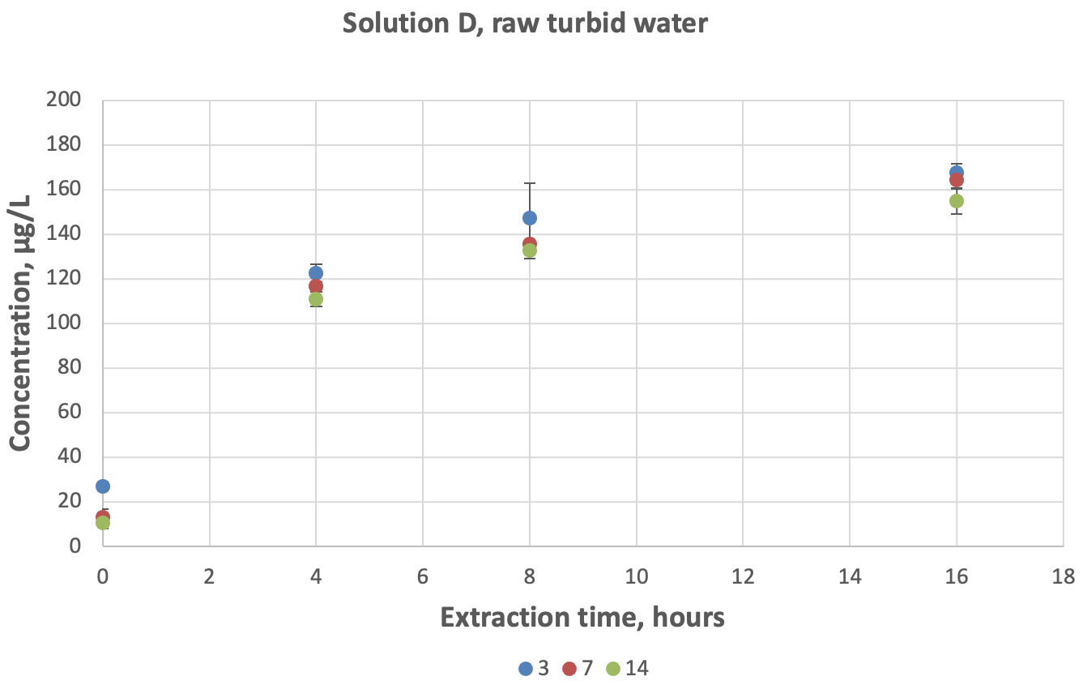
Figure D.2 Percent recovery of chromium in raw turbid water solution D for different holding times (3, 7 and 14 days) and pH 1.75 ± 0.1 extraction periods
Bars = standard deviation, n = 3
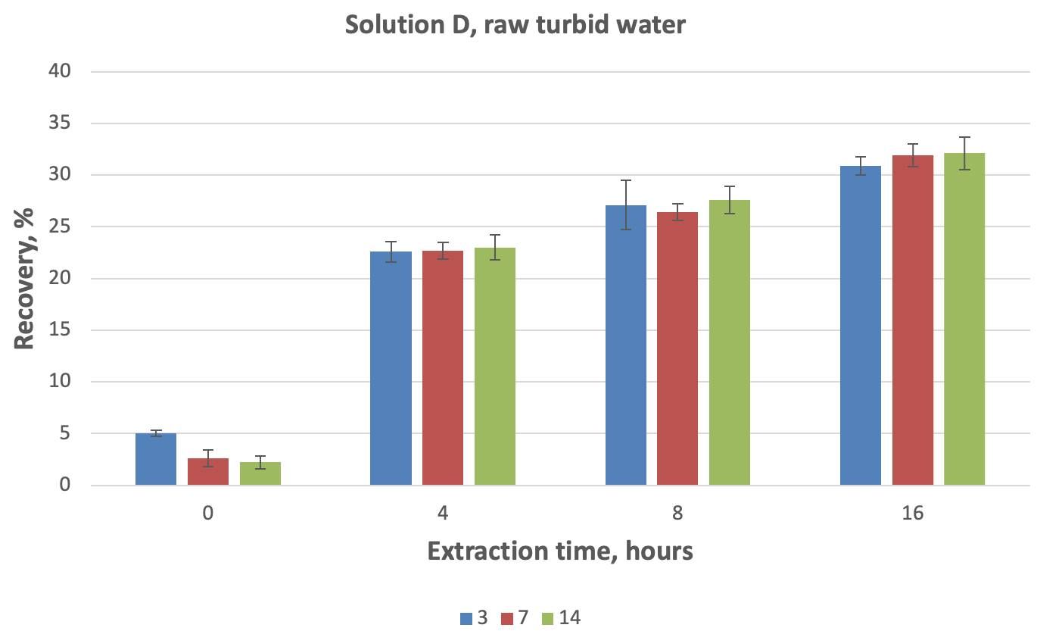

Results for sea water solution
Table E.1 Physical and chemical parameters for sea water solutions A, B, C and D
Parameters | Solution A | Solution B | Solution C | Solution D
pH | 8.06 | 7.84 | 8.07 | 7.86
Conductivity (µS/cm) | 52,094.22 | 52,123.17 | 51,307.52 | 51,324.08
Alkalinity (mg/L) | 119.2 | 113.83 | 117.49 | 111.66
Dissolved oxygen (at 22°C) | 7.3 mg/L or 88% | n/a | n/a | n/a
Dissolved chromium (µg/L) | < 1 | 9.4 | 1.1 | 8.8
Total chromium (µg/L) | < 1 | n/a | n/a | n/a
Total organic carbon (mg/L) | 1.39 | 1.37 | 1.71 | 1.95
Dissolved organic carbon (mg/L) | 1.27 | 1.08 | 1.10 | 1.10
Total suspended solids (mg/L) | n/a | n/a | 47.7 | 49.0
Table E.2 Concentration of dissolved chromium in pre-extracted samples (time 0) and acid-extracted samples 4 hours, 8 hours and 16 hours after acidification
Samples were acidified 3 days after preparation. RSD = relative standard deviation.
Solution | Chromium (µg/L) | Duplicates average (µg/L) | Total recoverable (µg/L) | Recovery (%) | Solution average (µg/L) | RSD (µg/L) | Average recovery (%) | Recovery RSD (µg/L)
Blk1-3-0 | < 1.00
Blk2-3-0 | < 1.00
A1-3a-0 | < 1.00
A1-3b-0 | < 1.00
A2-3a-0 | < 1.00
A2-3b-0 | < 1.00
B1-3a-0 | 7.41 | 7.57 | 516.20 | 1.47 | 7.90 | 0.33 | 1.53 | 0.06
B1-3b-0 | 7.72
B2-3a-0 | 8.12 | 7.91 | 514.38 | 1.54
B2-3b-0 | 7.70
B3-3a-0 | 8.25 | 8.22 | 516.35 | 1.59
B3-3b-0 | 8.19
C1-3a-0 | < 1.00
C1-3b-0 | < 1.00
C2-3a-0 | < 1.00
C2-3b-0 | < 1.00
C3-3a-0 | < 1.00
C3-3b-0 | < 1.00
D1-3a-0 | 13.27 | 13.23 | 530.53 | 2.49 | 13.35 | 0.17 | 2.50 | 0.03
D1-3b-0 | 13.19
D2-3a-0 | 12.92 | 13.27 | 538.43 | 2.46
D2-3b-0 | 13.62
D3-3a-0 | 13.44 | 13.54 | 535.31 | 2.53
D3-3b-0 | 13.64
Blk1-3-4 | < 1.00
Blk2-3-4 | < 1.00
A1-3a-4 | < 1.00
A1-3b-4 | < 1.00
A2-3a-4 | < 1.00
A2-3b-4 | < 1.00
B1-3a-4 | 482.22 | 479.44 | 516.20 | 92.88 | 477.47 | 2.91 | 92.60 | 0.68
B1-3b-4 | 476.66
B2-3a-4 | 475.15 | 478.84 | 514.38 | 93.09
B2-3b-4 | 482.52
B3-3a-4 | 474.86 | 474.12 | 516.35 | 91.82
B3-3b-4 | 473.38
C1-3a-4 | < 1.00
C1-3b-4 | < 1.00
C2-3a-4 | < 1.00
C2-3b-4 | < 1.00
C3-3a-4 | < 1.00
C3-3b-4 | < 1.00
D1-3a-4 | 473.28 | 474.54 | 530.53 | 89.45 | 479.26 | 4.13 | 89.62 | 0.40
D1-3b-4 | 475.80
D2-3a-4 | 482.60 | 481.03 | 538.43 | 89.34
D2-3b-4 | 479.46
D3-3a-4 | 477.35 | 482.20 | 535.31 | 90.08
D3-3b-4 | 487.05
Blk1-3-8 | < 1.00
Blk2-3-8 | < 1.00
A1-3a-8 | < 1.00
A1-3b-8 | < 1.00
A2-3a-8 | < 1.00
A2-3b-8 | < 1.00
B1-3a-8 | 495.59 | 498.82 | 516.20 | 96.63 | 499.95 | 1.47 | 96.96 | 0.49
B1-3b-8 | 502.05
B2-3a-8 | 504.49 | 501.61 | 514.38 | 97.52
B2-3b-8 | 498.73
B3-3a-8 | 499.66 | 499.42 | 516.35 | 96.72
B3-3b-8 | 499.17
C1-3a-8 | < 1.00
C1-3b-8 | < 1.00
C2-3a-8 | < 1.00
C2-3b-8 | < 1.00
C3-3a-8 | < 1.00
C3-3b-8 | < 1.00
D1-3a-8 | 494.89 | 498.70 | 530.53 | 94.00 | 506.19 | 7.37 | 94.66 | 1.09
D1-3b-8 | 502.51
D2-3a-8 | 509.38 | 506.43 | 538.43 | 94.06
D2-3b-8 | 503.48
D3-3a-8 | 515.59 | 513.43 | 535.31 | 95.91
D3-3b-8 | 511.27
Blk1-3-16 | < 1.00
Blk2-3-16 | < 1.00
A1-3a-16 | < 1.00
A1-3b-16 | < 1.00
A2-3a-16 | < 1.00
A2-3b-16 | < 1.00
B1-3a-16 | 522.66 | 520.19 | 516.20 | 100.77 | 519.28 | 1.00 | 100.71 | 0.09
B1-3b-16 | 517.73
B2-3a-16 | 512.59 | 518.21 | 514.38 | 100.74
B2-3b-16 | 523.82
B3-3a-16 | 521.23 | 519.43 | 516.35 | 100.60
B3-3b-16 | 517.63
C1-3a-16 | < 1.00
C1-3b-16 | < 1.00
C2-3a-16 | < 1.00
C2-3b-16 | < 1.00
C3-3a-16 | < 1.00
C3-3b-16 | < 1.00
D1-3a-16 | 537.04 | 534.52 | 530.53 | 100.75 | 535.06 | 0.54 | 100.06 | 0.65
D1-3b-16 | 531.99
D2-3a-16 | 533.88 | 535.59 | 538.43 | 99.47
D2-3b-16 | 537.29
D3-3a-16 | 535.42 | 535.07 | 535.31 | 99.96
D3-3b-16 | 534.73
Blk1-3-TR | < 1.00
Blk2-3-TR | < 1.00
A1-3a-TR | < 1.00
A2-3a-TR | < 1.00
A1-3b-TR | < 1.00
A2-3b-TR | < 1.00
B1-3a-TR | 517.75 | 516.20
B1-3b-TR | 514.65
B2-3a-TR | 509.34 | 514.38
B2-3b-TR | 519.42
B3-3a-TR | 515.56 | 516.35
B3-3b-TR | 517.13
C1-3a-TR | 1.72 | 1.83
C1-3b-TR | 1.95
C2-3a-TR | 1.63 | 1.67
C2-3b-TR | 1.70
C3-3a-TR | 1.56 | 1.58
C3-3b-TR | 1.60
D1-3a-TR | 529.79 | 530.53
D1-3b-TR | 531.27
D2-3a-TR | 541.19 | 538.43
D2-3b-TR | 535.66
D3-3a-TR | 531.24 | 535.31
D3-3b-TR | 539.37

Table E.3 Concentration of dissolved chromium in pre-extracted samples (time 0) and acid-extracted samples 4 hours, 8 hours and 16 hours after acidification
Samples were acidified 7 days after preparation. RSD = relative standard deviation.
Solution | Chromium (µg/L) | Duplicates average (µg/L) | Total recoverable (µg/L) | Recovery (%) | Solution average (µg/L) | RSD (µg/L) | Average recovery (%) | Recovery RSD (µg/L)
Blk1-7-0 | < 1.00
Blk2-7-0 | < 1.00
A1-7a-0 | < 1.00
A1-7b-0 | < 1.00
A2-7a-0 | < 1.00
A2-7b-0 | < 1.00
B1-7a-0 | 4.19 | 4.16 | 480.84 | 0.87 | 4.11 | 0.14 | 0.85 | 0.04
B1-7b-0 | 4.13
B2-7a-0 | 3.88 | 3.95 | 490.69 | 0.81
B2-7b-0 | 4.02
B3-7a-0 | 4.24 | 4.22 | 477.21 | 0.88
B3-7b-0 | 4.21
C1-7a-0 | < 1.00
C1-7b-0 | < 1.00
C2-7a-0 | < 1.00
C2-7b-0 | < 1.00
C3-7a-0 | < 1.00
C3-7b-0 | < 1.00
D1-7a-0 | 6.23 | 6.23 | 501.81 | 1.24 | 6.28 | 0.08 | 1.25 | 0.01
D1-7b-0 | 6.24
D2-7a-0 | 6.39 | 6.24 | 496.26 | 1.26
D2-7b-0 | 6.09
D3-7a-0 | 6.39 | 6.38 | 505.54 | 1.26
D3-7b-0 | 6.38
Blk1-7-4 | < 1.00
Blk2-7-4 | < 1.00
A1-7a-4 | < 1.00
A1-7b-4 | < 1.00
A2-7a-4 | < 1.00
A2-7b-4 | < 1.00
B1-7a-4 | 430.93 | 433.59 | 480.84 | 90.17 | 435.81 | 2.03 | 90.26 | 1.39
B1-7b-4 | 436.24
B2-7a-4 | 434.38 | 436.30 | 490.69 | 88.92
B2-7b-4 | 438.22
B3-7a-4 | 438.90 | 437.55 | 477.21 | 91.69
B3-7b-4 | 436.20
C1-7a-4 | < 1.00
C1-7b-4 | < 1.00
C2-7a-4 | < 1.00
C2-7b-4 | < 1.00
C3-7a-4 | < 1.00
C3-7b-4 | < 1.00
D1-7a-4 | 444.36 | 447.86 | 501.81 | 89.25 | 450.42 | 2.61 | 89.87 | 1.24
D1-7b-4 | 451.36
D2-7a-4 | 450.88 | 453.08 | 496.26 | 91.30
D2-7b-4 | 455.28
D3-7a-4 | 452.09 | 450.31 | 505.54 | 89.08
D3-7b-4 | 448.52
Blk1-7-8 | < 1.00
Blk2-7-8 | < 1.00
A1-7a-8 | < 1.00
A1-7b-8 | < 1.00
A2-7a-8 | < 1.00
A2-7b-8 | < 1.00
B1-7a-8 | 456.24 | 458.43 | 480.84 | 95.34 | 459.24 | 1.08 | 95.11 | 1.17
B1-7b-8 | 460.62
B2-7a-8 | 461.83 | 460.47 | 490.69 | 93.84
B2-7b-8 | 459.10
B3-7a-8 | 456.31 | 458.82 | 477.21 | 96.15
B3-7b-8 | 461.34
C1-7a-8 | < 1.00
C1-7b-8 | < 1.00
C2-7a-8 | < 1.00
C2-7b-8 | < 1.00
C3-7a-8 | < 1.00
C3-7b-8 | < 1.00
D1-7a-8 | 463.35 | 466.63 | 501.81 | 92.99 | 463.18 | 3.68 | 92.42 | 1.37
D1-7b-8 | 469.91
D2-7a-8 | 462.98 | 463.62 | 496.26 | 93.42
D2-7b-8 | 464.25
D3-7a-8 | 458.84 | 459.31 | 505.54 | 90.86
D3-7b-8 | 459.77
Blk1-7-16 | < 1.00
Blk2-7-16 | < 1.00
A1-7a-16 | < 1.00
A1-7b-16 | < 1.00
A2-7a-16 | < 1.00
A2-7b-16 | < 1.00
B1-7a-16 | 468.86 | 486.39 | 480.84 | 101.15 | 482.02 | 3.89 | 99.83 | 1.94
B1-7b-16 | 503.91
B2-7a-16 | 479.04 | 478.93 | 490.69 | 97.60
B2-7b-16 | 478.81
B3-7a-16 | 480.11 | 480.75 | 477.21 | 100.74
B3-7b-16 | 481.39
C1-7a-16 | < 1.00
C1-7b-16 | < 1.00
C2-7a-16 | < 1.00
C2-7b-16 | < 1.00
C3-7a-16 | < 1.00
C3-7b-16 | < 1.00
D1-7a-16 | 486.46 | 486.82 | 501.81 | 97.01 | 488.51 | 1.95 | 97.48 | 1.23
D1-7b-16 | 487.18
D2-7a-16 | 489.66 | 490.65 | 496.26 | 98.87
D2-7b-16 | 491.63
D3-7a-16 | 485.47 | 488.07 | 505.54 | 96.54
D3-7b-16 | 490.67
Blk1-7-TR | < 1.00
Blk2-7-TR | < 1.00
A1-7a-TR | < 1.00
A2-7a-TR | < 1.00
A1-7b-TR | < 1.00
A2-7b-TR | < 1.00
B1-7a-TR | 483.31 | 480.84
B1-7b-TR | 478.36
B2-7a-TR | 484.51 | 490.69
B2-7b-TR | 496.86
B3-7a-TR | 481.79 | 477.21
B3-7b-TR | 472.63
C1-7a-TR | 1.18 | 1.24
C1-7b-TR | 1.29
C2-7a-TR | 1.44 | 1.39
C2-7b-TR | 1.34
C3-7a-TR | 1.69 | 1.50
C3-7b-TR | 1.31
D1-7a-TR | 501.85 | 501.81
D1-7b-TR | 501.77
D2-7a-TR | 497.37 | 496.26
D2-7b-TR | 495.16
D3-7a-TR | 506.26 | 505.54
D3-7b-TR | 504.81
Table E.4 Concentration of dissolved chromium in pre-extracted samples (time 0) and acid-extracted samples 4 hours, 8 hours and 16 hours after acidification
Samples were acidified 14 days after preparation. RSD = relative standard deviation.
Solution | Chromium (µg/L) | Duplicates average (µg/L) | Total recoverable (µg/L) | Recovery (%) | Solution average (µg/L) | RSD (µg/L) | Average recovery (%) | Recovery RSD (µg/L)
Blk1-14-0 | < 1.00
Blk2-14-0 | < 1.00
A1-14a-0 | < 1.00
A1-14b-0 | < 1.00
A2-14a-0 | < 1.00
A2-14b-0 | < 1.00
B1-14a-0 | 3.68 | 3.74 | 475.23 | 0.79 | 3.75 | 0.01 | 0.78 | 0.01
B1-14b-0 | 3.81
B2-14a-0 | 3.76 | 3.74 | 482.90 | 0.77
B2-14b-0 | 3.72
B3-14a-0 | 3.64 | 3.75 | 476.51 | 0.79
B3-14b-0 | 3.87
C1-14a-0 | < 1.00
C1-14b-0 | < 1.00
C2-14a-0 | < 1.00
C2-14b-0 | < 1.00
C3-14a-0 | < 1.00
C3-14b-0 | < 1.00
D1-14a-0 | 4.52 | 4.61 | 495.51 | 0.93 | 4.64 | 0.04 | 0.94 | 0.02
D1-14b-0 | 4.71
D2-14a-0 | 4.57 | 4.61 | 493.90 | 0.93
D2-14b-0 | 4.66
D3-14a-0 | 4.66 | 4.68 | 488.52 | 0.96
D3-14b-0 | 4.70
Blk1-14-4 | < 1.00
Blk2-14-4 | < 1.00
A1-14a-4 | < 1.00
A1-14b-4 | < 1.00
A2-14a-4 | < 1.00
A2-14b-4 | < 1.00
B1-14a-4 | 467.34 | 470.34 | 475.23 | 98.97 | 482.27 | 21.18 | 100.86 | 4.82
B1-14b-4 | 473.33
B2-14a-4 | 467.96 | 469.75 | 482.90 | 97.28
B2-14b-4 | 471.54
B3-14a-4 | 506.51 | 506.73 | 476.51 | 106.34
B3-14b-4 | 506.96
C1-14a-4 | < 1.00
C1-14b-4 | < 1.00
C2-14a-4 | < 1.00
C2-14b-4 | < 1.00
C3-14a-4 | < 1.00
C3-14b-4 | < 1.00
D1-14a-4 | 476.22 | 472.56 | 495.51 | 95.37 | 468.47 | 4.35 | 95.09 | 0.24
D1-14b-4 | 468.90
D2-14a-4 | 468.92 | 468.95 | 493.90 | 94.95
D2-14b-4 | 468.99
D3-14a-4 | 466.13 | 463.90 | 488.52 | 94.96
D3-14b-4 | 461.66
Blk1-14-8 | < 1.00
Blk2-14-8 | < 1.00
A1-14a-8 | < 1.00
A1-14b-8 | < 1.00
A2-14a-8 | < 1.00
A2-14b-8 | < 1.00
B1-14a-8 | 471.07 | 473.21 | 475.23 | 99.57 | 474.83 | 2.74 | 99.30 | 1.18
B1-14b-8 | 475.35
B2-14a-8 | 476.05 | 473.29 | 482.90 | 98.01
B2-14b-8 | 470.52
B3-14a-8 | 475.56 | 477.99 | 476.51 | 100.31
B3-14b-8 | 480.43
C1-14a-8 | < 1.00
C1-14b-8 | < 1.00
C2-14a-8 | < 1.00
C2-14b-8 | < 1.00
C3-14a-8 | < 1.00
C3-14b-8 | < 1.00
D1-14a-8 | 469.61 | 472.75 | 495.51 | 95.41 | 470.66 | 2.33 | 95.54 | 0.25
D1-14b-8 | 475.89
D2-14a-8 | 471.90 | 471.09 | 493.90 | 95.38
D2-14b-8 | 470.27
D3-14a-8 | 468.08 | 468.14 | 488.52 | 95.83
D3-14b-8 | 468.20
Blk1-14-16 | < 1.00
Blk2-14-16 | < 1.00
A1-14a-16 | < 1.00
A1-14b-16 | < 1.00
A2-14a-16 | < 1.00
A2-14b-16 | < 1.00
B1-14a-16 | 473.09 | 475.75 | 475.23 | 100.11 | 475.26 | 0.42 | 99.39 | 0.91
B1-14b-16 | 478.40
B2-14a-16 | 476.27 | 475.02 | 482.90 | 98.37
B2-14b-16 | 473.78
B3-14a-16 | 475.43 | 475.02 | 476.51 | 99.69
B3-14b-16 | 474.60
C1-14a-16 | < 1.00
C1-14b-16 | < 1.00
C2-14a-16 | < 1.00
C2-14b-16 | < 1.00
C3-14a-16 | < 1.00
C3-14b-16 | < 1.00
D1-14a-16 | 460.17 | 461.74 | 495.51 | 93.18 | 462.90 | 2.24 | 93.97 | 0.69
D1-14b-16 | 463.31
D2-14a-16 | 468.04 | 465.49 | 493.90 | 94.25
D2-14b-16 | 462.93
D3-14a-16 | 464.58 | 461.48 | 488.52 | 94.46
D3-14b-16 | 458.38
Blk1-14-TR | < 1.00
Blk2-14-TR | < 1.00
A1-14a-TR | < 1.00
A2-14a-TR | < 1.00
A1-14b-TR | < 1.00
A2-14b-TR | < 1.00
B1-14a-TR | 474.03 | 475.23
B1-14b-TR | 476.43
B2-14a-TR | 482.54 | 482.90
B2-14b-TR | 483.27
B3-14a-TR | 474.70 | 476.51
B3-14b-TR | 478.33
C1-14a-TR | 1.78 | 3.74
C1-14b-TR | 2.08
C2-14a-TR | 1.89 | 3.74
C2-14b-TR | 2.27
C3-14a-TR | 1.92 | 3.75
C3-14b-TR | 1.99
D1-14a-TR | 497.63 | 495.51
D1-14b-TR | 493.39
D2-14a-TR | 498.40 | 493.90
D2-14b-TR | 489.40
D3-14a-TR | 484.59 | 488.52
D3-14b-TR | 492.45

Table E.5 Change of dissolved chromium concentration in sea water solutions after additional (exceeding 16 hours) acid extraction
TR = total recoverable chromium.
Solution | 16 hr | +1 d | +2 d | +3 d | +4 d | +6 d | +9 d | +16 d | TR (µg/L) | Final recovery (%)
B1-3 | 520.2 | 508.0 |  |  | 535.2 |  |  | n/a | 516.2 | n/a
B2-3 | 518.2 | 513.7 |  |  | 539.9 |  |  | 544.6 | 514.4 | 105.9
B3-3 | 519.4 | 521.6 |  |  | 537.7 |  |  | 537.5 | 516.3 | 104.1
D1-3 | 534.5 | 510.0 |  |  | 541.4 |  |  | 531.6 | 530.5 | 100.2
D2-3 | 535.6 | 530.8 |  |  | 543.7 |  |  | 521.2 | 538.4 | 96.8
D3-3 | 535.1 | 531.7 |  |  | 543.0 |  |  | 521.9 | 535.3 | 97.5
B1-7 | 486.4 |  |  | 500.1 |  | 507.7 | 509.6 |  | 480.8 | 106.0
B2-7 | 478.9 |  |  | 508.7 |  | 515.1 | 511.2 |  | 490.7 | 104.2
B3-7 | 480.7 |  |  | 510.3 |  | 514.3 | 511.5 |  | 477.2 | 107.2
D1-7 | 486.8 |  |  | 507.5 |  | 516.1 | 513.6 |  | 501.8 | 102.4
D2-7 | 490.6 |  |  | 510.7 |  | 512.8 | 513.0 |  | 496.3 | 103.4
D3-7 | 488.1 |  |  | 507.9 |  | 509.0 | 503.9 |  | 505.5 | 99.7
B1-14 | 475.7 |  | 484.7 |  | 480.5 | 460.3 |  |  | 475.2 | 96.9
B2-14 | 475.0 |  | 490.4 |  | 484.9 | 464.5 |  |  | 482.9 | 96.2
B3-14 | 475.0 |  | 487.9 |  | 479.2 | 462.1 |  |  | 476.5 | 97.0
D1-14 | 461.7 |  | 484.4 |  | 467.8 | 452.3 |  |  | 495.5 | 91.3
D2-14 | 465.5 |  | 483.7 |  | 472.6 | 453.5 |  |  | 493.9 | 91.8
D3-14 | 461.5 |  | 482.2 |  | 465.8 | 454.2 |  |  | 488.5 | 93.0

Table E.6 Concentration of chromium in the final solutions A and B of sea water before and after additional extraction steps for turbid samples
US EPA (1994) 200.8 method. TR = total recoverable chromium.
Solution | TR (µg/L) before additional extraction without filtering | TR (µg/L) before additional extraction with filtering | TR (µg/L) after additional extraction with filtering
Blk1-3 | < 1.00 | < 1.00 | < 1.00
Blk2-3 | < 1.00 | < 1.00 | < 1.00
A1-3a | < 1.00 | < 1.00 | < 1.00
A2-3a | < 1.00 | < 1.00 | < 1.00
A1-3b | < 1.00 | < 1.00 | < 1.00
A2-3b | < 1.00 | < 1.00 | < 1.00
B1-3a | 510.65 | 509.10 | 517.7
B1-3b | 512.94 | 513.71 | 514.6
B2-3a | 513.02 | 516.17 | 509.3
B2-3b | 501.96 | 509.83 | 519.4
B3-3a | 507.96 | 512.83 | 515.6
B3-3b | 509.62 | 514.19 | 517.1
Blk1-7 | < 1.00 | < 1.00 | < 1.00
Blk2-7 | < 1.00 | < 1.00 | < 1.00
A1-7a | < 1.00 | < 1.00 | < 1.00
A2-7a | < 1.00 | < 1.00 | < 1.00
A1-7b | < 1.00 | < 1.00 | < 1.00
A2-7b | < 1.00 | < 1.00 | < 1.00
B1-7a | 493.57 | 501.39 | 483.3
B1-7b | 494.12 | 498.52 | 478.4
B2-7a | 505.89 | 502.05 | 484.5
B2-7b | 518.32 | 502.70 | 496.9
B3-7a | 500.01 | 499.21 | 481.8
B3-7b | 497.43 | 500.22 | 472.6
Blk1-14 | < 1.00 | < 1.00 | < 1.00
Blk2-14 | < 1.00 | < 1.00 | < 1.00
A1-14a | < 1.00 | < 1.00 | < 1.00
A2-14a | < 1.00 | < 1.00 | < 1.00
A1-14b | < 1.00 | < 1.00 | < 1.00
A2-14b | < 1.00 | < 1.00 | < 1.00
B1-14a | 502.62 | 495.53 | 474.0
B1-14b | 502.67 | 498.43 | 476.4
B2-14a | 507.58 | 498.87 | 482.5
B2-14b | 512.42 | 500.17 | 483.3
B3-14a | 510.83 | 494.56 | 474.7
B3-14b | 514.08 | 494.33 | 478.3

Table E.7 pH control before (pre-extraction) and 0 hours, 4 hours, 8 hours and 16 hours after acidification of sea water solutions A, B, C and D
Solution | Pre-extraction | 0 hour | 4 hours | 8 hours | 16 hours
A1-3 | 8.053 | 1.812 | 1.783 | 1.755 | 1.798
A2-3 | 8.079 | 1.810 | 1.803 | 1.781 | 1.800
A1-7 | 8.065 | 1.775 | 1.758 | 1.761 | 1.766
A2-7 | 8.080 | 1.784 | 1.758 | 1.773 | 1.782
A1-14 | 8.047 | 1.808 | 1.780 | 1.808 | 1.783
A2-14 | 8.094 | 1.818 | 1.787 | 1.818 | 1.814
B1-3 | 7.972 | 1.812 | 1.809 | 1.759 | 1.794
B2-3 | 7.967 | 1.800 | 1.802 | 1.749 | 1.762
B3-3 | 7.967 | 1.807 | 1.800 | 1.774 | 1.796
B1-7 | 8.029 | 1.767 | 1.779 | 1.762 | 1.773
B2-7 | 8.044 | 1.758 | 1.782 | 1.760 | 1.764
B3-7 | 8.013 | 1.755 | 1.757 | 1.758 | 1.763
B1-14 | 8.077 | 1.781 | 1.780 | 1.792 | 1.787
B2-14 | 8.070 | 1.774 | 1.770 | 1.798 | 1.799
B3-14 | 8.088 | 1.776 | 1.770 | 1.789 | 1.787
C1-3 | 8.109 | 1.802 | 1.764 | 1.760 | 1.786
C2-3 | 8.123 | 1.810 | 1.762 | 1.762 | 1.791
C3-3 | 8.128 | 1.807 | 1.786 | 1.757 | 1.784
C1-7 | 8.078 | 1.755 | 1.751 | 1.768 | 1.754
C2-7 | 8.074 | 1.750 | 1.755 | 1.755 | 1.759
C3-7 | 8.078 | 1.745 | 1.755 | 1.751 | 1.759
C1-14 | 8.074 | 1.772 | 1.769 | 1.776 | 1.775
C2-14 | 8.155 | 1.789 | 1.765 | 1.775 | 1.797
C3-14 | 8.136 | 1.796 | 1.805 | 1.806 | 1.782
D1-3 | 7.963 | 1.795 | 1.780 | 1.743 | 1.760
D2-3 | 7.989 | 1.797 | 1.793 | 1.748 | 1.782
D3-3 | 7.973 | 1.795 | 1.795 | 1.771 | 1.788
D1-7 | 8.032 | 1.738 | 1.739 | 1.744 | 1.753
D2-7 | 8.000 | 1.741 | 1.750 | 1.758 | 1.753
D3-7 | 8.020 | 1.743 | 1.757 | 1.753 | 1.758
D1-14 | 8.011 | 1.767 | 1.801 | 1.779 | 1.768
D2-14 | 8.105 | 1.765 | 1.789 | 1.772 | 1.768
D3-14 | 7.976 | 1.760 | 1.776 | 1.774 | 1.767

Figure E.1 Dissolution of chromium in sea water solution B for different holding times (3, 7 and 14 days) and pH 1.75 ± 0.1 extraction periods
Bars = standard deviation, n = 3.
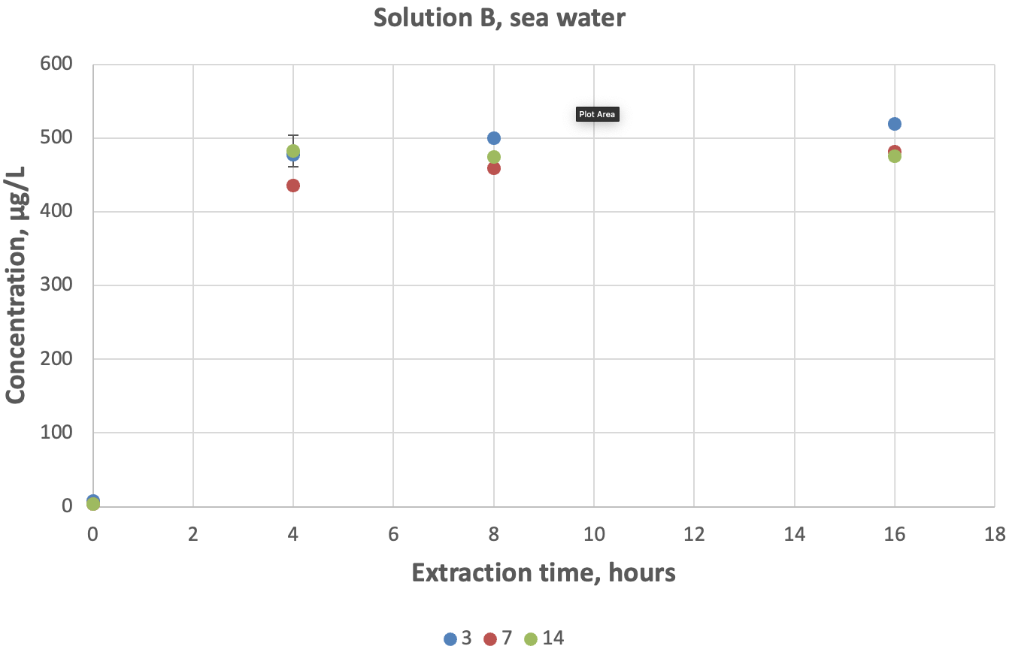
Figure E.2 Percent recovery of chromium in sea water solution B for different holding times (3, 7 and 14 days) and pH 1.75 ± 0.1 extraction periods
Bars = standard deviation, n = 3.
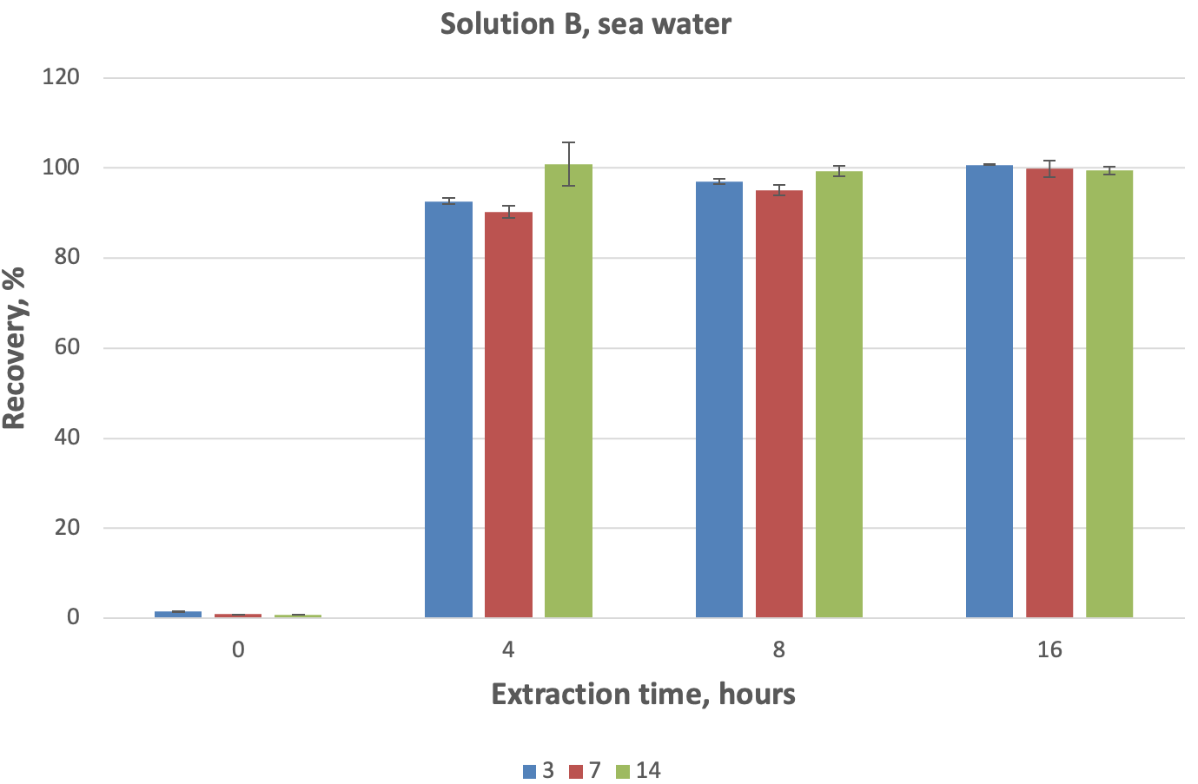
Figure E.3 Dissolution of chromium in sea water solution D for different holding times (3, 7 and 14 days) and pH 1.75 ± 0.1 extraction periods
Bars = standard deviation, n = 3.
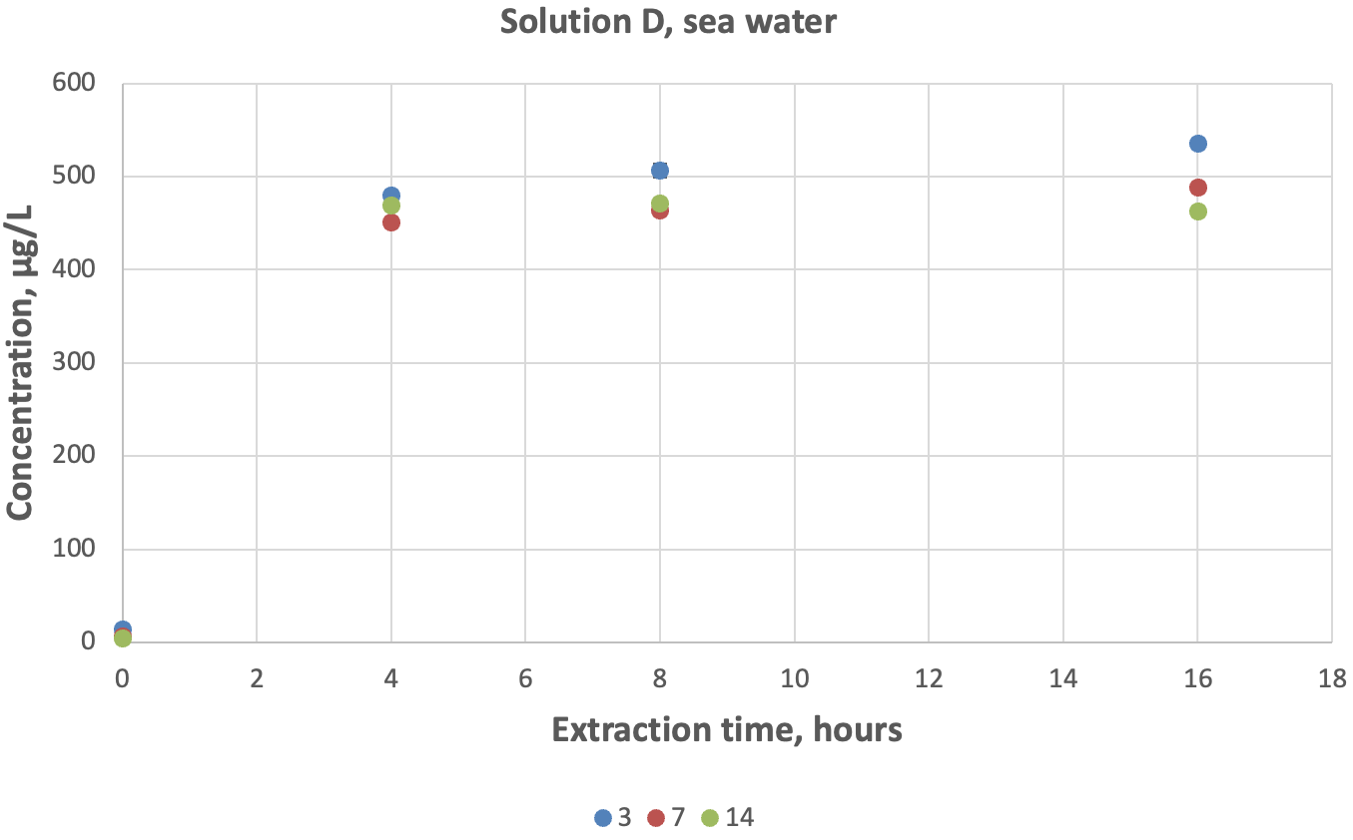
Figure E.4 Percent recovery of chromium in sea water solution D for different holding times (3, 7 and 14 days) and pH 1.75 ± 0.1 extraction periods
Bars = standard deviation, n = 3.
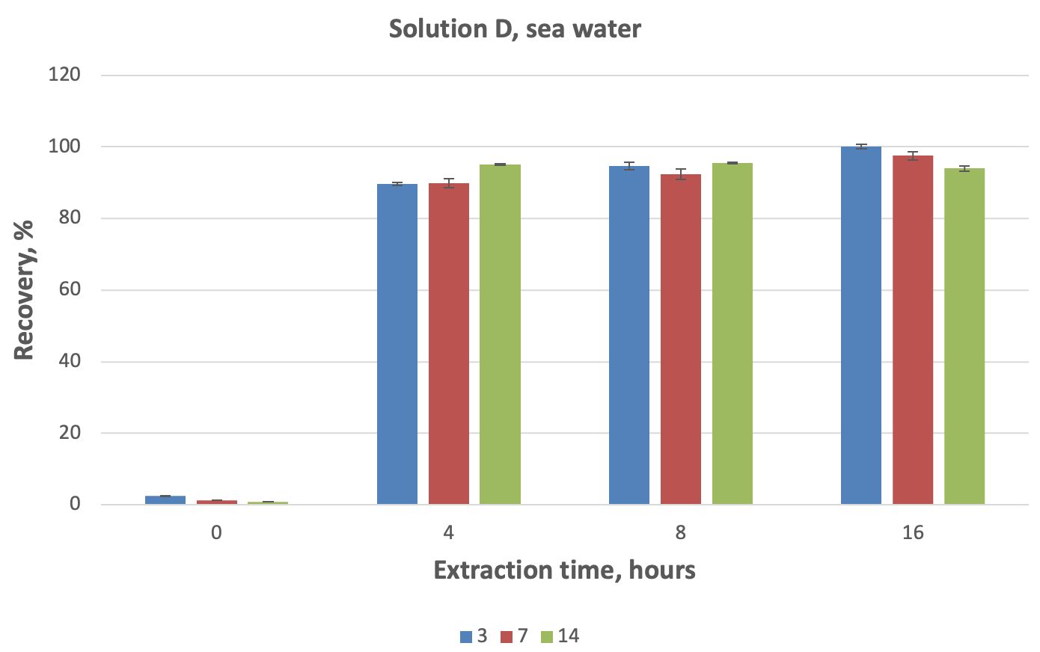

Evaluation of different acid-digestion methods for determination of chromium in aqueous solutions
- NATA-accredited method based on 3030 E of Standard methods for the examination of water and wastewater (APHA, AWWA, WEF 2023). Adopted by the Inorganic Chemistry Laboratory of the Public and Environmental Health Reference Laboratories (PEHRL), Queensland Health.
Acid preservatives contents: 50% HNO₃ + 0.5% HCl + 5 mg/L gold (Au) (dissolved).
Preparation of acid preservatives: Add 1.25-L ultra-high purity water to a 2.5-L plastic bottle. Add 1.250 L concentrated HNO₃ plus 12.5 mL concentrated HCl and 1.25 mL 10,000 mg/L Au. Mix gently by inversion. Dispense into 5.0-mL tubes ready for distribution to clients. Each tube now contains 5 mL of preservative to be used per 250-mL of water sample.
Total chromium analysis: Collect water samples in acid-washed 250-mL HDPE bottles and add 5 mL acid preservative per 250 mL sample. Mix gently by inversion. Prior to analysis, heat water samples on a hot plate for 4 hours at 120°C. Allow the samples to cool to room temperature and shake each bottle before ICP-MS analysis.
Dissolved chromium analysis: Filter water samples through 0.45-µm filters directly into acid-washed 250-mL HDPE bottles before adding 5 mL acid preservative. If a smaller volume is collected, use proportionate amount of acid preservative. Mix gently by inversion. Prior to analysis, heat water samples on a hot plate for 4 hours at 120°C. Allow the samples to cool to room temperature and shake each bottle before ICP-MS analysis.
- US EPA (1991) 200.1 pH 1.75 ± 0.1 extraction method.
Collect water samples in acid-washed 250-mL HDPE bottles. Upon receiving the sample in the laboratory, measure water pH and check that the holding time has not exceeded 3 days. Acidify 250 mL of water samples with 0.625 mL of 50% HNO₃ (1:1) and mix. Measure the pH of the sample – pH should be within the range of 1.75 ± 0.1.
If the sample pH is outside this range, add either 1:1 HNO₃ or 1:9 ammonium hydroxide in a dropwise manner until the sample pH is within the range of 1.65–1.85. Once the pH of the sample is properly adjusted and the sample is thoroughly mixed, set the sample aside for a minimum of 16 hours for the required dissolution to occur.
At the end of the extraction period, measure the pH again to verify that the proper pH was maintained during 16 hours of extraction. If so, filter 10 mL of the sample through a 0.45-µm PES syringe filter into a 15 mL plastic tube and add 100 µL of concentrated HNO₃. Mix the sample and analyse for chromium by ICP-MS.
If pH was not maintained, a new sample should be used, and more care and time taken in the initial pH adjustment.
- US EPA (1994) 200.8 method section 11.3 for turbid samples.
This method was an additional extraction step to the US EPA (1991) 200.1 method for turbid samples to estimate TR chromium. Turbid samples with maximum 3-day storage time prior to acidification and at least 16 hours of acid extraction with 50% HNO₃ (1:1) at pH 1.75 ± 0.1 underwent the following additional extraction procedure:
- Evaporate the 50 mL sample down to 5 mL.
- Digest sample for 30 minutes with addition of 2 mL 33% HNO₃ (diluted 1:2) and 5 mL of 16.67% HCl (diluted 1:5)
- Increase volume to 50 mL by adding 5 mL of 20% HCl (diluted 1:4) and the rest ultra-high purity water.
- Filter the sample through 0.45-µm PES syringe filter.
Table F.1 below summarises the characteristics of the described chromium acid-extraction methods specific to a sample volume of 250 mL.
Table F.1 Characteristics of the chromium extraction methods specific to a sample volume of 250 mL
PEHRL = Public and Environmental Health Reference Laboratories.
Characteristics | PEHRL | US EPA (1991) 200.1 method | US EPA (1994) 200.8 method
Preliminary procedures | No | No | US EPA (1991) 200.1 method (no filtering)
Concentrated hydrochloric acid | 25 µL | No | 9.15 mL
Concentrated nitric acid | 2.5 mL | 0.313 mL | 3.66 mL
Digestion time | 4 h | 16 h | 30 min
Digestion temperature | 120°C | 22°C to 23.5°C | 22°C to 23.5°C
Concentration of gold | 5 mg/L | No | No
Filtering, 0.45 µm | Yes | Yes | Yes
According to the PEHRL method for dissolved chromium concentration, water samples must be filtered and acidified in the field immediately after collection. Therefore, in this study, synthetic water, raw water, raw turbid water and sea water were filtered and acidified on day 1, immediately after the preparation. They were then digested at 120°C for 4 hours and analysed by ICP-MS. All samples were kept at room temperature for 1–4 months and reanalysed by ICP-MS to evaluate their stability over time. The results are presented in Table F.2.
As demonstrated by the data in Table F.2, the concentrations of chromium in solutions do not significantly change over time once they are filtered, acidified and digested using the PEHRL method.

Table F.2 Evaluation of the dissolved chromium concentration in different solutions after acid digestion by the Public and Environmental Health Reference Laboratories method over time
Target concentration is 500 µg/L.
Solutions | Solution B (µg/L) | Solution D (µg/L)
Synthetic (original, analysed 3 April 2024) | 369 | 261
Synthetic (analysed 13 August 2024) | 391 | 274
Raw water (original, analysed 21 June 2024) | 206 | 226
Raw water (analysed 13 August 2024) | 202 | 222
Raw turbid water (original, analysed 5 July 2024) | – | 196
Raw turbid water (analysed 13 August 2024) | – | 188
The PEHRL method was also used to evaluate total chromium concentrations in synthetic, raw, raw turbid and sea water solution B and D samples. As solution D samples contained significant amount of particulate matter (added Cr₂O₃), they were filtered through 0.45-µm PES syringe filters before ICP-MS analysis. Note, such samples are normally centrifuged in a PEHRL laboratory.
Total and dissolved chromium concentrations in different solutions estimated by PEHRL method are presented in Table F.3.
The data in Table F.3 indicates that the dissolved concentration of chromium in freshwater solutions is approximate 2.5 times lower than its total concentration while in sea water the ratio is approximate 6 times.
Table F.3 Total and dissolved chromium concentrations (C µg/L) estimated in different solutions using the Public and Environmental Health Reference Laboratories method
Target concentration is 500 µg/L.
Solution | Dissolved chromium (filtered, acidified and digested solutions) | Total chromium (acidified and digested solutions) | Total chromium (acidified, digested, and filtered solutions)
Synthetic B | 391 | – | –
Synthetic D | 274 | – | –
Raw water B | 202 | 496 | 494
Raw water D | 222 | – | 495
Raw turbid water D | 188 | 480 | 467
Sea water B | 82 | 509 | 509
Sea water D | 94 | – | 507
The PEHRL method was evaluated against the US EPA (1991) 200.1 method for 3 days holding time and 16 hours acid digestion at pH 1.75 ± 0.1 and against the US EPA (1994) 200.8 method for turbid samples by estimation of dissolved and total chromium concentrations in the same solutions under different conditions. The results are summarised in Table F.4.
Table F.4 Concentration of chromium (C µg/L) in fresh and sea water solutions estimated by different methods
Target concentration is 500 µg/L. PEHRL = Public and Environmental Health Reference Laboratories. TR = total recoverable.
Solution | PEHRL (dissolved) | US EPA (1991) 200.1 method (3 days, 16 hours) | TR, US EPA (1991) 200.1 method (3 days) | TR, US EPA (1994) 200.8 method (3 days)
Synthetic B | 369* | 140 | 492 | –
Synthetic D | 261* | 304 | – | 508
Raw water B | 206* | 293 | 454 | 525
Raw water D | 226* | 293 | – | 531
Raw turbid water D | 196* | 168 | – | 543
Sea water B | 82 | 519 | 513 | 516
Sea water D | 94 | 535 | – | 535
* Concentrations estimated from the original runs (see Table F.2).
Comparison of different acid-extraction methods for the determination of chromium concentration in freshwater and sea water solutions revealed the following:
- In freshwater solutions, dissolved chromium concentrations estimated by PEHRL and US EPA (1991) 200.1 method for 3 days holding time and 16 hours of acid extraction differ by a factor of 2.6 for synthetic solution B – 14% for synthetic solution D, 30% and 23% for raw water solutions B and D, respectively, and 14% for raw turbid water (see Table F.4).
- Compared to the US EPA (1991) 200.1 method, the PEHRL method significantly underestimates dissolved chromium concentration in saline water.
- All methods provide good recovery of total chromium in different freshwater and sea water solutions (Table F.3 and Table F.4).
- The use of the US EPA (1994) 200.8 method as an additional extraction step to the US EPA 200.1 method does not significantly change the recovery of total chromium in turbid solutions.
- The PEHRL method appears to be less labour intensive than The US EPA (1991) 200.1/US EPA (1994) 200.8 method in the case of analysis of total chromium in turbid waters. Both methods provide similar results.
- Further experiments are recommended to support these conclusions.

Method for the determination of potentially bioavailable chromium (III) in environmental freshwater and sea water through acid extraction at pH 1.75 ± 0.1

Scope
The scope of the proposed study was to undertake additional validation and improvement of the US EPA (1991) 200.1 method. The method can be used to determine acid-soluble chromium in ambient waters. Results from this method may be used to calculate or estimate the potential impact of bioavailable chromium on aquatic life and water quality.

Summary of the method
This method describes the procedure for sample handling, preservation and preparation prior to analysis by ICP-MS. This method does not include details of ICP-MS analysis. Established NATA-accredited ICP-MS methods for analysis of chromium in freshwater and sea water developed in the Inorganic Chemistry Laboratory of PEHRL were used for quantification of chromium.

Safety
Risk assessment and recommended controls
Mi = minor, U = unlikely, M = medium, N = negligible, R = rare, L = low, Mo = moderate.
Hazard | Risk | Risk controls required | Risk rating with controls
Hazard | Risk | Risk controls required | Consequence | Likelihood | Risk rating
Chemical – concentrated nitric acid and hydrochloric acid | Strong fumes may irritate exposed skin, eyes or respiratory system if opened on bench. | Use gloves, goggles, lab coat, closed shoes and/or shoe covers. Work in a fume hood. | Mi | U | M
Chemical – dilute acid/s, chromium stock solution | Irritation to exposed skin or eyes only. Poisoning from heavy metal toxicity. | Use gloves, goggles, lab coat, closed shoes and/or shoe covers. Work in a fume hood. | N | U | L
Electrical | Electrocution from faulty cord/connections on instruments | Tested, tagged and on-site documentation. Safety switch. | Mo | R | L
Physical – slip from liquid waste spillage | Slip, acid irritation, metal toxicity | A bucket is used to contain any spillage from waste-bottle overflow. Waste bottle is kept inside this bucket during transportation to the sink where the waste is emptied. Use gloves, goggles, lab coat, closed shoes and shoe covers. | Mi | R | L
Working alone | Any of the above risks could happen | Hazardous activities are not usually undertaken alone. At least 2 staff check on each other periodically are allowed in the lab. | Mo | U | M
Refer to the safety recommendations listed in the safety data sheets for used chemicals.

Apparatus
- Calibrated pH meter.
- Calibrated piston-operated volumetric apparatus (POVA) – 100 µL, 1 mL and 10 mL.
- 250-mL HDPE acid-washed wide-mouthed bottles for storage of samples (note: 100-mL HDPE bottles can be used, as 100 mL is sufficient volume for the analysis).
- Plastic sample-collection tubes (15-mL HDPE tubes for a 10-mL sample volume) and caps. Tubes and caps should be acid washed before using – soak in 10% (v/v) HNO₃ for at least 24 hours, then rinsed with ultra-pure deionised water 3 times and air dried.
- 10-mL or 20-mL disposable, sterilised syringes.
- 0.45-µm syringe PES filters.
- 50-mL trace-element-free plastic tubes with lids.

Reagents and standards
- Ultra-pure deionised water (> 18 MΩ/cm resistivity at 25°C)
- Concentrated HNO₃ (70%) – instrument-quality (IQ) grade for trace-element analysis.
- Concentrated HCl (32%) – IQ grade for trace-element analysis.
- 50% (v/v) HNO₃ prepared by adding equal volumes of concentrated HNO₃ (IQ grade) and ultra-pure deionised water.
- Concentrated HNO₃ – analytical-reagent grade for preparation of 10% (v/v) HNO₃ solution for cleaning of tubes and caps.
- pH buffer solutions – pH 2.00, 4.01 and 7.00 at 25°C for pH-meter calibration. The use of commercial buffer solutions is recommended.

Sample collection
- During sample collection, wear disposable gloves to minimise contamination. Replace gloves at each new site.
- Pre-rinse sampling bottles with water from the site prior to collection of the water sample.
- Recap sample bottles as soon as possible after sampling of water to minimise sample contamination.

Sample storage and preservation
- Once collected, transport samples to the laboratory as soon as possible.
- Samples can be acidified in the laboratory rather than in the field to avoid any transportation problems and safety risks associated with handling of concentrated HNO₃.
- Store samples at room temperature (22°C to 23°C ) in the laboratory.
- To achieve the highest recovery of chromium, acidify water samples within 3 days of sampling. Samples can be held up to 14 days at room temperature (22°C to 23°C) in case they were collected from a remote location. However, this will affect chromium recovery. Acceptable holding time may be different if samples are stored at higher temperature.
- To achieve the highest recovery of chromium in water, filter 3-day-old samples at least 16 hours after acidification. Filtering samples 8 hours after acidification is also acceptable and does not significantly affect the recovery. However, an 8-hour extraction period is likely to be less convenient for analytical laboratories.
- Once filtered and acidified to 1% HNO₃, samples can be safely stored at room temperature for up to 6 months before ICP-MS analysis (US EPA 2018).

pH meter calibration
- Calibrate the pH meter on the day of use. Instructions for the calibration of the pH meter depend on the pH meter used. Mettler Toledo SevenDirect SD20 pH meter was used in this study.
- Ideally, the calibration must include 3 points: pH 2.00, pH 4.01 and pH 7.00.

pH 1.75 ± 0.1 extraction
- Using a clean calibrated pH probe, measure the pH of the sample (and blanks) directly in the sample bottle. Rinse the probe thoroughly with ultra-pure deionised water between measurements.
- Using a 1-mL calibrated POVA, acidify the sample to pH 1.75 ± 0.1 by adding 50% (v/v) HNO₃ directly to the bottle. Shake the bottle. Note, a 250-mL sample with original pH in the range of 7.3–9.5 will require 0.625 mL of 50% v/v HNO₃ to achieve pH 1.75 ± 0.1.
- Measure pH of the sample directly in the sample bottle. Wait for the pH reading to settle. If pH is within the range, recap the bottle and put it aside for 16 hours extraction at room temperature.
- At the end of the extraction period, measure the pH again to verify that the proper pH was maintained during 16 hours of extraction. If so, proceed with sample filtration.
- Repeat the above steps for all samples, rinsing the probe thoroughly with ultra-pure deionised water between measurements.

Sample filtration
- Rinse the 0.45-µm PES syringe filter with at least 60 mL of ultra-pure deionised water before filtration.
- Rinse the 0.45-µm PES syringe filter and syringe with sample water (by drawing up a full syringe of sample and pushing the sample through the filter to waste) prior to filtering the sample for ICP-MS analysis.
- Filter ~10 mL of sample into a 15-mL acid-washed plastic tube.
- It is recommended to use a different 0.45-µm PES syringe filter and syringe for every sample to avoid cross contamination of samples.

Sample acidification
- Acidify sample (about 10 mL) with 100 µL concentrated IQ-grade HNO₃ (1% HNO₃).
- Store acidified samples at room temperature before ICP-MS analysis (it is not necessary to keep samples cool once they have been acidified, according to US EPA 2018).

Sample analyses
- Freshwater samples can be analysed on Agilent ICP-QQQ using a NATA-accredited method such as QIS 27441 (Determination of trace elements in aqueous solutions by ICP-MS) with required quality controls in place.
- Sea water samples were analysed on Agilent ICP-QQQ using a NATA-accredited method such as QIS 35180 (Trace elements in sea water by ICP-MS) with required quality controls in place.

Quality control
- Washing procedure for tube and cap can be regularly checked and confirmed by running 7 blanks at the beginning of each ICP-MS run. Blanks consist of ultra-pure deionised water and 5% HNO₃ (IQ grade). ICP-MS run should be accepted only if readings (counts per second) for all metals in blanks are below their corresponding detection limits. Otherwise, the run is repeated with a new set of acid-washed tubes and lids.
- Washing procedure for 250-mL bottle and lid can be regularly checked by analysing 1% of total amount of prepared bottles and lids. Randomly selected bottles are filled with ultra-pure deionised water and acid preservatives (2.5 mL HNO₃ and 25 µL HCl) are added to the bottles. Bottles are closed with lids and shaken. Two 10 mL tubes are then filled with the sample and set aside. Bottles are heated on a hot plate at 120°C for 4 hours. After cooling, bottles are mixed again and allowed to rest upside down for 24 hours, to mimic transport conditions and determine if the caps are contributing metals. Two additional 10-mL tubes are then sampled from each bottle and water is analysed by ICP-MS for all trace metals. Taking samples before and after heating is to assess whether metals are being extracted from the bottle during heating. Taking duplicate samples at each stage is to ensure that any positive result is not due to random contamination in the 10-mL tube. The batch of acid-washed bottles is acceptable only if ICP-MS readings for all metals are below their corresponding detection limits. Otherwise, the batch of bottles and lids should be acid washed again, and additional bottles submitted to the lab for testing.
- Filter blank – 0.45-µm PES syringe filters should be washed with at least 60 mL of ultra-pure deionised water before using. The filtered blank samples were regularly (with every set of experiments) checked for chromium to ensure no chromium contamination. The 0.45-µm PES syringe filters were also checked for possible release of chromium when they were used to filter acidified water samples: 2.5 mL concentrated HNO₃ and 25 µL concentrated HCl were added to 250 mL of ultra-pure deionised water, solution was mixed, digested on a hot plate at 120°C for 4 hours, and filtered through 0.45-µm PES syringe filters. No chromium was found in filtrates analysed by ICP-MS.
- Procedural blank – concentrations of chromium in originally prepared synthetic, freshwater and sea water solutions (solutions A) that were not spiked with dissolved chromium and went through all stages of acid extraction and filtering (through 0.45-µm PES syringe filters) procedures should be below the ICP-MS detection limit.
- All POVAs used in the current experiment should be verified every 3 months internally and calibrated every 12 months externally.
- The pH meter should be calibrated on the day of application using 3-point calibration at pH 2.00, pH 4.01 and pH 7.00.
- Quality control in ICP-MS analysis – low (1 µg/L Cr) and high (10 µg/L Cr) quality controls should be run after every 20 samples and should fall within ± 3 SDs (SD = standard deviation from the mean) control limits, replicates should be run every 20 samples (with acceptable 5% difference), 7 blanks should be used in every run and their values are averaged for blank correction, internal standard solution should also be used for online addition to correct chromium signal.

References
Alldredge AL, Passow U and Logan BE (1993) ‘The abundance and significance of a class of large, transparent organic particles in the ocean’, Deep Sea Research Journal, 40(6):1131–1140, doi:10.1016/0967-0637(93)90129-Q.
ANZG (Australian and New Zealand Guidelines) (2025) Optimisation of the US EPA (1991) pH-2 extraction method for measuring potentially bioavailable iron (iron III), Australian and New Zealand guidelines for fresh and marine water quality, Australian and New Zealand Governments and Australian state and territory governments, Canberra.
APHA, AWWA, WEF (American Public Health Association, American Water Works Association, Water Environment Federation) (2023). Standard methods for the examination of water and wastewater, 24th edn, Lipps WC, Braun-Howland EB, Baxter TE (eds.), APHA Press Washington DC.
Chin W-C, Orellana MV and Verdugo P (1998) ‘Spontaneous assembly of marine dissolved organic matter into polymer gels’, Nature, 391:568–572.
Fang Z, Liu W, Yao T, Zhou G, Wei S and Qin L (1922) ‘Experimental study of chromium (III) coprecipitation with calcium carbonate’, Geochimica et Cosmochimica Acta, 322:94–108.
Kepkay PE (1994) ‘Particle aggregation and the biological reactivity of colloids’, Marine Ecology Progress Series, 109:293–304.
McNeill LS, McLean JE, Parks JL and Edwards MA (2012) ‘Hexavalent chromium review, part 2: chemistry, occurrence and treatment’, Journal – American Water Works Association, 104(7):E395–E405, doi:10.5942/jawwa.2012.104.0092.
Richard FC and Bourg ACM (1991) ‘Aqueous geochemistry of chromium: a review’, Water Research, 25(7):807–816, doi:10.1016/0043-1354(91)90160-R.
US EPA (United States Environmental Protection Agency) (1991) ‘Method 200.1: determination of acid-soluble metals’, in Methods for the determination of metals in environmental samples, EPA/600/4-91/010, Office of Research and Development, Cincinnati.
U.S. EPA (1994) Method 200.8: determination of trace elements in waters and wastes by inductively coupled plasma-mass spectrometry, Revision 5.4. Cincinnati, OH
US EPA (2018) ‘Chapter 3, Inorganic analytes’, in Test methods for evaluating solid waste: physical/chemical methods compendium, SW-846, Version VI.
Verdugo P, Alldredge AL, Azam F, Kirchman DL, Passow U and Santschi PH (2004) ‘The oceanic gel phase: a bridge in the DOM-POM continuum’, Marine Chemistry, 92(1–4):67–85, doi:10.1016/j.marchem.2004.06.017.
WHO (World Health Organization) (2003). Chromium in drinking-water. Background document for development of WHO guidelines for drinking-water quality, WHO/SDE/WSH/03.04/04, WHO, Geneva.
Yan J, Manelski R, Vasilas B and Jin Y (2018) ‘Mobile colloidal organic carbon: an underestimated carbon pool in global carbon cycles?’, Frontiers in Environmental Science, 6(148):1–12, doi:10.3389/fenvs.2018.00148.
Zhitkovich A (2011) ‘Chromium in drinking water: sources, metabolism and cancer risks’, Chemical Research in Toxicology, (24)10:1617–1629, doi:10.1021/tx200251t.

